***Intro To Computer Science***

***Sheet 10***

Problem 10.1:

1. 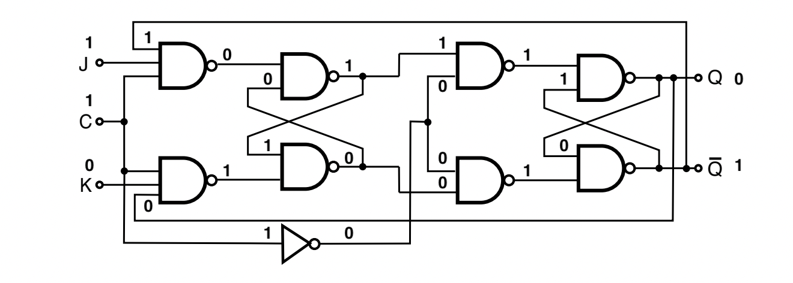
2. 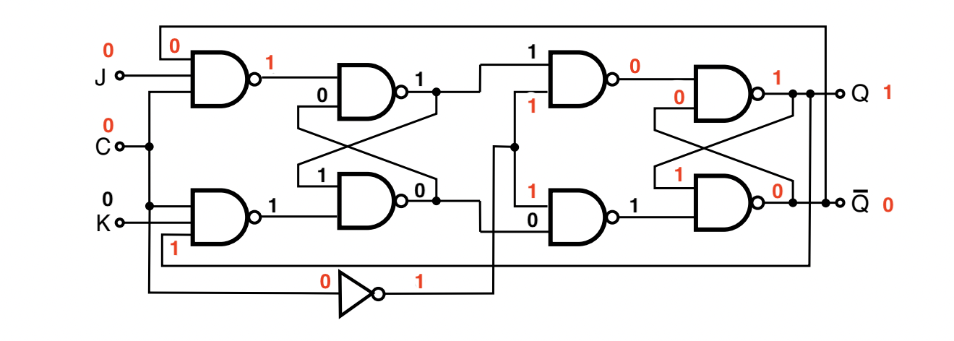
3. 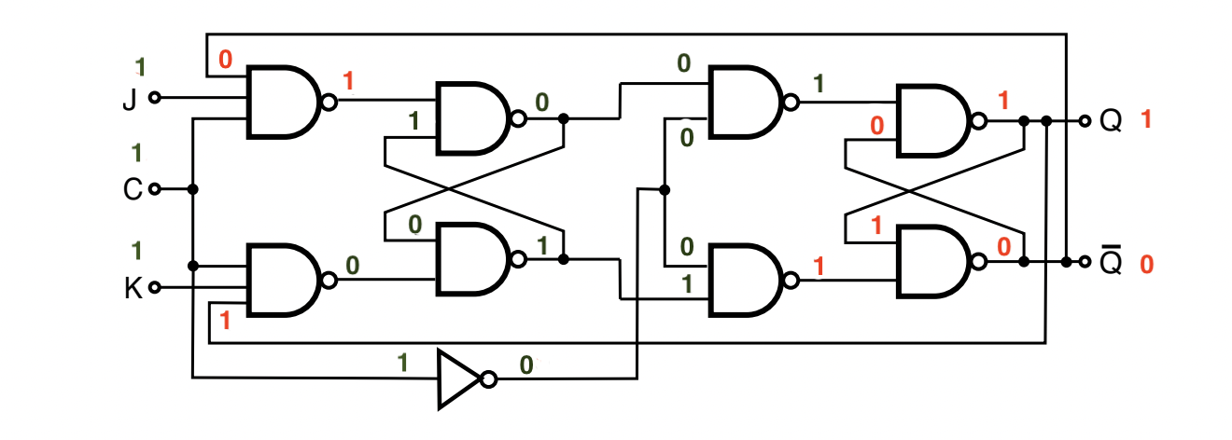

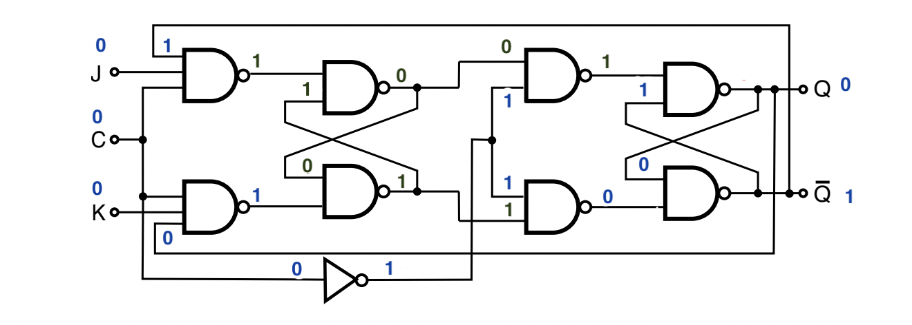

Problem 10.2:

A+B)

|  |  |  |  |  |
| --- | --- | --- | --- | --- |
| **Cell** | **Hex** | **Binary** | **Assembler** | **Description** |
| 0 | 2e | 001 0 1110 | LOAD 14 | Load the value of memory location 14 into ACC |
| 1 | b0 | 101 1 0000 | EQUAL #0 | Skip instruction if ACC is equal to value 0 |
| 2 | d4 | 110 1 0100 | JUMP #4 | Jump to instruction 4 |
| 3 | e0 | 111 0 0000 | HALT | Stop execution |
| 4 | 2f | 001 0 1111 | LOAD 15 | Load the value of memory location 15 in ACC |
| 5 | 6f | 011 0 1111 | ADD 15 | Add the value stored in memory location 15 to ACC |
| 6 | 4f | 010 0 1111 | STORE 15 | Store the value of ACC in memory location 15 |
| 7 | 2e | 001 0 1110 | LOAD 14 | Load the value of memory location 14 into ACC |
| 8 | 91 | 100 1 0001 | SUB #1 | Subtract the value 1 from value in ACC |
| 9 | 4e | 010 0 1110 | STORE 14 | Store value of ACC in memory location 14 |
| 10 | cb | 110 0 1011 | JUMP 11 | Jump to instruction stored in memory location 11 |
| 11 | 00 | 000 0 0000 | DATA 0 | 0 |
| 12 | 00 | 000 0 0000 | DATA 0 | 0 |
| 13 | 00 | 000 0 0000 | DATA 0 | 0 |
| 14 | 06 | 000 0 0110 | DATA 6 | 6 |
| 15 | 01 | 000 0 0001 | DATA 1 | 1 |

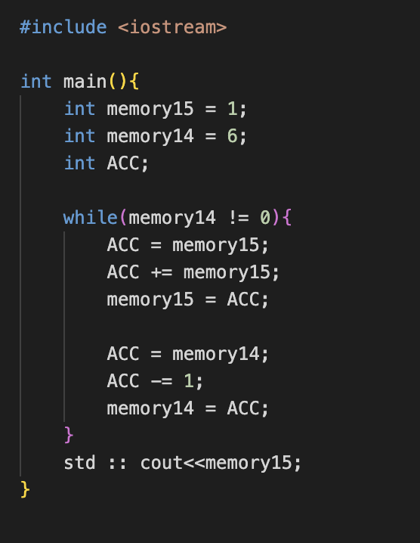C)

D) The value in memory 14 will change to 0 and then the value in memory location 15 will add to itself in each iteration while the iteration also decrements the value of memory location 14 to 0. Once the value in memory location is 0, the code will halt.