Room Security and Automation System

# Objective

To develop a logic-based circuit that secures access to a room using a digital password. When the entered code matches a stored code, it unlocks the room and automatically activates devices (such as lights, fans, or indicators). The system is built using basic logic gates, flip-flops, display decoders, and manual switches.

# Component List

|  |  |  |  |
| --- | --- | --- | --- |
| **Component** | **Label** | **Qty** | **Function** |
| SPST Switches | U1-U10 | 10 | Simulate user-entered and stored password bits |
| XNOR Gates | U12-U15 | 4 | Compare input and stored bits |
| 5-input AND Gate | U16 | 1 | Ensures all bits match (match condition) |
| 2-input AND Gates | U17, U18, U27, U3 | 06-U32 | Conditional logic for output activation |
| NOT Gates | U19, U24, U34 | 3 | Invert logic signals for control and JK Flip-Flop |
| JK Flip-Flops | U21, U22 | 2 | Used to store security state (locked/unlocked) |
| Clock Generator (2Hz) | U23 | 1 | Provides timing for JK Flip-Flop toggling |
| HEX to 7-Segment Decoder | U26 | 1 | Converts binary to displayable form |
| 7-Segment Display | Black Box | 1 | Shows system status: locked/unlocked |
| Output Loads (LEDs/Fans etc.) | X1-X5 | 5 | Indicate active devices |
| Power Supplies | 2.5V, 1.5V | 2 | Power logic components |
| Grounds | GND Symbols | Multiple | Common grounding for logic circuit |

**Component-wise Working**

## SPST Switches:

Used to simulate both user input and stored password values. Each switch represents a binary digit (0 or 1).

## XNOR Gates:

Compares user input with stored password bits. XNOR outputs HIGH only if both inputs match.

## 5-input AND Gate:

Takes outputs from XNOR gates and outputs HIGH only if all bits match, confirming password validity.

## 2-input AND Gates:

Used for conditional control logic-activates outputs only when the system is in 'unlocked' state.

## NOT Gates:

Invert logic signals to properly control JK flip-flops and gate conditions.

## JK Flip-Flops:

Act as memory elements to store the system state (locked/unlocked). Toggle based on clock and input.

## Clock Generator (2Hz):

Provides timing signal for stable toggling of JK flip-flops. Ensures sync in logic.

## HEX to 7-Segment Decoder:

Converts binary code into a displayable format for visual feedback.

## 7-Segment Display:

Displays system status, indicating whether the system is locked or unlocked.

## Output Loads:

Represent devices like fans, LEDs, or alarms that activate on valid password entry.

## Power Supplies:

Provide necessary voltage levels to power the logic components.

## Grounds:

Ensure common reference point and safe operation of all logic circuits.

# System Block Diagram

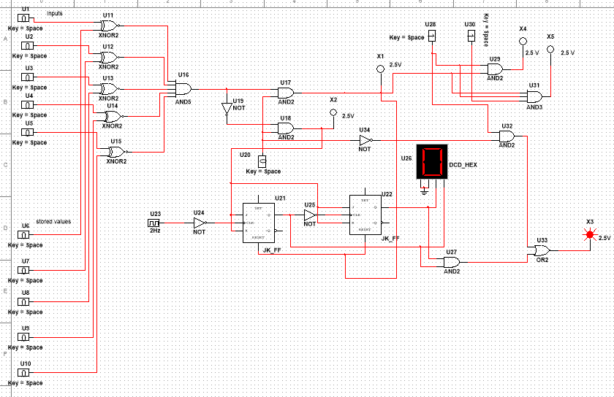

**Conclusion**

The Room Security and Automation System is a robust and logical implementation of a secure access

mechanism built using fundamental digital logic components. It offers dual functionality-ensuring security via password validation, and controlling devices based on access state. Through a combination of logic gates and flip-flops, the system accurately verifies the user's input and manages output loads like lights or alarms. Additionally, the 7-segment display provides real-time feedback. This system is scalable, cost-effective, and reliable for educational demonstrations or prototype development of real-world automation systems.