ENSF381 – Lab03

**Section:** L03

**Date:** 2024-01-29

|  |  |  |
| --- | --- | --- |
| Created by: | | |
| First name | Last name | UCID |
| Muhammed | Bilal | 30188943 |
| Fateh Ali | Syed Bukhari | 30123431 |

# 2.5.1

Git-hub repository link: <https://github.com/Bilal4700/Lab3.git>

# 2.5.2

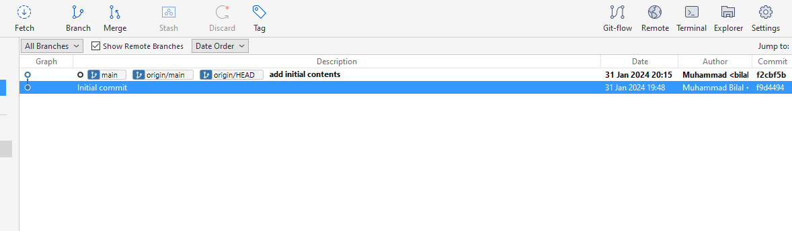

# 3.2.6

The issue arises from the first row of the table, where a 100% width setting affects the size of the row beneath it, regardless of the specified split width. To address this problem, it is necessary to place the medium and small sections of the website into a distinct table.

# 3.2.9

The website lacks optimization for smaller screens as users would need to horizontally scroll to view the complete content on mobile devices, potentially compromising the overall mobile user experience.

# 3.3.1

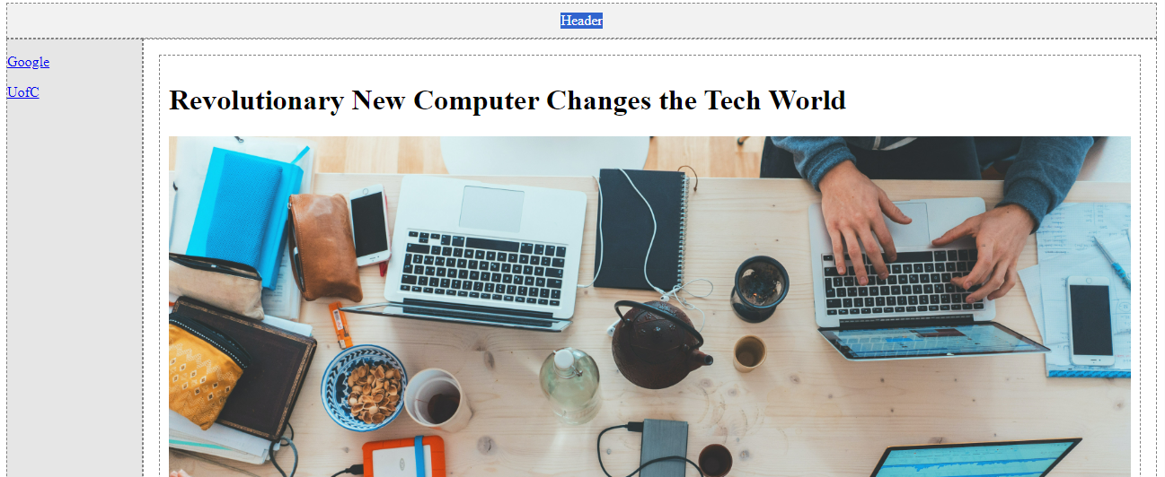

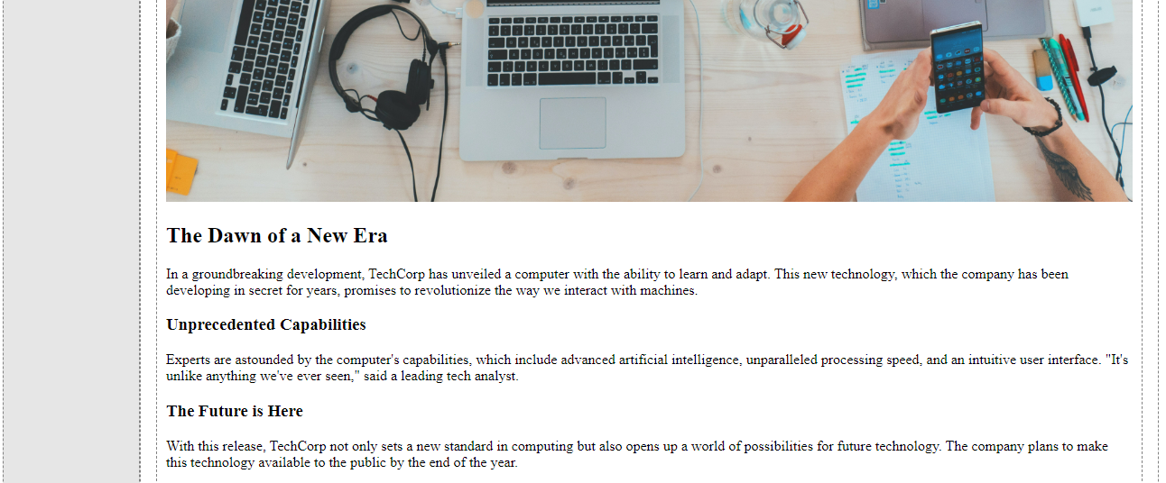

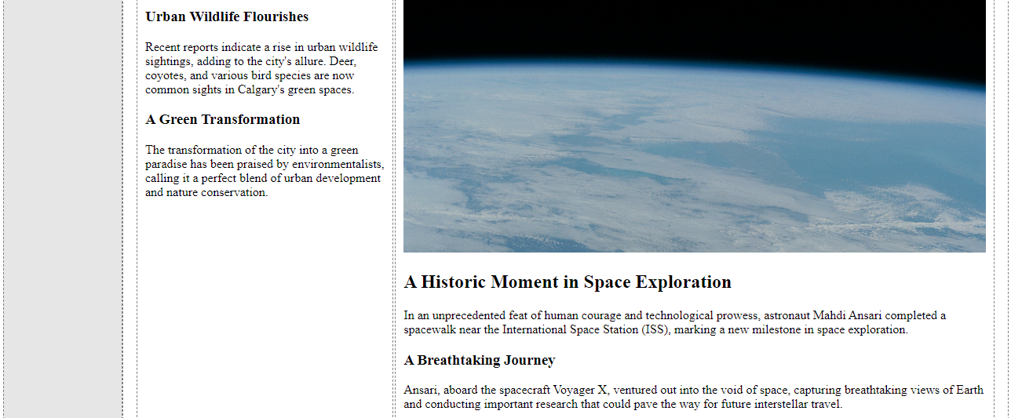

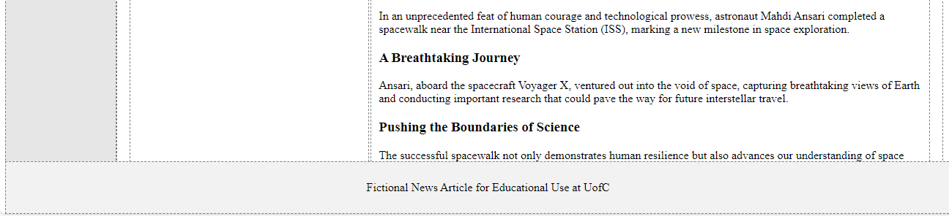

In this file, modifications include the introduction of a new table where the small and medium sections are now placed independently from the large section. Additionally, the author's name in the medium section has been updated to reflect our own.

# 4.2.1

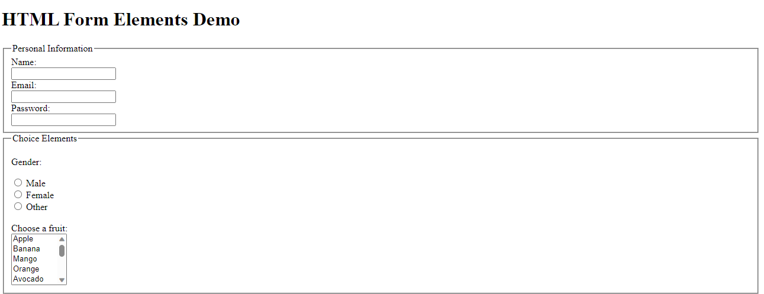

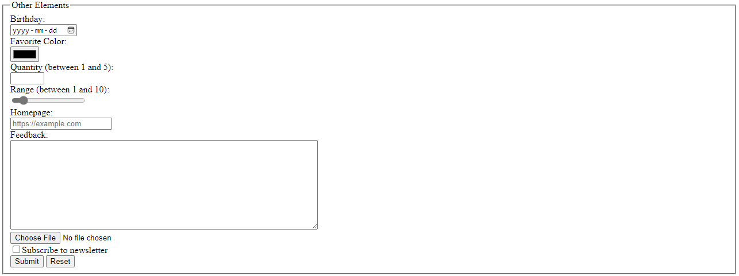

# 5.2.1

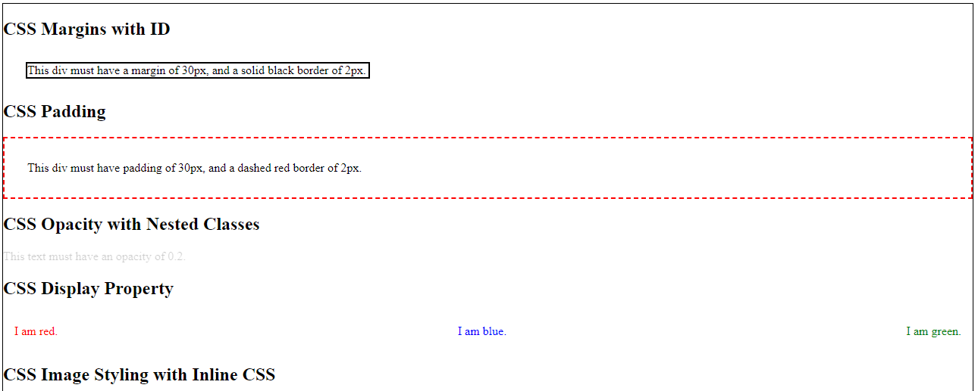

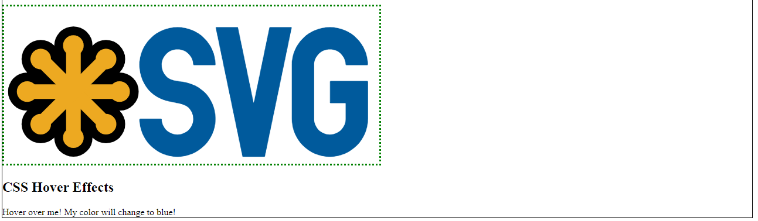

# 5.2.2

The default margin around html webpage serves a purpose to create a visual separation between the edge of the browser window and the content of the page, it was set by default to increase legibility and overall visual appearance of the page for developers only working with html. Since languages were originally designed to be used independently, and html served the purpose to display something on the webpage and if it was too close to the browsers edge it would make the content not so legible defying the purpose of being able to use the language independently without the use of CSS to make your html content legible. We can also overwrite this default margins by typing the following line of code body{margin:0px;}.

References:

Tuscannypolk. (2021b). Mysterious padding/ extra space for no reason!? Retrieved from https://forum.freecodecamp.org/t/mysterious-padding-extra-space-for-no-reason/447590.