[CEN 323 ] Computer Organization & Assembly Language
Lab 6 Journal

Name : Bilal Aamir
Enrollment Number: 01-135232-016

Lab Deliverables (submission guideline)

Create a folder named after your enrollment number and add the following files:
  - Create a folder named YourRollNumber_Lab6 containing:
- .asm files of the three practice tasks.
- Add full screen screenshots of the code and output in this word file.
  - Zip the Folder and upload to LMS.

Lab Task

Task 1:
Code (TEXT):
.data
.code
main:
mov ax,@data
mov ds,ax
mov cx,26
mov dl,'z'
mov ah,02h
MyLoop:
int 21h
DEC DL
loop MyLoop
mov ah,4Ch
int 21h
end main

Screenshot (CODE):

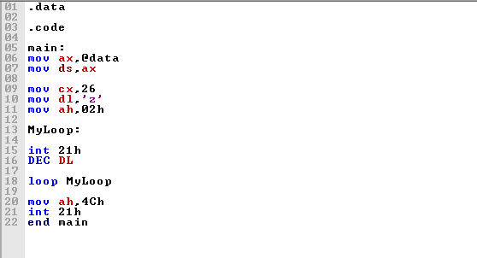
Screenshot (OUTPUT):

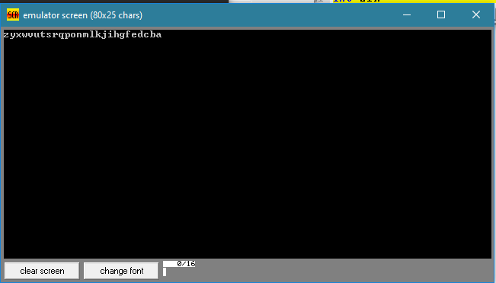

Task 2:
Code (TEXT):
.data

msg db 13,10,"The first five numbers in reverse order: ",13,10,'$'
divisor db 2

.code
main:

mov ax,@data
mov ds,ax
mov cx,9
MyLoop:
xor ax,ax
mov al,cl
div divisor
cmp ah,0
jne Print
jmp Cont

Print:
mov dl,cl
add dl,48
mov ah,02h
int 21h
Cont:
loop MyLoop
mov ah,4Ch
int 21h
end main

Screenshot (CODE):
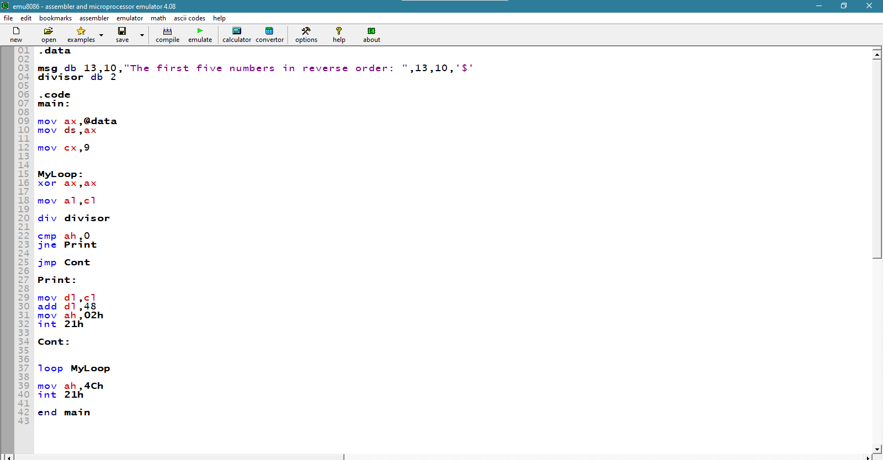

Screenshot (OUTPUT):
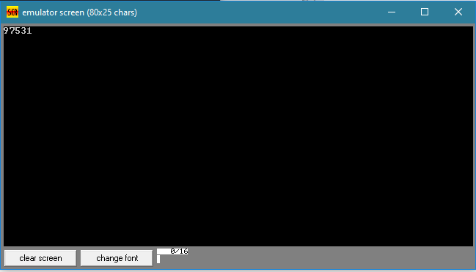

Task 3:
Code (TEXT):
.data

msg db 13,10,"Enter the number : ",13,10,'$'
greatest db ?
msg2 db 13,10,"The Greatest number is : ",13,10,'$'

.code
main:
mov ax,@data
mov ds,ax
mov ah,09h
LEA dx,msg
int 21h
mov ah,01h
int 21h
mov greatest,al
mov cx,9
MyLoop:
mov ah,09h
LEA dx,msg
int 21h
mov ah,01h
int 21h
cmp al,greatest
jg NewGreatest
jmp Cont
NewGreatest:
mov greatest ,al
Cont:
loop MyLoop
mov ah,09h
LEA dx,msg2
int 21h
mov ah,02h
mov dl,greatest
int 21h
mov ah,4Ch
int 21h
end main

Screenshot (CODE):
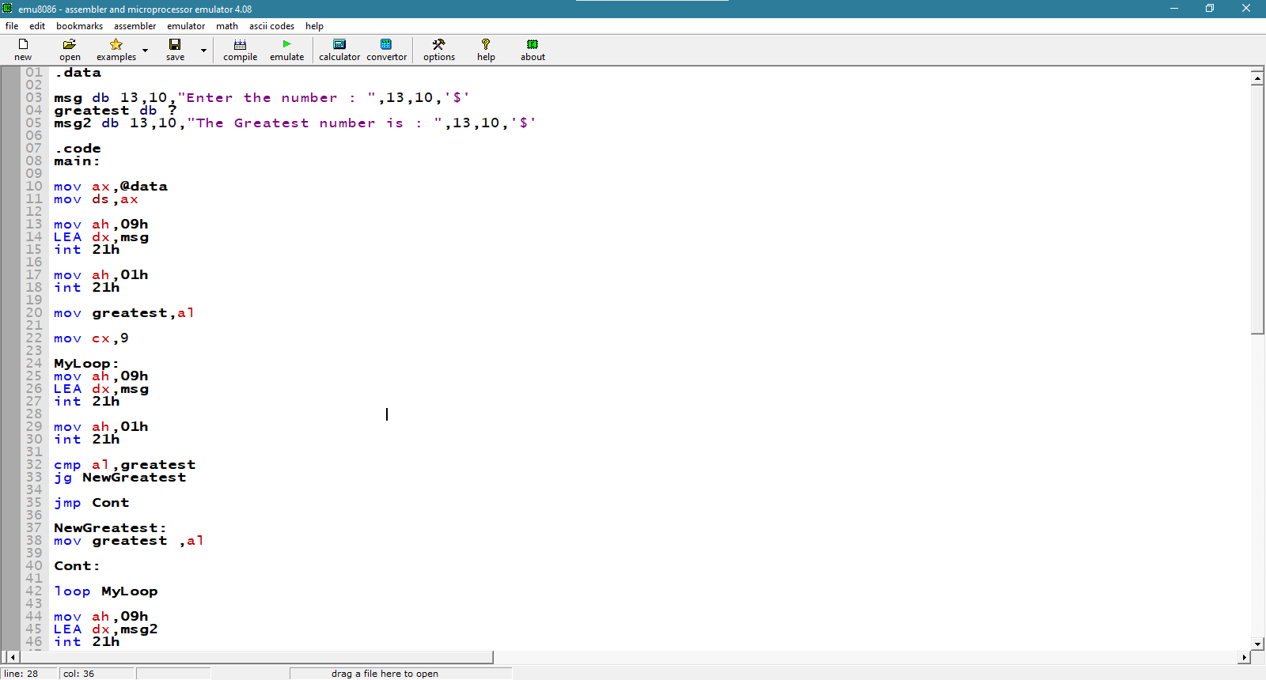

Screenshot (OUTPUT):

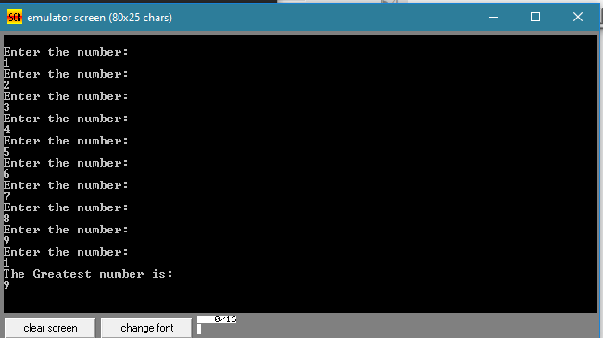

Unseen Task
Code:

.data
bckp db ?
bckp2 db ?
bckpdl db ?
newl db 13,10,'$'
comp db 4

.code
main:

mov ax,@data
mov ds,ax

mov cx,4
OuterLoop:
mov bckp,cl
InnerLoop:
cmp cl,0
jg Print1
jmp Cont1
Print1:
mov dl,cl
mov bckpdl,dl
add dl,48
mov ah,02h
int 21h
mov dl,bckpdl
Cont1:
loop InnerLoop
mov dl,cl
add dl,2
mov cl,bckp
InnerLoop2:
cmp dl,comp
jle Print2
jmp Cont2
Print2:
mov bckpdl,dl
add dl,48
mov ah,02h
int 21h
mov dl,bckpdl
INC dl
Cont2:
loop InnerLoop2
DEC comp
mov cl,bckp
mov ah,09h
LEA dx,newl
int 21h
loop OuterLoop
mov ah,4Ch
int 21h
end main

Output:

