[CEN 323 ] Computer Organization & Assembly Language
Lab 11 Journal

Name :Bilal Aamir
Enrollment Number:10-135232-016

Lab Deliverables (submission guideline)

Create a folder named after your enrollment number and add the following files:
  - Create a folder named YourRollNumber_Lab11 containing:
- .asm files of the three practice tasks.
- Add full screen screenshots of the code and output in this word file.
  - Zip the Folder and upload to LMS.

Lab Task

Task 1:
Code (TEXT):
INCLUDE EMU8086.INC
DEFINE_SCAN_NUM

JMP START
n DW 0
isPrime DB 1

START:

READ_NUM PROC

CALL SCAN_NUM

MOV n, CX
PRINTN ""

RET
READ_NUM ENDP

CHECK_PRIME PROC
MOV isPrime, 1 ; isPrime = true
MOV CX, 2 ; i = 2

PRIME_LOOP:

MOV AX, n
MOV DX, 0
MOV BX, 2
DIV BX ; AX = n/2

CMP CX, AX
JG PRIME_DONE ; if i > n/2 ? exit loop

MOV AX, n
MOV DX, 0
MOV BX, CX ; divisor = i
DIV BX ; DX = n % i

CMP DX, 0 ; remainder 0?
JNE CONTINUE ; no ? keep looping

MOV isPrime, 0 ; isPrime = false
RET ; break

CONTINUE:
INC CX ; ++i
JMP PRIME_LOOP

PRIME_DONE:
RET
CHECK_PRIME ENDP

MAIN PROC

PRINT "Enter a positive integer: "
PRINTN ""
CALL READ_NUM

CALL CHECK_PRIME

CMP isPrime,1
JE PRINT_PRIME

PRINT "This is not a prime number "
JMP EXIT_PROG

PRINT_PRIME:

PRINT "This is a prime number"

EXIT_PROG:

MOV AH, 4CH
INT 21H

MAIN ENDP

END MAIN

Screenshot (CODE):

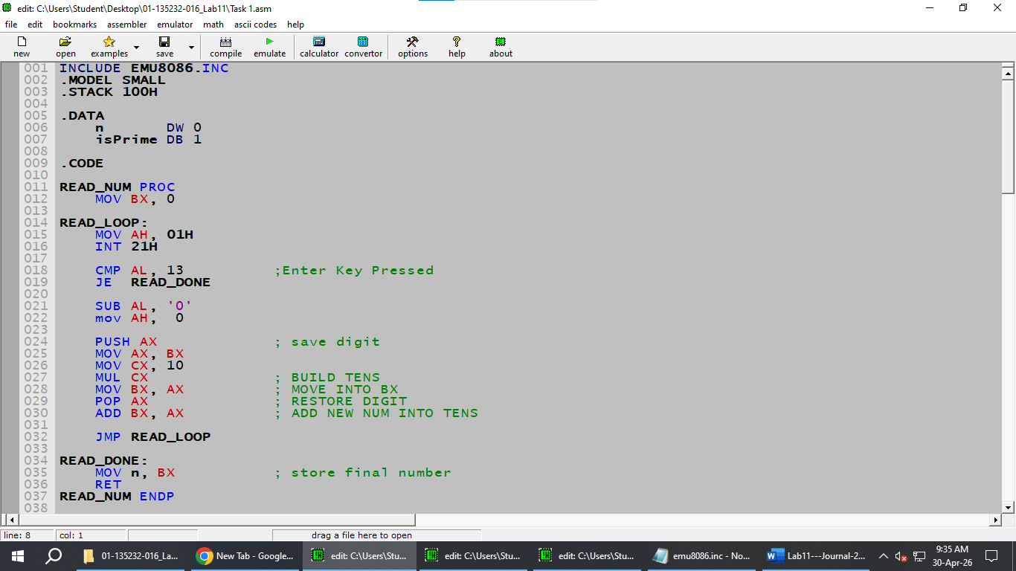

Screenshot (OUTPUT):

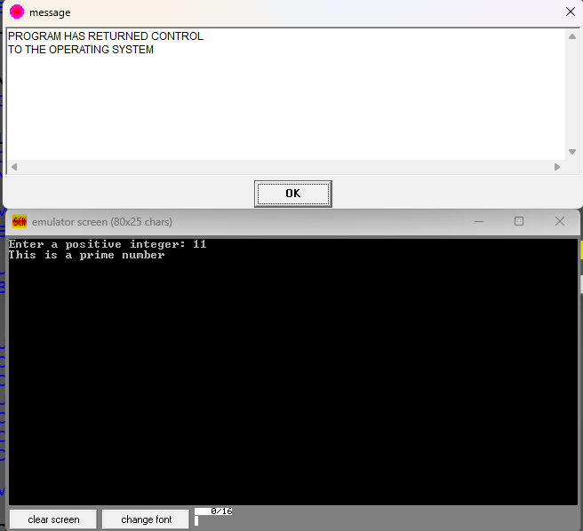

Task 2:
Code (TEXT):
INCLUDE EMU8086.INC
ORG 100H
DEFINE_SCAN_NUM

JMP MAINN
NUM1 DW ?
NUM2 DW ?
TEMP DW ?

SWAP PROC
PRINT "NUMBERS BEFORE SWAPPING: "
PRINTN ""

; Print NUM1
PRINT "NUM1 = "
MOV AX, NUM1
CALL PRINT_NUM
PRINTN ""

; Print NUM2
PRINT "NUM2 = "
MOV AX, NUM2
CALL PRINT_NUM
PRINTN ""

; Swap using TEMP
MOV AX, NUM1
MOV TEMP, AX ; TEMP = NUM1
MOV AX, NUM2
MOV NUM1, AX ; NUM1 = NUM2
MOV AX, TEMP
MOV NUM2, AX ; NUM2 = TEMP

PRINTN ""
PRINT "NUMBERS AFTER SWAPPING: "
PRINTN ""

PRINT "NUM1 = "
MOV AX, NUM1
CALL PRINT_NUM
PRINTN ""

PRINT "NUM2 = "
MOV AX, NUM2
CALL PRINT_NUM
PRINTN ""

RET
SWAP ENDP

PRINT_NUM PROC

CMP AX, 10 ; is it less than 10?
JL SINGLE_DIGIT ; yes ? skip tens logic

MOV BL, 10
DIV BL ; AL = tens, AH = units
MOV CL, AH ; save units in CL

ADD AL, '0'
MOV DL, AL
MOV AH, 02H
INT 21H ; print tens digit

MOV AL, CL ; move units into AL

SINGLE_DIGIT:
ADD AL, '0'
MOV DL, AL
MOV AH, 02H
INT 21H

RET
PRINT_NUM ENDP

MAINN:
MAIN PROC

PRINT "ENTER THE FIRST NUMBER: "
CALL SCAN_NUM
MOV NUM1,CX

PRINTN ""

PRINT "ENTER THE SECOND NUMBER: "
CALL SCAN_NUM
MOV NUM2,CX

PRINTN ""

CALL SWAP

MAIN ENDP
END MAIN

Screenshot (CODE):
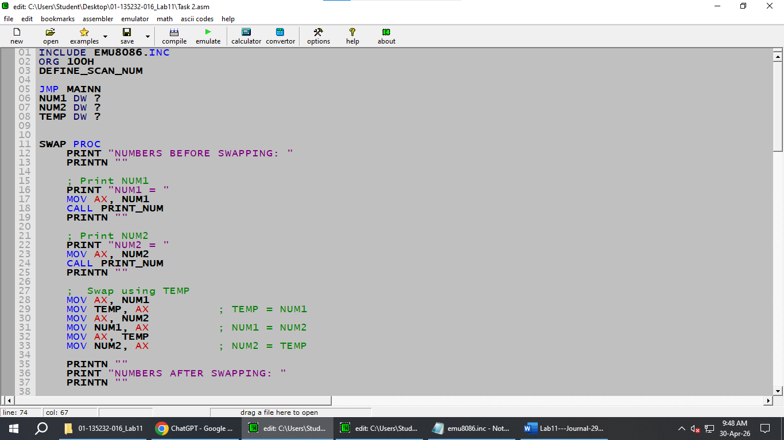

Screenshot (OUTPUT):
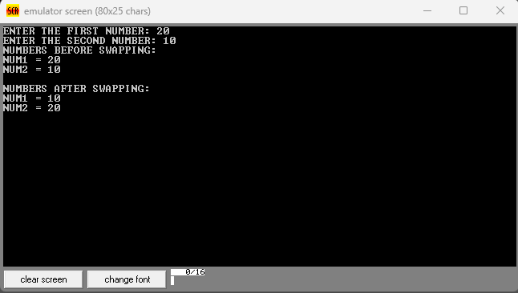

Task 3:
Code (TEXT):
INCLUDE EMU8086.INC
.MODEL SMALL
.STACK 100H
.DATA
num DB ?
count DB 0
num_count DB 0
swapped DB 0
limit DB 0
arr DB ?
.CODE

READ_INPUT PROC
MOV AX, @DATA
MOV DS, AX

PRINT "Enter the numbers you want to Sort : "
PRINTN ""

MOV SI, 0 ; array index
MOV count, 0
MOV num, 0

Input:
MOV AH, 01H
INT 21H

CMP AL, 27 ; ESC ? exit
JE InputDone

CMP AL, 13 ; Enter ? store number
JE Store

INC count
SUB AL, 48

CMP count, 2
JE Double

MOV num, AL ; save first digit
JMP Input

Double:
MOV AH, 0
MOV BL, 10
XCHG num, AL ; AL = first digit, num = second digit
MUL BL
ADD AL, num ; AL = tens + units
MOV num, AL ; save built number
JMP Input

Store:
MOV AL, num ; get the built number
MOV arr[SI], AL ; store into array
INC SI
INC num_count

PRINTN ""

MOV count, 0
MOV num, 0
JMP Input

InputDone:
PRINTN ""
RET
READ_INPUT ENDP

BUBBLE_SORT PROC
MOV AL, num_count
DEC AL
MOV limit, AL

OuterLoop:
MOV BX, 0
MOV swapped, 0

InnerL:
MOV AL, arr[BX]
CMP AL, arr[BX+1]
JBE NoSwap

MOV DL, arr[BX+1]
MOV arr[BX+1], AL
MOV arr[BX], DL
MOV swapped, 1

NoSwap:
INC BX
MOV AL, BL
CMP AL, limit
JNE InnerL

CMP swapped, 1
JE OuterLoop

RET
BUBBLE_SORT ENDP

PRINT_ARR PROC
PRINTN ""
PRINT "The Sorted Array is : "

MOV SI, 0
XOR BX, BX
MOV BL, num_count

PrintLoop:
CMP BL, 0
JE PrintDone

MOV DL, arr[SI]

CMP DL, 9
JBE Single

; Double digit
XOR AX, AX
MOV AL, DL
MOV CH, 10
DIV CH ; AL = tens, AH = units
MOV CL, AH ; save units

ADD AL, 48
MOV DL, AL
MOV AH, 02H
INT 21H ; print tens

MOV DL, CL

Single:

ADD DL, 48
MOV AH, 02H
INT 21H

PRINT " "
INC SI
DEC BL
JMP PrintLoop

PrintDone:
RET
PRINT_ARR ENDP

MAIN PROC
CALL READ_INPUT
CALL BUBBLE_SORT
CALL PRINT_ARR

MOV AH, 4CH
INT 21H

MAIN ENDP
END MAIN

Screenshot (CODE):
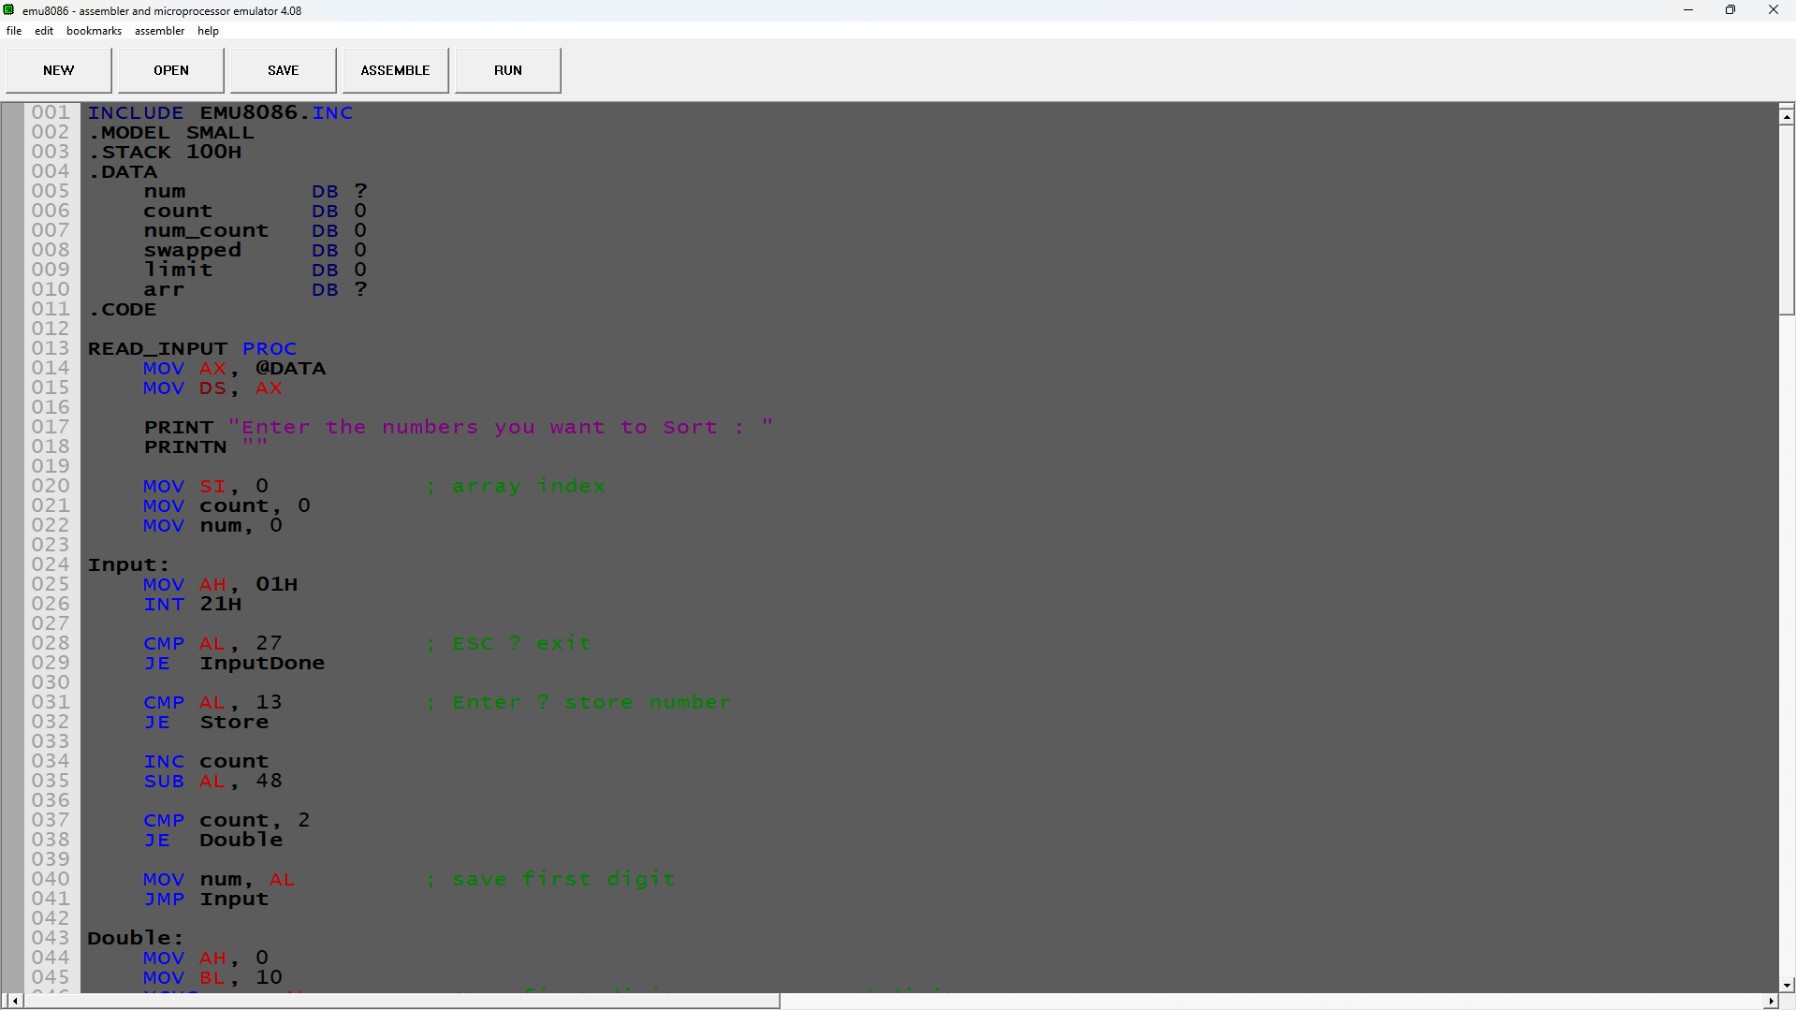

Screenshot (OUTPUT):
