Bilal Afzal  Full-Stack Software Engineer  E-Mail: bilalafzal4014@gmail.com  Address: Model Town, Lahore  Cell# 0345-4130565 | 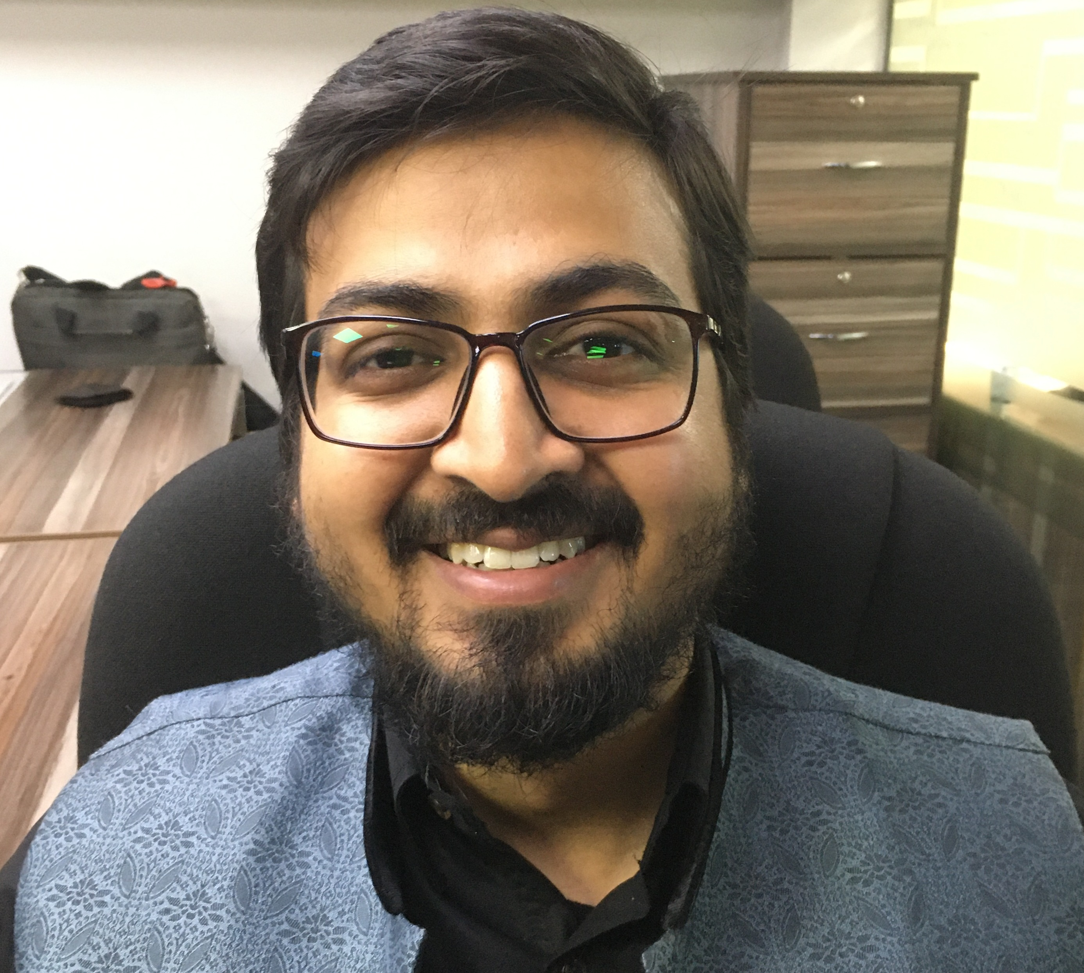

OBJECTIVE

I want to further my experience and knowledge in the field of information technology by working in a challenging environment that offers me opportunities of learning and self-growth.

PROFESSIONAL SKILLS

- Front-End
  - ReactJS
  - VueJS
  - Jquery
- Back-End
  - NodeJS
  - Laravel
- Others
  - Git
  - AWS
  - Docker
  - MySQL
  - MongoDB
  - RabbitMQ
  - Sequelize
  - Redis

Projects:

Synavos From: Oct-2019

Project: Iapps

Description: A tool to engage employees of your organization and create a fun learning environment. The complete project consists of admin panel, user panel, android learner app and ios learner app. Admin can create a game with different question and also create courses along with the content library while the learners can play the game and win points hence increasing their knowledge.
Role: I worked on both front-end (ReactJs) and backend (NodeJS, MySQL). Mainly, I wrote API’s for different features which were utilized by mobile developers and front end developers as well. I also learned and designed the architecture of a multi-tenant system. Later on we implemented it. I closely worked with the software architect to improve the architecture of the application using different state of the art technologies e.g. Microservices, Redis, RabbitMQ, Load Balancers and Auto Scaling.

Eureka Technologies From: May-2018 To: Oct-2019 (1.5 years)

Project: Engagement

Description: A Web based project to generate ads to improve business. Admin can create ad campaigns and target specific users for that campaign based on segmentation. A campaign could be In app, email or push notification.

Role: I worked on both front-end (vuejs) and backend (laravel, MySQL). Mainly I worked with campaign, segments and news feed part. The main challenge in this application was to maintain the non-relational data in the MySQL database. I learned query optimization and how we can leverage the power of cursor at database level to improve the performance. I also created a SDK for internal use for this project.

Project: Secure-Geni

Description: A Web based project to implement content library.
Role: I worked on both front-end (ReactJS) and backend (NodeJS). The main challenge in this application was to maintain the data since the documents uploaded by users can be large insize sometimes. I learned query optimization in this application.

Zin Technologies From: Dec-2016 To: May-2018 (1.4 year)

Project: EverestHR

Description: A Web base HR system to manage all the managerial requirements of a company. Main features included attendance, leave management, authentication.

Role: Again I worked with both front-end (vuejs, reactjs) and back-end (laravel, MongoDB). Initially I worked with angularjs which was replaced with vuejs later on. Mainly, I learned how a single page application works with API based project. Also, learned how JWT works.

EDUCATION

National University of Computer & Emerging Sciences Lahore (2012 - 2016 | FAST-NU)

Bachelor of Science in Computer Science

