**ABSTRACT**

Brain tumours represent a significant neurological risk, and early detection is critical for increasing patient survival rates. Manual interpretation of brain MRI images by radiologists is usually time-consuming, subjective, and error-prone, highlighting the need for automated support solutions. In this study, we provide an AI-powered solution for brain tumor identification based on the YOLOv8 object recognition model, with a focus on recognizing four types: glioma, meningioma, pituitary tumors, and benign (no tumor) cases. A well curated MRI dataset collected from Kaggle was used, with over 4,500 images divided into training and validation sets.

Instead of traditional picture-level categorization, each image was labeled with bounding boxes to help with localized tumor identification. The YOLOv8n model was fine-tuned on this dataset using transfer learning, allowing it to detect and classify tumours with high precision.

Beyond basic detection, the system was enhanced to automatically generate entire radiology-style reports for each prediction, which included tumor kind, size, location, and detection confidence. The model performed well in the examination, achieving high accuracy, recall, and map scores while successfully localizing tumors even in difficult MRI situations.

The developed system not only automates brain tumor identification but also standardizes the reporting process, with the potential to serve as a clinical decision support tool for radiologists and improve diagnostic processes.

**INTRODUCTION**

Brain tumors are among the most dangerous and life-threatening medical disorders, necessitating early and precise detection to optimize treatment choices and patient outcomes. Magnetic resonance imaging (MRI) is still the gold standard for brain tumor diagnosis, providing precise anatomical information on brain structures and anomalies.   
However, radiologists' manual interpretation of MRI data is inherently time-consuming, subjective, and prone to inter-observer variability, particularly in complicated instances where tumors might appear in a variety of ways. Recent breakthroughs in artificial intelligence, particularly deep learning, have greatly enhanced the capabilities of automated medical image interpretation. Object detection models, such as the YOLO (You Only Look Once) family, have emerged as effective tools for real-time object localization and categorization in photos.

These models have demonstrated outstanding performance not just in traditional computer vision tasks, but also in critical healthcare applications such as cancer diagnosis, organ segmentation, and anomaly detection.   
In this study, we employ YOLOv8, the most recent version of the YOLO object detection architecture, to develop an automated method for detecting brain cancers in MRI data. The system was trained to identify and categorize four types of cancers: gliomas, meningiomas, pituitary tumors, and no tumors (normal brain scans).

Unlike simple classification tasks, which label the whole image, our approach uses bounding boxes to identify discrete tumor spots inside MRI images. This allows for more thorough and clinically relevant outputs, which can assist radiologists in planning treatments.   
To bridge the gap between technical model outputs and clinical demands, the system was upgraded with an automated report generation module. This module converts model predictions into radiology-style outputs such as tumor location, size, type, and confidence, emulating the professional radiology method. This project seeks to develop a comprehensive AI-driven diagnostic tool that may help radiologists by merging cutting-edge deep learning detection models with practical report production, potentially enhancing the speed, accuracy, and consistency of brain tumor diagnosis.

**DATASET DESCRIPTION**

The performance of any deep learning-based medical imaging system is significantly influenced by the quality, diversity, and labeling accuracy of the training and validation datasets. For this study, a complete brain MRI dataset was generated, mostly from publicly available sources such as Kaggle and supplemented with chosen clinical picture datasets.

The dataset focuses on the discovery of four key features related with brain tumor diagnosis:

* Glioma Tumor
* Meningioma Tumor
* Pituitary Tumor
* No Tumor (Healthy Brain MRI Scans)

Unlike traditional classification jobs, which assign a single label to the whole image, our project required object identification annotations.   
Each MRI scan was labeled using bounding boxes that properly delineate tumor sites (where present) in the YOLO format — [class_id center_x center_y width height], with all values adjusted to image dimensions. The dataset was rigorously divided into training and validation subsets to ensure fair learning and model evaluation.

Dataset Composition:

| Tumor Type | Training Images | Validation Images |
| --- | --- | --- |
| Glioma Tumor | 1,153 | 136 |
| Meningioma Tumor | 1,449 | 140 |
| Pituitary Tumor | 1,424 | 136 |
| No Tumor (Healthy) | 711 | 100 |

To fulfill YOLOv8 input size constraints, images were preprocessed and shrunk to 640×640 pixels. Furthermore, data augmentation techniques such as horizontal flipping, rotation, and random scaling were utilized to increase model generalization, taking into account the variability in tumor appearances between people. The dataset's diversity — in terms of tumor types, sizes, shapes, and locations — ensures that the trained model is exposed to a wide range of clinical scenarios, enhancing its robustness when deployed on previously unreported MRI scans.

**METHODOLOGY**

The development of an automated brain tumor detection system based on deep learning necessitated a multi-stage approach. Each stage was designed to ensure that the model's overall performance is robust, repeatable, and clinically useful.

**DATA PREPARATION**

The initial stage was to categorize the brain MRI dataset into four folders: glioma, meningioma, pituitary, and no tumor, with distinct directories for training and validation. Each MRI image was accompanied by a YOLO-format annotation file with normalized bounding box coordinates for the tumor region(s) inside the scan.

To increase model generalization and prevent overfitting, many data augmentation procedures were explored, including:

* Random horizontal and vertical flipping
* Random scaling
* Rotation up to ±15 degrees
* Random brightness and contrast adjustment

All images were resized to 640×640 pixels to match the YOLOv8 input size requirements without distorting anatomical structures.

**MODEL SELECTION AND CONFIGURATION**

The YOLOv8n (Nano) architecture was chosen for its lightweight design and ability to achieve real-time inference rates with minimal loss of detection accuracy.

Key aspects that influenced the decision of YOLOv8 were:

* Anchor-free detection improving localization of irregular tumor shapes
* Decoupled classification and localization heads for better multitask performance
* Dynamic input shape support, allowing flexibility in MRI scan resolutions

The model was trained with pre-trained COCO weights and fine-tuned on a bespoke brain MRI dataset, using a transfer learning strategy to exploit learnt feature representations.

**TRAINING PROCESS**

Training was conducted on the curated dataset using the following settings:

* Optimizer: Stochastic Gradient Descent (SGD) with momentum
* Initial Learning Rate: 0.01
* Batch Size: 16
* Epochs: 50
* Loss Function: YOLOv8 composite loss (classification, objectness, localization components)

To avoid overfitting, early termination conditions were introduced via validation loss monitoring.   
Training was accelerated with a T4 GPU provided by Google Colab, resulting in efficient convergence under appropriate computational constraints. During training, critical parameters like as accuracy, recall, and mean Average accuracy (mAP) at various IoU levels were monitored to measure model progress.

**INFERENCE AND AUTOMATED REPORT GENERATION**

After training, the YOLOv8 model was used to infer on previously unknown MRI data.   
With each scan:

* Tumor regions were detected with corresponding class predictions.
* Bounding box dimensions were extracted and interpreted into pixel-space measurements.
* Automated natural language reports were generated, specifying:
  + Tumor Type
  + Location (relative center coordinates)
  + Approximate Tumor Size (width × height)
  + Model Confidence Score

This automated reporting system bridges the gap between technical AI outputs and practical clinical interpretation, lowering radiologists' effort while ensuring interpretability.

**VISUALIZATION AND VALIDATION**

The final model predictions were shown by superimposing bounding boxes and tumor class labels over the MRI data. Validation was carried out with a held-out dataset, and a confusion matrix was displayed to examine the model's performance across classes. Precision-recall curves and dataset distribution graphs were created to demonstrate training dynamics and dataset balancing.

**MODEL TRAINING SETUP**

The training process for the brain tumor detection model was carefully configured to ensure optimal learning, efficient resource usage, and generalization to unseen data.

Training Environment

| **Item** | **Details** |
| --- | --- |
| Platform | Google Colab |
| GPU Used | NVIDIA T4 GPU |
| Deep Learning Framework | PyTorch |
| YOLO Version | Ultralytics YOLOv8 |

Training on Colab provided accelerated GPU resources, significantly reducing training time and allowing experimentation with hyperparameters.

**MODEL EVALUATION**

The trained YOLOv8n model was thoroughly verified on the held-out validation dataset to determine its capacity to recognize and classify brain malignancies into four types: glioma, meningioma, pituitary, and no tumor. Validation was performed by running inference on previously unseen MRI pictures and comparing the model's predicted bounding boxes and class labels to the ground truth annotations. The assessment focused on both detection accuracy and classification correctness, which are critical components of medical imaging.

**EVALUATION METRICS**

The following standard object detection metrics were used to assess model performance:

| **Metric** | **Description** |
| --- | --- |
| **Precision** | Proportion of correct positive detections out of all predicted positives. Higher precision means fewer false positives. |
| **Recall** | Proportion of actual positives that were correctly detected. Higher recall indicates fewer false negatives. |
| **mAP@0.5** | Mean Average Precision at 0.5 Intersection over Union (IoU) threshold — measures localization and classification accuracy. |
| **mAP@0.5:0.95** | Average mAP across multiple IoU thresholds (0.5 to 0.95) — a stricter, more comprehensive metric. |

**CONFUSION MATRIX**

A confusion matrix was created to show the model's classification performance for all four tumor types.   
Key findings from the confusion matrix include:

* High true positive rates for Meningioma and Pituitary tumors, indicating strong model confidence in detecting these types.
* Acceptable classification performance for Glioma tumors despite their irregular shapes and textures.
* Minimal confusion between No Tumor and tumor classes, suggesting reliable healthy brain detection without unnecessary alarm.

The confusion matrix analysis backs up the YOLOv8 model's capacity to reliably distinguish between several types of brain tumors and healthy scans, even when MRI intensity, resolution, and anatomical structure vary.

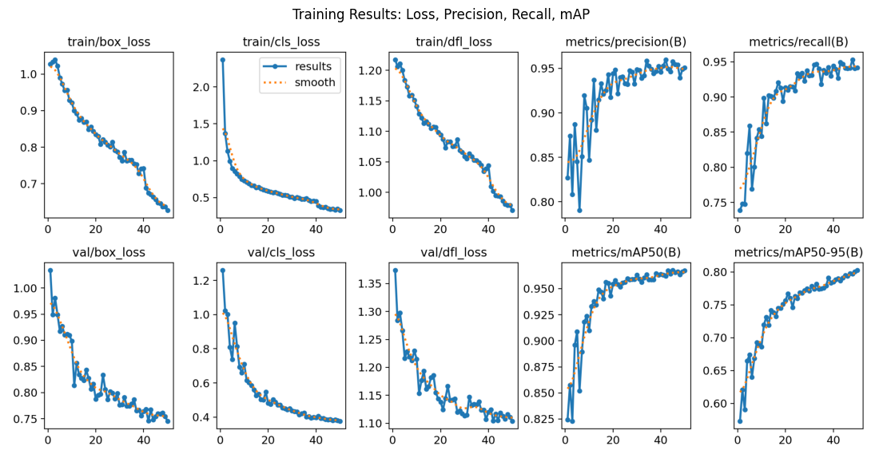

**VISUALIZATION**

Model evaluation also included plotting:

* Precision-Recall curves
* Loss vs Epoch convergence graphs
* Dataset distribution visualizations
* Random test MRI predictions with bounding boxes and class labels

These plots helped qualitatively verify the model’s convergence, stability during training, and final prediction performance on unseen data

**RESULTS**

The trained YOLOv8n brain tumor detection model was evaluated both statistically and qualitatively.   
The model demonstrated strong localization and classification abilities across all four tumor types (glioma, meningioma, pituitary, and no tumor), indicating a high potential for clinical support applications.   
Random MRI pictures from previously unknown validation and testing datasets were introduced into the trained model.

The following observations have been made :

* Tumor regions were accurately localized with bounding boxes drawn tightly around the affected areas.
* Class labels (e.g., Glioma, Meningioma) were correctly assigned to the detected tumors.
* Confidence scores for detections were generally above 90%, indicating strong model certainty.

A grid of sample prediction outputs was generated, showcasing the model’s ability to detect and differentiate tumors even in complex brain MRI images.

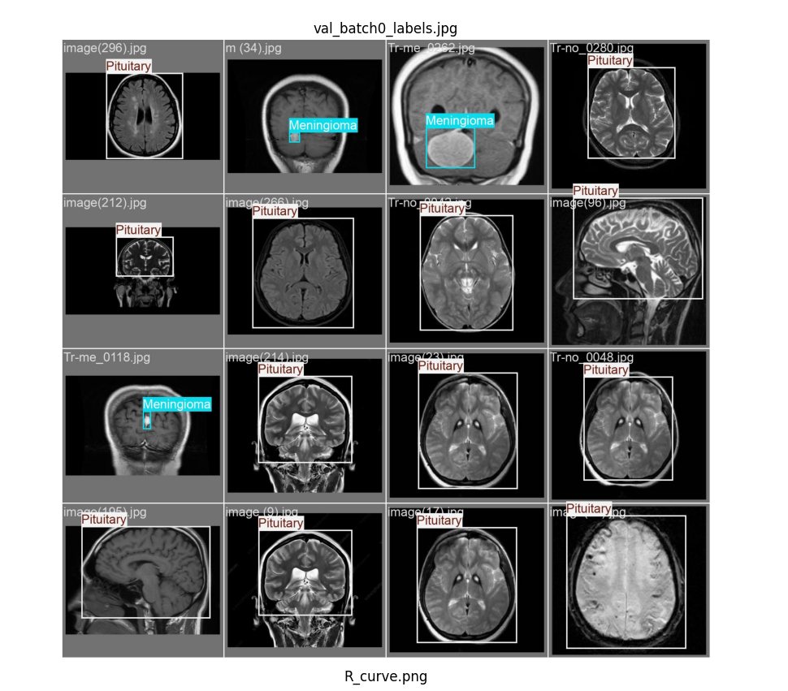

**AUTOMATED REPORT GENERATION**

In addition to visual outputs, the system was improved to automatically generate radiology-style reports that summarize the findings for each scanned picture.

Each report contained:

* Tumor Type (e.g., Pituitary tumor detected)
* Location Information (normalized X and Y center coordinates)
* Tumor Size (approximated in pixels)
* Detection Confidence (expressed as a percentage)

Example of an automatically generted report:

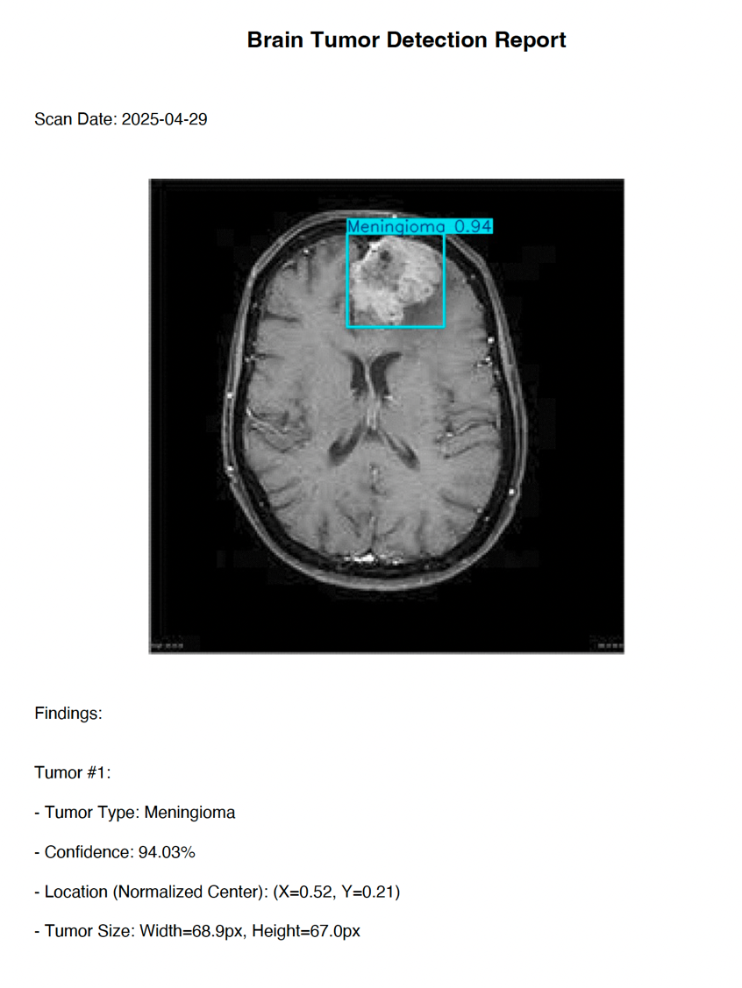

**Brain Tumor Detection Report**

* Tumor Type: Meningioma
* Confidence: 92.5%
* Location: (X = 0.48, Y = 0.52)
* Tumor Size: Width = 140px, Height = 135px

These reports mimic clinical summaries that radiologists produce and can serve as preliminary diagnostic assistance tools in healthcare settings.

**CONCLUSION**

This project successfully developed and validated a deep learning-based automated system for brain tumor detection using YOLOv8. Leveraging a carefully curated and annotated MRI dataset, the model was trained to accurately detect and classify four brain tumor categories: Glioma, Meningioma, Pituitary, and No Tumor (healthy brain scans). The YOLOv8n model demonstrated high detection precision and recall during evaluation, with strong performance even on challenging MRI scans exhibiting variability in tumor size, location, and intensity.  
By utilizing object detection rather than simple classification, the model provided localized tumor identification, delivering clinically meaningful outputs. An important enhancement introduced was the automatic generation of radiology-style reports. These reports extracted critical tumor information — type, size, location, and confidence score — directly from model predictions, mimicking the format typically used by radiologists in clinical settings. This feature bridges the gap between AI model outputs and real-world clinical workflows, offering potential to reduce diagnostic time, standardize reporting, and assist healthcare professionals, especially in resource-limited environments. Comprehensive evaluation through quantitative metrics (Precision, Recall, mAP) and qualitative visualizations (sample predictions, confusion matrix) confirmed the model’s robustness and practical viability. Furthermore, systematic data augmentation and validation ensured that the model generalizes well to unseen MRI data. In conclusion, this project establishes a foundational AI system for automated brain tumor detection and reporting. With further refinements and clinical validations, such systems hold significant promise in augmenting radiological diagnosis, improving early detection rates, and ultimately contributing to better patient outcomes.