Fast**National University of Computer & Emerging Sciences, Karachi  
Fall-2020 Department of Computer Science  
Assignment 5  
Due: 20th December 2021**

**Max Marks: 60 Points**

**Question # 1** 20 Points

Explain in your own words

1. What is meant by P and NP Problems? Explain P = NP
2. Why it is important to find approximate solutions for NP Complete Problems
3. What is the difference between NP Complete and NP Hard
4. A problem that is solvable in time complexity of and space complexity of and it can be validated in time. Is it a NP-Complete or NP-Hard? Explain

**Question #2**

Consider the following APPROX-VERTEX-COVER algorithm. Proof that this algorithm is 2-approximation method for VERTEX-COVER. 10 Points

**APPROX-VERTEX-COVER**(G)

;

E’=G.E;

while(E’ ){

Randomly choose a edge (u,v) in E’, put u and v into C;

Remove all the edges that covered by u or v from E’

}

Return C;

**Question 3** 10 Points

An Instance of the set-covering problem consists of a finite set X and a family F of subset of X, such that every element of X belongs to at least one subset of F:

We say that a subset covers all elements in X. Our goal is to find a minimum size subset whose members cover all of X.

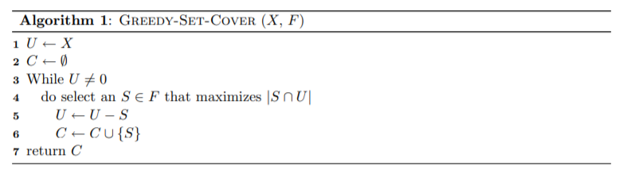

Consider each of the following words as a set of letters: {arid, dash, drain, heard, lost, nose, shun, slate, snare, thread}. Show which set cover GREEDY-SET-COVER produces, when we break ties in favor of the word that appears first in the dictionary.

**Question 4:** 20 Points

Consider following points in 2D

(6,2), (9,5), (-2,2), (-3,4), (-8,8), (-10,4), (-10,3), (-8,-6), (-4,-4), (6,4), (6,-6), (-6,-10), (8,0)

Find the smallest convex set containing all the points using Package Wrap (Jarvis March) and Graham Scan (Show all iterations).

**BEST OF LUCK**