**National University of Computer & Emerging Sciences**

**Karachi Campus**



**SDA ASSIGNMENT # 04**

**Ashmal Anis Vayani**

**19K-0305**

**Sec: H**

**Question # 01(a)**

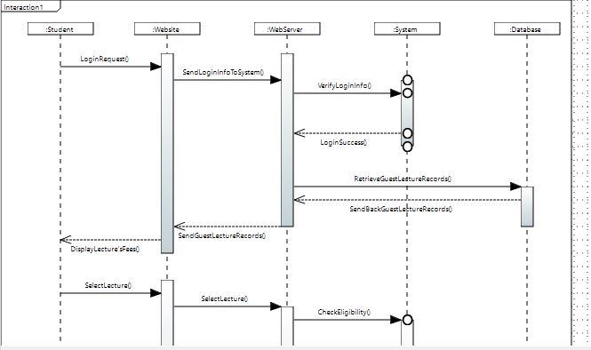

**Question # 01(b)**

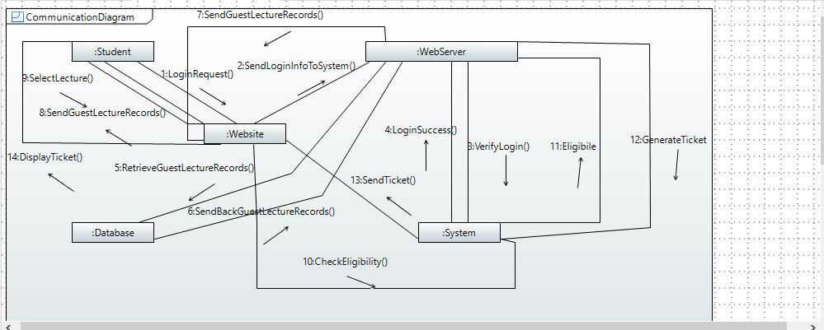

**Question # 02(a)**

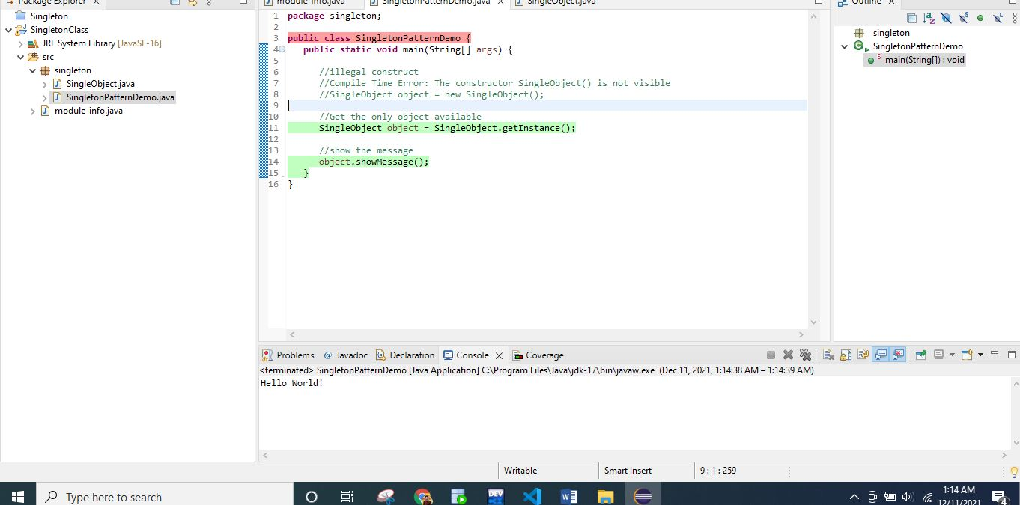

**Code**

**SingleObject:**

package singleton;

public class SingleObject {

//create an object of SingleObject

private static SingleObject instance = new SingleObject();

//make the constructor private so that this class cannot be

//instantiated

private SingleObject(){}

//Get the only object available

public static SingleObject getInstance(){

return instance;

}

public void showMessage(){

System.out.println("Hello World!");

}

}

**SingletonPatternDemo:**

package singleton;

public class SingletonPatternDemo {

public static void main(String[] args) {

//illegal construct

//Compile Time Error: The constructor SingleObject() is not visible

//SingleObject object = new SingleObject();

//Get the only object available

SingleObject object = SingleObject.getInstance();

//show the message

object.showMessage();

}

}