**National University of Computer & Emerging Sciences**

**Karachi Campus**



**SDA ASSIGNMENT # 02**

**Ashmal Anis Vayani**

**19K-0305**

**Sec: H**

**Question # 01**:

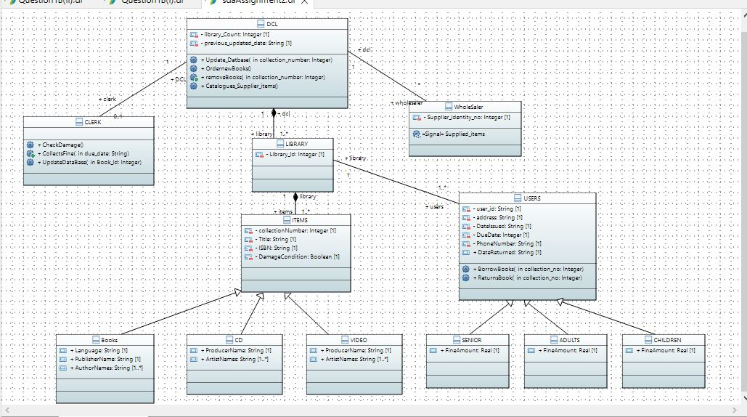

**Question # 02 (i):**

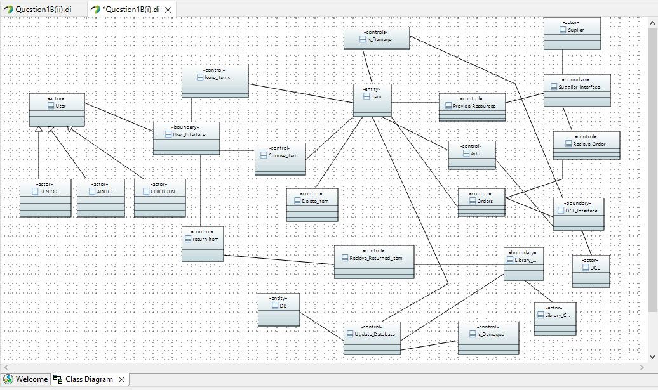

**Question # 02 (ii):**

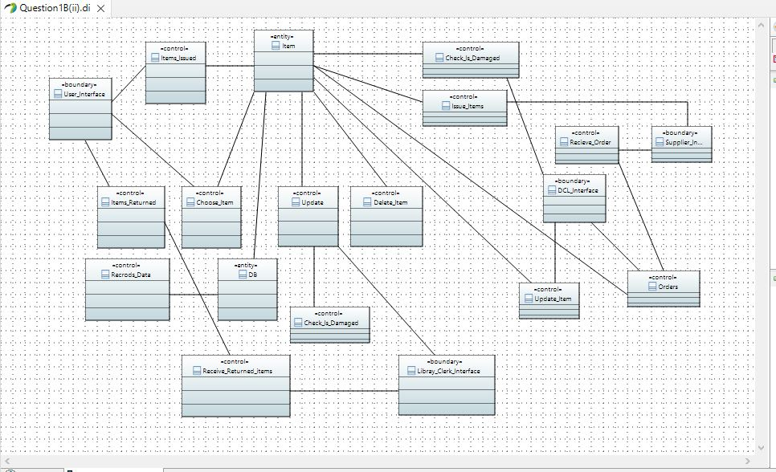

**Code**

**Adults.java:**

// --------------------------------------------------------

// Code generated by Papyrus Java

// --------------------------------------------------------

package sdaAssignment2;

/************************************************************/

/**

*

*/

public class ADULTS extends USERS {

/**

*

*/

public float fine = 1.0;

/**

*

*/

public float FineAmount = 1.0;

}

**Books.java:**

// --------------------------------------------------------

// Code generated by Papyrus Java

// --------------------------------------------------------

package sdaAssignment2;

/************************************************************/

/**

*

*/

public class Books extends ITEMS {

/**

*

*/

public String Language;

/**

*

*/

public String PublisherName;

/**

*

*/

public String[] AuthorNames;

}

**CD.java:**

// --------------------------------------------------------

// Code generated by Papyrus Java

// --------------------------------------------------------

package sdaAssignment2;

/************************************************************/

/**

*

*/

public class CD extends ITEMS {

/**

*

*/

public String Producer_name;

/**

*

*/

public int no_of_artists;

/**

*

*/

public String[] artists;

/**

*

*/

public String ProducerName;

/**

*

*/

public String[] ArtistNames;

}

**Children.java**

// --------------------------------------------------------

// Code generated by Papyrus Java

// --------------------------------------------------------

package sdaAssignment2;

/************************************************************/

/**

*

*/

public class CHILDREN extends USERS {

/**

*

*/

public float fine = 0.05;

/**

*

*/

public float FineAmount = 1.0;

}

**Clerk.java**

// --------------------------------------------------------

// Code generated by Papyrus Java

// --------------------------------------------------------

package sdaAssignment2;

/************************************************************/

/**

*

*/

public class CLERK {

/**

*

*/

public float fine_collected;

/**

*

*/

public boolean damaged;

/**

*

*/

public void check_damage() {

}

/**

*

* @param due_date

* @param date_of_return

*/

public void calculate_fine(String due_date, String date_of_return) {

}

/**

*

* @param user_id

* @param collection_no

* @param date_of_borrow

*/

public void update1(int user_id, int collection_no, String date_of_borrow) {

}

/**

*

* @param date_of_return

* @param fine

*/

public void update2(String date_of_return, float fine) {

}

/**

*

*/

public void CheckDamage() {

}

/**

*

* @param due_date

*/

public void CollectsFine(String due_date) {

}

/**

*

* @param Book_Id

*/

public void UpdateDataBase(int Book_Id) {

}

}

**DCL.java**

// --------------------------------------------------------

// Code generated by Papyrus Java

// --------------------------------------------------------

package sdaAssignment2;

/************************************************************/

/**

*

*/

public class DCL {

/**

*

*/

public int no_of_libraries;

/**

*

*/

public String last_updated_date;

/**

*

*/

private int library_Count;

/**

*

*/

private String previous_updated_date;

/**

*

* @param collection_no

*/

public void update(int collection_no) {

}

/**

*

*/

public void order() {

}

/**

*

* @param collection_no

*/

public void remove(int collection_no) {

}

/**

*

* @param collection_number

*/

public void Update_Datbase(int collection_number) {

}

/**

*

*/

public void OrdernewBooks() {

}

/**

*

* @param collection_number

*/

public void removeBooks(int collection_number) {

}

/**

*

*/

public void Catalogues_Supplier_items() {

}

}

**ITEMS.java**

// --------------------------------------------------------

// Code generated by Papyrus Java

// --------------------------------------------------------

package sdaAssignment2;

/************************************************************/

/**

*

*/

public class ITEMS {

/**

*

*/

public int collection_no;

/**

*

*/

public String title;

/**

*

*/

public String ISBN;

/**

*

*/

public String condition;

/**

*

*/

public boolean borrowed_this_yr;

/**

*

*/

private int collectionNumber;

/**

*

*/

private String Title;

/**

*

*/

private String ISBN;

/**

*

*/

private boolean DamageCondition;

}

**LIBRARY.java**

// --------------------------------------------------------

// Code generated by Papyrus Java

// --------------------------------------------------------

package sdaAssignment2;

/************************************************************/

/**

*

*/

public class LIBRARY {

/**

*

*/

public String name;

/**

*

*/

public String address;

/**

*

*/

public int id;

/**

*

*/

private int Library_Id;

}

**Senior.java**

// --------------------------------------------------------

// Code generated by Papyrus Java

// --------------------------------------------------------

package sdaAssignment2;

/************************************************************/

/**

*

*/

public class SENIOR extends USERS {

/**

*

*/

public float fine = 0.5;

/**

*

*/

public float FineAmount = 1.0;

}

**USERS.java**

// --------------------------------------------------------

// Code generated by Papyrus Java

// --------------------------------------------------------

package sdaAssignment2;

/************************************************************/

/**

*

*/

public class USERS {

/**

*

*/

public String user_id;

/**

*

*/

public String address;

/**

*

*/

public String phone_no;

/**

*

*/

public int date_of_return;

/**

*

*/

public String date_of_borrow;

/**

*

*/

public String duedate;

/**

*

*/

private String user_id;

/**

*

*/

private String DateIssued;

/**

*

*/

private String address;

/**

*

*/

private String PhoneNumber;

/**

*

*/

public String DateReturned;

/**

*

*/

private int DueDate;

/**

*

* @param collection_no

*/

public void borrows(int collection_no) {

}

/**

*

* @param collection_no

*/

public void returns(int collection_no) {

}

/**

*

* @param collection_no

*/

public void BorrowBooks(int collection_no) {

}

/**

*

* @param collection_no

*/

public void ReturnsBook(int collection_no) {

}

}

**VIDEO.java**

// --------------------------------------------------------

// Code generated by Papyrus Java

// --------------------------------------------------------

package sdaAssignment2;

/************************************************************/

/**

*

*/

public class VIDEO extends ITEMS {

/**

*

*/

public String Producer_name;

/**

*

*/

public int no_of_artists;

/**

*

*/

public String[] artists;

/**

*

*/

public String ProducerName;

/**

*

*/

public String[] ArtistNames;

}

**Wholesaler.java**

// --------------------------------------------------------

// Code generated by Papyrus Java

// --------------------------------------------------------

package sdaAssignment2;

/************************************************************/

/**

*

*/

public class WholeSaler {

/**

*

*/

public int supplier_id;

/**

*

*/

public String supplier_name;

/**

*

*/

private int Supplier_identity_no;

/**

*

*/

public void supply_items() {

}

}