**National University of Computer & Emerging Sciences**

**Karachi Campus**



**SDA ASSIGNMENT # 03**

**Ashmal Anis Vayani**

**19K-0305**

**Sec: H**

**Question# 01:**

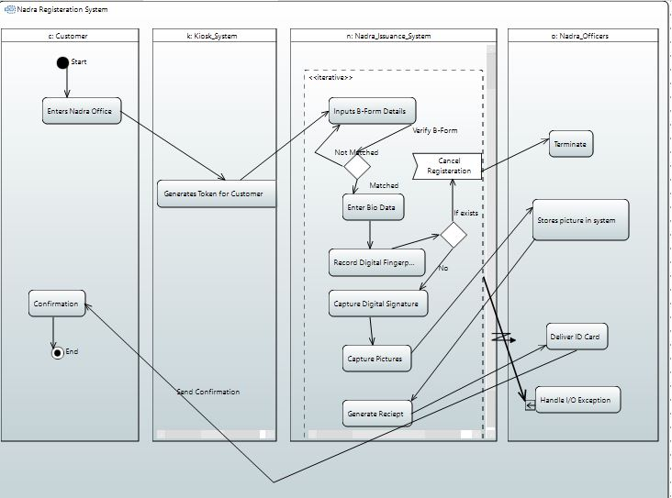

**Question# 02(b):**

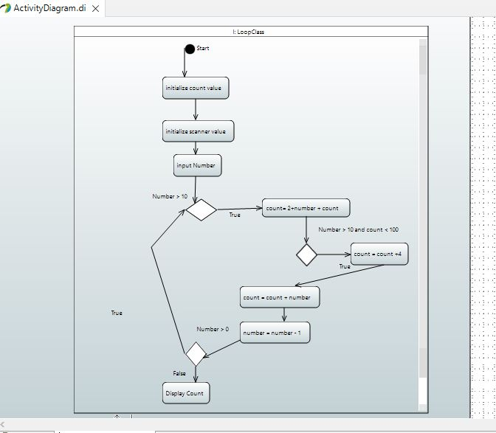

**Question# 02(c):**

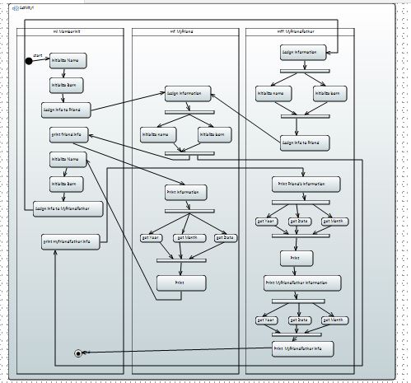

**Code**

**JavaCode:**

package com.javacode;

public class JavaCode {

public static int recievePaymentRequest() {

System.out.println("Payment request recieved!");

int payment = 5;

return payment;

}

public static void contactCustomer() {

System.out.println("Customer Contacted!");

}

public static boolean stillBookingLesson() {

System.out.println("Lesson is being booked!");

return true;

}

public static void sendPaymentRequest() {

System.out.println("Payment request sent!");

}

public static void sendConfirmationReceipt() {

System.out.println("Confirmation receipt sent!");

}

public static void sendCancellationReceipt() {

System.out.println("Reciept cancellation sent!");

}

public static void main(String args[]) {

boolean booking=false;

int payment_details = recievePaymentRequest();

if(payment_details <= 5)

booking = true;

else{

contactCustomer();

if(stillBookingLesson() == true) {

sendPaymentRequest();

}

else

booking = false;

}

if(booking == true)

sendConfirmationReceipt();

else

sendCancellationReceipt();

}

}

**PaymentDetails:**

package com.javacode;

public class PaymentDetails {

public static boolean recievePaymentRequest() {

System.out.println("Payment request recieved!");

boolean payment = true;

return payment;

}

}