
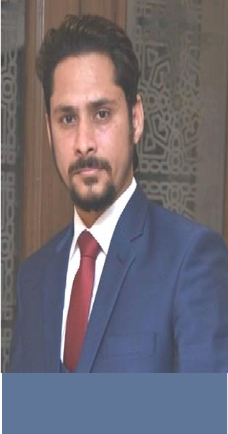

BILALAHMED

OBJECTIVE

To use my skills and potential to assist an organization in achieving its goals while seeking long term career with optimum growth. This objective is supported by my qualification, in addition to the management experience and multi-lingual command.
EDUCATION:
CONTACT
2010 | FEDERAL URDU UNIVERSITY, ISLAMABAD  M. B. A (Finance)
2007 | A. I. O. U, ISLAMABAD  B. Sc (Business Math, State & Economics)

bilal.ahmed4817@gmail.com
EXPERIENCE
033151 95278

https://www.linkedin.com/in/bilal-ahmed-684bb41b6/
Freelance career
MERN Stack Skills 2023 onward
- Proficiency in MongoDB for database management.
- Expertise in Express.js for creating robust server-side applications and APIs.
- Advanced knowledge of React for building interactive and responsive user interfaces.
- Strong understanding of Node.js for server-side scripting and backend development.
- Utilized ES6 features like arrow functions, template literals, and destructuring to write clean and maintainable code
- Experience with JavaScript, HTML, CSS, and related libraries and frameworks.
- Familiarity with RESTful APIs and modern web development practices.
- Problem-solving abilities and the capability to work within a team.

Projects:
- Authentication and Authorization using jwt.
- Authentication and Authorization using passport-local strategy.
- Passport google, passport Facebook Authentication.
- Group chat (Admin can add chatrooms, Admin can block users, Admin can remove users, Admin have access to unwanted messages to remove, chat users can update their profile as well)
- Ecommerce website.(User base Authentication(JWT), Protected Apis Front & backend, Admin dashboard, Client Dashboard ,Stripe payment, Captcha protection ) using Redux-Toolkit & RTK-Query.
- Private Chat(one on one) using (socket.io ,passport-local ,Nodemailer, Multer ) Features(Authorization, Any file exchange and download, emoji’s and text , Online , Offline status, Last message under chat users, with unread messages notifications)

PERSONAL DETAILS
Father's Name: Muhammad Ahmed
Date of Birth: 11th September 1984
CNIC No: 37302-2577678-1
Nationality: Pakistani


- English
- Urdu
- Punjabi

IT SKILLS


A
wordpress
Wordp
Nodejs















Core PHP
JavaScript/
ES6/Jquery
Css/Tailwind/bootstrap
React Js
Redux-Toolkit
/Rtk-query
Html
AJAX
Express Js

SQL Mongo Db
GIT
SEO
Google search console
CDN Activation SSL Certification
Website Compression
Shared & Cloud hosting
Stack overflow

WordPress Skills 2020 onward
- Classic theme development from scratch (Customizer, Settings API ).
- Plugin development from scratch.
- Well versed in Custom post type (custom labels, custom columns,
custom filters, Custom fields, Meta boxes, Multiple Featured Images etc.
- Expertise in Advance Custom Fields Plugin.
- Can built fully function E-commerce Website and Blog websites.
- Payment gateway integration.
- Word press security Guarantee.
- Malware, virus removel expertise.
- Local host to live website with and without Plugin. Vice versa.
- Elementor complete understanding.
- Figma, Psd design to WordPress with pixel perfection.
- Custom CSS according to need.
- Form validation.
- Plugin Editing.
- Theme Editing.
- Capcha protection.
- Webmail configured with Gmail.
- SMTP configuration.(C panel, cyber panel and local host).
- Website speed optimization with free plugins even share hosting.
- Brotli and G-zip compression of a website.
- CDN Activation, SSL certification.

Projects:
Project’s Detail are mentioned in Linked-in profile.

PHP Skills 2020 onward
- Proficient in PHP programming language.
- Experience with web development frameworks (e.g. Laravel).
- Strong understanding of front-end technologies (HTML, CSS, JavaScript).
- Database management skills MySQL.
- Familiarity with version control systems, Git.
- Knowledge of security best practices in web development.
- Problem-solving and debugging skills.
- Good communication and teamwork skills.
- Continuous learning and staying updated with the latest industry trends.

Projects:
- Built an e-commerce website with front-end technologies html, css, and java script and php (PHP project).
- Laravel Authentication and Authorization (middleware) with built-in Authentication and Custom Authentication with Forget password and reset password as well.
- Laravel Social Media Login integration (Facebook, Google).

