PRODUCT ARCHITECTURE BLUEPRINT · VERSION 3.0
Multi-Tenant, Plug-and-Play
Digital Banking & Cross-Border Remittance Platform
A configuration-driven, white-label platform launching first in Pakistan, the UAE and Saudi Arabia and built to extend to further markets — now with a concrete technology stack, closed gaps, rendered diagrams, and a companion set of per-service and per-adapter build documents.

Field | Details
Document title | Product Architecture Blueprint v3.0 — Multi-Tenant, Plug-and-Play Digital Banking & Remittance Platform
Document type | Master Architecture Blueprint (supersedes v2.0; v2.0 supersedes v1.1)
Companion documents | 01 – Technology Stack & Decision Record; 02–13 – Service Specifications (one per bounded context); 14–22 – Adapter/SPI Specifications (one per port family); 23 – Documentation Index & Build Order
Prepared for | Architecture Review Board, Platform Engineering, Product Management, Compliance, Security, and Delivery/Squad Leads
Version | 3.0 — Build-Ready Baseline
Date | 2 July 2026
Purpose of this revision | Close the gaps identified in the v2.0 review (§2): replace descriptive figure captions with rendered diagrams, commit to a concrete, versioned technology stack, add testing/CI-CD/team-topology guidance, quantify NFRs, and split implementation detail into standalone per-service and per-adapter documents so engineering squads can start building directly from this set.
Classification | Confidential — Internal Use
Status | For architecture review board, product, security and compliance sign-off

Document Control
How this revision relates to v2.0. v2.0 correctly established productization as an architectural property, not a feature. v3.0 keeps every decision in v2.0 that held up under review, and adds the things a delivery team needs on day one: a committed stack, real diagrams, numeric NFRs, a testing and CI/CD strategy, team topology, and one focused document per service and per adapter so a squad can pick up its document and start building without re-deriving the whole platform.
This document is the entry point. It should be read alongside Document 23 (Documentation Index & Build Order), which lists every companion document, its owner squad, and the recommended reading/build sequence.

Table of Contents
- 1. Executive Summary
- 2. Gap Analysis — What v2.0 Was Missing and How v3.0 Closes It
- 3. Architecture Goals, Principles and Constraints
- 4. Clean / Hexagonal Architecture Foundation
- 5. Multi-Tenancy Architecture
- 6. Configuration and Extensibility Model
- 7. Plug-and-Play Domain Deep Dives (Summary — full detail in service docs)
- 8. Composable Capability Catalog and Service Map
- 9. Ledger and Money Movement
- 10. API and Developer Platform
- 11. Complete Technology Stack (see also Document 01)
- 12. Reference Deployment Architecture
- 13. Security and Tenant Isolation
- 14. Data Residency, Sovereignty and Privacy
- 15. Observability, Metering and Tenant SLAs
- 16. Tenant Onboarding and Provisioning
- 17. Configuration Governance and Change Management
- 18. Product-Grade Non-Functional Requirements (Quantified)
- 19. Testing and Quality Strategy
- 20. CI/CD, Environments and Release Strategy
- 21. Team Topology and Ownership
- 22. Migration Path from v1.1 / v2.0 to v3.0
- 23. Key Architectural Decisions (ADR Log)
- 24. Risks, Anti-Patterns and Mitigations
- 25. Companion Document Index and Build Order
- 26. Best-Practice References, Glossary and Assumptions

1. Executive Summary
The objective is unchanged from v2.0: build a single, multi-tenant platform that an operator can sell, configure and operate on behalf of many banks, electronic-money institutions (EMIs) and fintechs across many countries, where compliance, language, bank profile, database/data-residency, currency, banking rules and fees are plug-and-play through configuration and swappable adapters — never a code fork per customer.
The confirmed launch sequence is Pakistan, the United Arab Emirates and the Kingdom of Saudi Arabia. These three markets were deliberately chosen as the first proving ground for the plug-and-play model: they span three regulators (SBP, CBUAE, SAMA), three currencies (PKR, AED, SAR), two scripts and reading directions (Latin/Urdu in Nastaliq and Arabic, both requiring RTL support), and — critically — Saudi Arabia's strict in-Kingdom data-residency requirement, which on its own forces the platform to prove real regional data-plane isolation from day one rather than deferring it to a later “multi-region” phase. Every example, regulatory mapping and reference deployment in this document set is grounded in these three markets first; §14 gives the residency and compliance detail, and §12/Figure 2 show the resulting three-region topology.
v2.0 got the architecture right but stopped one level too high for a delivery team to start building: figures were captions rather than diagrams, the technology stack was a table of “reference choices” without versions or justification, non-functional requirements had no numbers, and there was no guidance on testing, CI/CD, environments or team ownership. v3.0 keeps every structural decision from v2.0 — Clean/Hexagonal core, control-plane/data-plane split, the three-mechanism extensibility engine, the double-entry ledger — and adds exactly what was missing to move from “approved architecture” to “sprint one.”
This master document carries the product-level narrative and cross-cutting concerns. Implementation-level detail — API contracts, data models, event schemas, and adapter interface signatures — now lives in 21 companion documents (Documents 01–22), one per service and one per adapter family, indexed in §25. This keeps the master blueprint reviewable as a whole while giving each engineering squad a focused, buildable specification.

1.1 What changed since v2.0, at a glance
Area | v2.0 state | v3.0 change
Diagrams | 10 figure captions describing what a diagram would show | 10 rendered architecture diagrams (Graphviz-generated, versioned as source + PNG), embedded in this document and reused in service docs
Technology stack | One table of illustrative, unversioned “reference choices” | Fully versioned stack per layer with justification and named alternatives (§11, Document 01)
NFRs | Qualitative statements (“days–weeks”, “high availability”) | Quantified targets: latency percentiles, throughput, RPO/RTO, onboarding SLAs by tier (§18)
Testing strategy | Not addressed | Full test pyramid, contract testing, isolation/chaos testing, compliance-pack certification testing (§19)
CI/CD & environments | Mentioned once (“IaC + GitOps”) | Concrete pipeline stages, environment topology, promotion and rollback mechanics (§20)
Team topology | Not addressed | Squad-per-bounded-context model mapped to Conway's Law, with a platform/enablement team (§21)
Service-level detail | One paragraph per capability in §8 | One full specification document per service: API, data model, events, ports (Documents 02–13)
Adapter detail | Ports named, adapters implied | One specification document per adapter family: interface contract, certification checklist, 2+ named candidate providers (Documents 14–22)
Regulatory mapping | Generic “compliance pack” concept | Illustrative pack contents mapped to named frameworks per target region (§14, and each service doc)

2. Gap Analysis — What v2.0 Was Missing and How v3.0 Closes It
This section is the direct answer to “enhance this document by covering all flaws.” Each row names a real gap found on close reading of v2.0, why it matters for a team about to start building, and where in this document set it is now closed.
Gap found in v2.0 | Why it matters | How v3.0 closes it
No rendered diagrams | Ten figures were captions only (“Figure 2 — Multi-tenant platform topology...”) with no actual image. A reviewer cannot verify a topology they cannot see, and an engineer cannot build from a sentence describing a picture. | §4, §5, §6, §8, §9, §12, §16 now embed real diagrams; source .dot files are kept under version control so diagrams are reviewable and diffable like code.
No committed technology stack | “Reference choice” language (“containerised microservices on Kubernetes”) gives no version, no language/framework per service type, and no rationale a team could cite in a design review. | §11 and Document 01 commit to specific, versioned technologies per layer, with a documented alternative and switch cost for each, so the choice is defensible and the exit is understood up front.
Non-functional requirements are not measurable | “High availability” and “days–weeks” cannot be tested, budgeted, or used as a release gate. | §18 restates every NFR as a number (p99 latency, RPO/RTO in minutes, onboarding lead time in business days by tier) that can be a CI gate or an SLO.
No testing strategy | A platform this compliance-sensitive was previously silent on how isolation, money-movement correctness, and compliance-pack behaviour would be verified before release. | §19 defines the test pyramid, mandatory cross-tenant isolation tests (already implied as a P1 gate in v2.0 §12, now given a concrete test design), contract tests between services, and compliance-pack certification test suites.
No CI/CD or environment model | Onboarding, migrations and config governance referenced “promotion” and “pipelines” without defining environments, gates, or rollback mechanics. | §20 defines the environment chain (dev → sandbox → staging → canary cell → production), pipeline stages, and a rollback contract for both code and configuration.
No team topology | A 10-capability, multi-region platform was left without an ownership model; without one, bounded contexts drift back together (Conway's Law in reverse). | §21 assigns one squad per bounded context plus a platform/enablement squad owning the control plane, configuration engine and paved-road tooling.
Service-level detail deferred entirely to “future work” | §8 named ten capabilities in one paragraph each with no API shape, no data model, no events — not enough to size or start a sprint. | Documents 02–13 give each service its own specification: responsibilities, API surface, core data model, events published/consumed, dependent ports, and NFRs.
Adapters were named, not specified | Ports (ScreeningPort, FxRatePort, CoreBankingPort, ...) were listed, but no interface contract, certification checklist, or candidate provider list existed for any of them. | Documents 14–22 specify each port's interface contract, a certification checklist an adapter must pass before going live for a tenant, and 2–4 named candidate providers with trade-offs.
Compliance packs were structurally described but not populated | §7.1 listed what a pack contains in the abstract, with no worked example tying it to a real regulatory regime. | §14 and the Compliance/AML service doc (Document 03) map illustrative pack contents to named frameworks for the three confirmed launch markets — Pakistan (SBP/FMU), UAE (CBUAE/DIFC/ADGM) and KSA (SAMA/SAFIU/PDPL) — as a starting template, still to be confirmed with counsel per market, exactly as v2.0's own assumptions required.
Event-driven contracts were assumed, not defined | The transactional outbox and event backbone were named (§9.2) but no topic naming convention, schema format, or versioning policy existed — a common source of integration breakage between squads. | §11.4 and each service doc define topic naming (‹capability›.‹entity›.‹event›.v‹n›), Avro/JSON-Schema-based schema evolution rules, and a schema registry.
Cost / FinOps model was mentioned once, not designed | §14 said “infrastructure cost is attributed per tenant” without a mechanism. | §15 (Observability) adds a concrete cost-attribution mechanism (per-tenant resource tagging + usage-based allocation) feeding the billing pipeline.
No golden-path / starter template for engineers | Nothing told a new squad how to actually start a new service consistent with the hexagonal discipline. | Document 01 (Technology Stack) includes a service scaffolding checklist and repository template layout so every service starts from the same shape.

3. Architecture Goals, Principles and Constraints
These carry over from v2.0 unchanged in substance — they were sound — and are restated here for completeness so this document is self-contained.

3.1 Product goals
- One codebase, many banks, many countries — customer difference lives in data (config, packs, rules, pricing) and adapter selection, never in source branches.
- Plug-and-play across seven dimensions — compliance, language, bank profile, database/residency, currency, banking rules and fees, each independently configurable without redeploying the core.
- Isolation and residency by construction — tenant data is logically (and where required physically) separated, encrypted with its own keys, and kept in its mandated region.
- Composable and sellable in parts — capabilities are API-first products, licensable individually or as bundles.
- Fast, repeatable onboarding — a new tenant is provisioned and live in days–weeks (quantified in §18), not a multi-month bespoke build.
- Evolvable — compliance rules, pricing and providers change constantly; the platform absorbs that as configuration, safely, per tenant.

3.2 Guiding principles
Principle | What it means for a product
Configuration over code | Anything that varies by tenant, country, product, channel or corridor is externalized, versioned, effective-dated, audited data — not a code path.
Clean / Hexagonal core | Domain logic depends only on ports. Infrastructure and providers are adapters. Swapping a provider is a packaging/config change.
Tenant context is pervasive | A tenant identifier is present on every request, event, row, log line and metric.
Control plane vs data plane | Tenant-agnostic management is separated from regulated workloads, which run in regional data planes.
Isolation first, share deliberately | Default to strong tenant isolation; share infrastructure only where safe and economical, with explicit noisy-neighbour controls.
Composability | Each bounded context is independently deployable, owns its data, exposes versioned APIs, publishes events, and can be sold on its own.
Compliance & audit are first-class | Screening, limits, monitoring, maker-checker and immutable audit are core services every money movement passes through.
Blast-radius containment | Failures, bad config and incidents are contained to a tenant or a cell; they do not cascade.

3.3 Constraints and assumptions
- Each tenant holds (or will hold) the banking/EMI/PSP licences for every market it serves; the platform configures to those obligations but does not assume them.
- Brand references (Mashreq-style, Meezan-style, Western Union-style, Wise-like) describe capability categories only and imply no use of any proprietary system.
- Data-residency and hosting decisions are confirmed per jurisdiction, with counsel, before a tenant goes live in that jurisdiction.
- External providers expose integration interfaces; mock/sandbox adapters are built first so delivery is never blocked on partner readiness.
- Target deployment is public cloud or a compliant private cloud with multi-AZ regions and at least one warm-standby DR region per active region.

4. Clean / Hexagonal Architecture Foundation
“Plug-and-play” is, at the code level, the dependency-inversion principle applied rigorously. Each domain service is built as a hexagon: a pure domain core surrounded by an application layer, talking to the outside world only through ports (interfaces it owns). Concrete adapters implement those ports for specific technologies and providers. Because the core depends on the port and the adapter depends on the core, an adapter can be replaced without the domain knowing or changing.
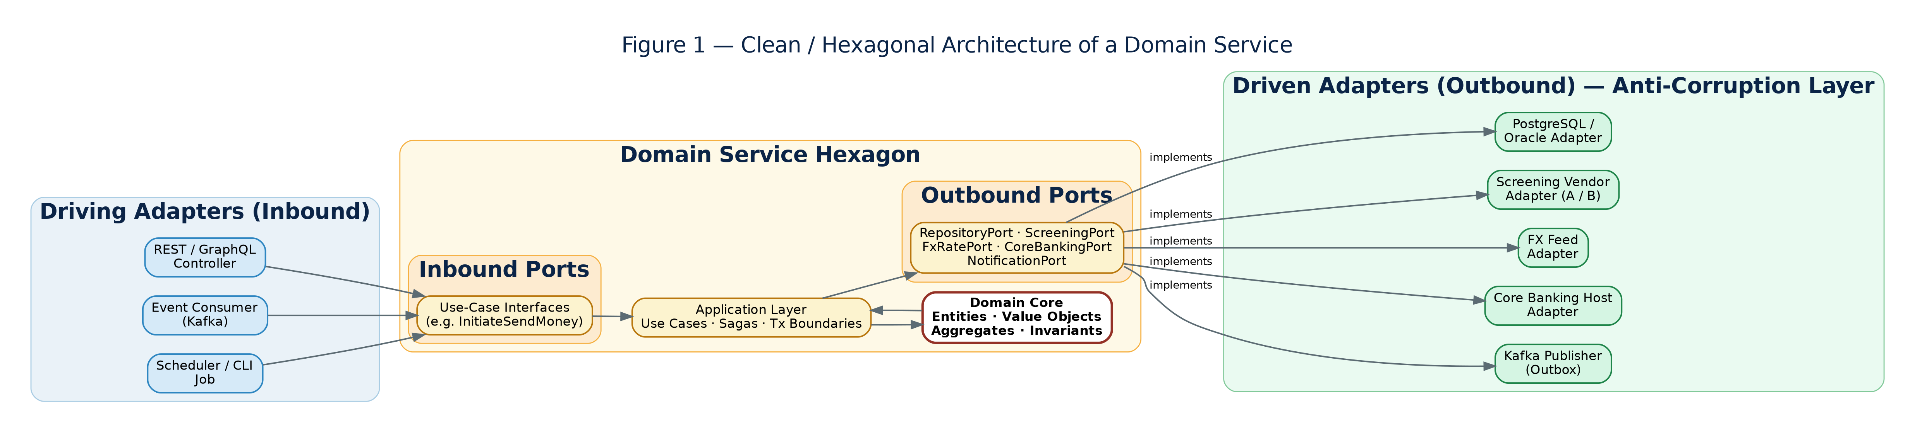
Figure 1 — Clean / Hexagonal architecture of a domain service: driving adapters feed inbound ports into the domain core; the core drives outbound ports implemented by swappable driven adapters.

4.1 The layers
Layer | Contains | Depends on | Examples
Domain core | Entities, value objects, aggregates, domain services, invariants | Nothing external | Money, Ledger entry, Limit, Beneficiary, Risk rule, Transaction aggregate
Application | Use cases, orchestration, saga coordination, transaction boundaries | The domain + ports | “Initiate send-money”, “Release compliance hold”, “Provision tenant”
Ports | Interfaces the application needs (inbound & outbound) | The domain (types only) | ScreeningPort, LedgerPort, FxRatePort, CoreBankingPort, NotificationPort, RepositoryPort
Adapters | Concrete implementations of ports | The domain + ports | PostgresRepository, ComplyAdvantageScreening, Iso20022CoreBanking, KafkaPublisher

4.2 Anti-corruption layers
Every external system is wrapped by an adapter that also acts as an anti-corruption layer (ACL): it translates the partner's model into the platform's domain language and absorbs its quirks (field names, status codes, retries, idempotency, rate limits, circuit-breaking). A new partner in the same category is “just another adapter” satisfying the same port — the structural pre-condition for swapping providers per tenant.

4.3 Why this is the mechanism for plug-and-play
- Database layer → RepositoryPort with PostgreSQL and Oracle adapters (Document 14).
- Compliance → ScreeningPort + rule/policy engine; vendors and rule sets vary per tenant behind the same interface (Documents 15–16).
- Currency / FX → FxRatePort with multiple feed adapters; the Money value object enforces correctness regardless of source (Document 17).
- Core banking & rails → CoreBankingPort / PayoutPort with per-tenant host adapters and ISO 20022/8583 messaging (Documents 18–19).
- Channels → inbound adapters (REST/GraphQL, events, per-channel BFF) so the same use cases serve mobile, web, branch, agent and partner traffic.

5. Multi-Tenancy Architecture
The design answers three questions at once: how tenants are isolated, where their data lives, and how a single operations team runs hundreds of them economically. The chosen pattern is a shared global control plane over regional data planes, with per-tenant data cells and explicit tenant tiers.
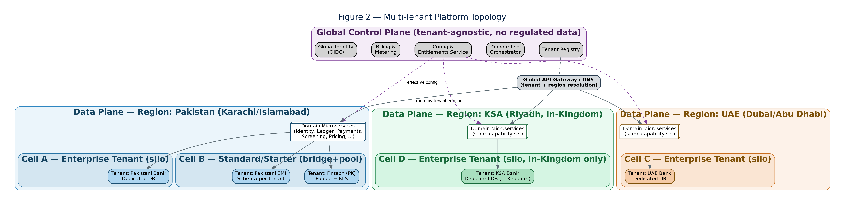
Figure 2 — Multi-tenant platform topology at launch: a shared control plane drives three regional data planes — Pakistan (Karachi/Islamabad), UAE (Dubai/Abu Dhabi) and KSA (Riyadh, fully in-Kingdom) — with each tenant's regulated data in its own isolated cell within its home market.

5.1 Tenancy models and the recommendation
Model | Description | Isolation | Cost / density | Use for
Silo | Dedicated stack/DB per tenant | Strongest | Lowest density, highest cost | Tier-1 banks, strict residency, heavy volume
Bridge | Shared compute; isolated data (DB- or schema-per-tenant) | Strong (data) | Medium | Most regulated tenants (recommended default)
Pool | Shared everything; tenant_id + row-level security (RLS) | Logical only | Highest density, lowest cost | Small tenants, sandboxes, lower-risk capabilities
Recommendation. Compute is pooled within a region for density but is strictly tenant-aware and rate-limited per tenant. The data tier is isolated per tenant: database-per-tenant for higher tiers, schema-per-tenant for mid-tier, pooled-with-RLS only for low-risk capabilities or sandboxes. “Bridge by default, silo on demand, pool where safe.”

5.2 Cells, regions and blast-radius containment
A data plane is a regional, multi-AZ deployment holding regulated workloads and tenant data for that region. Inside it, tenants are grouped into cells (deployment stamps): a complete, bounded slice of the platform serving a known set of tenants. Cells cap blast radius, enable progressive rollout, and provide a natural sharding unit as the tenant base grows. New capacity is added by standing up new cells, not by growing one ever-larger shared system.

5.3 Tenant context propagation
- Gateway / BFF resolve the tenant and attach it to the request context.
- Services pass tenant context through synchronous calls (headers / call context) and never infer it from data.
- Every domain event carries the tenant id; consumers filter and route on it.
- Persistence uses the tenant to select the correct database/schema (bridge/silo) or to set the RLS predicate (pool).
- Logs, metrics and traces are tagged with the tenant for per-tenant observability, metering and support.
Isolation must be enforced at the lowest layer. For pooled data, isolation is enforced with database row-level security so the predicate applies even if a query forgets it. For bridge/silo, the tenant resolver selects the datastore connection, so a query physically cannot reach another tenant's data. Cross-tenant access is a P1 security defect, covered by automated isolation tests in CI (§19.3).

5.4 Tenant tiers
Tier | Data isolation | Compute | Typical SLA | Onboarding
Enterprise | Dedicated DB (silo) + dedicated cell option | Reserved capacity, per-tenant quotas | 99.95%, priority support | Assisted, white-glove
Standard | Schema- or DB-per-tenant (bridge) | Pooled, fair-share quotas | 99.9% | Guided
Starter / Sandbox | Pooled + RLS | Pooled, capped | 99.5% / best-effort | Self-serve

5.5 Tenant lifecycle
Tenants move through a lifecycle owned by the control plane: provisioning (registry entry, region/tier assignment, resource creation, config/pack application — §16), active, suspended (access blocked, data retained), and offboarding (controlled export in a portable format, then deletion honouring retention law, with crypto-shredding of per-tenant keys — §14). Each transition is audited and, for destructive steps, maker-checker controlled.

6. Configuration and Extensibility Model
If the Clean/Hexagonal core provides the structural seams, the configuration and extensibility model is what travels through them — the difference between “we onboard a new bank by editing data” and “we fork the codebase per customer.” Three mechanisms work together: a hierarchical configuration store, a rules/policy engine, and a provider-adapter (SPI) registry.
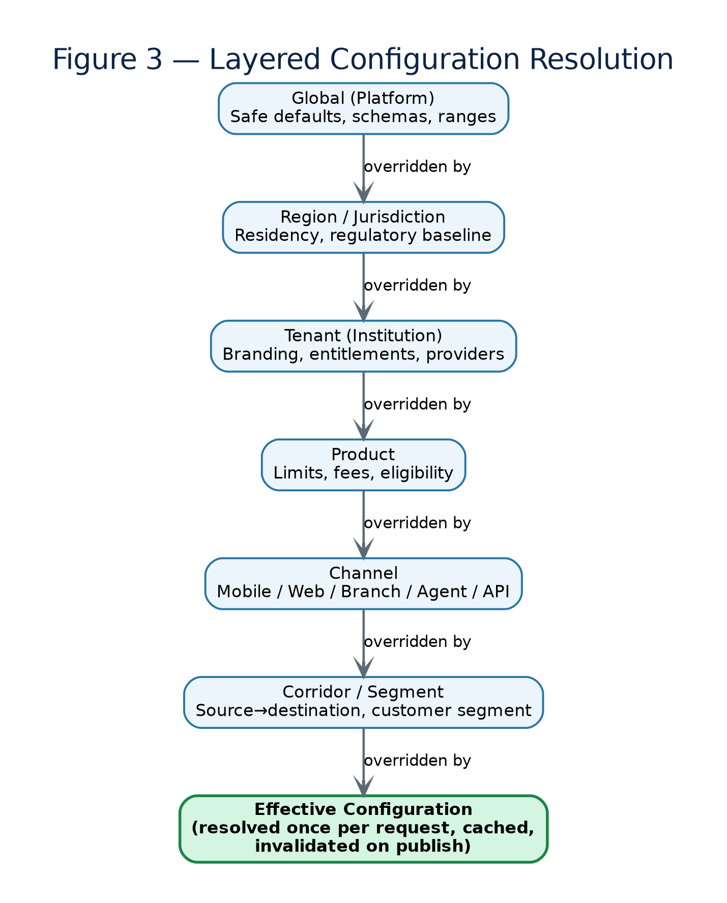
Figure 3 — Layered configuration resolution: Global defaults are progressively overridden by Region, Tenant, Product, Channel and Corridor scopes to produce one deterministic effective configuration per request.

6.1 The configuration hierarchy
Scope | Owns / typically sets | Set by | Overrides
Global (platform) | Safe defaults, supported value ranges, baseline schemas | Platform product team | —
Region / jurisdiction | Residency, data-plane placement, regulatory baselines | Platform + compliance | Global
Tenant (institution) | Branding, entitlements, provider selection, tenant-wide rules & pricing | Tenant admin (maker-checker) | Region, Global
Product | Per-product limits, fees, eligibility, ledger accounts | Tenant product owner | Tenant
Channel | Mobile / web / branch / agent / partner-API specifics | Tenant | Product
Corridor / segment | Source→destination corridor, or customer segment overrides | Tenant | Channel

6.2 Resolution and merge semantics
- Scalars: most-specific-wins — nothing is averaged or combined.
- Maps/objects: deep merge — a tenant can override one nested setting without restating the rest.
- Lists: explicit strategy — replace, append or remove; default is replace, to avoid surprising accumulation.
- Sentinels for inherit and clear — the absence of a key and the deliberate clearing of a key are distinguishable.
- Resolved once, cached, invalidated on publish — request-time resolution is cheap.

6.3 Configuration is versioned, effective-dated and governed
- Versioned and immutable — each published set is immutable, with a hash; nothing is edited in place.
- Effective-dated — a version can be scheduled to take effect at a future timestamp; old versions are retained for audit.
- Maker-checker controlled — authored by one principal, approved by another; high-impact scopes require elevated approval.
- Validated before publish — schema validation, range checks and policy linting run first.
- Audited — who changed what, when, why and which approver signed off, recorded immutably.

6.4 The three pluggability mechanisms
Mechanism | What it solves | Primarily serves
Hierarchical configuration | Values that differ by tenant/market/product but follow a known schema | Language, bank profile, currency setup, fees, rule parameters
Rules / policy engine | Decisions and logic that vary and change often, beyond simple values | Compliance screening & monitoring, limits, eligibility, approval matrices
Provider-adapter (SPI) registry | Swapping the actual technology or partner behind a capability | Database layer, screening/KYC vendors, FX feeds, core banking, payout rails, messaging
A value belongs in configuration. A decision belongs in the rules engine. A technology or partner choice belongs in the adapter registry. Forcing logic into configuration, or hard-coding decisions that should be rules, is the most common source of later rigidity.

7. Plug-and-Play Domain Deep Dives — Summary
Full detail for each of the seven dimensions now lives in the relevant service document (Documents 02–13); this section keeps a one-paragraph summary so the master blueprint remains readable end-to-end.
Dimension | Mechanism | Detailed in
Compliance | Jurisdiction “compliance packs” bundling KYC/KYB, screening, monitoring, limits, reporting, retention | Document 03 — Screening & AML Service; Document 08 — Compliance Reporting Service
Language / localization | Externalized resource bundles, ICU MessageFormat, locale resolution chain, RTL support, CLDR formatting — launch locales: en-PK, ur-PK (Urdu, RTL/Nastaliq), ar-AE, ar-SA (Arabic, RTL) | Document 11 — Developer Platform & BFF Service
Bank profile / white-label | Design tokens, custom domains, entitlements/feature flags, per-tenant BFF composition | Document 11 — Developer Platform & BFF Service; Document 12 — Tenant & Control-Plane Service
Database layer / residency | RepositoryPort with PostgreSQL/Oracle adapters; isolation tier by tenant tier; residency routing | Document 14 — Persistence/Database Adapter Specification
Currency / money | ISO 4217 registry, Money value object, explicit rounding policy, FxRatePort | Document 04 — Ledger Service; Document 17 — FX Rate Adapter Specification
Banking rules | Parameterised product catalog, limits engine, eligibility rules, approval matrices, calendars | Document 06 — Wallets & Accounts Service; Document 05 — Payments & Remittance Service
Fees and pricing | Deterministic quote/pricing service: schedules, commission, FX margin, tax, promotions | Document 10 — Pricing, Billing & Metering Service

8. Composable Capability Catalog and Service Map
The platform's bounded contexts are built as independently deployable, API-first capabilities, each owning its data and publishing events — sellable as a complete end-to-end product, as bundles, or as individual capabilities (Banking-/Fintech-as-a-Service).
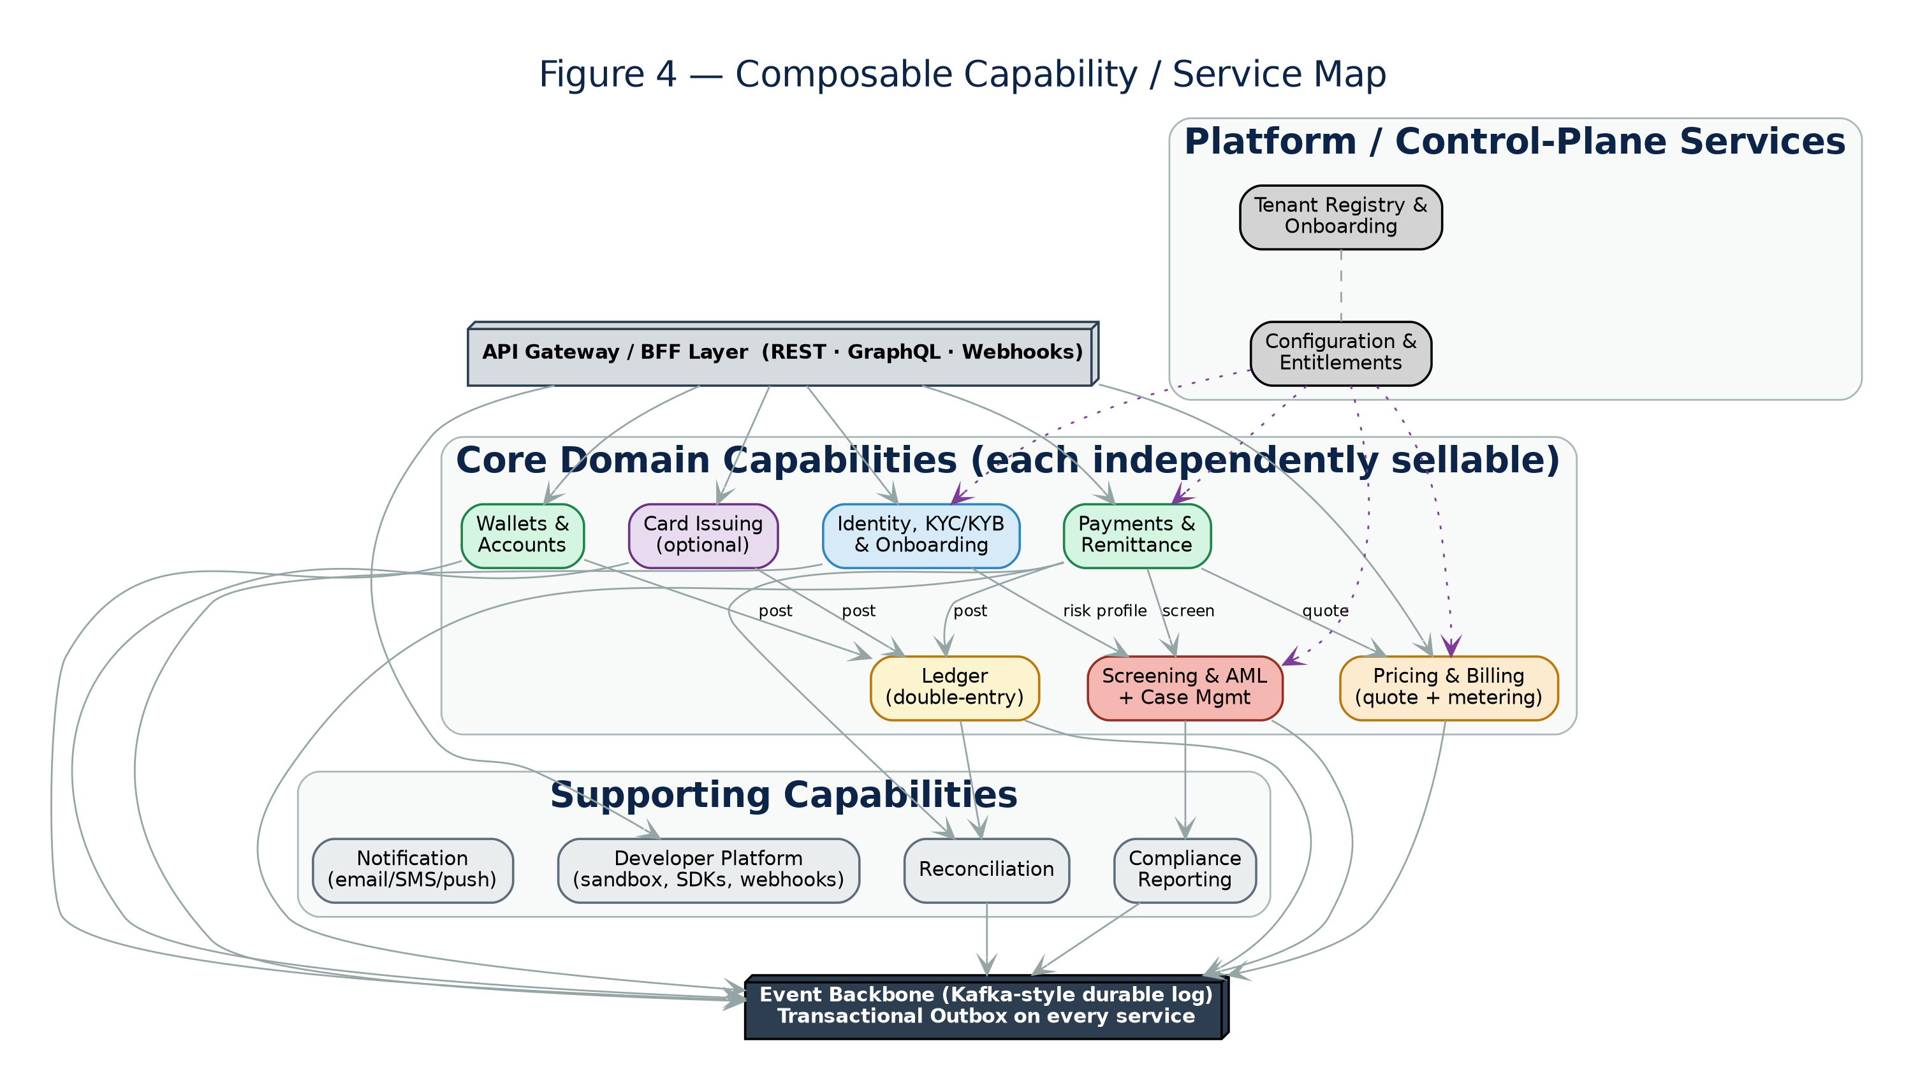
Figure 4 — Composable capability / service map: API layer, core domain capabilities, supporting capabilities, platform/control-plane services, all publishing to a shared event backbone.
Capability | Sellable standalone? | Specification document
Identity, KYC/KYB & onboarding | Yes | Document 02
Screening & AML + case management | Yes | Document 03
Ledger | Yes | Document 04
Payments & remittance | Yes | Document 05
Wallets & accounts | Yes | Document 06
Card issuing (optional) | Yes | Document 07
Compliance reporting | With AML/ledger | Document 08
Reconciliation | With ledger/payments | Document 09
Pricing, billing & metering | Yes | Document 10
Developer platform & API gateway / BFF | Yes | Document 11
Tenant registry, onboarding & control plane | Platform-internal | Document 12
Notification (email/SMS/push) | With any capability | Document 13

9. Ledger and Money Movement
The ledger is the system of record for value and must be correct, immutable and reconcilable. The design is a double-entry, append-only ledger: every financial event produces a balanced journal of debit and credit postings; balances are derived from postings and never edited in place. Full detail, including the data model and API, is in Document 04.
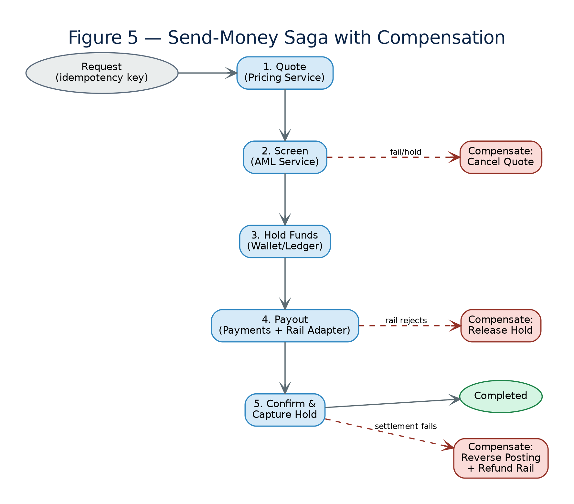
Figure 5 — Send-money as a saga: each step carries tenant context; screening and limit checks gate the movement; postings hit the ledger; failures trigger explicit compensating actions.

9.1 Ledger model
- Double-entry & immutable — debits equal credits for every journal; corrections are new reversing entries, never mutations.
- Multi-currency — each posting is single-currency; conversions are explicit linked entries.
- Tenant-scoped — ledgers are partitioned per tenant within the tenant's data isolation.
- Derived, queryable balances — balances/statements are projections over postings; event-sourcing/CQRS lets the write and read models scale independently.

9.2 Reliable money movement
- Idempotency — every money-movement command carries an idempotency key so retries never double-post.
- Sagas with compensation — multi-step movements are orchestrated as sagas; a failure triggers explicit compensating actions.
- Transactional outbox — state changes and their events are written in the same transaction and relayed via an outbox, so the ledger and event stream never diverge.
- Holds and confirmations — funds are held, then captured or released, so in-flight movements are always represented and reconcilable.
- Reconciliation — automated reconciliation compares ledger postings against rail/partner statements and flags breaks (Document 09).

10. API and Developer Platform
If capabilities are to be composable and sellable, the API surface is the product, designed for third-party integration from day one. Full contract conventions are in Document 11.
- API styles — stable, versioned REST for commands/queries; async events/webhooks for state changes; an optional GraphQL BFF for rich clients.
- Versioning & deprecation — explicit, dated API versions with a published deprecation policy and sunset windows.
- Per-tenant OAuth2 — machine traffic uses OAuth2 client-credentials with per-tenant clients and fine-grained scopes; tenant context travels in the token.
- Idempotency keys — all mutating endpoints accept one, aligning with the ledger's idempotency.
- Webhooks — signed, retried, replayable, with per-tenant endpoints and secrets.
- Sandbox & SDKs — a full sandbox with test data and simulated providers, generated SDKs, and an OpenAPI specification.
- Quotas & rate limits — per-tenant, tied to plan/tier, doubling as a metering signal.
- Consistent error & pagination model — one error envelope, one pagination scheme across capabilities.

11. Complete Technology Stack
v2.0 deliberately stayed technology-agnostic at the domain level, which is correct — that is the point of ports and adapters. But “replaceable behind a port” is not the same as “undecided”: a delivery team still needs one concrete, defensible stack to start writing code on day one. This section commits to that stack. Every choice remains swappable behind its port; the “alternative” column records the next-best option and why it was not the default. Full rationale and setup detail are in Document 01.

11.1 Language and service framework
Layer | Primary choice | Alternative (also supported) | Rationale
Core domain services (Ledger, Payments, Screening, Wallets, Pricing, Compliance) | Java 21 (LTS) + Spring Boot 3.3, hexagonal package structure (domain / application / ports / adapters) | Kotlin 2.x on the same JVM/Spring stack for teams that prefer it — fully interoperable in the same repo | Mature banking ecosystem, strong typing, first-class Kafka/Postgres/observability libraries, large regional talent pool in target markets
Identity/KYC orchestration & Case Management | Java 21 + Spring Boot 3.3 | Node.js + NestJS if the squad is document/workflow heavy and prefers TypeScript end-to-end | Same platform consistency; heavy document/file handling libraries are mature in both
BFFs (mobile, web, partner) & Developer Portal | Node.js 22 LTS + NestJS (TypeScript) | Deno/Fresh for a lighter footprint on the developer portal only | BFFs are I/O-bound composition layers; Node's async model and TypeScript's contract-sharing with frontend teams reduce integration friction
Frontend web apps (admin console, tenant portal) | React 18 + TypeScript, Vite build, Tailwind + design-token theming | Next.js if SSR/SEO is required for a public developer-portal marketing site | Component reuse across tenant themes (§7.3) via design tokens; large ecosystem
Mobile apps (reference clients) | React Native (shared business logic) or native Kotlin/Swift where a tenant mandates it | Flutter as a second reference option | Reference implementation only — tenants typically build their own branded app against the public API/SDKs
Rules / policy engine | Open Policy Agent (OPA)/Rego for eligibility & authorization-style rules; a decision-table engine for monitoring/pricing rules authored by compliance/product | Drools if a heavier BRMS with a business-user authoring UI is required at scale | OPA is the de facto standard for policy-as-code and integrates cleanly with the gateway for authorization; decision tables keep non-developer-authored rules simple and auditable

11.2 Data tier
Concern | Primary choice | Alternative | Rationale
Primary OLTP datastore | PostgreSQL 16 (managed: Amazon RDS/Aurora or Azure Flexible Server), Citus extension option for sharded pooled tier | Oracle Database 19c/21c adapter for tenants that mandate it | Strong relational + JSONB flexibility for config, native RLS for the pooled tier, mature managed-service ecosystem
Read models / CQRS projections | PostgreSQL materialized views for simple cases; OpenSearch for search-heavy read models (case management, transaction search) | ClickHouse for high-volume analytical/reporting read models | Keeps read scaling independent of the ledger write path
Cache | Redis 7 (managed: ElastiCache/Azure Cache for Redis), tenant-keyed | Hazelcast for embedded/in-JVM caching in a specific service | Sub-millisecond effective-config and session lookups; native TTL for cache invalidation on config publish
Object storage | S3-compatible object storage (AWS S3 / Azure Blob), per-tenant prefix + KMS key | MinIO for on-prem/private-cloud deployments | KYC documents, statements, exports, compliance-report artifacts
Event backbone | Apache Kafka (managed: MSK/Confluent Cloud) with Debezium CDC for the transactional outbox relay | Redpanda as a Kafka-API-compatible, lower-ops alternative | Durable log semantics, per-tenant partitioning strategy, wide ecosystem
Schema registry | Confluent Schema Registry (Avro) or Apicurio (open-source) | JSON Schema in-repo if avoiding a registry dependency initially | Enforces the event-versioning policy in §11.4

11.3 Platform, runtime and infrastructure
Concern | Primary choice | Alternative | Rationale
Container orchestration | Kubernetes 1.30+ (managed: EKS/AKS/GKE), one cluster per region, namespace-per-cell | Nomad for a lighter scheduler — not recommended given Kubernetes' maturity for multi-tenant quota/network-policy needs | Native namespace/quota/NetworkPolicy primitives map directly onto the cell/tenant isolation model
Service mesh | Istio (mTLS between services, traffic policy, per-tenant rate limiting at the mesh layer) | Linkerd for lower operational overhead | mTLS everywhere is a baseline control for a regulated platform; Istio AuthorizationPolicy maps well to tenant-aware access rules
API gateway | Kong Gateway (or cloud-native equivalent: AWS API Gateway / Azure APIM) in front of per-channel BFFs | Apigee if commercial developer-portal tooling is valued over Kong's OSS core | Plugin ecosystem for OAuth2, rate limiting, request transformation; tenant resolution plugin at the edge
Identity provider (OIDC/OAuth2) | Keycloak (self-hosted, per-tenant realms) or Auth0/Okta (managed) | AWS Cognito for deep AWS-native integration | Per-tenant realm/client separation maps directly onto §5.3 tenant-context propagation; avoids per-MAU vendor pricing at scale
Secrets & key management | HashiCorp Vault (dynamic secrets, transit engine for envelope encryption) + cloud KMS for BYOK-capable master keys | Cloud-native secrets manager only, if Vault overhead is not justified at initial scale | Per-tenant transit keys map cleanly onto the per-tenant envelope encryption and BYOK requirement
Infrastructure as code | Terraform (modules per cell/region) + Terragrunt for environment composition | Pulumi for IaC in a general-purpose language | Mature provider support across AWS/Azure/GCP; module reuse across cells is central to onboarding automation
GitOps / delivery | ArgoCD for Kubernetes manifest delivery, GitHub Actions for CI pipelines | Flux CD as an ArgoCD alternative; GitLab CI if standardised elsewhere | Declarative, auditable deployment state matches “config as data with the discipline of code”

11.4 Messaging conventions
- Topic naming: ‹capability›.‹entity›.‹event›.v‹n› — e.g. payments.transfer.completed.v1, screening.case.opened.v1.
- Every event envelope carries: event_id, event_type, event_version, tenant_id, occurred_at, correlation_id, causation_id, and a typed payload.
- Schema evolution is additive-only within a major version; breaking changes publish a new v‹n+1› topic and both versions run in parallel through a deprecation window.
- Every producer implements the transactional outbox pattern (state + event written in one local transaction; Debezium relays to Kafka) — no dual-write anywhere in the platform.
- Consumers are idempotent by event_id and tolerate at-least-once delivery.

11.5 Observability stack
Signal | Choice | Notes
Traces | OpenTelemetry SDK → Jaeger or Grafana Tempo | Every span tagged with tenant_id, cell, region
Metrics | OpenTelemetry → Prometheus → Grafana dashboards | Per-tenant SLO dashboards generated from a shared template (§15)
Logs | Structured JSON logs → Fluent Bit → Loki (or ELK if already standard) | Tenant_id and correlation_id mandatory fields; PII redaction at the logging library level
Alerting | Grafana Alerting or Prometheus Alertmanager → PagerDuty/Opsgenie | Alerts scoped to tenant/cell where the SLO is tenant-specific

11.6 Service scaffolding checklist (golden path)
Every new service starts from a shared template repository so hexagonal discipline is structural, not a code-review reminder. The template (Document 01, Appendix A) pre-wires:
- The domain/application/ports/adapters package layout, with a build-time architecture test (ArchUnit for JVM services) that fails the build if a domain class imports an infrastructure package.
- OpenTelemetry instrumentation, structured logging with tenant_id/correlation_id fields, and health/readiness endpoints, pre-configured.
- A transactional outbox table and Debezium connector configuration.
- OAuth2 resource-server configuration reading the tenant claim from the token.
- A contract-testing harness (Pact) stub for both provider and consumer roles.
- A Helm chart and ArgoCD Application manifest parameterised by cell/tenant-tier.

12. Reference Deployment Architecture
The diagram below makes the reference stack from §11 concrete as a deployable topology, extending v2.0 §11's control-plane/data-plane split with actual technology names.
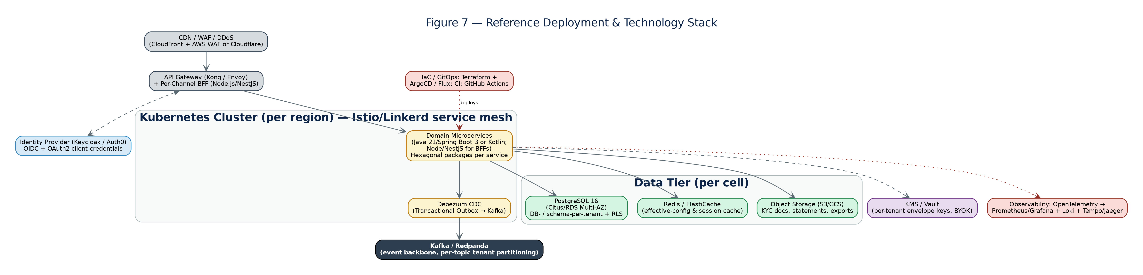
Figure 7 — Reference deployment and technology stack: edge → gateway → service mesh → domain services → data tier, with cross-cutting IaC/GitOps and observability.

12.1 Control plane vs data plane deployment
The control plane (tenant registry, onboarding, configuration, entitlements, billing, global identity) is deployed once, globally, on its own small Kubernetes footprint, and holds little or no regulated customer data. Each data plane is a regional Kubernetes cluster running the domain services and holding tenant data for that region, organised into cell namespaces (§5.2). At launch, three data planes are stood up — Pakistan, UAE and KSA — per the topology in Figure 2 and the residency rationale in §14. Adding a fourth region later means standing up a new data-plane cluster from the same Terraform modules; adding capacity within an existing market means adding cells.

12.2 Environment topology
Environment | Purpose | Data | Promotion gate
dev | Per-squad or shared development cluster; fast iteration | Synthetic data only | Unit + component tests pass
sandbox | Public-facing developer sandbox (§10); simulated provider adapters | Synthetic tenants only | Contract tests + sandbox smoke suite
staging | Pre-production, production-like topology, one cell per region | Masked/synthetic data mirroring production shape | Full regression + isolation + performance test suite
canary cell | One real production cell, small tenant cohort, first to receive a release | Real tenant data (cohort-scoped) | Automated health/SLO checks over a soak window
production | All remaining cells, progressive rollout after canary | Real tenant data | Canary soak passed; manual go/no-go for high-impact changes

13. Security and Tenant Isolation
In a multi-tenant regulated platform, the highest-severity risk is one tenant reaching another tenant's data or configuration. Security extends v1.1's controls with isolation as a continuously tested property.
- Tenant-aware authorization — authentication via OIDC; authorization combines role-based and attribute-based checks that always include the tenant claim.
- Per-tenant key management — envelope encryption with a distinct data-encryption key per tenant, wrapped by a tenant key in KMS/Vault; Enterprise BYOK lets a tenant control its own key.
- Isolation enforced low — at the datastore (separate connection or row-level security), not merely checked in application code.
- Automated isolation tests in CI — cross-tenant access attempts are exercised automatically; any cross-tenant read/write is a P1 defect that blocks release (full test design in §19.3).
- Data protection — encryption in transit and at rest everywhere (mTLS via the service mesh); secrets in Vault, never in code or config; least-privilege service identities.
- Secure SDLC & supply chain — dependency and container scanning (Trivy/Snyk), SBOMs, signed artifacts (Sigstore/cosign), and regular independent penetration testing.

13.1 Shared-responsibility model
Area | Platform (operator) provides | Bank-tenant owns
Licensing | Configurable controls and audit evidence | Holding the banking/EMI/PSP licence; regulatory relationship
Compliance config | Pack framework, screening/monitoring engines, report generators | Selecting/approving packs, thresholds and risk appetite
Data | Isolation, encryption, residency, backups | Data classification decisions, retention choices within the law
Identity | AuthN/Z platform, tenant boundaries | Its own users, roles and access reviews
Keys | KMS/Vault, envelope encryption; BYOK option | Custody of its key under BYOK; rotation policy
Operations | Availability, monitoring, incident response for the platform | Its own customer support and operational use of the product

14. Data Residency, Sovereignty and Privacy
Residency and privacy are configuration-driven and enforced structurally, because the platform serves many jurisdictions with conflicting rules. The table below is a v3.0 addition, updated to reflect the confirmed launch sequence — Pakistan, the United Arab Emirates and the Kingdom of Saudi Arabia — with an illustrative mapping of compliance-pack contents to named regulatory frameworks per market. This is a starting template only, to be confirmed with counsel and the local regulator before any tenant goes live in that market.
Launch market | Representative frameworks to confirm | Residency posture
Pakistan | State Bank of Pakistan (SBP) prudential/EMI regulations and AML/CFT regulations; Financial Monitoring Unit (FMU) goAML-aligned reporting; PECA data-handling provisions; draft Personal Data Protection Bill | Pakistan-resident data plane (Karachi/Islamabad); SBP guidance on cloud/outsourcing and data localisation for regulated financial data confirmed per current circulars before go-live
United Arab Emirates | Central Bank of the UAE (CBUAE) AML/CFT regulations and retail-payment/stored-value rules; UAE Financial Intelligence Unit goAML reporting; DIFC/ADGM data-protection regimes where a tenant is licensed in one of those free zones | UAE-resident data plane (Dubai/Abu Dhabi); onshore vs DIFC/ADGM residency posture depends on the tenant's specific licensing zone
Saudi Arabia | Saudi Central Bank (SAMA) Cyber Security Framework and AML/CFT rules; Saudi Arabia Financial Intelligence Unit (SAFIU) reporting; Personal Data Protection Law (PDPL) | In-Kingdom data residency mandated for regulated financial data — a dedicated KSA data plane, never sharing infrastructure with the Pakistan or UAE planes
Future FATF-aligned markets (post-launch expansion) | Local AML/CFT law aligned to FATF recommendations; local data-protection statute; goAML or equivalent FIU reporting format where adopted | A new regional data plane nearest the market, following the same pattern as §12.1, unless local law mandates in-country residency
Why three separate data planes, not one shared regional plane. All three launch markets require or strongly favour in-country/in-region processing of regulated financial data, and Saudi Arabia's residency requirement is the strictest of the three. The reference deployment therefore stands up three separate data planes — Pakistan, UAE and KSA — from day one (§12, Figure 2), rather than combining any of them into a shared region, so that adding a fourth market later is “stand up one more data plane from the same Terraform modules,” not a re-architecture.
- Residency as configuration — each tenant's home region is configured and enforced by routing (Document 14, Persistence Adapter Specification).
- Data classification — data is classified (PII, financial, operational) so controls (encryption, residency, retention, masking) can be applied by class.
- Cross-border controls — where data must not leave a jurisdiction, processing — not just storage — is pinned to the region; any permitted transfer is explicit, logged and lawful-basis-checked.
- Consent & data-subject rights — consent is captured and versioned; access/rectification/erasure/portability requests are supported per the assigned compliance pack.
- Retention per pack — retention durations come from the jurisdiction pack; records are retained for the mandated period, then disposed.
- Erasure on an immutable ledger via crypto-shredding — because the ledger is append-only, erasure of personal data is achieved by destroying the per-tenant/subject encryption key, so data becomes unrecoverable while the ledger's integrity and balances are preserved.

15. Observability, Metering and Tenant SLAs
Running hundreds of tenants economically requires seeing and charging per tenant. Every telemetry signal carries a tenant dimension, and usage is metered as a billing input (stack specifics in §11.5).
- Tenant-tagged telemetry — metrics, logs and traces are tagged with tenant, cell and region.
- Usage metering → billing — billable events (API calls, transactions, active customers, screening checks) flow through a metering pipeline (collect → aggregate → rate → invoice), tied to the pricing engine.
- Cost attribution (FinOps) — v3.0 addition: every Kubernetes namespace/cell is resource-tagged by tenant/tier; a nightly job allocates shared infrastructure cost (compute, storage, egress) proportionally by measured usage, feeding a per-tenant margin report.
- Tenant dashboards & status — each tenant sees its own usage, health and incident status; the operator sees the fleet.
- SLOs, error budgets — service-level objectives are tracked per tenant/tier with error budgets.

15.1 Tiered SLAs
Tier | Availability target | Support | DR posture (illustrative)
Enterprise | 99.95% | Priority, dedicated | Lower RPO/RTO; optional dedicated cell
Standard | 99.9% | Business hours + on-call escalation | Standard regional DR
Starter / Sandbox | 99.5% / best-effort | Self-serve / community | Best-effort
Targets are reference figures to be confirmed commercially per tenant and market; §18 restates these as engineering-testable numbers (latency, RPO/RTO in minutes) rather than availability percentages alone.

16. Tenant Onboarding and Provisioning
Repeatable onboarding is what turns a platform into a business. The goal is days-to-weeks, not months, achieved by automating provisioning and reducing go-live to configuration.
Figure 6 — Tenant onboarding and provisioning flow: registry entry through automated resource provisioning, pack and branding configuration, provider binding, sandbox certification and controlled go-live.
- 1. Register the tenant in the control-plane registry; assign region(s) and tier.
- 2. Provision resources via Terraform: datastore (DB/schema per tier), Vault transit keys, Kubernetes namespace and quotas in the correct cell.
- 3. Assign compliance pack(s) for each market the tenant will serve — at launch: Pakistan (SBP/FMU), UAE (CBUAE) and/or KSA (SAMA/SAFIU) — and confirm residency.
- 4. Apply branding & entitlements — design tokens, custom domains, sender identities, licensed capabilities and products.
- 5. Bind provider adapters — select adapters for screening, KYC, FX, core banking and payout rails per tenant/region.
- 6. Configure rules, limits and pricing, authored and approved under maker-checker.
- 7. Certify in sandbox — the tenant integrates and runs UAT against the sandbox and simulated providers.
- 8. Go live through a checklist gate (compliance sign-off, security review, runbook, support readiness), then progressive enablement starting in a canary cell.
Onboarding lead-time targets by tier. Enterprise (silo): 15–20 business days, largely gated by compliance-pack certification and BYOK key exchange, not infrastructure. Standard (bridge): 3–5 business days. Starter/Sandbox (pool): self-serve, typically under 1 business day to a working sandbox integration. This is the v3.0 quantification of v2.0's qualitative “days/weeks” target.

17. Configuration Governance and Change Management
With behaviour expressed as configuration, governing configuration is a core operational capability — config is managed as data with the lifecycle discipline of code.
- Authoring → validation → review — changes are authored, automatically validated (schema, ranges, policy lint), then reviewed under maker-checker before publish.
- Environments and promotion — changes move dev → sandbox → staging → production through promotion, never edited directly in production.
- Simulation / what-if — high-impact changes (limits, pricing, screening thresholds) can be simulated against recent traffic before going live.
- Per-tenant change isolation & cohorts — a change is scoped to a tenant or cohort/cell; platform-wide defaults change rarely and roll out progressively.
- Versioning, effective-dating and rollback — every published set is a version with an effective date and a one-click rollback to the previous known-good version.
- Audit — all of the above is recorded immutably (who, what, when, why, approver).

18. Product-Grade Non-Functional Requirements (Quantified)
This is a direct v3.0 gap fix: every NFR that v2.0 stated qualitatively is restated here as a number that can be a CI gate, a load-test target, or an SLO.
Quality attribute | v2.0 statement | v3.0 quantified target
API latency | Not stated | p50 < 150 ms, p99 < 800 ms for synchronous read APIs; p99 < 1.5 s for command APIs excluding downstream provider latency
Throughput | Not stated | Each core service load-tested to 3x projected peak tenant traffic before GA; gateway sustains 5,000 req/s per region at launch scale
Availability (Enterprise) | “99.95%, priority support” | 99.95% monthly uptime; error budget 21.9 minutes/month; burn-rate alerting at 2x and 10x budget consumption
RPO / RTO (Enterprise) | “Lower RPO/RTO” (unquantified) | RPO ≤ 5 minutes (continuous WAL streaming replication); RTO ≤ 30 minutes single-cell failover; RTO ≤ 4 hours full regional failover
RPO / RTO (Standard) | “Standard regional DR” | RPO ≤ 15 minutes; RTO ≤ 2 hours regional failover
Onboarding lead time | “Days/weeks” | See §16: 1 day (Starter) / 3–5 days (Standard) / 15–20 days (Enterprise)
Isolation test coverage | “Automated isolation tests in CI” (unquantified) | 100% of repository/persistence adapters covered by an automated cross-tenant-access negative test; zero tolerance — any failure blocks the release pipeline
Configuration resolution latency | Not stated | Effective-config resolution served from cache in < 5 ms p99; cache invalidation propagates within 2 seconds of publish
Event delivery lag | Not stated | Outbox-to-Kafka relay lag p99 < 2 seconds under normal load
Data-residency violations | “Enforced configuration” (unquantified) | Zero tolerance; residency-routing correctness covered by a dedicated automated test suite per region, run on every deployment

19. Testing and Quality Strategy
v2.0 implied testing (“automated isolation tests in CI”) without defining a strategy. This is a full v3.0 addition.

19.1 Test pyramid
Layer | Scope | Tooling | Owner
Unit | Domain core logic in isolation — Money arithmetic, limit checks, rule evaluation | JUnit 5 / Kotest; Jest for Node services | Service squad
Component | A single service with its adapters stubbed (in-memory or Testcontainers Postgres/Kafka) | Testcontainers, WireMock for provider stubs | Service squad
Contract | Producer/consumer API and event contracts between services | Pact (consumer-driven contracts) + schema-registry compatibility checks | Service squad, enforced in CI for both sides
Integration / end-to-end | A full user journey across services in a staging-like environment (e.g. send-money saga) | Cucumber/Gherkin scenarios against staging | Cross-squad, owned by QA guild
Isolation (security) | Automated attempts to read/write another tenant's data through every repository adapter and every API endpoint | Custom isolation-test harness run in every pipeline; any failure is a P1 release blocker | Platform/security squad, mandatory gate for all squads
Performance / load | Per-service and full-journey load tests against the quantified NFRs in §18 | k6 or Gatling, run against staging before each major release | Service squad + platform squad
Chaos / resilience | Pod/node/AZ failure injection; provider-adapter timeout/circuit-breaker verification | Chaos Mesh or Gremlin, scheduled “game days” quarterly per region | Platform/SRE squad
Compliance-pack certification | A jurisdiction pack's screening/limits/reporting behaviour verified against a fixed scenario suite before a tenant can go live in that market | Scenario-based test suite maintained by the compliance/AML squad; sign-off required before pack publish | Compliance/AML squad

19.2 Contract-first development
Every service publishes its API as an OpenAPI 3.1 specification and its events as Avro/JSON schemas before implementation begins; consumer squads write Pact contracts against that specification. CI fails a build that breaks a contract another squad depends on, catching integration breakage before it reaches staging.

19.3 Cross-tenant isolation test design (detail)
For every persistence adapter: seed two tenants with identical-shaped data, attempt every read/write operation exposed by the repository interface using tenant A's context against tenant B's data, and assert every attempt is rejected or returns empty. For pooled/RLS datastores, the same suite runs directly against the database connection (bypassing the application layer) to prove the database — not just the code — enforces the boundary. This suite runs on every pull request that touches a persistence adapter or a database migration.

20. CI/CD, Environments and Release Strategy
v2.0 mentioned “IaC + GitOps pipelines” once; this section makes the pipeline concrete.

20.1 Pipeline stages
- 1. Commit — lint, unit tests, static analysis (SonarQube), dependency/container vulnerability scan, SBOM generation.
- 2. Build — compile, build container image, sign image (cosign), push to registry.
- 3. Component & contract tests — Testcontainers-based component tests; Pact contract verification against the broker.
- 4. Deploy to dev — automatic on merge to main, via ArgoCD sync.
- 5. Promote to sandbox / staging — manual or scheduled promotion; full regression, isolation and performance suites run against staging.
- 6. Canary cell — progressive rollout to one production cell with a small tenant cohort; automated SLO/error-budget checks over a soak window (typically 2–24 hours depending on change risk).
- 7. Full production rollout — remaining cells updated progressively (e.g. 25% → 50% → 100%), each gated on the same automated health checks; one-command rollback via ArgoCD at any stage.

20.2 Configuration releases follow the same discipline
Configuration changes (compliance packs, pricing, limits) are versioned artifacts promoted through the same dev → sandbox → staging → canary-cohort → production chain described in §17, using the same rollback mechanics, so a bad configuration change is exactly as recoverable as a bad code deployment.

20.3 Release cadence and change risk tiers
Change risk tier | Example | Rollout policy
Low | Bug fix, non-breaking API addition, UI copy change | Continuous deployment; canary soak 2 hours, then full rollout same day
Medium | New feature flag, new adapter version, non-critical schema migration | Canary soak 24 hours; staged rollout over 1–2 days
High | Limits/pricing/screening-threshold change, breaking schema migration, new compliance pack | Maker-checker approval required; canary soak 48–72 hours; staged rollout with compliance sign-off at each stage

21. Team Topology and Ownership
Not addressed in v2.0. Without an explicit ownership model, a bounded-context design drifts back toward a shared codebase as teams take shortcuts under delivery pressure (Conway's Law in reverse). v3.0 assigns one squad per bounded context, sized 5–8 engineers, each squad owning its service end-to-end (design, build, test, deploy, on-call).
Squad | Owns | Companion document(s)
Identity & Onboarding | Identity, KYC/KYB service; eKYC adapters | Documents 02, 16
Compliance & AML | Screening/AML service, compliance reporting, screening & KYC provider adapters | Documents 03, 08, 15, 16
Ledger & Money Movement | Ledger service, reconciliation, persistence adapters, FX adapters | Documents 04, 09, 14, 17
Payments & Remittance | Payments/remittance service, core-banking and payout-rail adapters | Documents 05, 18, 19
Accounts & Cards | Wallets/accounts service, card issuing service and adapter | Documents 06, 07, 20
Pricing & Billing | Pricing/billing/metering service | Document 10
Developer Platform | API gateway/BFF, developer portal, sandbox, notification service and adapter | Documents 11, 13, 21
Platform / Enablement | Tenant registry & control plane, configuration engine, IaC modules, paved-road tooling, identity/OIDC adapter, observability stack | Documents 12, 22, 01
Security & SRE (cross-cutting) | Isolation testing framework, chaos engineering, incident response, key management operations | §13, §19.3, §20
Ownership boundary. Each squad's service is the unit of deployment, on-call rotation and public API versioning. The Platform/Enablement squad owns the shared scaffolding template (§11.6) and the configuration engine, acting as an internal platform team in the Team Topologies sense — it serves the other squads as a product, not a ticket queue.

22. Migration Path from v1.1 / v2.0 to v3.0
The phased strangler approach from v2.0 §18 is retained unchanged in sequence; v3.0 adds the technology and testing detail to each phase.
Phase | Focus | v3.0 addition
0. Foundations | Tenant context end-to-end; tenant registry in a control plane | Stand up Keycloak realms and the tenant claim structure; scaffold the control-plane service from the golden-path template (§11.6)
1. Externalize config | Lift settings into the hierarchical config store; versioning, effective-dating, maker-checker | Build the config service on PostgreSQL + Redis cache exactly as specified in Document 12; add config-change contract tests
2. Ports & adapters | Extract ports for volatile dependencies; wrap current integrations as adapters | Apply the adapter certification checklist (Documents 14–22) retroactively to existing integrations
3. Compliance packs | Refactor compliance into packs; certify the three launch packs — Pakistan (SBP/FMU), UAE (CBUAE), KSA (SAMA/SAFIU) | Run the compliance-pack certification test suite (§19.1) before certifying each pack
4. First design-partner tenant (Pakistan) | Isolate data per tenant; onboard a real second tenant in the Pakistan data plane with the SBP/FMU pack | Run the full cross-tenant isolation suite (§19.3) as an exit criterion for this phase
5. Multi-region | Second and third regional data planes (UAE, then in-Kingdom KSA, after the Pakistan plane from Phase 4) and the cell model; residency routing | Stand up each new Kubernetes cluster from the same Terraform modules (§11.3); run the residency-routing test suite (§18) per market — the KSA plane additionally proves full in-Kingdom isolation
6. Composable & metered | Harden the public API; sandbox, webhooks; usage metering | Publish OpenAPI specs and generated SDKs; turn on the FinOps cost-attribution job (§15)

23. Key Architectural Decisions (ADR Log)
The load-bearing decisions from v2.0, carried forward, plus the new technology and process decisions from this revision. Each should be expanded into a full ADR (context, decision, consequences) in the engineering wiki before implementation begins.
Decision | Choice | Rationale and trade-off accepted
Tenancy posture | Bridge by default; silo on demand; pool where safe | Strong data isolation + residency at manageable cost; more datastores to operate than pure pool
Plane split | Shared global control plane over regional data planes | Centralised management, regional regulated data; control/data interaction must be designed carefully
Blast radius | Cell-based (deployment stamps) | Contained failures and progressive rollout; cell orchestration and routing complexity
Extensibility | Config hierarchy + rules engine + adapter registry | Each kind of variation handled by the right mechanism; governance needed to prevent config sprawl
Domain structure | Clean/Hexagonal over DDD contexts | Providers and tech swappable per tenant; more interfaces/indirection up front
Ledger | Immutable double-entry, idempotent, saga-coordinated | Correctness, auditability, reliable money movement; corrections via reversals, eventual consistency to manage
Core service language | Java 21 + Spring Boot 3.3 (v3.0 addition) | Ecosystem maturity and talent availability; heavier runtime footprint than Go for the same throughput
Orchestration | Kubernetes + Istio (v3.0 addition) | Native multi-tenant primitives; mesh operational overhead accepted for mTLS-everywhere baseline
Event backbone | Kafka + transactional outbox via Debezium (v3.0 addition) | Durable, replayable event log; operational complexity of running Kafka accepted over simpler queues
Identity provider | Keycloak, self-hosted, per-tenant realms (v3.0 addition) | Avoids per-MAU vendor pricing at scale and gives full realm-isolation control; operational ownership of an IdP accepted
Product shape | API-first, composable capabilities | Sell whole or in parts; expand revenue without re-platforming; public-contract discipline required

24. Risks, Anti-Patterns and Mitigations
Risk / anti-pattern | Mitigation
Cross-tenant data leakage | Enforce isolation at the datastore, not app code; automated isolation tests in CI (§19.3) are release-blocking
Configuration sprawl | Typed schemas, validation, policy linting, versioning, maker-checker, simulation before publish, cohort-scoped rollout
Noisy neighbour | Per-tenant quotas/rate limits at the mesh layer (Istio); fair-share scheduling; reserved capacity or dedicated cells for Enterprise; per-tenant SLO monitoring
Compliance-pack drift | Packs versioned, effective-dated, certified via the test suite in §19.1; audit trail of which tenant ran which pack version when
Over-configurability | Sensible global defaults; constrained value ranges; expose only what genuinely varies
Provider lock-in | Ports + multiple adapters; mock adapters first; anti-corruption layers keep provider models out of the domain
Ledger / money errors | Money value object (no floats), double-entry invariants, idempotency keys, reconciliation, immutable corrections via reversals
Migration risk | Strangler approach (§22); keep existing capability working; design-partner tenant before scale; expand/contract schema migrations
Residency violation | Residency as enforced, tested configuration; processing pinned to region; explicit, logged, lawful cross-border transfer only
Team boundary erosion (v3.0 addition) | Squad-per-bounded-context ownership (§21); contract tests (§19.2) catch cross-service coupling before it merges
Stack fragmentation (v3.0 addition) | Golden-path scaffolding template (§11.6) makes the approved stack the path of least resistance; deviations require an ADR

25. Companion Document Index and Build Order
The full set is listed here for convenience; Document 23 (Documentation Index & Build Order) is the authoritative, standalone version of this table with reading order and squad ownership.
# | Document | Type
01 | Technology Stack & Decision Record | Cross-cutting
02 | Identity, KYC/KYB & Onboarding Service | Service
03 | Screening & AML + Case Management Service | Service
04 | Ledger Service | Service
05 | Payments & Remittance Service | Service
06 | Wallets & Accounts Service | Service
07 | Card Issuing Service | Service
08 | Compliance Reporting Service | Service
09 | Reconciliation Service | Service
10 | Pricing, Billing & Metering Service | Service
11 | Developer Platform, API Gateway & BFF Service | Service
12 | Tenant Registry & Control-Plane Service | Service
13 | Notification Service | Service
14 | Persistence / Database Adapter Specification | Adapter
15 | Screening & AML Provider Adapter Specification | Adapter
16 | KYC / eKYC Provider Adapter Specification | Adapter
17 | FX Rate Provider Adapter Specification | Adapter
18 | Core Banking Host Adapter Specification | Adapter
19 | Payout Rail Adapter Specification | Adapter
20 | Card Issuing Processor Adapter Specification | Adapter
21 | Notification / Messaging Adapter Specification | Adapter
22 | Identity Provider (OIDC) Adapter Specification | Adapter
23 | Documentation Index and Build Order | Index

26. Best-Practice References, Glossary and Assumptions

26.1 References
- Hexagonal Architecture (Ports & Adapters) — Alistair Cockburn; Clean Architecture — Robert C. Martin.
- Domain-Driven Design — Eric Evans; Implementing Domain-Driven Design — Vaughn Vernon.
- Enterprise Integration Patterns and the microservices pattern language (saga, transactional outbox, API composition, CQRS).
- AWS SaaS body of knowledge (SaaS Lens / SaaS Factory); Microsoft Azure Architecture Center multitenant guidance and the Deployment Stamps pattern.
- Double-entry bookkeeping and immutable ledger practice; event sourcing for auditable financial history.
- ISO 4217, ISO 20022, ISO 8583, BCP 47, Unicode CLDR / ICU MessageFormat.
- OWASP ASVS and NIST guidance; PCI DSS where card data is handled; FATF-aligned AML/CFT practice and goAML.
- Team Topologies — Matthew Skelton & Manuel Pais (team-boundary and platform-team model referenced in §21).
Research basis. As in v2.0, this environment does not have live web retrieval of primary regulatory sources at authoring time; every regulatory specific named in §14 and elsewhere is a starting template and must be confirmed with each target market's regulator and the tenant's own compliance/legal function before launch.

26.2 Glossary
Term | Meaning in this document
Tenant | A customer institution (bank, EMI, PSP) served by the platform
Control plane | Shared, tenant-agnostic management services: registry, onboarding, configuration, entitlements, billing, global identity
Data plane | A regional deployment running domain services and holding tenant data for that region
Cell (deployment stamp) | A complete, bounded slice of the platform serving a known set of tenants
Compliance pack | A versioned, assignable bundle of a jurisdiction's KYC, screening, monitoring, limits, reporting and retention configuration
Port / Adapter | An interface owned by the domain (port) and its concrete, swappable implementation (adapter)
SPI registry | The binding of a port to a chosen adapter per tenant/region
BYOK | Bring-Your-Own-Key: a tenant supplies/controls its encryption key in its KMS
Crypto-shredding | Rendering data unrecoverable by destroying its encryption key
Maker-checker | A control requiring a second principal to approve a change made by the first
Golden path | The pre-wired, officially supported way to build a new service (§11.6), making the correct architecture the easiest one to produce

26.3 Assumptions
- Each tenant holds (or will obtain) the licences required in every market it operates; the platform configures to those obligations but does not assume them.
- Target deployment is cloud or a compliant private cloud with multi-AZ regions and at least one DR region per active region.
- External providers expose integration interfaces; mock adapters are built first so delivery is never blocked on partner readiness.
- Brand references describe capability categories only and imply no use of any proprietary system.
- All specific regulatory thresholds, residency rules, retention periods and report formats are confirmed per jurisdiction before that market goes live.
- This blueprint extends, and does not replace, the v1.1 domain design and the v2.0 productization design; both remain authoritative where not explicitly revised here.
- Technology choices in §11 are the recommended default for a greenfield build; an organisation with existing platform standards (e.g. an established Go or .NET estate) can substitute equivalent technologies behind the same ports without changing the architecture.

