DEVELOPMENT READINESS · DOCUMENT 27 · SHARED (BANKING + TAKAFUL)
Repository, Branching & Development Readiness
GitHub organisation, branching strategy, environments, CI/CD, issues and the day-one setup runbook
Everything the team needs to move from the completed blueprint set (Documents 00–26) into actual development on GitHub — repos, branch model, develop/staging/production promotion, tooling, and the order to set it all up.
Field | Details
Document title | Repository, Branching & Development Readiness
Part of | Product Architecture Blueprint v3.1 + Shared Adapter Platform (Banking + Takaful)
Applies to | All repositories, both apps, all shared adapters, all environments (develop / staging / production pk·ae·sa)
Platform choice | GitHub (repos, branch protection, Actions, Environments, Issues, Projects) — deliberately simple
Owning squad | Platform / Enablement
Status | Ready to execute — this is the first document meant to be acted on, not just read
Version | 1.0
Date | 16 July 2026
Classification | Confidential — Internal Use

1. Purpose and Principles
Documents 00–26 define what to build. This document defines how the team works while building it: which repositories exist, how branches flow to production, how develop/staging/production environments are promoted, what tooling every developer installs, and the exact order to set everything up. It is deliberately opinionated so that day one is executing a checklist, not holding a meeting.
- Simple over clever: GitHub's native features (branch protection, Actions, Environments, Issues, Projects) cover everything this team needs — no external ALM, no plugins, no exotic branch models.
- main is always releasable. Anything on main has passed every required check and could ship. Environments are promoted by moving a built, signed artifact through tags and approvals — never by merging between long-lived branches.
- Environments are a deployment concern, not a branching concern. There is no 'develop branch' or 'staging branch'; there are develop, staging and production environments fed from main (see §4 for why, and Appendix A if the team ever insists on classic Git Flow).
- Everything as code, everything by PR: application code, infrastructure (Terraform), deployment state (GitOps repo), API contracts, rule packs, ADRs and this document itself all change through pull requests with the same review discipline.

2. Repository Topology
Neither one giant monorepo (couples both apps' release cadence and makes CODEOWNERS/permissions coarse) nor forty micro-repos (drowns a small team in maintenance). Eight repositories, each with a clear owner and release unit:
Repository | Contains | Owner (CODEOWNERS) | Release unit
platform-docs | Blueprint docx set, all design.md files, ADR log, RFCs, this document | Platform / Enablement | — (merge = published)
platform-packages | TS workspace: @platform/money, tsconfig, telemetry, persistence (TS), oidc, pact-fixtures + the ESLint money rule | Platform / Enablement | npm packages, independent semver via Changesets
platform-adapters | The 8 shared adapters (Docs 02/03-backing services where shared, 24, 25, 26 etc.) as independently deployable services in one workspace | Platform Adapters squad | One container image + chart per adapter, independent semver tags (adapter-tax-v1.2.0)
banking-app | Banking-only services: Ledger, Payments, Wallets, Cards, Pricing, Reconciliation, banking BFFs | Banking squads | One image per service, app release tags (banking-v1.4.0)
takaful-app | Takaful-only services: Policy Admin, Underwriting, Claims, participant pool, takaful BFF | Takaful squads | One image per service, app release tags (takaful-v0.3.0)
platform-infra | Terraform modules (clusters, DBs, Kafka, registries per region) + the ArgoCD GitOps state (env overlays) | Platform / Enablement | Terraform applies by PR; GitOps state is the deployment record
service-template-ts | The NestJS golden path (Doc 01 §4.1): layout, dependency-cruiser, ESLint money rule, CI workflow, Helm chart | Platform / Enablement | GitHub template repo
service-template-jvm | The Spring Boot golden path (Doc 01 §4.2): ArchUnit, Money VO, CI workflow, Helm chart — used only by Ledger & Pricing | Platform / Enablement | GitHub template repo
Monorepo-per-domain, not monorepo-for-everything. Why the shared adapters are one repo, not eight: a small organisation cannot healthily maintain eight separately-plumbed repos with identical CI, and the Platform Adapters squad owns them all anyway. Inside the workspace each adapter versions, builds and deploys independently (path-filtered CI, per-adapter tags), so the governance model — adapters as versioned internal products — is preserved without repo sprawl. Split one out later only if its cadence or ownership genuinely diverges.

2.1 Repository conventions (applied to every repo)
- Naming: kebab-case; services inside workspaces as apps/<name>, packages as packages/<name>.
- Every repo has: README (run it in 10 minutes), CODEOWNERS, CONTRIBUTING.md (points at this document), .github/ISSUE_TEMPLATE forms, PR template with a checklist, LICENSE-internal notice.
- Default branch main. Branch protection (§4.4) enabled before the first PR, not after the first incident.
- Conventional Commits enforced by commitlint on PR titles (squash merge makes the PR title the commit): feat:, fix:, chore:, docs:, refactor:, test:, perf: with optional scope — e.g. feat(tax): PK provincial rates v2.
- Contracts live with the code: each service keeps /contracts/openapi.yaml and /contracts/events/*.avsc; a spec change is a PR (often the first PR of a feature) reviewed before implementation.

3. Specs, Requirements and Decisions in Git
Artifact | Where it lives | How it changes
Blueprint & design specs (Docs 00–26) | platform-docs /blueprint + /design | PR with squad review; version bump recorded in the doc-control table
ADRs (architecture decisions) | platform-docs /adr/NNNN-title.md | One ADR per decision; PR review by affected squads; superseding ADRs link back
RFCs (cross-squad proposals, esp. shared-adapter changes) | platform-docs /rfc + a GitHub Discussion for comment | Draft PR → discussion window → Platform Adapters squad decision recorded in the RFC
API & event contracts | each service's /contracts | Spec-first PR; generated types/consumers update in the same or follow-up PR; Pact keeps consumers honest
Country rule packs (tax, compliance) | platform-adapters /packs/<country> | Maker PR + checker review (CODEOWNERS enforces the second approver); effective-dated, never edited in place
Requirements / user stories | GitHub Issues on the owning repo, organised by a GitHub Project (§6) | Issue forms → refinement → 'Ready' column; PRs link with Closes #NNN

4. Branching Strategy
GitHub Flow plus tagged releases. Short-lived branches merge to a protected main; environments are fed by artifact promotion (tags + GitHub Environments approvals), not by branch merges.
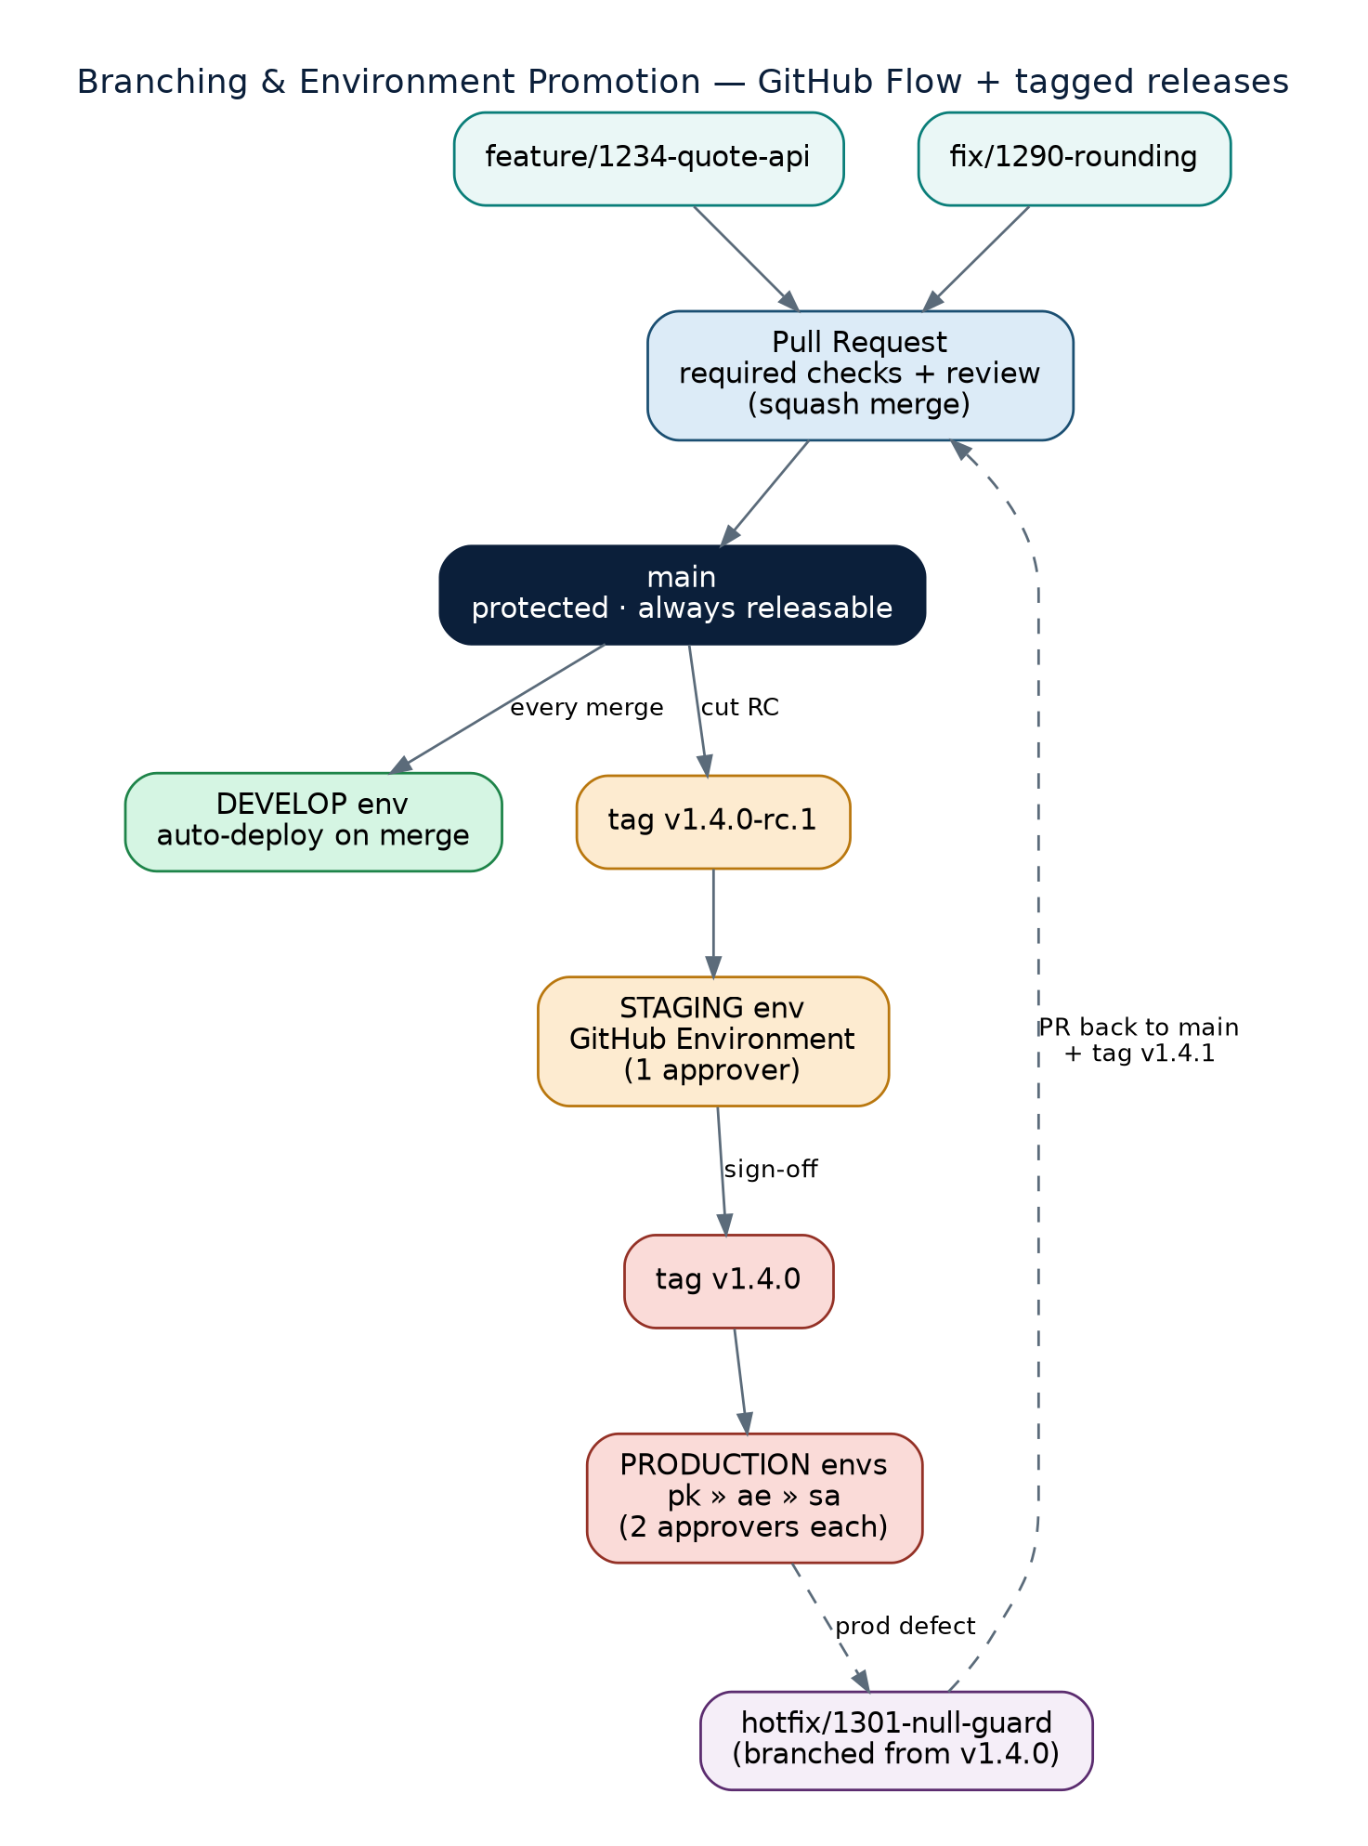
Figure — branch and promotion flow: feature branches → PR → main → develop env automatically; staging and production by tags with environment approvals; hotfixes branch from the production tag and return via PR.

4.1 Branches
Branch | Created from | Merges to | Rules
main | — | — | Protected; always releasable; squash merges only; never commit directly
feature/<issue>-<slug> | main | main via PR | One issue, one branch; target < 3 days of life; rebase on main, never merge main into it repeatedly
fix/<issue>-<slug> | main | main via PR | Non-urgent defect fixes; same rules as feature
chore/<slug>, docs/<slug>, spike/<slug> | main | main via PR (spikes may close unmerged) | Spikes are time-boxed and clearly labelled; spike code is never promoted directly
hotfix/<issue>-<slug> | the production tag (e.g. banking-v1.4.0) | PR to main + patch tag from the hotfix branch | Only for production-down/severity-1; produces v1.4.1 immediately, then reconciles to main the same day

4.2 Releases and environment promotion
- develop environment: every squash-merge to main auto-deploys the changed services to the shared develop cluster. No approval — this is the integration playground and it is allowed to break (briefly).
- staging environment: a release manager cuts an RC tag from main (banking-v1.4.0-rc.1). The pipeline promotes the exact images already built for that commit — no rebuild — into staging after one approval on the GitHub 'staging' Environment. Staging runs the full E2E, Pact-verified, migration-rehearsed suite against production-shaped data.
- production environments: sign-off on the RC produces the final tag (banking-v1.4.0). The pipeline deploys region by region — pk, then ae, then sa — each behind its own protected GitHub Environment requiring two approvals; the sa environment's deploy job runs against in-Kingdom infrastructure only.
- Rollback is redeploying the previous tag through the same pipeline (ArgoCD makes this a pointer move). Database migrations must therefore be backward-compatible one version in each direction (expand–migrate–contract pattern).
- Shared adapters version independently of the apps: adapter-tax-v1.2.0 can promote on its own cadence; consuming apps pin adapter versions and move deliberately (the vN / vN+1 deprecation-window rule from the governance model).

4.3 Pull request rules
- Small by design: target < 400 changed lines; anything bigger needs a stated reason in the description or gets split.
- Reviews: 1 approval for app repos, 2 for platform-packages, platform-adapters and platform-infra; CODEOWNERS auto-requests the owning squad; authors never approve their own PR; stale approvals dismissed on new pushes.
- The PR description answers: what, why, how tested, and links the issue (Closes #NNN). The template enforces a checklist: contracts updated? migration backward-compatible? docs/ADR touched if behaviour changed?
- Merge method: squash only — linear history on main, PR title becomes the commit message (commitlint-checked).
- Draft PRs early and often; CI runs on drafts so feedback is continuous.

4.4 Branch protection (main, every repo)
- Require a pull request before merging; require approvals per §4.3; dismiss stale approvals; require review from CODEOWNERS.
- Require status checks to pass (see §5.2 for the exact check names per repo) and require branches to be up to date before merging.
- Require linear history; block force pushes and deletions; restrict who can push tags matching release patterns to the release-managers team.
- Require signed commits is enabled from day one (developers set up SSH/GPG signing during onboarding, §7).

5. CI/CD, Environments and Hosting

5.1 The moving parts
Concern | Choice | Notes
CI | GitHub Actions | GitHub-hosted runners to start; move heavy Testcontainers jobs to self-hosted runners when the bill or queue times say so
Container registry | GHCR (ghcr.io) per org | Native to GitHub auth; images signed with cosign; mirrored/pulled into each region's cluster — the sa cluster pulls through an in-Kingdom mirror
CD / GitOps | ArgoCD in each cluster watching platform-infra /gitops overlays | Deploy = a PR (or automated bot PR) bumping an image tag in the right overlay; ArgoCD syncs; the git log IS the deployment audit trail
Environments | GitHub Environments: develop, staging, production-pk, production-ae, production-sa | Approvals and environment-scoped secrets live here; production-sa reviewers include the KSA compliance owner
Infrastructure | Terraform in platform-infra, applied by Actions with OIDC federation to the cloud account(s) | No long-lived cloud keys in GitHub; plan on PR, apply on merge with environment approval
Runtime secrets | Vault (per plane) — apps never read GitHub secrets | GitHub Environment secrets are for pipelines only (registry, Pact broker, cloud OIDC role names)
Contract broker | Pact Broker (PactFlow SaaS to start, self-hostable later) | can-i-deploy gates every promotion; adapter CI verifies BOTH consumer apps
Clusters | 1 shared develop cluster · 1 staging cluster · 3 production clusters (pk / ae / sa per Doc 00 §12) | develop/staging in the most convenient region; production-sa strictly in-Kingdom from day one so residency is proven early, not retrofitted

5.2 Required checks per repo (the names branch protection enforces)
Repo | Required status checks
banking-app / takaful-app / platform-adapters (TS services) | lint-and-test (ESLint incl. money rule, tsc --noEmit, unit) · boundaries (dependency-cruiser) · security (CodeQL + dependency review + image scan) · component (Testcontainers PG/Kafka) · contracts (Pact verify — for platform-adapters this means BOTH apps) · build (image + cosign sign + SBOM)
banking-app JVM services (Ledger, Pricing) | lint-and-test (unit + jqwik property suite) · boundaries (ArchUnit) · security · component · contracts (Pact provider) · build
platform-packages | lint-and-test · boundaries · publish-dry-run (Changesets) · security
platform-infra | terraform fmt/validate · terraform plan (posted to the PR) · policy check (tflint/OPA) · kustomize/helm render of GitOps overlays
platform-docs | markdown lint · link check · ADR/RFC front-matter check
Dependency updates are day-one, not phase-two. Dependabot (or Renovate) is enabled on every repo from day one for npm, Maven/Gradle, Actions and Terraform providers, grouped weekly. Waiting until 'later' is how a platform ends up two majors behind on everything with a CVE backlog.

6. Issues, Projects and Planning on GitHub
- Issues live on the repo that owns the work (a tax-rule bug on platform-adapters; a claims story on takaful-app). Cross-cutting epics live on platform-docs and link child issues.
- Issue forms (YAML templates) per type: Story (user value, acceptance criteria, definition of done), Bug (repro, expected/actual, severity), Tech task, RFC pointer, Incident. Free-form blank issues are disabled.
- Labels — one taxonomy across all repos: type/{story,bug,tech,rfc,incident} · app/{banking,takaful,shared} · squad/<name> · priority/{p1,p2,p3} · phase/{A,B,C,D} · good-first-issue.
- One organisation-level GitHub Project ('Platform Delivery') pulls issues from all repos. Fields: Status (Backlog → Ready → In Progress → In Review → Done), App, Squad, Phase, Priority, Target release. Squads may add filtered views; nobody maintains a second tracker.
- Milestones map to the delivery phases (A: shared core build, B: three new adapters, C: Takaful PK pilot, D: scale-out) plus per-app release milestones (banking-v1.4.0).
- PRs must link their issue (Closes #NNN) — the automation moves cards; humans do not drag them.

7. Developer Tooling (Per-Machine Checklist)
Tool | Version / choice | Purpose
Git + GitHub CLI (gh) | latest | Everything is PR-driven; gh makes issue/PR flow fast; commit signing configured (SSH signing is fine)
Node.js via Volta (or nvm) | 22 LTS pinned per repo | TS services, adapters, packages; Volta pins per-project so 'works on my machine' dies early
npm (workspaces) + Changesets | npm 10+ | Package management and versioned releases of @platform/*
Java (Temurin) + Gradle | 21 LTS / Gradle 8 | Ledger & Pricing only; Gradle wrapper checked in — nobody installs a global Gradle
Docker (Desktop or Colima) + Compose | latest | docker compose --profile <service> runs local PG + Redpanda + mock adapters (Doc 01 §6)
kubectl + Helm + k9s | matching cluster minor | Cluster access read-only by default; write via GitOps PRs, not kubectl apply
Terraform | 1.8+ (tfenv) | platform-infra contributors only; everyone else consumes
Pre-commit stack | husky + lint-staged + commitlint | Ships in both templates; formats, lints and checks the commit message before it ever reaches CI
IDE | VS Code (TS) / IntelliJ IDEA (JVM) | Shared settings + recommended-extensions checked into each repo (ESLint, dependency-cruiser viewer, SonarLint)
platform-cli (internal) | from platform-packages | Scaffolds a service from the right template, registers it with the local gateway, wires the Keycloak dev realm

7.1 Access checklist (granted during onboarding, in this order)
- GitHub org membership → squad team → repo permissions via teams only (never individual grants).
- GHCR read (all) / write (via CI only — humans do not push images).
- Pact Broker account; Vault dev-plane access; cloud SSO with read-only console for develop.
- Environment approver roles: staging (release managers), production-pk/ae (squad leads), production-sa (squad leads + KSA compliance owner).

8. Day-One Setup Runbook (Execute in Order)
# | Step | Done when
1 | Create the GitHub organisation; enable 2FA-required, default read for members; create squad teams and the release-managers team | Org exists; teams mirror the squad map in Doc 23 §4
2 | Create platform-docs; commit the blueprint set (00–26), ADR template, RFC template, this document; enable Discussions | Docs repo is the single source of truth; first ADR (0001: repo & branching strategy = this doc) merged
3 | Create service-template-ts and service-template-jvm as template repos with the full golden path (layout, guardrails, CI workflow, Helm chart, issue forms, PR template, CODEOWNERS stub) | A scaffolded hello-service passes every required check unmodified
4 | Create platform-packages; publish @platform/tsconfig, money, telemetry, oidc, pact-fixtures v0.1.0 via Changesets to GitHub Packages (npm) | A template-scaffolded service installs and builds against them
5 | Create platform-infra; Terraform the develop cluster + GHCR wiring + Vault dev; bootstrap ArgoCD watching /gitops/develop; set up GitHub OIDC → cloud federation | ArgoCD deploys the hello-service to develop from a GitOps PR
6 | Configure GitHub Environments (develop, staging, production-pk/ae/sa) with approvers and environment secrets; set branch protection + required checks on every repo; stand up the Pact Broker and wire can-i-deploy into the pipelines | A full promote of hello-service: merge → develop, rc tag → staging (1 approval), tag → production-pk (2 approvals) works end to end
7 | Create platform-adapters, banking-app, takaful-app from the templates; open the Phase-A epics and stories in the Platform Delivery project | Squads pick up 'Ready' issues; Phase A (build the five designed adapters + walking skeleton) begins
8 | Terraform staging, then production-pk (production-ae/sa follow their phases — but production-sa MUST be in-Kingdom from its first apply) | Staging live before the first RC; production-pk live before the Phase-C pilot
Prove the pipeline with the skeleton. Steps 1–6 are one to two weeks of Platform/Enablement work and they gate everything else. The walking skeleton (Doc 23, Phase 2) should be the first real code through the full merge → develop → staging → production-pk pipeline — proving the path to production before there is anything valuable to ship on it.

9. Shared-Adapter Governance, Expressed in GitHub Mechanics
Governance rule (from the platform deck) | GitHub mechanism that enforces it
Adapters are versioned internal products | Independent semver tags per adapter (adapter-tax-v1.2.0); release notes generated from Conventional Commits; a published roadmap as a pinned Project view
A change that breaks either consumer app cannot merge | The 'contracts' required check on platform-adapters runs Pact verification against BOTH banking-app and takaful-app pacts, plus can-i-deploy on promotion
One owning squad; apps contribute by RFC + inner-source PRs | CODEOWNERS = Platform Adapters squad on the whole repo; external-squad PRs welcome but merge requires owner approval; rfc label + Discussion thread for anything contract-shaped
Deprecation, never surprise (vN alongside vN+1) | Both major versions kept deployable from tags; a deprecation issue with a milestone marks the migration window; consuming apps pin versions in their GitOps overlays
Per-app quotas / noisy-neighbour protection | app_id is part of the contract (Docs 24–26); dashboards and alerts split by app_id; quota configs live in the control-plane packs and change by PR like everything else

Appendix A — If the Team Insists on a develop Branch (Classic Git Flow)
The recommendation above deliberately avoids a long-lived develop branch: it drifts from main, doubles merge work, hides integration pain until 'release hardening', and conflates branching with deployment. If, despite this, the team adopts classic Git Flow, the non-negotiables are: develop auto-deploys the develop environment; release/x.y branches are cut from develop, deploy staging, and merge to BOTH main and develop; main deploys production by tag; hotfixes branch from main and merge back to both. Every protection rule, required check and environment approval in §4–§5 applies unchanged. Revisit after one quarter — teams that start with Git Flow on a platform this size almost always simplify back to trunk-based flow once release cadence stabilises.

Appendix B — Quick Reference Card
- Start work: gh issue develop 1234 --checkout → branch feature/1234-slug off main.
- Ship it: push → draft PR early → checks green → review → squash merge → auto-deploys develop.
- Release: tag banking-v1.4.0-rc.1 → staging (1 approval) → sign-off → tag banking-v1.4.0 → production pk → ae → sa (2 approvals each).
- Prod fire: hotfix/1301-slug from the prod tag → PR checks → tag v1.4.1 → promote → PR the fix back to main same day.
- Never: commit to main, merge without green checks, deploy from a laptop, edit a rule pack in place, or push an image by hand.

