DEVELOPMENT PLAN · DOCUMENT 29 · BANKING + TAKAFUL
Development Plan, Sequencing & Milestones
Where to start, what runs sequentially, what runs in parallel, and the gates that define progress
The execution plan for the whole programme: squad structure, the critical path, phase-by-phase work streams, a sprint-level timeline, and nine milestones with hard exit criteria.
Field | Details
Document title | Development Plan, Sequencing & Milestones
Covers | All 24 services and adapters, both applications, three markets
Builds on | Doc 23 (build order) · Doc 27 (branching/CI) · Doc 28 (repositories) · the 24 feature specs
Team assumption | ~20 engineers across 5 squads (+ a Takaful squad forming at Phase C)
Sprint length | 2 weeks
Status | Plan for approval — nothing is built yet; this is the sequence to start executing
Version | 1.0
Date | 17 July 2026
Classification | Confidential — Internal Use

1. Purpose and How to Use This Plan
Twenty-eight documents describe what to build. This one describes the order to build it in, who builds what at the same time, and how we know a phase is genuinely finished. It answers three questions directly: where do we start on day one, what must wait for something else, and what can run in parallel so that twenty engineers are never idle.
Read §4 (the two rules of sequencing) and §5 (the critical path) before anything else — they explain every decision in the phase plan. §6 is the phase-by-phase work breakdown, §7 is the sprint-level timeline, and §8 is the milestone set with exit criteria. §9 onward covers how parallel work is kept safe, what threatens the schedule, and the first thirty days in concrete terms.
On estimates — read this first. Durations in this plan are sprint-count estimates for planning, not commitments. They are deliberately expressed in sprints rather than dates so the plan survives a start-date change. Validate every estimate with the squad that will do the work before it becomes a commitment to anyone outside engineering — and re-baseline after Milestone M1, when the team's real velocity on this codebase is known for the first time.

2. Planning Principles
- Prove the pipeline before the product. The first thing through the full merge → develop → staging → production path is a trivial service, not a valuable one.
- Build the foundation before the features. Control Plane, OIDC and Persistence are dependencies of everything; building a domain service before them means building against a stub you will throw away.
- One vertical slice early. A thin end-to-end journey (onboard → verify → post a journal) proves the architecture far better than several half-finished services.
- Mock at the port, integrate later. Every external provider has a mock binding first, so app teams are never blocked waiting on a vendor or a regulator.
- Compliance is a feature, not a phase. Screening, residency and audit are built into each service as it is written — never retrofitted before go-live.
- Takaful waits. The shared-adapter payoff depends on the adapters being real and proven by the banking app first.
- External certification starts early and runs in parallel. Provider and regulator lead times are the most common cause of a missed date, and they are not ours to control.

3. Squad Structure and Allocation
Five squads at the outset, sized so each owns a coherent slice of the architecture and can work without waiting on another squad's keyboard. A sixth (Takaful) forms at Phase C from a mix of reallocation and hiring.
Squad | Size | Owns (repos / components) | Primary skills
Platform / Enablement | 4 | platform-infra, platform-packages, templates, Control Plane (12), Persistence (14), OIDC (22), Dev Platform/BFF (11) | TypeScript, Kubernetes, Terraform, CI/CD, security
Ledger & Money (JVM) | 3 | Ledger (04), Pricing (10), FX library (17), Reconciliation (09) | Java 21, Spring Boot, exact-arithmetic discipline, property testing
Identity & Compliance | 4 | Identity/KYC (02), Screening & AML (03), Compliance Reporting (08) | TypeScript/NestJS, regulatory domain, case-management UX
Payments | 3 | Payments saga (05), Wallets & Accounts (06), corridors | TypeScript/NestJS, distributed sagas, payment schemes
Platform Adapters | 4 | platform-adapters: eKYC (16), Screening (15), Rails (19), Messaging (21), Notification (13), Tax (25), E-Sign (26), Bureau (24) | TypeScript/NestJS, third-party integration, contract testing
QA & Release (embedded) | 2 | Test automation, isolation suite, Pact broker, release management | Test automation, Testcontainers, performance testing
Takaful (forms at Phase C) | 4–6 | takaful-app: policy admin, underwriting, claims, pool accounting, BFF | TypeScript/NestJS, insurance/Takaful domain
Note that Notification (13) sits with the Platform Adapters squad rather than a product squad: it is consumed by both applications and is effectively platform plumbing, and pairing it with the messaging adapter (21) keeps one team across the whole delivery path.

4. The Two Rules of Sequencing
Every scheduling decision in this plan follows from distinguishing two very different kinds of ordering.

4.1 Dependency-forced sequence (cannot be parallelised)
Some work genuinely cannot start until other work exists, because it would otherwise be built against something that will change underneath it. These are non-negotiable:
This cannot start… | …until this exists | Why
Any service | Templates + @platform packages + CI (Sprint 0) | Otherwise every service is born inconsistent and retrofitting the guardrails is expensive
Any service with tenant data | Control Plane (12) + Persistence (14) + OIDC (22) | Tenant identity, effective config and isolation are inputs to every request
Wallets (06), Payments (05), Pricing (10) | Ledger (04) | They compose balances from, hold against, and post to the ledger
Payments saga (05) completion | Screening (03) and Pricing (10) | The saga's screen and quote steps are real steps, not stubs, before go-live
Pricing (10) tax lines | Country Tax adapter (25) — or an interim flat rule pack | Quotes must carry correct tax lines; see §9.2 for the interim option
Credit Bureau adapter (24) | E-Signature / Consent adapter (26) | A bureau inquiry legally requires captured consent — this order is a legal constraint, not a preference
Takaful app services | The shared adapters proven by the banking app | Building both consumers at once doubles the risk on unproven adapters
Any market go-live | That market's provider + regulator certification | External, and frequently the longest single lead time

4.2 Team-forced parallelism (should be parallelised)
Everything else is limited only by how many people we have. Wherever two pieces of work touch different repositories or different services and communicate through an agreed contract, they run at the same time. The three concrete enablers are: contract-first development (the OpenAPI/Avro spec merges before the implementation, so a consumer can build against it immediately), mock bindings at every adapter port, and Pact verification to catch drift before integration.

5. The Critical Path
One chain of work determines the earliest possible Pakistan go-live. Everything on it must be watched weekly; everything off it has slack and can absorb surprises without moving the date.
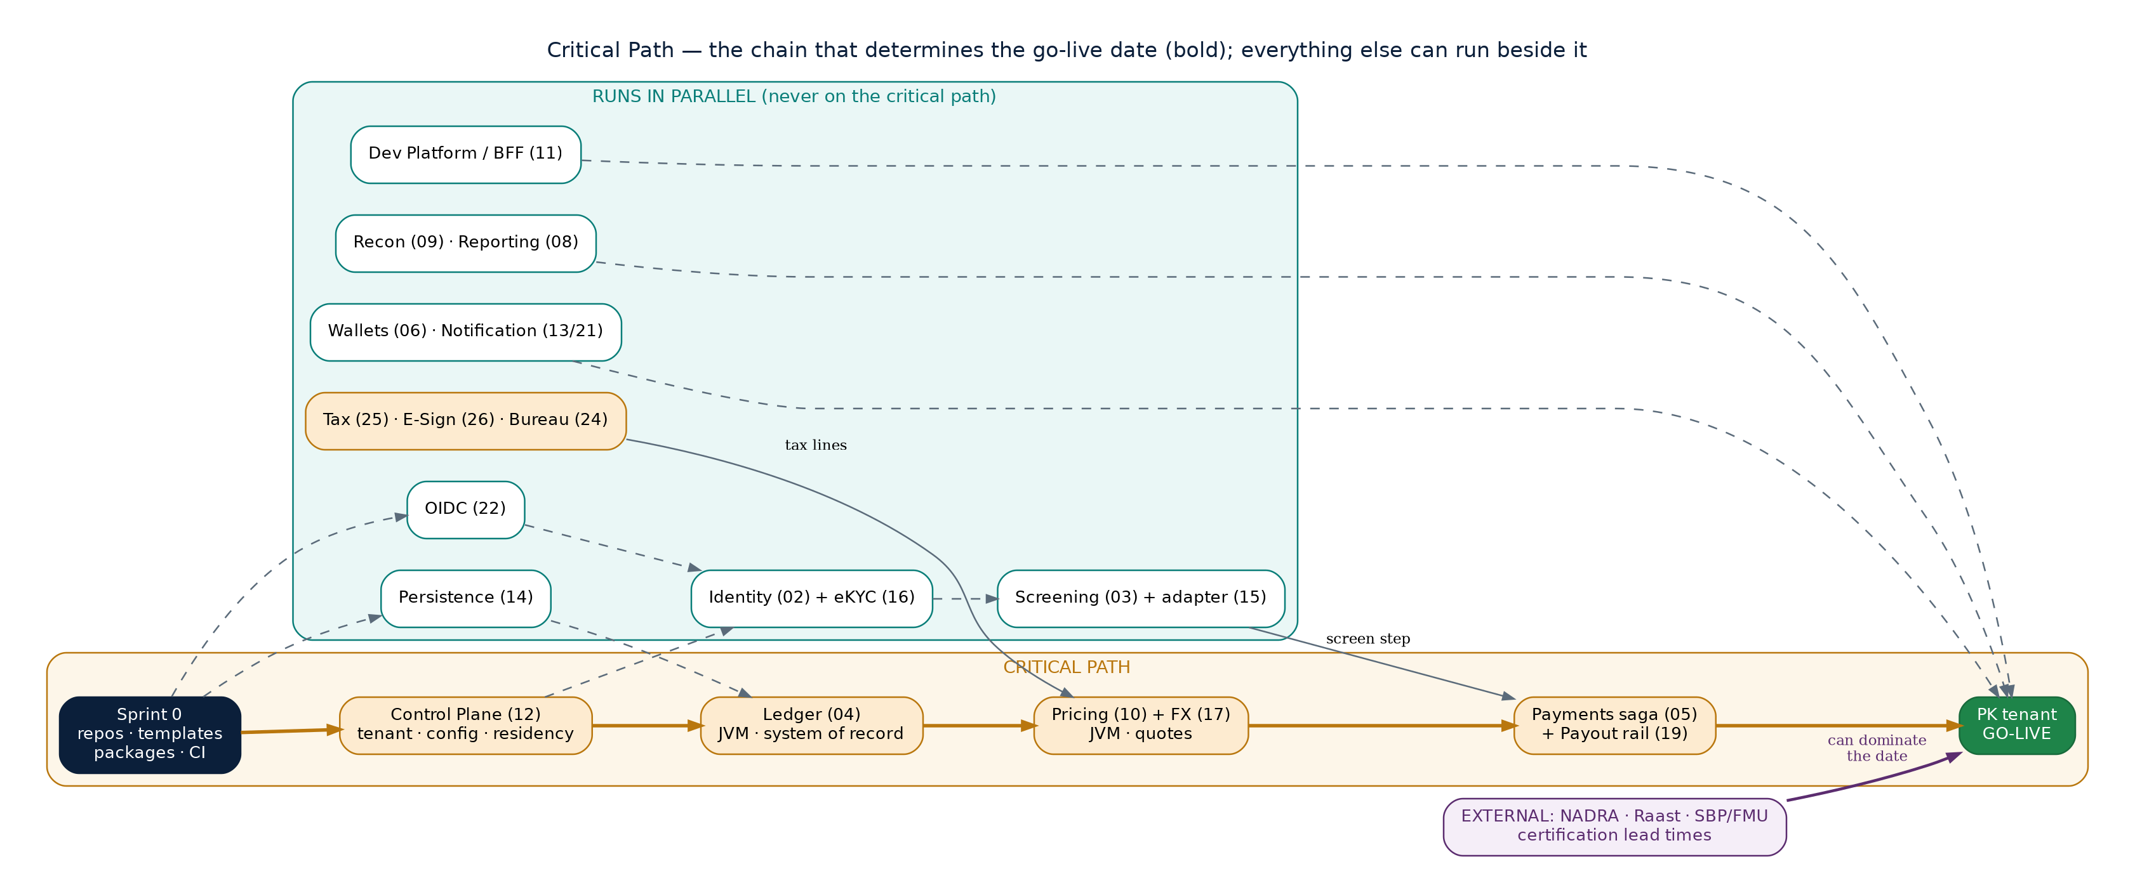
Figure 1 — the critical path (bold amber) versus work that runs beside it. External certification is shown separately because it can dominate the date regardless of engineering progress.
The chain is: Sprint 0 → Control Plane (12) → Ledger (04) → Pricing (10) + FX (17) → Payments saga (05) + Payout rail (19) → Pakistan go-live. Two things follow from this. First, any slip in the Ledger is a slip in the programme, which is why it gets the strongest squad and the earliest start after the foundation. Second, Identity, Screening, Wallets, Notification, the BFF and reporting all have slack — they are essential for go-live but they are not what makes the date, so they are the right place to absorb scope growth or an unexpected problem.

6. Phase-by-Phase Plan
Each phase below states its goal, the parallel work streams inside it, and the exit gate that must be demonstrably true before the phase is called done. The gates matter more than the durations.

6.0 Phase 0 — Engineering foundation (Sprint 0) · ~3 sprints
Goal: a developer can scaffold a service and get it to production through a real pipeline. No product code is written in this phase.
Stream | Squad | Work
Repos & docs | Platform / Enablement | GitHub org, teams, 2FA; create platform-docs and commit the blueprint set; ADR-0001 records the branching/repo strategy
Golden paths | Platform / Enablement | service-template-ts and service-template-jvm with layout, guardrails (dependency-cruiser / ArchUnit), CI workflow, Helm chart
Shared packages | Platform / Enablement | @platform/money (+ the ESLint money rule), tsconfig, telemetry, oidc, persistence-ts, pact-fixtures at v0.1.0
Infrastructure | Platform / Enablement | Terraform the develop cluster, GHCR, Vault dev, ArgoCD bootstrap, GitHub OIDC federation to the cloud
Pipeline & gates | QA & Release | GitHub Environments with approvers, branch protection + required checks on every repo, Pact broker wired to can-i-deploy
Certification kick-off | Identity & Compliance | Begin NADRA, Raast and SBP/FMU engagement paperwork now — the lead time starts here, not later
Gate M0 — Pipeline proven. Exit gate (M0): a scaffolded hello-service passes every required check unmodified and travels merge → develop → staging (1 approval) → production-pk (2 approvals) through the real pipeline. Certification engagement is formally open with NADRA, Raast and SBP.

6.1 Phase 1 — Foundation trio · ~4 sprints (three streams in parallel)
Goal: a request can arrive authenticated, resolve its tenant's effective configuration, and reach the correctly-isolated database in the correct region. This is the first real code, and all three streams run simultaneously.
Stream | Squad | Work and first-cut scope
Control Plane (12) | Platform / Enablement | Tenant registry + lifecycle; the hierarchical config store and resolveEffectiveConfig hot path with L1 LRU + Redis; entitlements; home_region routing; config publish with maker-checker and rollback
Persistence (14) | Platform / Enablement | RepositoryPort in TS and Java; silo / bridge / pool routing; RLS policies; residency assertion; the transactional-outbox helper; the isolation test suite
OIDC (22) | Platform / Enablement | @platform/oidc: token validation with JWKS caching and rotation, JwtTenantGuard, realm-per-tenant model and the realm-bootstrap hook, client-credentials for M2M
Gate M1 — Foundation ready. Exit gate (M1): config resolution meets p99 < 5 ms on cache hit; the isolation suite is green across all three isolation models and is a blocking CI check; a request carrying a tenant JWT resolves effective config and reaches a correctly-routed database; a KSA-flagged tenant demonstrably touches only in-Kingdom infrastructure. Re-baseline the plan here.

6.2 Phase 2 — Walking skeleton · ~4 sprints (three streams in parallel)
Goal: one thin vertical slice works end to end — onboard a customer, verify them against a mock provider, and post a journal — with real tenant context, isolation and events. This is the moment the architecture is proven.
Stream | Squad | Work and first-cut scope
Ledger (04) | Ledger & Money (JVM) | Money value object; balanced double-entry posting; append-only storage with UPDATE/DELETE revoked; holds place/capture/release; balance projection + cache; idempotent posting; outbox events
Identity / KYC (02) | Identity & Compliance | Customer registration; verification case orchestration; risk-tier computation; pack-driven onboarding workflow; MANUAL_REVIEW fallback
eKYC adapter (16) | Platform Adapters | The port plus the mock binding first (deterministic fixtures), then begin the NADRA sandbox integration behind the same port
Gate M2 — Walking skeleton. Exit gate (M2): in the develop environment, a customer is onboarded, verified through the mock eKYC binding, and a balanced journal is posted — all under real tenant context, with isolation enforced and outbox events flowing. Ledger property tests (jqwik) and the nightly projector-versus-postings reconciliation are both in place.

6.3 Phase 3 — Compliance gate · ~3 sprints (overlaps Phase 4 start)
Goal: no customer is onboarded and no transaction proceeds without passing screening, and hits become managed cases. This phase begins while the money-movement phase is starting, because Payments needs a real screening step only at its integration point, not on day one.
Stream | Squad | Work and first-cut scope
Screening & AML (03) | Identity & Compliance | Real-time entity and transaction screening; fuzzy/transliteration matching; pack-driven list scope and thresholds; case queue with maker-checker disposition; monitoring rules as versioned decision tables
Screening adapter (15) | Platform Adapters | Vendor binding(s) plus domestic-list ingestion; score normalisation calibration; list-version stamping; honest ProviderUnavailable errors (never a synthetic CLEAR)
Dev Platform / BFF (11) | Platform / Enablement | Gateway tenant/channel resolution, scope enforcement, rate limits; first BFF; webhooks; sandbox; locale chain including RTL
Gate M3 — Compliance gate live. Exit gate (M3): onboarding and transaction screening are enforced fail-safe closed — an induced provider timeout produces HOLD, never CLEAR; the certification fixture suite (known sanctioned names produce expected hits) passes; cases can be opened, investigated and dispositioned with two-person sign-off on high severity.

6.4 Phase 4 — Money movement · ~5 sprints (four streams in parallel)
Goal: money actually moves, correctly priced, with every compensation path proven. This is the densest phase and sits squarely on the critical path.
Stream | Squad | Work and first-cut scope
Pricing (10) + FX (17) | Ledger & Money (JVM) | Itemised, rate-bound quotes; fee schedules (flat/percentage/tiered); FX margin over the in-process mid-rate; staleness and sanity guards; usage metering ingestion
Payments saga (05) | Payments | The persisted saga: quote → screen → hold → payout → settle; explicit compensation for screen-fail, rail-reject and settle-fail; first-class IN_FLIGHT with a status-inquiry job; idempotent initiation
Payout rail adapter (19) | Platform Adapters | Raast binding first (domestic PK), then the cross-border partner for UAE→PK; idempotent execution by end-to-end id; status inquiry; statement retrieval
Country Tax (25) | Platform Adapters | The TaxPort with the PK rule pack (FBR + provincial); effective-dated versioned tables; rule-traceable lines; explain(). Pricing consumes it — see §9.2
Gate M4 — Money moves safely. Exit gate (M4): a domestic PK transfer completes end to end in a sandbox, and fault-injection drills prove all three compensation paths (screen-fail cancels the quote, rail-reject releases the hold, settle-fail reverses the journal). A forced rail timeout resolves via status inquiry rather than a guess. No double-pay occurs under aggressive retry testing.

6.5 Phase 5 — First Pakistan tenant · ~4 sprints (five streams in parallel)
Goal: a real tenant is live in production with a certified compliance pack. The remaining customer-facing and back-office services land here, mostly in parallel and mostly off the critical path.
Stream | Squad | Work
Wallets & Accounts (06) | Payments | Product catalogue, account lifecycle with the zero-balance close guard, composed balance views, statements
Notification (13) + messaging (21) | Platform Adapters | Versioned localized templates (en-PK, ur-PK RTL), preferences with a non-optional security category, idempotent send, regional sender routing
Reconciliation (09) | Ledger & Money (JVM) | Raast statement ingestion, three-way match, break queue, resolution only via a linked Ledger adjustment
Compliance Reporting (08) | Identity & Compliance | goAML-format STR generation for FMU, periodic returns, pre-submission reconciliation, maker-checker submission tracking
Certification & cutover | Identity & Compliance + Platform | NADRA and Raast production certification, SBP/FMU pack sign-off, production-pk cluster, tenant provisioning, runbooks and on-call
Gate M5 — Pakistan live. Exit gate (M5 — the big one): a real Pakistani tenant is live in production. The isolation suite is green against production configuration; NADRA and Raast are certified live; the SBP/FMU compliance pack is signed off by counsel; reconciliation runs clean for a full cycle; on-call, runbooks and rollback have been rehearsed.

6.6 Phase 6 — The three new shared adapters · ~3–4 sprints (partly overlapping Phase 5)
Goal: complete the shared adapter platform so the Takaful app can be built on eight real adapters rather than six. Tax (25) has usually landed already in Phase 4; the ordering constraint here is that E-Signature precedes the Bureau adapter.
Stream | Squad | Work and ordering note
E-Signature / Consent (26) | Platform Adapters | Envelopes over hashed documents; evidence-bundle assembly with region-local retention; first-class revocable consent with a local, highly-available verify path. Build FIRST of the three
Credit Bureau (24) | Platform Adapters | Consent-gated inquiry (verifying against 26), eCIB binding first; thin-file UNRATED handling; licence-bound caching; idempotent inquiries to avoid double-billing. Build AFTER 26
Country Tax (25) — finish | Platform Adapters | If not completed in Phase 4: add the AE and SA packs and the explain() surface
Gate M6 — Adapter platform complete. Exit gate (M6): all eight shared adapters exist with Pact provider verification running for both consumer applications; the end-to-end consent lifecycle works across adapters (capture → verify → bureau inquiry → revoke → verify fails); each adapter is a versioned internal product with published release notes.

6.7 Phase 7 — Takaful pilot (Pakistan) · ~6 sprints
Goal: the sibling application's first live journey, reusing the shared adapters. The Takaful squad forms at the start of this phase; banking squads continue on hardening and the UAE plane in parallel.
Stream | Squad | Work
Policy administration & underwriting | Takaful | Products, policies, contribution schedules; underwriting risk assessment consuming the Bureau adapter (24)
Claims & pool accounting | Takaful | Claim intake, assessment, payout orchestration; the tabarru' pool and wakala-fee model on @platform/money
Takaful BFF & channels | Takaful + Platform | The takaful BFF; participant-facing journeys
Adapter reuse integration | Platform Adapters | Second-consumer Pact contracts for all eight adapters; per-app quotas and dashboards split by app_id
Insurance compliance pack | Identity & Compliance | SECP Takaful Rules variant of the PK pack; Shariah board review of the product and wakala model
Gate M7 — Takaful pilot live. Exit gate (M7): a takaful policy is issued and a contribution collected via Raast in production for a pilot tenant, using the shared adapters unchanged; the insurance compliance pack is certified and the Shariah board has signed off; the claims path works end to end in the sandbox.

6.8 Phase 8 — Market scale-out: UAE then KSA · ~4 sprints each
Goal: prove the plug-and-play claim by adding markets through configuration and one more data plane, not through new code. UAE first (lighter residency constraints), then KSA in-Kingdom.
Stream | Squad | Work
UAE data plane & bindings | Platform / Enablement + Adapters | UAE cluster; UAE Pass/Emirates ID (16), AECB (24), FTA VAT pack (25), Aani (19), UAE Pass signing (26), ar-AE locale
KSA in-Kingdom plane & bindings | Platform / Enablement + Adapters | Riyadh cluster with strict in-Kingdom egress; Absher/Yakeen (16), SIMAH (24), ZATCA VAT pack (25), sarie/mada (19), Nafath signing (26), ar-SA locale
Corridor hardening | Payments | UAE→PK and KSA→PK corridors live with cut-off calendars and partner reconciliation
Regulator certification | Identity & Compliance | CBUAE and SAMA engagement, packs certified per market with counsel
Gate M8 — Three markets live. Exit gate (M8): a UAE tenant and a KSA tenant are live on their own data planes with zero code forks — only configuration and provider bindings differ; KSA regulated data provably never leaves the Kingdom; both remittance corridors settle in production.

7. Sprint-Level Timeline
The chart below shows every stream on its squad's track, so overlap and idle capacity are visible at a glance. Milestone markers are the gates from §8. Bars are sprint-count estimates, not commitments.
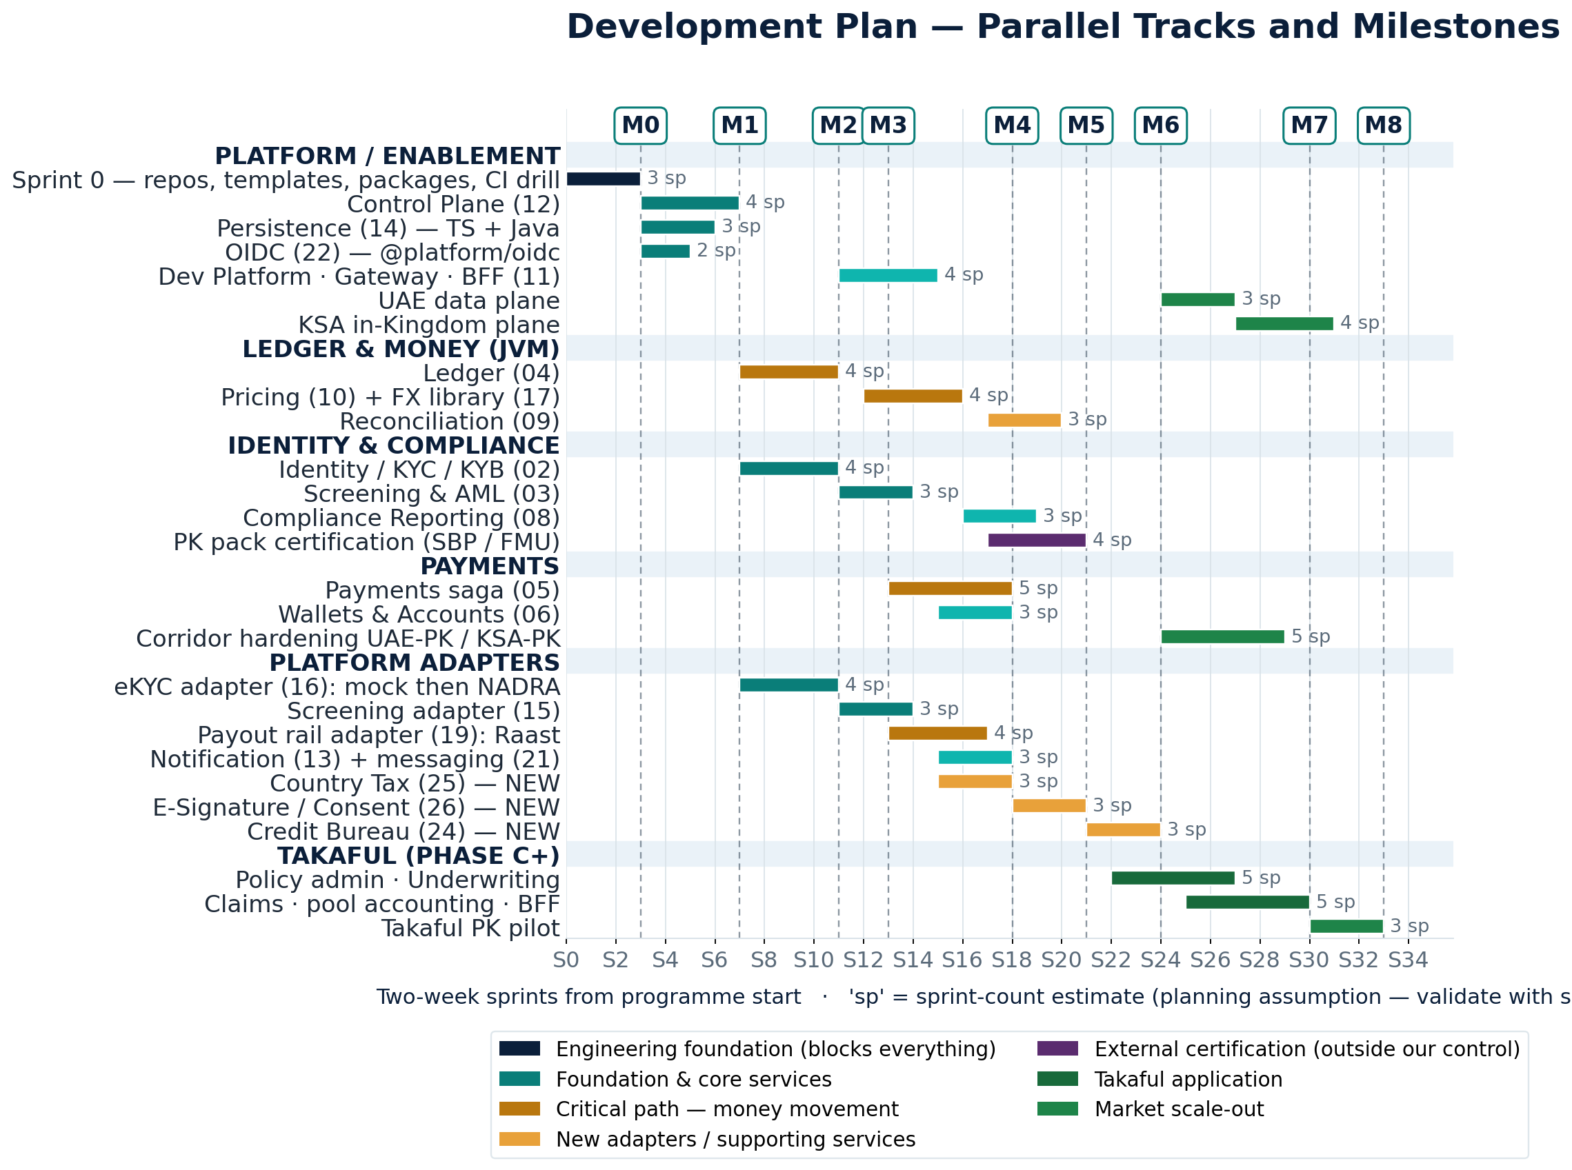
Figure 2 — parallel tracks and milestones across roughly 33 sprints. Amber bars are the critical path; the purple bar is external certification, which is tracked but not controlled by engineering.
Reading the chart: Pakistan go-live (M5) lands around sprint 21 — roughly ten months at a two-week cadence — with the Takaful pilot (M7) near sprint 30 and all three markets (M8) beyond sprint 33. Note that the Platform Adapters and Identity tracks are close to continuously busy while the JVM track has gaps between Ledger, Pricing and Reconciliation; that spare JVM capacity is the natural place to absorb critical-path pressure, and it is a deliberate reason not to grow the JVM squad.

8. Milestones and Exit Criteria
Nine milestones. A milestone is reached only when its exit criteria are demonstrated — not when the calendar says so. Each one unblocks specific downstream work, which is why slipping a gate quietly is far more expensive than declaring it late.
ID | Milestone | Exit criteria (demonstrated, not asserted) | Unblocks
M0 | Pipeline proven (~S3) | hello-service passes all required checks unmodified and reaches production-pk through the real pipeline; certification engagement opened | All service development
M1 | Foundation ready (~S7) | Config resolve p99 < 5 ms; isolation suite green and blocking; tenant JWT → correctly-routed DB; KSA in-Kingdom proven | Every domain service; re-baseline the plan
M2 | Walking skeleton (~S11) | Onboard → verify (mock) → post a balanced journal, under real tenant context with outbox events | Screening, money movement
M3 | Compliance gate live (~S13) | Screening enforced fail-safe closed (timeout ⇒ HOLD); certification fixtures pass; case workflow with maker-checker | Payments screen step; reporting
M4 | Money moves safely (~S18) | Domestic PK transfer end to end; all three compensation paths proven by fault injection; no double-pay under retry | First tenant; corridors
M5 | Pakistan live (~S21) | Real tenant in production; NADRA + Raast certified; SBP/FMU pack signed off; clean reconciliation cycle; on-call rehearsed | Revenue; Takaful build; scale-out
M6 | Adapter platform complete (~S24) | All eight adapters with dual-consumer Pact; consent lifecycle works across 26 → 24; versioned release notes | Takaful app development
M7 | Takaful pilot live (~S30) | Policy issued + contribution collected via Raast in production; insurance pack certified; Shariah sign-off | Takaful scale-out
M8 | Three markets live (~S33+) | UAE and KSA tenants live on their own planes, no code forks; KSA residency proven; both corridors settling | Commercial expansion

9. Making Parallel Work Safe

9.1 The three enablers
- Contract first. The OpenAPI or Avro change merges before the implementation, so a consuming squad codes against the agreed shape immediately. Pact verification then catches any drift in CI rather than at integration.
- Mock bindings at every port. Every adapter ships a deterministic mock binding before its first real provider. App squads never wait on a vendor sandbox, and integration becomes a configuration swap rather than a rewrite.
- Vertical slices, not horizontal layers. A squad delivers a thin end-to-end capability rather than 'all the repositories' or 'all the controllers', so integration risk surfaces in week two instead of month five.

9.2 Two dependencies that need an explicit decision now
- Pricing needs tax lines. Pricing (10) composes tax lines from the Country Tax adapter (25). Either build 25 in Phase 4 alongside Pricing (the plan above), or ship an interim single-rule PK pack and treat the full multi-market packs as Phase 6. Decide before Phase 4 planning, because it changes the Platform Adapters squad's load at exactly its busiest point.
- E-Signature precedes the Bureau adapter. This is legal, not architectural: a bureau inquiry requires captured consent. If the Bureau adapter is pulled earlier for a lending initiative, E-Sign must move with it.

9.3 Standing quality gates (every sprint, every service)
- The isolation suite and the boundary check (dependency-cruiser / ArchUnit) are blocking CI checks from Phase 1 onward — not pre-launch activities.
- Pact verification blocks merges on both sides of every seam; for shared adapters that means both consumer apps once Takaful exists.
- Every mutation has an idempotency key; every producer writes through the transactional outbox; every amount uses integer minor units, enforced by lint.
- Fail-safe-closed behaviour on screening and card authorization is tested by fault injection, not by inspection.

10. Schedule Risks and Where the Slack Is
Risk | Impact on the plan | Mitigation / where the slack is
External certification lead times (NADRA, Raast, SBP; later CBUAE, SAMA) | The single most likely cause of a missed go-live — and outside engineering's control | Open engagement in Sprint 0, run it as its own tracked stream, and build behind mock bindings so engineering never waits on it
Ledger slips | Direct slip to the programme — it is on the critical path | Strongest squad, earliest start after M1, property-tested from day one; the JVM track's later gaps give room to recover
Platform Adapters squad overload in Phase 4–6 | Four adapters plus the new builds land close together | The §9.2 tax-pack decision; borrow from the JVM track's gap; defer Core Banking (18) and Card Processor (20) entirely until a tenant needs them
Foundation gold-plating in Phase 1 | A slow start that delays everything without visible product | Timebox Phase 1 to its exit gate; the config resolver and isolation suite are 'meets the gate', not 'perfect'
Starting Takaful too early | Two consumers on unproven adapters doubles rework risk | Hard rule: no Takaful service development before M5 (Pakistan live) and ideally M6
Velocity assumptions wrong | Every date after M1 shifts | M1 is an explicit re-baseline point — the first honest read on real velocity for this codebase
Optional scope creeping in (Cards, Core Banking host) | Diverts squads from the critical path | Both are explicitly out of the plan until a licensed tenant requires them; they are Won't-have for the pilot

11. How Progress Is Tracked
- One organisation-level GitHub Project ('Platform Delivery') per Document 27 §6, with milestones M0–M8 as GitHub Milestones and phase labels (phase/0 … phase/8).
- Each phase's streams become epics; the Must-tier features from the 24 feature specifications become the stories under them. Should-tier features are groomed but not committed until the phase before.
- Weekly: critical-path review only — Sprint 0 items, Control Plane, Ledger, Pricing/FX, Payments/rail, and the certification stream. Everything else is reviewed at sprint boundaries.
- At each milestone: a written gate review against the exit criteria, recorded as an ADR in platform-docs so the decision to proceed (or not) is auditable.
- Re-baseline formally at M1 and M5; anywhere else, changes are handled as scope trades rather than date optimism.

12. The First Thirty Days — Concretely
When | Who | What
Week 1 | Platform / Enablement | GitHub org, teams, 2FA policy; platform-docs created with the blueprint set; ADR-0001 merged; both template repos scaffolded
Week 1 | Identity & Compliance lead | Open NADRA, Raast and SBP/FMU certification engagement — paperwork starts on day one
Week 2 | Platform / Enablement | @platform packages published at v0.1.0; hello-service scaffolds and passes every check locally and in CI
Week 2 | QA & Release | Branch protection and required checks on every repo; GitHub Environments with approvers; Pact broker live
Week 3 | Platform / Enablement | Terraform the develop cluster; ArgoCD bootstrapped; hello-service deploys from a GitOps PR
Week 3–4 | All squads | Phase 1 planning against the §6.1 scope; contract-first OpenAPI stubs for Control Plane, Persistence and OIDC merged
Week 4 | Platform + QA | Full promotion drill: merge → develop → staging → production-pk with approvals. Declare M0 at the gate review
The single most important sequencing decision. If only one thing is taken from this plan: start Sprint 0 and the regulator/provider certification engagement in the same week. Engineering can be recovered with people; certification lead time cannot.

