MILESTONE PLAN · LEDGER SERVICE (04)
Ledger Service — Milestone Plan
Six milestones from foundation-ready to consumer-ready
A single-service view for the Ledger squad: what gets built in what order, and the exit criteria for each milestone.
Field | Details
Component | Ledger Service (04)
Runtime | Java 21 + Spring Boot 3.3 · PostgreSQL 16 (append-only)
Owning squad | Ledger & Money Movement
Programme position | On the critical path — starts after gate M1, completes into gate M2
Estimated duration | ≈ 4–5 sprints (2-week sprints) — estimate, to be confirmed by the squad
Feature scope | Per the Ledger Feature Specification (Service 04)
Status | Plan — not started
Version | 1.0
Date | 28 July 2026
Classification | Confidential — Internal Use

1. Context
The Ledger is the system of record for value: nothing else in the platform may hold a balance. It sits on the programme's critical path, so any slip here is a slip to the Pakistan go-live date. It cannot start until the foundation is ready (gate M1: Control Plane, Persistence-Java and OIDC), and its completion is what makes the walking-skeleton gate (M2) possible.
The milestones below build inward-out: the money and domain rules first with no database at all, then persistence, then holds, then balances, then hardening for the services that will consume it. This order means the arithmetic and invariants are proven before any infrastructure complexity is added.
Scope note — FX and rates. This plan incorporates ADR-0002 (FX conversion, rate provenance and statement reporting). The Ledger does not manage exchange rates: Pricing (10) locks the rate and it arrives as an input to the posting. What the Ledger owns is provenance — journals.quote_id links a booked entry to the quote that set the rate, and journals.display_meta keeps customer statements reproducible after quote retention lapses. For the Pakistan pilot the ledger books PKR only; the FX_CONVERSION journal type and FX position accounts are built behind a capability flag (ADR-0002 D7).
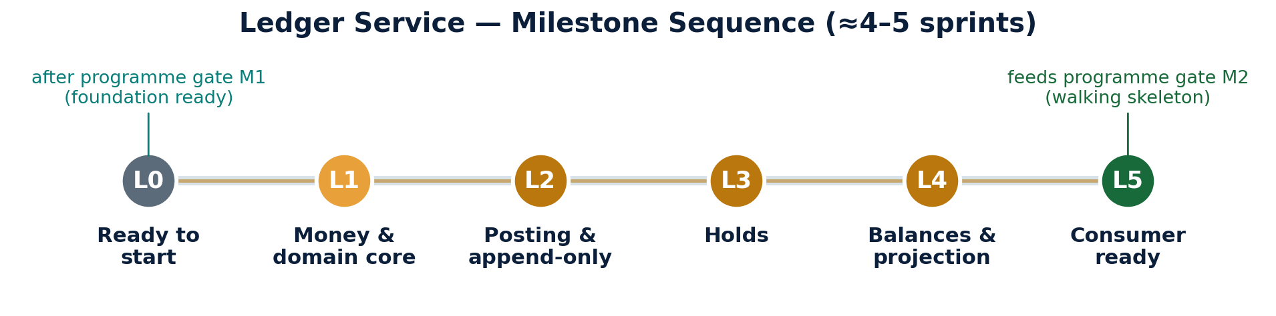

2. Milestones
ID | Milestone | What is delivered | Exit criteria | Est.
L0 | Ready to start | Entry gate only — no Ledger code. Confirms the foundation and JVM golden path are in place. | Programme gate M1 passed; service-template-jvm scaffolds a service that passes all required checks; Persistence-Java library available; a JVM service deploys to develop. | —
L1 | Money & domain core | The Money value object (integer minor units, BigDecimal); journal/posting domain model; the balancing invariant; reversal semantics. Plus the ADR-0002 rules: rate scale 8, and the ArchUnit rule barring rate lookup on the posting path. No database, no HTTP. | An unbalanced journal is rejected in the domain; property tests (jqwik) pass for arithmetic and the sum-to-zero rule; no floating-point type exists anywhere in the module; ArchUnit boundary rules pass, including no posting-path call to FxRatePort (ADR-0002 D6); rate comparison uses compareTo not equals (D5). | 1 sprint
L2 | Posting & append-only persistence | Journal posting through to PostgreSQL; append-only enforcement; idempotent posting; the transactional outbox; the quote_id and display_meta columns (ADR-0002). | A balanced journal persists and emits its event in one transaction; the database denies UPDATE and DELETE (verified by test); the same idempotency key returns the identical journal and never double-posts; a kill between write and event leaves both rows or neither; a priced journal carries quote_id and display_meta and a consistency test confirms display_meta matches the referenced quote (ADR-0002 D1/D2). | 1 sprint
L3 | Holds | Place, capture and release holds; hold expiry policy. | Place / capture / release work end to end and are idempotent; a released hold cannot later be captured; expiry runs on schedule; every transition is auditable. | 1 sprint
L4 | Balances & projection | Balance projection from postings; Redis-fronted read; the nightly projector-versus-postings reconciliation job. | Balances are derivable purely from postings and can be rebuilt from empty; cached reads reflect a posting within the outbox-lag budget; the reconciliation job detects and alerts on any injected drift. | 1 sprint
L5 | Consumer ready | Reversal endpoint; performance tuning; Pact provider contracts for consuming services; isolation and residency verification. | Posting p99 < 200 ms and balance read p99 < 50 ms under target load; Pact provider verification green for Payments, Wallets and Pricing; isolation suite green; a KSA-flagged tenant touches only in-Kingdom infrastructure; runbook written. | 1 sprint
Where to concentrate review effort. L2 is the milestone to protect. Append-only storage, idempotent posting and the transactional outbox are the three properties that make the Ledger trustworthy, and they are far cheaper to build correctly now than to retrofit once other services depend on the behaviour.

3. Definition of Done (applies to every milestone)
- All amounts are integer minor units; no floating-point arithmetic anywhere in the service.
- Journals and postings are immutable — corrections are reversals, never edits or deletes.
- Every mutation accepts an idempotency key and converges on retry.
- Every state change emits its event through the transactional outbox in the same transaction as the write.
- ArchUnit boundary rules and the isolation suite are green and blocking in CI.
- Unit and property tests pass; component tests run against a real PostgreSQL via Testcontainers.

4. Dependencies
Depends on | Needed by | If unavailable
Persistence-Java library (14) | L2 onward | Cannot persist; L1 (pure domain) can still proceed
Control Plane (12) — tenant metadata | L2 onward | No tenant routing; posting is blocked
FX library (17) | Multi-currency journals only | Single-currency posting proceeds; defer multi-currency
service-template-jvm + @platform packages | L1 onward | Blocks the start entirely (this is gate L0)

5. Risks
Risk | Control
A slip here slips the whole programme (critical path) | Strongest squad, earliest start after M1; weekly critical-path review; the JVM track's later gaps absorb recovery
Rounding or precision defect | Integer minor units + BigDecimal + property-based tests from L1, before any persistence exists
Silent balance drift over time | Nightly projector-versus-postings reconciliation with alerting, delivered in L4 rather than after launch
Scope creep into pricing or payments logic | The Ledger records value only; fees, FX margin and orchestration belong to Pricing (10) and Payments (05)

