Task 6
Write a test to change behaviour of a locked pmp region using smepmp extension in spike (Smepmp task)
a. Pre-requisites
    - Read RISCV privileged architecture spec for PMP
    - Read about Smepmp extension
b. Write an assembly test.
    - Start your test in M mode. Configure a locked pmp region for read, write and execute permissions.
    - What two things happen when you configure a locked pmp region??
    - Now, try to change permissions of that region to only read from read,write and execute. How it can be achieved using smepmp extension

➢ Solution:
Github Link:
https://github.com/BilalAli10x/Riscv_Arch_Test/tree/main/BilalAli_Task6
Test Description
This test verifies:
- Behavior of a locked PMP region (L=1).
- That locked PMP entries:
  - Become immutable.
  - Apply to M-mode.
- How Smepmp (mseccfg.RLB) allows modification of locked PMP entries.
- Runtime permission change from RWX -> Read-only.
- Behavior difference:
  - With SMEPMP disabled
  - With SMEPMP enabled
The test runs on Spike and validates behavior using CSR readback and trap detection.
Q): What Two Things Happen When PMP Region is Locked?
From Privileged Spec:
When L = 1 for a PMP entry:
1) Entry Becomes Immutable
- Writes to:
  - pmpcfgX
  - pmpaddrX
- Are ignored.
- The entry cannot be modified until reset.
2) Entry Applies to M-mode
Normally:
- PMP does NOT restrict M-mode.
But when L = 1:
- The region also applies to Machine mode.
- M-mode accesses are checked against that PMP entry.
This is explicitly defined in:
Privileged Spec – PMP Section 3.7.1 (Page no 60)
Why Locked PMP Cannot Be Modified Normally
- Without Smepmp:
csrw pmpcfg0, new_value
- If entry has L=1:
-> Write is silently ignored.
- Readback:
csrr t1, pmpcfg0
Will show old value.
How Smepmp Solves This
From Smepmp extension:
- The mseccfg CSR introduces:
-> RLB (Rule Locking Bypass) Bit
- If:
mseccfg.RLB = 1
- Then:
Locked PMP entries may be modified.
Lock protection is bypassed.
- BUT -> Important rule from spec:
If any PMP entry has L=1 while RLB=0, then RLB becomes read-only 0.
- So:
-> RLB must be set before locking behavior permanently blocks it.
Implementation Overview
Step 1: Configure PMP Regions
Two TOR regions configured:
Region | Mode | Permissions | Lock
0 | TOR | RWX | 0
1 | TOR | RWX | 1

Configuration written:
- pmpcfg0 = 0x00008F0F
- Region 1:
L=1, A=TOR, X=1, W=1, R=1
Step 2: Test Locked Region (Initial RWX)
Operations performed in M-mode:
- Store -> Success
- Load -> Success
- Execute -> Success
Because region is RWX.
Step 3: Attempt to Change Locked Region to Read-Only
New configuration attempted:
pmpcfg0 = 0x0000890F
Region 1 becomes:
Now behavior depends on SMEPMP.
Case 1 – WITHOUT SMEPMP
- (#define SMEPMP commented)
- (#define NO_SMEPMP uncommented)
Expected Behavior:
- Write to locked PMP entry is ignored.
- Readback shows old configuration.
- RWX permissions remain active.
- No traps occur.
CSR Check in Code
- csrr t1, pmpcfg0
- beq t1, t4, fail_cfg_change
If configuration changed -> FAIL
Since it should NOT change.
Access Results
Operation | Result
Write | Success
Read | Success
Execute | Success
Final Output:
PASS (gp = 1)
Spike Log Snapshot:
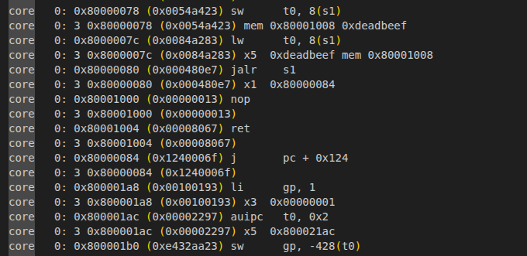
Case 2 – WITH SMEPMP (#define SMEPMP enabled)
- (#define SMEPMP commented)
- (#define NO_SMEPMP uncommented)
Before configuring PMP:
- li t0, (1 << 2)
- csrw mseccfg, t0
This sets:
- mseccfg.RLB = 1
What RLB Does
Rule Lock Bypass allows:
- Modification of locked PMP entries.
Expected Behavior
- Configuration change succeeds.
- Readback matches new value.
- Region becomes Read-only.
- Write and Execute cause traps.

Access Results
Operation | Result
Write | Store Access Fault
Read | Success
Execute | Instruction Access Fault
Trap handler confirms:
- mcause = 1 -> Instruction fault
- mcause = 7 -> Store fault
Final Output
PASS (gp = 1)
Spike Log Snapshot:
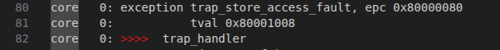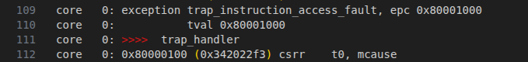
Reference to Specification
RISC-V Privileged Architecture Specification
- Section 3.1.15 - mcause
  - Instruction page fault = 12
  - Load page fault = 13
  - Store/AMO page fault = 15
- Section 3.7:PMP Section - Physical Memory Protection CSRs
- Section 3.7.1:PMP Section - Address matching and L-bit behavior
- SMEPMP Spec Chapter 2: Proposal behavior of bit 2

