Apartment Management System Report

I plan to build an apartment management system where only apartment managers have a membership and apartment managers can make changes on the page of their apartments. I want to make a system where residents can see information about the apartment after entering the site and choosing their own apartment.

The requirements:

Home page.

Login Page .

Register Page.

Apartment list page.

Apartment dues list page.

Apartment gallery page.

Announcement page.

Can be improved…

The use case:

In home page you can see login and register buton and also you can use it.

In home page you can see gallery of the apartment.

In home page you can see dues list of apartment.

If you use login or register button you redirect the login and register page.

After register you can login the page.

After login you can update the dues list and apartment gallery.

After login you can logout.

Screenshots and Explanations:

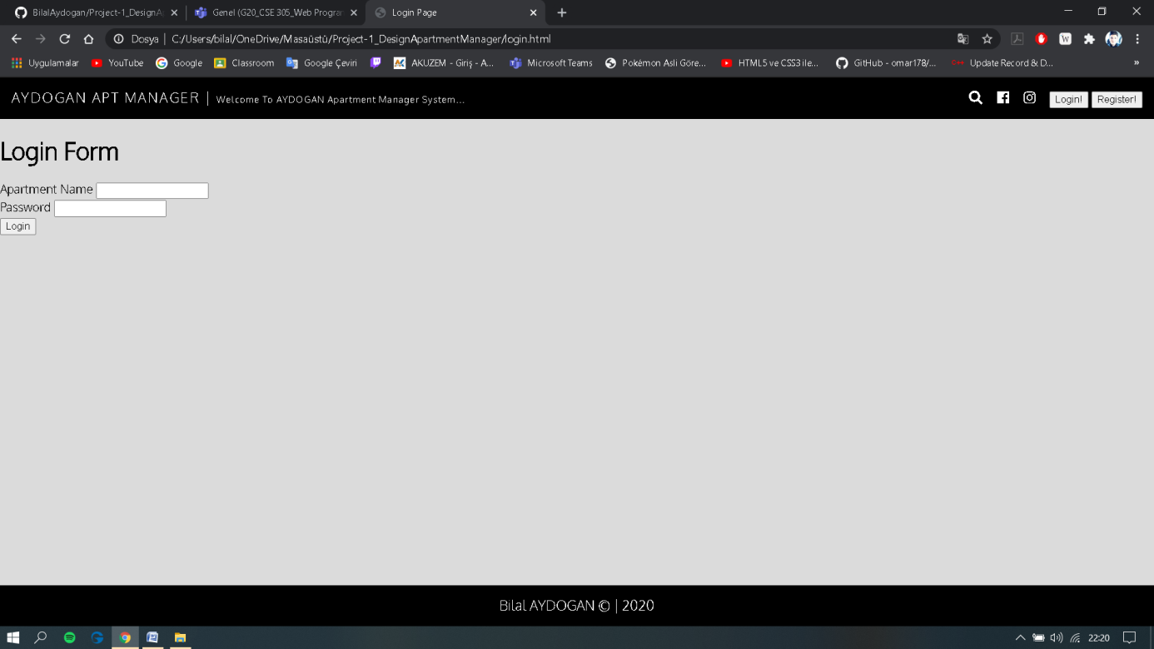

This page shows the login page(the page will be updated(with css and bootstrap)).

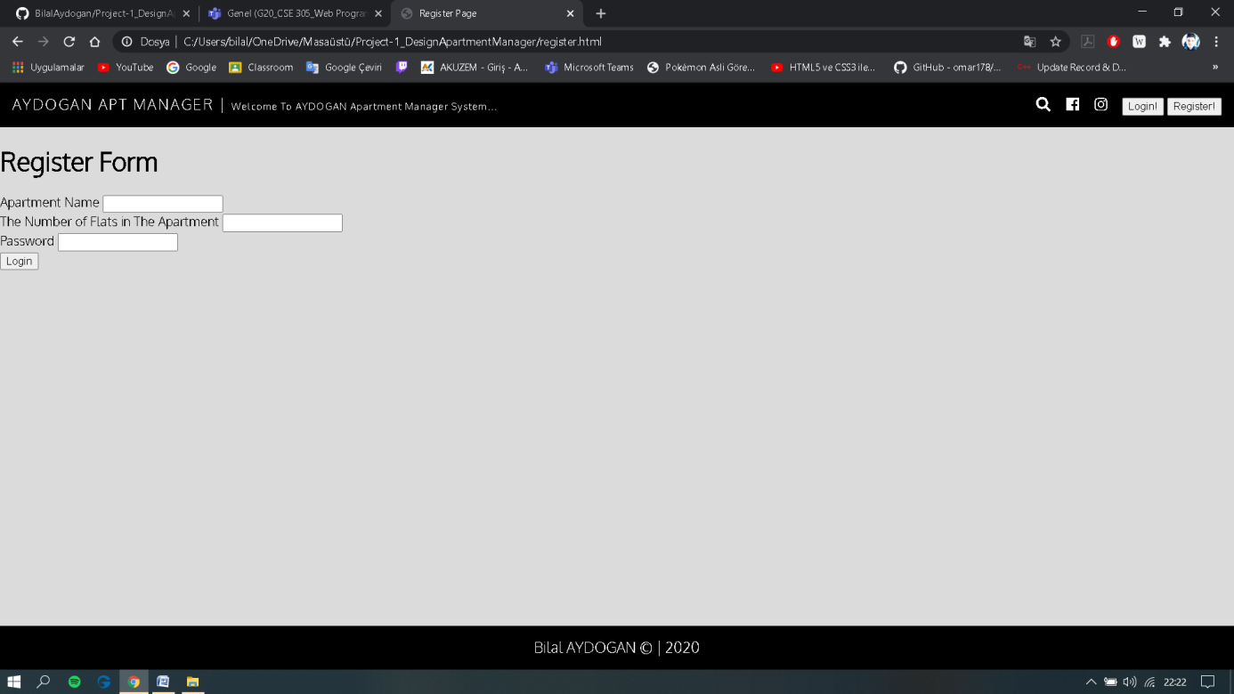

This page shows the register page(the page will be updated(with css and bootstrap).

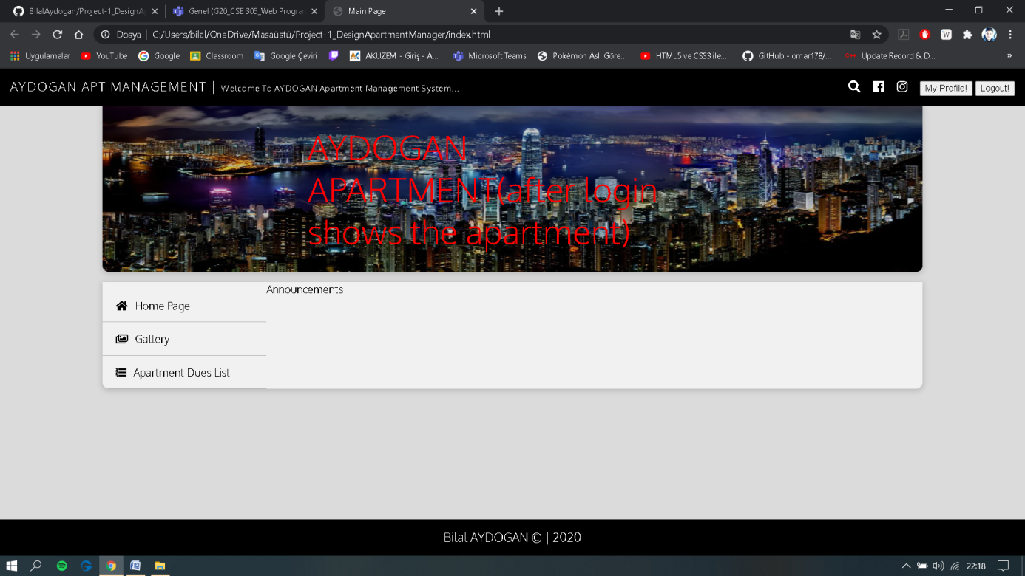

This screenshots shows that you can update the gallery and apartment dues list.

Also you can update the announcements.

The website and report will improve over time.