Graph Interpretations Report

# Income Distribution Histogram

This histogram illustrates the spread of income values across the dataset. If a particular income range has a high frequency, it suggests that many individuals earn within that bracket. In contrast, a uniform distribution might indicate an even spread of income values.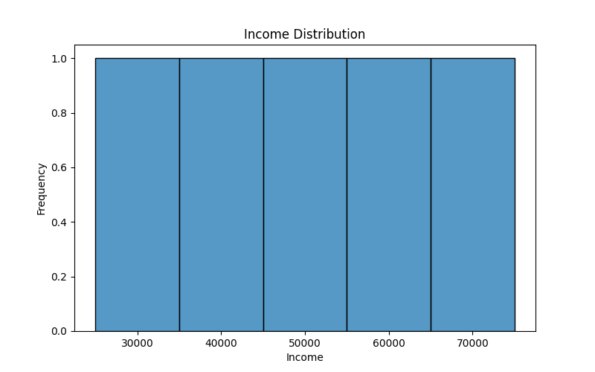

# Monthly Sales Comparison

The line plot comparing monthly sales of two products showcases their performance over time. Differences in trends can highlight shifts in consumer demand, revealing periods of high or low sales for either product.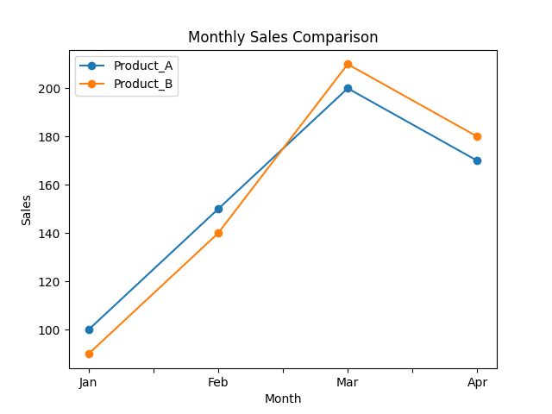

# Math vs Science Scatter Plot

This scatter plot shows the relationship between Math and Science scores. A clustering of points along an upward-sloping line suggests that higher math scores tend to be associated with higher science scores, indicating a potential positive correlation.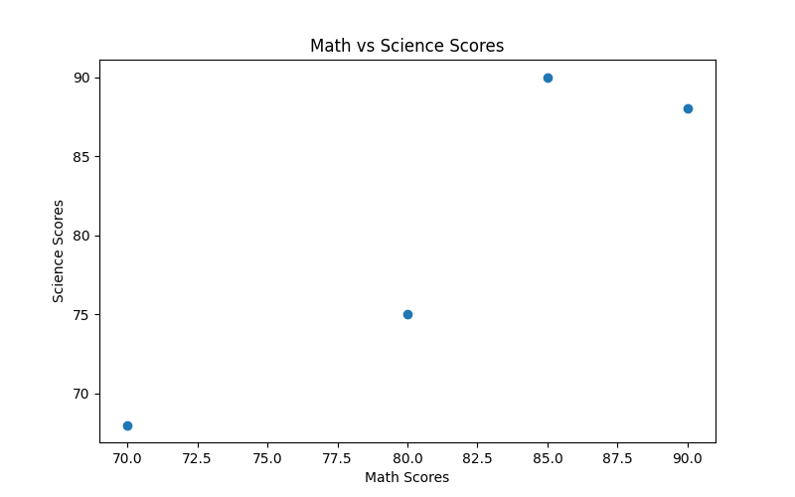

# Jointplot (Scatter with Marginal Histograms)

A jointplot includes both a scatter plot and marginal histograms, providing a comprehensive view of data distribution and relationships. The scatter plot in the center depicts the bivariate relationship, while the histograms on the sides show the univariate distributions.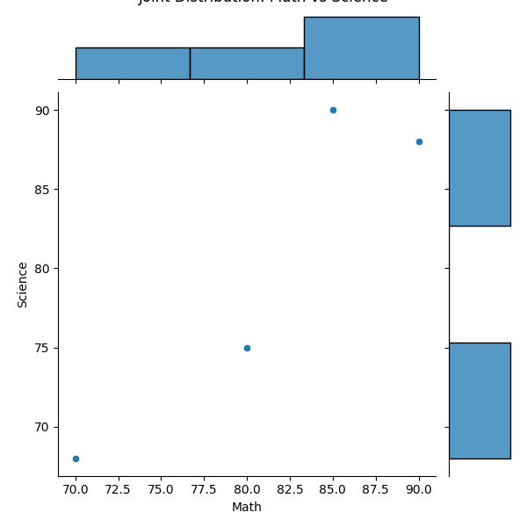

# Income Boxplot by Job

The boxplot visualizes income variations across different job categories, displaying median income, quartiles, and possible outliers. This helps in comparing income variability and central tendencies among job groups.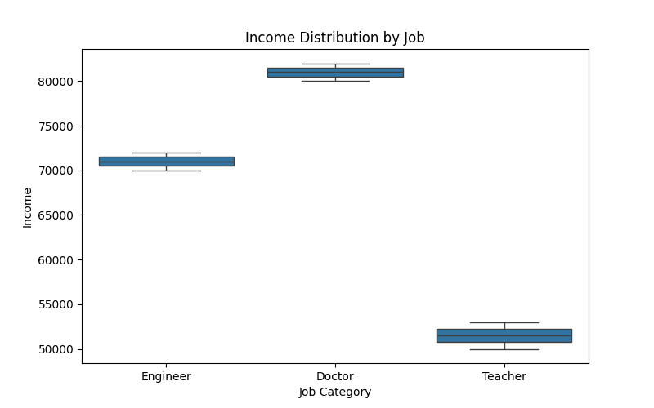

# Product Preference Count Plot by Gender

This count plot displays the frequency of product preferences separated by gender. It highlights any disparities in product popularity between different gender groups.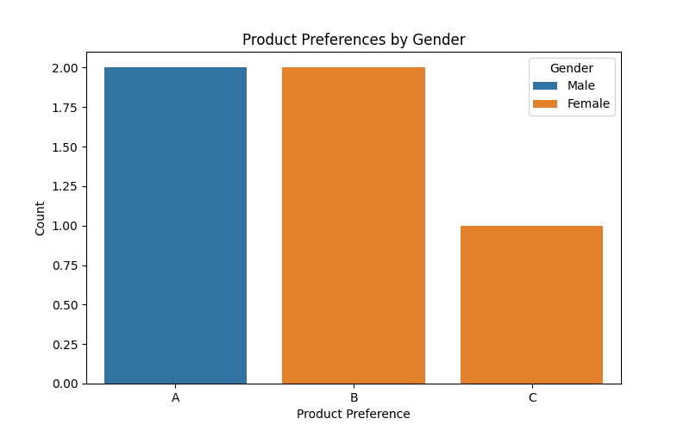

# Correlation Heatmap

The correlation heatmap uses color intensity to represent the strength and direction of linear relationships between variables. Cells with strong positive or negative correlations are highlighted with deeper colors, while weaker correlations appear lighter. This visualization is valuable for identifying redundant features or potential multicollinearity.