**Please explain pickup and Delivery Helper**

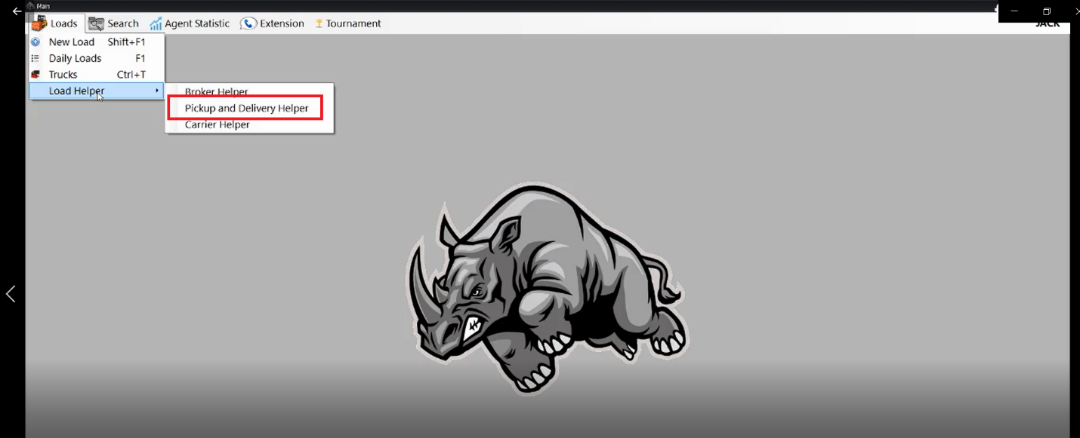

Please explain “**Credit Check”** for load

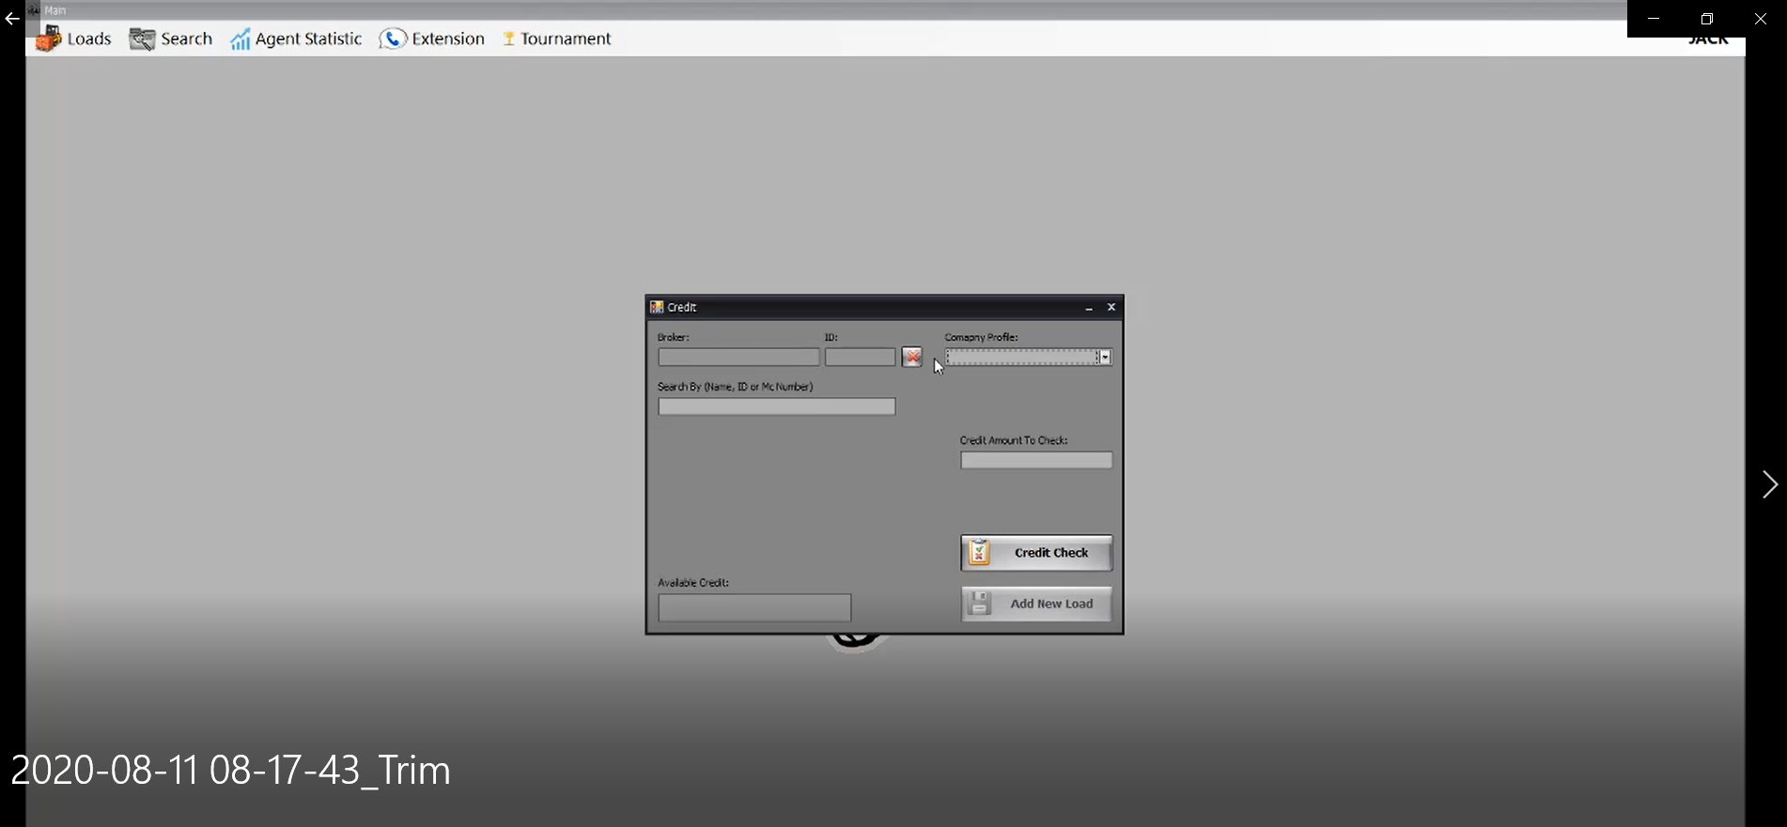

**Charges Section**

Please explain **“BY”** Column in below detail **(Charges Section)**

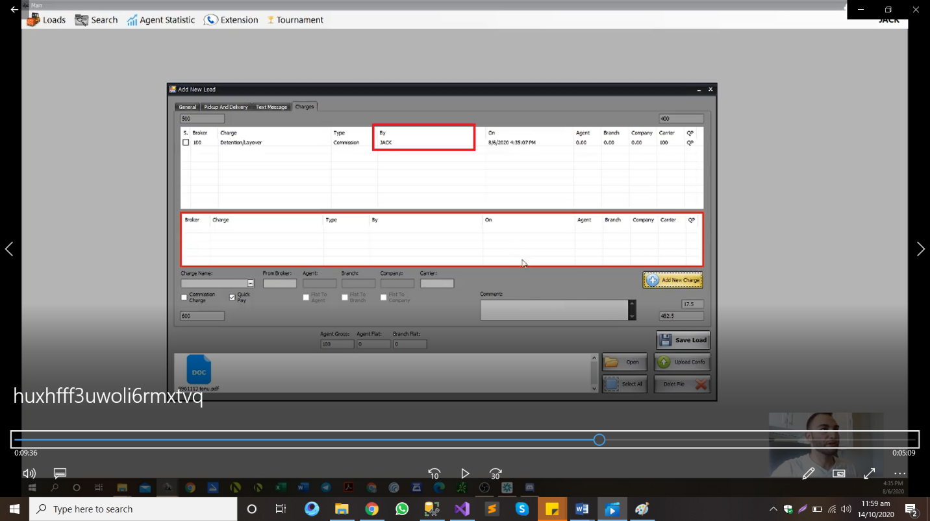

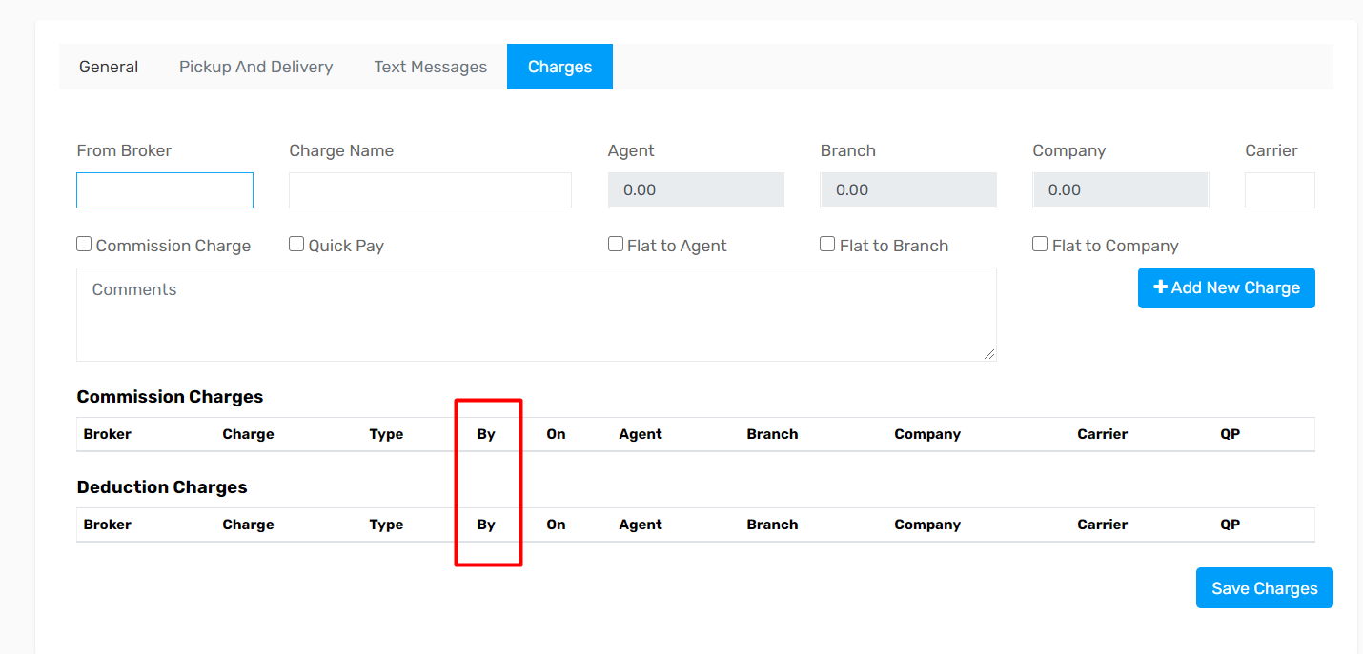

1. **Please confirm below hierarchy**

Country 🡪Zone 🡪State 🡪City

**For Example**

|  |  |  |  |
| --- | --- | --- | --- |
| **Country** | **Zone Name** | **State Name** | **City** |
| United States | Zone 0 | NH, ME, VT, MA, RI, CT, NJ | (cities will under each state?) |
| United States | Zone 1 | NY, PA DE |  |
| United States | Zone 2 | SC, VA, NC, WV, MD, DC |  |
| United States | Zone 3 | MS, AL, TN, GA, FL |  |
| United States | Zone 4 | MI, IN, OH, KY |  |
| United States | Zone 5 | MT, ND, SD, MN, IA, WI |  |
| United States | Zone 6 | NE, KS, MO, IL |  |
| United States | Zone 7 | TX, OK, AR, LA |  |
| United States | Zone 8 | NV, ID, UT, WY, CO, AZ, NM |  |
| United States | Zone 9 | CA, OR, WA |  |

1. Please explain **“Call” column** in below details (Truck Details)

