# LAB1:

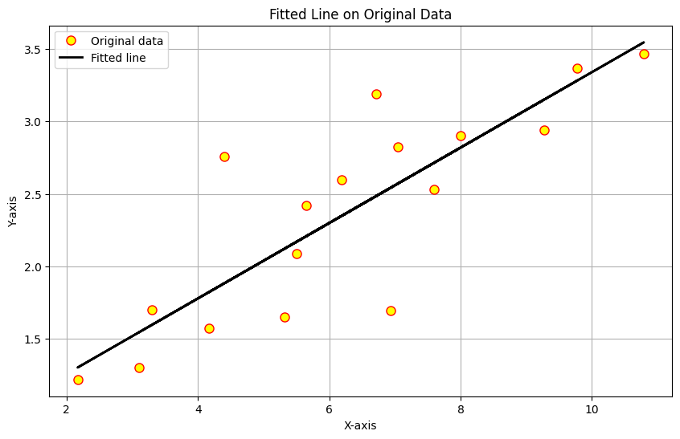

# __________________________________________

# LAB2:

**Task1:** “91”

**Task2:**

Enter SSID: 2315119

0.6960345686960417

0.6960345686960417

# __________________________________________LAB3:

**Model summary:**

Model: "sequential_1"

_________________________________________________________________

Layer (type) Output Shape Param #

=================================================================

flatten_1 (Flatten) (None, 784) 0

dense_3 (Dense) (None, 128) 100480

dense_4 (Dense) (None, 64) 8256

dense_5 (Dense) (None, 10) 650

=================================================================

Total params: 109386 (427.29 KB)

Trainable params: 109386 (427.29 KB)

Non-trainable params: 0 (0.00 Byte)

______________________________________

**Accuracy:** 0.8847

**Task 2:**

Final Predicted Output:

0.889550613969795 0.8003996080673895

Weights:

w1: 0.1426292115450811

w2: 0.2372865501866814

w3: 0.47051684618032436

w4: 0.5491462007467256

w5: 0.7131460577254054

w6: 0.786432750933407

w7: 0.6984692974318825

w8: 0.7984562338574279

w9: 0.8976344195574385

w10: 0.0976142308304555

Biases:

b1: 0.495359734641656

b2: 0.4960508500433624

# __________________________________________

# LAB 4:

**Model Sumary:**

Model: "sequential_9"

_________________________________________________________________

Layer (type) Output Shape Param #

=================================================================

dense_29 (Dense) (None, 152) 3040

dense_30 (Dense) (None, 114) 17442

dense_31 (Dense) (None, 76) 8740

dense_32 (Dense) (None, 19) 1463

dense_33 (Dense) (None, 1) 20

=================================================================

Total params: 30705 (119.94 KB)

Trainable params: 30705 (119.94 KB)

Non-trainable params: 0 (0.00 Byte)

_________________________________________________________________

**Model Loss:**

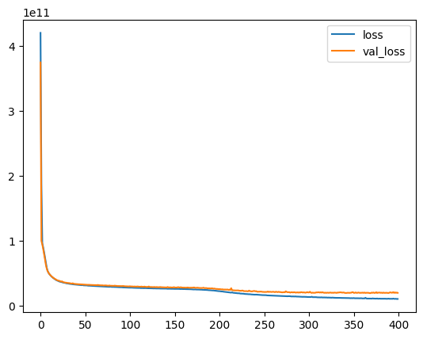

# _________________________________________

# LAB5:

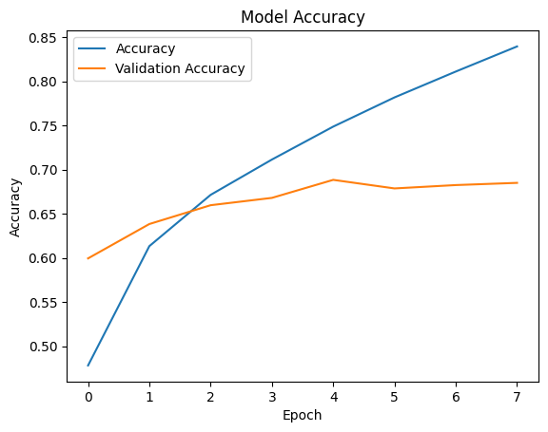

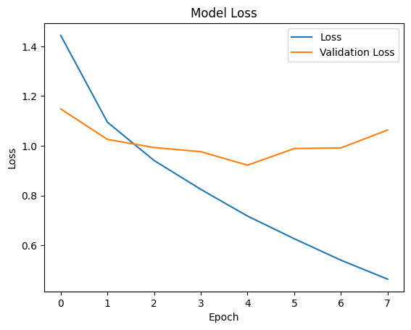

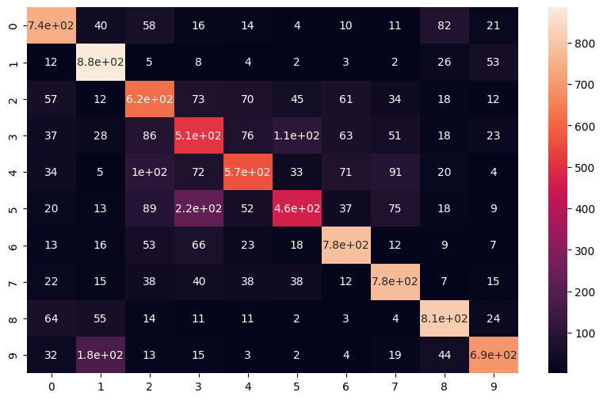

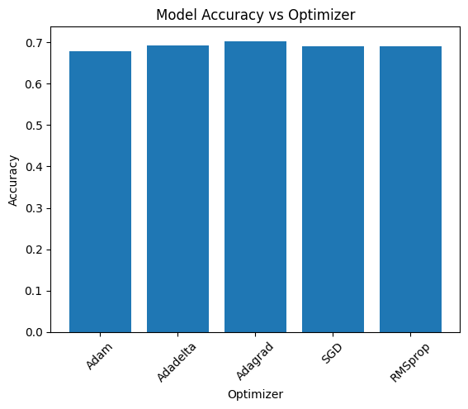

# _________________________________________

# LAB6:

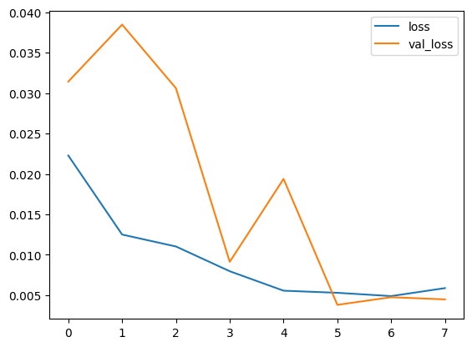

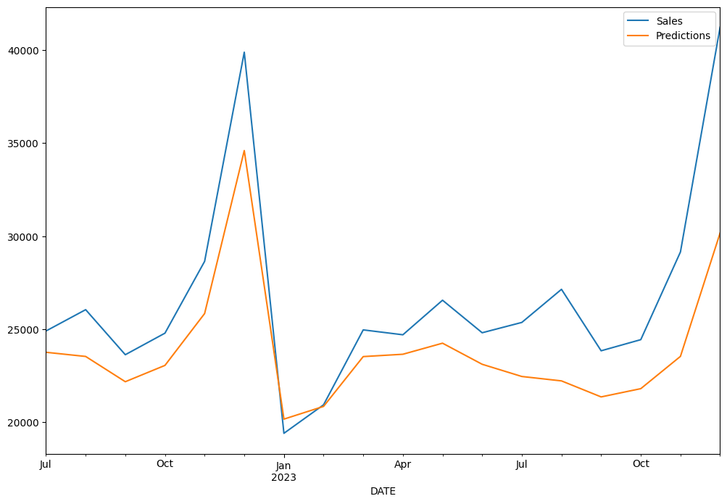

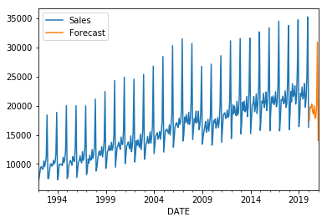

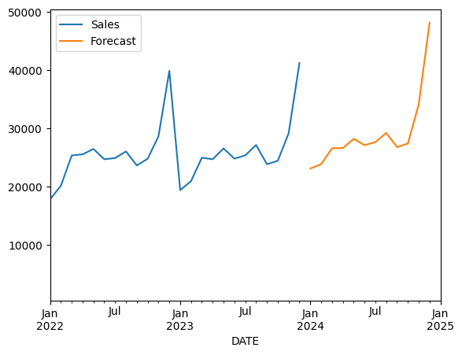

# _________________________________________

# LAB7:

**Encoder**:

Model: "sequential_20"

_________________________________________________________________

Layer (type) Output Shape Param #

=================================================================

flatten_7 (Flatten) (None, 784) 0

dense_40 (Dense) (None, 400) 314000

dense_41 (Dense) (None, 200) 80200

dense_42 (Dense) (None, 100) 20100

dense_43 (Dense) (None, 50) 5050

dense_44 (Dense) (None, 25) 1275

=================================================================

Total params: 420625 (1.60 MB)

Trainable params: 420625 (1.60 MB)

Non-trainable params: 0 (0.00 Byte)

_________________________________________________________________

**Decoder**:

Model: "sequential_21"

_________________________________________________________________

Layer (type) Output Shape Param #

=================================================================

dense_45 (Dense) (None, 50) 1300

dense_46 (Dense) (None, 100) 5100

dense_47 (Dense) (None, 200) 20200

dense_48 (Dense) (None, 400) 80400

dense_49 (Dense) (None, 784) 314384

reshape_8 (Reshape) (None, 28, 28) 0

=================================================================

Total params: 421384 (1.61 MB)

Trainable params: 421384 (1.61 MB)

Non-trainable params: 0 (0.00 Byte)

_________________________________________________________________

**Autoencoder:**

Model: "sequential_22"

_________________________________________________________________

Layer (type) Output Shape Param #

=================================================================

sequential_20 (Sequential) (None, 25) 420625

sequential_21 (Sequential) (None, 28, 28) 421384

=================================================================

Total params: 842009 (3.21 MB)

Trainable params: 842009 (3.21 MB)

Non-trainable params: 0 (0.00 Byte)

_________________________________________________________________

**TASK 2:**

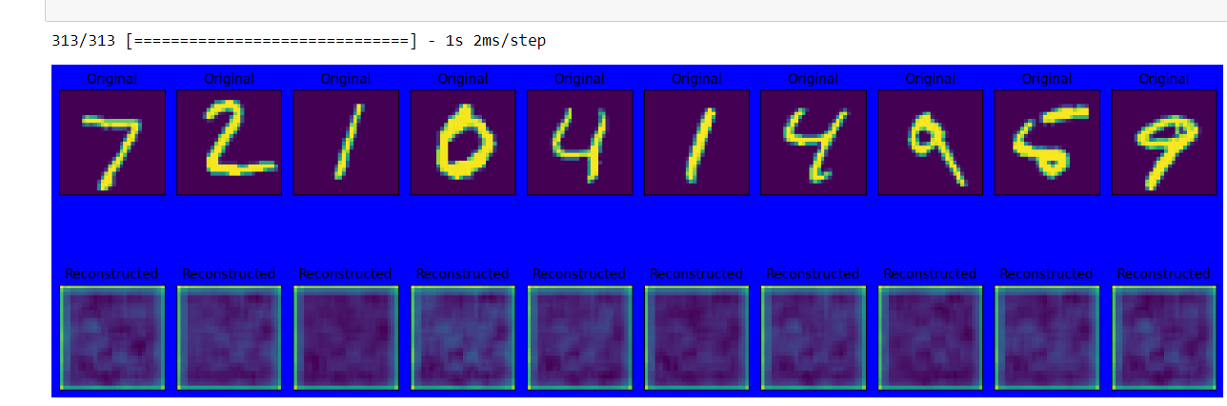

# _________________________________________

# LAB8:

EPOCH 19:

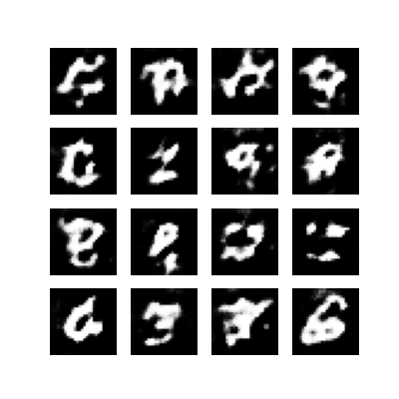

# _________________________________________

# LAB9:

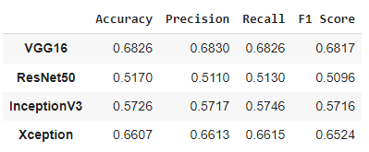

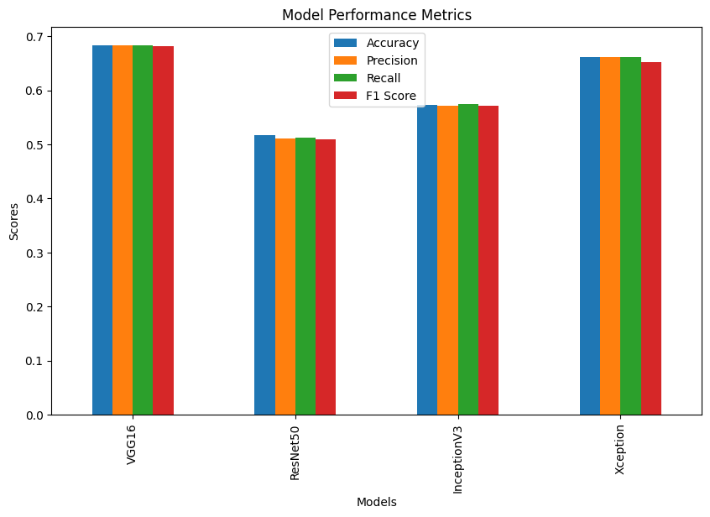

# _________________________________________

# LAB10:

