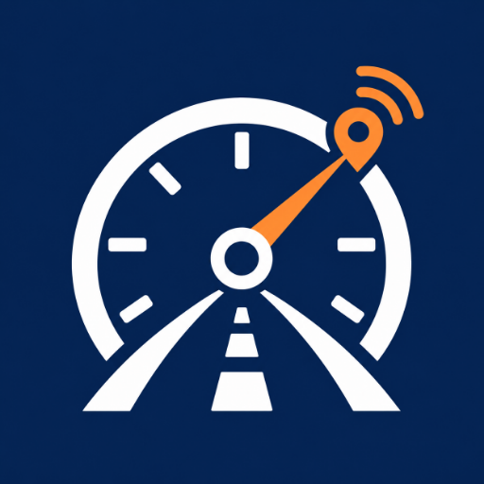

Google Play Store Listing
  - ServicePing · English (United States) · Release 1.0.0
DRAFT · Replace the temporary contact email before publication.

Store identity
App name: ServicePing: Vehicle Tracker
Default language: English (United States), en-US
App type: App
Category: Auto & Vehicles
Package identifier: com.serviceping.service_ping
Version: 1.0.0 (build 1)

Short description
Track car and motorcycle maintenance, service costs and mileage. Works offline.

Full description
Keep every journey ready with ServicePing — your offline vehicle maintenance tracker for cars and motorcycles.
Build a clear picture of your garage, from the last oil change to the next service date. Manage multiple vehicles, log maintenance and track expenses without creating an account.
YOUR WHOLE GARAGE, IN ONE PLACE
Add cars and motorcycles with their own service records, mileage and maintenance schedules. Save manufacturer, model and optional year and registration details. Choose kilometres or miles for each vehicle.
RECORD THE WORK THAT MATTERS
Log oil changes, air filters, tires, brakes, batteries, general servicing or a custom service type. Add the service date, odometer reading, cost and notes. Edit records when details change.
PLAN YOUR NEXT SERVICE
Set a next service date, an odometer target, or both. Maintenance becomes due when either threshold is reached. See the remaining distance and identify overdue work. Enable local notifications for date-based reminders on the days you choose.
MILEAGE YOU CONTROL
Update the odometer manually and keep a history of readings. Decrease protection helps prevent accidental lower entries. ServicePing checks mileage-based maintenance status when you update the reading; it does not automatically detect vehicle mileage.
A HISTORY YOU CAN FIND
Search service records and filter by vehicle and service type. See the mileage and cost of each service, plus the total for the records in view. Recording a completed scheduled service preserves the work in your history.
UNDERSTAND YOUR MAINTENANCE COSTS
View total expenses, completed services, the most recent service and upcoming maintenance. Explore a simple monthly maintenance cost chart for the last six months. Costs use the amounts you enter; the app does not convert currencies.
OFFLINE BY DESIGN
Your garage is stored on your device. No login, no ads and no cloud account are required. Choose light, dark or system appearance.
GOOD TO KNOW
• Odometer readings are always entered manually.
• Date notification delivery depends on device permissions and operating-system settings. The nearest 64 future reminders are queued and refilled when you reopen the app.
• No new maintenance interval is generated automatically.
• There is no cloud backup, cross-device sync or account recovery. Removing the app or clearing its data removes local records; device-level backups follow system settings.
• ServicePing organizes your records and reminders; follow your vehicle manufacturer's maintenance guidance.
Make the next service easier to remember, and every past service easier to find.

Release notes — 1.0.0
Welcome to ServicePing 1.0!
• Manage cars and motorcycles offline.
• Log service records and maintenance costs.
• Set date and mileage service targets.
• Update your odometer manually and keep its history.
• Explore maintenance statistics in light or dark mode.

Contact and policy fields
Support email: support@serviceping.example — TEMPORARY; replace before submission.
Privacy policy URL: REPLACE_WITH_PUBLIC_HTTPS_PRIVACY_POLICY_URL.
Developer website: optional; leave blank until you have a live support site.
Developer display name, legal identity and required account contact details: use your verified Play Console information.

Upload assets
App icon: branding/app-icon-512.png (512 × 512, opaque RGBA PNG).
Feature graphic: branding/feature-graphic-1024x500.png (1024 × 500, RGB PNG).
Phone screenshots: screenshots/play-store/01-dashboard.png through 07-dark-mode.png, in numbered order (each 1080 × 1920, RGB PNG).
Original real Flutter captures: screenshots/raw/ (for reference; do not substitute for the numbered store layouts).

App access and content facts
All app features are available without sign-in, an invitation, a payment or a remote account. No reviewer credentials are required. The app has no ads, purchases, user chat, public user-generated content, violence, gambling or sexual content. Suggested target audience: people aged 16 and over managing cars or motorcycles; choose the actual intended audience in Play Console. Complete the official content-rating questionnaire; the store determines the final rating. Suggested pricing: free for this version, subject to your own pricing decision.

Data safety — current build
No user data is transmitted off-device by the app or shared with the developer or third parties. Local vehicle details, readings, service costs, notes and schedules are processed on-device. No login, ad SDK, analytics SDK or automatic mileage sensor is present. This assessment applies to the current source and dependencies; recheck it if you add network services or other SDKs. Follow the separate data-safety-guide.md for the form.

Before uploading
Replace the temporary email in store/source/policy.json, set contact_is_placeholder to false, regenerate the documents, rebuild the app and verify the in-app policy. Host the HTML privacy policy at a public HTTPS URL and paste that live URL into Play Console. A DOCX/PDF or GitHub source-file page does not replace the required hosted policy webpage. Upload a signed release AAB; the debug APK is for testing. The generated screenshots contain fictional demo data and are not seeded into the production app.

