# NewsBridge Project Report

## Introduction

Welcome to **NewsBridge**, a comprehensive news aggregator platform designed to provide users with the latest news and insights from various categories and regions. This platform aims to create an engaging and user-friendly experience, allowing users to access breaking news, explore articles by category, and search for specific topics with ease.

## Table of Contents

* Introduction
* Project Overview
* Features
* Installation
* Technologies Used
* Key Improvements
* Future Enhancements
* Contributing
* Visit the App

## Project Overview

The name **NewsBridge** encapsulates the platform's core mission: to bridge the gap between users and the wealth of information available in the news landscape. By simplifying access to news, **NewsBridge** empowers users to stay informed and engaged in today's fast-paced world. This platform connects readers with diverse and accurate news stories from around the globe, making it easier to navigate through the vast sea of information.

## Features

### Home Page

* **Breaking News Display**: The home page prominently features breaking news in card format, complete with headlines, summaries, and publication times. Users can click **Read More** to access full articles, ensuring they stay updated on the latest events.

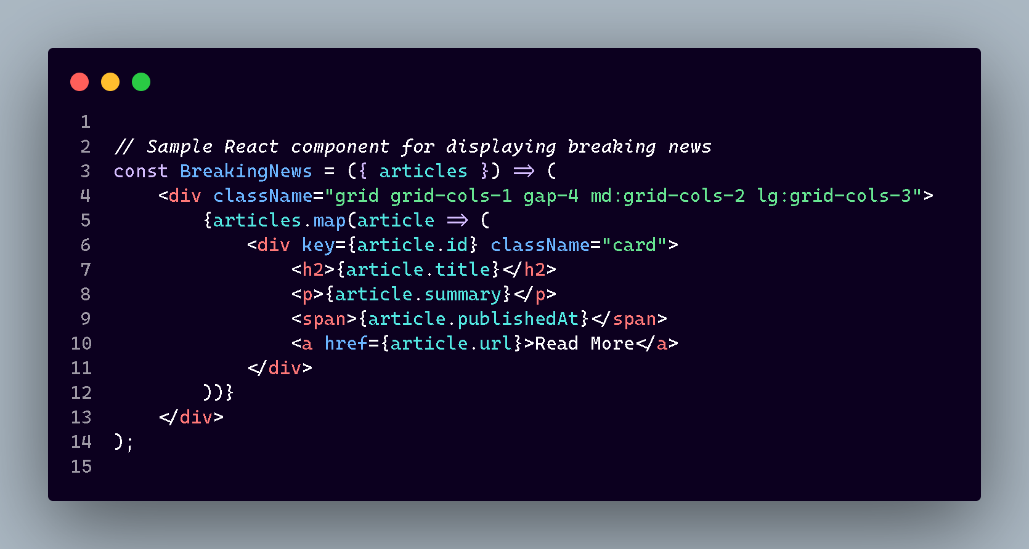

### Category Page

* **Categorized News**: News articles are categorized by various topics, making it easy for users to find specific content. Each category link is shareable, with the state updated in the URL query parameters.

### Search Page

* **Topic Search**: Users can search for articles on specific topics. The search results include publication times, and clicking **Read More** opens the complete article for in-depth reading.

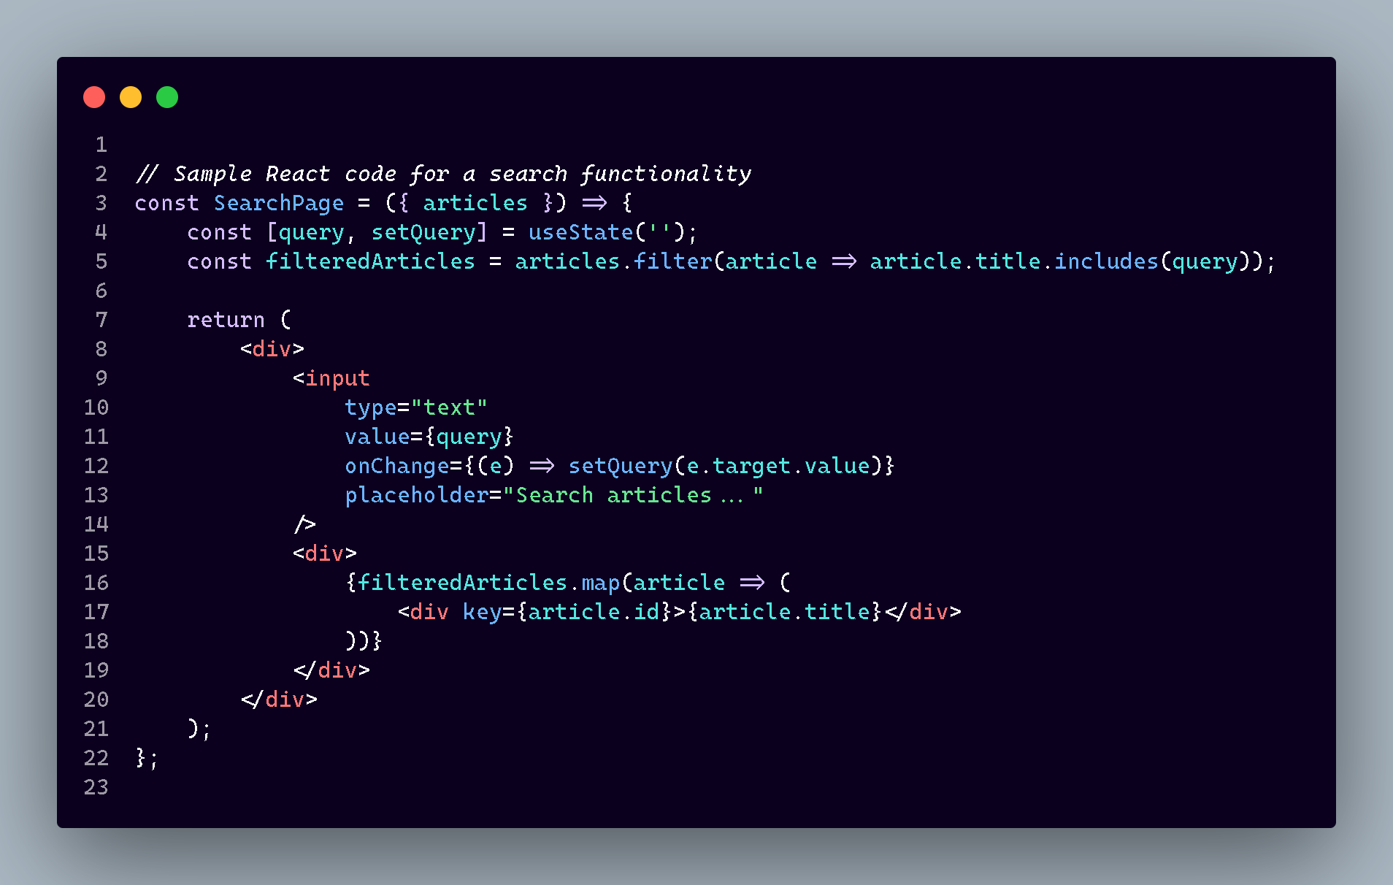

### About Us Page

* **Our Team**: This section introduces the dedicated team behind **NewsBridge**, providing insights into their expertise and commitment to delivering quality content.
* **Our Mission**: The mission of **NewsBridge** is to empower individuals with accurate and timely information sourced from multiple trusted outlets.
* **Why We Aggregate**: The platform aggregates news from various reputable sources, offering diverse perspectives on important topics.
* **Trusted Sources**: Emphasis is placed on collecting news from reliable publications, ensuring accuracy and trustworthiness in every article.
* **Meet the Team**: This section introduces the journalists and editors committed to delivering the best content for users.

### Contact Page

* **Feedback Form**: Users can share their thoughts, feedback, and ideas through an accessible feedback form.
* **Social Media Links**: The platform connects with its audience through various social media channels, including Facebook, Instagram, LinkedIn, and X (formerly Twitter).
* **Subscribe Button**: A subscription feature allows users to sign up for notifications and updates.

### Theme and Language Configuration

* **Theme Selector**: Users can personalize their experience by selecting from multiple themes, including options such as 'night', 'light', 'corporate', and 'synthwave'. This customization is stored in local storage for convenience.

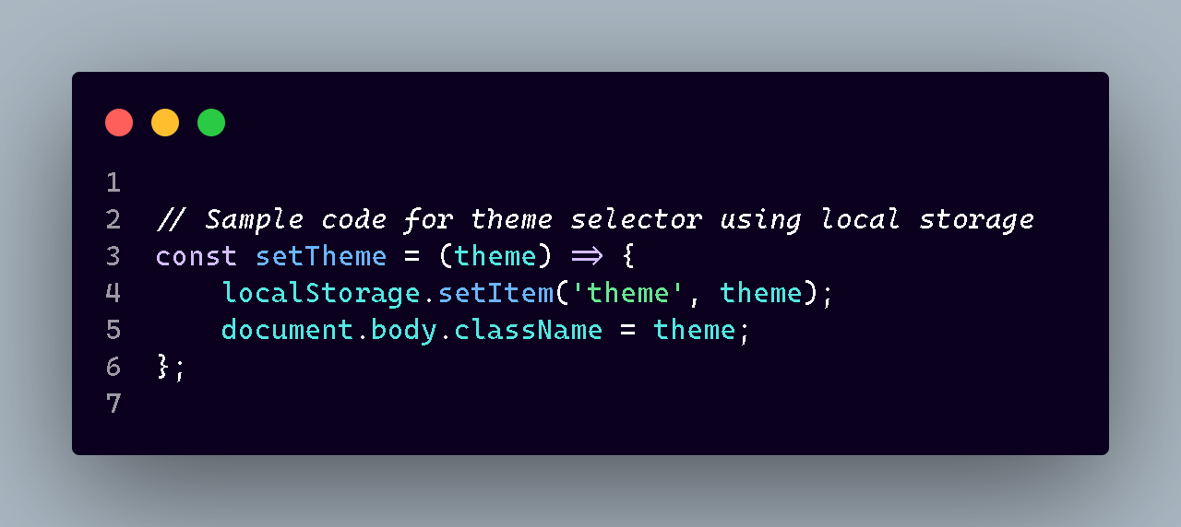

* **Language Options**: The platform currently supports English in its free version, with plans to expand language offerings in the future.
* **Country Selection**: At this stage, users can focus on news from the United States, with future expansions planned.
* **Source Selection**: While currently disabled, users will eventually be able to choose their preferred news sources, such as BBC, CNN, and Al Jazeera.

## Installation

To set up the platform locally, follow these steps:

1. **Clone the repository**:

git clone https://github.com/your-username/news-aggregator-platform.git

1. **Navigate into the project directory**:

cd news-aggregator-platform

1. **Install dependencies**:

npm install

## Technologies Used

* **React.js**: The frontend library used for building dynamic user interfaces.
* **Vite**: A fast development tool that enhances the development experience.
* **Tailwind CSS**: A utility-first CSS framework that provides styling flexibility.
* **React Router**: Used for managing navigation and routes throughout the application.
* **React Icons**: This library enables the integration of customizable icons into the UI.
* **DaisyUI**: A Tailwind CSS plugin offering pre-designed components for rapid development.

## Key Improvements

* **Clear Organization**: The report is organized logically, aiding in quick information retrieval.
* **Concise Language**: Descriptions have been simplified for clarity while retaining essential details.
* **Local Storage Note**: The report includes an explanation of local storage usage for theme selection.
* **Consistent Formatting**: The use of markdown formatting enhances readability and professionalism.

## Future Enhancements

* **User Authentication**: Implement user authentication for personalized news experiences and to save preferences across devices.
* **Mobile Optimization**: Further improve mobile responsiveness for a better user experience on smartphones and tablets.
* **Enhanced Search Functionality**: Develop advanced filtering options in the search page to allow users to narrow down results by date, category, and source.
* **Real-time Updates**: Integrate real-time news updates to keep users informed instantly as news breaks.

## Contributing

The **NewsBridge** project is open for contributions from the community. Developers and users are encouraged to open issues, fork the repository, and submit pull requests to enhance the platform's functionality and user experience.

## Visit the App

You can access the live version of NewsBridge by visiting [NewsBridge Live](http://your-website-link.com). Explore the latest news, categories, and share articles with your community!