Journal of Cyber Security and Risk Auditing

https://www.jcsra.thestap.com/





Enhanced Security for Wireless Sensor Networks Through Lightweight Machine Learning-Based Anomaly Detection and Attack Classification
Mohammed Fakhrulddin Abdulqader¹ , Qasim Mustafa Zainel², Adnan Yousif Dawod^{3,*}, , Saadaldeen Rashid Ahmed^{4,5}, Fahmid Al Farid⁶, Maruf Al Hossain Prince ⁷, Mohd Nizam Husen, ^{8*},Abu Saleh Musa Miah, ^{8,9*}
¹University of Kirkuk, College of Computer Science and Information Technology, Kirkuk 36001, Iraq
²University of Kirkuk, College of Physical Education and Sport Science, Kirkuk 36001, Iraq
³University of Kirkuk, College of Nursing, Kirkuk 36001, Iraq
⁴Al-Ayen University, College of Engineering, Artificial Intelligence Engineering Department, Thi-Qar 64006, Iraq
⁵Bayan University, Department of Computer Science, Erbil, Kurdistan 44001, Iraq
⁶Berlin School of Business and Innovation, Faculty of Computer Science and Informatics, Berlin 12043, Germany
⁷Bangladesh Army University of Science and Technology, Department of Computer Science and Engineering, Saidpur 5220, Bangladesh
⁸Universiti Kuala Lumpur, Malaysian Institute of Information Technology (UniKL MIIT), Kuala Lumpur 50250, Malaysia
⁹University of Rajshahi, Department of Computer Science and Engineering, Rajshahi 6205, Bangladesh

Article details

Article History
Received: 17-03-2025 Revised: 30-05-2025 Accepted: 11-08-2025
Published: 12-08-2025

Vol.2025, No.3

DOI:

*Corresponding author. Email: mnizam@unikl.edu.my, musa.cse@ru.ac.bd adnanalshef@uokirkuk.edu.iq

Orcid:

Open-access article distributed under the Creative Commons Attribution 4.0 licence (http://creativecommons.org/licenses/by/4.0/).
Publisher: STAP.

A B S T R A C T

Cyber-physical systems as varied as patient monitoring, smart factories, precision agriculture, environmental sensing and surveillance now depend on wireless sensor networks (WSNs). The nodes are short of processing power and energy, talk over open radio links and are often left alone in the field, so they make easy targets for attackers and are poorly served by conventional defences. Machine learning (ML) can help to flag abnormal behaviour and to name the attack, yet many published studies rely on one dataset, cover few attack types or test a single model, and only a handful check whether the model would fit on a sensor-class device or work on a different dataset.
The study builds a machine-learning pipeline that spots abnormal behaviour and names the attack in LEACH-based sensor networks. Since we could not obtain a WSN-specific benchmark, we wrote a LEACH simulator, called LEACH-Sim (80 networks, 100 nodes each, 448,294 node-round records, four kinds of attacker), and also used NSL-KDD and UNSW-NB15 as general-purpose benchmarks. Two unsupervised detectors (an isolation forest and an autoencoder) and five supervised classifiers (random forest, SVM, XGBoost, LSTM and k-NN) were trained; the supervised five were then merged by a soft vote whose weights Optuna tuned.
On 24 simulated networks that were unseen in training, the ensemble reaches 99.55% accuracy and 92.94% macro-F1. On NSL-KDD and UNSW-NB15 the macro-F1 is 58.0% and 51.0%, and on neither does the ensemble clearly beat the best single model. The ensemble occupies 24.5 MB and so belongs at the base station or a gateway; the autoencoder needs only 8.9 KB. At ε = 0.10 a transferred FGSM attack lowers ensemble accuracy by 7.6 points. Size and latency were measured on an x86 CPU and not on sensor hardware, and the sensor-network evidence is simulated, so the results should be read as a baseline for further testing on real traffic.

Keywords: Cybersecurity, Wireless Sensor Networks (WSNs), Internet of Things (IoT), Intrusion Detection, Attack Classification, Anomaly Detection, Machine Learning, Ensemble Learning.

How to cite the article

- Introduction
Applications from remote patient care and factory automation to crop monitoring, ecology and surveillance increasingly rely on WSNs. Their appeal lies in low cost, flexible deployment and live data from widely scattered points. The same traits cause trouble: nodes have little processing power and energy, transmit over open radio channels and mostly run without supervision, which leaves them open to many forms of attack.
Compared with an ordinary network device, a sensor node has far less processing power and memory, so full-size security software cannot simply be put on it. What is needed is an IDS [1] that spots abnormal behaviour at low computational cost. Existing safeguards lean on authentication, encryption and rules [2], at times with device identification from hardware and software fingerprints [3], and they can fail against new attacks or against threats that evolve in changing WSN conditions [4].
ML-based detection has attracted interest because learning algorithms can find intricate traffic patterns and single out unusual behaviour [5]. Signature-based systems cope well with attacks they already know but cannot defend against new variants. Anomaly-based systems instead watch for departures from normal behaviour, and their weak point is that harmless fluctuations in legitimate traffic may trigger false alarms [6]. Cutting those false alarms, especially for zero-day attacks, is now a research problem of its own. Learning methods offer a way forward because they derive discriminating features directly from the traffic and so recognise more complex attack patterns.
WSN attacks can strike at the routing, network or application layer [8,9]. The network layer is the most troublesome, since multi-hop forwarding and routing give an attacker many weak points to exploit. A sensible countermeasure depends on which behaviour is at work, which means the detector must separate the attack types from one another and not merely raise an alarm.
ML-based intrusion detection for WSNs has advanced a great deal, but four problems remain. Most studies test their models on only one benchmark dataset, so it is unclear whether what the models learn carries over to other networks. Computational cost is usually measured on a server, and running on constrained devices gets less attention. Most methods use one learning algorithm, which leaves the benefit of combining complementary classifiers in an optimised ensemble poorly understood. Finally, there is little work on how robust ML-based IDSs are in a WSN setting [6, 8].
This paper studies those four problems with a pipeline that detects anomalies and assigns attack classes from cluster-head behaviour in LEACH networks. Five supervised classifiers (SVM, random forest, XGBoost, LSTM and k-nearest neighbours) and two unsupervised detectors (an isolation forest and an autoencoder) are compared on a simulated LEACH data set written for this work and on the NSL-KDD and UNSW-NB15 benchmarks. A soft-voting ensemble with weights tuned by Bayesian search combines the five classifiers. We report results as they came out, including those where the ensemble gives no gain.
Our contributions are as follows.

- A reproducible data set and protocol: LEACH-Sim, a LEACH simulator with four attacker types whose test networks are never seen in training, together with the two public benchmarks NSL-KDD and UNSW-NB15.
- A set of 36 cluster-head features in four groups, reduced to 18 by recursive elimination, with mutual-information and SHAP analyses of what drives the decisions.
- A tuned soft-voting ensemble set against each of its members and against isolation-forest and autoencoder detectors, with an account of where the ensemble helps and where it does not.
- Measured model size and single-sample latency on an x86 CPU, used to argue which components could run on cluster heads and which belong at the base station. No sensor hardware was used.
- A stress test with FGSM and PGD perturbations computed on the LSTM and fed to the other models, plus sweeps over the proportion of malicious nodes and over added packet loss.

The paper continues as follows. Section 2 surveys earlier machine-learning work on WSN intrusion detection, ensembles and adversarial inputs. Section 3 describes the data, preprocessing, features, models, tuning and evaluation protocol. Section 4 presents the results: accuracy, per-class behaviour, resource cost, adversarial sensitivity and what drives the decisions. Section 5 concludes and lists future work.
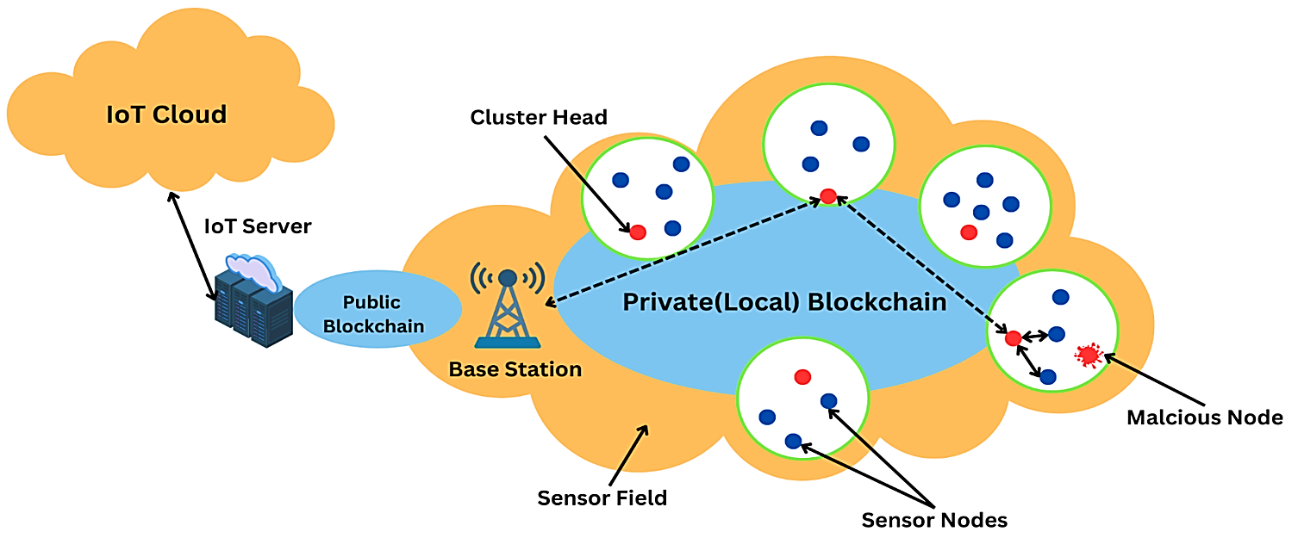
Figure 1. Context only: a sensor network feeding IoT services, with blockchain proposed as a way to keep the data trustworthy. Nothing in this layer was implemented or evaluated here.
Table 1. Typical sensor-node platforms, and the trained models that would fit in each one's flash memory. No board listed here was used in the experiments.
Node | Processor | Speed (MHz) | RAM (KB) | ROM (KB) | Wireless interface | Power source | Models whose stored size fits in ROM
TelosB | TI MSP430F1611 | 8 | 10 | 48 | CC2420, IEEE 802.15.4 | Two AA cells, 3,000 mAh | autoencoder
MicaZ | ATmega128L | 7.3 | 4 | 128 | CC2420, IEEE 802.15.4 | Two AA cells, 3,000 mAh | autoencoder, SVM
Zolertia Z1 | TI MSP430F2617 | 16 | 8 | 92 | CC2420, IEEE 802.15.4 | Two AAA cells, 1,200 mAh | autoencoder
Zolertia RE-Mote | Cortex-M3 (ARM) | 32 | 32 | 512 | IEEE 802.15.4 with BLE | 600 mAh LiPo | autoencoder, SVM, LSTM
ESP32-WROOM-32 | Dual-core Xtensa LX6 | 240 | 520 | 4,096 | Wi-Fi (802.11n) and BLE 5 | 3,000 mAh LiPo | autoencoder, SVM, LSTM, isolation forest, XGBoost
nRF52840-DK | Cortex-M4F (ARM) | 64 | 256 | 1,024 | IEEE 802.15.4 with BLE 5 | 3,400 mAh Li-ion | autoencoder, SVM, LSTM
Raspberry Pi Zero 2 W | Quad-core Cortex-A53 (ARM) | 1,000 | 512,000 | MicroSD | Wi-Fi 802.11 (b, g, n) | 5,000 mAh LiPo | All, incl. ensemble
Build machine (x86-64) | 2 vCPU, x86-64 server core | ∼2,500 | ∼7,000,000 | SSD | None (measurement host) | Mains | All models; the only place latency was measured

- Literature Review

Existing Approaches to Intrusion Detection in WSNs
As ML takes over more of network intrusion detection, two concerns grow: explainability and resistance to tampering. A recent book chapter argues that explainable AI (XAI) makes detectors harder to deceive with adversarial inputs [10]. Surveys of ML security for WSNs [9, 11, 12] describe a trajectory from classical learners such as random forests and SVMs to recurrent and convolutional networks (CNN), and report that WSN-DS and UNSW-NB15 are increasingly used for testing.
A systematic review of deep-learning IDSs for software-defined WSNs finds a shift away from statistical classifiers to deep networks and notes the absence of a standard benchmarking protocol for WSNs [13]. Among simple methods, [14] showed that grouping the training data by clustering before fitting even a plain Naive Bayes model improves anomaly detection, so preparation of the data pays off. Nature-inspired techniques have been tried too: swarm intelligence is used in [15] against dynamic black-hole attacks on WSN routes, in place of statistical or supervised classifiers.
Sequence and graph models have been applied as well. LSTMs trained on UNSW-NB15 for IoT intrusion detection were reported in [16], where recurrent networks coped with modern traffic. Work [17] used graph neural networks for multi-class attack detection and found that reordering the input features gave the graph encoding of the traffic more discriminating power. A lightweight IDS trained by federated learning to resist distributed denial-of-service attacks in smart-city WSNs [18] carries collaborative, privacy-preserving training beyond the usual fog-based IoT setting.
Hierarchical and trust-based designs address security from the deployment side. In [19], aggregator nodes of a hierarchical WSN are chosen according to the past trustworthiness of each node, so routes steer clear of aggregators that are compromised or unreliable. Where IDS nodes should be placed is a question that has been studied apart from the choice of classifier: [6] proposed a congestion-aware rule for picking the WSN nodes that run intrusion detection, which complements trust-based aggregator selection.
Ensembles have proved their worth in nearby security problems. A hybrid of SVM and random forest outperformed each single classifier when detecting malware statically [20]. This invites the question of whether diversity among members also helps network-security classification, and there is evidence that it does.
Ensembles also resist deception attacks better than single models [21]; in that study robustness depends on how far the members disagree, so the choice of members matters.
Wider IoT security problems, namely many attack surfaces, scarce resources and mixed devices, are documented at length in [22] and motivate detection that is flexible and light. Within this broader field, deep multi-class classifiers have been used to prevent multi-layer DDoS and to classify attacks on cloud-connected architectures, much as in conventional network intrusion detection [23].
Networks are naturally graphs, so graph-based learning has drawn interest. Reference [24] embeds traffic relations in a graph neural network to improve detection. Topology is retained well, but such models need detailed knowledge of the network structure, which a dynamic, resource-limited WSN seldom provides.
2.2. Related Work Compared, and the Gap
Table 2 sets representative intrusion and attack-detection studies against the aspects we consider important: multi-class classification, WSN-specific features, evaluation on a device, adversarial tests, cross-validation and ensemble diversity. Four gaps appear. No reviewed study was tested on a WSN-specific benchmark or used WSN topology or protocol features, which is also true of much ML-based intrusion research. Running such models on constrained embedded hardware has barely been studied. Adversarial robustness is rarely examined, though dependable ML-based security needs it. And while ensembles help in malware and general traffic analysis, we found no systematic study of tuned ensembles for WSN intrusion detection. These gaps motivate the present study, which brings together multi-class detection on one simulated WSN dataset and two public benchmarks, WSN-specific cluster-head features, measured model size and latency, white-box adversarial perturbations and a tuned ensemble, and which states plainly where each part is weak (Section 4).
Table 2. Related IDS studies for WSNs and IoT, judged against our evaluation criteria, with their principal weaknesses and the position of the present work.
Ref. | Method | Data | Multi-class | WSN traits | On-device | Adv. tests | CV | Diversity | Main limitation
[14] | Naive Bayes with clustering | General networks | ✗ | ✗ | ✗ | ✗ | ✗ | ✗ | Treats detection as a yes/no anomaly question with a simple classical model and no sensor-network features
[16] | LSTM | UNSW-NB15 | ✗ | ✗ | ✗ | ✗ | ✗ | ✗ | General IoT study; suitability for WSNs not shown
[17] | Graph NN (feature reordering) | General networks | ✓ | ✗ | ✗ | ✗ | ✗ | ✗ | Not WSN-specific; no embedded or adversarial evaluation reported
[19] | Trust-based routing | — | ✗ | ✗ | ✗ | ✗ | ✗ | ✗ | Secures routing through trust scoring; it is not a learned attack classifier
[20] | SVM + RF hybrid | Malware samples | ✗ | ✗ | ✗ | ✗ | ✗ | ✗ | Aimed at malware files, with no network-traffic or WSN focus
[21] | Ensemble of DNNs | General networks | ✗ | ✗ | ✗ | ✓ | ✗ | ✓ | General ensemble-robustness study; neither WSN- nor IDS-specific
[23] | CNN | DDoS traffic in the cloud | ✓ | ✗ | ✗ | ✗ | ✗ | ✗ | Concerns cloud systems rather than WSNs; running on small devices is not discussed
[24] | Graph NN (embedding) | General networks | ✗ | ✗ | ✗ | ✗ | ✗ | ✗ | A general-purpose network IDS; fit for WSNs and for small devices is left open
This work | Soft-voting ensemble | LEACH-Sim + 2 public sets | ✓ | ✓ | ✗ | ✓ | ✗ | ✓ | WSN traits come from simulated data; no on-device test; on NSL-KDD and UNSW-NB15 the ensemble is not better than the best single model

3. Research Methodology
3.1. Outline of the Framework
The framework has four stages. Records from the three data sources are first prepared. Features are then engineered and, for LEACH-Sim, reduced by recursive feature elimination. Next the base learners are trained and tuned on a validation split, and finally their class probabilities are merged by a weighted soft vote that yields the label. Evaluation always uses data the models never saw: whole simulated networks for LEACH-Sim and the official test files for the two public sets.
Seven learners appear in Figure 2: a random forest, an SVM with RBF kernel, XGBoost, an LSTM, k-NN, an isolation forest and an autoencoder. The first five are supervised multi-class classifiers and form the ensemble. The isolation forest and the autoencoder are fitted on normal records only and give an attack-versus-normal score; they are judged by AUC (Table 12) and take no part in the vote. The vote weights come from a TPE search on the validation split (Table 6).
Everything was written in Python with scikit-learn, XGBoost, PyTorch, imbalanced-learn, Optuna and SHAP, using a fixed random seed of 42. The simulator, feature code, training scripts and result files accompany this paper, so each number reported here can be regenerated (see Availability).
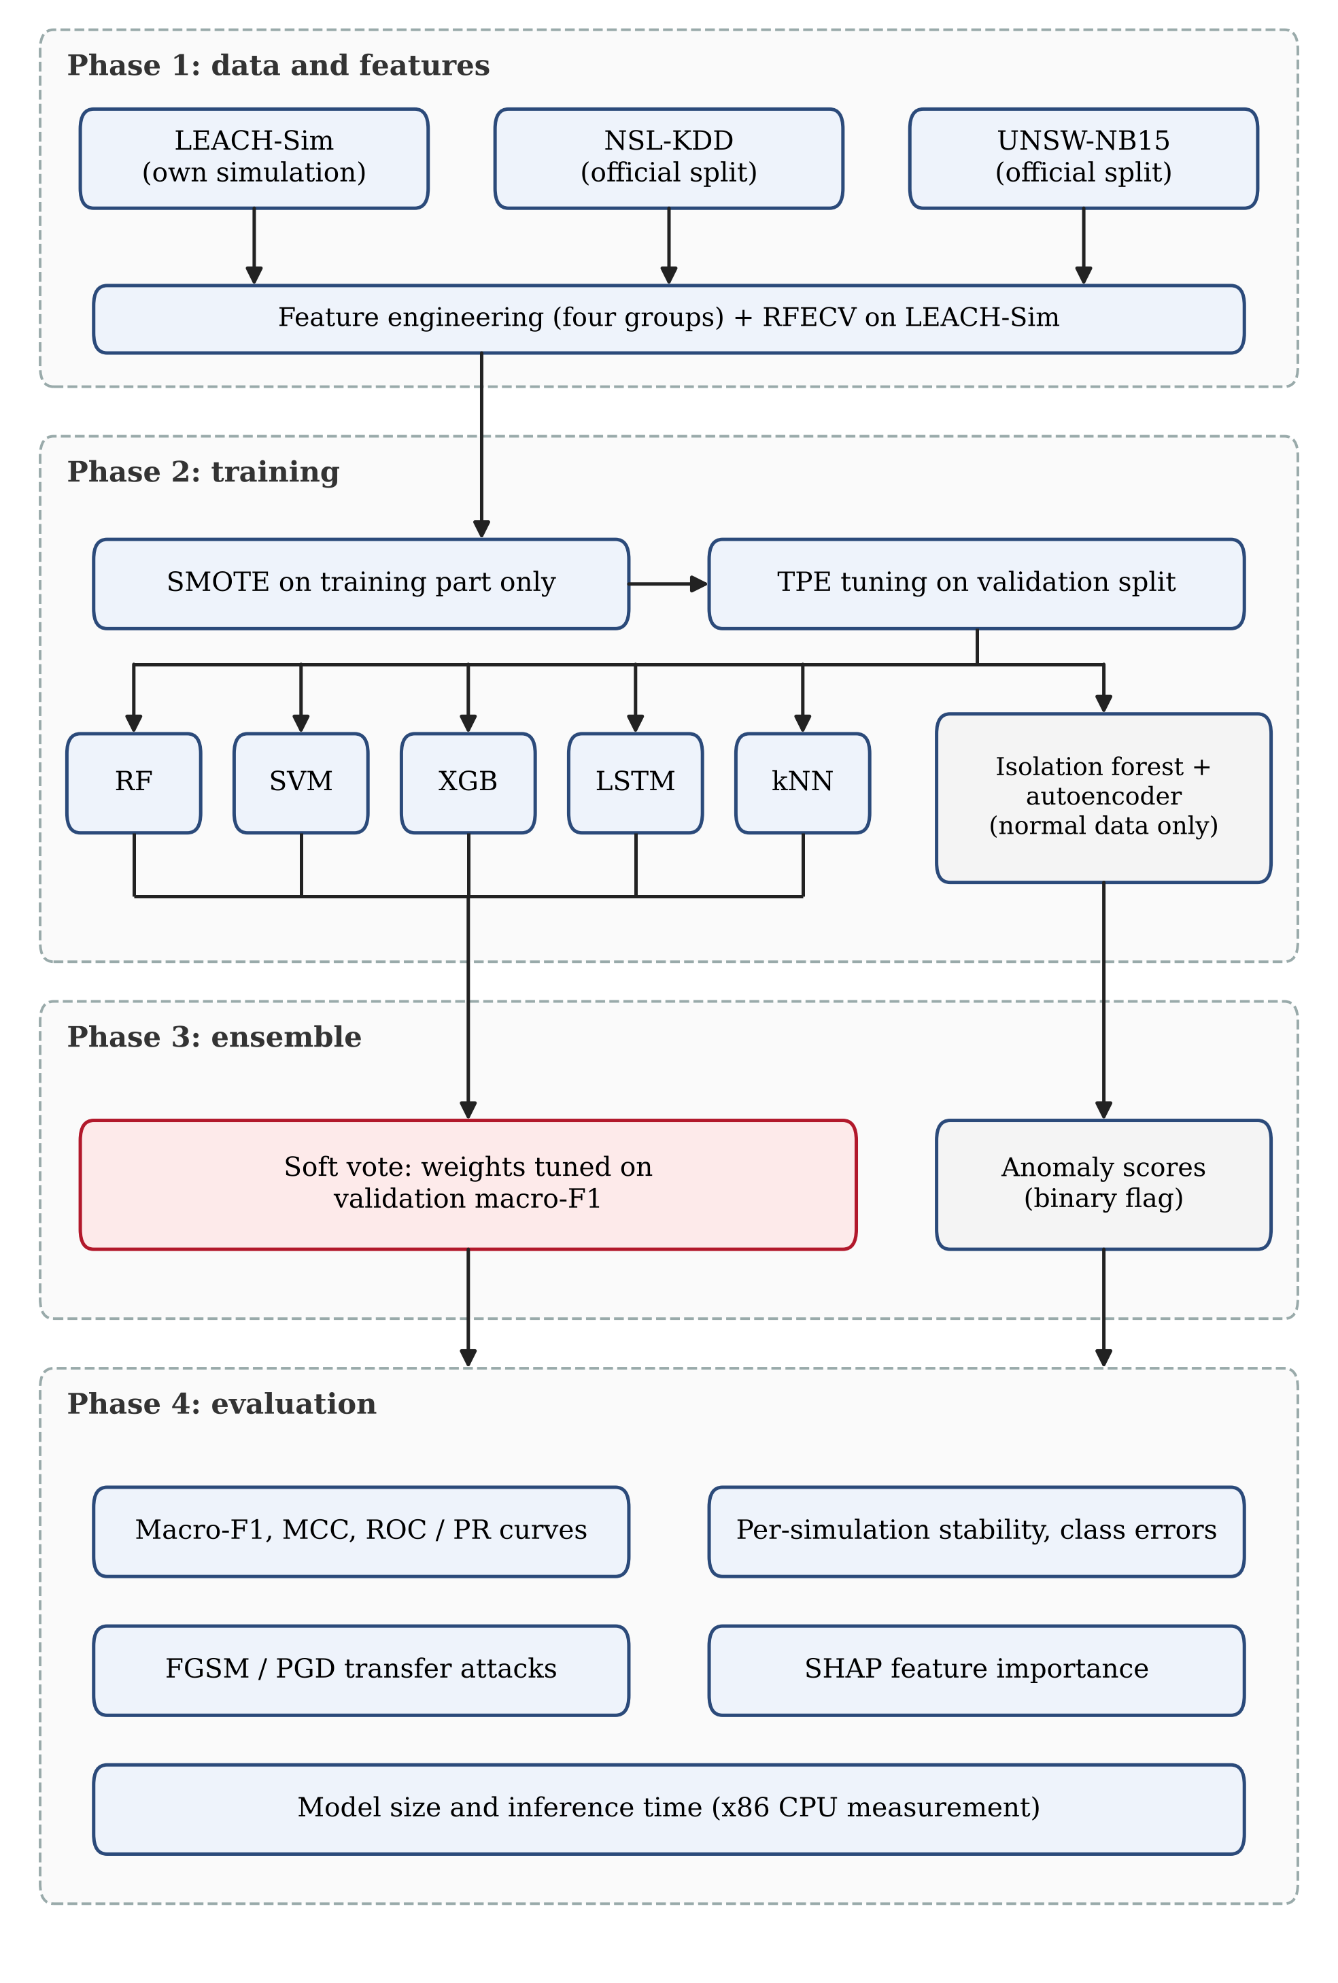
Figure 2. Study workflow: preparing the data, engineering features, training and tuning the base models, then the weighted vote and the evaluation stages.
3.2. Data Sources and Threat Model
Three data sources are used (Table 3). LEACH-Sim was generated by us, because the WSN-DS benchmark usually used for LEACH attacks could not be obtained for this study. NSL-KDD and UNSW-NB15 are general network benchmarks and contain no sensor-network fields.
NSL-KDD is the cleaned version of KDD Cup 1999, from which duplicate records were removed. We use its official KDDTrain+ and KDDTest+ files and group the attacks into DoS, Probe, R2L and U2R next to Normal. UNSW-NB15 was captured on an IXIA cyber range; we use the official training and testing partitions, which hold nine attack families and normal traffic. For both sets 15% of the training file is held out, stratified by class, for validation and tuning.
LEACH-Sim imitates a LEACH network of 100 nodes placed uniformly in a 100 m × 100 m field, with the base station 75 m beyond one edge, a cluster-head probability of 0.05, 60 rounds per run, a first-order radio energy model and 2 J of initial energy per node. In every round each living node yields one record with the counts of advertisement, join, schedule and data messages it sent and received, the packets that reached the base station, link distance and quality, hop count, neighbours and energy spent. In each run 5–25% of the nodes are malicious and each follows one attacker type. A record carries an attack label only in rounds where its node is acting as cluster head; all other records are Normal. Benign noise includes short loss bursts in 15% of cluster-head rounds, 3% random forwarding failures and jitter in the link-quality readings. We ran 80 simulations with different seeds (448,294 records) and assigned whole simulations to training (48), validation (8) or test (24). Because the traffic is synthetic, LEACH-Sim shows what the pipeline can do under stated assumptions; it does not replace measurements from a real deployment.
Table 4 lists the attacks. LEACH-Sim implements Blackhole, Grayhole, Flooding and Scheduling attacks as misbehaving cluster heads; Sybil, wormhole, sinkhole, vampire and jamming attacks, and the selective-forwarding variant, appear for context only and were not simulated. NSL-KDD and UNSW-NB15 hold general network attacks such as DoS, probing and exploits, not sensor-network attacks.
Table 3. Overview of the three data sources used.
Property | NSL-KDD | UNSW-NB15 | LEACH-Sim | Note
Records (total) | 148,517 | 257,673 | 448,294 | LEACH-Sim rows are node-round records
Training set | 125,973 | 175,341 | 313,847 | 15% of NSL-KDD/UNSW train held out for validation; LEACH-Sim split by simulation (48 train, 8 validation)
Test set | 22,544 | 82,332 | 134,447 | Official test files; 24 unseen simulations for LEACH-Sim
Number of features | 41 | 42 | 36 engineered | Categorical fields one-hot encoded for NSL-KDD and UNSW-NB15
Attack classes | 5 | 10 | 5 | Counted with the Normal class
Year released | 2009 | 2015 | Generated here | Public sets predate current IoT traffic
How generated | Derived from DARPA 1998 captures | IXIA PerfectStorm cyber range | Python LEACH simulator (sim.py) | Only LEACH-Sim contains sensor-network protocol fields
Physical-layer features | No | No | Simulated LQI only | No real radio measurements
Topology information | No | No | Yes | Distances, neighbours, hop count
Most skewed class | 1:1,301 (U2R) | 1:429 (Worms) | 1:161 (Flooding) | Oversampling applied to training data in all three

3.3. Data Preparation
Preprocessing follows a fixed order and every step learns its parameters from training rows only. Categorical fields (protocol type, service and flag in NSL-KDD; proto, service and state in UNSW-NB15) are one-hot encoded, which gives 122 input columns for NSL-KDD and 194 for UNSW-NB15. Values are scaled with a robust scaler (median and inter-quartile range) and clipped to ±10 so that a few extreme packet counts cannot dominate.
The training sets are imbalanced, so minority classes are enlarged with SMOTE on the training part alone: every class is raised to at least the smaller of 5% of the largest class and 5,000 rows, and no class is reduced. This gives 277,073 training rows for LEACH-Sim, 111,911 for NSL-KDD and 154,301 for UNSW-NB15. Validation and test rows are left as they are.
Table 4. The ten WSN attacks considered: layer affected, mechanism, effect and, for the four simulated attacks, the ensemble's F1 on LEACH-Sim.
Attack | Layer | How it works | Impact | Ensemble F1 | Implemented in
Blackhole | NET | Cluster head forwards nothing to the base station in 80% of its rounds | Every flow through the node is lost | 90.33% | LEACH-Sim
Grayhole | NET | Cluster head drops a random 10–70% of the aggregated packets in 80% of its rounds | Intermittent loss that looks like ordinary radio faults | 85.14% | LEACH-Sim
Sybil | NET | Impersonates many nodes with forged IDs | Corrupts voting and route selection | Not simulated | —
Wormhole | PHY/NET | Hidden link that joins two far-apart regions | Skews the topology and can cause routing loops | Not simulated | —
Sinkhole | NET | Attracts neighbours by announcing a very low route cost | Gives the attacker a central point to intercept traffic | Not simulated | —
Flooding/DoS | MAC/NET | Cluster head sends 3–40 advertisement messages per round plus junk packets to the BS | The service becomes unreachable | 99.94% | LEACH-Sim
Scheduling | APP | Cluster head assigns duplicate TDMA slots to 20–95% of its members | Nodes fall out of time sync | 89.34% | LEACH-Sim
Selective forwarding | NET | Randomly withholds selected packets | Missing or incomplete data | Not simulated | —
Vampire/Depletion | MAC | Keeps nodes awake with specially crafted traffic | Batteries drain within a few hours | Not simulated | —
Jamming | PHY | Constant radio interference | Links are completely blocked | Not simulated | —

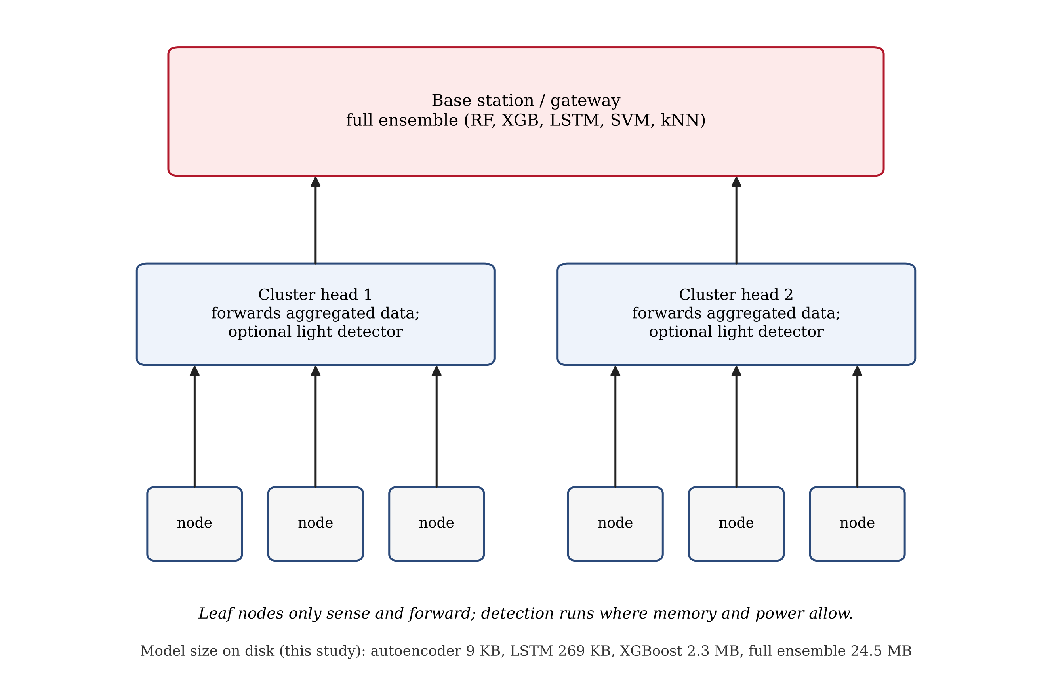
Figure 3. Proposed placement of detectors: leaf nodes only sense and relay, cluster heads may carry a compact detector, and the whole ensemble runs at the base station or a gateway. This is a design proposal and has not been tried on real nodes.
3.4. Order of Operations
The order is: split, encode, scale, oversample. The scaler and encoder see training rows only, and SMOTE runs after the split and on the training rows alone, so no synthetic row reaches validation or test data. For LEACH-Sim the split is by simulation, so the rounds of one network never appear on both sides. Recursive feature elimination (random forest, 3-fold cross-validation, 30,000 training rows) removed 18 of the 36 candidate LEACH-Sim features. Figure 5 shows which part of the data each step may use.
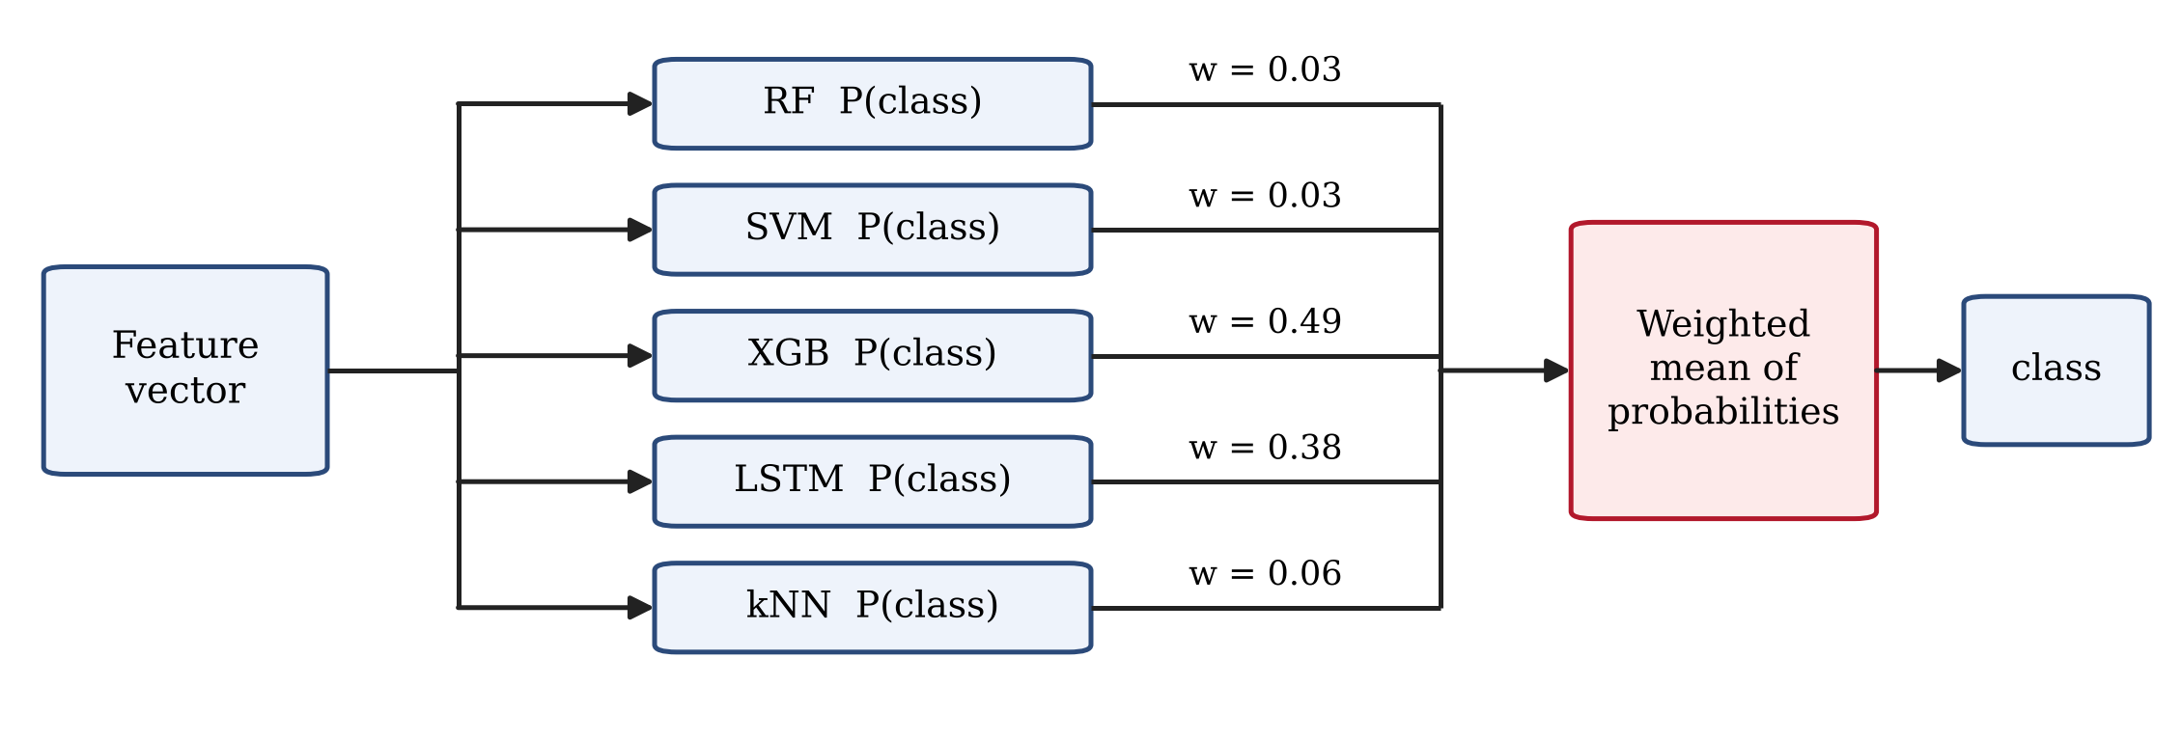
Figure 4. Structure of the soft vote: five classifiers produce class probabilities side by side, and their weighted average, using the weights shown, gives the predicted class.
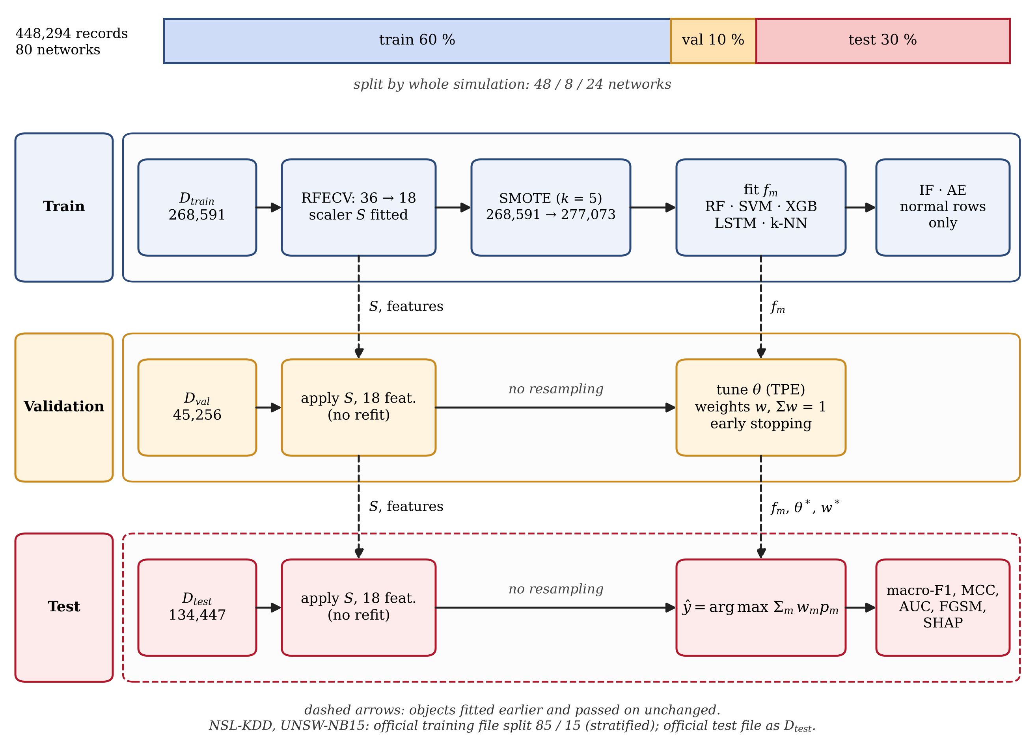
Figure 5. Data-handling schematic: the split of the 80 simulated networks (drawn to scale) and the lane each part follows. Dashed arrows carry objects fitted earlier without refitting; the test lane takes no part in any choice.
3.5. Feature Construction and Selection
Table 5 lists the 15 most informative of the 18 features that survive elimination. The 36 candidates fall into four groups. Statistical flow features (8 of 10 kept; MI 0.09–0.16) count the data packets a cluster head received, aggregated and delivered, and include the forwarding ratio, that is packets heard at the base station divided by packets received from members. Temporal features (4 of 7; MI 0.07–0.13) are exponentially weighted averages and run lengths over earlier rounds, such as how often a node has been cluster head in the last ten rounds.
Protocol features (5 of 10; MI 0.12–0.14) count advertisement, join and schedule messages and their ratios. Topology features (link distance, hop count, neighbours, link quality) are the least useful here: 1 of 9 survived (EWMA of CH changes). This follows from the simulator, where attackers sit at random positions and misbehave in the same way wherever they are; real attackers may differ.
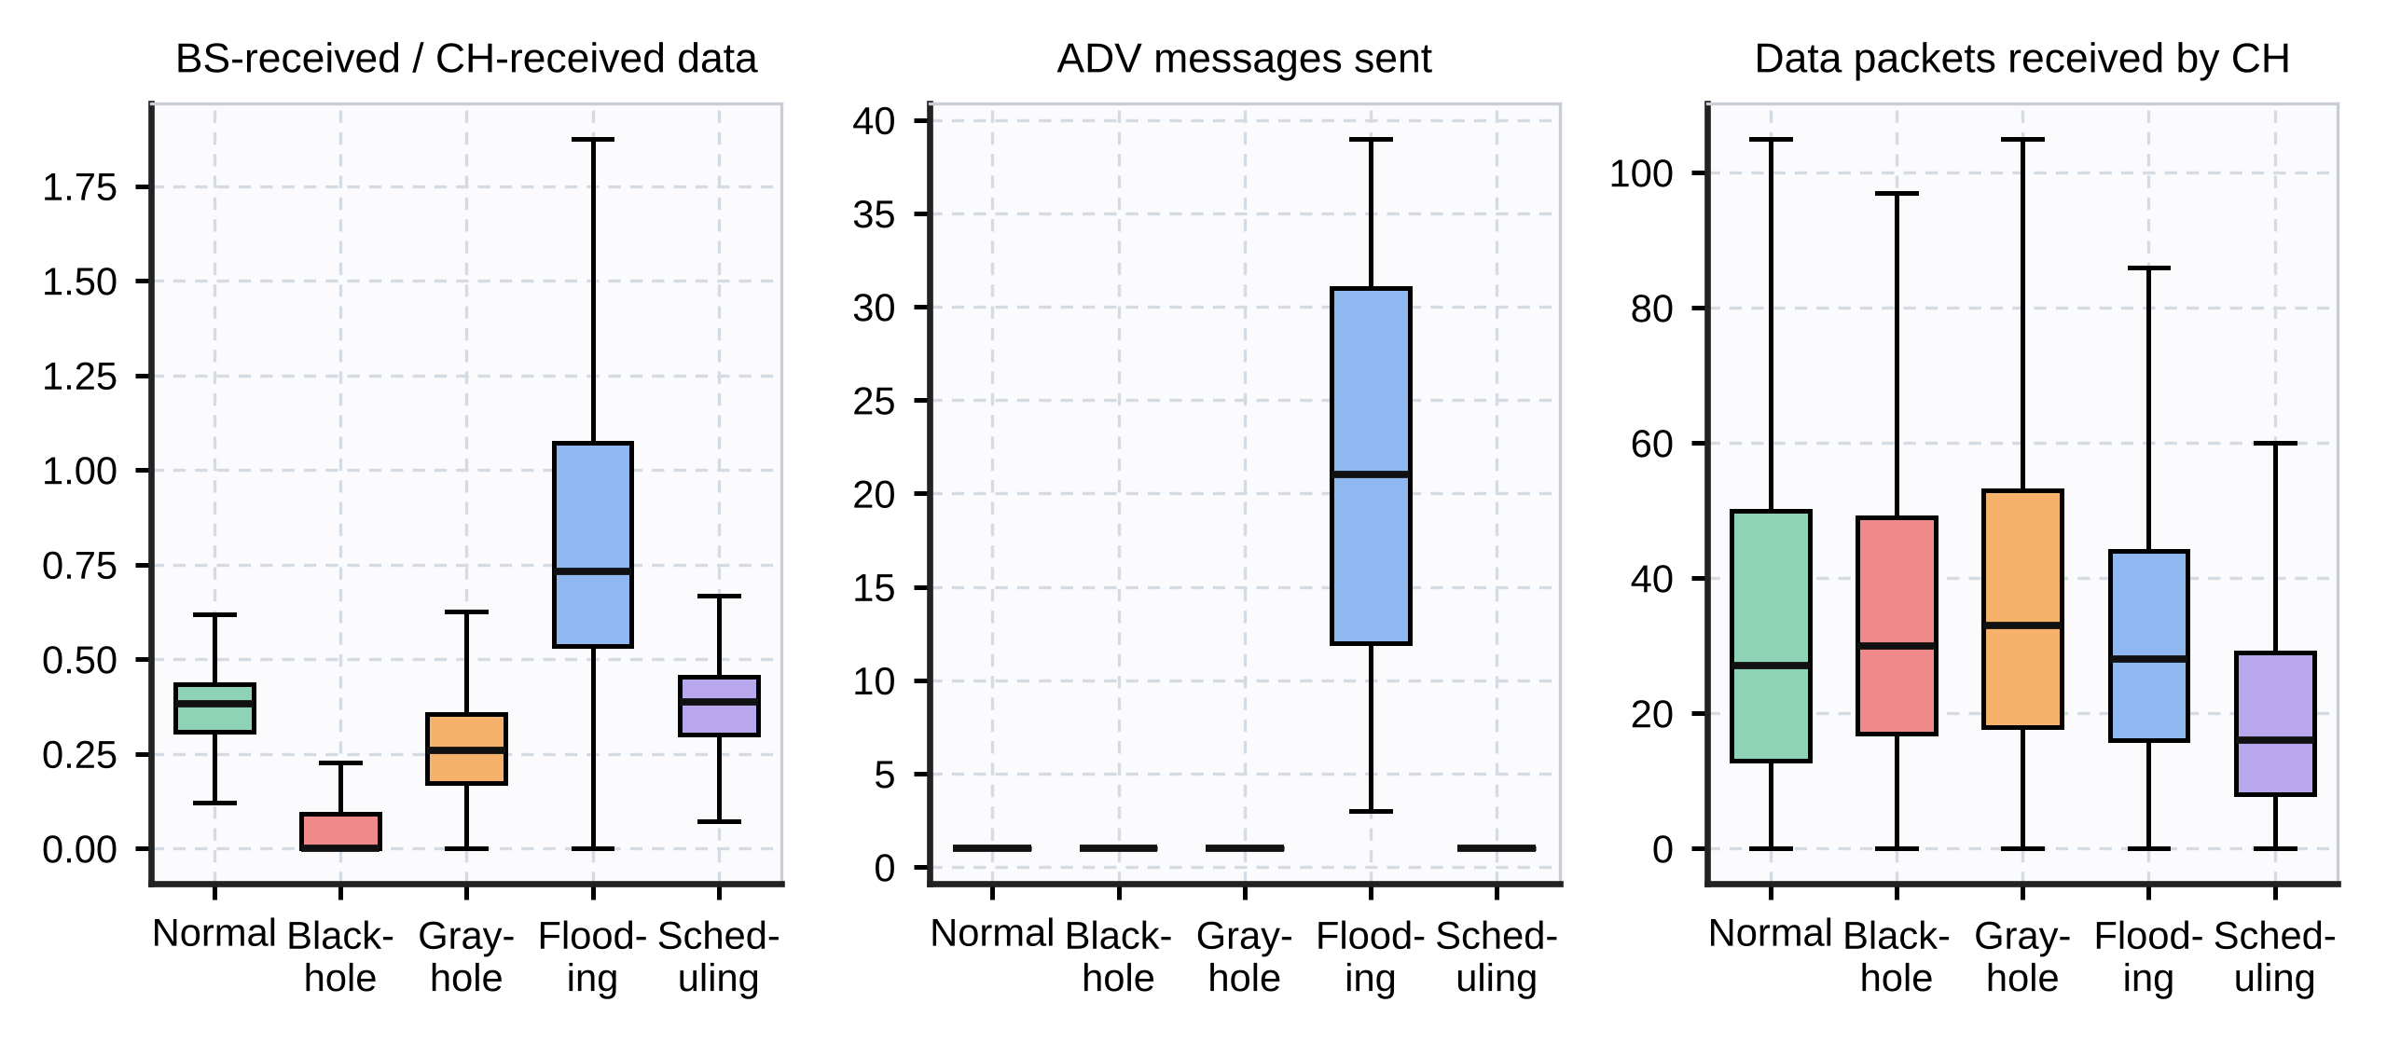
Figure 6. How cluster heads behave in each LEACH-Sim class: forwarding ratio, advertisements sent and data packets received (box plots, outliers hidden).

Table 5. Mutual information (MI) ranking of the 15 strongest among the 18 retained LEACH-Sim features, with each feature's group and the attack class whose mean departs furthest from Normal.
# | Feature | Group | MI | Most shifted class
1 | Sent ratio (to BS / aggregated) | Statistical | 0.162 | Flooding
2 | Forwarding ratio (BS-received / CH-received) | Statistical | 0.148 | Flooding
3 | ADV messages sent | Protocol | 0.144 | Flooding
4 | Drop rate (1 − forwarding ratio) | Statistical | 0.143 | Flooding
5 | Delivery ratio (received / expected) | Statistical | 0.138 | Scheduling
6 | Data packets per member | Statistical | 0.137 | Scheduling
7 | EWMA of ADV messages sent | Temporal | 0.133 | Flooding
8 | CH frequency (last 10 rounds) | Temporal | 0.120 | Blackhole
9 | JOIN received per ADV heard | Protocol | 0.119 | Flooding
10 | JOIN requests received | Protocol | 0.119 | Scheduling
11 | Rounds since last CH role | Temporal | 0.119 | —
12 | Schedule messages sent | Protocol | 0.118 | Scheduling
13 | Data packets received by CH | Statistical | 0.117 | Scheduling
14 | Schedule / JOIN ratio | Protocol | 0.116 | Flooding
15 | Packets sent to BS by CH | Statistical | 0.101 | Blackhole

3.6. Models and Ensemble
Five supervised models are trained on all classes: a random forest, an RBF-kernel SVM, XGBoost, an LSTM and k-NN. The ensemble forms the probability p(x) = Σ w_m p_m(x) over these five, with w_m ≥ 0 and Σ w_m = 1; the weights come from 80 TPE trials on validation macro-F1. The LSTM reads the feature vector as a short sequence of 8 consecutive slices. A record has no time order of its own, so this is only a convenient architecture; real temporal behaviour enters through the averaged features. The autoencoder and the isolation forest (200 trees) are fitted on up to 100,000 normal training rows; the autoencoder's score is its reconstruction error.

3.7. Training Procedure
Section 3.2 describes how every data source is divided into a part for fitting, a part for tuning and a held-out part for testing. Models are fitted on the training part, settings and ensemble weights are chosen on the validation part, and the test part is touched once for the numbers reported.
The search used Optuna's TPE sampler with small budgets, set by the two CPU cores available: 8 trials each for the random forest and XGBoost on 40,000-row subsets, 6 for the SVM, four width and dropout pairs for the LSTM, five values of k and three autoencoder widths (Table 6). The SVM and k-NN final models were fitted on random subsets of 20,000 and 60,000 rows because their cost grows steeply with data size.
The LSTM used the Adam optimiser (learning rate 1e-3, batches of 512) and a cross-entropy loss. Training ran for at most 40 epochs and stopped when the validation loss had not improved for four epochs.
We report accuracy, macro-averaged precision, recall, F1 and false-positive rate, the Matthews correlation coefficient, balanced accuracy and ROC-AUC. Most classes are small, which makes macro-F1 the headline figure; accuracy alone would hide how the rare attacks fare. Table 6 lists the chosen settings.

3.8. Resource Measurement and Explainability
This section covers the cost of storing and running the trained models, and how their decisions are explained.
Model size is the size of the serialised object (a pickle for scikit-learn models, the raw booster for XGBoost, and four bytes per parameter for the neural networks). Latency is the median over 200 single-sample calls, and throughput comes from scoring 2,000 samples in one batch, both with one thread on an x86-64 server CPU. These are not measurements on sensor hardware; they cannot be turned into milliwatts or battery life, and they only indicate relative cost and what could fit in memory.
To see which inputs matter, we compute SHAP values for the XGBoost model (TreeExplainer, 2,000 test rows) and compare them with random-forest impurity importance and with mutual information. Stability is checked by comparing SHAP rankings from two disjoint halves of the test data.

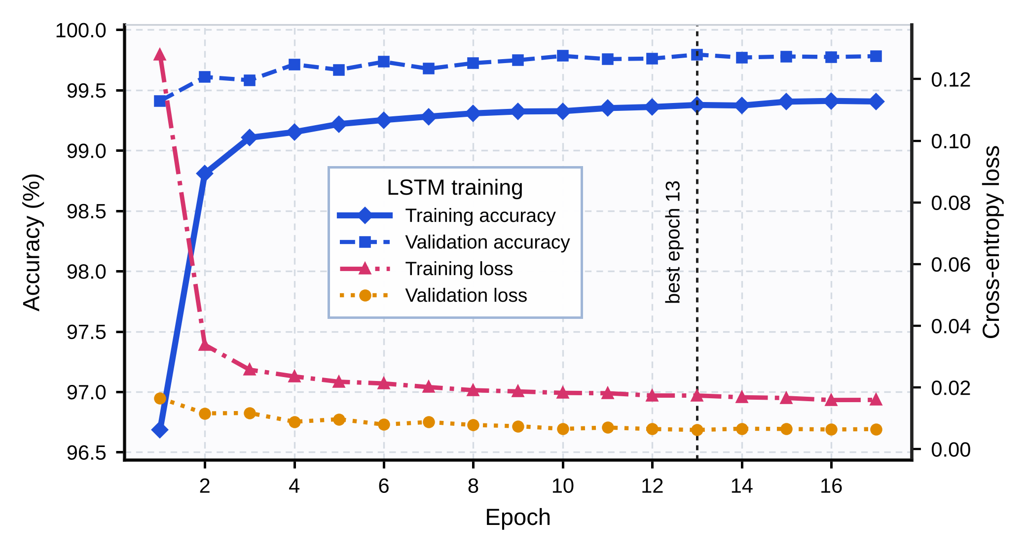
Figure 7. LSTM accuracy and loss across training and validation epochs on LEACH-Sim; early stopping picked epoch 13 of 17.
Table 6. Search ranges, chosen values and trial counts for each model.
Model | Parameter | Search space | Selected | Trials
RF | Number of trees | [50–300] | 89 | 8
 | Features per split | {sqrt, log2} | sqrt
 | Minimum samples per leaf | [1–4] | 4
SVM-RBF | Penalty C | [0.1–1,000], log | 84.7 | 6
 | Kernel γ | [1e-4–1], log | 0.0248
XGBoost | Number of trees | [100–400] | 350 | 8
 | Tree depth | [3–10] | 4
 | Learning rate | [0.03–0.3], log | 0.046
LSTM | Hidden units / dropout | 4 pairs: 32/0.1, 64/0.3, 128/0.3, 128/0.5 | 128 / 0.5 | 4
 | Input steps (feature vector reshaped) | fixed | 8
 | Epochs (patience 4) | max 40 | best 13 of 17 run
kNN | Neighbours k (distance-weighted) | {3, 5, 7, 11, 15} | 15 | 5
Autoencoder | Bottleneck width | {4, 8, 16} | 16 | 3
Isolation forest | Number of trees | fixed | 200 | —
Soft vote | Vote weight per classifier | [0–1] each, normalised | RF 0.03; SVM 0.03; XGB 0.49; LSTM 0.38; kNN 0.06 | 80
.

4. Results and Discussion

4.1 Overall Results on LEACH-Sim

Scores for the five classifiers and the ensemble on LEACH-Sim are collected in Table 7. The test data are 134,447 records, in five classes, from 24 networks that were kept out of training and tuning. With these data the ensemble obtains 99.55% accuracy, 92.94% macro-F1 and an MCC of 0.943. XGBoost (92.90%) and the random forest (92.68%) are almost as good, so the ensemble's margin of 0.04 points over XGBoost is too small to matter. All models score high on accuracy (99.15–99.55%), largely because 95.9% of the records are Normal; macro-F1 discriminates better, ranging from 87.3% for k-NN to 92.9%.
Training time differs widely: 0.01 s for k-NN (which only stores the data), 3 s for the SVM on its 20,000-row subset, 5 s for the random forest, 18 s for XGBoost and 195 s for the LSTM on two CPU cores. The tuned vote gives XGBoost a weight of 0.49 and the LSTM 0.38; the other three share the remaining 0.13.

Table 7. Scores of all classifiers on the LEACH-Sim test set (134,447 records, five classes), with precision, recall, F1 and FPR macro-averaged.
Model | Acc. (%) | Macro prec. (%) | Macro rec. (%) | Macro F1 (%) | Macro FPR (%) | MCC | BAcc (%) | Train time (s)
RF | 99.53 | 92.93 | 92.43 | 92.68 | 0.41 | 0.941 | 92.43 | 4.7
SVM-RBF | 99.28 | 89.52 | 88.22 | 88.86 | 0.77 | 0.909 | 88.22 | 3.4
XGBoost | 99.54 | 93.09 | 92.71 | 92.90 | 0.39 | 0.942 | 92.71 | 18.1
LSTM | 99.51 | 92.70 | 91.88 | 92.28 | 0.53 | 0.938 | 91.88 | 194.9
kNN | 99.15 | 88.77 | 86.01 | 87.25 | 1.18 | 0.891 | 86.01 | 0.01
Soft-vote ensemble | 99.55 | 93.30 | 92.58 | 92.94 | 0.45 | 0.943 | 92.58 | —
4.2. Results by Class on LEACH-Sim
Per-class ensemble scores, with the false-negative rate and the precision–recall AUC, appear in Table 8. Normal traffic (99.9% F1) and Flooding (99.9%) are almost perfectly separated: a flooding cluster head sends many more advertisements than any honest one. The three attacks that act on forwarding or slot allocation are harder: Blackhole 90.3%, Scheduling 89.3% and Grayhole 85.1% F1. Grayhole is the weakest, probably because its drop rate (10–70%) overlaps with both honest loss bursts and the other attacks. Its most frequent error is to be labelled Scheduling (102 of 1,463 records). The ensemble raised a false alarm on 37 of the 128,962 normal records (0.03%), which include 6,113 normal cluster-head rounds.
Table 8. Ensemble scores per class on the LEACH-Sim test set (134,447 records).
Class | Prec. (%) | Rec. (%) | F1-score (%) | FP rate (%) | FN rate (%) | PR-AUC | Support
Normal | 99.92 | 99.97 | 99.95 | 1.88 | 0.03 | 1.0000 | 128,962
Blackhole | 90.82 | 89.85 | 90.33 | 0.10 | 10.15 | 0.9636 | 1,487
Grayhole | 85.52 | 84.76 | 85.14 | 0.16 | 15.24 | 0.9334 | 1,463
Flooding | 99.88 | 100.00 | 99.94 | 0.00 | 0.00 | 1.0000 | 828
Scheduling | 90.35 | 88.34 | 89.34 | 0.12 | 11.66 | 0.9626 | 1,707
Weighted mean | 99.54 | 99.55 | 99.54 | 1.81 | 0.45 | 0.9984 | 134,447

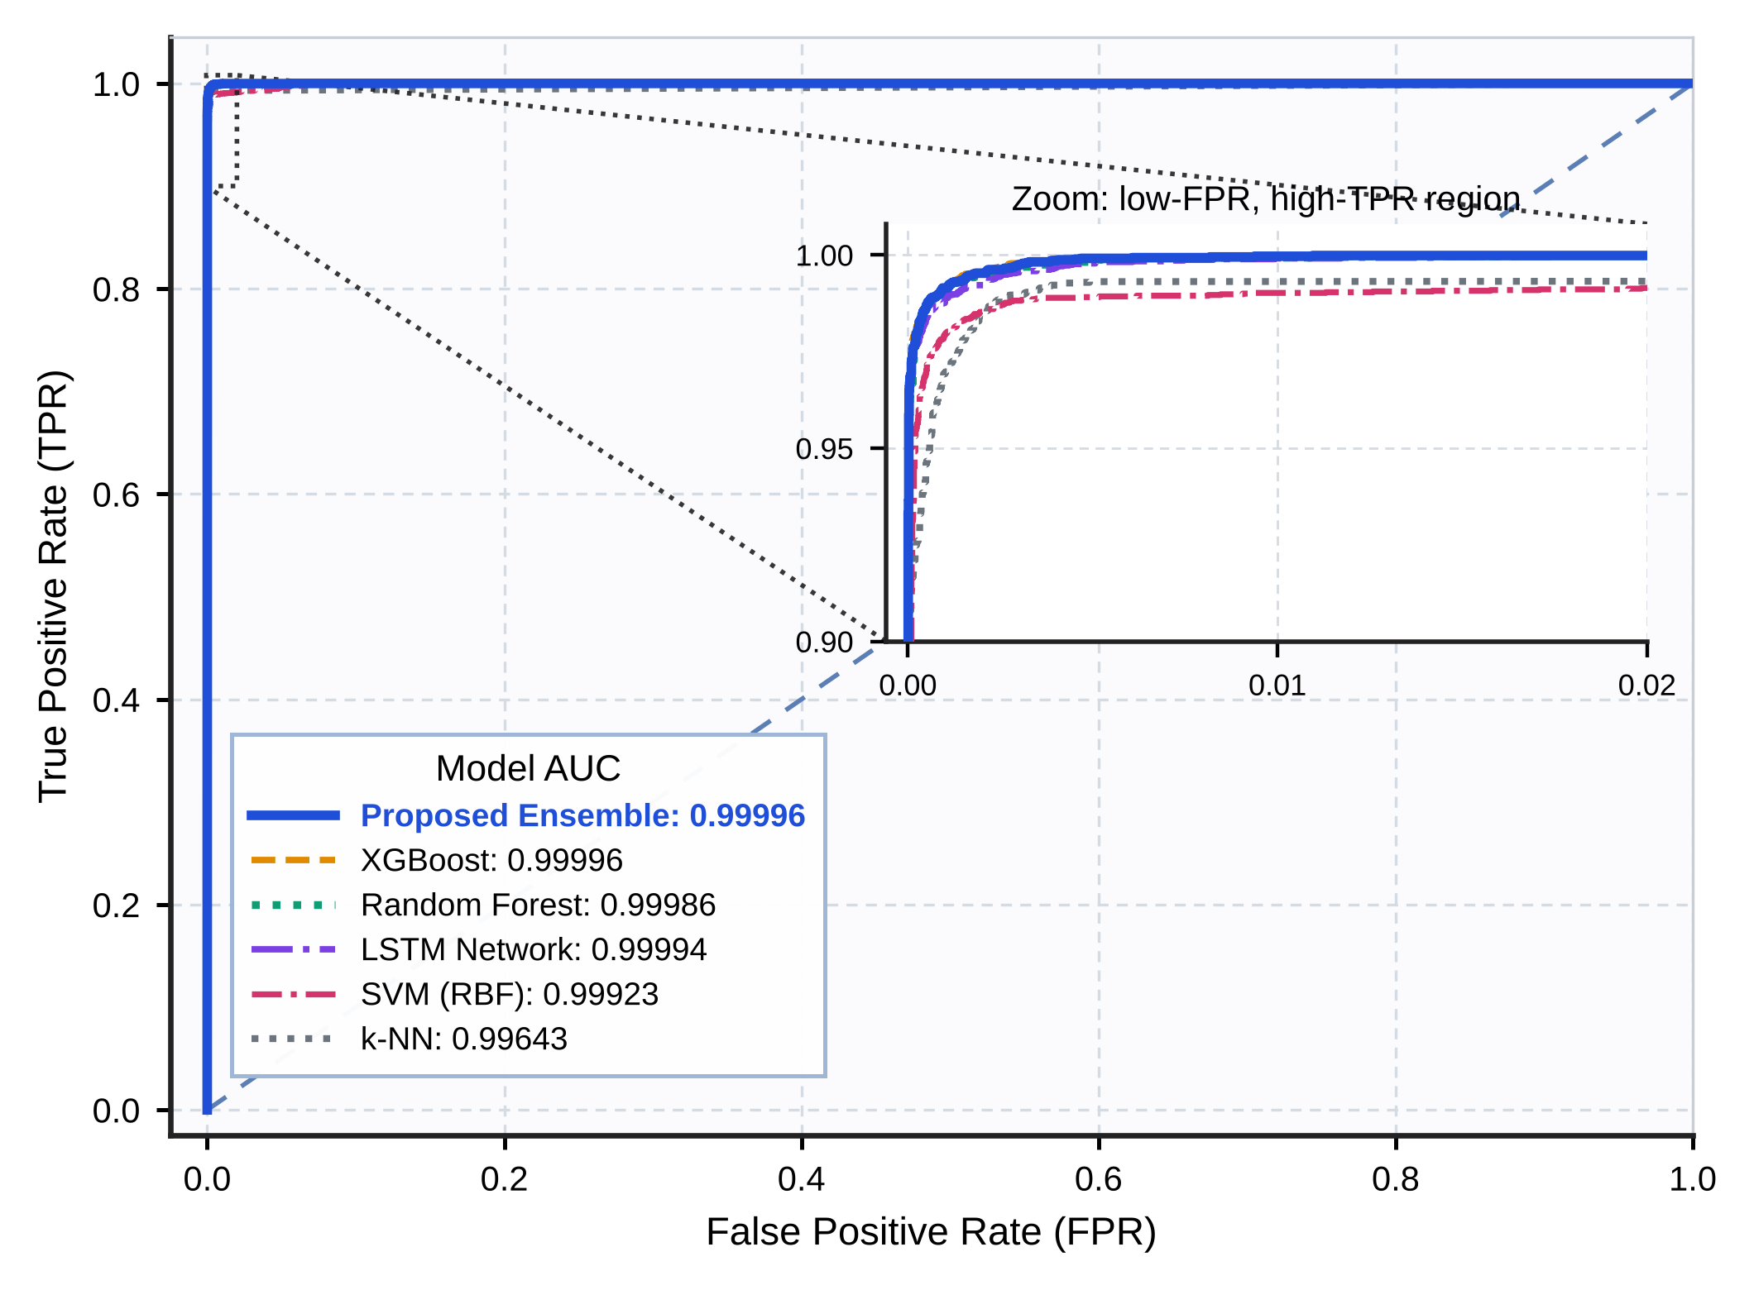
Figure 8. ROC curves (attack versus normal) on LEACH-Sim, with the low-false-positive corner enlarged in the inset.
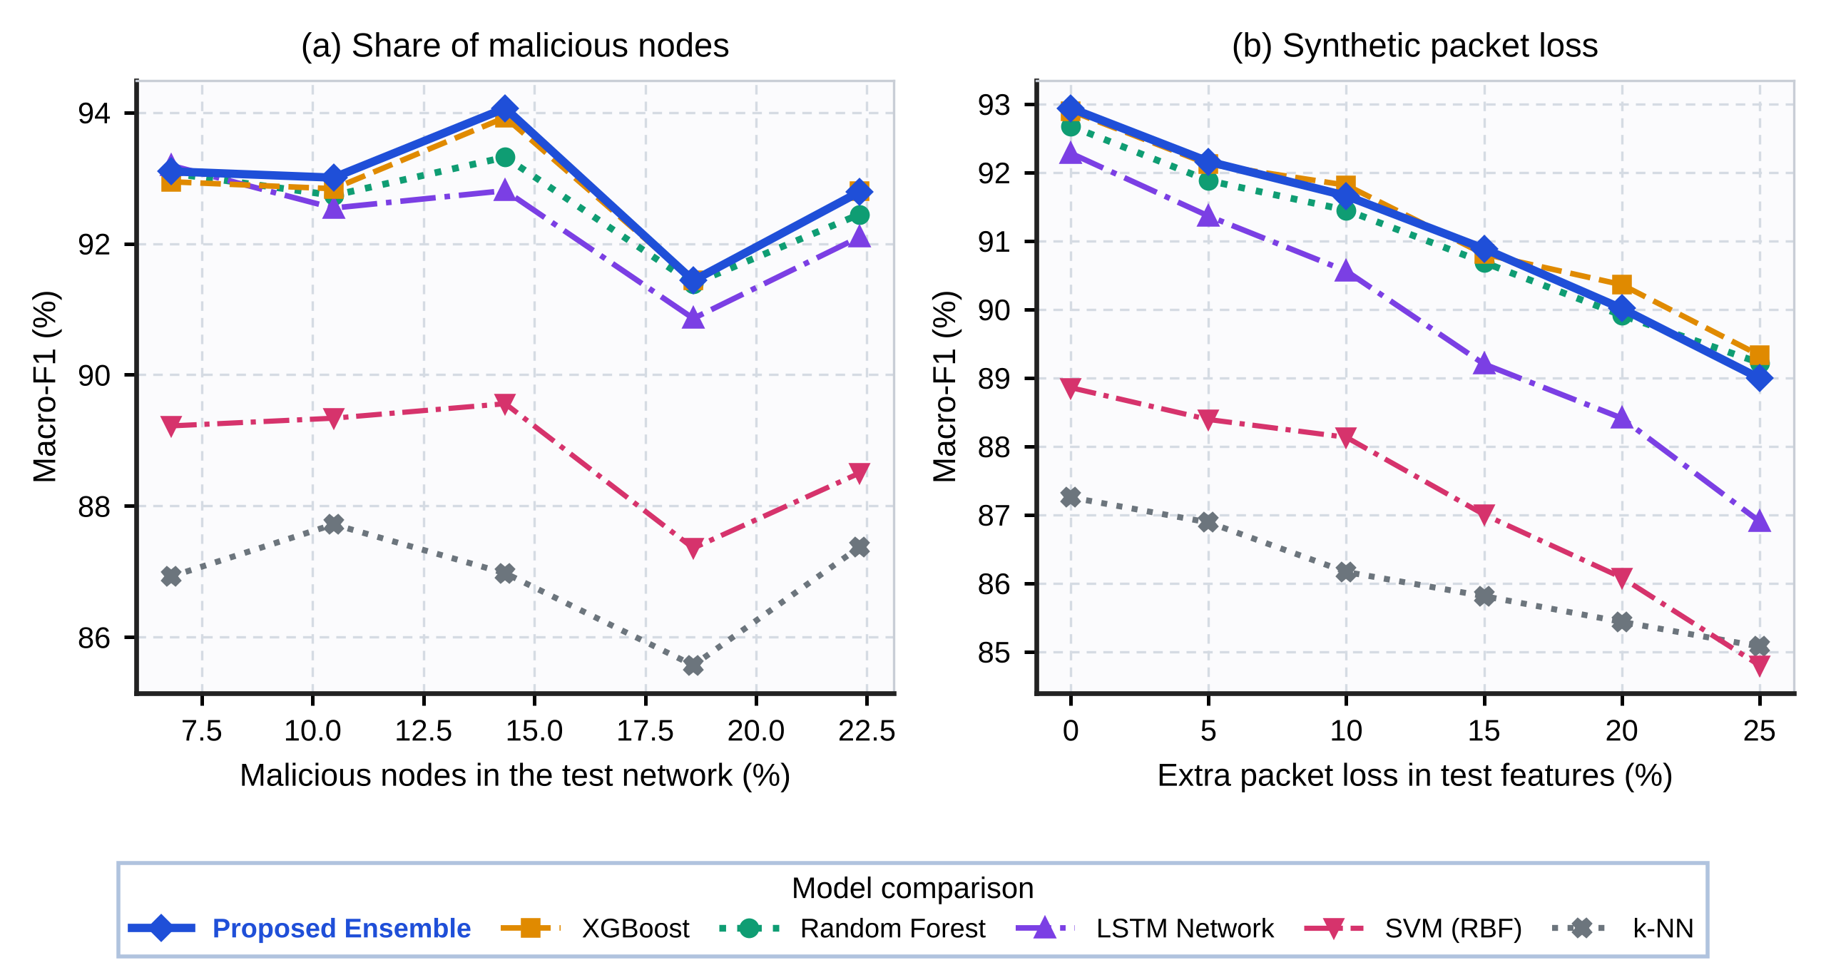
Figure 9. Macro-F1 of each model (a) for networks with different shares of malicious nodes and (b) when extra packet loss is applied to test-time counts.
4.3. Error Analysis by Class
Table 9 holds the ensemble's confusion matrix for the five LEACH-Sim classes. Of the 128,962 normal records, 128,925 are classified correctly and 37 are flagged as an attack. Most of the attack errors are between attack classes: 72 Grayhole records are called Blackhole and 102 are called Scheduling, while 108 Scheduling records are called Grayhole. Only 103 of 5,485 attack records (1.9%) are passed as Normal. Across the 24 test networks the accuracy of the ensemble is 99.54% ± 0.33 (mean ± standard deviation) and macro-F1 is 90.81% ± 6.11; the larger spread of the latter reflects networks that contain few records of some attack. Between the lowest and highest proportion of attacker nodes in the sweep of Figure 8a the macro-F1 stays between 0.914 and 0.941 with no clear trend. In Figure 8b, added packet loss lowers macro-F1 from 0.929 to 0.890 at 25% extra loss.
Table 9. LEACH-Sim confusion matrix of the ensemble, true classes in rows and predicted classes in columns; the bottom-right cell is overall accuracy.
True \ Predicted | Normal | Blackhole | Grayhole | Flooding | Scheduling | Row sum | Recall (%)
Normal | 128,925 | 4 | 15 | 0 | 18 | 128,962 | 99.97%
Blackhole | 22 | 1,336 | 87 | 1 | 41 | 1,487 | 89.85%
Grayhole | 49 | 72 | 1,240 | 0 | 102 | 1,463 | 84.76%
Flooding | 0 | 0 | 0 | 828 | 0 | 828 | 100.00%
Scheduling | 32 | 59 | 108 | 0 | 1,508 | 1,707 | 88.34%
Precision (%) | 99.92 | 90.82 | 85.52 | 99.88 | 90.35 | — | 99.55%

4.4. NSL-KDD Results
Table 10 reports category-level ensemble scores for the 22,544 NSL-KDD test records. Accuracy is 76.3% and macro-F1 58.0%, far below LEACH-Sim. DoS (85.8% F1), Normal (78.6%) and Probe (75.8%) are handled tolerably, but R2L reaches only 11.3% recall (2,543 of its 2,885 records are labelled Normal) and U2R 19.4% recall (the test file holds 67 such records). Part of the difficulty is a known property of this benchmark: the test file contains attack types that never occur in the training file, so a model fitted to the training distribution misses them. Among the single models XGBoost is best (78.1% accuracy, macro-F1 58.1%), and the ensemble's macro-F1 is 0.580, level with the best single model (XGBoost, 0.581), so it gives no gain.
Table 10. NSL-KDD test file (22,544 records): ensemble scores for each traffic category.
Category | Prec. (%) | Rec. (%) | F1-score (%) | FP rate (%) | Support | Example attacks
Normal | 66.42 | 96.39 | 78.65 | 36.87 | 9,711 | Benign TCP, UDP and ICMP flows
DoS | 96.10 | 77.53 | 85.82 | 1.56 | 7,460 | Teardrop, Neptune, Smurf, Ping-of-Death
Probe | 81.95 | 70.51 | 75.80 | 1.87 | 2,421 | Nmap, Satan, IPsweep, Portsweep
R2L | 99.39 | 11.33 | 20.35 | 0.01 | 2,885 | phf, FTP-write, guess-password
U2R | 61.90 | 19.40 | 29.55 | 0.04 | 67 | Loadmodule, Perl, Rootkit, buffer overflow
All classes | 82.11 | 76.26 | 73.11 | 16.60 | 22,544 | All five categories (weighted mean)

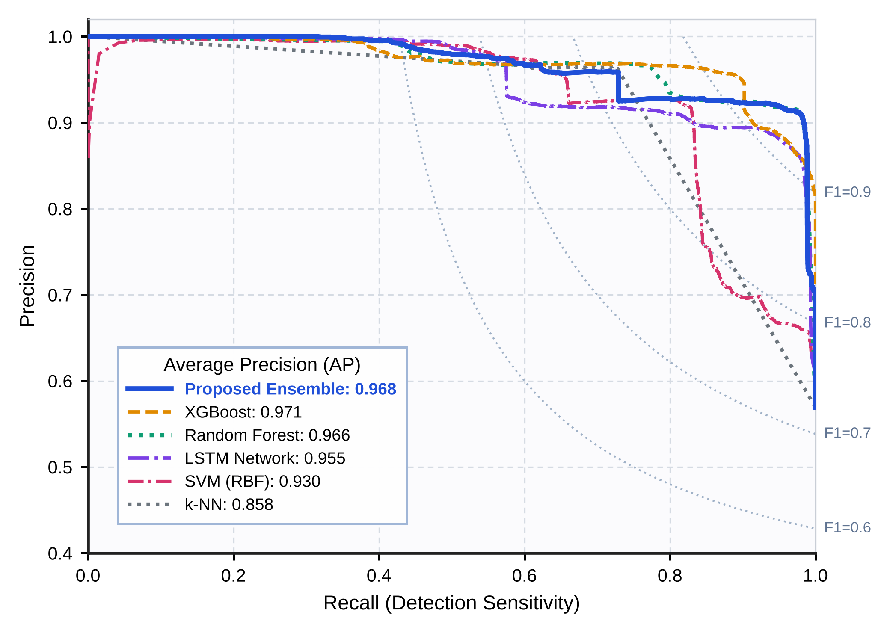
Figure 10. NSL-KDD precision–recall curves for separating attacks from normal traffic.
4.5. UNSW-NB15 Results
Table 11 reports category-level ensemble scores for the 82,332 UNSW-NB15 test records. Accuracy is 76.2% and macro-F1 51.0%. Generic (98.4% F1), Reconnaissance (86.5%) and Normal (84.6%) are recognised well, and Exploits fairly (70.3%). Analysis (3.9%), Backdoor (4.4%) and DoS (18.8%) are barely detected: most DoS records are labelled Exploits (2,454 of 4,089), and Analysis and Backdoor records are mostly labelled Exploits. With these features the models cannot separate these small classes from the larger ones. As on NSL-KDD, the ensemble's macro-F1 is 0.510, below the best single model (XGBoost, 0.516); the tuned weights put 0.74 on XGBoost.
Table 11. UNSW-NB15 test file (82,332 records): ensemble scores for each traffic category.
Category | Prec. (%) | Rec. (%) | F1-score (%) | FP rate (%) | Support | Description
Normal | 96.46 | 75.34 | 84.60 | 2.26 | 37,000 | Ordinary TCP and UDP application flows
Fuzzers | 30.29 | 56.58 | 39.46 | 10.35 | 6,062 | Injects random or badly formed values into protocol fields
Analysis | 2.96 | 5.61 | 3.88 | 1.53 | 677 | Port scans, HTML injection, malicious PDF files
Backdoor | 2.93 | 8.92 | 4.41 | 2.11 | 583 | Setting up hidden remote-access channels
DoS | 44.97 | 11.91 | 18.83 | 0.76 | 4,089 | Service denial over HTTP, TCP or UDP
Exploits | 60.13 | 84.51 | 70.27 | 8.76 | 11,132 | Traffic that abuses published vulnerabilities (CVEs)
Generic | 99.77 | 97.03 | 98.38 | 0.07 | 18,871 | Signatures that work regardless of protocol
Reconnaissance | 93.61 | 80.41 | 86.51 | 0.24 | 3,496 | Probing to map hosts and topology
Shellcode | 32.79 | 80.16 | 46.54 | 0.76 | 378 | Heap-spray injection followed by shellcode execution
Worms | 58.14 | 56.82 | 57.47 | 0.02 | 44 | Self-replicating worm traffic spreading across the network
All classes | 83.01 | 76.20 | 77.89 | 3.06 | 82,332 | Weighted mean over the ten classes
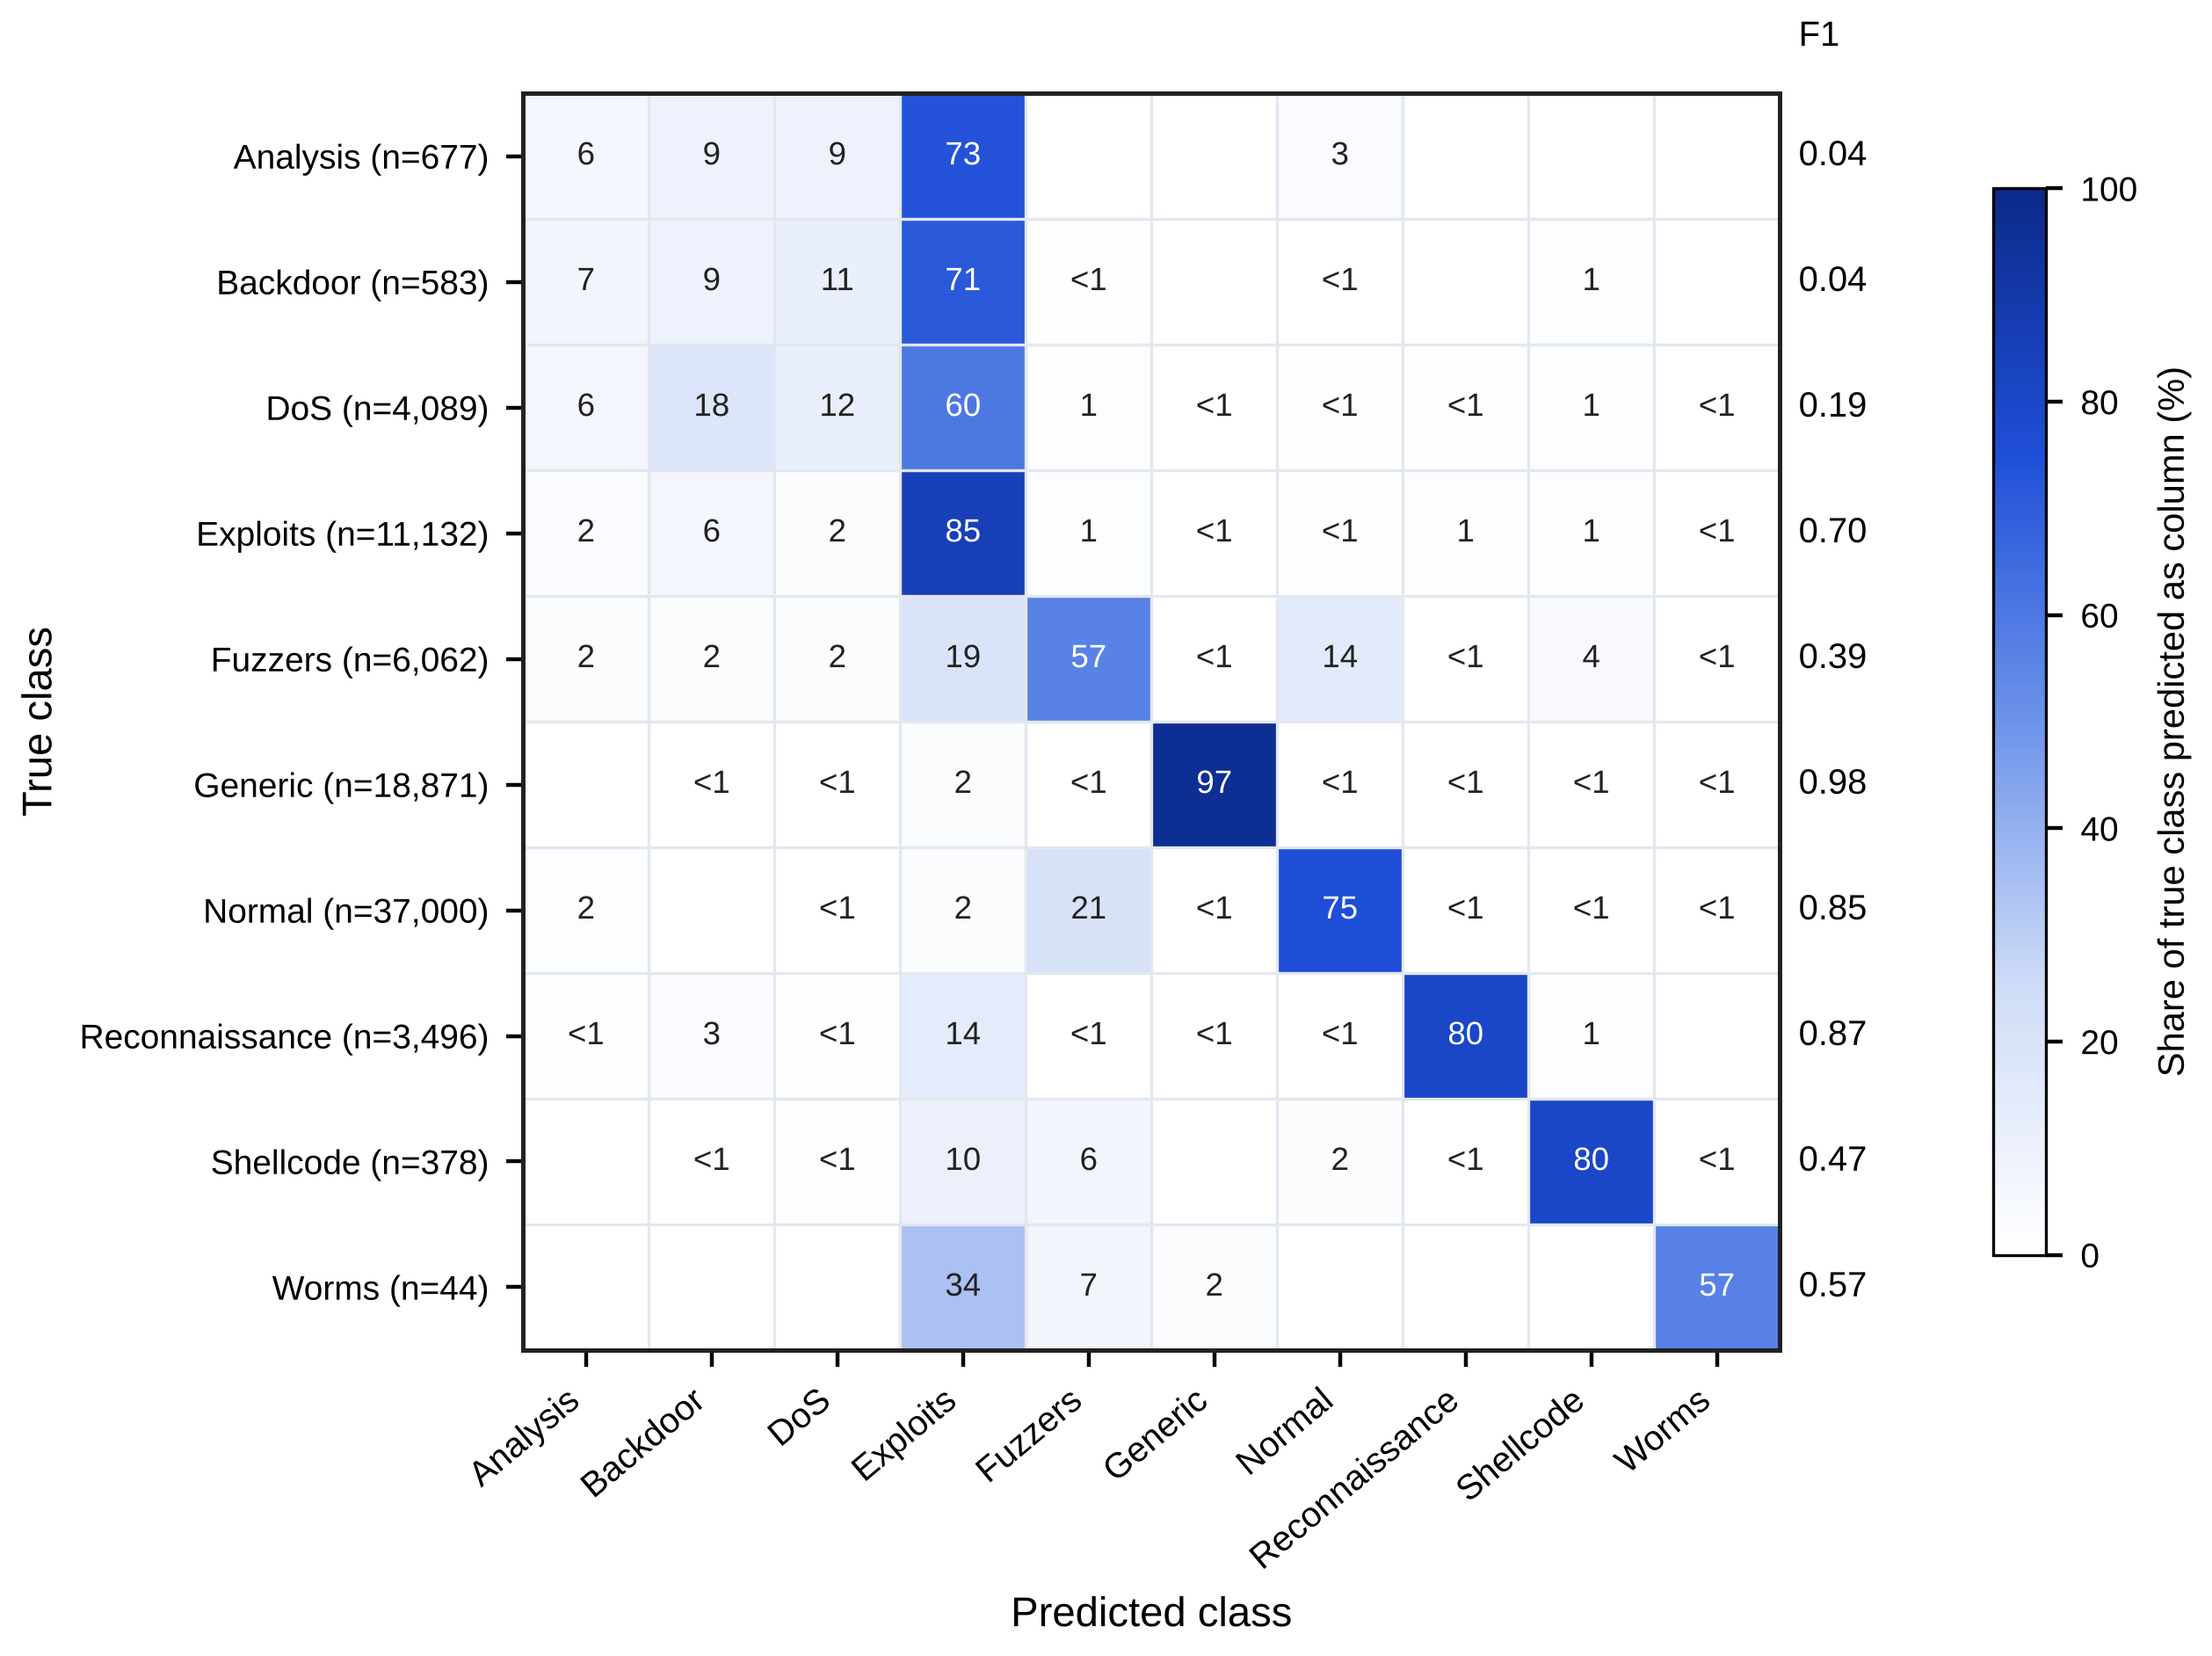
Figure 11. Row-normalised confusion matrix built from ensemble predictions for the 82,332 UNSW-NB15 test records; each class's F1-score is printed to the right of its row.
4.6. Ranking Quality (AUC)
Table 12 compares every model by AUC on all three sources, using one-versus-rest macro averaging for the multi-class case and a pooled attack-against-normal score for the binary case. The ensemble has a multi-class AUC of 0.9995 on LEACH-Sim, 0.9384 on NSL-KDD and 0.9609 on UNSW-NB15. The ranking of models is not the same everywhere: XGBoost has the highest multi-class AUC on all three sets (0.9996, 0.9511, 0.9628). On LEACH-Sim the unsupervised detectors, which never see an attack during training, reach attack-versus-normal AUCs of 0.9976 (isolation forest) and 0.9988 (autoencoder). On NSL-KDD they reach 0.949 and 0.941, and on UNSW-NB15 0.783 and 0.755. A high AUC with a modest F1, as on NSL-KDD, shows that the scores rank records well but that the decision thresholds learned on the training distribution do not carry over to the shifted test file.
Table 12. Area under the ROC curve for each model on all three sources, both multi-class (macro, one-versus-rest) and attack against normal; † marks unsupervised detectors, which give only a binary score.
Model | LEACH-Sim multi-class | LEACH-Sim attack vs normal | NSL-KDD multi-class | NSL-KDD attack vs normal | UNSW-NB15 multi-class | UNSW-NB15 attack vs normal
RF | 0.9994 | 0.9999 | 0.9478 | 0.9630 | 0.9484 | 0.9801
SVM-RBF | 0.9978 | 0.9992 | 0.8480 | 0.8926 | 0.9371 | 0.9600
XGBoost | 0.9996 | 1.0000 | 0.9511 | 0.9675 | 0.9628 | 0.9836
LSTM | 0.9995 | 0.9999 | 0.9173 | 0.9449 | 0.9598 | 0.9824
kNN | 0.9946 | 0.9964 | 0.7969 | 0.8463 | 0.8664 | 0.9329
Isolation forest† | — | 0.9976 | — | 0.9488 | — | 0.7826
Autoencoder† | — | 0.9988 | — | 0.9410 | — | 0.7545
Soft-vote ensemble | 0.9995 | 1.0000 | 0.9384 | 0.9620 | 0.9609 | 0.9825
4.7. Position Relative to Published Work
We make no numerical comparison with published results. The studies cited in Section 2 differ in data, class definitions and reporting, and several do not concern WSNs, so a ranking built on their figures could not be defended. Nor can our results be set against WSN-DS, which we did not use. We therefore rely on the gap analysis of Table 2: the earlier work does not combine WSN-specific cluster-head features, adversarial testing and measured model cost, whereas this study does, within the limits given in the Conclusion. Independent re-runs of baselines on real WSN data and on newer IoT datasets such as TON_IoT and CIC-IoT-2023 are left to future work.

4.8. Model Size, Speed and Deployment
Table 13 gives latency, throughput and stored size measured on an x86-64 CPU rather than on a sensor node. The autoencoder is by far the smallest model (8.9 KB, 0.055 ms per sample), and the SVM (122 KB) and LSTM (269 KB) are of the order of a few hundred kilobytes. XGBoost needs 2.3 MB, k-NN 8.7 MB (it stores 60,000 training rows) and the random forest 13.1 MB, and the five-model ensemble together 24.5 MB. Only the autoencoder and the SVM are under 256 KB. On NSL-KDD and UNSW-NB15 the ensemble is much larger (96.0 and 1017.6 MB).
Table 13. Single-thread cost of each model on an x86-64 CPU: latency per sample, batch throughput and size on disk.
Model | Latency, 1 sample (ms) | Throughput (samples/s) | Stored size, LEACH-Sim (KB) | Stored size, NSL-KDD (KB) | Stored size, UNSW-NB15 (KB) | < 256 KB
RF | 5.472 | 212,312 | 13,419 | 37,180 | 928,469 | No
SVM-RBF | 0.162 | 29,692 | 122 | 1,506 | 14,146 | Yes
XGBoost | 0.503 | 68,618 | 2,358 | 1,619 | 7,656 | No
LSTM | 0.281 | 65,205 | 269 | 295 | 315 | No
kNN | 1.259 | 9,514 | 8,907 | 57,657 | 91,407 | No
Isolation forest† | 12.708 | — | 1,718 | 1,597 | 2,408 | No
Autoencoder† | 0.055 | — | 8.9 | 35.3 | 53.6 | Yes
Soft-vote ensemble | 8.369 | 5,911 | 25,075 | 98,256 | 1,041,993 | No
Figure 12 shows latency against throughput. The ensemble needs 8.4 ms for one sample and about 5,911 samples per second in a batch, because it runs five models in sequence; a 100-node network produces only 100 records per round, so this is far more than a base station would need. A mote would be far slower than this CPU and its memory is far smaller, so the figures say nothing about real nodes except that the ensemble and its larger members do not fit them. We therefore suggest a split: a tiny detector, for example the autoencoder, at cluster heads to raise a flag, and the ensemble at the base station for classification. This split is untested.
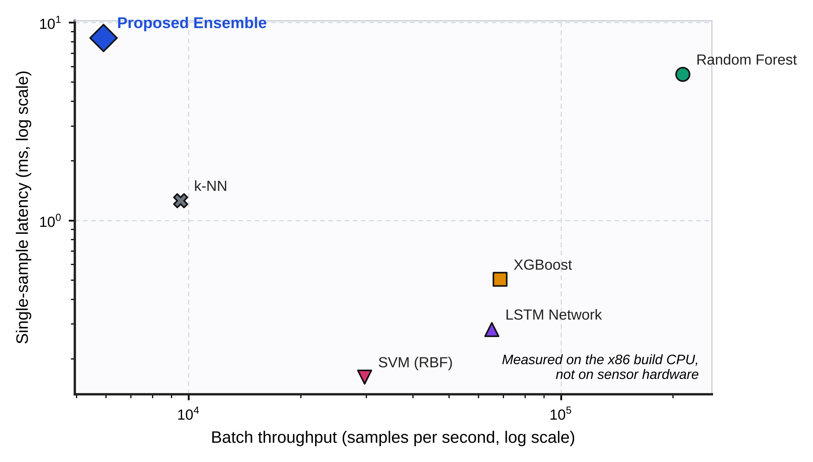
Figure 12. Per-model latency against throughput on an x86-64 CPU (not sensor hardware).
4.9. Sensitivity to Adversarial Perturbations
In Table 14, accuracy on LEACH-Sim is measured on a class-balanced sample of 2,000 test records after perturbations computed from the LSTM. ε is in robust-scaled feature units (one unit is the interquartile range of the feature). The clean accuracy of this sample is 92.6% for the ensemble. At FGSM ε = 0.10 the ensemble loses 7.6 points, the LSTM 8.1, XGBoost 9.5, the random forest 6.8, the SVM 3.8 and k-NN 1.6. PGD with ten steps is only slightly stronger than FGSM.
The perturbation is crafted with white-box access to the LSTM only, which is a differentiable network. Random forest, XGBoost, SVM and k-NN are attacked by transfer: the same perturbed inputs are simply fed to them. This is a weaker threat than an attacker who knows each model, because a gradient from one model need not point in a harmful direction for another. The numbers are therefore a lower bound on the damage an informed attacker could do.
On NSL-KDD and UNSW-NB15 the damage is much larger. At ε = 0.10 the LSTM loses 33.2 points on NSL-KDD and 39.1 on UNSW-NB15, XGBoost 16.1 and 37.0, and the ensemble 10.6 and 35.3. The ensemble inherits the weakness of the member that carries the highest weight: XGBoost holds 74% of the vote on UNSW-NB15. Averaging several models therefore does not by itself give robustness. The models that lose least are k-NN (1.7 and 1.2 points) and the SVM (5.4 and 12.9).
These results are not a certified defence. We did not test attacks designed against the tree models, such as boundary or decision-based attacks, nor perturbations restricted to features an attacker can really change. Perturbing flow counts in feature space is a stress test and not a model of a realistic adversary in a network.
In its present form the ensemble offers no adversarial guarantee. Adversarial training of the LSTM, input validation and weighting the vote toward the more resistant members are possible mitigations, but we did not test them.
Table 14. Accuracy (%) on a class-balanced LEACH-Sim sample under FGSM and PGD perturbations computed on the LSTM and passed on to the other models.
Model | No attack (%) | FGSM at 0.01 | FGSM at 0.05 | FGSM at 0.10 | FGSM at 0.15 | PGD at 0.01 | PGD at 0.05 | PGD at 0.10 | ∆@ε=0.10
RF | 92.5 | 92.2 | 90.0 | 85.8 | 80.2 | 92.2 | 90.0 | 85.6 | −6.8 pp
SVM-RBF | 88.3 | 87.9 | 86.3 | 84.5 | 82.4 | 87.8 | 86.4 | 84.5 | −3.8 pp
XGBoost | 92.7 | 90.6 | 88.2 | 83.2 | 78.6 | 90.6 | 87.7 | 82.3 | −9.5 pp
LSTM | 92.0 | 91.2 | 88.5 | 83.9 | 77.6 | 91.2 | 88.4 | 83.5 | −8.1 pp
kNN | 86.5 | 86.4 | 85.8 | 84.9 | 84.0 | 86.4 | 85.7 | 84.9 | −1.6 pp
Soft-vote ensemble | 92.6 | 91.1 | 89.2 | 85.0 | 79.7 | 91.1 | 88.9 | 84.4 | −7.6 pp
4.10. What Drives the Decisions: SHAP
To make the decisions interpretable we computed SHAP values for the XGBoost model on 2,000 LEACH-Sim test records. SHAP attributes each prediction additively to the input features. The 15 features with the largest mean absolute SHAP value are in Table 15. Three features carry 60% of the total: the forwarding ratio (22.5%), the number of advertisements sent (21.2%) and the cluster-head frequency over the last ten rounds (16.6%). The first marks Blackhole and Grayhole nodes, which deliver less than they receive; the second marks Flooding nodes; the third marks nodes that become cluster head far more often than the 5% expected, which is how the simulator makes attackers claim the role. That last feature is partly an artefact of our attacker model. By group, statistical-flow features hold 41% of the SHAP mass, protocol features 30%, temporal features 27% and topology features 2%.

Table 15. The 15 LEACH-Sim features with the highest mean |SHAP| for XGBoost, plus their ranks under random-forest importance and mutual information. Groups: S statistical flow, Tm temporal, P protocol, T topology.
Rank | Feature | Group | Mean |SHAP| | Share (%) | Rank by RF | Rank by MI | Most shifted class
1 | Forwarding ratio (BS-received / CH-received) | S | 1.338 | 22.5 | 5 | 2 | Flooding
2 | ADV messages sent | P | 1.256 | 21.2 | 3 | 3 | Flooding
3 | CH frequency (last 10 rounds) | Tm | 0.987 | 16.6 | 4 | 8 | Blackhole
4 | EWMA of ADV messages sent | Tm | 0.378 | 6.4 | 1 | 7 | Flooding
5 | Data packets per member | S | 0.373 | 6.3 | 9 | 6 | Scheduling
6 | Drop rate (1 − forwarding ratio) | S | 0.278 | 4.7 | 13 | 4 | Flooding
7 | EWMA forwarding ratio | Tm | 0.263 | 4.4 | 6 | 17 | Flooding
8 | Schedule / JOIN ratio | P | 0.200 | 3.4 | 17 | 14 | Flooding
9 | Sent ratio (to BS / aggregated) | S | 0.198 | 3.3 | 2 | 1 | Flooding
10 | JOIN requests received | P | 0.189 | 3.2 | 11 | 10 | Scheduling
11 | JOIN received per ADV heard | P | 0.139 | 2.3 | 10 | 9 | Flooding
12 | EWMA of CH changes | T | 0.093 | 1.6 | 15 | 18 | Blackhole
13 | Data packets received by CH | S | 0.086 | 1.4 | 14 | 13 | Scheduling
14 | Delivery ratio (received / expected) | S | 0.080 | 1.3 | 7 | 5 | Scheduling
15 | Packets sent to BS by CH | S | 0.051 | 0.9 | 12 | 15 | Blackhole
16–18 | Remaining 3 features | Mixed | 0.033 | 0.6 | — | — | —
4.11. Agreement Between Importance Measures
Table 16 checks whether the importance rankings are stable and whether the measures agree. Within each data source, SHAP rankings from two disjoint halves of the test data agree almost perfectly (Spearman ρ = 1.000, 1.000 and 0.991). Agreement between SHAP and random-forest importance is weaker and varies with the data: ρ = 0.598 on LEACH-Sim, 0.939 on NSL-KDD and 0.695 on UNSW-NB15. On LEACH-Sim, SHAP and mutual information agree with ρ = 0.551.
The three data sources have different feature sets, so the rankings cannot be correlated feature by feature across them, and we make no claim about transfer between data sets. On NSL-KDD the leading features are src_bytes, count, dst_host_srv_count; on UNSW-NB15 they are sbytes, sttl, proto_udp.
Table 16. How well the importance rankings agree within each data source.
Dataset | Features analysed | ρ (SHAP, RF) | ρ (two halves) | Top-5 share (%) | Top feature | Top share (%) | SHAP vs RF
LEACH-Sim | 18 | 0.598 | 1.000 | 72.9 | fwd_ratio | 22.5 | Partly
NSL-KDD | 122 | 0.939 | 1.000 | 42.1 | src_bytes | 17.1 | Agrees
UNSW-NB15 | 194 | 0.695 | 0.991 | 40.9 | sbytes | 10.2 | Partly

5. Conclusions and Future Work

We built and evaluated a machine-learning pipeline that detects anomalies and classifies attacks in LEACH-based wireless sensor networks. With no WSN benchmark at hand, the sensor-network evidence comes from LEACH-Sim, a simulator written for this study, while NSL-KDD and UNSW-NB15 serve as general network checks. On 24 simulated networks unseen during training, the soft-voting ensemble reaches 99.55% accuracy and 92.94% macro-F1; its F1 is 99.9% for Flooding but only 85.1% for Grayhole. The tuned weights are RF 0.03, SVM 0.03, XGB 0.49, LSTM 0.38 and kNN 0.06. On NSL-KDD and UNSW-NB15 the macro-F1 values are 58.0% and 51.0%, and on neither does the ensemble clearly outperform XGBoost.
The SHAP analysis (Table 15) shows that on LEACH-Sim the forwarding ratio, the number of advertisements sent and the frequency of cluster-head election explain most decisions, while topology features add little in this simulator. SHAP and random-forest importances agree only moderately (ρ = 0.598), so any single ranking should be read with care.
- Deployment: the ensemble (24.5 MB, 8.4 ms per sample on an x86 CPU) is a base-station or gateway component.
- Screening at cluster heads: the autoencoder (8.9 KB) reaches an attack-versus-normal AUC of 0.9988 on LEACH-Sim without seeing attacks in training; it was not run on sensor hardware.
- Robustness: perturbations transferred from the LSTM lower ensemble accuracy by 7.6 points on LEACH-Sim and by 35.3 points on UNSW-NB15 at ε = 0.10, so the ensemble should not be treated as robust.
The main limitations are these. The sensor-network evidence is simulated, and attackers in LEACH-Sim follow simple rules (for example, they elect themselves cluster head too often), so real attackers may be harder or easier to find. Only 36 candidate features were engineered and the search budgets were small (6–8 trials per model) because of limited computing. There is no cross-dataset transfer test, because the data sources have different features, and no repeated random splits, so confidence intervals are not available. Latency and size were measured on an x86 CPU, not on motes. Future work should (1) repeat the study on real WSN traffic or a published WSN data set, (2) measure the small detectors on actual microcontrollers such as the nRF52840 or Zolertia boards, (3) test attacks that target the tree models and adversarial training, (4) examine federated training across clusters, and (5) add the attacks that were not simulated, notably Sybil, wormhole and sinkhole.

Correspondence

Mohd Nizam Husen
mnizam@unikl.edu.my
Adnan Yousif Dawod
adnanalshef@uokirkuk.edu.iq

Acknowledgments
None.

Funding
This research received no external financial support.

Author contributions
Conceptualisation was shared by all eight authors. Q.M.Z., A.Y.D., M.F.A. and S.R.A. designed the methods and carried out the investigation; data curation was done by Q.M.Z., A.Y.D. and M.F.A. Q.M.Z., A.Y.D., M.F.A. and S.R.A. wrote the first draft, which M.A.H.P., F.A.F., M.N.H. and A.S.M.M. reviewed and edited. M.N.H. and A.S.M.M. supervised, and project administration was handled by A.Y.D., M.N.H. and A.S.M.M. All authors approved the final version.

Availability: The NSL-KDD and UNSW-NB15 datasets can be downloaded from their original publishers. We supply the LEACH-Sim simulator, the feature and training code, the plotting scripts and every result file as supplementary material, so each table and figure can be reproduced.

Ethics statement
The work involved no human or animal subjects.

Consent to publish
No consent was required.

Conflict of interest
No competing interests are declared by the authors.

References

- Muhammad Ilyas Abu Saleh Musa Miah Fahmid Al Farid Md. Hezerul Abdul Karim Sarmad Dheyaa Azeez, Saadaldeen Rashid Ahmed. Intrusionnet: Deep learning-based hybrid model for detection of known and zero-day attacks. Computers, Materials & Continua, 88(1):–, 2026.
- Md. Tomig Uddin Ahmed, Nazrul Islam Bhuiya, and Md. Mahbubur Rahman. A secure enterprise architecture focused on security and technology-transformation (seast). In 2017 12th International Conference for Internet Technology and Secured Transactions (ICITST), pages 215–220. IEEE, 2017.
- Yu Jiang, Yufei Dou, and Aiqun Hu. Identification of iot devices based on hardware and software fingerprint features. Symmetry, 16(7):846, 2024.
- Asaduzzaman et al. Jony. An effective method to detect dhcp starvation attack using port scanning. In 2023 International Conference on Next-Generation Computing, IoT and Machine Learning (NCIM), pages 1–6, 2023.
- Anna L. Buczak and Erhan Guven. A survey of data mining and machine learning methods for cyber security intrusion detection. IEEE Communications Surveys & Tutorials, 18(2):1153–1176, 2016.
- Jaeun Choi, Gisung Kim, and Sehun Kim. A congestion-aware ids node selection method for wireless sensor networks. International Journal of Distributed Sensor Networks, 8(7):582139, 2012.
- Priya Pitre, Arya Gandhi, Vaishnavi Konde, Rahul Adhao, and Vinod Pachghare. An intrusion detection system for zero-day attacks to reduce false positive rates. In 2022 International Conference for Advancement in Technology (ICONAT), pages 1–6. IEEE, 2022.
- Eleni Darra and Sokratis K. Katsikas. A survey of intrusion detection systems in wireless sensor networks. In Intrusion Detection and Prevention for Mobile Ecosystems, pages 393–458. CRC Press, 2017.
- Tahesin Samira Delwar, Unal Aras, Sayak Mukhopadhyay, Akshay Kumar, Ujwala Kshirsagar, Yangwon Lee, Mangal Singh, and Jee-Youl Ryu. The intersection of machine learning and wireless sensor network security for cyber-attack detection: A detailed analysis. Sensors, 24(19):6377, 2024.
- Ali Akbar ForouzeshNejad, Farzad Arabikhan, and Ramin Taheri. The role of explainable ai (xai) in enhancing the security of machine learning systems against adversarial attacks. In Adversarial Example Detection and Mitigation Using Machine Learning, pages 153–170. Springer, 2026.
- Fahmid Al Farid Md. Shamim Anower Abu Saleh Musa Miah Md. Hezerul Abdul Karim Md. Al-Hasan, Mst. Rubina Aktar. Performance analysis of bandwidth aware hybrid powered 5g cloud radio access network. Computers, Materials & Continua, 87(1):–, 2026.
- Shihab Hossen Rafat, Mishat Nissat Jarin, Taher Muhammad Mahdee, Abu Saleh Musa Miah, Najmul Haque, Md Mahbubur Rahman Tusher, Jungpil Shin, and Istiaque Ahmed. Lightweight cryptographic algorithm analysis for secure iot communication on esp-32 platforms. In 2025 International Conference on Quantum Photonics, Artificial Intelligence, and Networking (QPAIN), pages 1–6. IEEE, 2025.
- Doaa A. Hamdi, Ayman M. Bahaa-Eldin, and Mohammed A. Sobh. A systematic literature review on deep learning-driven ids for software-defined wsn. Journal on Wireless Communications and Networking, 2026(1), 2026.
- Uma Subramanian and Hang See Ong. Analysis of the effect of clustering the training data in naive bayes classifier for anomaly network intrusion detection. Journal of Advances in Computer Networks, 2(1):85–88, 2014.
- Rashmi Benni, Sanjana A. More, Sameksha Bafna, and Amit V. Kachavimath. Securing wireless sensor networks: Swarm-enabled intrusion detection systems against dynamic black hole attacks. In Fifth Congress on Intelligent Systems, pages 397–420. Springer, 2025.
- Nazek Hassouneh and Saleh Al-Sharaeh. Intrusion detection in iot networks using lstm deep learning models with the unsw-nb15 dataset. In 2025 International Conference on New Trends in Computing Sciences (ICTCS), pages 263–269. IEEE, 2025.
- Hong-Dang Le and Minho Park. Enhancing multi-class attack detection in graph neural network through feature rearrangement. Electronics, 13(12):2404, 2024.
- Manu Devi, Priyanka Nandal, and Harkesh Sehrawat. Federated learning-enabled lightweight intrusion detection system for wireless sensor networks: A cybersecurity approach against ddos attacks in smart city environments. Intelligent Systems with Applications, 27:200553, 2025.
- N. Shantha Kumar and K. Hareesh. Secure routing through trust evaluation for aggregator node in hierarchical wireless sensor networks (wsn). International Journal of Computer Networks and Applications, 12(6):1005–1018, 2025.
- Varuna W. Rose, S. Naveen, and K. Shruthi. Hybrid svm–random forest ensemble superiority for static malware detection: A comparative study. International Journal of Recent Trends in Multidisciplinary Research, 2026.
- Ling Liu, Wenqi Wei, Ka-Ho Chow, Margaret Loper, Emre Gursoy, Stacey Truex, and Yanzhao Wu. Deep neural network ensembles against deception: Ensemble diversity, accuracy and robustness. In 2019 IEEE 16th International Conference on Mobile Ad Hoc and Sensor Systems (MASS), pages 274–282. IEEE, 2019.
- Kewei Sha, Wei Wei, T. Andrew Yang, Zhiwei Wang, and Wei Shi. On security challenges and open issues in internet of things. Future Generation Computer Systems, 83:326–337, 2018.
- Tanuj Singh, Animesh Jha, and K. Deepa Thilak. Cnn-based multi-layer ddos prevention and multi-class attack classification in cloud architecture. In 2025 10th International Conference on Communication and Electronics Systems (ICCES), pages 1465–1470. IEEE, 2025.
- Dinh-Hau Tran and Minho Park. Fn-gnn: A novel graph embedding approach for enhancing graph neural networks in network intrusion detection systems. Applied Sciences, 14(16):6932, 2024.
- Georg Disterer, Ame Alles, and Axel Hervatin. Denial-of-service (dos) attacks: Prevention, intrusion detection, and mitigation. In Cyber Warfare and Cyber Terrorism, pages 262–272. IGI Global, 2007.‏

Biographies (Required)

Qasim Mustafa Zainel: He obtained a Bachelor’s degree in Computer Software Engineering from Kirkuk Technical College, Kirkuk, Iraq in 2004, and a Master’s degree in Computer Engineering from Cankaya University, Ankara, Turkiye in 2016. During 2005–2012 he worked as an engineer and administrator of the Computer and Internet Division in the College of Management and Economics, University of Kirkuk. During 2017–2020, he worked as a lecturer in the College of Management and Economics, University of Kirkuk. From 2020 until now, he has worked as a lecturer and as an engineer and administrator of the Computer and Internet Division in the College of Physical Education and Sports Science, University of Kirkuk. In 2025, he received a PhD from Urmia University, Iran.


Adnan Yousif Dawod: He obtained a Bachelor’s degree in Computer Software Engineering from Kirkuk Technical College, Kirkuk, Iraq in 2003, and a Master’s degree in Computer Engineering from the Sam Higginbottom Institute, Allahabad, India in 2014. During 2004–2012 he worked as an engineer and administrator of the Computer and Internet Division in the College of Nursing, University of Kirkuk. During 2012–2020, he worked as a lecturer and head of the Computer and Internet Division at the College of Nursing, University of Kirkuk. In 2020, he worked as a lecturer and head of the Continuing Education Division at the College of Computer Science and Information Technology, University of Kirkuk, and from 2023 until now he has worked as a lecturer and head of the Continuing Education Division at the College of Nursing, University of Kirkuk.

Mohammed Fakhrulddin Abdulqader: He received his Bachelor’s degree in Computer Software Engineering from Kirkuk Technical College, Kirkuk, Iraq in 2003, and his Master’s degree in Computer Engineering from the Sam Higginbottom Institute, Allahabad, India in 2014. During 2004–2006 he worked as an engineer in the Presidency of the University of Kirkuk, and in 2006 he joined the College of Engineering, University of Kirkuk, to work as an engineer and head of the Computer and Internet Division. During 2006–2020, he worked as a lecturer and head of the Computer and Internet Division at the College of Engineering, University of Kirkuk. During 2020–2022, he worked as a lecturer and official of the Computer and Internet Division at the College of Computer Science and Information Technology, University of Kirkuk. From 2022 until now, he works as a lecturer, official, and director of scientific affairs at the College of Computer Science and Information Technology, University of Kirkuk.


Saadaldeen Rashid Ahmed: is a researcher and academic in Computer Science, Information Technology, and Computer Engineering. He received his B.Sc. in Computer Science from Tikrit University, Iraq, his M.Sc. in Information Technology from Altinbas University, Turkiye, and his Ph.D. in Computer Engineering from Karabuk University, Turkiye. He currently serves as the Director of the Scientific Research Center at Bayan University, Erbil, Iraq. His research interests include Artificial Intelligence, Machine Learning, Deep Learning, Computer Vision, Cybersecurity, Wireless Sensor Networks, and Internet of Things technologies. Dr. Ahmed has authored and co-authored numerous Scopus- and SCI-indexed publications and has served as editor, chair, and organizer for several international conferences. He was recognized as a Distinguished Researcher in 2022 and listed among the world’s top 2% of scientists.

Fahim Al Farid: He is a Faculty Lecturer at the Berlin School of Business & Innovation (BSBI), Germany, specializing in computer vision and artificial intelligence. With over 12 years of academic and research experience, he focuses on image and video analysis, deep learning, and intelligent visual systems. He previously served as a Postdoctoral Research Scientist at the Multimedia University and held research positions at the University of Ulsan and Sungkyunkwan University in South Korea. He earned his PhD in Information Technology from Multimedia University, an MSc in Electrical and Computer Engineering from the University of Ulsan, and a BSc in Computer Science and Engineering from the University of Chittagong. An active member of the IEEE, Dr. Al Farid has authored numerous peer-reviewed publications in areas including hand gesture recognition, crowd density estimation, plant disease detection, and intelligent monitoring systems. Beyond core AI research, his expertise extends to applied domains such as smart farming, medical imaging, electric-vehicle smart-charging systems, and solar photovoltaic home systems. Passionate about teaching and mentorship, he supervises postgraduate research and collaborates internationally to advance innovation in AI-driven technologies.


Maruf Al Hossain Prince: He received the B.Sc. Engg. degree in computer science and engineering from the Department of Computer Science and Engineering, Bangladesh Army University of Science and Technology (BAUST), Saidpur-5310, Bangladesh, in 2021, and is currently pursuing the M.Sc. Engg. degree at the Islamic University of Technology, Gazipur-1704, Bangladesh. He has served as a Lecturer in the Department of Computer Science and Engineering at German University Bangladesh, Gazipur-1702, Bangladesh, and currently serves as a Research Assistant at Chandpur Science and Technology University, Chandpur-3600, Bangladesh. He also serves as an Adjunct Lecturer at Gazipur Agricultural University, Gazipur-1706, Bangladesh.


Mohd Nizam Husen: He received the B.Sc. degree in computing from the University of Portsmouth, U.K., in 1997, the master’s degree in information technology from Universiti Utara Malaysia, Malaysia, in 2007, and the Ph.D. degree in computer engineering from Sungkyunkwan University, Suwon, South Korea, in 2017. He has been in the academic, research, and consultancy field, since 1997. He is currently a Deputy Dean (academic and technology) and an Associate Professor at the Universiti Kuala Lumpur Malaysian Institute of Information Technology (UniKL MIIT), Malaysia. He is the author of more than 40 research articles. His research interests include intelligent systems, visual attention, pattern recognition, and indoor localization. He is a Reviewer of various well-known journals, among others are the IEEE Communications Letters, IEEE Transactions on Industrial Electronics, Journal of Pattern Recognition Research, Mobile Networks and Applications (Springer), and Journal of Location Based Services. He is also a Certified Professional Technologist from the Malaysia Board of Technologist (MBOT), where he is actively involved as an Evaluation Panel for Technology and Technical Academic Programmes Accreditation. He is also appointed by the government as an Expert Panel for the Ministry of Science, Technology and Innovation (MOSTI) Research and Development Fund for the period of 2021–2023. Other than that, he is also a Certified iOS Application Developer and Certified Android Application Developer.


Abu Saleh Musa Miah: He received the B.Sc.Engg. and M.Sc.Engg. degrees in computer science and engineering from the Department of Computer Science and Engineering, University of Rajshahi, Rajshahi-6205, Bangladesh, in 2014 and 2015, respectively, achieving the first merit position. He received his Ph.D. in computer science and engineering from the University of Aizu, Japan, in 2024, under a scholarship from the Japanese government (MEXT). He assumed the positions of Lecturer and Assistant Professor at the Department of Computer Science and Engineering, Bangladesh Army University of Science and Technology (BAUST), Saidpur, Bangladesh, in 2018 and 2021, respectively. Currently, he is working as a visiting researcher (postdoc) at the University of Aizu since April 1, 2024. His research interests include AI, ML, DL, Human Activity Recognition (HCR), Hand Gesture Recognition (HGR), Movement Disorder Detection, Parkinson’s Disease (PD), HCI, BCI, and Neurological Disorder Detection. He has authored and co-authored more than 50 publications in widely cited journals and conferences.

