Image | 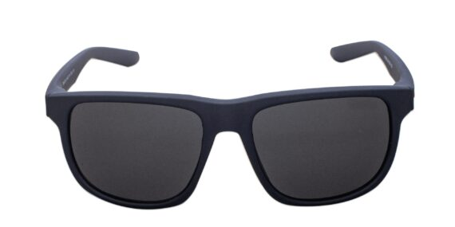
Brand | GUCCI
Model Name | Amable SPG
Price | RS 2500
PRODUCT DETAILS

