Image | 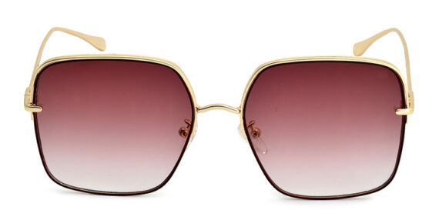
Brand | GUCCI
Model Name | Anticipate
Price | RS 1800
PRODUCT DETAILS

