Image | 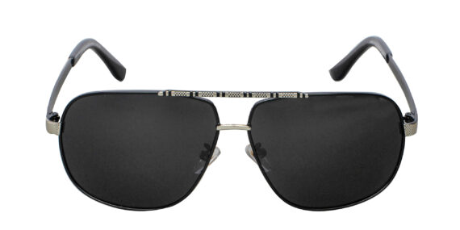
Brand | GUCCI
Model Name | Attraente SFG
Price | RS 2000
PRODUCT DETAILS

