Image | 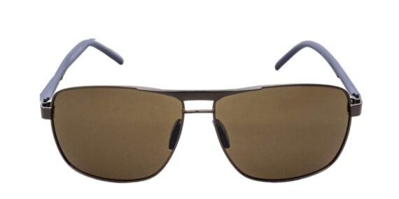
Brand | GUCCI
Model Name | Colosal SFG
Price | RS 2000
PRODUCT DETAILS

