Image | 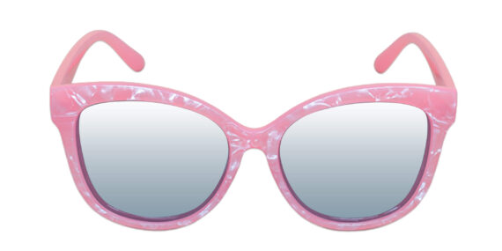
Brand | GUCCI
Model Name | Ecstasy P-6589
Price | RS 1500
PRODUCT DETAILS

