Image | 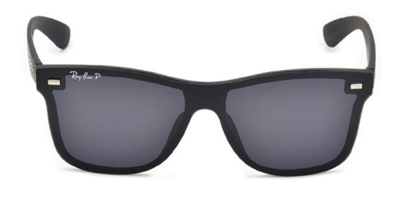
Brand | GUCCI
Model Name | Gleam
Price | RS 1800
PRODUCT DETAILS

