Image | 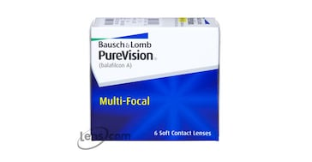
Brand | MICHEAL KORS
Model Name | BAUSH & LOMB PURE VISION (MULTI FOCAL)
Price | RS 1499
PRODUCT DETAILS

