Technical Solution Description

eCare

Table of Contents

Table of Contents
1. Task 3
Part 1 3
Part 2 3
2. Used technologies 4
3. Additional features 5
4. Database schema 6
5. Architecture 8
5.1 First application 8
5.2 Second application 11
6. Tests 12
7. Deployment 13
8. GUI 14

1. Task

Part 1

The task is to develop an application that models the information system of the mobile operator.

Application must provide the following functionality:

For clients:
- View contracts
- Manage contracts
- Manage options

For managers:
- Create account for client
- Find clients by phone
- View all clients and tariffs
- Create and manage contracts
- Create and manage tariffs
- Create and manage options

Part 2

The task is to develop an application for advertising stand, showing tariffs from first application.

Requirements
- Applications should communicate through MQ

2. Used technologies

Technology | Version
ActiveMQ | 5.15.8
MySQL | 5.7
Spring | 4.3.18.RELEASE
Spring-Security | 4.2.5.RELEASE
ModelMapper | 0.7.4
Java | 8
Wildfly | 14.0.1.Final
Hibernate | 4.3.11.Final
JUnit | 4.12
Log4j | 1.2.17
Mockito | 1.10.19
lombok | 1.18.2
JSF | 2.3
Maven | 3.2.0
IntelliJ IDEA | 2018.3
AspectJ | 1.8.13
Jackson | 2.4.1

3. Additional features

- Forgotten password recovery - First application can send a link (with a unique token) to the client by mail. Client can use this link to change password.

- Top up account - Clients can deposit money into their account using a credit card or Yandex.Money. First application receives notifications from Yandex, checks the transaction token and puts the data into the database.

- Speech recognition - frontend of the first application can recognize words and find the corresponding item in the menu.

- Continuous integration - Jenkins downloads sources from GitHub, builds and tests applications and deploy them to WildFly.

4. Database schema

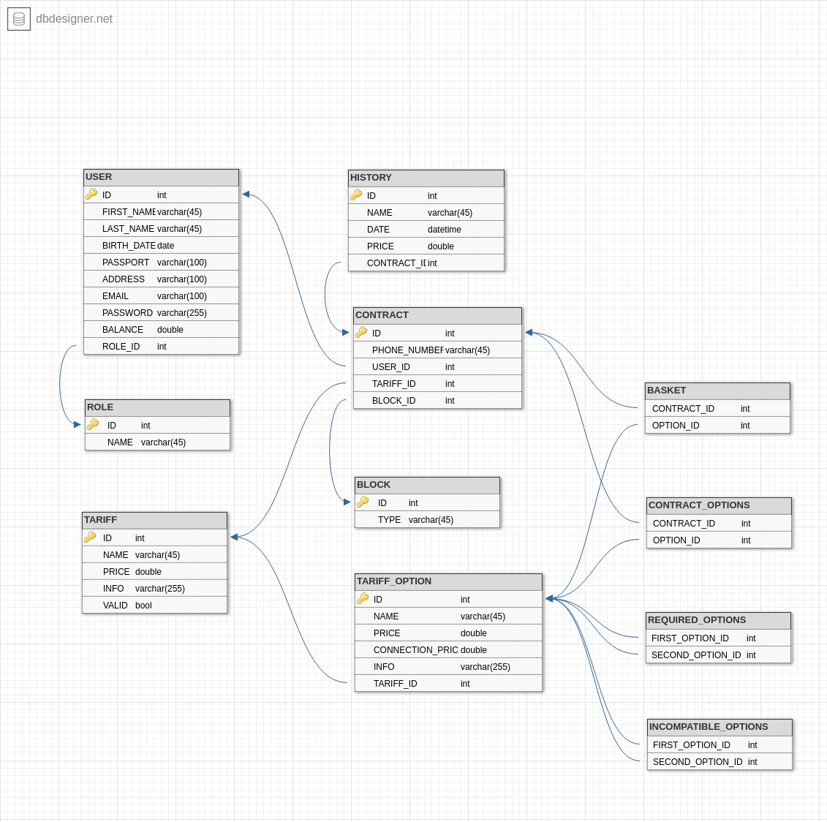Illustration 1: database

5. Architecture

5.1 First application
- Dao level
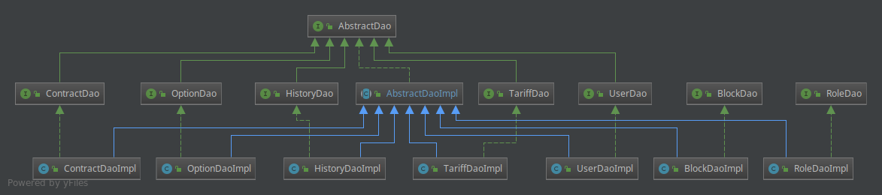Illustration 2: Dao level

- Service level
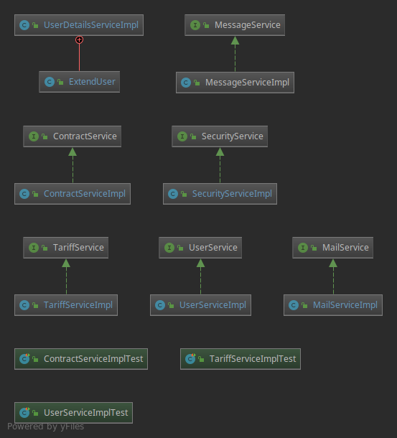Illustration 3: Service level

- Controllers level
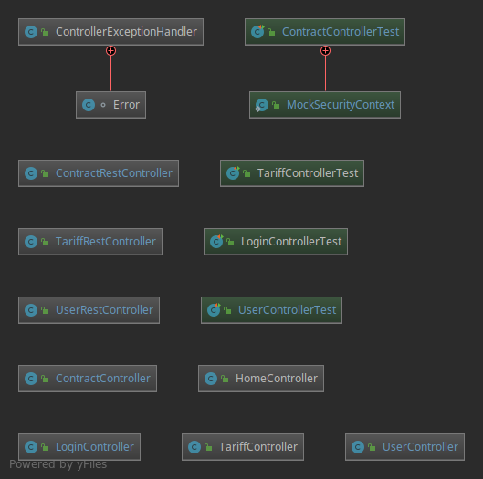Illustration 4: Controllers level

- View level
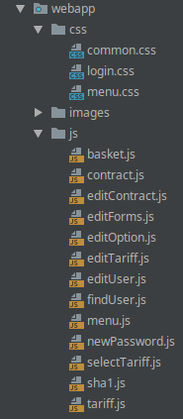
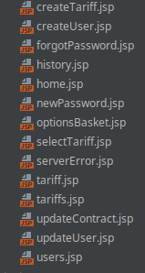
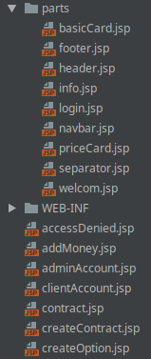Illustration 5: View level

- Exceptions level
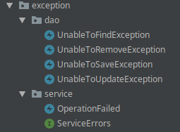Illustration 6: Exceptions level

- Entity level
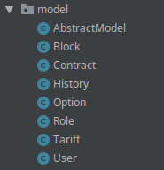Illustration 7: Entity level

- Dto level
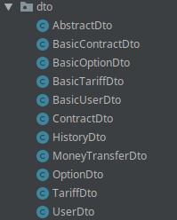Illustration 8: Dto level

- Converters level
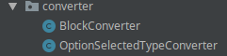Illustration 9: Converters level

- For logging was used AOP

5.2 Second application
Second application has next structure:
- View level
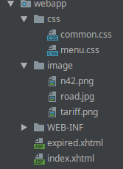Illustration 10: View level

- Controllers level
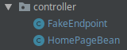Illustration 11: Controllers level

- Service level
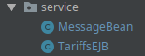Illustration 12: Service level

6. Tests
JUnit tests:
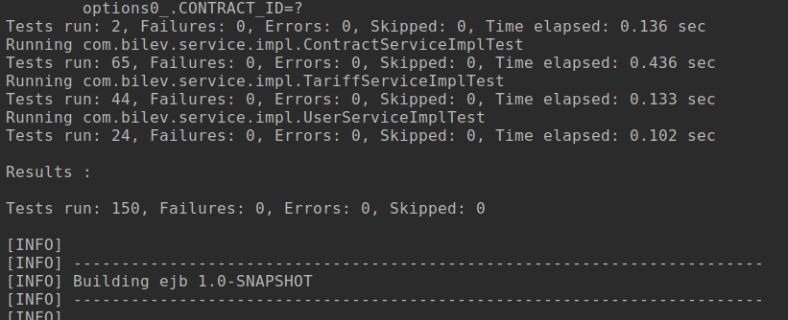Illustration 13: tests results
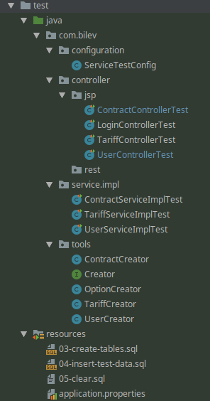Illustration 14: JUnit tests

7. Deployment

Project can be built with Jenkins, so all you need to build and deploy is commit changes to Github:

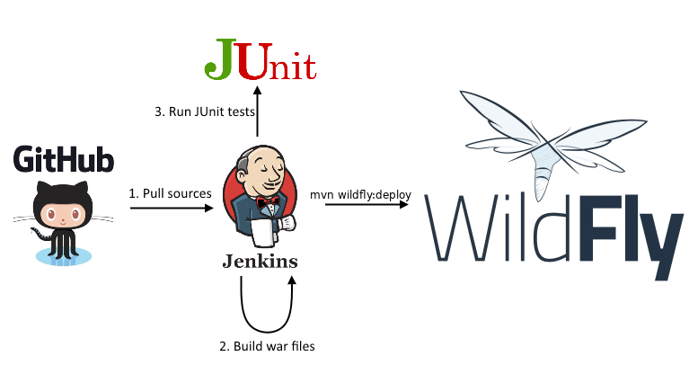

Manual build
mvn clean install
mvn wildfly:deploy

8. GUI

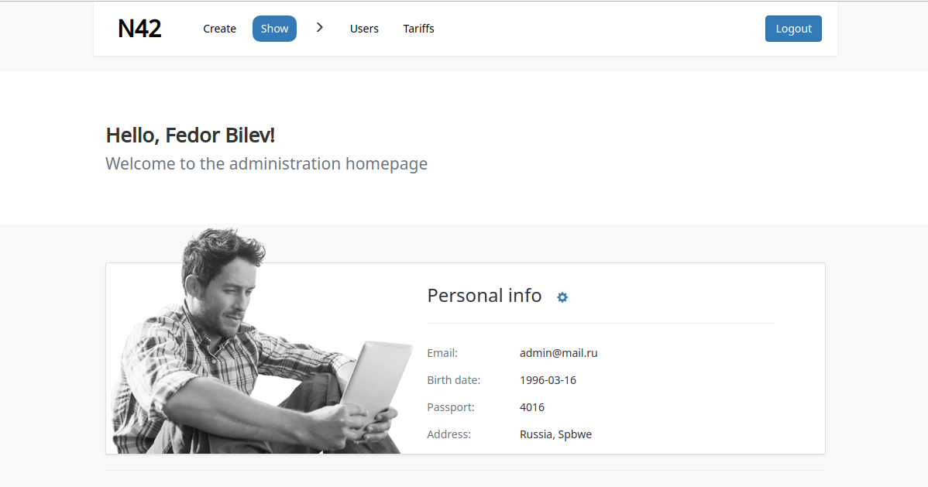Illustration 15: accoount

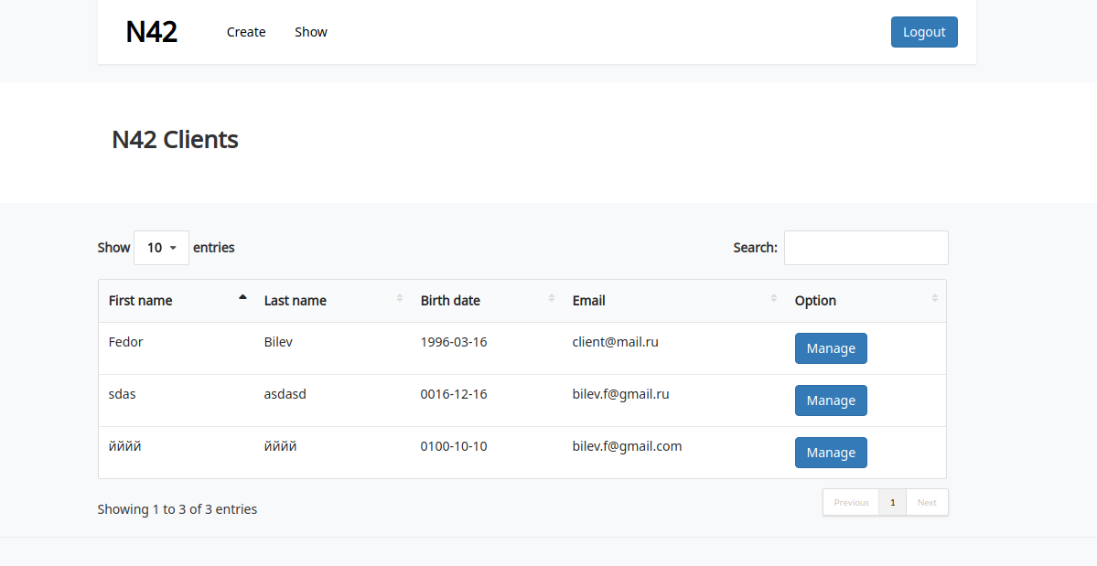Illustration 16: list of clients

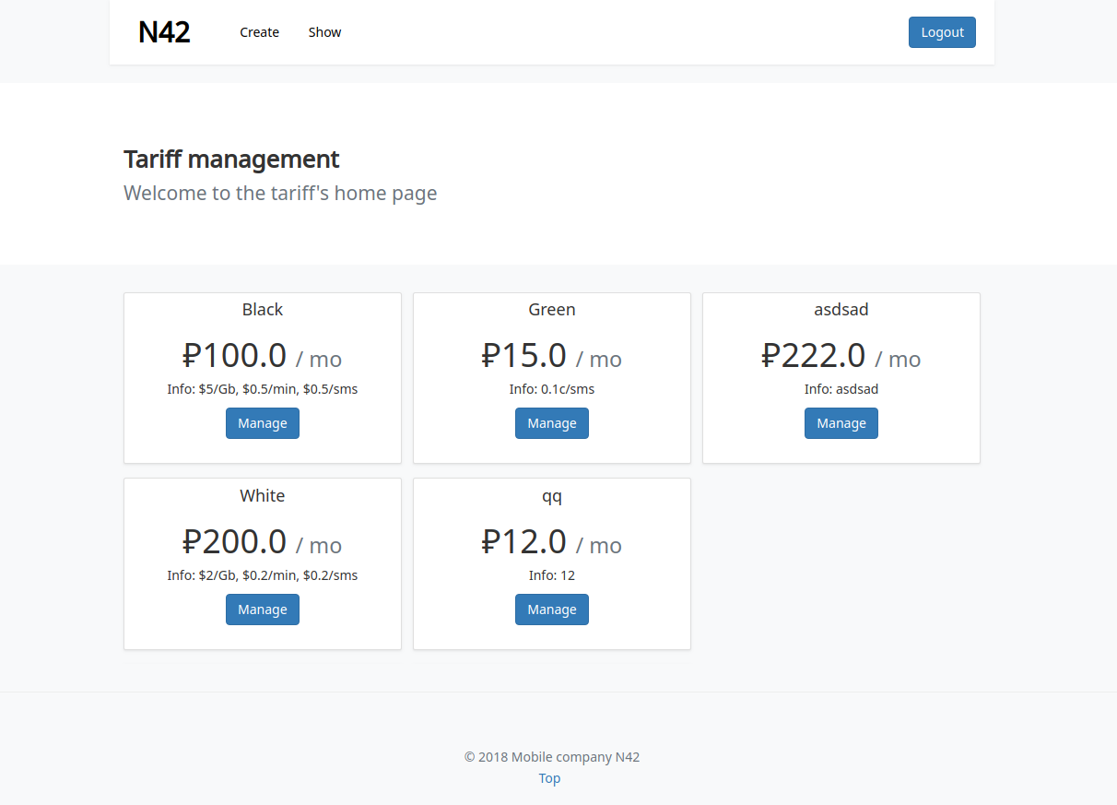Illustration 17: list of tariffs
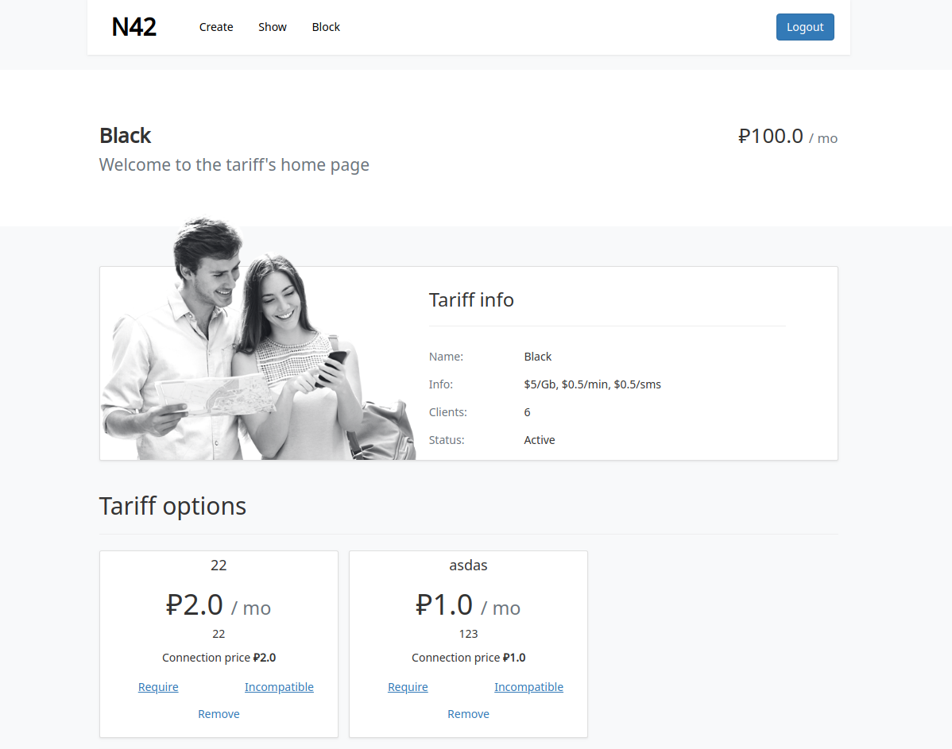Illustration 18: tariff's home page
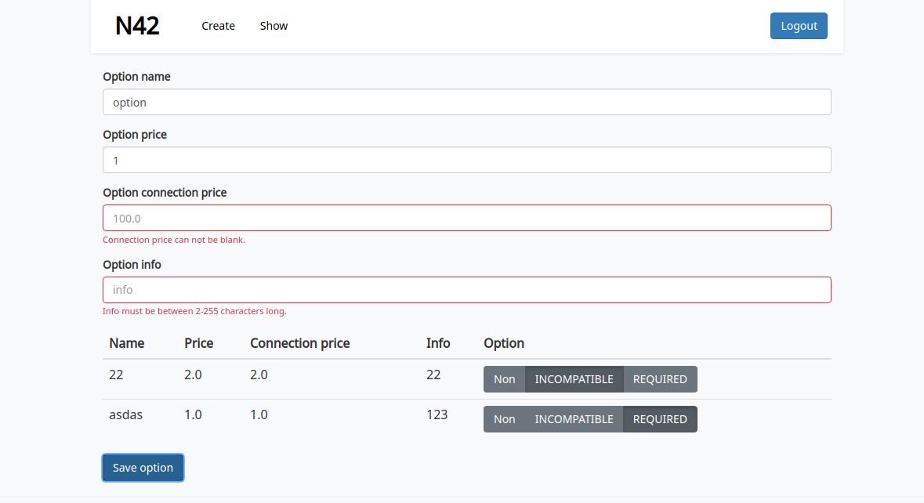Illustration 19: new option
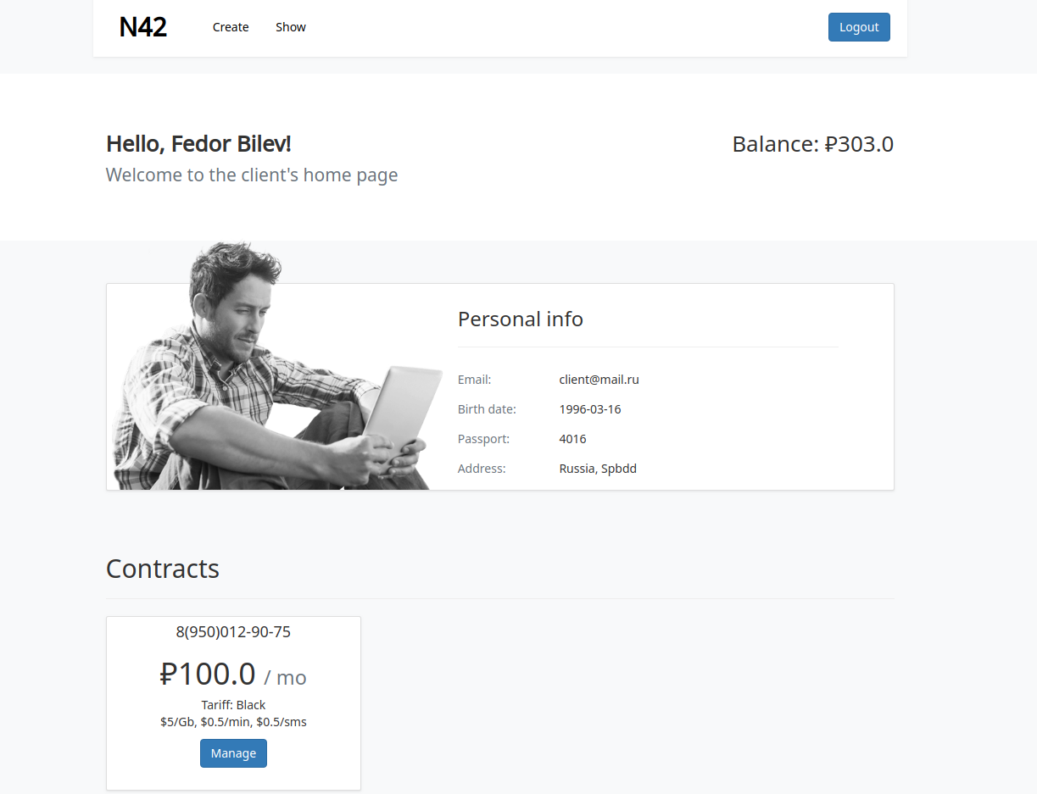Illustration 20: client account
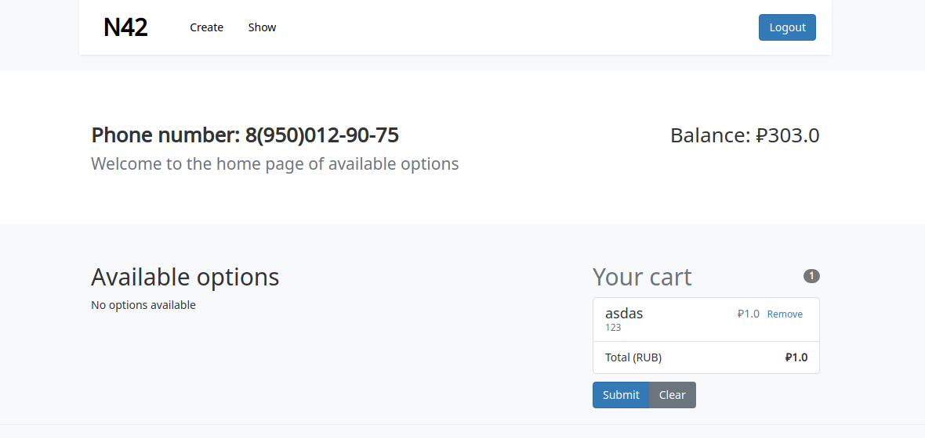Illustration 21: basket
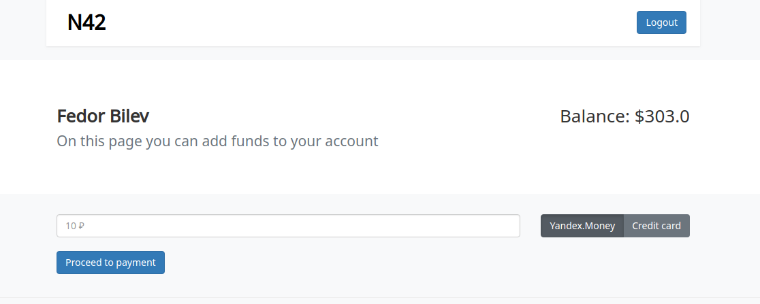Illustration 22: add money

