DATA SCIENCE METHODS

Assignment 01

09/03/2022

***Group 01:***

Bilge Kasapoğlu – u941664

Hoan Van Nguyen – u1274449

Jiahe Wang – u489199

Roshini Sudhaharan – u725261

# QUESTION 01

#create matrix with n = 6 observations and p = 2 features;   
#third column indicating cluster: 1 is cluster A, 2 is cluster B  
set.seed(1)  
m = cbind(x1 = c(4, 1, 0, 2, 6, 4), x2 = c(1, 3, 4, 1, 2, 0), clusters = c(2,1,1,2,1,2))  
m

## x1 x2 clusters  
## [1,] 4 1 2  
## [2,] 1 3 1  
## [3,] 0 4 1  
## [4,] 2 1 2  
## [5,] 6 2 1  
## [6,] 4 0 2

### a.

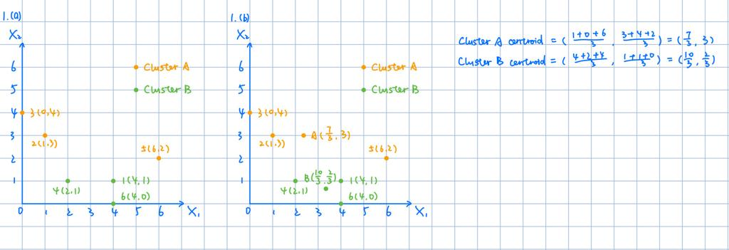

#plot x1 against x2  
  
plot(m[,1], m[,2], col = ifelse(m[,3] == 1, "blue", "red"))  
legend(3,4,legend = c("Cluster A", "Cluster B"), col = c("Blue", "Red"), pch = 1)

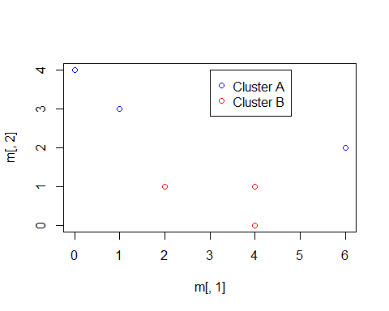

### b.

#calculate centroids for two clusters A & B and plot them  
  
centroidA = c(mean(m[m[,3]==1, 1]), mean(m[m[,3]==1, 2]))  
centroidB = c(mean(m[m[,3]==2, 1]), mean(m[m[,3]==2, 2]))  
print(centroidA)

## [1] 2.333333 3.000000

print(centroidB)

## [1] 3.3333333 0.6666667

plot(m[,1], m[,2], col = ifelse(m[,3] == 1, "blue", "red"))  
legend(3,4,legend = c("Cluster A", "Cluster B"), col = c("Blue", "Red"), pch = 1)  
points(x = centroidA[1], y = centroidA[2], col = "blue", pch = 16, cex = 2)  
points(x = centroidB[1], y = centroidB[2], col = "red", pch = 16, cex = 2)

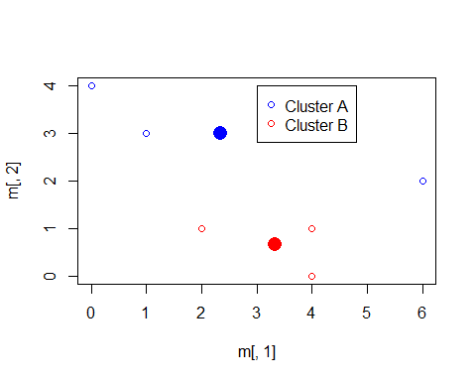

### c.

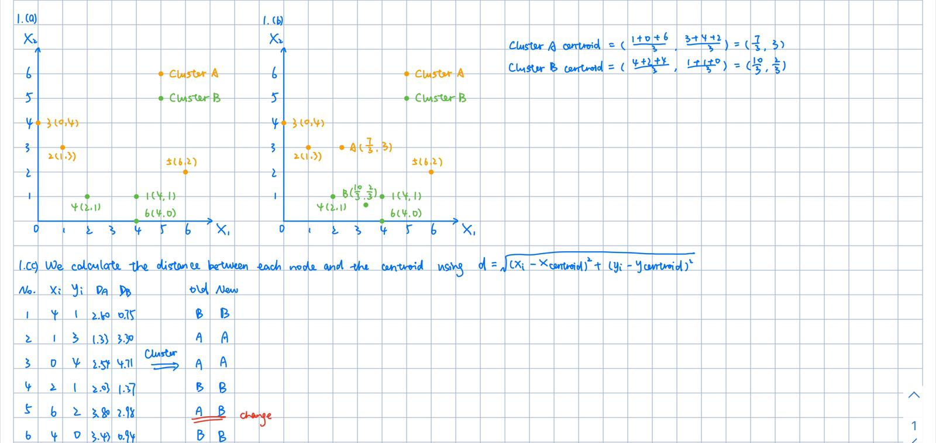

#assign each observations to the centroid   
#to which it is the closest in terms of Euclidean distance  
  
euclidean = function(a, b) {  
 return(sqrt((a[1] - b[1])^2 + (a[2]-b[2])^2))  
}  
assign_clusters = function(m, centroidA, centroidB) {  
 new_clusters = rep(NA, nrow(m))  
 for (i in 1:nrow(m)) {  
 if (euclidean(m[i,], centroidA) < euclidean(m[i,], centroidB)) {  
 new_clusters[i] = 1  
 } else {  
 new_clusters[i] = 2  
 }  
 }  
 return(new_clusters)  
}  
new_clusters = assign_clusters(m, centroidA, centroidB)  
new_clusters

## [1] 2 1 1 2 2 2

#new matrix including new cluster membership  
  
m1 <- cbind(m, new_clusters)  
m1

## x1 x2 clusters new_clusters  
## [1,] 4 1 2 2  
## [2,] 1 3 1 1  
## [3,] 0 4 1 1  
## [4,] 2 1 2 2  
## [5,] 6 2 1 2  
## [6,] 4 0 2 2

#new plot showing new cluster membership  
  
plot(m1[,1], m1[,2], col = ifelse(m1[,4] == 1, "blue", "red"))  
legend(3,4,legend = c("Cluster A", "Cluster B"), col = c("Blue", "Red"), pch = 1)

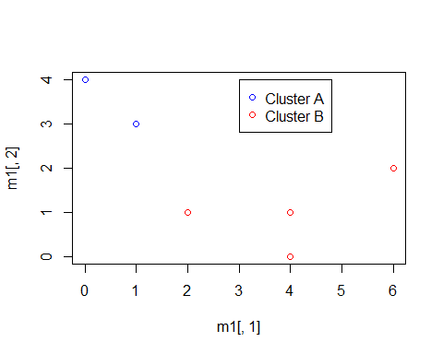

### d.

#repeat 1c until the answer stops changing  
  
last_clusters = rep(-1, 6)  
while (!all(last_clusters == new_clusters)) {  
 last_clusters = new_clusters  
 centroidA = c(mean(m1[m1[,4] == 1, 1]), mean(m1[m1[,4] == 1, 2]))  
 centroidB = c(mean(m1[m1[,4] == 2, 1]), mean(m1[m1[,4] == 2, 2]))  
 print(centroidA)  
 print(centroidB)  
 new_clusters = assign_clusters(m1, centroidA, centroidB)  
}

## [1] 0.5 3.5  
## [1] 4 1

new_clusters

## [1] 2 1 1 2 2 2

#### According to the results above, we can conclude that observations 2 and 3 belong to one cluster, and other observations 1, 4, 5, and 6 belong to another cluster.

# QUESTION 02

# Create a directory to store downloaded data  
dir.create("A1/data")

## Warning in dir.create("A1/data"): cannot create dir 'A1\data', reason 'No such  
## file or directory'

# Download data  
download_data <- function(url, filename){  
 download.file(url = url, destfile = paste0(filename, ".csv"))  
}  
  
url <- "https://drive.google.com/uc?id=1DaYBBo_qohz-QiMOIPu08m0QXbjRsu0Q&export=download"  
  
download_data(url, "2020_NL_Region_Mobility_Report")  
  
# Load the data  
dta <- read.csv("2020_NL_Region_Mobility_Report.csv")

# cleaning the dataset  
d = dta[!(is.na(dta$sub_region_1) | dta$sub_region_1 =="") & (is.na(dta$sub_region_2) | dta$sub_region_2==""),]  
d <- d %>% select(date,sub_region_1,sub_region_2,  
 transit_stations_percent_change_from_baseline,   
 workplaces_percent_change_from_baseline,   
)  
  
# reshaping the dataset  
  
transit = d %>% pivot_wider(  
 id_cols = "date",  
 names_from = "sub_region_1",names_prefix = "transit",  
 names_sep = "_",  
 values_from = c(transit_stations_percent_change_from_baseline),  
)  
  
work = d %>% pivot_wider(  
 id_cols = "date",  
 names_from = "sub_region_1",names_prefix = "work",  
 names_sep = "_",  
 values_from = c(workplaces_percent_change_from_baseline),  
)  
  
  
combined = merge(transit,work,by='date',all=T)  
combined$date=as.Date(combined$date)

### a.

combined_new = combined[,1] %>% as.data.frame()  
names(combined_new)[1] <- "date"  
regions <- names(combined)[2:ncol(combined)]  
date = combined[,1] %>% as.Date   
for (i in c(2:ncol(combined))){  
 ts1 <- combined[,c(1,i)]  
 ts1 = na.omit(ts1)  
 ts = ts1[,2]  
 smoothed <- hpfilter(ts, freq=200)  
 ts1[,2] = as.matrix(smoothed$trend)  
 combined_new = combined_new  
 combined_new <- merge(ts1, combined_new, by = "date", all.y = TRUE)  
 names(combined_new)[ncol(combined_new)] <- regions[i-1]  
}   
summary(combined_new)

## date workZeeland.V1 workUtrecht.V1   
## Min. :2020-02-15 Min. :-61.15221 Min. :-66.16620   
## 1st Qu.:2020-05-05 1st Qu.:-25.78338 1st Qu.:-37.30416   
## Median :2020-07-24 Median :-17.13599 Median :-27.35050   
## Mean :2020-07-24 Mean :-20.24214 Mean :-30.03427   
## 3rd Qu.:2020-10-12 3rd Qu.:-12.50645 3rd Qu.:-22.49182   
## Max. :2020-12-31 Max. : 4.22166 Max. : 0.73892   
## NA's :3   
## workSouth Holland.V1 workOverijssel.V1 workNorth Holland.V1  
## Min. :-61.82493 Min. :-66.26223 Min. :-63.37622   
## 1st Qu.:-34.14222 1st Qu.:-32.43427 1st Qu.:-36.13931   
## Median :-25.56455 Median :-20.24331 Median :-28.14503   
## Mean :-27.83801 Mean :-23.83178 Mean :-30.21807   
## 3rd Qu.:-21.33089 3rd Qu.:-15.73630 3rd Qu.:-24.27495   
## Max. : 1.44974 Max. : 3.71588 Max. : 2.69142   
##   
## workNorth Brabant.V1 workLimburg.V1 workGroningen.V1   
## Min. :-63.30115 Min. :-60.83267 Min. :-63.32686   
## 1st Qu.:-32.52579 1st Qu.:-30.05247 1st Qu.:-33.94933   
## Median :-21.30181 Median :-19.02152 Median :-23.49639   
## Mean :-24.91900 Mean :-23.13396 Mean :-25.93769   
## 3rd Qu.:-17.19576 3rd Qu.:-15.48453 3rd Qu.:-18.04952   
## Max. : 3.12409 Max. : 4.16776 Max. : 4.12526   
##   
## workGelderland.V1 workFriesland.V1 workFlevoland.V1   
## Min. :-63.45007 Min. :-63.28986 Min. :-63.69390   
## 1st Qu.:-32.01014 1st Qu.:-30.94973 1st Qu.:-32.95734   
## Median :-19.78411 Median :-18.86011 Median :-25.18019   
## Mean :-23.42368 Mean :-22.19315 Mean :-26.61321   
## 3rd Qu.:-15.36001 3rd Qu.:-14.64459 3rd Qu.:-19.59444   
## Max. : 2.11215 Max. : 4.69689 Max. : 2.41037   
## NA's :3   
## workDrenthe.V1 transitZeeland.V1 transitUtrecht.V1   
## Min. :-63.38117 Min. :-58.75816 Min. :-74.17694   
## 1st Qu.:-30.09956 1st Qu.:-36.89267 1st Qu.:-58.27816   
## Median :-19.55987 Median :-26.33716 Median :-51.93085   
## Mean :-22.00000 Mean :-20.82432 Mean :-49.43925   
## 3rd Qu.:-14.18033 3rd Qu.: 1.87876 3rd Qu.:-45.05694   
## Max. : 4.37224 Max. : 16.74319 Max. : 7.53359   
## NA's :3 NA's :25   
## transitSouth Holland.V1 transitOverijssel.V1 transitNorth Holland.V1  
## Min. :-64.19970 Min. :-67.51329 Min. :-74.33453   
## 1st Qu.:-47.22250 1st Qu.:-48.88477 1st Qu.:-60.76767   
## Median :-43.46913 Median :-41.15154 Median :-55.08408   
## Mean :-41.07165 Mean :-39.66355 Mean :-50.57944   
## 3rd Qu.:-36.31919 3rd Qu.:-34.46636 3rd Qu.:-42.78297   
## Max. : 0.95582 Max. : 3.86257 Max. : 1.62485   
##   
## transitNorth Brabant.V1 transitLimburg.V1 transitGroningen.V1  
## Min. :-68.40679 Min. :-59.93348 Min. :-64.37397   
## 1st Qu.:-51.64226 1st Qu.:-38.04448 1st Qu.:-47.01244   
## Median :-46.84983 Median :-31.98389 Median :-39.43008   
## Mean :-44.16199 Mean :-30.48598 Mean :-38.32087   
## 3rd Qu.:-39.77811 3rd Qu.:-21.72211 3rd Qu.:-34.01597   
## Max. : 10.16420 Max. : 7.70066 Max. : 5.27273   
##   
## transitGelderland.V1 transitFriesland.V1 transitFlevoland.V1  
## Min. :-61.27717 Min. :-52.77479 Min. :-66.14571   
## 1st Qu.:-42.86606 1st Qu.:-28.73414 1st Qu.:-44.77956   
## Median :-37.18129 Median :-14.04728 Median :-37.02641   
## Mean :-35.62617 Mean :-13.90159 Mean :-37.27987   
## 3rd Qu.:-29.68818 3rd Qu.: 2.86600 3rd Qu.:-30.94921   
## Max. : 1.91965 Max. : 20.24478 Max. : 3.54422   
## NA's :6 NA's :3   
## workZeeland.V1   
## Min. :-61.37160   
## 1st Qu.:-38.08222   
## Median :-33.98673   
## Mean :-33.06984   
## 3rd Qu.:-28.93562   
## Max. : 4.71238   
## NA's :6

names(combined_new)[2:ncol(combined_new)] = regions  
  
transit_hp = combined_new[,c(1:ncol(transit))]  
work_hp = select(combined_new,c(date, workDrenthe:workZeeland))  
  
cl <- rainbow(12)  
  
plot(transit_hp$date, transit_hp$transitDrenthe, type="l", col = cl[1], ylim = c(-80,50), xlab = "Date", ylab = "Trend in Transit")  
lines(transit_hp$date, transit_hp$transitFlevoland, type = "l", col = cl[2])  
lines(transit_hp$date, transit_hp$transitFriesland, type = "l", col = cl[3])  
lines(transit_hp$date, transit_hp$transitGelderland, type = "l", col = cl[4])  
lines(transit_hp$date, transit_hp$transitGroningen, type = "l", col = cl[5])  
lines(transit_hp$date, transit_hp$transitLimburg, type = "l", col = cl[6])  
lines(transit_hp$date, transit_hp$transitNorthBrabant, type = "l", col = cl[7])  
lines(transit_hp$date, transit_hp$transitNorthHolland, type = "l", col = cl[8])  
lines(transit_hp$date, transit_hp$transitOverijssel, type = "l", col = cl[9])  
lines(transit_hp$date, transit_hp$transitSouthHolland, type = "l", col = cl[10])  
lines(transit_hp$date, transit_hp$transitUtrecht, type = "l", col = cl[11])  
lines(transit_hp$date, transit_hp$transitZeeland, type = "l", col = cl[12])

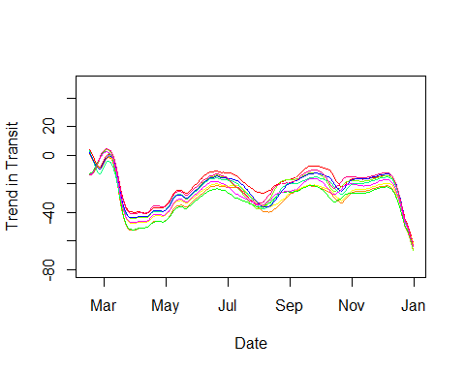

#### We see a comovement in transit among different regions.

plot(work_hp$date, work_hp$workDrenthe, type="l", col = cl[1], ylim = c(-80,50), xlab = "Date", ylab = "Trend in Work")  
lines(work_hp$date, work_hp$workFlevoland, type = "l", col = cl[2])  
lines(work_hp$date, work_hp$workFriesland, type = "l", col = cl[3])  
lines(work_hp$date, work_hp$workGelderland, type = "l", col = cl[4])  
lines(work_hp$date, work_hp$workGroningen, type = "l", col = cl[5])  
lines(work_hp$date, work_hp$workLimburg, type = "l", col = cl[6])  
lines(work_hp$date, work_hp$workNorthBrabant, type = "l", col = cl[7])  
lines(work_hp$date, work_hp$workNorthHolland, type = "l", col = cl[8])  
lines(work_hp$date, work_hp$workOverijssel, type = "l", col = cl[9])  
lines(work_hp$date, work_hp$workSouthHolland, type = "l", col = cl[10])  
lines(work_hp$date, work_hp$workUtrecht, type = "l", col = cl[11])  
lines(work_hp$date, work_hp$workZeeland, type = "l", col = cl[12])

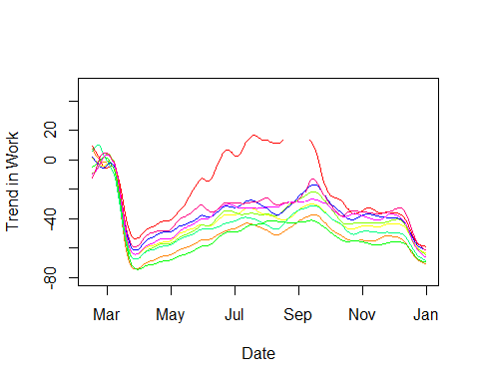

#### We see a comovement in work among different regions. However, we think the comovement is weaker in comparison to transit.

### b.

t <- transit_hp[,2:ncol(transit_hp)]  
t <- na.omit(t)  
t <- scale(t)  
pc_transit<-princomp(t,cor=TRUE,scores=TRUE)  
  
loadings_transit_2 <- pc_transit$loadings[,1:2]  
loadings_transit_2

## Comp.1 Comp.2  
## transitDrenthe 0.2872077 0.2736024  
## transitFlevoland 0.2882801 0.3007488  
## transitFriesland 0.2869774 0.3093989  
## transitGelderland 0.2902589 -0.2750322  
## transitGroningen 0.2869498 -0.1930421  
## transitLimburg 0.2891917 0.2803822  
## transitNorth Brabant 0.2873059 0.2891416  
## transitNorth Holland 0.2891703 -0.3223546  
## transitOverijssel 0.2902784 0.2606661  
## transitSouth Holland 0.2879154 -0.3724490  
## transitUtrecht 0.2910786 -0.2249646  
## transitZeeland 0.2894484 -0.3203945

PC1 <- loadings_transit_2[2]   
PC2 <- loadings_transit_2[3]   
  
checkPC1 <- as.data.frame(loadings_transit_2) %>% arrange(abs(loadings_transit_2[,1]))  
checkPC2 <- as.data.frame(loadings_transit_2) %>% arrange(abs(loadings_transit_2[,2]))  
  
# loadings plot  
plot(loadings_transit_2)

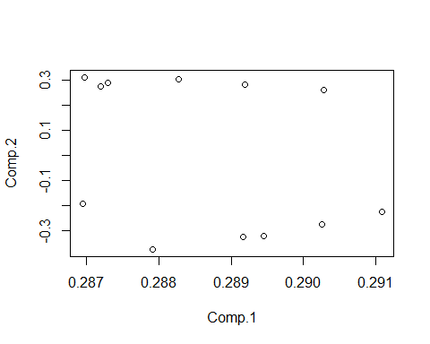

#### We see that provinces cluster together. It seems like they cluster together on the second loading.

### c.

pr.var=pc_transit$sdev^2  
pve = pr.var/sum(pr.var)  
  
# Put two plots side by side  
par(mfrow=c(1,2))  
plot(pve,xlab="PC",ylab="% Variance Explained",ylim=c(0,1),type='b')  
plot(cumsum(pve),xlab="PC",ylab="Cumulative PVE",ylim=c(0,1),type='b')

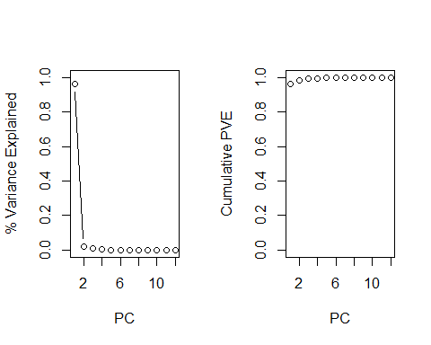

#### The first two components seem to explain the most of the variation in the data.Thus, the first two components seems to be the appropriate solution for the PCA problem.

### d.

# The first component of the transit  
loadings_transit_1 <- pc_transit$loadings[,1]  
  
# The first component of the work  
w <- work_hp[,2:ncol(work_hp)]  
w <- na.omit(w)  
w <- scale(w)  
pc_work<-princomp(w,cor=TRUE,scores=TRUE)  
  
loadings_work_1 <- pc_work$loadings[,1]  
loadings_work_1

## workDrenthe workFlevoland workFriesland workGelderland   
## 0.2321948 0.2952406 0.3006682 0.3010604   
## workGroningen workLimburg workNorth Brabant workNorth Holland   
## 0.2929839 0.2940664 0.2997617 0.2959767   
## workOverijssel workSouth Holland workUtrecht workZeeland   
## 0.3014886 0.2385959 0.3007852 0.2996846

# The first component of the whole  
whole <- combined_new[,2:ncol(combined_new)]  
whole <- na.omit(whole)  
whole <- scale(whole)  
  
pc_whole<-princomp(whole,cor=TRUE,scores=TRUE)  
  
loadings_whole_1 <- pc_whole$loadings[,1]  
loadings_whole_1

## transitDrenthe transitFlevoland transitFriesland   
## 0.2101852 0.2152953 0.2152513   
## transitGelderland transitGroningen transitLimburg   
## 0.2057773 0.2165807 0.2051754   
## transitNorth Brabant transitNorth Holland transitOverijssel   
## 0.2029695 0.2064625 0.2064379   
## transitSouth Holland transitUtrecht transitZeeland   
## 0.2026282 0.2117402 0.2041070   
## workDrenthe workFlevoland workFriesland   
## 0.1429487 0.2034520 0.2076602   
## workGelderland workGroningen workLimburg   
## 0.2133238 0.1958040 0.2023335   
## workNorth Brabant workNorth Holland workOverijssel   
## 0.2071205 0.2143730 0.2120688   
## workSouth Holland workUtrecht workZeeland   
## 0.1549028 0.2141133 0.2107004

plot(loadings_transit_1, loadings_work_1, type ="p")  
  
comb_trans_work <- append(loadings_transit_1, loadings_work_1)  
  
par(mfrow = c(1, 2))  
# the plot : work vs transit  
plot(loadings_transit_1, loadings_work_1, type ="p")  
abline(lm(loadings_work_1 ~ loadings_transit_1), lty = 2, col = "green")

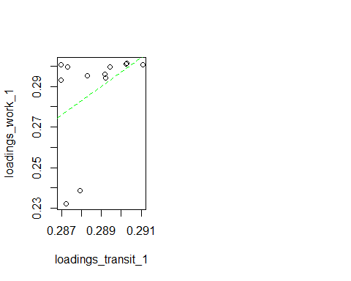

#### It seems like the first PCs of Transit and Work do not seem to comove with each other.

# the plot : work + transit vs whole  
plot(comb_trans_work, loadings_whole_1, type ="p")  
abline(lm(loadings_whole_1 ~ comb_trans_work), lty = 2, col = "green")

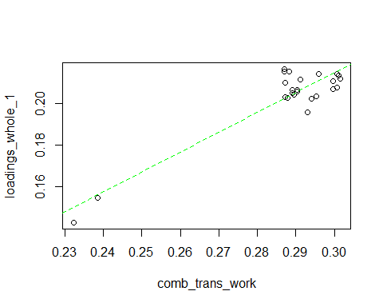

#### This is the plot of the first PCs of Work and Transit vs the combined data. It seems like they comove with each other pretty much. It makes more intuitive sense that the second one has comovement because the points are close to the green line (45 degrees line). We do not observe the same thing from the first plot.

### e.

# Explained variance in % - transit  
pr.var=pc_transit$sdev^2  
pve = pr.var/sum(pr.var) # the first PC explains 96% var. in the data  
  
  
# Explained variance in % - work  
pr.var_work=pc_work$sdev^2  
pve_work = pr.var_work/sum(pr.var_work) # the first PC explains 89% var. in the data  
  
# Explained variance in % - combined  
pr.var_combined=pc_whole$sdev^2  
pve_combined = pr.var_combined/sum(pr.var_combined) # the first PC explains 85% var. in the data

#### We think that work and transit are closer to a consistent estimate of the true underlying mobility since their first PC explains a higher variation in the data in comparison to the combined one.

#### When we compare work and transit, transit seems to be closer to the consistent estimate since it explains a higher variation in the data.

### f.

# The scores of the first component of the whole  
scores_whole_1 <- pc_whole$scores[,1]  
  
# the plot : the combined PC from the whole dataset over time, with two lockdowns  
plot(1:296, scores_whole_1, type ="p", xlab = "Date", ylab = "The Combined PC (Scores)")  
abline(v = c(31, 265), lty = c(2, 2), lwd = c(2, 2), col = c("green", "red"))  
text(c(60, 236), c(-10, -10), c("2020-03-16", "2020-12-15"), col = c("green", "red"))

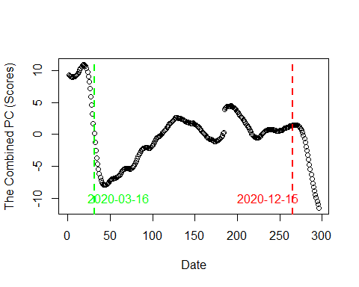

#### The first lockdown on 2020-03-16 was most successful. In the second one, it was already low compared to the first one, so the marginal effect was much stronger in the first one.

# QUESTION 03

