## Skip List

A skip list is a data structure that allows for efficient search and insertion of elements in a sorted list. In our implementation we took a dictionary file on input which acts as a sorted list, and we insert the list to the skip list then as for the searching algorithm we took another file to search words in the file that are not present in the dictionary.

It is a probabilistic data structure which in our case the randomLevel function is the probabilistic part, therefore its average time complexity is determined through a probabilistic analysis.

Skip lists have an average time complexity of O(log n) for both search and insertion.

We must set the number of pointers of the first node equal to max height and successive nodes will have pointers where the number of pointers are decided by randomLevel function in a probabilistic manner. This insertion process makes the skip list a probabilistic data structure.

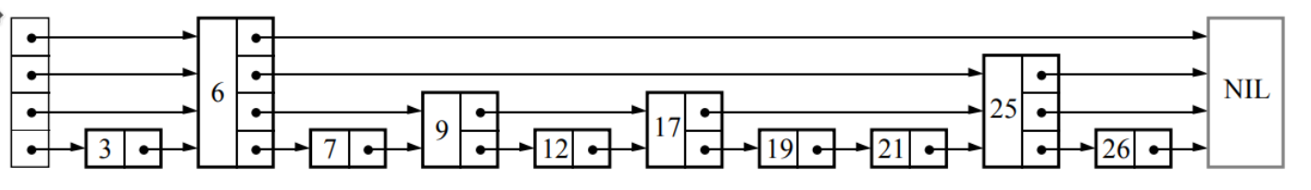

| Max height | Program execution time | Chart |
| --- | --- | --- |
| 8 | 32.0380000000 sec |
| 9 | 12.0870000000 sec |
| 10 | 5.0210000000 sec |
| 11 | 2.3900000000 sec |
| 12 | 1.2430000000 sec |
| 13 | 0.6470000000 sec |
| 14 | 0.4850000000 sec |
| 15 | 0.3970000000 sec |