**<Bilibili Video Data Analysis Platform>**

**System Design Specification (SDS)**

**<Version 3>**

**<5.26>**

**杨钧涯**

**王孟涵**

**缪润杰**

**苏泊鑫**

**肖嘉皓**

**Computer Science and Technology Program**

**United International College**

1. Document Change Log

|  |  |  |  |
| --- | --- | --- | --- |
| ***Change Date*** | ***Changed By*** | ***Version*** | ***Change Description*** |
| *04/23/2024* | *Junya YANG* | *1.0* | *Prepared Document* |
| *05/23/2024* | *Junya YANG* | *2.0* | *Design Overview* |
| *05/26/2024* | *Junya YANG&*  *Menghan WANG* | *3.0* | *Document Complete* |
|  |  |  |  |
|  |  |  |  |
|  |  |  |  |
|  |  |  |  |
|  |  |  |  |
|  |  |  |  |
|  |  |  |  |

1. Table of Contents

1. Document Change Log 2

2. Table of Contents 3

3. Design Overview 4

4. Tools and Standards 5

4.1. Tools 5

4.2. Standards 5

5. User Interface Design 6

5.1. Usage Scenario 1 6

5.2. Usage Scenario 2 6

1. Design Overview

**Design Overview for the Data Analysis Platform**

## Overview

Firstly, We have implemented an automated movie review scraper to quickly obtain a large volume of movie reviews and ratings data. Based on this dataset (over 50,000 entries), we trained and implemented two favorability rate analysis models: one based on a favorability rate dictionary and Naive Bayes (machine learning), and another retrained on a transformer with whole word masking pre-training. Additionally, we developed a scraper capable of dynamically obtaining Bilibili video information (comments, bullet chats, etc.). Finally, we integrated these features using FastAPI to achieve front-end and back-end separation, supporting dynamic retrieval of Bilibili-related information and favorability rate analysis of comments on specified Bilibili videos using the two trained models, with dynamic data presentation to the front end.

## Core Features

1. **Automated Movie Review Scraper**:
   * Rapidly obtains a large volume of movie reviews and ratings data.
2. **favorability rate Analysis Models**:
   * **Model 1**: favorability rate dictionary combined with Naive Bayes (machine learning).
   * **Model 2**: Transformer-based model with whole word masking pre-training, retrained for favorability rate analysis.
3. **Dynamic Bilibili Video Information Scraper**:
   * Fetches detailed video information including comments and bullet chats dynamically.
4. **FastAPI-based Front-End and Back-End Integration**:
   * Supports dynamic retrieval of Bilibili-related information.
   * Facilitates dynamic favorability rate analysis of specified Bilibili video comments using the two trained models.
   * Provides real-time data presentation to the front end.

## Contribution

* 杨钧涯 30%
* 王孟涵 30%
* 缪润杰 15%
* 苏泊鑫 15%
* 肖嘉皓 10%

## Core Workflow

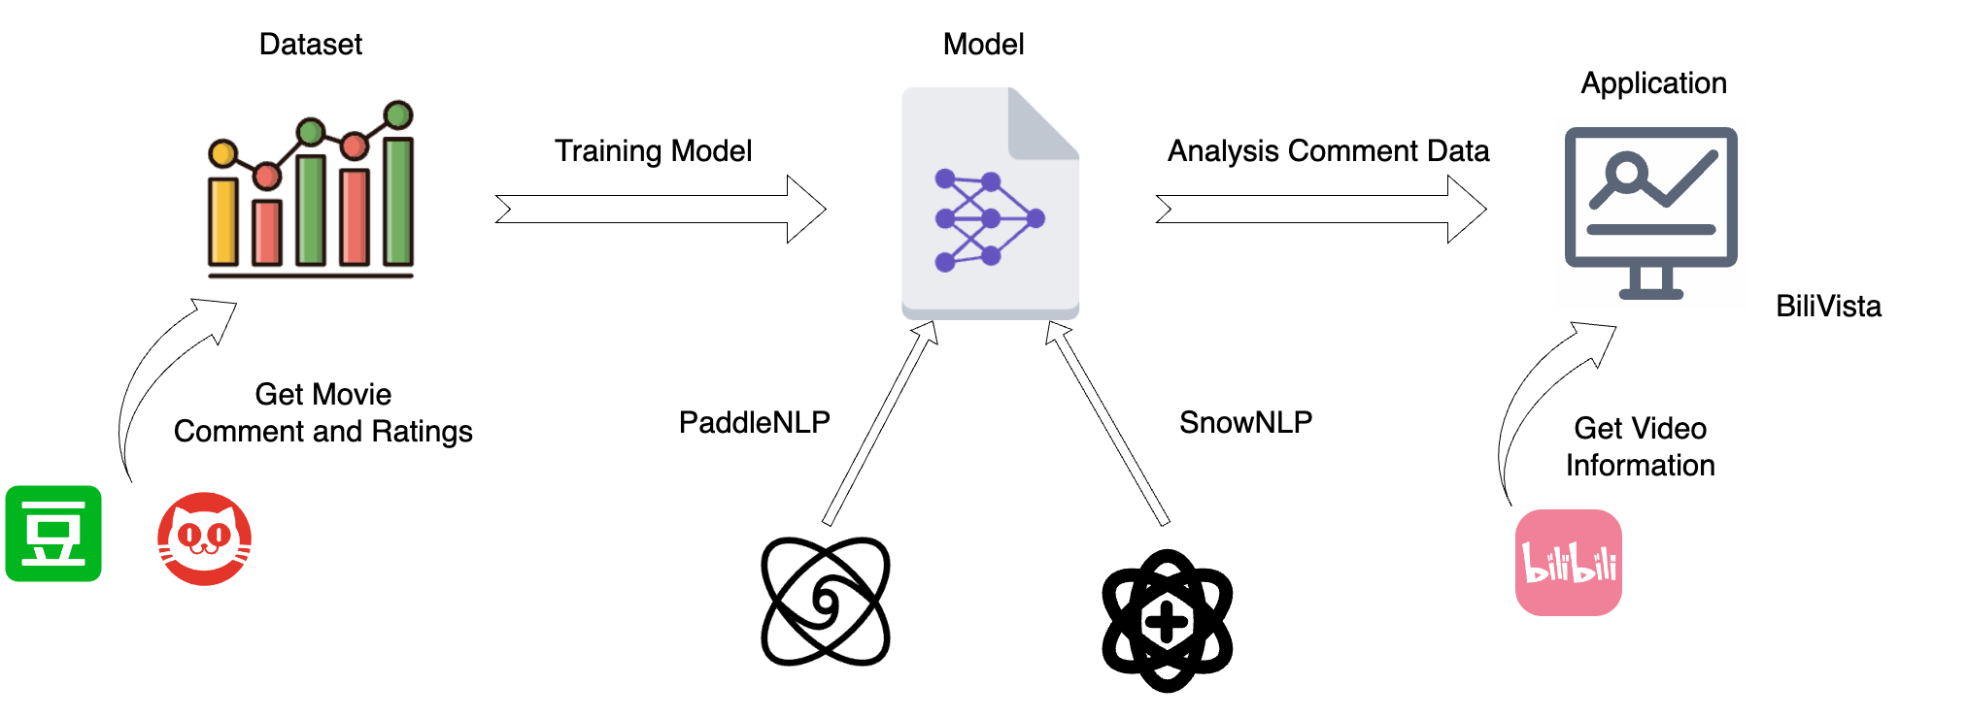

Core Workflow

1. **Data Acquisition**
   * *Crawling Movie Comments*
     + Douban: Collect comments from the Douban movie site.
     + Maoyan: Collect comments from the Maoyan movie site.
   * *Data Cleaning*
     + Perform data cleaning to ensure the quality and consistency of the collected comments.
2. **Model Training**
   * *Machine Learning Model*
     + favorability rate dictionary combined with Naive Bayes (machine learning).
   * *Deep Learning Model*
     + Transformer-based model with whole word masking pre-training, retrained for favorability rate analysis.
3. **Model Application**
   * *Crawling Data from Bilibili*
     + Implement real-time data crawling from Bilibili, allowing users to input a video url and retrieve video information and comments instantly.
   * *Backend Development*
     + Develop the backend using the **FastAPI** Python framework to handle data processing and model integration.
   * *Frontend Development*
     + Implement a user-friendly interface to visualize and interact with the analysis results.

## Dataset

### *Sources of Our Data*

* ***Douban***: A prominent movie site where users freely express their opinions on movies. These comments are often labeled by users’ favorability rates, making them invaluable for our analysis.
* ***Maoyan***: Another key player in the movie industry with a rich database of user comments, similarly labeled, allowing for comparative studies and robust model training.

### *Automated crawler to scrape movie reviews*

To quickly acquire a large dataset, we wrote an automated crawler for movie reviews to simplify the task. It can automatically scrape movie reviews and rating information from Douban and Maoyan.

Additionally, we have also open-sourced this crawler on [GitHub](https://github.com/open17/movie-comment-spider).

### *Why These Datasets?*

* ***Labeled Data***: We chose to focus on comments from *Douban* and *Maoyan* because they offer labeled datasets. This is critical as labeled data provides a foundation for training and evaluating our favorability rate analysis models with higher accuracy.

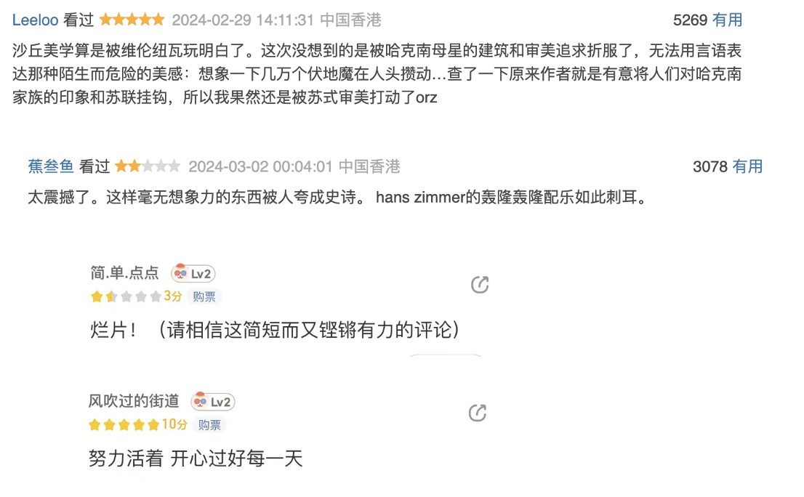

Comment on Douban and Maoyan

## Model Training

### Model: Machine Learning

#### Model Introduction

* Here we use favorability rate dictionary combined with Naive Bayes which is based on SnowNLP.[1]
* According the dataset we gained from crawl data (**50000+ entries**), Randomly spilit the dataset into traning dataset and test dataset (8:2).

#### More Detail

##### Naive Bayes Algorithm

* *Assumes* that features are **independent** of each other.
* *Estimates* probabilities based on the features and labels in the training dataset.

##### Split characters

***Split Chinese characters*** and calculate the probability that the term appears in the set

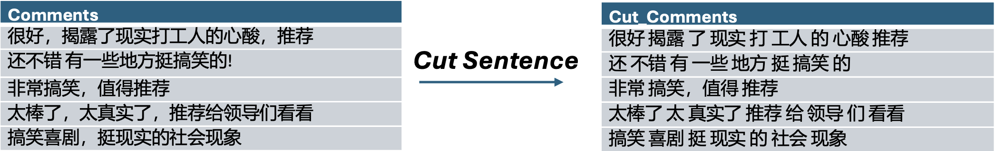

Cut Chinese Comment

### Model: Deep Learning

#### Model Introduction

* *Nowadays*,  studies have shown that Pretrained Models (PTM) based on large-scale unlabeled corpora can acquire generic language representations and perform well when fine-tuned to downstream tasks.
* Here we use Transformer-based model with whole word masking pre-training, retrained for favorability rate analysis which is based on Pre-training model ERNIE (Like Bert-wwm)
* According the dataset we gained from crawl data (**50000+ entries**), Randomly spilit the dataset into traning dataset, dev dataset(Used to dynamically adjust hyperparameters) and test dataset.

#### More Details

1. ***Remove*** a batch data from the dataloader
2. ***Feed batch data*** to the model for forward calculation
3. ***Pass forward*** calculation result to loss function to calculate loss. The forward calculation result is passed to the evaluation method, and the evaluation index is calculated.
4. ***Loss reverse*** return and update gradient. Repeat the above steps.

**Each time an epoch is trained, the program will evaluate the effectiveness of the current model training.**

### Model Evaluation

#### Test Accuracy

| Method | Test Dataset Accuracy |
| --- | --- |
| SnowNLP | 78.58% |
| PaddleNLP | 85.31% |

#### Generalizability Test

In order to test the generalizability of our model. We crawl the comment of the movie *《Wandering Earth 2》* From  the Bilibili, and analyze it with two models respectively.

1. ***Estimation the comment score***

* Machine Learning: Average comment favorability rate score is only ***0.54***. (Calculate method In the appendix)
* Deep Learning: Average comment favorability rate score is ***0.89***. (Calculate method In the appendix)

1. ***Favorability rate Score Distribution***

* Machine Learning Comment Score Distribution: 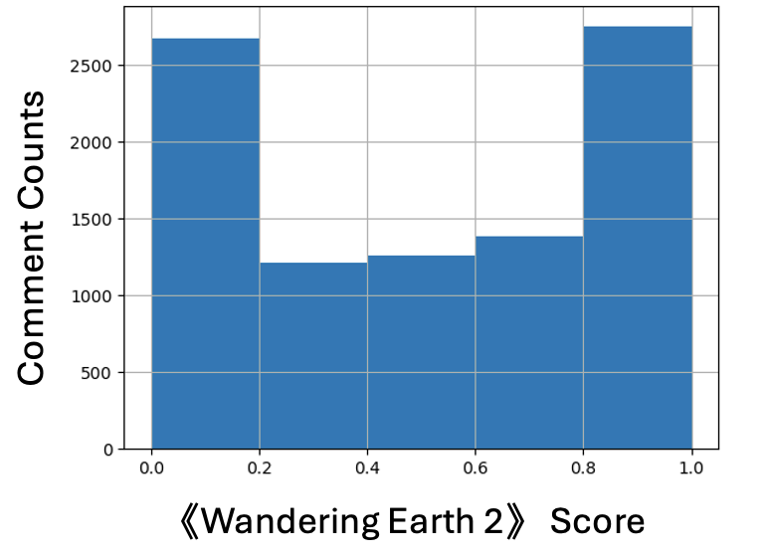 The distribution is polarized
* Deep Learning Comment Score Distribution: 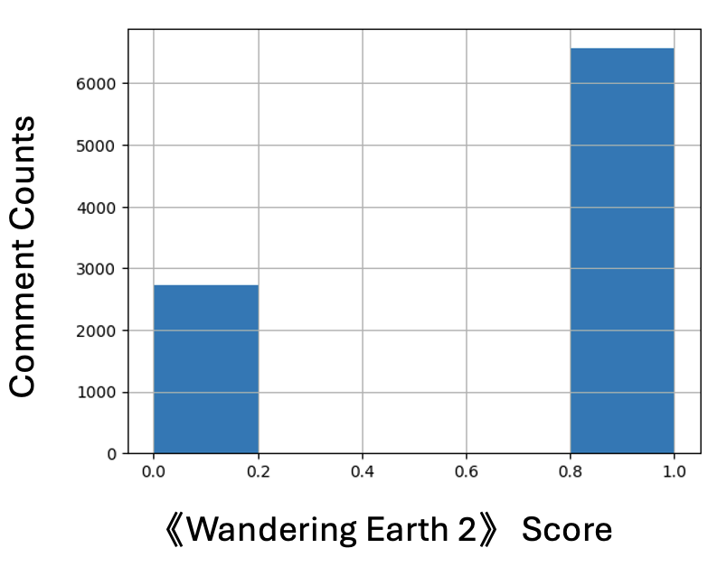

**Obviously, the deep learning approach is more convincing, and the machine learning approach runs much faster than the deep learning approach.**

## BiliVista

### Bilibili information Crawler

#### Crawler Introduction

A crawler capable of dynamically obtaining Bilibili video information (comments, bullet chats, etc.) which will be used in the backend part.

#### Crawler Details

1. ***Set the User-Agent and cookie information***

Through bvid access to the comment information of the video including:

* Comment
* Number of comments and likes

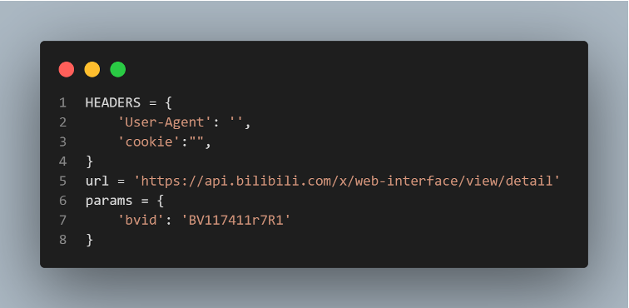

User-Agent

1. ***Crawl video basic information***

Through bvid access to the basic information of the video including:

* Title
* Author
* Reply count, Favorite count,
* Coin count, Share count

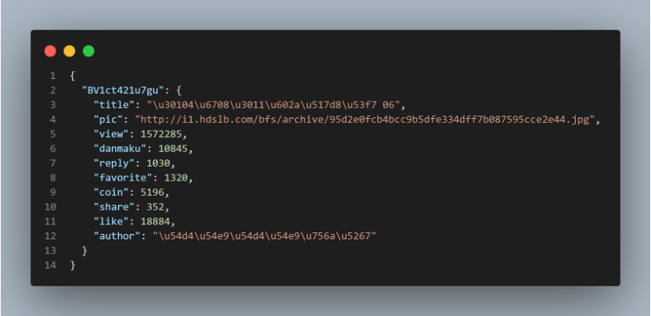

Video-info

1. ***Crawl video comment content and danmu content***

Through bvid request screen XML file obtained through basic information:

* Time
* Timestamp
* Danmu text

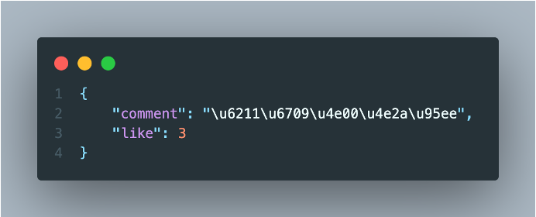 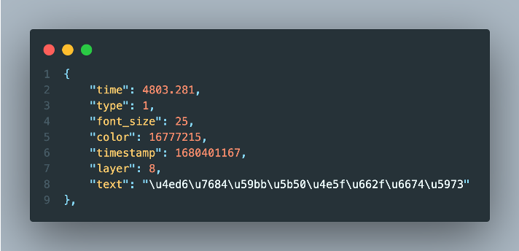

### Backend

#### Backend Introduction

Those features talking about above will be used in backend according to FastAPI (backend framwork) to achieve front-end and back-end separation, supporting dynamic retrieval of Bilibili-related information and favorability rate analysis of comments on specified Bilibili videos using the two trained models, with dynamic data presentation to the front end.

#### Backend Details

***Why FastAPI?***

*“FastAPI is a modern, fast (high-performance) web framework for building APIs with Python 3.6+.”*

* High performance
* Rapid development
* Automatic interactive API documentation
* Type hints for fewer bugs

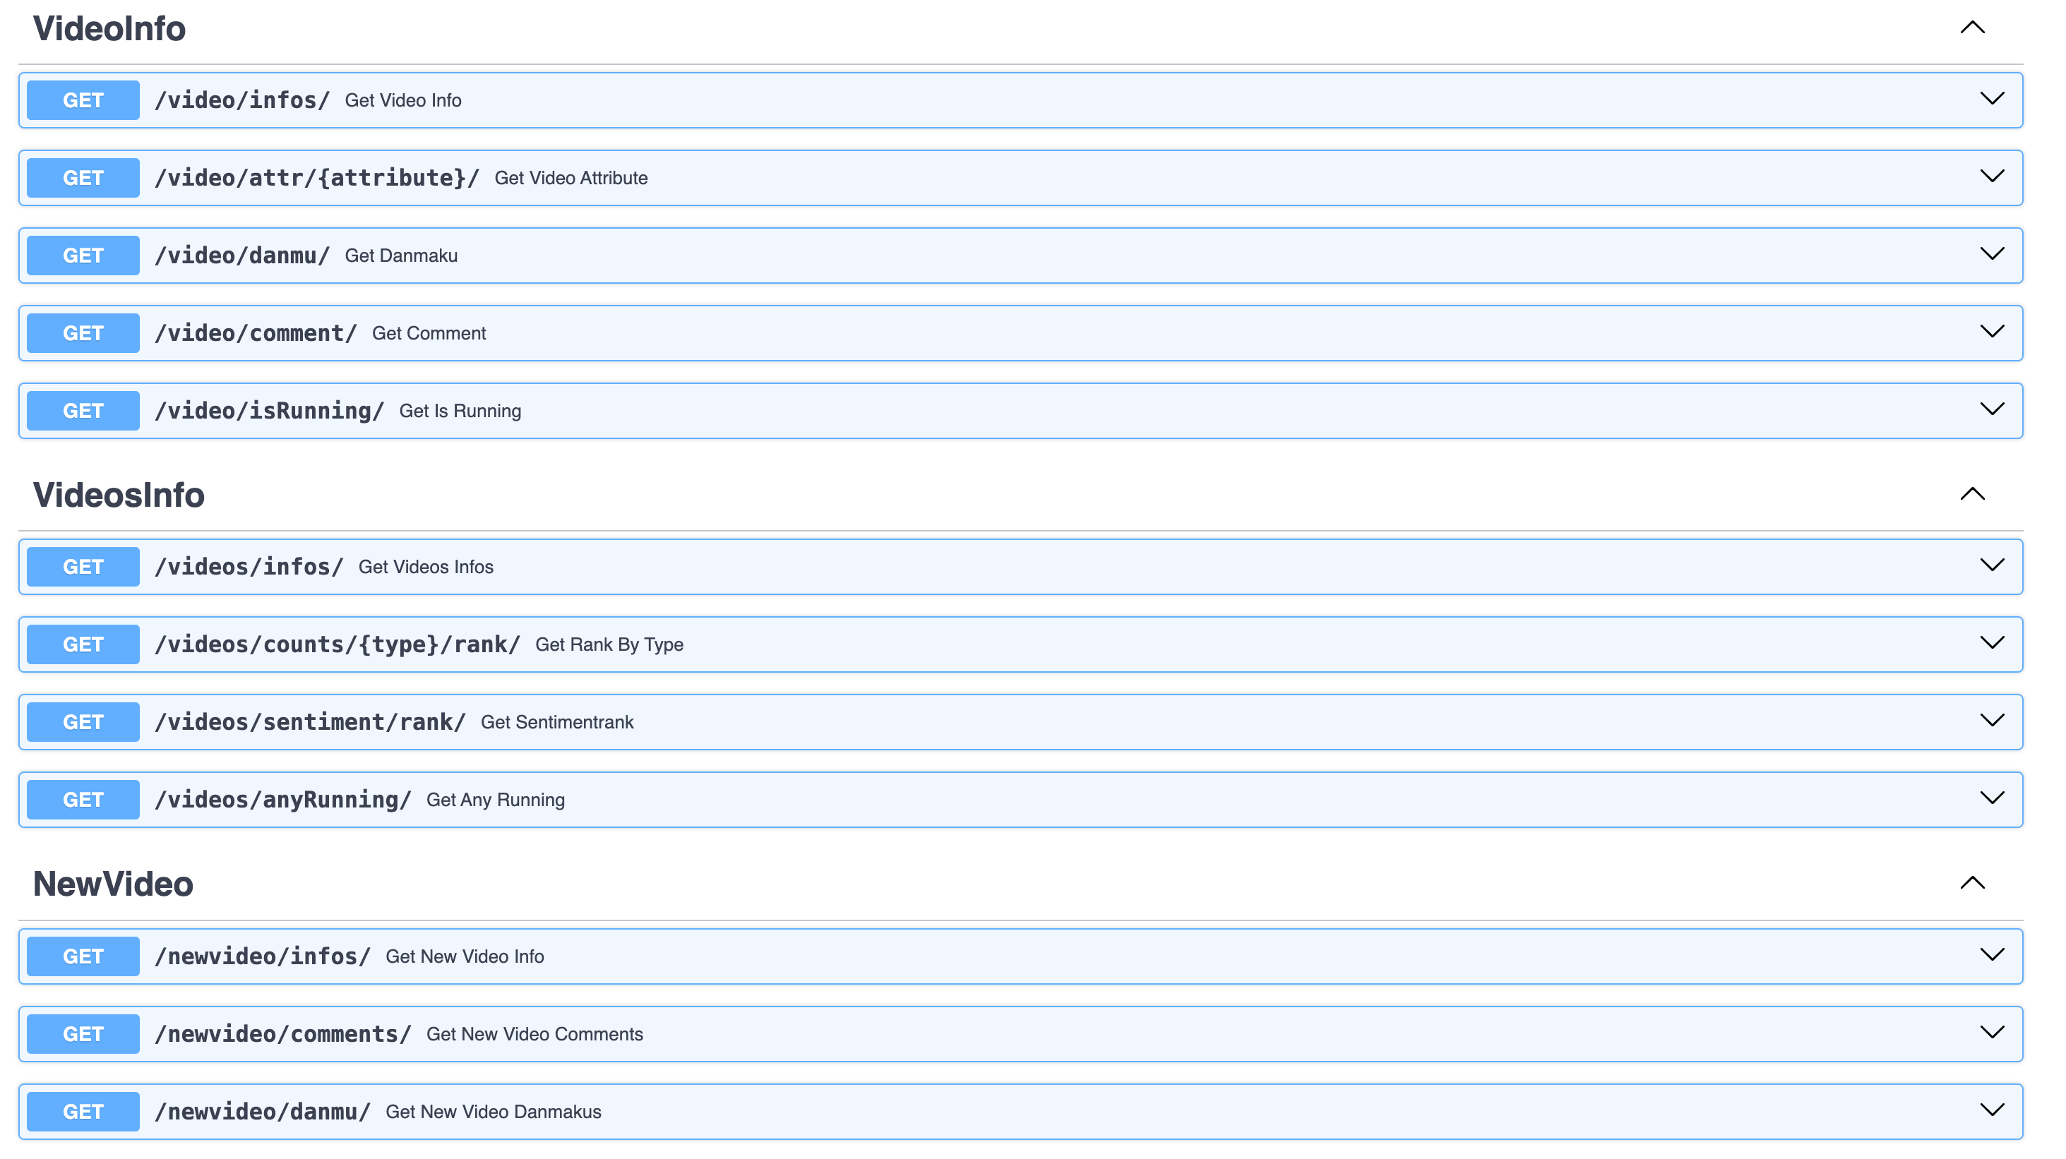

BackendAPI

***Introduction to the three main API categories: video, videos, newvideo***

* Usage of 3 APIs:
  + **video**: Fetch specific video information.
  + **videos**: Gather statistics on all scraped videos.
  + **newvideo**: Add new video data to the system.

1. Tools and Standards

## Tools

*In python we use the Numpy, pandas, sklearn, matplotlib, SnowNLP libraries*

## Standards

*Common to all platforms, including MacOS, Windows, Linux Accessible via browser on all platforms.*

1. User Interface Design

### Frontend

In this part, we use Vue3 + Typescripts + Arco Design + Vue-18n + Vite and connect the python backend to visualize data.

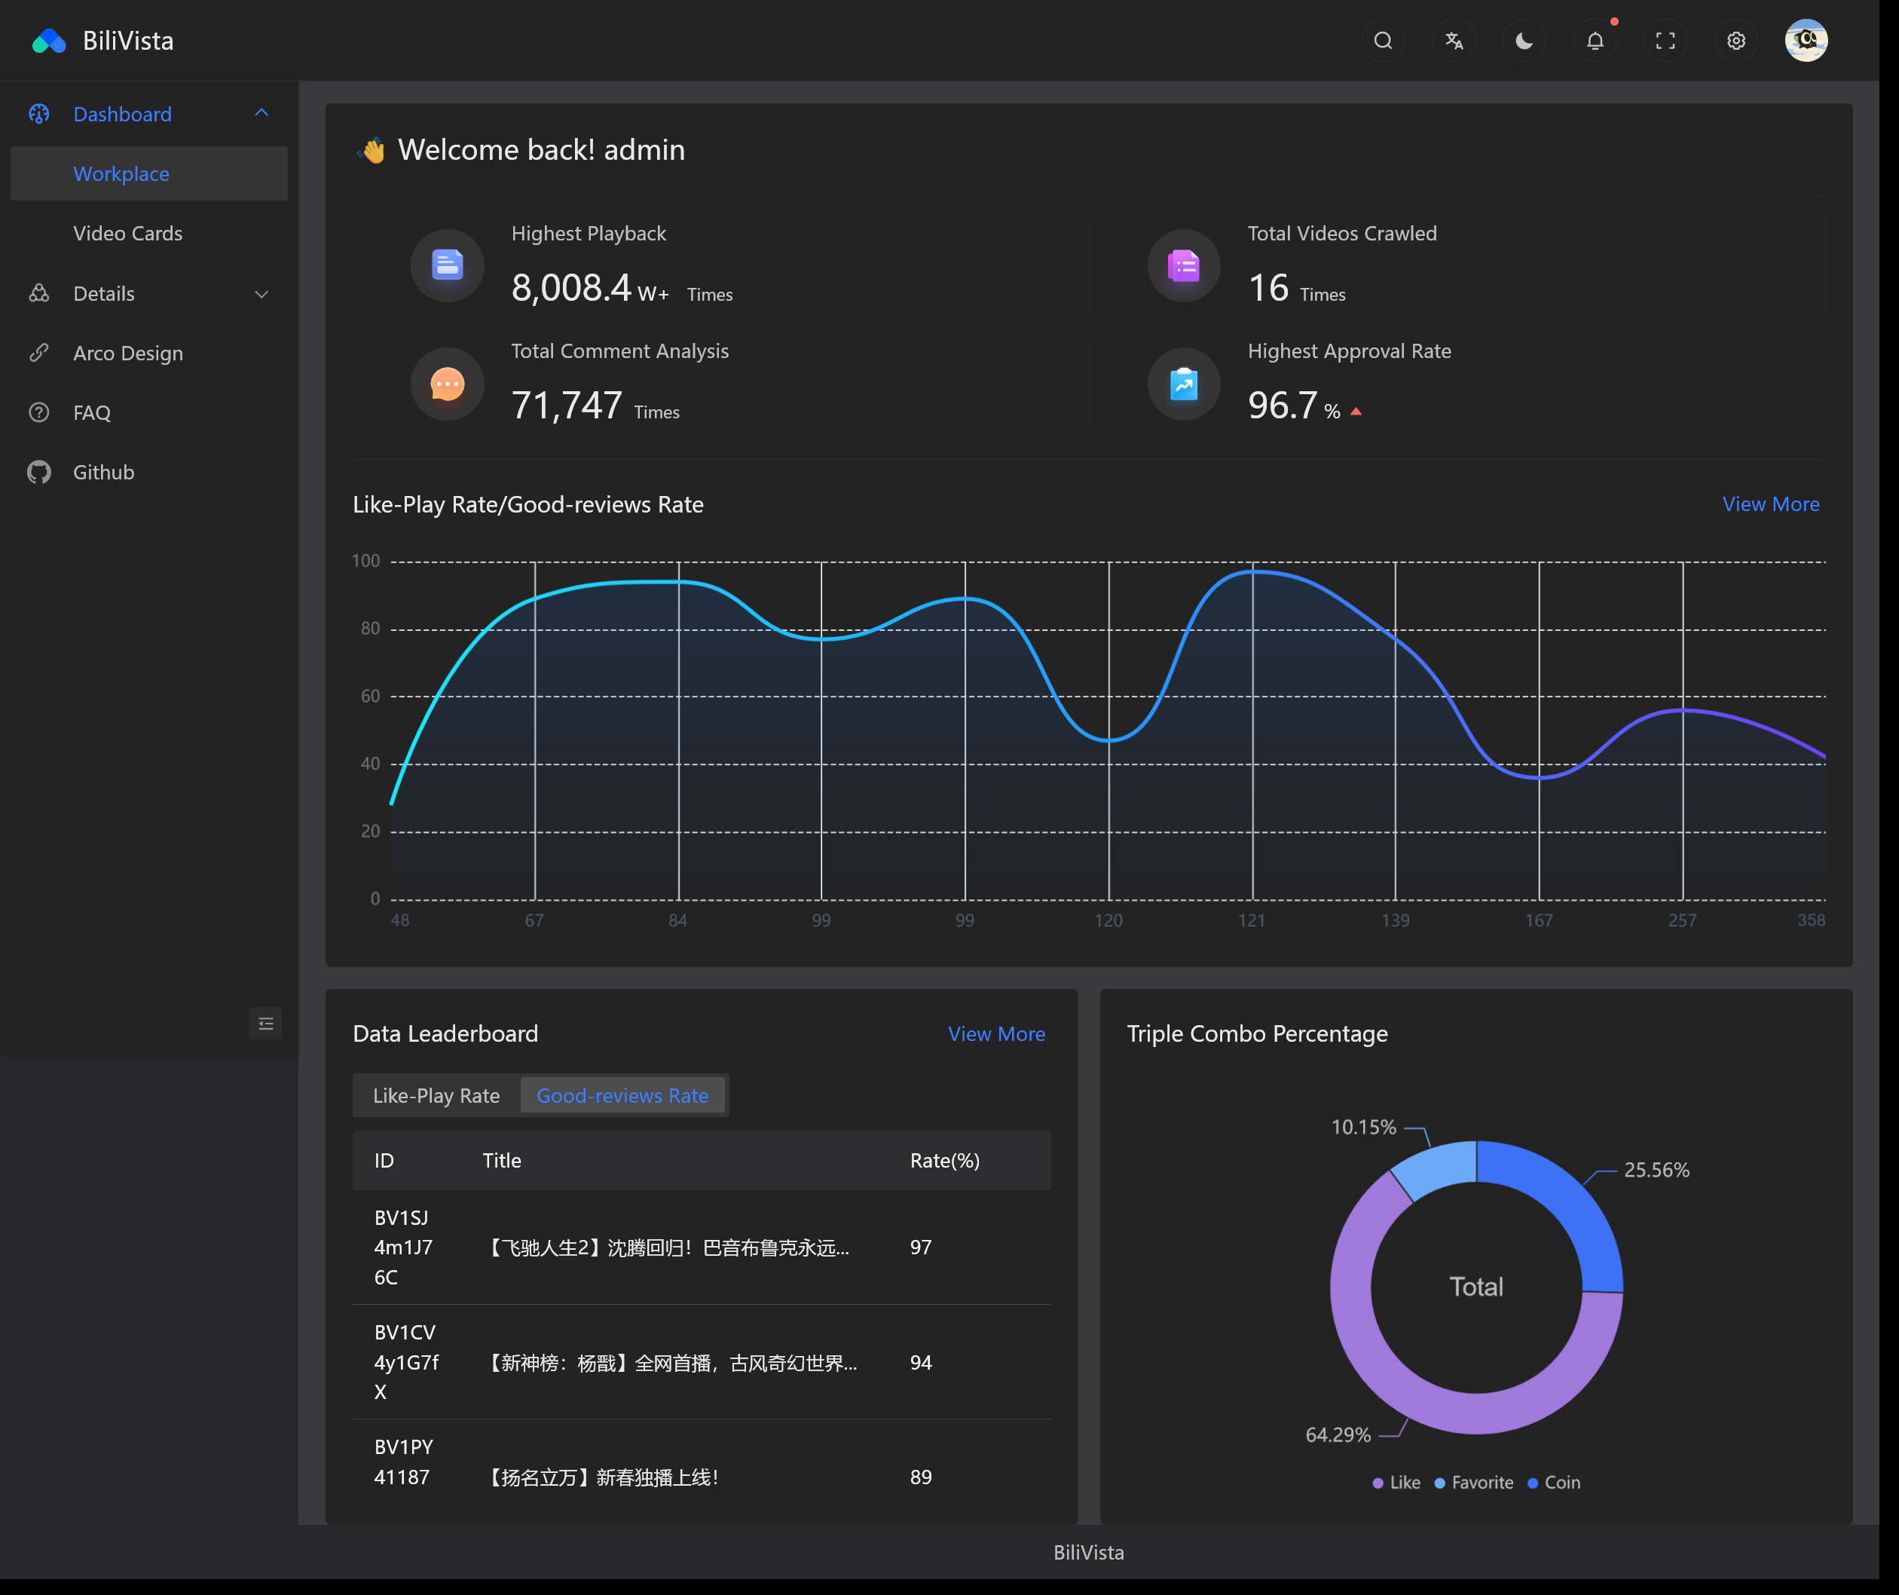

alt text

### Visualization details

#### Favoriate-Like-Coin Rate

* Backend

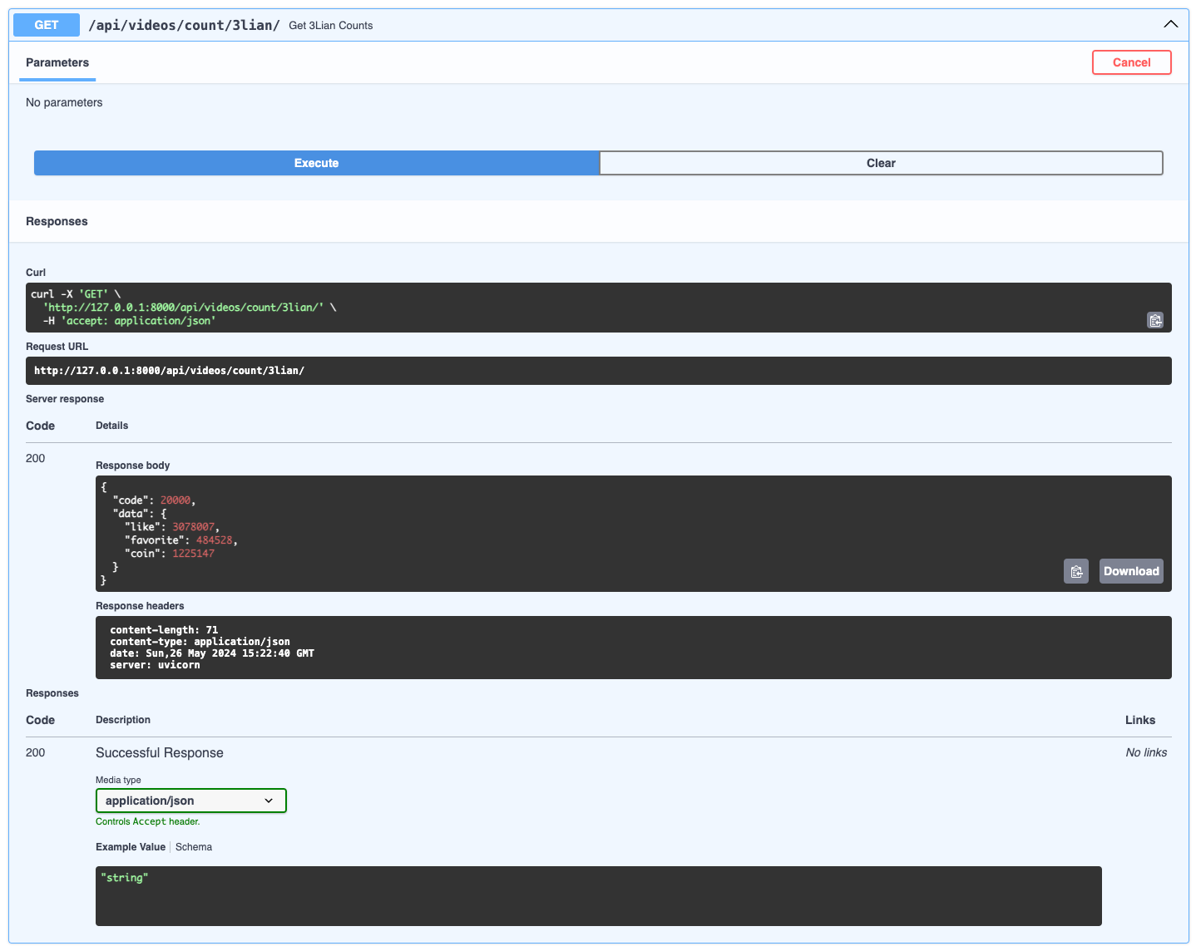

3lian

* Frontend

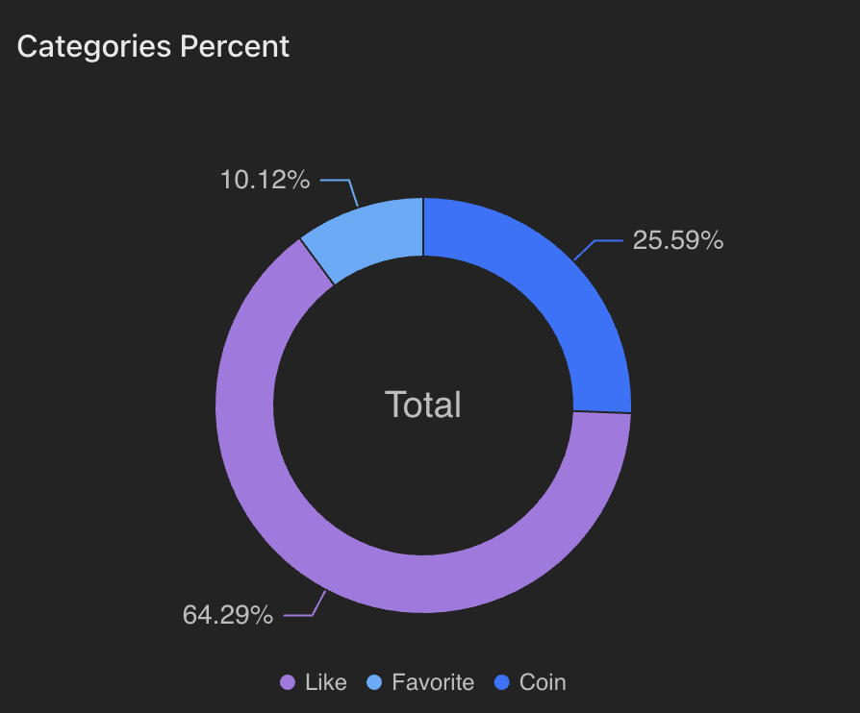

alt text

#### Popular Rank

* Backend

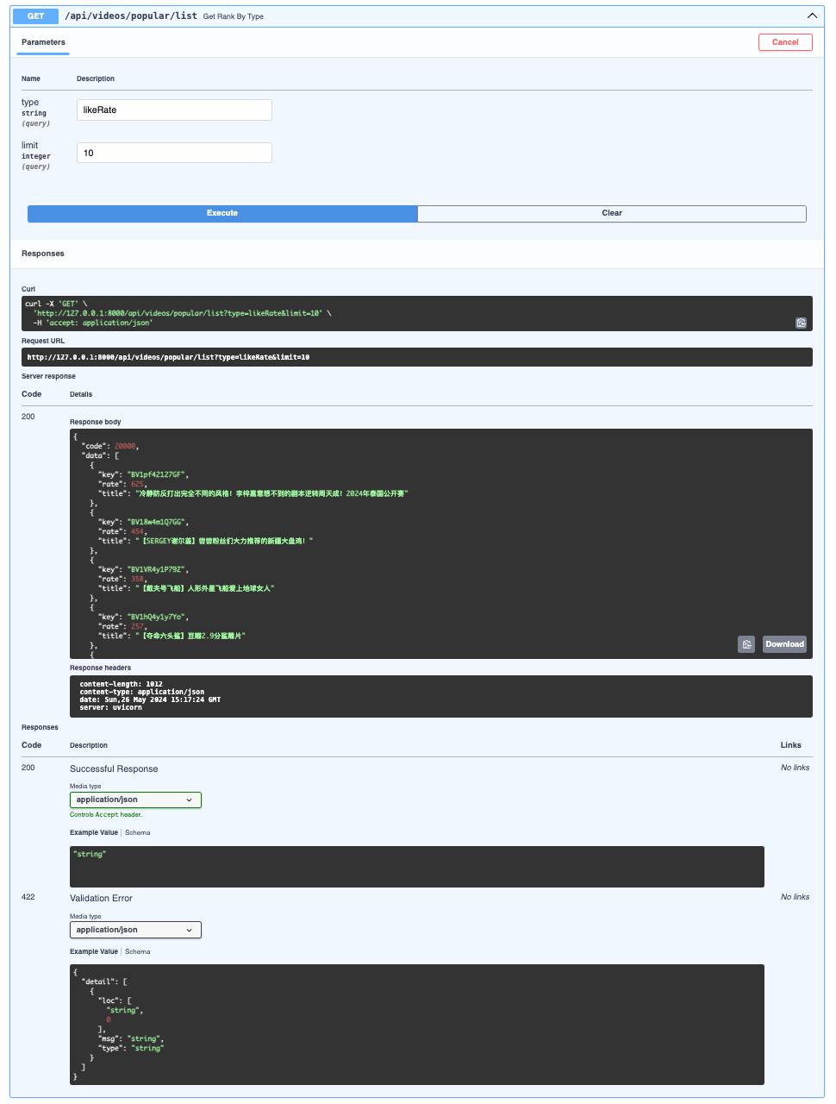

PopularRankbackend

* Frontend

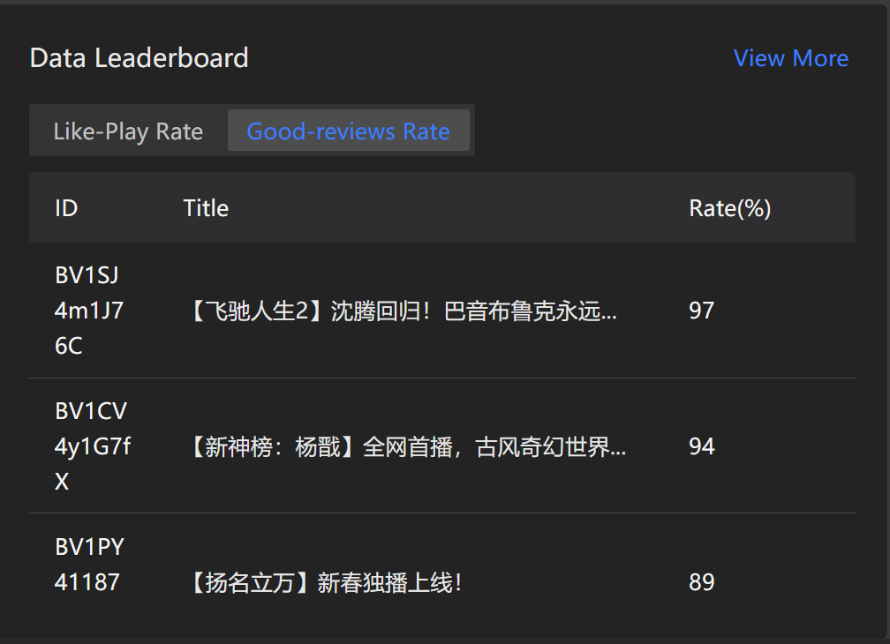

alt text

#### Video infos

* Backend

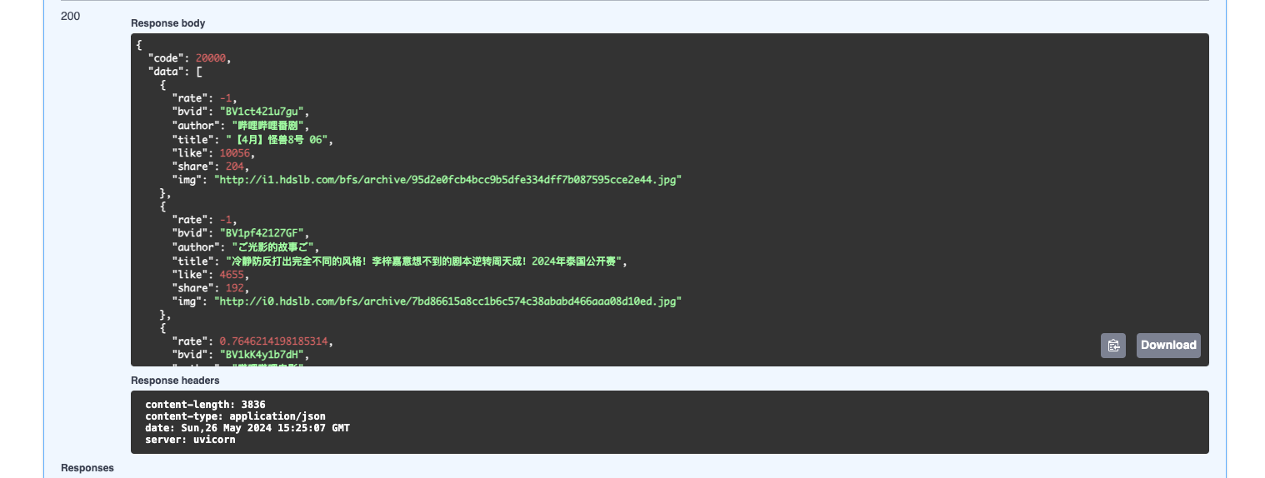

alt text

* Frontend 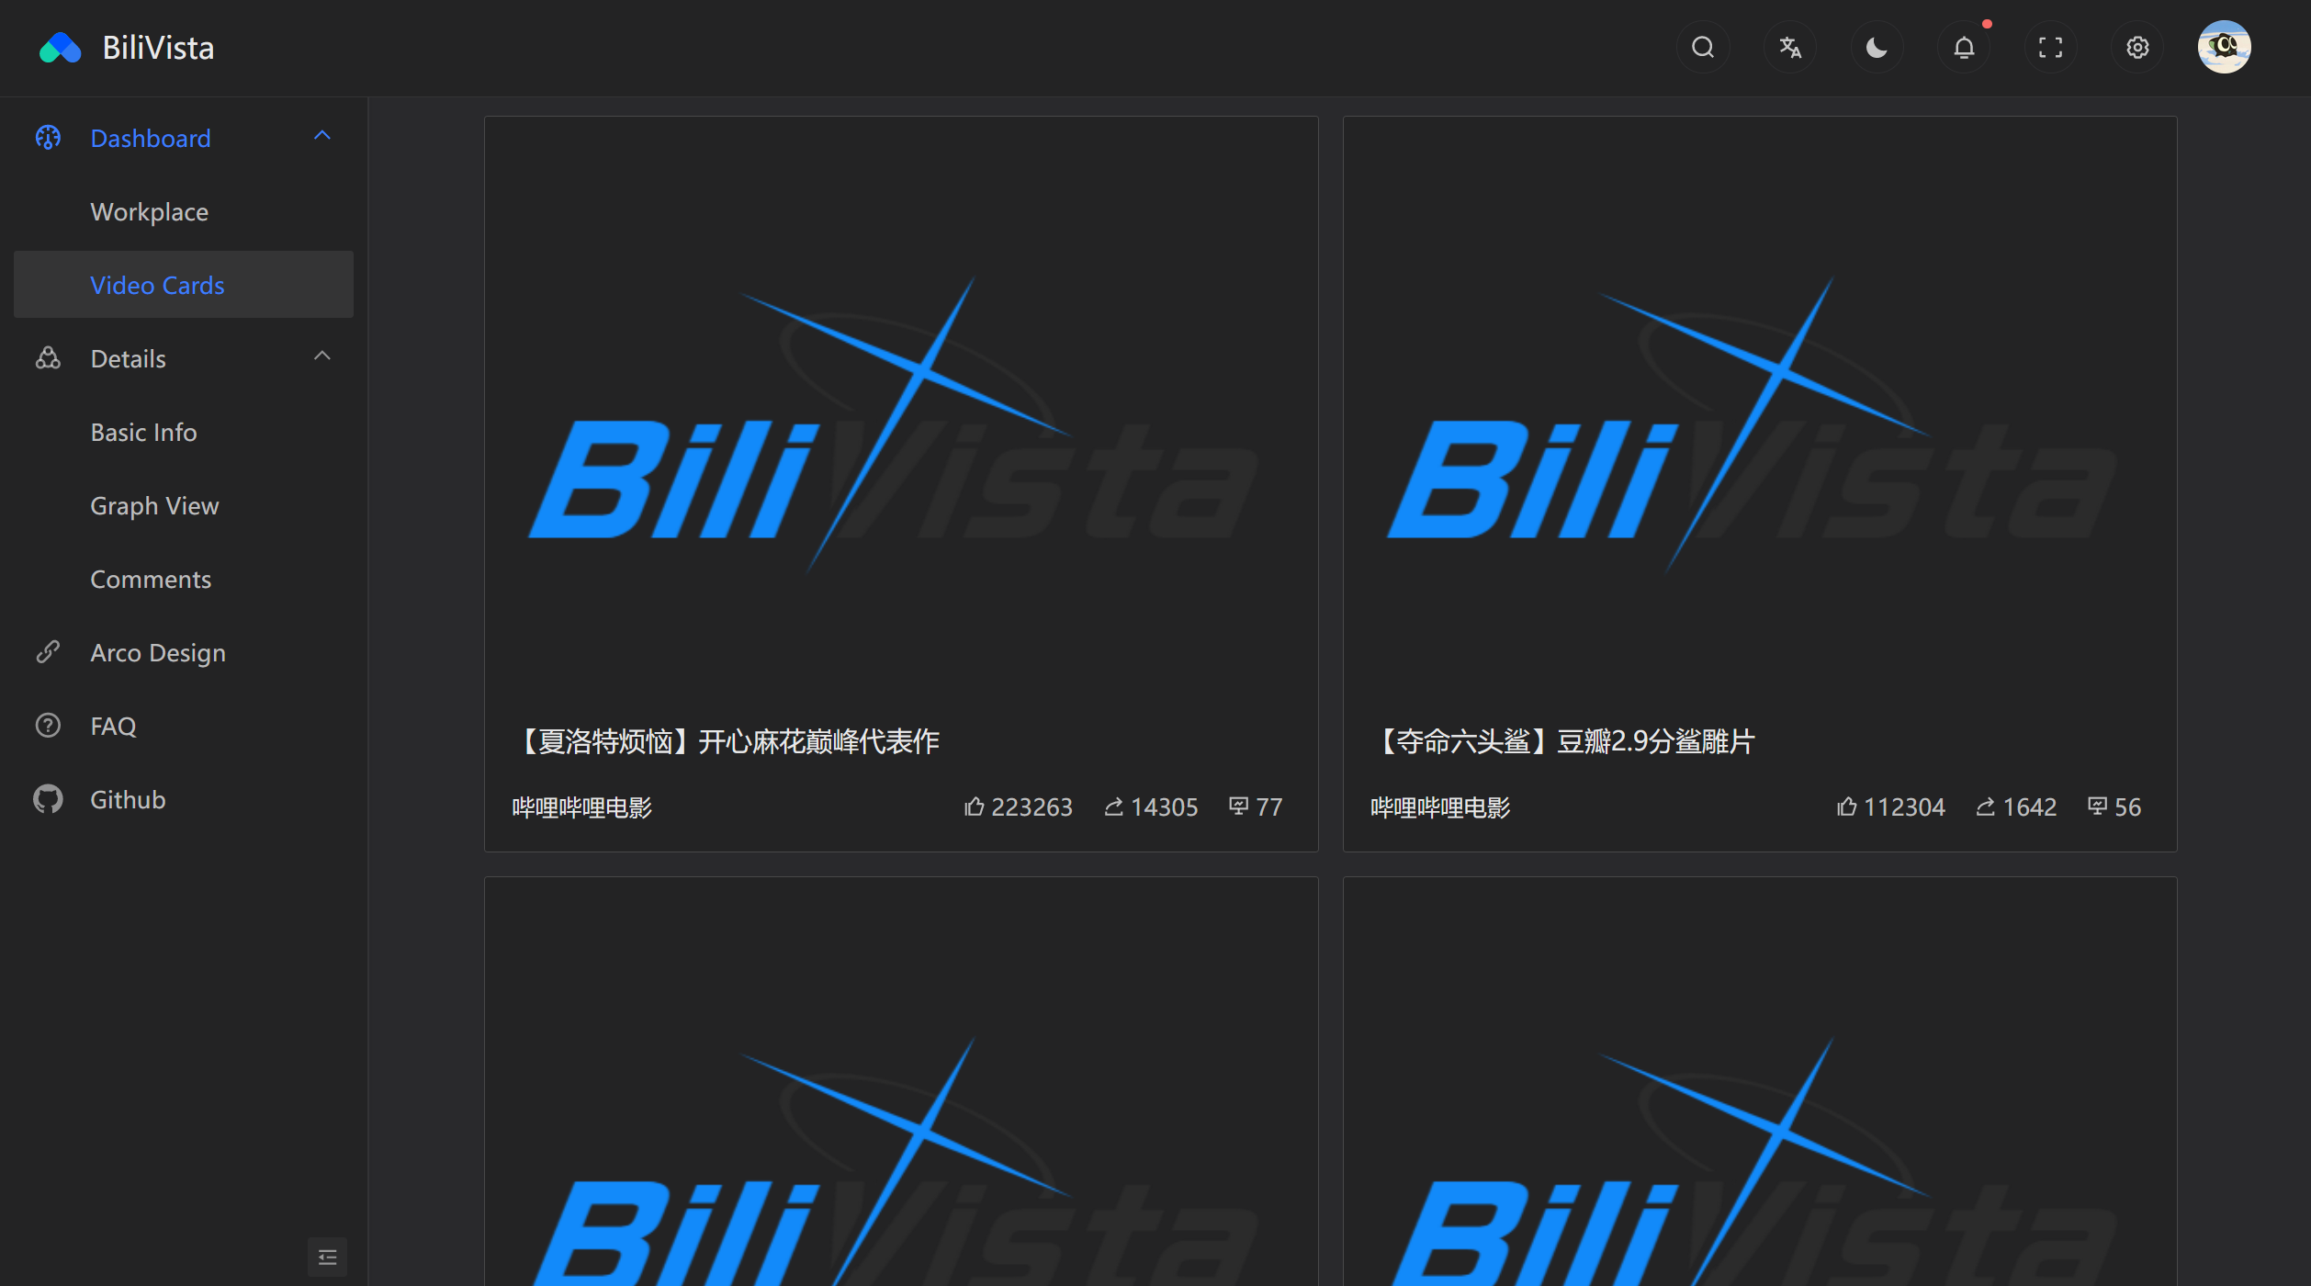

#### Video Comments

* Backend 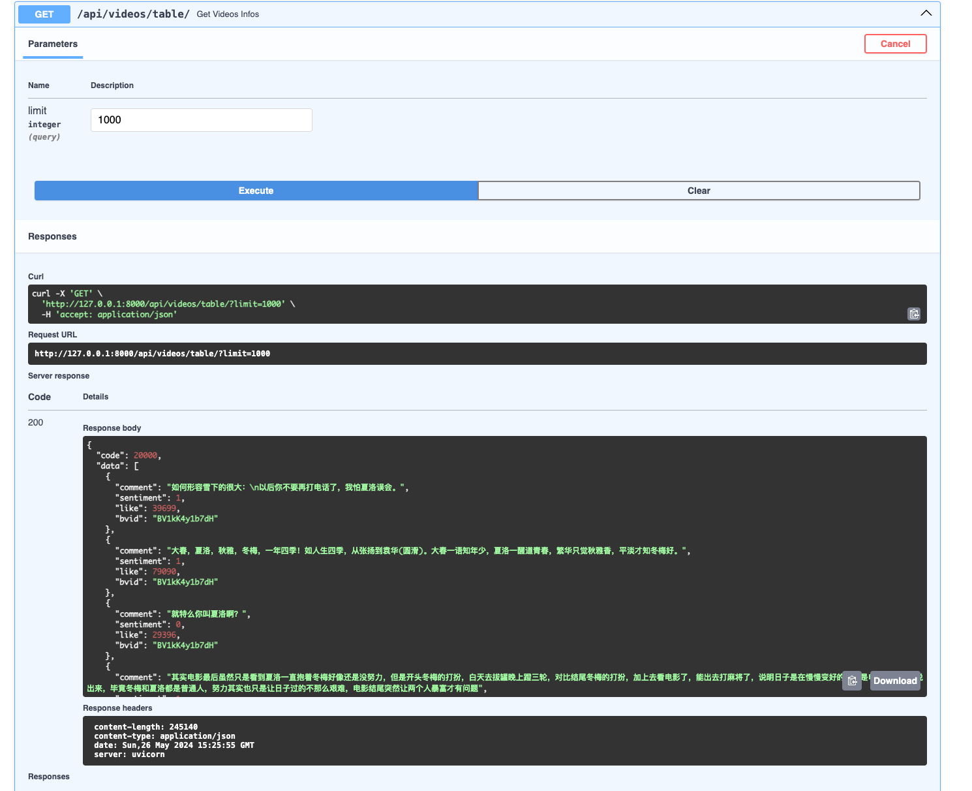
* Frontend 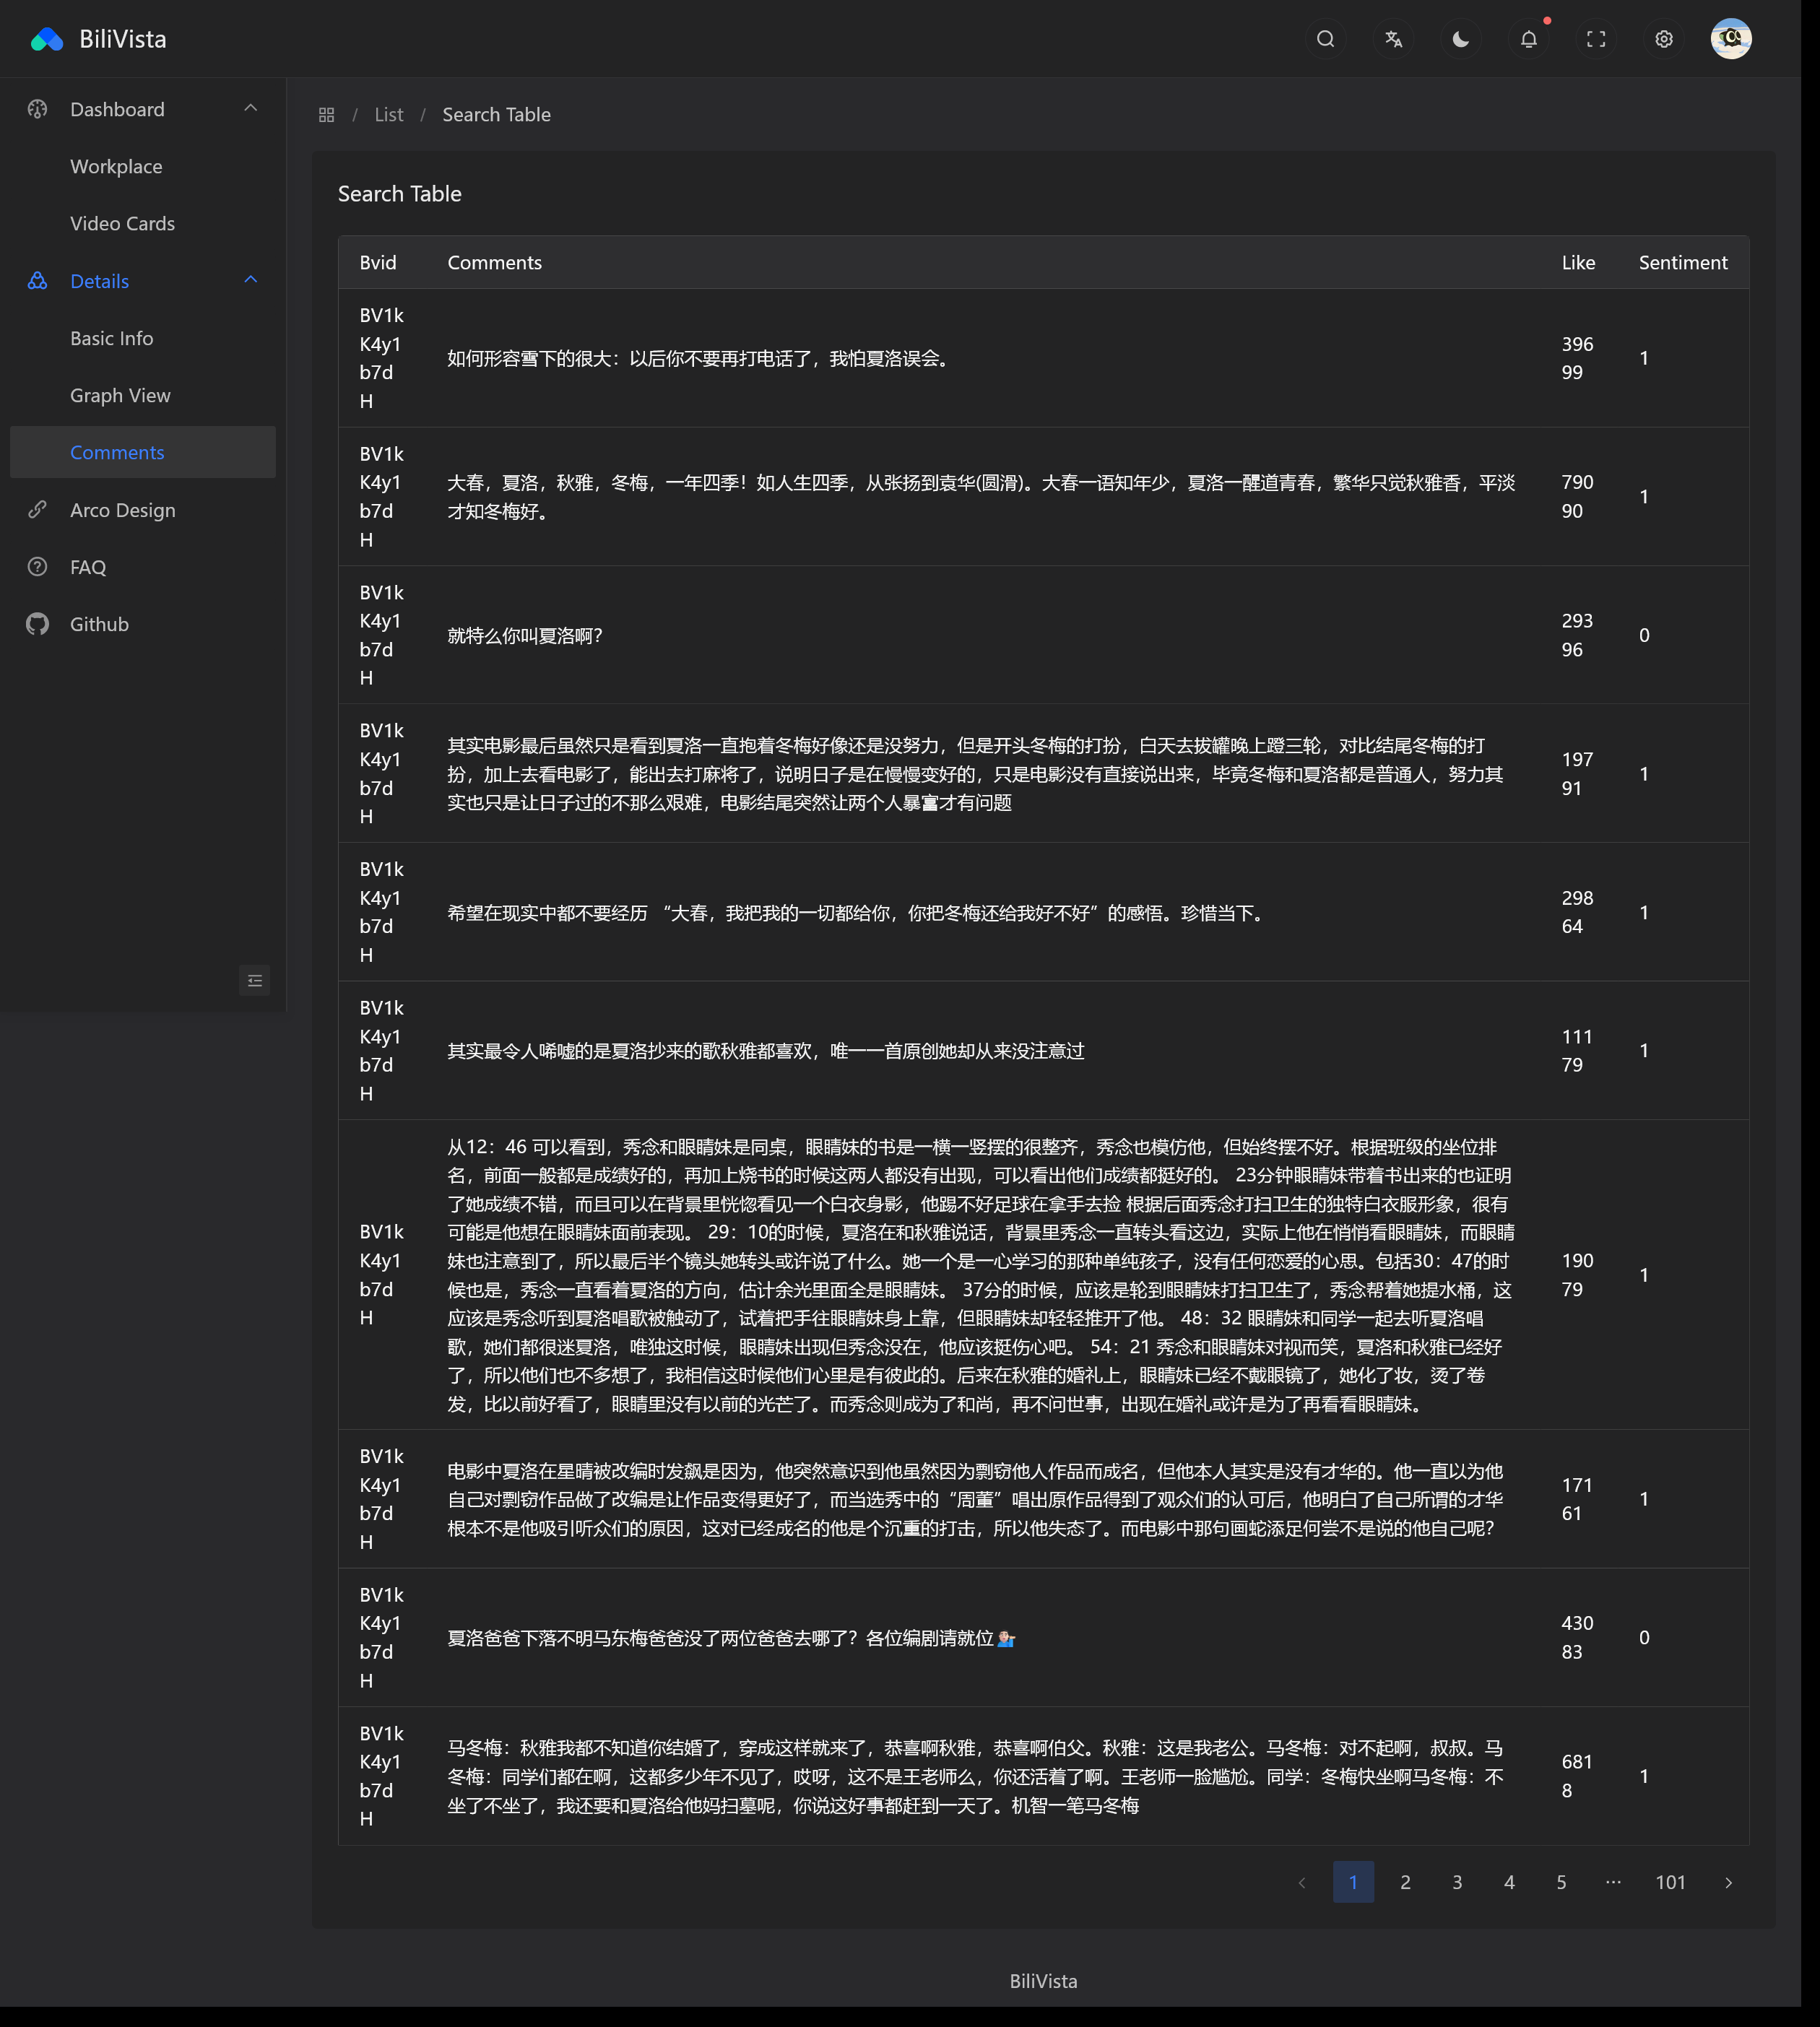

### Part of backend code

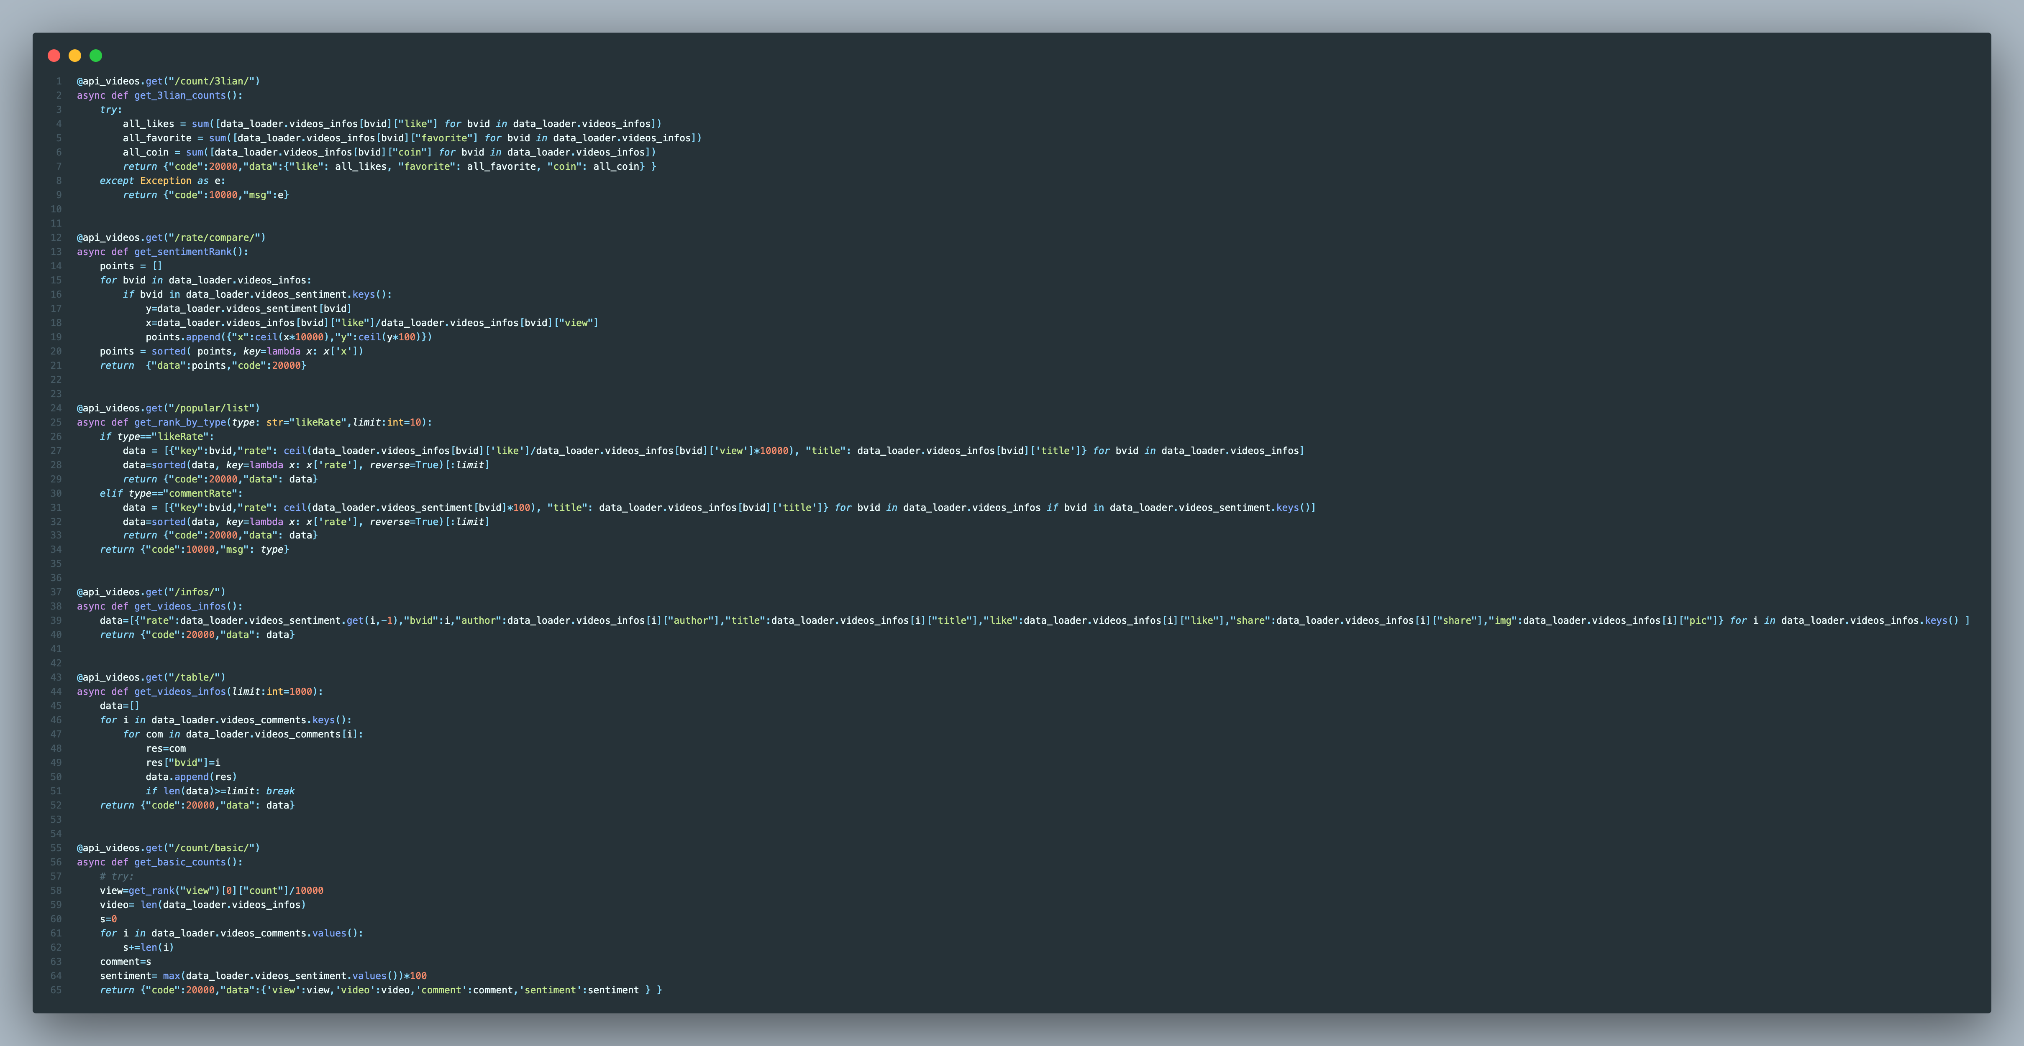

1. SnowNLP is a library focused on natural language processing tasks for Chinese text, such as favorability rate analysis and text processing.