WEBHOOK_TUT
A beginner tutorial
Building a Facebook messenger webhook

Today we will be learning how to setup Facebook messenger webhook.
In this tutorial we will discuss this in 2 sect; firstly we will cover the following;
what a Facebook messenger is?
what is webhook and why do we need it?
Then in the second sect, we will cover the setting up of the webhook through the following steps:
to set up this webhook we will need to
create a Facebook page
then create a Facebook app to link with the page we created
then we now guide on how to configure the webhook.
Facebook messenger platform is a space where developer can get easily accessible guide to set up various feature like chatbox, plugin, webhook and many more. However, we will be looking into the Facebook messenger webhook as one of the platform feature. The question is why Facebook messenger webhook?
Ok, let face it. It is obvious as Facebook have an enormous audience in it platform, so creating a webhook will help raise brand awareness. It can also help promote word of mouth among its audience and steer traffic to the business website. It will also help enable communication between business and it user to get information on what the business and product is all about for example, user might wanted to get more information concerning booking a reservation either in a restaurant and hotel or inquire about the product.
Good, as we now understand the webhook and why we need it. Let get to the second sect on how to now set up the webhook.
To begin log in your Facebook account at the left side in your account click on page.
On the page click on create page and fill in the required information by putting in your preferred page name. Add the category your falls in eg, education, graphic design ,even if your page is not for business you can put in” not a business”.Then you give the description of what your page is for in the space for description after you are done with all this then click create page.
WooHoo! the first step is down, now we will create a Facebook app and link it to this page we created.
Let go! To create the app, put this into your url→https://developers.facebook.com. It will give you the following
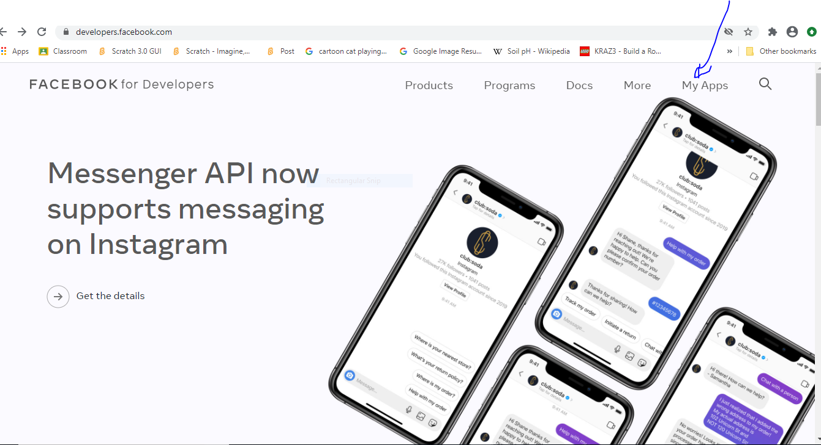
↓ On this page click on my apps
After clicking on my apps, you will get a page that looks like this, then click on create app.
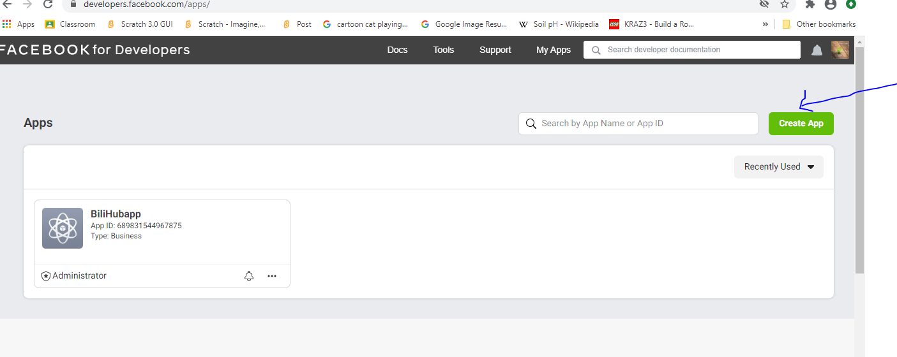

Another way to create the apps is by hovering your cursor on the logo at the far right corner, this will open a drop down then click create app
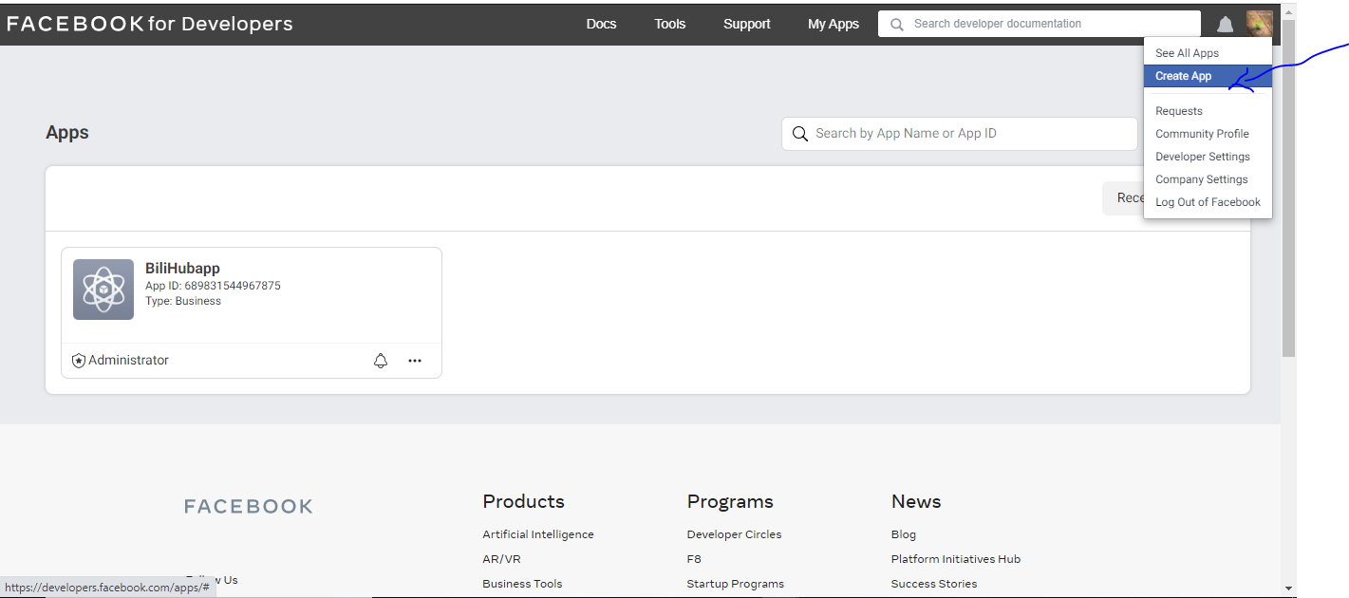

Ok, let continue, after clicking on the create app a form will pop up, here click on manage business integration, the first option with a bag and then click continue.

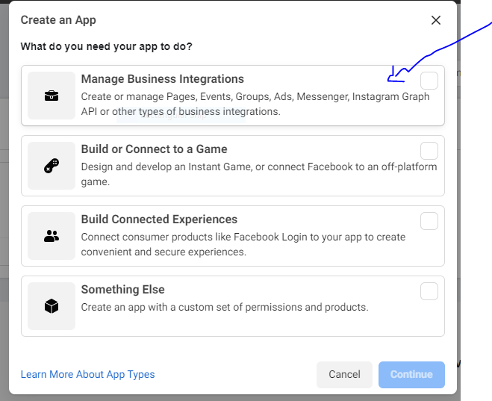

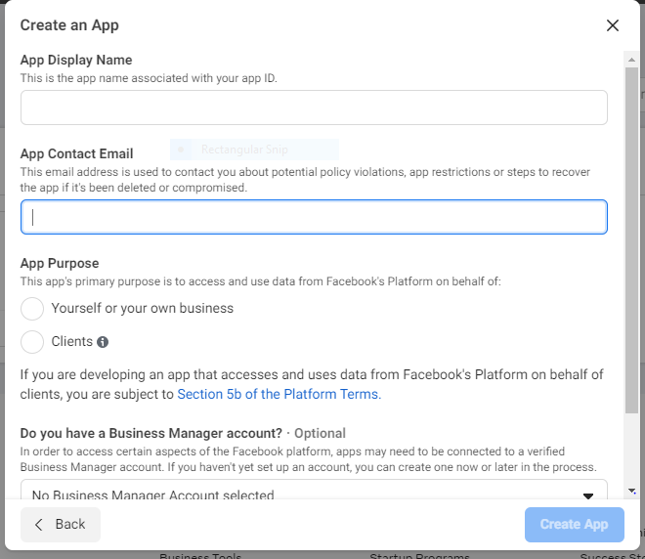
After clicking continue another form open up, please fill in the form put in the name you wanted for your app in the first space, your email in the second space and click on one of the two option under the app purpose but leave the last as it is then click on create app.

On clicking create App another form will open to make sure we complete a security check to show that we are not robot. Genuine! So check the box that say I am not a robot and then click submit.

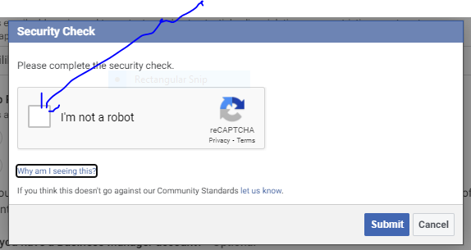
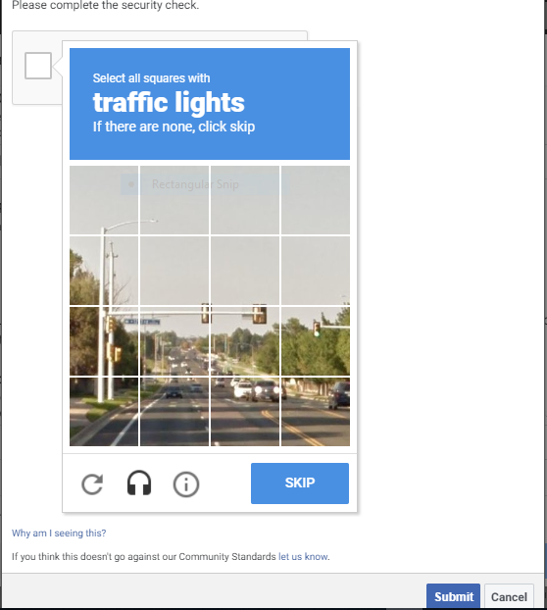
After this, patient! just a tiny step to finally create our app, before you go on after submitting the security check box, another form to really check that you are not a robot will pop up, select what required of you then click on submit.

After submitting this page or form, you will now get the page that looks like this ↓ Now look deeply on the page, you will see the arrow show your AppID at the top of the page and on the page. Good Job!
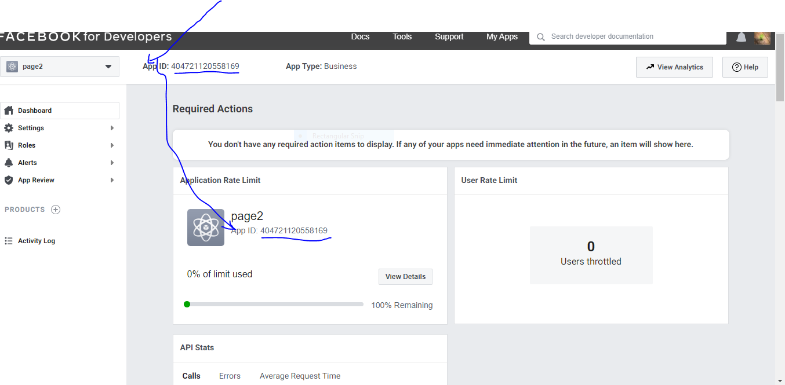
Second down, we’ve created the page and the app, Now let fired up to link the app to the page. To do this, on your app page scroll down to “ADD PRODUCT TO YOU APP”.

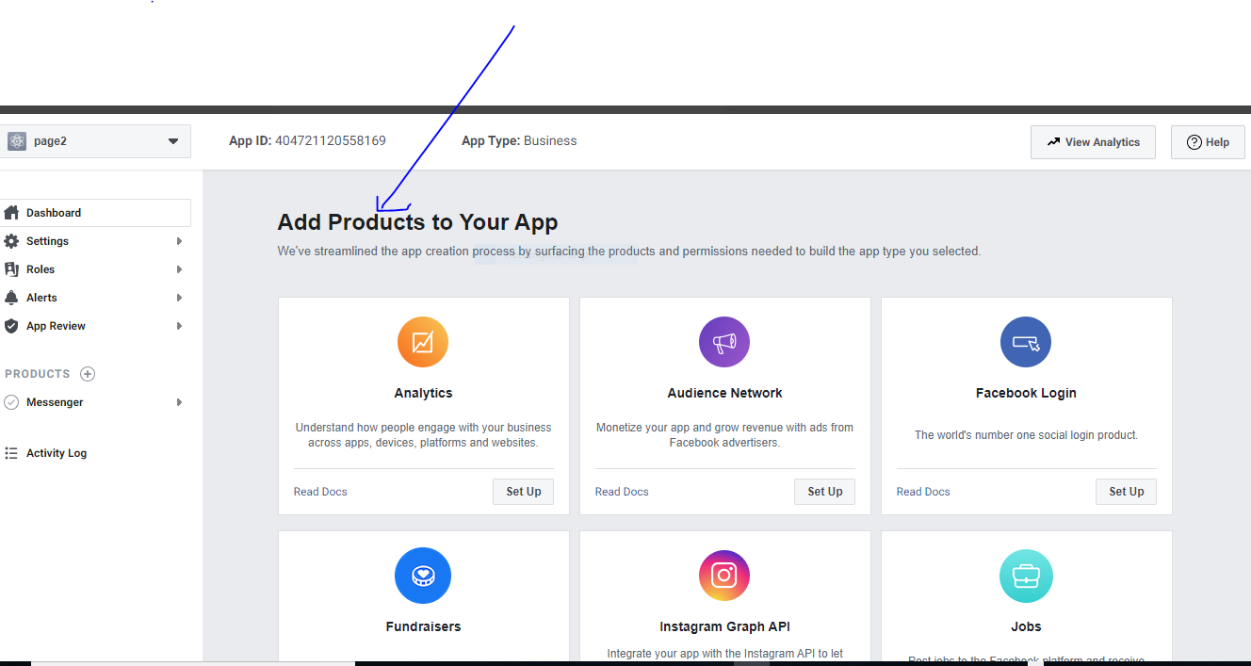

Cool! Under the add product to your app, you will see like Analytics, Audience network, Facebook Login etc. carefully scroll down when you get to “Messenger “click on the Set Up.
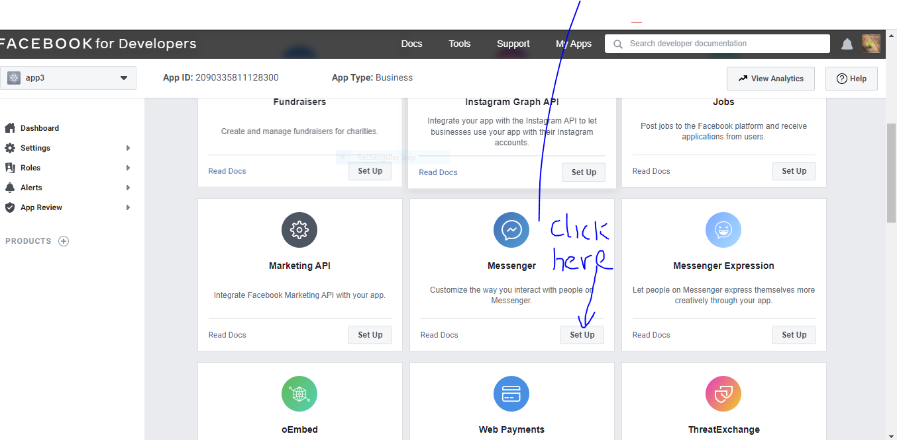

After clicking set up, a messenger platform page like this will open in your browser

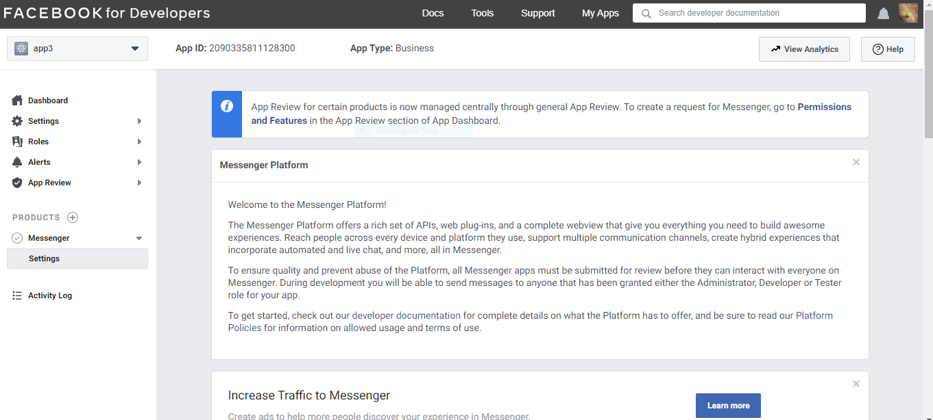

We are getting there, scroll down on the page where you see Access Token ,click on Add or remove page to link you app with the page you created earlier.
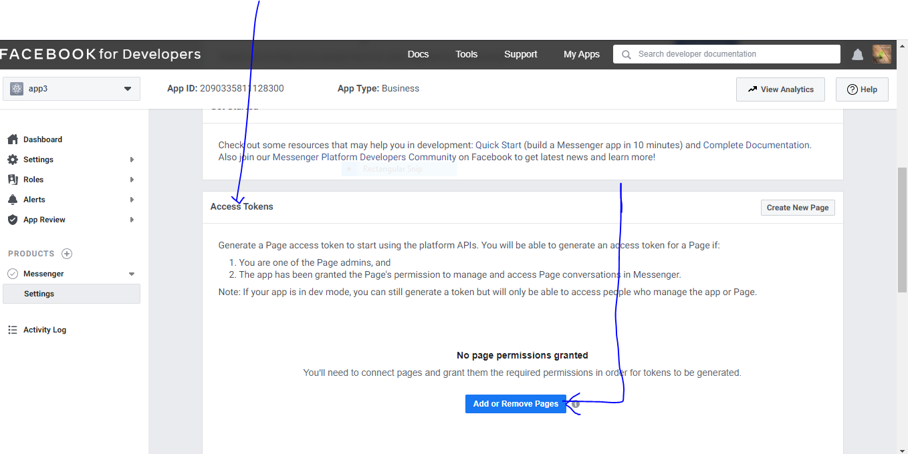
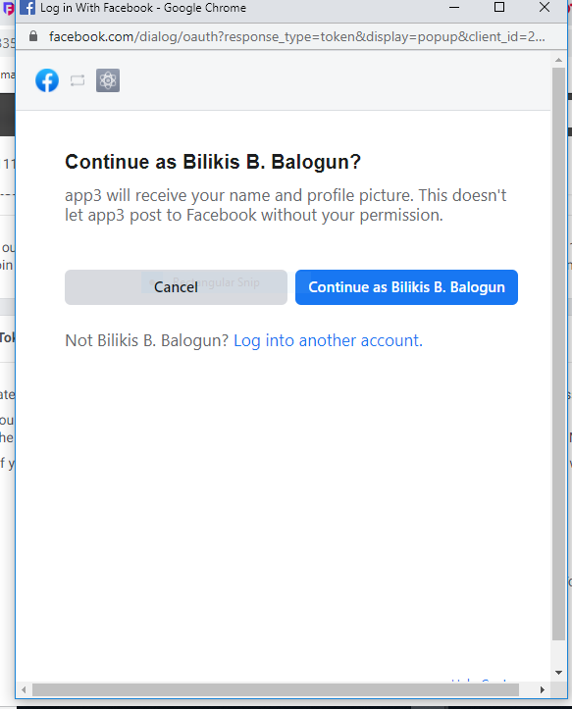
Hopsie!if you are logged out of your Facebook account you will have to confirm that it is you see this page ↓

but if not, don’t panic you will get this. just check on the page you created earlier and then click next.

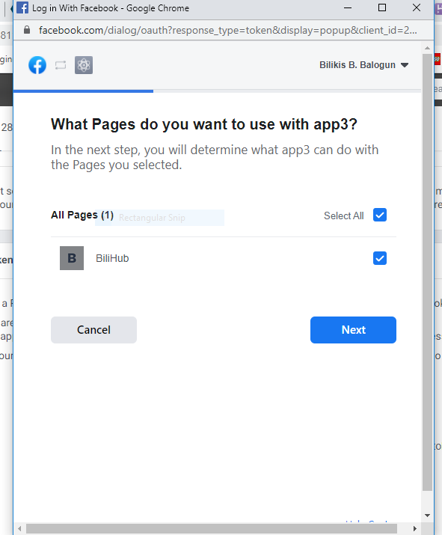

On clicking next another pop up form will open, please ignore the red “Submit for Login Review” and make sure you set Manage and access page conversation in messenger to “YES” and then click Done.

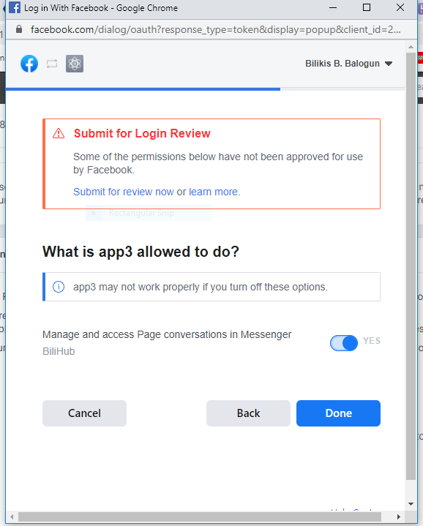

After clicking Done you will get this pop up page showing you’ve successfully link your page to your app. Yippee! So click OK

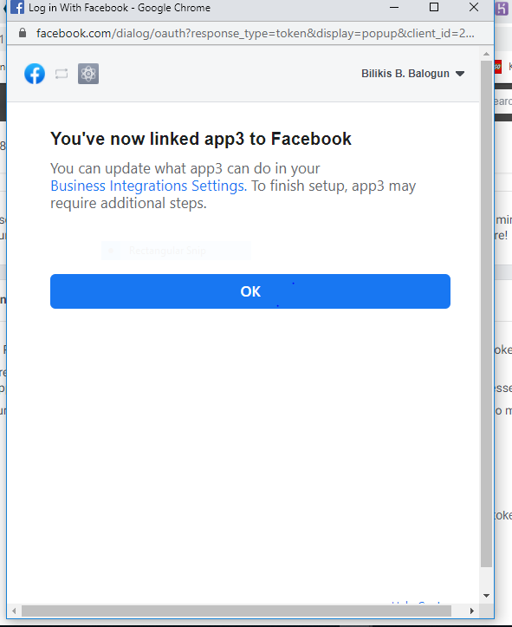

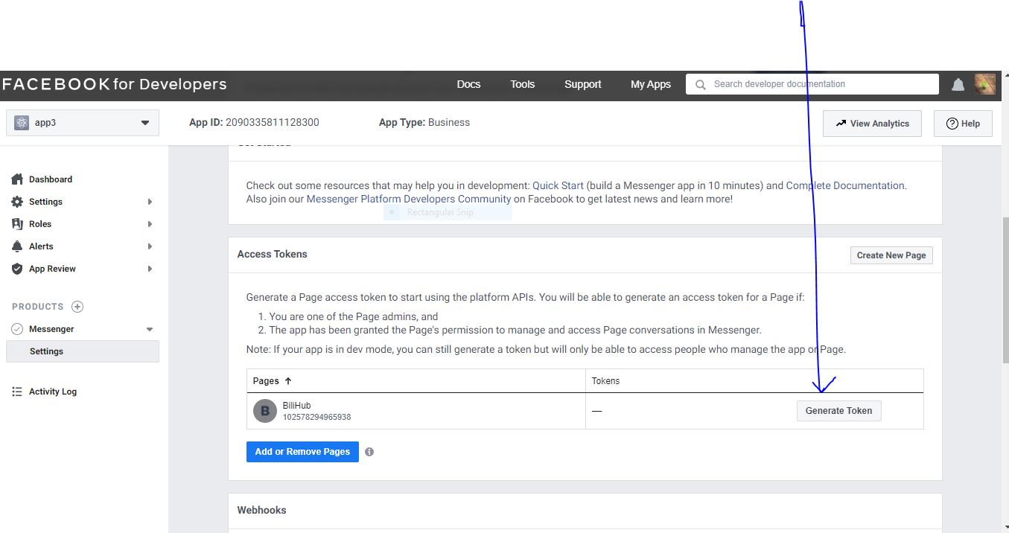
After clicking ok you will receive this page, which shows that you have successfully link your page to your app. Then you have to secure your generated token, please keep it safe to use it later.
Thanks for your effort so far, sigh of relieve but guys, one step to go.
This last league is very important, let get going!
We will now configure the Facebook messenger webhook by first setting up Node.js server.
To begin make sure you already have Node.js install in your computer, but if you don’t, panic not!
Go to google type in download Node.js. Click on the website to Node.js and Voila!
Depending on your operative system, kindly choose the one suitable for your computer. Then click on download, and then install it in your computer my following the prompt.
Ok to continue with our config, secondly, create an empty folder to hold your server, name the folder. Then, open up visual studio code. On the visual studio code, go to file and click on folder then click open.

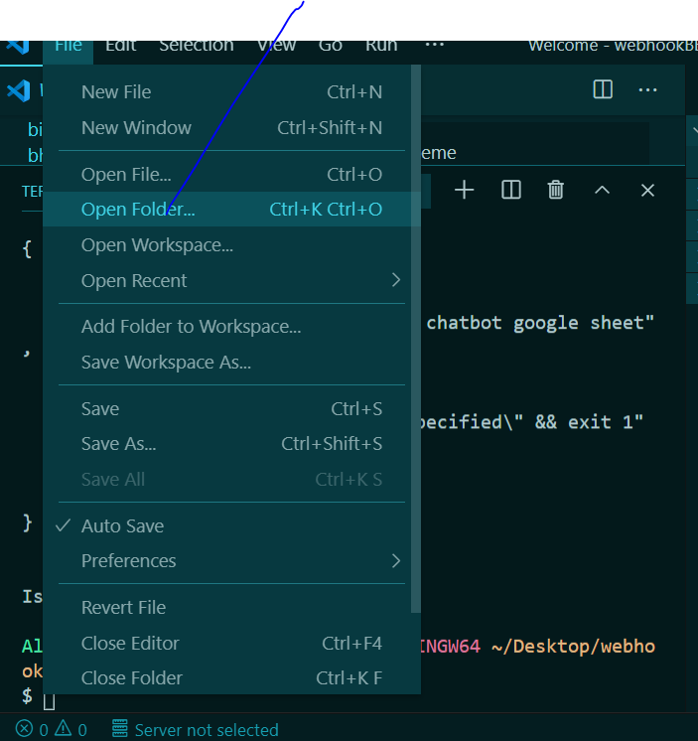

After this, go back to the visual studio code click on view and click on terminal to configure the node server
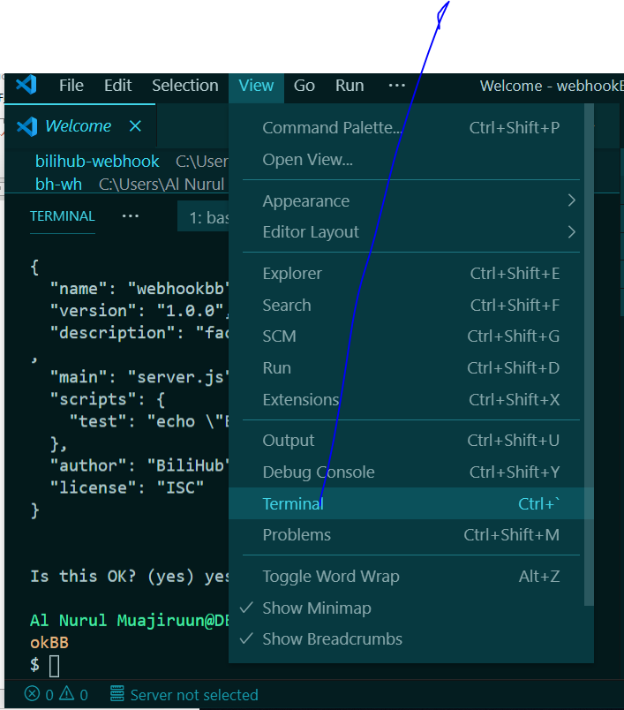

In the terminal, type in npm init to install a package and save it as a dependency in the package.json file and then press enter. And then another enter.
Fix your eyes on the terminal, after the display of description type in →Facebook messenger chatbot google sheet. And after the entry point →type in server.js and type in your name after the author. At this stage the package.json file will be save in your directory.

