AndroidBAT 2.0 user guide

AndroidBAT 2.0 was designed by Gina Cook and Alexandra Marquis (2012).
This guide was written by Catherine Gervais and Alexandra Marquis (2012).

You will need:
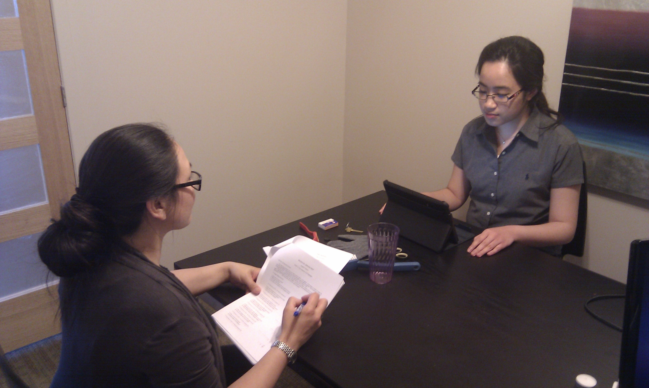
- Android tablet¹ with AndroidBAT 2.0 application installed
(http://play.google.com/store/apps/details?id=ca.ilanguage.bilingualaphasiatest)
- Administrator documents (BAT in your language version)
(available from http://www.mcgill.ca/linguistics/research/bat/)
- Following items for testing (may vary for some languages).
- The participant (right of picture) faces the tablet and the
experimenter who is across the table. Items should be placed in front of the participant, between the tablet and the experimenter.

Pointing
Ring
Button
Matches
Glove
Key
Scissors
Watch
Envelop
Glass
Brush

Simple and semi-complex commands
Ring
Matches
Glass
Pencil
Fork

Complex commands
3 pieces of paper (large, medium, small)
3 crayons (yellow, blue, red)
3 coins (large, medium, small)
3 pieces of wood (long, medium, short)
3 books

Naming
Book
Glasses
Key
Cup
Tie
Scissors
Spoon
Glove
Pencil
(playing) Card
Thermometer
Button
Cigarette
Fork
Feather
Ring
Candle
Envelop
Toothbrush
Watch

A tablet equipped with two cameras should preferably be used (e.g., Motorola Xoom, Acer Iconia, etc.), one located in the front of the tablet (to record participants’ eye gaze and lip movement) and one located in the back (to record objects’ selection). The AndroidBAT 2.0 application should work even with tablets with only one camera or none, in which case it will simply not record participants’ eye gaze, lip movement and objects’ selection video-recorded data.
Instructions

- Once the AndroidBAT 1.0 application is enabled, a settings page will appear. Enter needed information (first language being tested, participant’s information) then touch the back arrow to go back.
- Touch ‘load’, in the top right corner of the screen to begin an AndroidBAT session.
- You can perform each subtest individually by selecting it, or the full test in consecutive order, by pressing ‘start’. The subtests are in clockwise order. Once a subtest is complete, its circle will appear in gray to indicate that it is completed.
- At any given time, you may cancel a subtest by touching the back arrow.

AndroidBAT 1.0 subtests

- History of bilinguism
Complete all items in this subtest. Once the subtest is completed, touch the screen or back arrow of the tablet to return to the main screen of the application.
- English Background
Complete all items in this subtest. Once the subtest is completed, touch the screen or back arrow to return to the main screen of the application.
- Spontaneous speech
Start timer to calculate the time required.
Complete all items in this subtest. Once the subtest is completed, touch the screen or back arrow to return to the main screen of the application.
- Pointing (Verbal Comprehension)
(For required items, please refer to the beginning of this guide.)
Place all items in front of the participant, between the tablet and the experimenter.
Complete all items in this subtest. Once the subtest is completed, touch the screen or back arrow to return to the main screen of the application.
- Simple and semi-complex commands (Verbal Comprehension)
(For required items, please refer to the beginning of this guide.)
Place all items in front of the participant, between the tablet and the experimenter.
Complete all items in this subtest, then touch the screen or back arrow to return to the main screen of the application.
- Complex commands (Verbal Comprehension)
(For required items, please refer to the beginning of this guide.)
Place all items in front of the participant, between the tablet and the experimenter.
Complete all items in this subtest. Once the subtest is completed, touch the screen or back arrow to return to the main screen of the application.
- Verbal auditory discrimination
Participant is required to touch the image that best matches the word produced (pages will change automatically once a test item is completed).
Complete all items in this subtest. Once the subtest is completed, touch the screen or back arrow to return to the main screen of the application.
- Syntactic comprehension
To begin, touch the screen after the instructions have been given to the participant.
Participant is required to touch the image that best matches the sentence produced (pages will change automatically once all test items for a given picture are completed).
Complete all items in this subtest. Once the subtest is completed, touch the screen or back arrow to return to the main screen of the application.
- Semantic categories
Complete all items in this subtest. Once the subtest is completed, touch the screen or back arrow to return to the main screen of the application.
- Synonyms
Complete all items in this subtest. Once the subtest is completed, touch the screen or back arrow to return to the main screen of the application.
- Antonyms
Complete all items in this subtest. Once the subtest is completed, touch the screen or back arrow to return to the main screen of the application.
- Grammaticality judgment
Complete all items in this subtest. Once the subtest is completed, touch the screen or back arrow to return to the main screen of the application.
- Semantic acceptability
Complete all items in this subtest. Once the subtest is completed, touch the screen or back arrow to return to the main screen of the application.
- Lexical decision
Complete all items in this subtest. Once the subtest is completed, touch the screen or back arrow to return to the main screen of the application.
- Series
Complete all items in this subtest. Once the subtest is completed, touch the screen or back arrow to return to the main screen of the application.
- Verbal fluency
Start timer to calculate the time required.
Complete all items in this subtest. Once the subtest is completed, touch the screen or back arrow to return to the main screen of the application.
- Naming
(For required items, please refer to the beginning of this guide.)
Place each item one at a time, between the tablet and the experimenter (remove item once named).
Complete all items in this subtest. Once the subtest is completed, touch the screen or back arrow to return to the main screen of the application.
- Sentence construction
Complete all items in this subtest. Once the subtest is completed, touch the screen or back arrow to return to the main screen of the application.
- Semantic opposites
Complete all items in this subtest. Once the subtest is completed, touch the screen or back arrow to return to the main screen of the application.
- Derivational morphology
Complete all items in this subtest, and then touch the screen or back arrow to return to the main screen of the application
- Morphological opposites
Complete all items in this subtest. Once the subtest is completed, touch the screen or back arrow to return to the main screen of the application.
- Description
To start, touch the screen after the instructions have been given to the participant.
Complete this subtest, and then touch the screen or back arrow to return to the main screen of the application.
- Mental arithmetic
Complete all items in this subtest. Once the subtest is completed, touch the screen or back arrow to return to the main screen of the application.
- Listening comprehension
Complete all items in this subtest. Once the subtest is completed, touch the screen or back arrow to return to the main screen of the application.
- Reading
To start, touch the screen after the instructions have been given to the participant. Touch the screen to change pages once all test items for a given page are completed.
Complete all items in this subtest. Once the subtest is completed, touch the screen or back arrow to return to the main screen of the application.
- Copying
Provide the participant with paper and pencil.
To start, touch the screen after the instructions have been given to the participant.
Touch the screen again after the participant has finished writing.
Touch the ‘Take a picture’ button to take picture of copied words once finished.
Touch ‘ok’ to accept picture or take a new if needed.
And then touch the back arrow to return to the main screen of the application.
- Dictation
Provide the participant with paper and pencil.
Touch the ‘Take a picture’ button to take picture of written words once finished.
Touch ‘ok’ to accept picture or take a new one if needed.
And then touch the screen or back arrow to return to the main screen of the application.
- Reading comprehension for words
To start, touch the screen after the instructions have been given to the participant.
Participant is required to touch the image that best matches the word presented (pages will change automatically once an image has been selected).
Complete all items in this subtest. Once the subtest is completed, touch the screen or back arrow to return to the main screen of the application.
- Reading comprehension for sentences
To start, touch the screen after the instructions have been given to the participant.
Participant is required to touch the image that best matches the sentence presented (pages will change automatically once an image has been selected).
Complete all items in this subtest. Once the subtest is completed, touch the screen or back arrow to return to the main screen of the application.
- Writing
Provide the participant with a paper and pencil.
Touch the ‘Take a picture’ button to take picture of written words once finished.
Touch ‘ok’ to accept picture or take a new one if needed.
And then touch the screen or back arrow to return to the main screen of the application.

