**2. Software Architecture**

**2.1 Overview**

This section is about the decomposed parts of our software system, the classes will be divided into appropriate packages according to their functions. The aim of decomposing is to follow the common software architecture and professional approach, which eases for other developers to understand the code, and it is very advantageous for maintenance.

**2.2 Subsystem Decomposition**

In this section, we will discuss three parts of the software system, which is divided into three parts in order to follow MVC software design pattern. Therefore, we have Model classes, View classes and Controller classes.

There is a tight connection between classes in a particular package, because they are in a same package and their functions are same in the software when we look from software design pattern point of view.

However there is a loose connection between packages, because there is not as many dependencies as they are in a same package, so it is logical to divide into three mostly dependent parts to enhance modifiability, maintenance, and performance of the application.

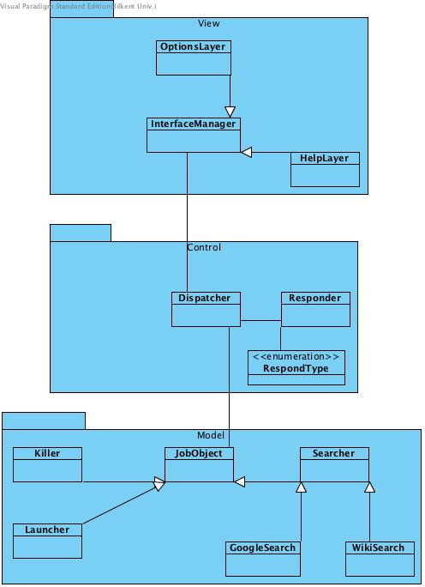

**2.3 Architectural Styles**

**2.3.1 Layers**

There are three layers in our system decomposition: View, Controller and Model in a respective hierarchy. A View layer, it is an interactive layer, which is visible to users, and gets data from users and responds back to them. The next lower layer is a Controller layer that is behind View layer, and it controls or forces to View to behave with respect to the commands of a controller layer. Additionally, Controller layer saves the data gotten by a user form View layer to a proper memory using Model layer. The lowest layer is Model layer, which is the layer of entity objects. Model layer objects are used by Controller layer classes, but they are not accessible by View layer directly.

**2.3.2 MVC**

Model classes are the objects that are used by other classes, because they are central to the application.

View classes are what users see as an application, its purpose is just to show the results and get some needed information from the user and pass it to other classes.

Control classes are very crucial part of the application, because it is the connection between Model and View classes, and it controls over the application. In the application, the all classes are divided into these three parts according to their functions.

**2.4 Hardware / Software Mapping**

We are planning to implement Genius application in C# programming language, because it seems to have more libraries that fit to our application requirements. As a hardware, keyboard is needed to type what kind of actions he/she is going to take, or searches he/she wants to do, a mouse for opening/closing the application and screen transition, microphone to get voice input from a user( it will be implemented if we have a sufficient time to finish, otherwise only written input will be used).

The application can execute only in later versions of Windows 8, so Windows 8, 9 or 10 is required.

**2.5 Persistent Data Management**

Genius application does not require complicated database management system, only basic saving and retrieving from a file is enough. The only thing that we store is data about where a user is left off when he/she closed the application to continue when it opens back. So all the search results, settings, help functionalities are saved to the file, and retrieved back from the file when the application is in execution.

**2.6 Access Control and Security**

For searching with Google or Wikipedia, the application requires an internet connection from a user. For security reasons, the application will not have an access to critical parts of an OS and personal information of a user to prevent information leakage to the internet.

**2.7 Boundary Conditions**

**Install**

To install the application we provide an .exe file, with minimum memory and other requirements. So, installation will be easy and it should not take too much time.

**Termination**

To terminate the running application, only Quit icon at the top left corner is enough. If anywhere else outside the application window is clicked, the application is not terminated, but just the window is closed and taken into sleep mode.

**Error**

Due to loss of memory file where the application get information from, an error can occur, as an application does not know where it should start from or where save data to.

The error may be caused by an internet interruption while the application was doing a search.