

CS 319 - Object-Oriented Software Engineering

Design Report – Final

Genius

Group 15
Asena Rana Yozgatlı | 21000132
Serhan Gürsoy | 21400840
Kutbidin Ululu Meder | 21303000
Mustafa Said Sarı | 21302224

Deadline: 26/11/2016

Course Instructor: Bora Güngören

Table Of Contents
1. Introduction 3
1.1 Purpose of the system 3
1.2 Design Goals 3
End User Criteria : 3
Maintenance Criteria : 4
Performance Criteria : 4
Trade Offs : 5
1.3 Definitions, acronyms, and abbreviations 5
Abbreviations: 5
1.4. References 5
1.5. Overview 5
2.Software Architecture 5
2.1. Overview 5
2.2. Subsystem Decomposition 6
2.3. Architectural Styles 8
2.3.1 Layers 8
2.3.2 Model View Controller 9
2.4. Hardware / Software Mapping 9
2.5. Persistent Data Management 9
2.6. Access Control and Security 10
2.7. Boundary Conditions 10
3. Subsystem Services 11
3.1. Design Patterns 11
Model-View-Controller Pattern: 11
3.2.View Subsystem 12
3.3 Control Subsystem 18
3.4 Model Subsystem 21
3.5 Detailed System Design 23

1. Introduction

1.1 Purpose of the system

Genius is an intelligence personal assistant for computers. User will use input box to command assistant and it will execute these commands whether they are related about getting an information from internet or related with personal computer -like starting an application.
Like all other intelligence personal assistants in the industry (Cortana, Siri, Google Assistant) our personal assistant’s priority also will be helping user but not being a companion to her/him. Yet, as a secondary goal, we can implement first phases of the natural language processing to give assistant to reply simple user questions (i.e. “How are you?”, “What is your name?”). However, this won’t be advanced and shouldn’t be confused with other Artificial Intelligence Chat Bots.

1.2 Design Goals

It's very important to define our system design goals before building our project to clearly show our project's focus. Our system's design goals are described below.

End User Criteria :
Ease of Use : Genius is an intelligence assistant so it's one of the main purpose makes using computer for people easier. Therefore; users don't want such programs to have difficult usage. For this reason, our system will provide user friendly interfaces that everything is easily understandable and usable.
Ease of Learning : User don't have to know pre information about program. Help document is provide general information and some easy commands about program. Via this document, user can easily become be capable of using program and use it more efficiently.

Maintenance Criteria :

Extendibility : We need to implement basic features which an assistant require to work functionally. In early versions, Genius will only take text-based inputs but in further releases assistant could recognize natural voice without the requirement for keyboard. Assistant will answer questions according to their form whether they are text input or voice input. If question is asked to learn something new but not to execute something, using certain API’s, user can get answer right away. Or user can use assistant to start applications like Word, Paint.

Portability : Portability is crucial for a software because it can be used very different range of users. We are planning to implement our program in C#. By design, C# is the programming language that most directly reflects the underlying Common Language Infrastructure (CLI)[1]. Therefore, portability is not a problem.

Modifiability : Modifying existing features of our program is not hard. We can succeed desired alteration via decrease the coupling and by this way avoid making huge effects on program components.

Performance Criteria :
Response Time : For assistant programs response time is important. Therefore, our program will responds to the user very quickly and execute user's request in a very short time period.

Trade Offs :

Ease Of Use and Ease of Learning vs. Functionality :
In our program users should be able to easily learn and use system. Complex functionalities is not priority for us. Therefore, usability has higher priority than functionality.

1.3 Definitions, acronyms, and abbreviations

Abbreviations:
MVC: Model View Controller

1.4. References
[1] https://en.wikipedia.org/wiki/C_Sharp_(programming_language)#Portability

1.5. Overview

In this part, we show purpose of the system, which is basically execute user-entered commands, to succeed this aim we describe design goals of our program. Providing portability, ease of use, ease of learning, high performance, high maintainability are the design goals of our program. We made some trade-offs to realize our aims. We sacrificed from functionality to make our system simpler and understandable.

2.Software Architecture

2.1. Overview

This section is about the decomposed parts of our software system, the classes will be divided into appropriate packages according to their functions. The aim of decomposing is to follow the common software architecture and professional approach, which eases for other developers to understand the code, and it is very advantageous for maintenance.

2.2. Subsystem Decomposition
In this section, we will discuss three parts of the software system, which is divided into three parts in order to follow MVC software design pattern. Therefore, we have Model classes, View classes and Controller classes.
There is a tight connection between classes in a particular package, because they are in a same package and their functions are same in the software when we look from software design pattern point of view.
However there is a loose connection between packages, because there is not as many dependencies as they are in a same package, so it is logical to divide into three mostly dependent parts to enhance modifiability, maintenance, and performance of the application.
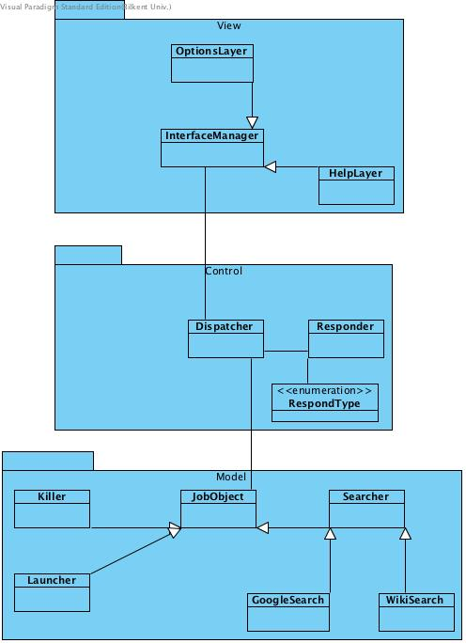
Figure 1(System Decomposition)

2.3. Architectural Styles

2.3.1 Layers

There are three layers in our system decomposition: View, Controller and Model in a respective hierarchy. A View layer, it is an interactive layer, which is visible to users, and gets data from users and responds back to them. The next lower layer is a Controller layer that is behind View layer, and it controls or forces to View to behave with respect to the commands of a controller layer. Additionally, Controller layer saves the data gotten by a user form View layer to a proper memory using Model layer. The lowest layer is Model layer, which is the layer of entity objects. Model layer objects are used by Controller layer classes, but they are not accessible by View layer directly.

View
Figure 2(Layers of System)

Control

Figure-3(Layers of system)

Model

2.3.2 Model View Controller
Model classes are the objects that are used by other classes, because they are central to the application.
View classes are what users see as an application, its purpose is just to show the results and get some needed information from the user and pass it to other classes.
Control classes are very crucial part of the application, because it is the connection between Model and View classes, and it controls over the application. In the application, the all classes are divided into these three parts according to their functions.

2.4. Hardware / Software Mapping
We are planning to implement Genius application in C# programming language, because it seems to have more libraries that fit to our application requirements. As a hardware, keyboard is needed to type what kind of actions he/she is going to take, or searches he/she wants to do, a mouse for opening/closing the application and screen transition, microphone to get voice input from a user( it will be implemented if we have a sufficient time to finish, otherwise only written input will be used).
The application can execute only in later versions of Windows 8, so Windows 8, 9 or 10 is required.

2.5. Persistent Data Management

Genius application does not require complicated database management system, only basic saving and retrieving from a file is enough. The only thing that we store is data about where a user is left off when he/she closed the application to continue when it opens back. So all the search results, settings, help functionalities are saved to the file, and retrieved back from the file when the application is in execution.

2.6. Access Control and Security

For searching with Google or Wikipedia, the application requires an internet connection from a user. For security reasons, the application will not have an access to critical parts of an OS and personal information of a user to prevent information leakage to the internet.

2.7. Boundary Conditions

Install
To install the application we provide an .exe file, with minimum memory and other requirements. So, installation will be easy and it should not take too much time.

Termination
To terminate the running application, only Quit icon at the top left corner is enough. If anywhere else outside the application window is clicked, the application is not terminated, but just the window is closed and taken into sleep mode.

Error
Due to loss of memory file where the application get information from, an error can occur, as an application does not know where it should start from or where save data to.
The error may be caused by an internet interruption while the application was doing a search.

3. Subsystem Services

In this section we will provide the detailed information about the interfaces of our subsystems.

3.1. Design Patterns

Model-View-Controller Pattern:
Model-View-Controller(MVC) pattern is an Architectural Software Design pattern for implementing software with user interfaces. As the name already suggest, MVC has three components which can be explained as;
- Model: Component that contains data, logic and rules. In other words, it's the component where most of internal interaction happens.
- View: Component that handles output operations, as an example, a button and response warning message on screen.
- Controller: Component that interprets inputs and tasks model or view accordingly.

In our design, we used MVC pattern because, our software requires user input for many cases. For the sake of brevity, we used simple names; View, Control and Model for subsystems. Our View Subsystem transfers inputs directly to the Control Subsystem without interpreting them which gives Control Subsystem efficient control over software while it keeps the simplicity of View and Model Subsystems. Separating Model, Controller and View also gives chance for modularity for any future subsystem change. MVC also makes data flow tracing easy for developers. For example, to start an application, data flow of our software generally proceeds like this;
View (Get user actions on GUI)→Control (Interpret inputs accordingly and command model)→Model (Start application)
Furthermore, for getting information from internet (Wikipedia for example) and showing it to the user, data flow proceeds like this;
View (Get user actions on GUI)→Control (Interpret inputs accordingly and command model)→Model (Get information, send data to Control to notify)→Control (Send data to View to show user)→View (Change GUI and show data retrieved from internet)

3.2.View Subsystem

View subsystem holds the graphical interface objects of our system. Its main purpose is to communicate with the user with different layers of screens. Other than managing these layers according to user selections, it also communicates with the Control subsystem via Interface Manager.

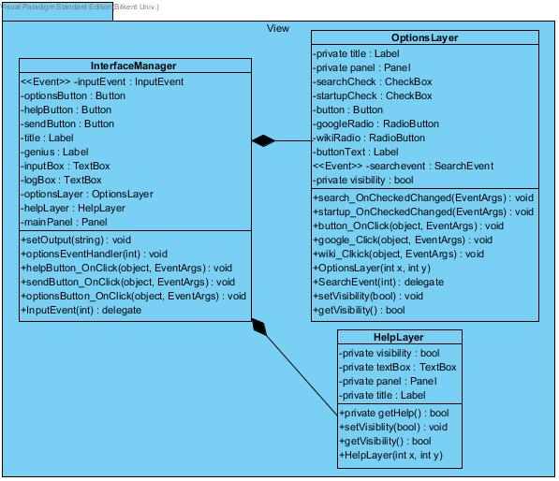
Figure 3(View Subsystem)

InterfaceManager Class

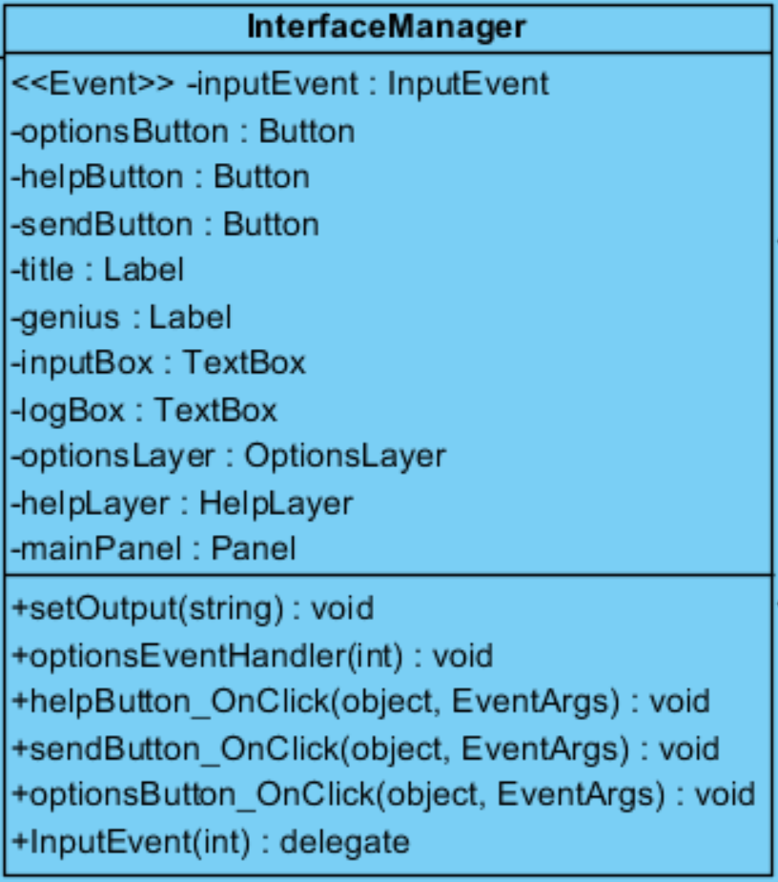

Attributes:

public InputEvent inputEvent : This event is the event where dispatcher class will get input string whenever InterfaceManager’s inputEvent triggered. This is essential for transmitting data to parent class. If we didn’t decide to use event system, we had to check InterfaceManager in short-timed periods/pulses to see whether we have new input or not. But this is not a good option because our user has to see and execute process in time.
private Button optionsButton: This is the option button object. With this button user will be able to see options button visually. Any click event will be trigger optionsButton_OnClick method.
private Button helpButton: This is the help button object. With this button user will be able to see help button visually on her/his screen. Any click will be trigger helpButton_OnClick method.
private Button sendButton: This is the send button object. User need to see this button visually in order to send typed input to the core. Any click on this object will trigger sendButton_OnClick method.
private Label title: This label for showing the “Chat Log:” string. This label will be on below the chat log text box area.
private Label genius: This label is for the main title. Presumably it will contain “Genius Smart Assistant” text.
private TextBox inputBox: This text area for user to insert his/her input. User will insert his/her input to this area and this will be cleared up when user clicks to send button.

private TextBox logBox: This text area for showing the chat log between user and Genius. Every returned string will be printed on here whether it is positive feedback or negative (Errors)
private OptionsLayer optionsLayer: This is attribute of OptionsLayer class. InterfaceManager will create optionsLayer in order to show options layer for user.
private HelpLayer helpLayer: This is the attribute of HelpLayer class. InterfaceManager will create helpLayer in order to show help box for user.
private Panel mainPanel: This is the panel class for main Genius frame. This will contain buttons and labels in it.

Methods:
public void SetOutput(string): This method will take a string argument in order to show set output in logBox textbox. This method will be used from parent class in order to set output strings.
private void optionsEventHandler(int): This method is for handling the optionsEvent. In this method we will evaluate whether user selected anything from options box or not.
private void helpButton_OnClick(object, EventArgs): This method is for handling the OnClick operation of Help button. If user clicks to help button, helpLayer will be visible so that user can read help section.
private void sendButton_OnClick(object, EventArgs): This method is for handling the OnClick operation of send button. If user clicks to send button, content of input box will be transferred to the dispatcher class to process.
private void optionsButton_OnClick(object, EventArgs): This method is for handling the OnClick operation of options button. If user clicks to option button, optionLayer will be visible so that user can change settings easily.
private void delegate InputEvent(int): This is the declaration of InputEvent. With InputEvent declaration, we will use event system properly.

OptionsLayer Class

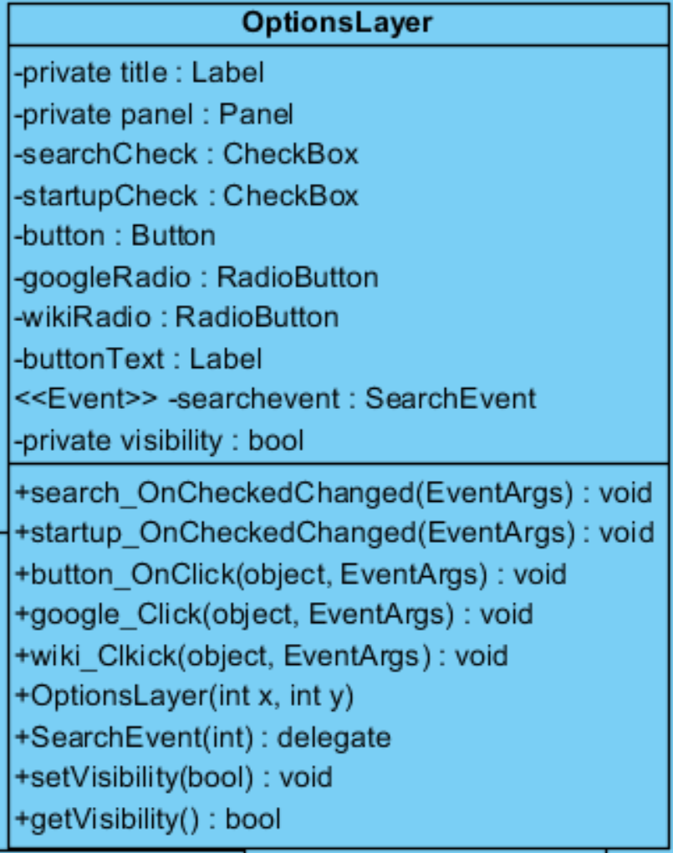

Attributes:
public Label title: This is the label object which will indicate the box’s title. Which will be “Options” in this case.
private Panel panel: This is the panel object which will store all buttons, labels and other visual stuff. Without panel, we cannot visually represent our options layer.
private CheckBox searchCheck: This checkbox is for to determine whether our user wants to set a default search engine or not. If user checks this box, then he/she will be asked to pick Wikipedia or Google with radio buttons. Changes on this checkbox will be handle by OnCheckedChanged method
private CheckBox startupCheck: This checkbox is for to determine whether our user wants assistant to run at startup or not. Changes on this checkbox will be handle by OnCheckedChanged method
private Button button: This button is for updating the newly installed application list. If user clicks on that, this will trigger scanning of newly installed applications to record their patsh.
private RadioButton googleRadio: This radio button is for Google search. If user select this, then Genius will only search in Google.
private RadioButton wikiRadio: This radio button is for Wikipedia search. If user select this, then Genius will only search in wikipedia.
private Label buttonText: This label area for indicating to newly installed scan button will records newly installed applications on Genius’ memory.
public event SearchEvent searchevent: This is event for sending data from optionbox to InterfaceManager. With this event, InterfaceManager will know the changes in options panel.
private bool visibility: This variable for keeping the visibility status of layer. Can be changed with set method.

Constuctor:
public OptionsLayer(int x, int y): Constructor of OptionsLayer class takes two arguments. Two integer values to determine its X and Y coordinates on screen.
Methods:
private void search_OnCheckedChanged(EventArgs): This method is for handling the checking operation of search checkbox. If user checks search checkbox, this method will capture it and enable radio buttons for user to pick. Also every change on this method will be immediately trigger searchEvent.
private void startup_OnCheckedChanged(EventArgs): This method is for handling the checking operation of startup checkbox. If user checks startup checkbox, Genius will start whenever user opens his PC. Every change on this method will be immediately trigger searchEvent.
private void button_OnClick(object, EventArgs): This method is for handling the OnClick operation of scan button. If user clicks to scan button, Genius will scan newly installed applications and save their paths in order to launch them on demand.
private void google_OnClick(object, EventArgs): This method is for handling the OnClick operation of google radio button. This change will trigger searchEvent to send changes to InterfaceManager.
private void wiki_OnClick(object, EventArgs): This method is for handling the OnClick operation of wikipedia radio button. This change will trigger searchEvent to send changes to InterfaceManager.
private void delegate SearchEvent(int): This is the declaration of SearchEvent. With SearchEvent declaration, we will use event system properly.
public bool getVisibility(): This method will return the visibility of layer to inform caller.
public void setVisibility(bool): This method will change the visibility of layer according to its Boolean argument.

HelpLayer Class

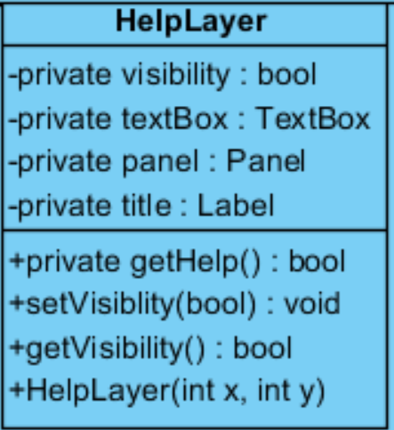

Attributes:
private bool visibility: This Boolean value to know whether HelpLayer is visible or not.
private Panel panel: This is the panel object which will store all buttons, labels and other visual stuff. Without panel, we cannot visually represent our options layer.
Private TextBox textbox: This text box will contain the help information for user. With this box, user can read and grasp the purpose of Genius easily. This text box will also contain version number and developer information.
Private Label title: This label will show the title of current layer. Which is “Help” in this case.
Constuctor:
public HelpLayer(int x, int y): Constructor of HelpLayer class takes two arguments. Two integer values to determine its X and Y coordinates on screen.
Methods:
private bool getHelp(): This method will be called at the initialization of HelpLayer in order to fill textbox with help information which will be received from reading an txt file from the disk. It will return bool value in order to inform caller whether it was successful to read or not.
public bool getVisibility(): This method will return the visibility of layer to inform caller.
public void setVisibility(bool): This method will change the visibility of layer according to its Boolean argument.

3.3 Control Subsystem

Control subsystem holds the control objects of our system. Its main purpose is to control the system dynamics according to user inputs. Other than managing the model objects, it also provides an appropriate response to user both according to user inputs and to inform the user about system. Model subsystem and View subsystem are communicated and manipulated via Dispatcher. Dispatcher creates, holds, manipulates, and destroys the model objects.

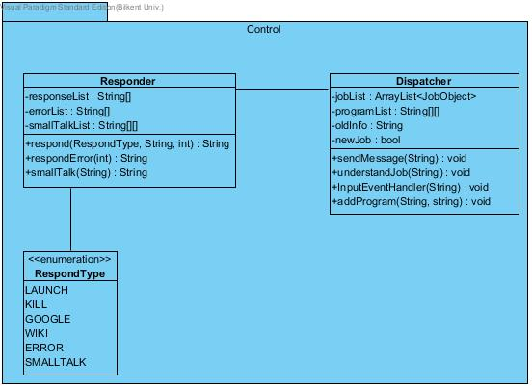
Figure 4(Control Subsystem)

Responder Class
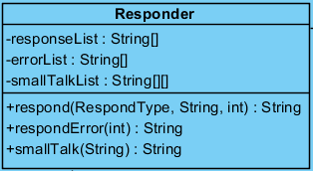

Attributes:
private String[] responseList: This array keeps the appropriate responses as String.
private String[] errorList: This array keeps the appropriate error messages as String.
private String[][] smallTalkList: This 2-D array keeps the keyword and response of that keyword as String.

Methods:
public String respond(RespondType, String, int): This method takes one RespondType Enumeration type value to understand what type of response to give. If this value is LAUNCH, KILL, GOOGLE, or WIKI then a response from responseList will be selected according to the integer value it receives as parameter. It does not need the second parameter. If this value is ERROR, then respondError method will be called with the integer value it receives as parameter to select the appropriate message. It does not need the second parameter. If this value is SMALLTALK, then smallTalk method will be called with the string it receives as parameter to select the appropriate message. It does not need the third parameter. This method will return the appropriate message to send to inform the caller.
private String respondError(int): This method takes an integer value as a parameter. This value keeps the error code. This method will find the appropriate error message and returns this information as a String to inform the caller.
private String smallTalk(String): This method takes a string value as a parameter. This value keeps the user input information. This method will find the appropriate message to keep the user busy and return this information as a String to inform the caller.

Dispatcher Class

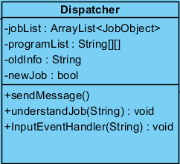

Attributes:
private ArrayList<JobObject> jobList: This ArrayList keeps a list of the active jobs as JobObject.
private String[][] programList: This 2-D array keeps the names and their corresponding paths of programs. This List initially contains the basic microsoft applications' information, suc as paint or notepad. It can be updated by the addProgram method.
private String oldInfo: This value keeps the incomplete info that is necessary to do the job.
private bool newJob: This value keeps if the dispatcher is taking a new job or getting some missing information from old input.

Methods:
public void sendMessage(String): This method takes a String value as a parameter. This value holds the message to be sent. This method calls the setOutput method of InterfaceManager class to set the output.
private void understandJob(String):This method takes a String value as a parameter. This value keeps the input information.This method first check the newJob value. If false it will add the old info to new info. This method will parse this string and try to understand the job. It will send this information to the responder and get a respond. After responding it will perform the job by creating a jobObject that can do the job. If the input has missing information, OldInfo, and newJob values will be updated. No jobs performed.
public void InputEventHandler(String): This method is for handling the InputEvent. In this method we will evaluate whether user entered an input or not.
private void addProgram(String, String): This method will take two String values as parameters. These strings hold the name of the program and the path of the program respectively. This method will update and add this program to the programList array.

RespondType Class

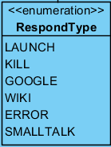

LITERALS:
LAUNCH
KILL
GOOGLE
WIKI
ERROR
SMALLTALK

3.4 Model Subsystem

Model subsystem holds the domain specific objects of our system. Our model objects inherits from a base class, called Job Object. Job Object class holds the information necessary for the Control subsystem to easily control the model objects. Control subsystem is communicated via Job Object.

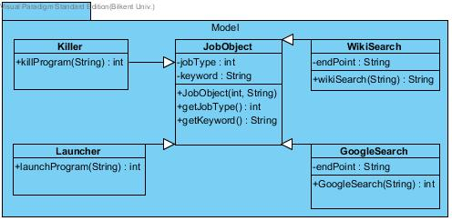
Figure 5(Model Subsystem)

Killer Class

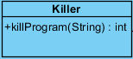

Methods:
public int killProgram(String): This method takes a String value as a parameter. This value is the program information that is required to kill a program or an application. This method will try and kill a program. If fails it will return an error code to inform the caller.

Launcher Class

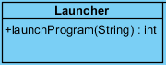
Methods:
public int launchProgram(String): This method takes a String value as a parameter. This value is the program information that is required to launch a program or an application. This method will try and launch a program. If fails it will return an error code to inform the caller.

GoogleSearch Class

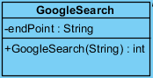

Attributes:
private String endPoint : This value keeps the end point of the URL to perform the Google Search.
Constuctor:
public int GoogleSearch(String): Constructor of GoogleSearch class takes a string value as a parameter.This string value is added to the endpoint value to determine the complete URL. Constructor will try and search Google. If fails, it will return an error code to inform the caller.

WikiSearch Class

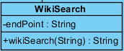

Attributes:
private String endPoint: This value keeps the end point of the URL to perform the Wikipedia Search.
Constuctor:
public String wikiSearch(String): Constructor of WikiSearch class takes a string value as a parameter.This string value is added to the endpoint value to determine the complete URL. Constructor will try and search Wikipedia. If succeeds it will return the search results as a string; If fails, it will return null to inform the caller.
JobObject Class

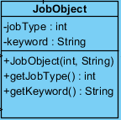

Attributes:
private int jobType: This variable keeps the type information of the job. This value is set by constructor and cannot be changed during the lifetime of a job.
private String keyword: This variable keeps the keyword for of the job. Keyword can be a program information or a search information.
Constuctor:
public JobObject(int, String): Constructor of JobObject class takes two arguments. One integer value to determine which type of job and one string value to determine the keyword of the job.

Methods:
public int getJobType(): This method will return type of job to inform the caller.
public String getKeyword(): This method will return keyword of the job to inform the caller.

3.5 Detailed System Design

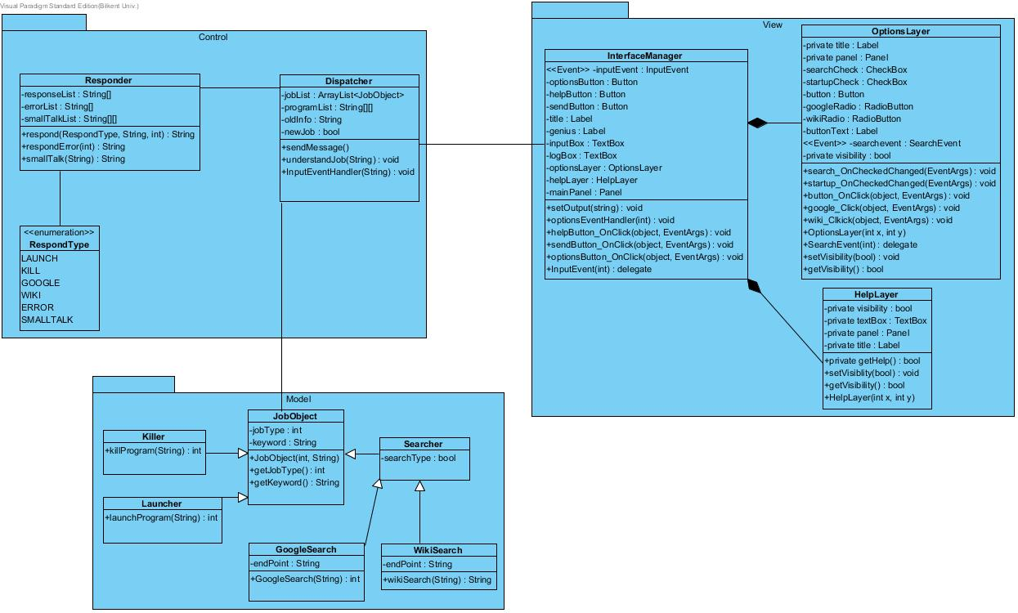
Figure 6(Detailed System Design)

