

CS 319 - Object-Oriented Software Engineering

Analysis Report – Draft

Genius

Group 15
Asena Rana Yozgatlı | 21000132
Serhan Gürsoy | 21400840
Kutbidin Ululu Meder | 21303000
Mustafa Said Sarı | 21302224

Deadline: 15/10/2016

Course Instructor: Bora Güngören

Table of Contents

1. Introduction 3

2. Overview 3

3. Functional Requirements 4

Main Menu 4

Closing The Application 4

Launching The Application 4

Searching With Google 5

Searching With Wikipedia 5

4. Nonfunctional Requirements 5

4.1 Usability Requirements 6

4.2 Reliability Requirements 6

4.3Security Requirements 6

4.4 Performance Requirements 6

4.5 Supportability Requirements 6
4.6 Constraints 7

5. System Models 7

5.1 Scenarios 7

Scenario 1: Play Game 7

Scenario 2: Change Settings 7

Scenario 3: Load and Save Game 8

Scenario 4: Search Google 8
Scenario 5: Search Wikipedia 8

5.2 Use Case Model 9

Use Case Descriptions 9

Use Case Diagram 14

5.3 Object Model 15

Data Dictionary 15

Class Diagram 15

5.4 Dynamic Models 15

Activity Diagram 15

Sequence Diagrams 15

5.5 User Interface 15

References 15
1. Introduction - 2. Overview

Genius is an intelligence personal assistant for computers. This Intelligence personal assistant will run at the background as a Windows Service. User will use his/her voice to command Genius and it will execute these commands whether they are related about getting an information from internet or related with personal computer -like starting an application. Further features will be listed below. To activate Genius, or in other words to wake it up to listen user’s commands, user should simply say the magic words (i.e. “Hey Jarvis!” or ”Hey Siri”) to the microphone.
Like all other intelligence personal assistants in the industry (Cortana, Siri etc) Genius’s priority also will be helping user but not being a companion to her/him. Yet, as a secondary goal, we can implement first phases of the natural language processing to give Genius to reply simple user questions (i.e. “How are you?”, “What is your name?”). However, this won’t be advanced and shouldn’t be confused with other Artificial Intelligence Chat Bots.
Although these features can be expanded in near feature, we need to implement basic features which an assistant require to work functionally. Genius can recognize natural voice without the requirement for keyboard. Genius will answer questions according to their form. If question is asked to learn something new but not to execute something, using certain API’s, user can get answer right away. Or user can use Genius to start applications like Word, Paint..

3. Functional Requirements

Main Menu
- The Application should show Launch Program button on the Main Menu
- The Application should show Close Program button on the Main Menu
- The Application should show Google Search button on the Main Menu
- The Application should show Wikipedia Search button on the Main Menu
- The Application should show Help button on one of the corner of the Main Menu as a small button
- The Application should show Settings button on the Main Menu screen as a small button

Closing The Application
- The Application should have an input field to enter the name of the program which is going to be closed in this page.
- The Application should have a voice recognition to convert a voice to characters and close the desired program.
- The Application should have close button in this page to close entered program.
- The Application should have a button to return to Main Page.

Launching the Application
- The Application should have an input field to enter the name of the program which is going to be launched in this page.
- The Application should have a voice recognition to convert the received voice to character and launch the desired program.
- The Application should have launch button in this page to launch entered program.
- The Application should have a button to return to Main Page.
.

Searching With Google
- The Application should have an input field to enter a text that he/she wants to search with Google.
- The Application should have search button in this page to search about entered text.
- The Application should open a default browser with search results given a text to search.
- The Application should have a button to return to Main Page.

Searching with Wikipedia
- The Application should have an input field to enter a text that he/she wants to search with Wikipedia.
- The Application should have search button in this page to search about entered text.
- The Application should open a default browser with search results given a text to search.
- The Application should have a button to return to Main Page.

4. Nonfunctional Requirements
- Usability Requirements
- The Application should be User-friendly and easy to use.
- The Application should use meaningful names for buttons and icons in order to ease navigation.
- The Application should provide Back and Forward buttons in order not to get stuck at the middle of the program.
- Every page of the Application should have a beautiful design.

- Reliability Requirements
- The Application should start from the point where it is left in case of power-loss.
- The Application should save the progress of the user in case of internet connection problem.
- The Application should save the progress in case of User closes the application abruptly.
- The Application should save the progress in case of User hides the application abruptly or transits to another program.
- Security Requirements
- The Application should get information for the user from reliable sources and not download viruses to the PC
- The Application should have and access only to what is allowed by the User.
- The Application should not have an information leakage from users PC to any other repository.
- Performance Requirements
- The Application should gather required information from Internet within a very short period of time.
- The Application’s transitions between pages in the Application should be smooth.
- The Application should handle animations smoothly.
- The Application voice recognition should be very accurate
- Supportability Requirements
- The Application software should be very well documented.
- The Application code should be very clearly commented.
- The Application should be supported by all Windows versions.

4.6 Constraints
- The Application should be implemented in C#.
- Adobe Photoshop should be used for graphical usage.

  - System Models

- Scenarios

Scenario 1 : Launch Program Case One
Kadri wants to open an application on his computer with using Genuis Assistant. Because Kadri have no idea about how Genius works, he first drag his mouse and clicks "Help" option. System prompts text which explains how Genius works. After reading instructions, Kadri presses to Back button and comes to menu. Then Kadri drags his mouse to the "Launch Program" option in order to open launch options. System asks Kadri to enter the name of the desired program to launch. Kadri types "Microsoft Word" to launch Microsft Word. Because Microsft Word was already registered in personal computer, Genius launchs Microsoft Word immediately.

Scenario 2: Launch Program Case Two
Yasin wants to open an application on his computer with using Genuis Assistant. Since Yasin already know how Genius works, he simply drags his mouse to the "Launch Program" option in order to open launch options. System asks Yasin to enter the name of the desired program to launch. Yasin types "Whatsapp" to launch Whatsapp. But Whatsapp is not installed on Yasin's personal computer, therefore Genuis prompts a text which says desired application is not installed on computer hence Genius failed to start it.

Scenario 3: Close Program
Oktay was done with his coding in Visual Studio. He knows some programs quite problematic to close. So he clicks Genius Assistant to close application. He drags his mouse on to the "Close Program" option in order to close program safely. System asks Oktay to enter the name of the program he wants to close. Oktay enters "Visual Studio". Genius stops execution of Visual Studio immediately.

Scenario 4: Search Google
Ahmet wants to search visual information about engines in Internet. Because he is also busy with something else, he don't want to spend time on going through all searching process, therefore, Ahmet drags his mouse and clicks to the "Google Search" in Genius's menu. Then system asks Ahmet the name of the desired object he want to search. Ahmet enters "Engines" and Genius launches default browser with result page with object searched in Google already.

Scenario 5: Search Wikipedia
Mehmet wants to know more about Pluto. Because he already knows about how Genius works, he simply clicks "Search Wikipedia" option on the Genius's menu. Then, system asks to the Mehmet what he want to know more about and he enters "Pluto". In less than a second, information about Pluto appears in the Genius's user interface screen.

5.2 Use Case Model

Use Case Descriptions
Use Case 1
Name: Launch Program
Participating Actors: User
Main Flow of events:
• User opens the launching options by selecting "Launch Program" option.
• System asks the user to enter the name of the desired program to launch.
• User enters the name of the desired program to launch.
• System launches the desired program since its already installed on the computer.

Entry Condition: User should start the application, press the "Launch Program" button, and enter a valid program name.
Exit Condition: The desired program is launched successfully.

Alternative Flow of Events:
• User enters the name of the desired program to launch but since it is not a valid name( i.e misspelling the name, entering a program that is not installed on the computer), an error message is displayed and user is asked to enter a valid name.
• User enters a valid name but since the desired program is not able to launch, an error message is displayed and user is asked to enter the name of the desired program to launch.
• User decides to not launch a program and presses the "Back" button to return to the main menu.

Use Case 2
Name: Close Program
Participating Actors: User
Main Flow of Events:
• User opens the closing options by selecting "Close Program" option.
• System asks the user to enter the name of the desired program to close.
• User enters the name of the desired program to close.
• System closes the desired program since its already running on the computer.

Entry Condition: User should start the application, press the "Close Program" button, and enter a valid program name.
Exit Condition: The desired program is closed successfully.

Alternative Flow of Events:
• User enters the name of the desired program to close but since it is not a valid name( i.e misspelling the name, entering a program that is not running on the computer), an error message is displayed and user is asked to enter a valid name.
• User enters a valid name but since the desired program is not able to close, an error message is displayed and user is asked to enter the name of the desired program to close.
• User decides to not close a program and presses the "Back" button to return to the main menu.
Use Case 3
Name: Search Google
Participating Actors: User
Main Flow of Events:
• User opens the search options by selecting "Search Google" option.
• System asks the user to enter the desired string to search.
• User enters the desired string to search.
• System launches the default browser and performs a Google search on the desired string.

Entry Condition: User should start the application, press the "Search Google" button, and enter a string to search.
Exit Condition: The default browser launched successfully, and the Google search for the desired string is done successfully.

Alternative Flow of Events:
• User enters the name of the desired string to search but since the default browser is not able to launch, an error message is displayed and system returns to main menu.
• User decides to not perform a search on Google and presses the "Back" button to return to the main menu.
Use Case 4
Name: Search Wikipedia
Participating Actors: User
Main Flow of Events:
• User opens the search options by selecting "Search Wikipedia" option.
• System asks the user to enter the desired string to search.
• User enters the desired string to search.
• System performs a Wikipedia search and displays the result on screen.

Entry Condition: User should start the application, press the "Search Wikipedia" button, and enter a string to search.
Exit Condition: The Wikipedia search for the desired string is done successfully, and user pressed the "Back" button.

Alternative Flow of Events:
• User decides to not perform a search on Wikipedia and presses the "Back" button to return to the main menu.
Use Case 5
Name: Options
Participating Actors: User
Main Flow of Events:
• User opens the options panel by selecting "Options" option.
• System displays the options panel on the screen.
• User changes the default browser by selecting the directory of the desired browser.
• System saves the settings.
• User returns to the main menu by pressing the "Back" button.

Entry Condition: User should start the application, and press the "Options" button.
Exit Condition: User presses the "Back" button.

Alternative Flow of Events:
• User decides to not change the default browser and presses the "Back" button.
Use Case 6
Name: Help
Participating Actors: User

Main Flow of Events:
• User opens the help panel by selecting "Help" option.
• System displays information about usage of the launcher, closer, and searching.
• User presses the "Back" button to return to main menu.

Entry Condition: User should start the application, and press the "Help" button.
Exit Condition: User presses the "Back" button.
Use Case 7
Name: View Credits
Participating Actors: User
Main Flow of Events:
• User opens the credits panel by selecting "Credits" option.
• System displays the version information of the program, and the names and e-mail addresses of the developers.
• User presses the "Back" button to return to main menu.

Entry Condition: User should start the application, and press the "Credits" button.
Exit Condition: User presses the "Back" button.

Use Case Diagram

Use case diagram is shown in below.

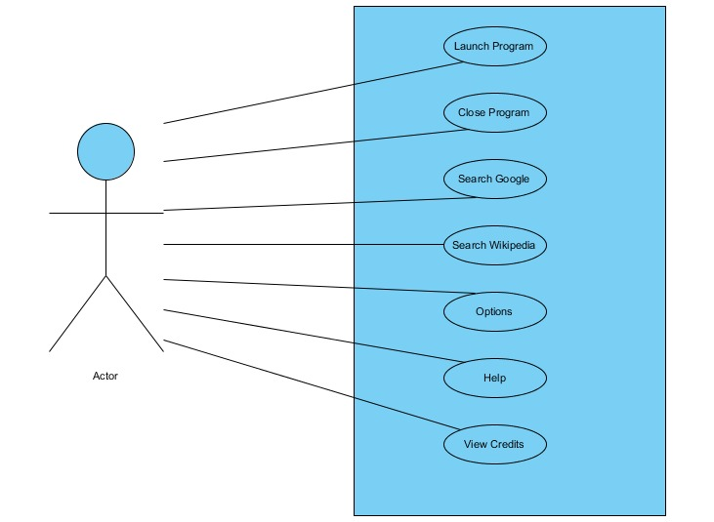
5.3 Object Model

Data Dictionary

Class Diagram

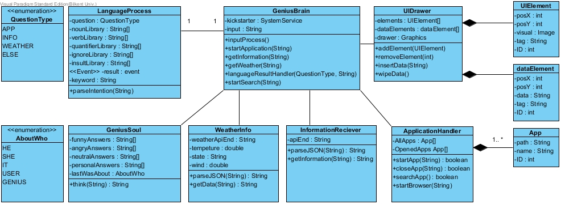

5.4 Dynamic Models

Activity Diagram

Sequence Diagrams

5.5 User Interface

In this part, user interfaces of the Bombplan game will be examined.

References

