1. Electronic Vehicles (EVs) are the future of automobile industry. But, sadly not many people are aware of the details. So, you can write a java program which will allow the user to enter the company name such as “tesla” which should be passed to the constructor of the **EVs** class. When the name of company is assigned then compare other company names using switch and call the appropriate method of the EV like tesla( ), hummer( ), etc. Use same set of variables as the features of the EV and print the output accordingly. Allow the user to enter input for three time using a loop. Finally, for if the company name method does not exist then provide the output message accordingly.

**(5 Marks)**

**OUTPUT:**

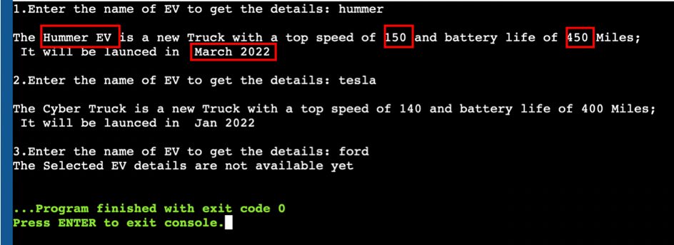

**Solution:**

Submit the code and output screen in the same word document using blackboard.

