**Quiz 1**

**:**

1. IMBD is the most reliable source of movie rating. Many people will access it, so the IMDb database should remain updated every time. Write a java program where admin can enter the movie name and rating using a for loop. The entered details should be passed to an arraylist which must be initialized in another class called movies. Finally, display the arraylist using enhanced for loop. For reference have look the below output screen.

**(5 Marks)**

**OUTPUT:**

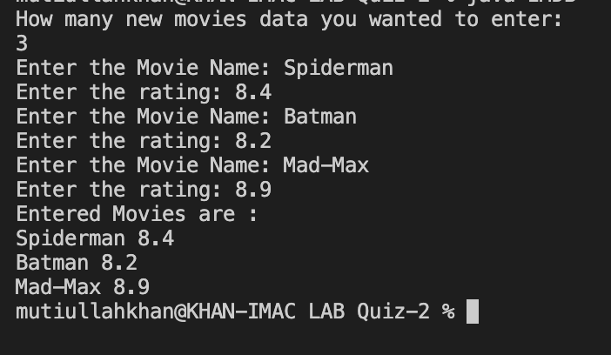

**Solution:**

Submit the code and output screen in the same word document using blackboard.