This homework is done by Tianwei Mo.

$$\frac{∂J}{∂w_{1}}=a_{1}w_{2}e^{z_{1}z_{2}}+2z_{1}a_{1}a_{2}w_{1}w_{2}e^{z_{1}z_{2}}$$

$$\frac{∂J}{∂w_{2}}=a_{1}w_{1}e^{z_{1}z_{2}}+z_{1}\left(a_{1}a_{2}w_{1}^{2}+2a_{1}a_{3}w_{2}\right)e^{z_{1}z_{2}}$$

1. The python function:

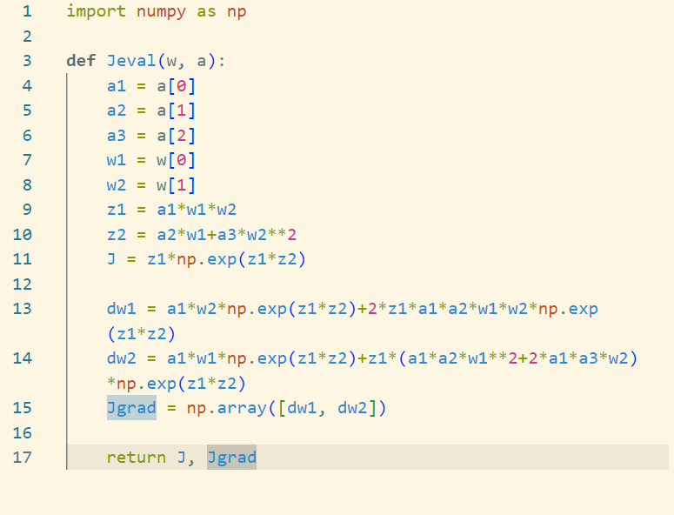

$$\frac{∂J}{∂w_{j}}=\sum_{i=1}^{N}{\frac{∂J}{∂{\hat{y}}_{i}}\frac{∂{\hat{y}}_{i}}{∂w_{j}}}=\sum_{i=1}^{N}{2\left(\log{{\hat{y}}_{i}}-\log{y_{i}}\right)x_{ij}}$$

$$\frac{∂J}{∂b}=\sum_{i=1}^{N}{\frac{∂J}{∂{\hat{y}}_{i}}\frac{∂{\hat{y}}_{i}}{∂b}}=\sum_{i=1}^{N}{2\left(\log{{\hat{y}}_{i}}-\log{y_{i}}\right)}$$

1. The python function:

1. Assume $A=\left[1 X\right]$, matrix with ones on the first column.
$$z_{i}=w_{0}+\sum_{j=1}^{d}{w_{j}x_{ij}}=\sum_{j=0}^{d}{w_{j}A_{ij}}$$

$$\frac{∂J}{∂w_{j}}=\sum_{i=1}^{n}{\frac{∂J}{∂z_{i}}\frac{∂z_{i}}{∂w_{j}}}=\sum_{i=1}^{n}{\left(-\frac{2}{z_{i}^{3}}+\frac{2y_{i}}{z_{i}^{2}}\right)A_{ij}}$$

2. The python function:

1. The python function:

1. Draft of :

1. The global minima of $f(x)$ is 0.
2. Let initial $x$ to be $1.1$. By gradient decent, it would converge to $1$. However, 1 is a local minima instead of global minima.

$$∇J\left(w\right)=\left[b_{1}w_{1}, b_{2}w_{2}\right]$$

$$w^{*}=[0, 0]$$

$$w_{1}^{k+1}=w_{1}^{k}-a∇f\left(w_{1}^{k}\right)=\left(1-ab_{1}\right)w_{1}^{k}$$

$$w_{2}^{k+1}=w_{2}^{k}-a∇f\left(w_{2}^{k}\right)=\left(1-ab_{2}\right)w_{2}^{k}$$

$$ρ_{1}=1-ab_{1}$$

$$ρ_{2}=1-ab_{2}$$

$$w^{k}→w^{*}=w^{k}→0$$

$$\left(1-ab_{1}\right)w_{1}^{k}→0, \left(1-ab_{2}\right)w_{2}^{k}→0$$

A should be a number such that $ab_{1}$ and $ab_{2}$ are both close to 1.

$$w_{1}^{k+1}=\left(1-\frac{2b_{1}}{b_{1}+b_{2}}\right)w_{1}^{k}=\left(\frac{b_{2}-b_{1}}{b_{1}+b_{2}}\right)w^{k}=\left(\frac{κ-1}{κ+1}\right)w^{k}=Cw^{k}$$

Thus,

$$w^{k}=C^{k}w^{0}$$

$$∇_{P}z_{i}=x_{i}^{T}x_{i}$$

1. A
$$∇_{P}J\left(P\right)=∇_{z_{i}}J\left(P\right)∇_{P}z_{i}=\sum_{i=1}^{n}{\left(\frac{1}{y_{i}}-\frac{1}{z_{i}}\right)}x_{i}^{T}x_{i}$$

2. The python function:

1. The python function:

We find $b^{*}$ when we iterate through above equation.

$$∇_{a}J\left(a, b\right)=2\sum_{i=1}^{n}{\left(y_{i}-\sum_{j=1}^{d}{b_{j}e^{-a_{j}x_{i}}}\right)\sum_{j=1}^{d}{b_{j}x_{i}e^{-a_{j}x_{i}}}}$$