1. My PTP protocol is similar to TCP protocol. First, it starts a socket for packet transmission. It does 3-way handshake before start sending messages and 4-way termination after sending all messages. It also maintains a timer. If a packet is sent without ACK received in a limited time, PTP would retransmit starting from that packet. PTP cannot do fast retransmission. It can only retransmit after timeout.
2. PTP header contains three main field. First field is seq, which carry sequence number. Second field is ACK, which carry ack number. Third field contains three flags, ack, syn and fin. ack is used to indicate whether the message is an ack message. syn is used for connection setup, while fin is used for teardown.
3. a). I first set 100 ms, a relevantly large timeout to guarantee complete transmission and checked log file to see how long it takes to transmit max window size of bytes. In screen shot 3.1, we can see a whole transmission and reception start from 409.11 ms and stop at 414.24 ms. Thus, a whole procedure takes about 5.13 ms. For such a transmission, setting timeout to 10 ms is sufficient. Picture 3.2 shows receiver’s log file. Picture 3.3 and 3.4 shows sender and receiver’s log file where dropping happened when pdrop = 0.3.

b).

|  |  |  |
| --- | --- | --- |
| timeout | Transmitted packets | Overall time |
| Tcurrent | 15699 | 8309.49 |
| 4 * Tcurrent | 15699 | 25325.36 |
| Tcurrent / 4 | 22243 | 4800.21 |

From the table we can find that number of transmitted packets for timeout Tcurrent and 4 * Tcurrent is same, but smaller than transmission with timeout Tcurrent / 4. This is Because in some moment acks is sending back when time is out. Then a retransmission starts, which take times. This is why time of transmission with timeout Tcurrent / 4 is half of transmission with timeout Tcurrent, while overall time of transmission with timeout Tcurrent is 4 times of transmission with timeout 4 * Tcurrent.

Data can be found in picture 3.5, 3.6 and 3.7.

Below is appendix.

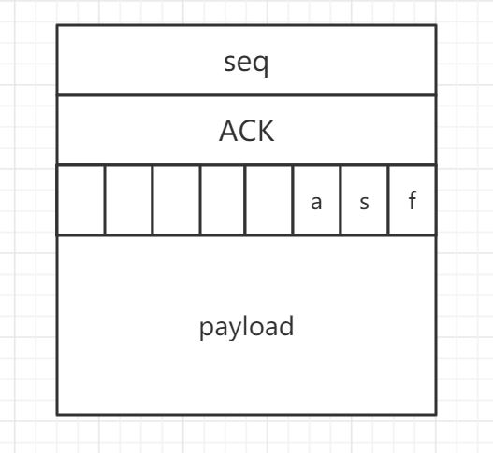

2.1 Header field

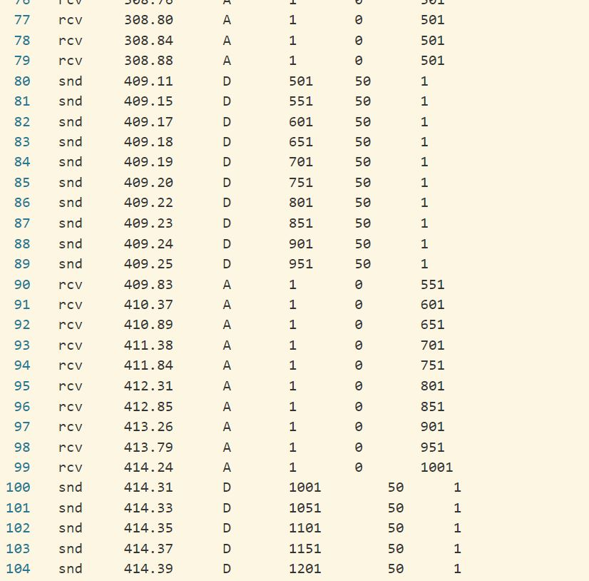

3.1 timeout estimation with pdrop = 0.1

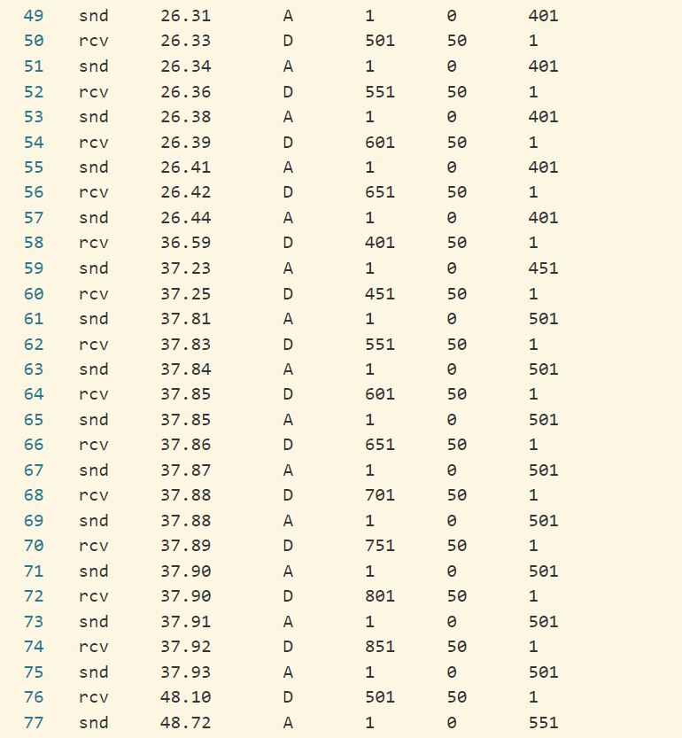

* 1. sequence of PTP packets that are observed at the receiver with timeout = 10, pdrop = 0.1

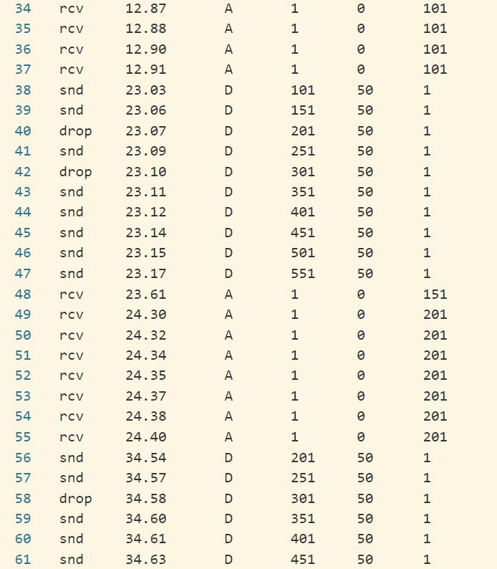

3.3 Sender log file where dropping occurred (timeout = 10, pdrop = 0.3)

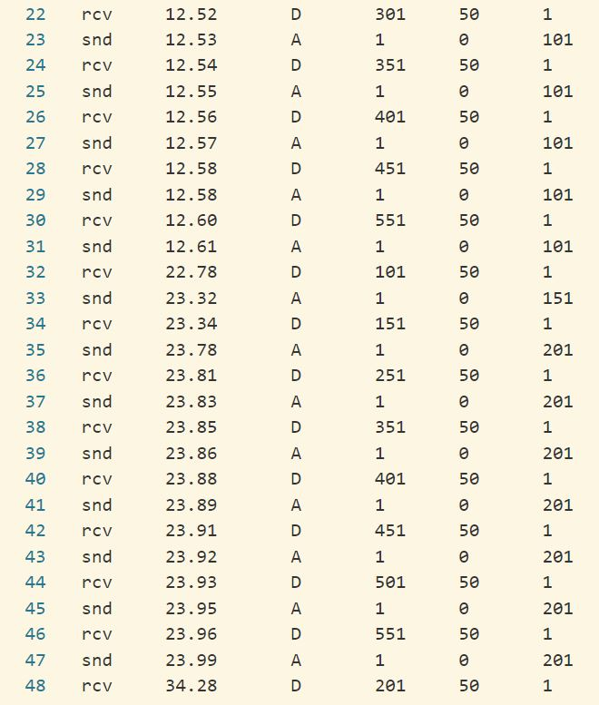

3.4 Sender log file where dropping occurred (timeout = 10, pdrop = 0.3)

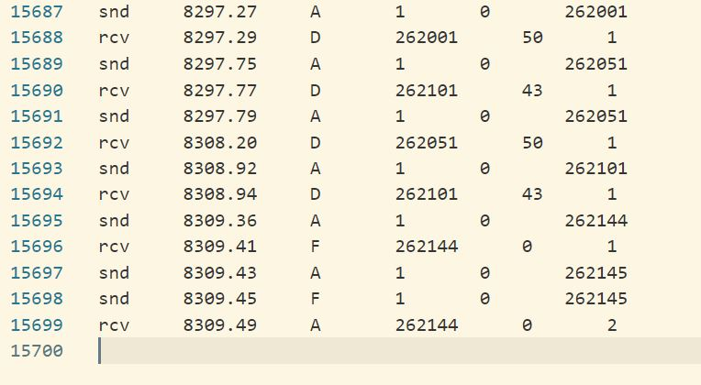

3.5 receiver log file of transmitting test2 with timeout Tcurrent

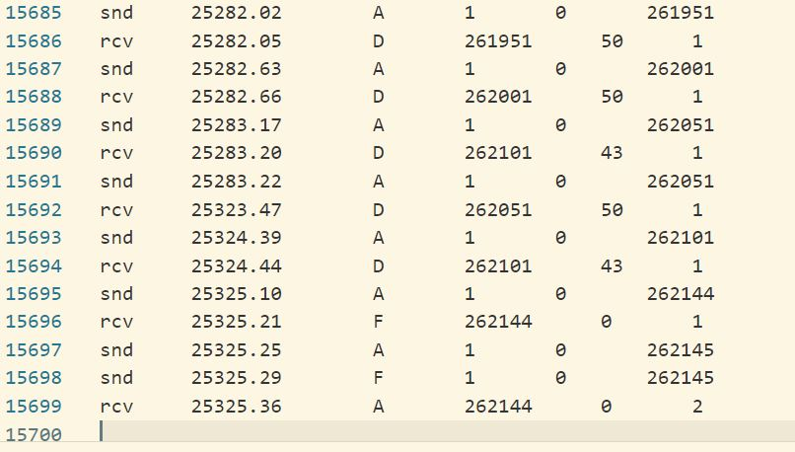

3.6 receiver log file of transmitting test2 with timeout 4 * Tcurrent

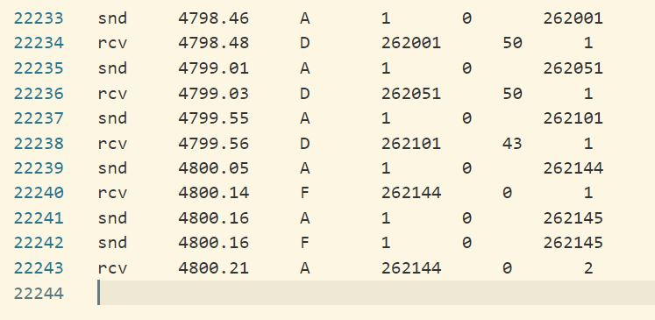

3.7 receiver log file of transmitting test2 with timeout Tcurrent / 4