Exercise 1.

1. The IP address of the website [www.koala.com.au](http://www.koala.com.au) is 104.21.45.210 and 172.67.219.46. There are several IP addresses because the website runs on several servers. Different locations of servers result in several IP addresses.

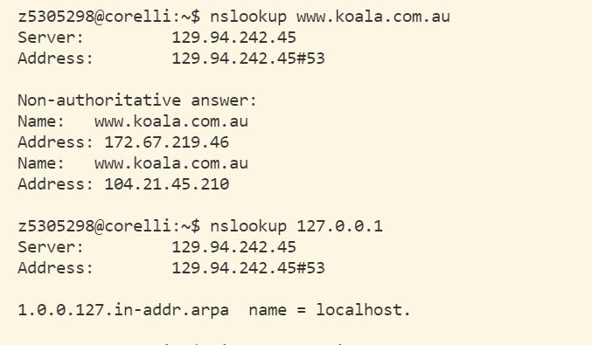

IP of www.koala.com.au and the name of 127.0.0.1

1. The name of the IP address 127.0.0.1 is localhost, which is the computer I am using. It is special because whenever and wherever I want to check IP address of device I am using, it gives 127.0.0.1.

Exercise 2.

Except host [www.getfittest.com.au](http://www.getfittest.com.au), [www.hola.hp](http://www.hola.hp), [www.kremlin.ru](http://www.kremlin.ru), the rest of the host are reachable. Hosts [www.getfittest.com.au](http://www.getfittest.com.au) and [www.hola.hp](http://www.hola.hp) seems like invalid websites. [www.kremlin.ru](http://www.kremlin.ru) is a valid website, which can be visited by browser. ping can send a packet to the host, but cannot receive it. It might because the host block the packet so that the packet lost somewhere.

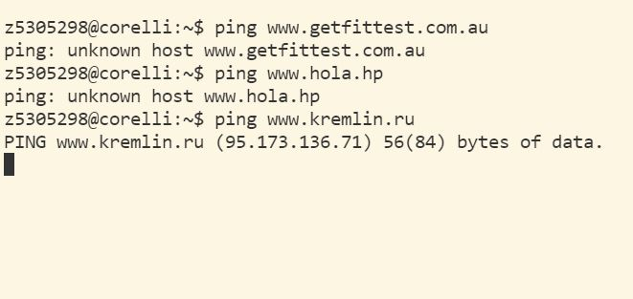

unreachable hosts

Exercise 3

1. There are 22 routers on this path. 5 of them are in part of UNSW network because only the first 5 routers have “unsw.edu.au” as part of address. The packet went across between router 9 and 10, whose addresses are “et-2-1-0.bdr1.a.sea.aarnet.net.au” and “abilene-1-lo-jmb-706.sttlwa.pacificwave.net”. because routes before route 9 have “au” suffix while router 10 did not. Also, the time packets returned became significantly longer between router 9 and 10.

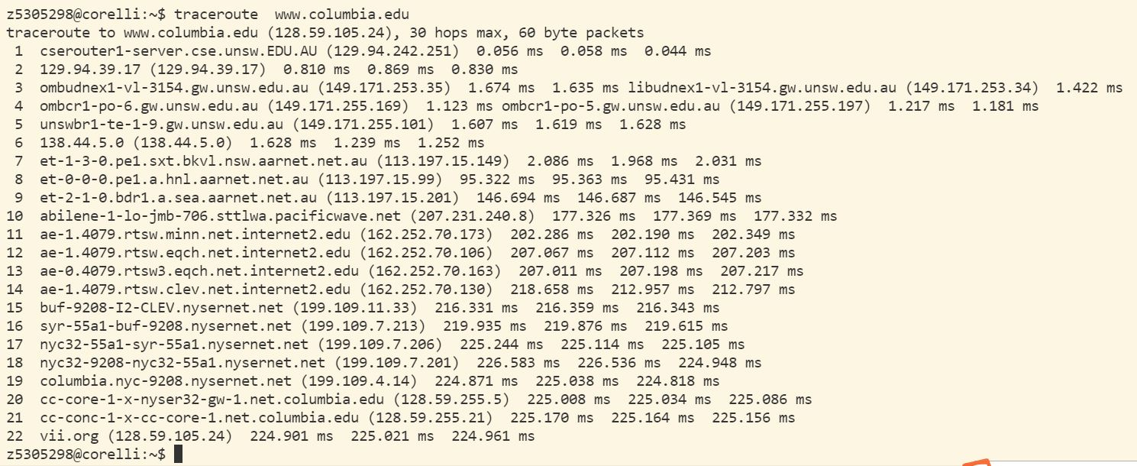

traceroute to www.colmbia.edu

1. After passing router with address 138.44.5.0, the paths diverge. The net name of the router is APNIC-ERX-138-44-0-0 and is supported by Asia Pacific Network Information Centre. The number of hops on paths are not proportional the physical distance. Take address [www.ucla.edu](http://www.ucla.edu) as destination. On This path, first 5 routers are in Surry Hills and geotropically close, while sixth router is in somewhere in South Australia.

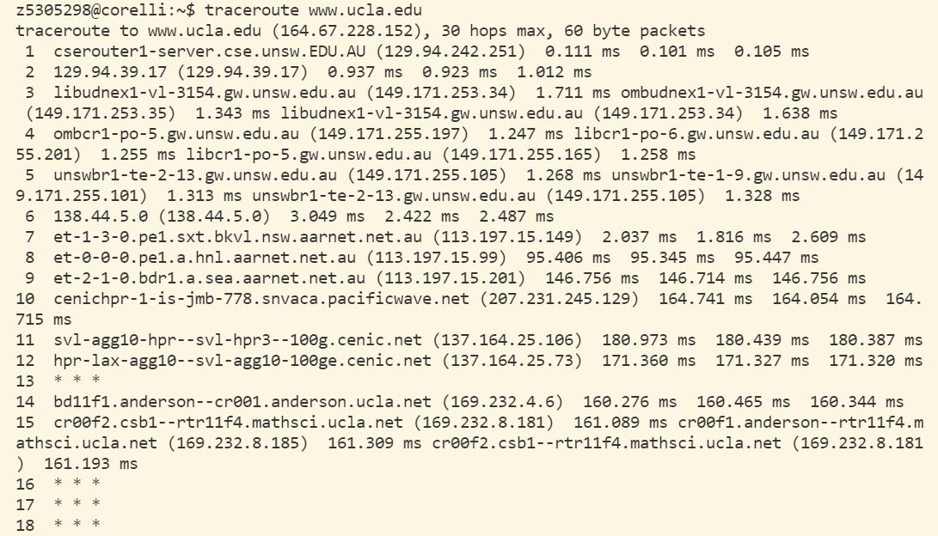

traceroute to www.ucla.edu

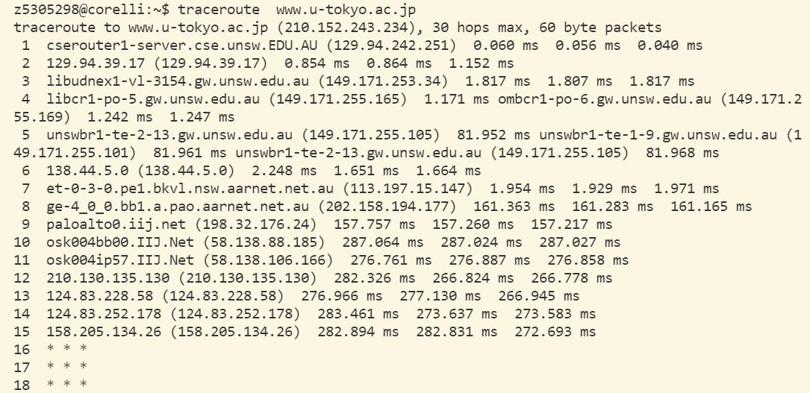

traceroute to www.u-tokyo.ac.jp

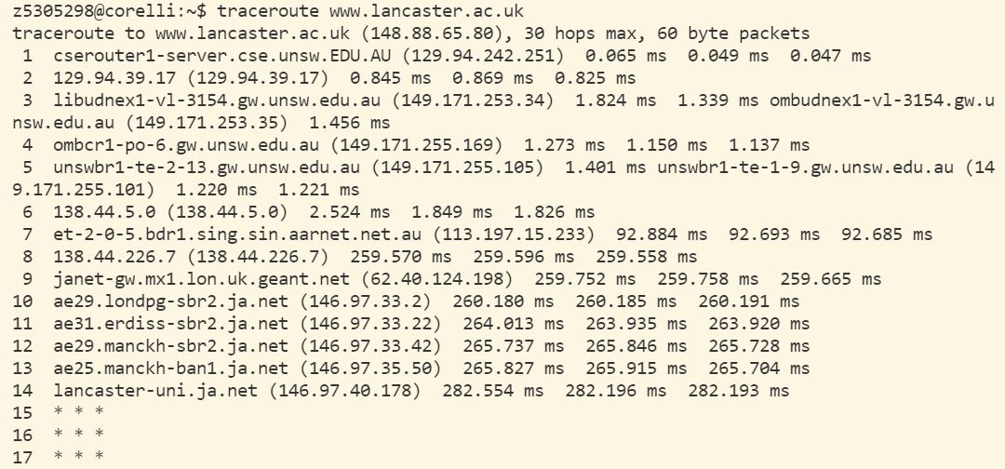

Traceroute to [www.lancaster.ac.uk](http://www.lancaster.ac.uk)

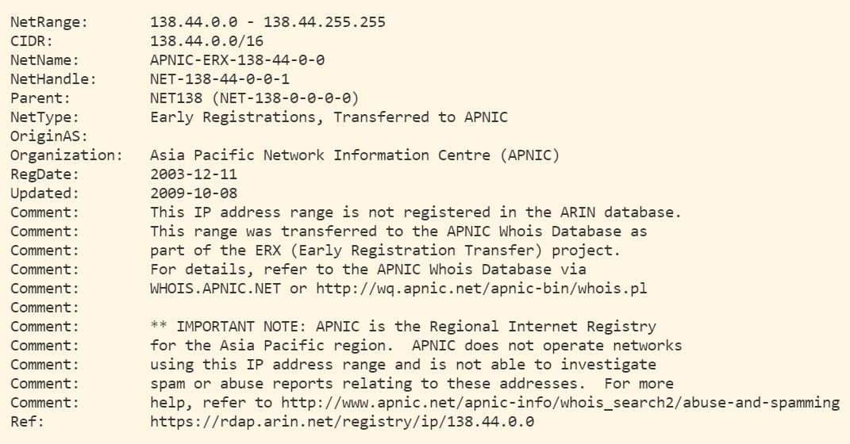

Information from whois 138.44.5.0

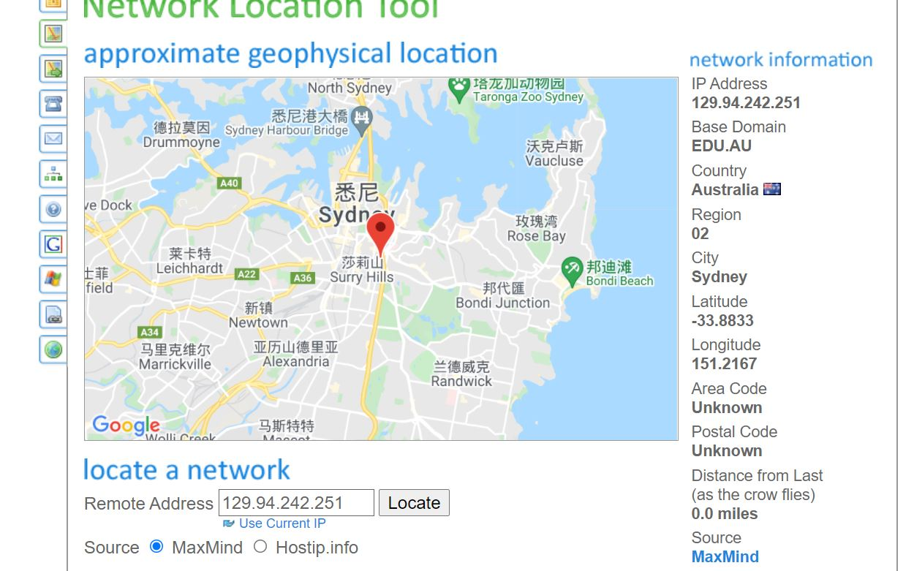

Location of the first router

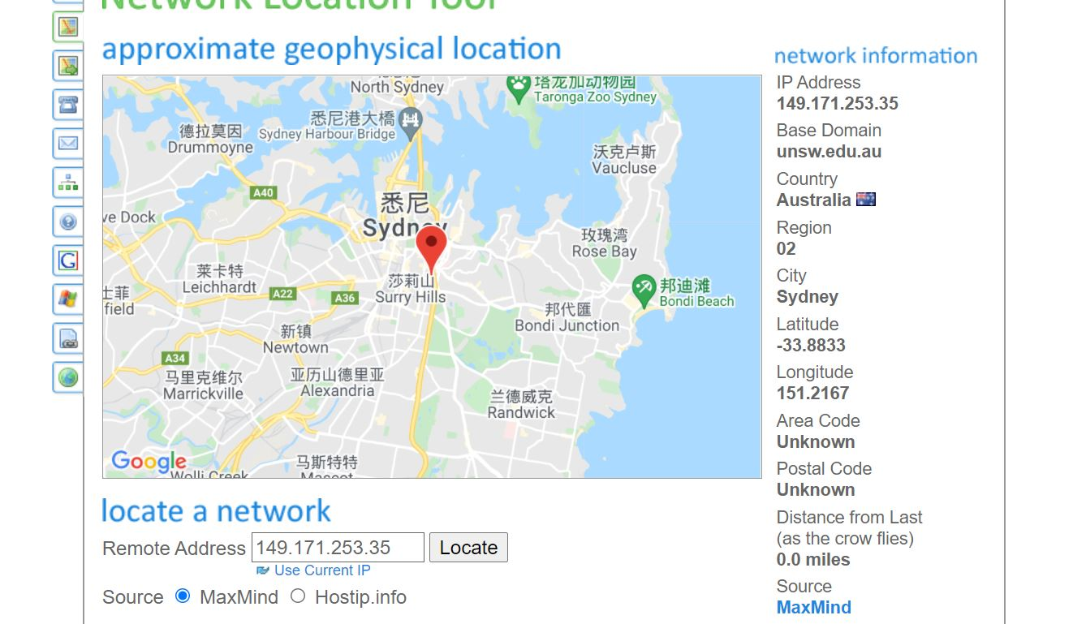

Location of the third router

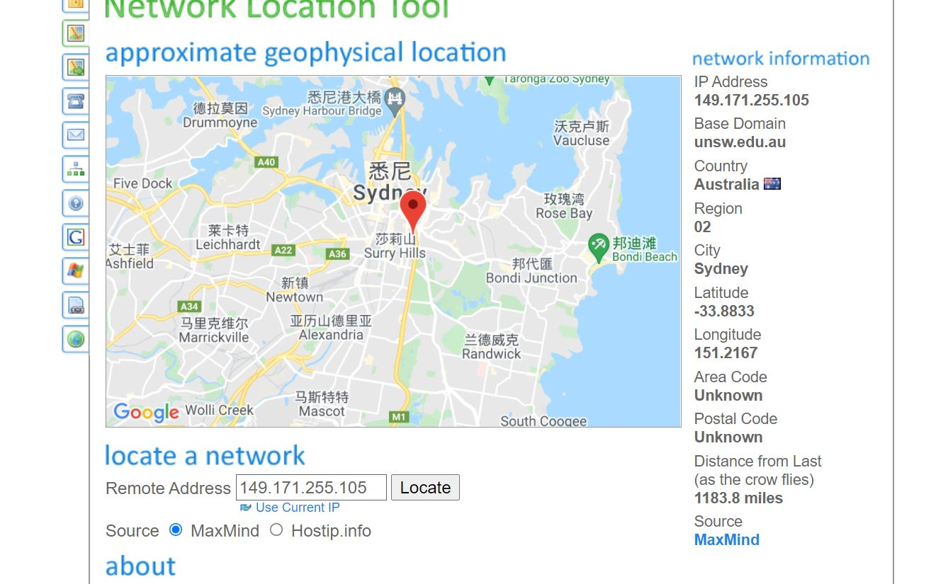

Location of the fifth router

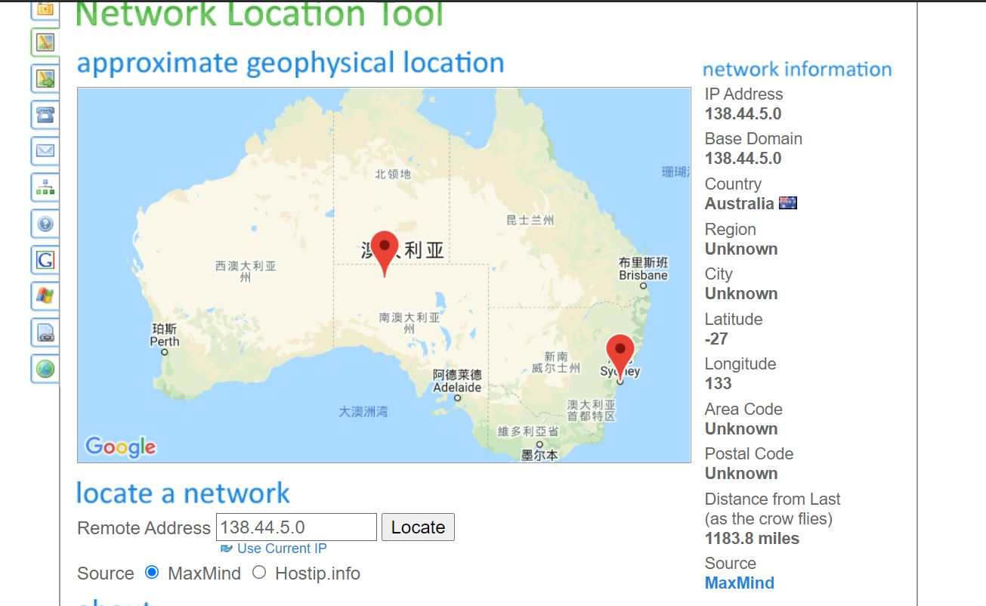

Location of the sixth router

1. The IP address of [http://www.speedtest.com.sg/tr.php is 202.150.221.170](http://www.speedtest.com.sg/tr.php%20is%20202.150.221.170). The IP address of [https://www.telstra.net/cgi-bin/trace is 203.50.5.178](https://www.telstra.net/cgi-bin/trace%20is%20203.50.5.178). the reverse path is different from the forward path. I did not find same routers in paths. It may be unnecessary to go forward and backward through a same path.

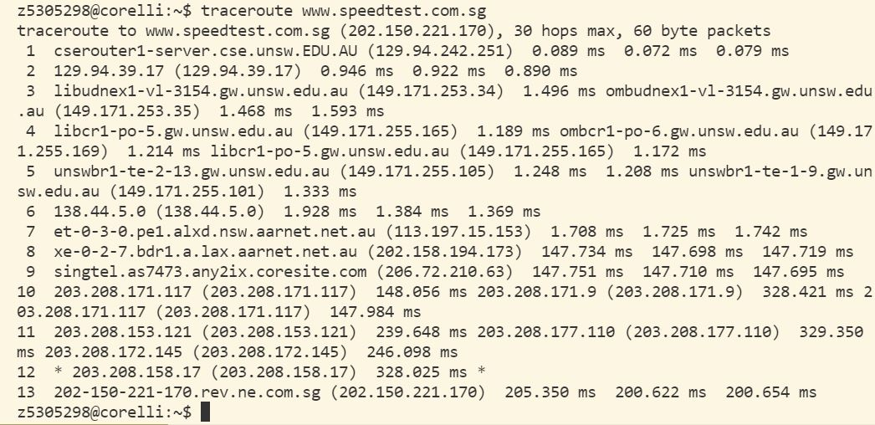

traceroute [www.speedtest.com.sg](http://www.speedtest.com.sg) and its IP

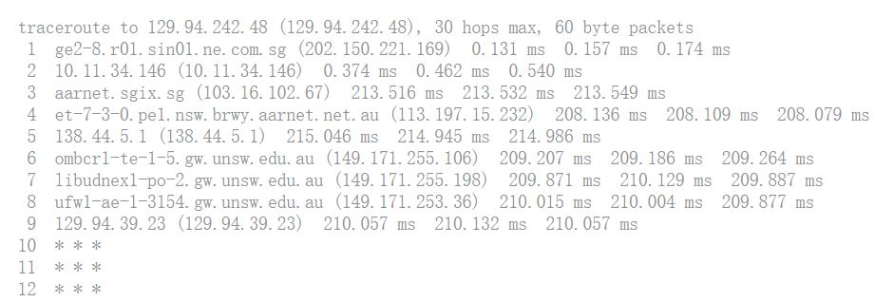

traceroute from [www.speedtest.com.sg](http://www.speedtest.com.sg) to my virtual machine

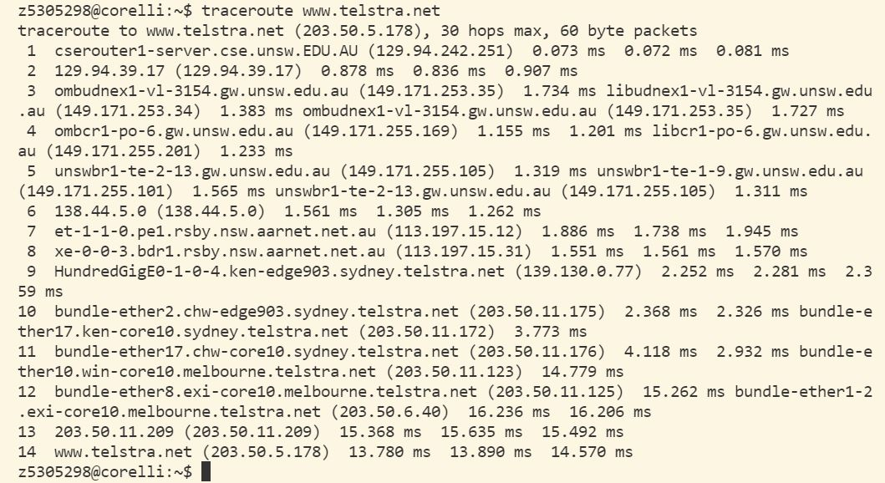

traceroute to [www.telstra.net](http://www.telstra.net) and its IP

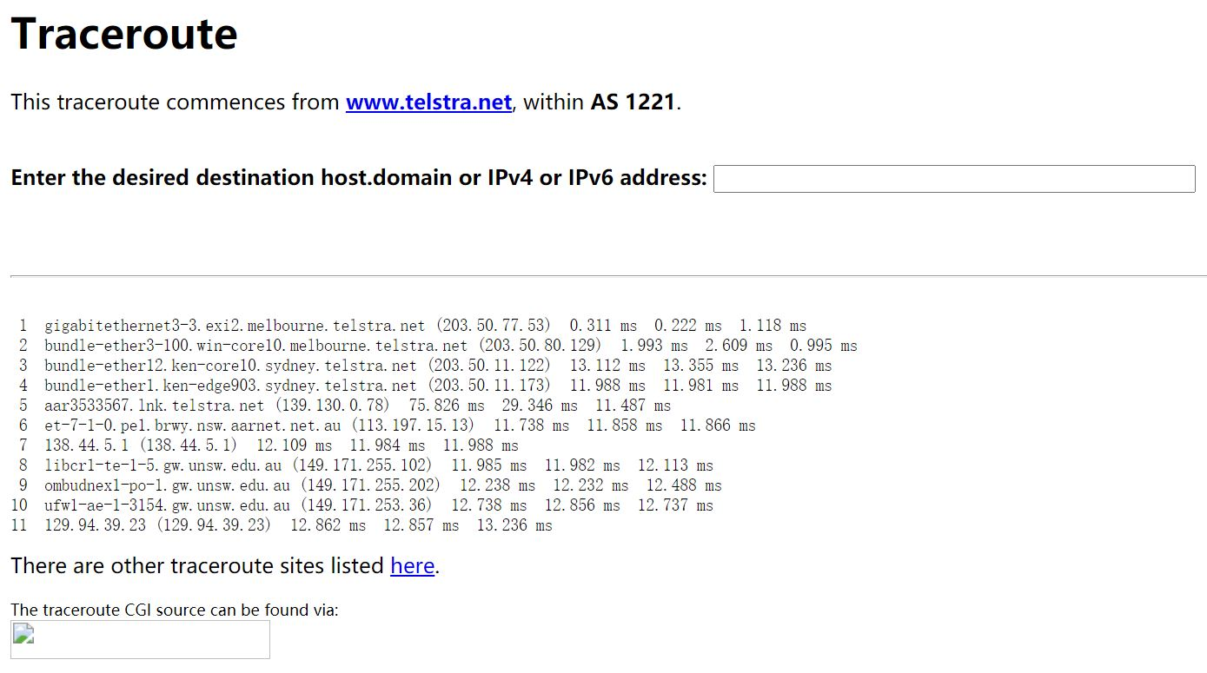

traceroute from [www.telstra.net](http://www.telstra.net) to my virtual machine

Exercise 4

1. One of the reasons that y is greater than 2 is while the calculated value used shortest distance between servers, in reality the path the routers on might not be the shortest one due to cost, geographical reasons and so on. Another question can be multiple delay, such processing delay, queueing delay, transmission delay, propagation delay and so on.

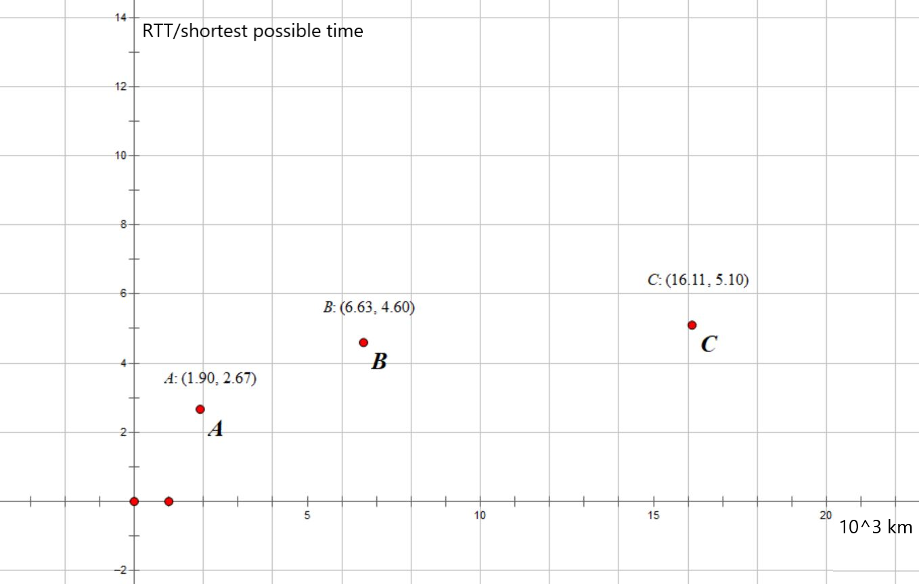

Ratio-distance graph. To get the data, I did calculations shown in below pictures.

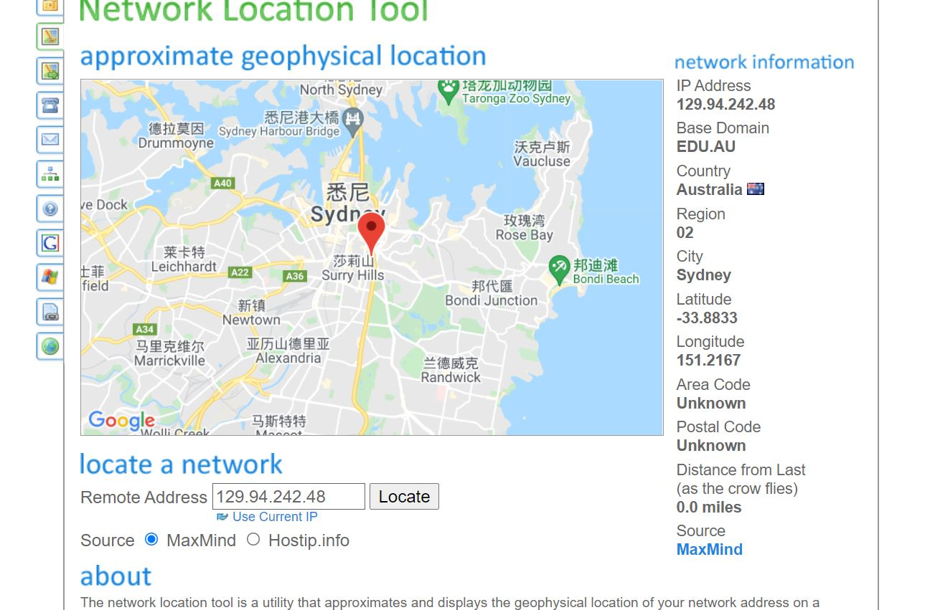

My local virtual machine

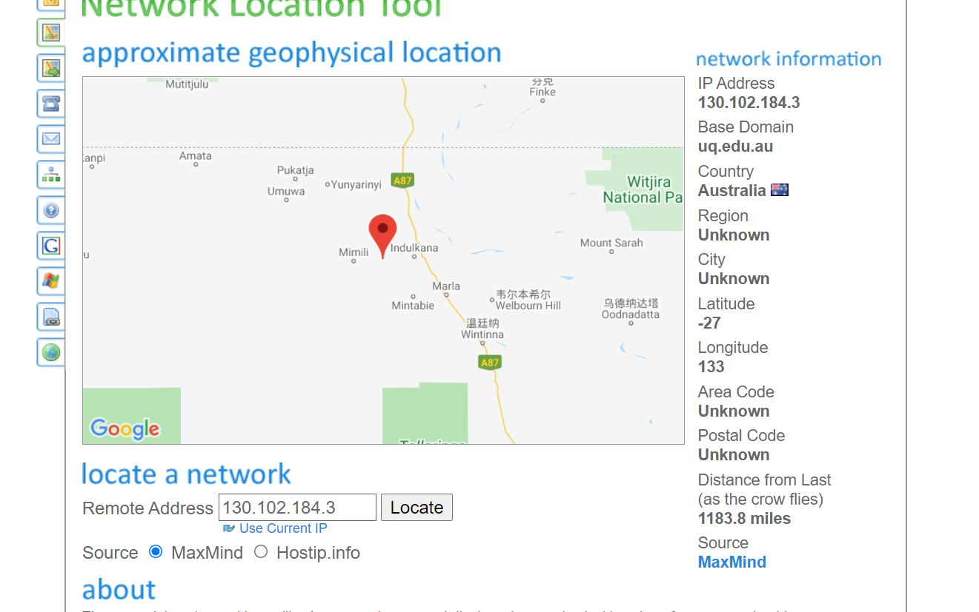

Distance from UNSW to servers of [www.uq.edu.au](http://www.uq.edu.au). 1183.8 miles 1900 km.

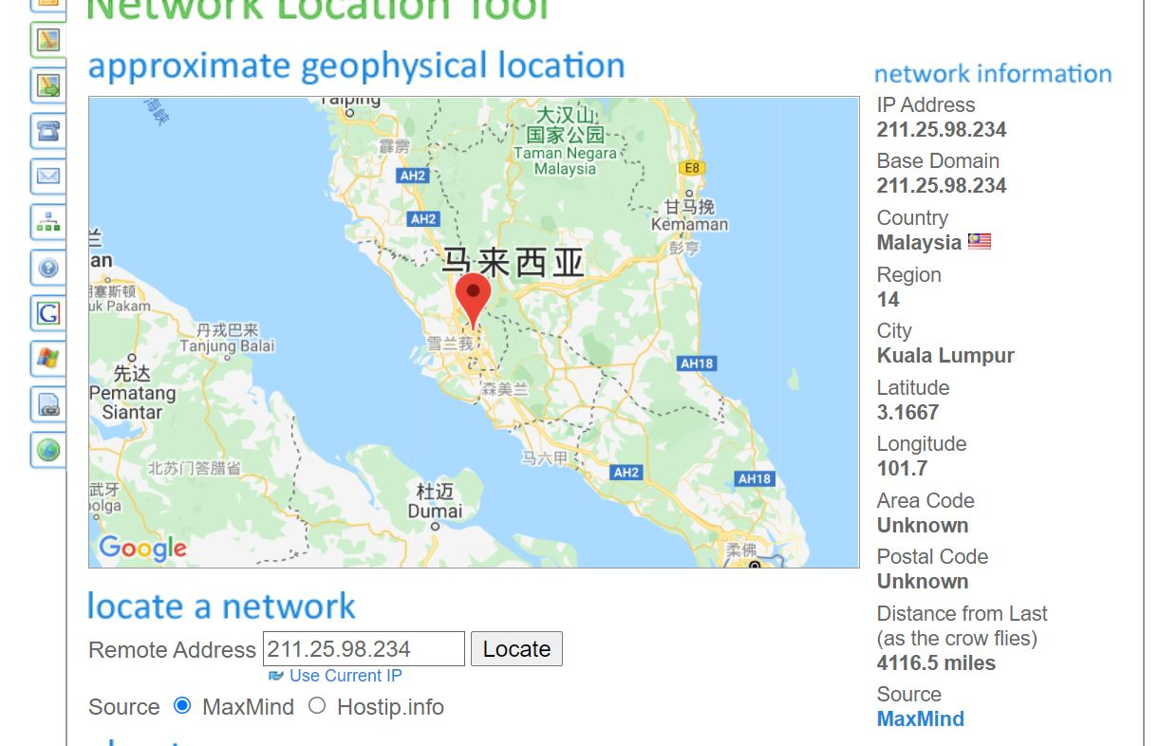

Distance from UNSW to servers of [www.upm.edu.my](http://www.upm.edu.my). 4116.5 miles 6630 km.

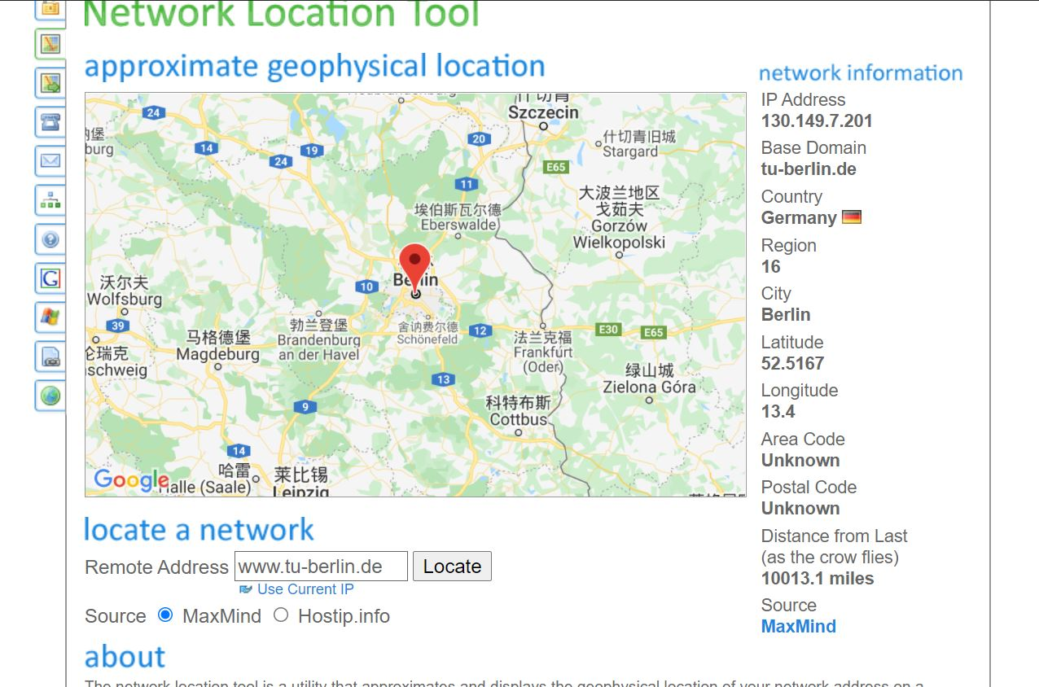

Distance from UNSW to servers of [www.tu-berlin.de](http://www.tu-berlin.de). 10013.1 miles 16110 km.

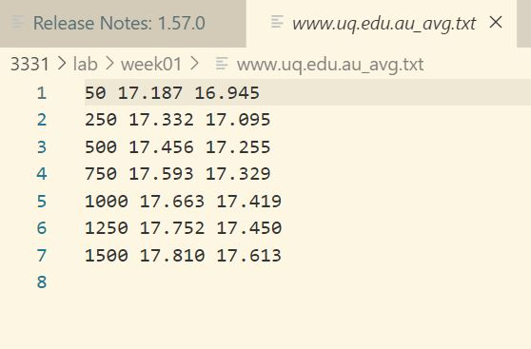

The minimum RTT for 50 byte packets is 16.945 ms. .

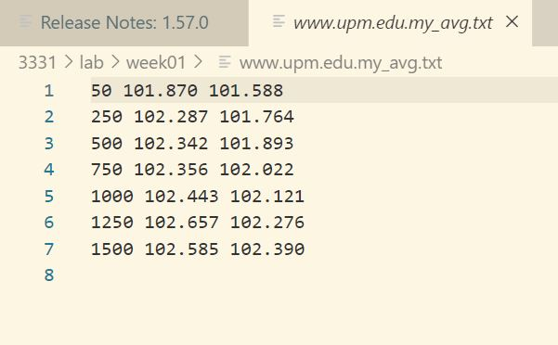

The minimum RTT for 50 byte packets is 101.588 ms. .

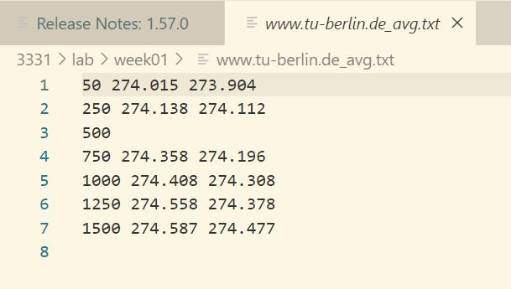

The minimum RTT for 50 byte packets is 273.904 ms. .

1. Delay varies over time. The further a packet needs to reach, the longer it takes, and more extra cost it needs. For example, the further it goes, the more routers it might pass, and more delay may happen while passing them.
2. The servers running [www.epfl.ch](http://www.epfl.ch/) is in the San Francisco. First we use nslookup to find IP of the host. Then use whois to find details of it.

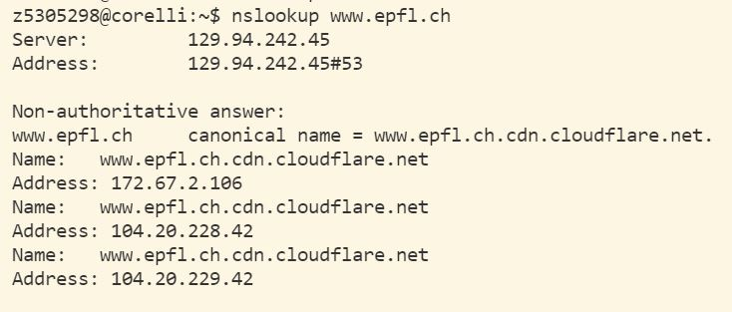

IP addresses of www.epfl.ch

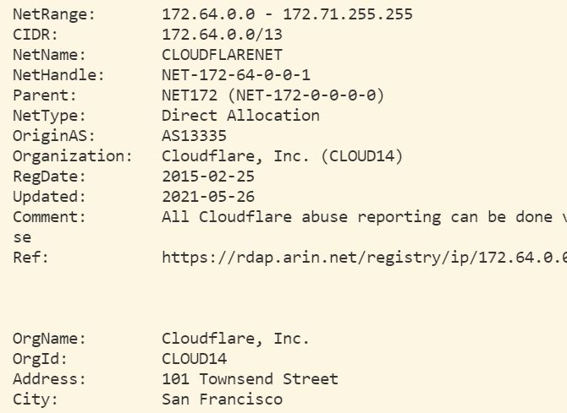

Information of first IP address. The city is San Francisco.

1. Propagation and queueing delay does not depend on packet size. Transmission and processing delay depends on packet size.