Exercise 3

1. The status code is 200. The returned phrase is “OK”.
2. It was last modified on 23 September 2003.

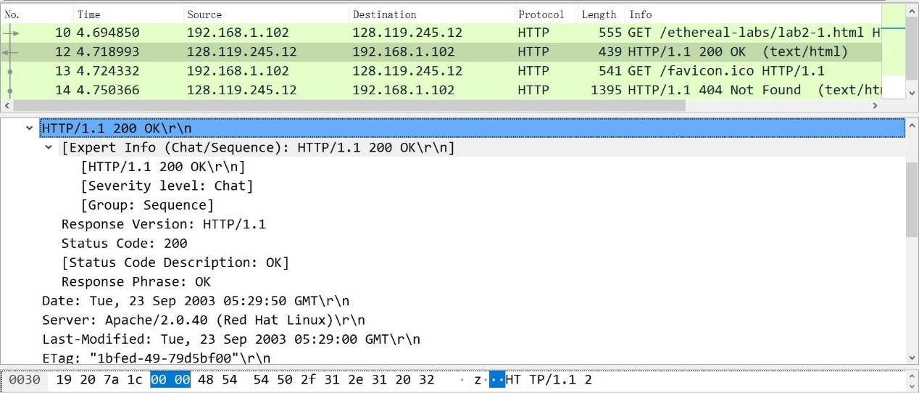

1. Because the request and response version is 1.1, the connection is persistent.
2. 73 bytes are returned.
3. It is a line: Congratulations. You’ve download the file lab2-1.html!

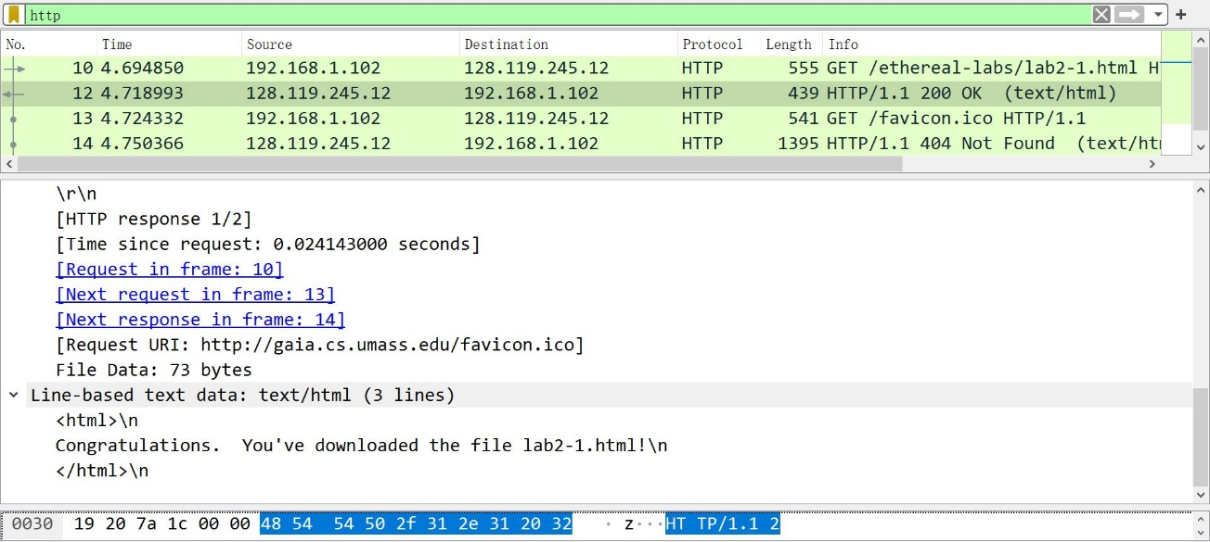

Exercise 4

1. No. I did not find “IF-MODIFIED-SINCE”.

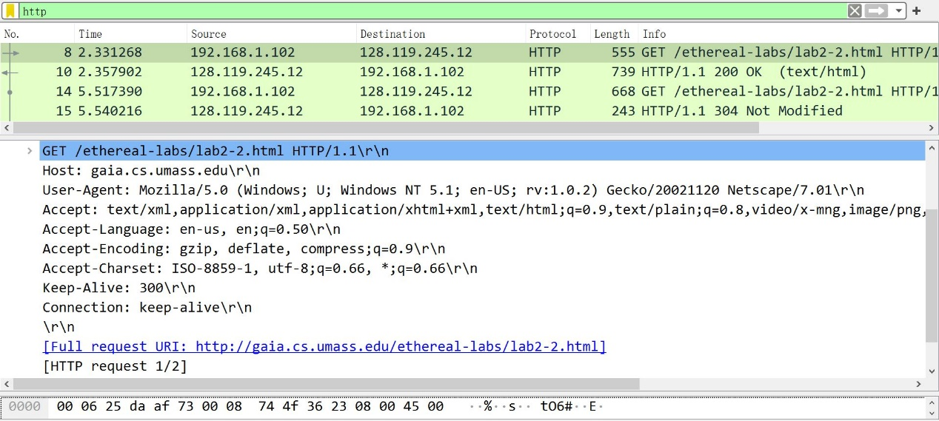

1. Yes. The last modified date 23 September 2003.

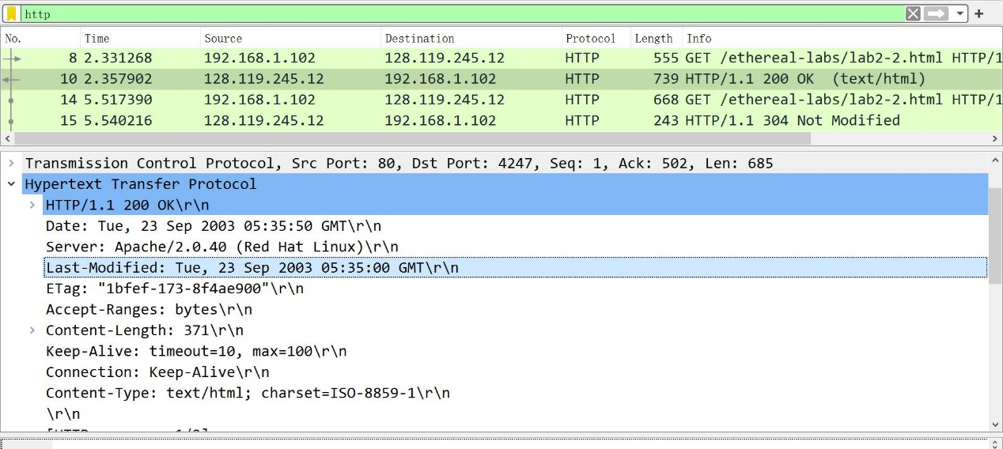

1. Yes. “IF-MODIFIED-SINCE” line contains the last modified date. “IF-NONE-MATCH” line contains an Etag from first response.

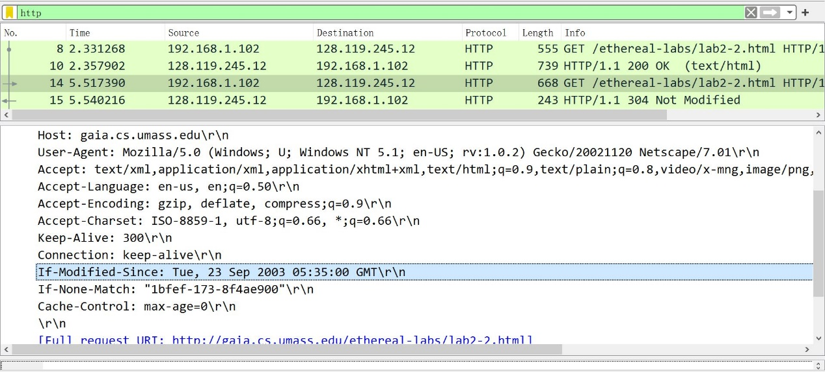

1. The status code is 304. The returned phrase is “Not Modified”. It did not return the contents of the file back, because the response said nothing has changed, which means there is no need to send the file back.

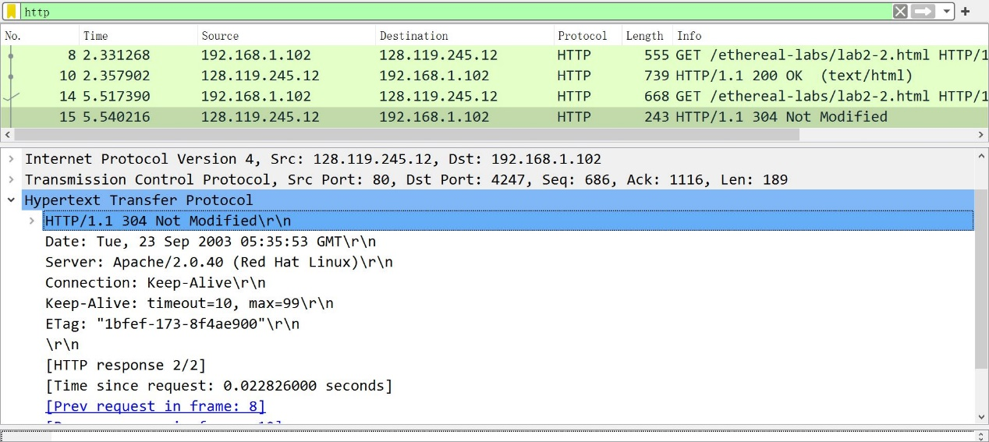

1. The value of the Etag is “1bfef-173-8f4ae900”. This is used to check is the file changed or not. If it hasn’t change, the response Etag should be the same as request Etag, which means the response only need to reply nothing has changed and do not need to send the file again, which saves time and data.

Exercise 5

This is a screen shot of terminal running client. There are 5 responses that are time out. The maximum RTT is 192 ms, the minimum RTT is 5 ms, and average RTT is 98 ms.

