Exercise 3

1. The IP address of [www.eecs.berkeley.edu](http://www.eecs.berkeley.edu) is 23.185.0.1. The type of DNS query to get this answer is A.

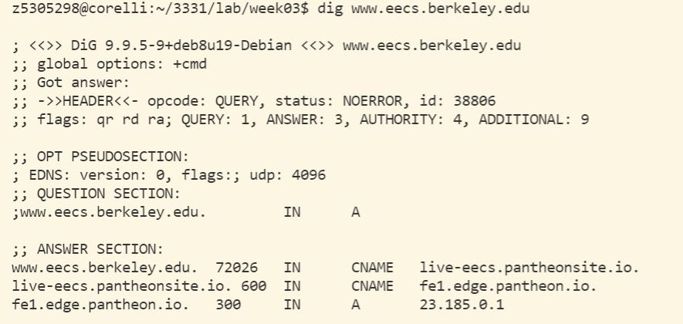

1. The canonical name for the eecs.berkeley webserver is “live-eecs.pantheonsite.io.”. Alias is needed because if we do some changes to eecs.berkeley server, we can simply do changes on the original domain name and do not need to change canonical names.
2. The authoritative name server is “edge.pantheon.io.”. There are 4 servers running it. The names in last column are their actual names. In Additional section, we can see details of the 4 servers.

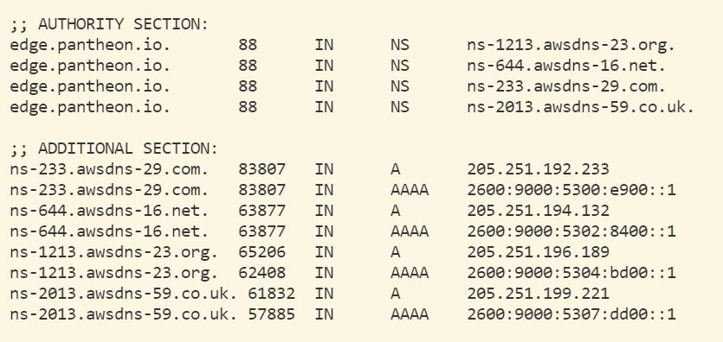

1. My local name server is 129.94.242.45.
2. The DNS nameservers for the “eecs.berkeley.edu.” domain are “adns3.berkeley.edu.”, “adns2.berkeley.edu.” “adns1.berkeley.edu.”, “ns.eecs.berkeley.edu.” and “ns.CS.berkeley.edu.”. their IP addresses are 192.107.102.142, 128.32.136.14 128.32.136.3, 169.229.60.153 and 169.229.60.61. They are NS type DNS queries.

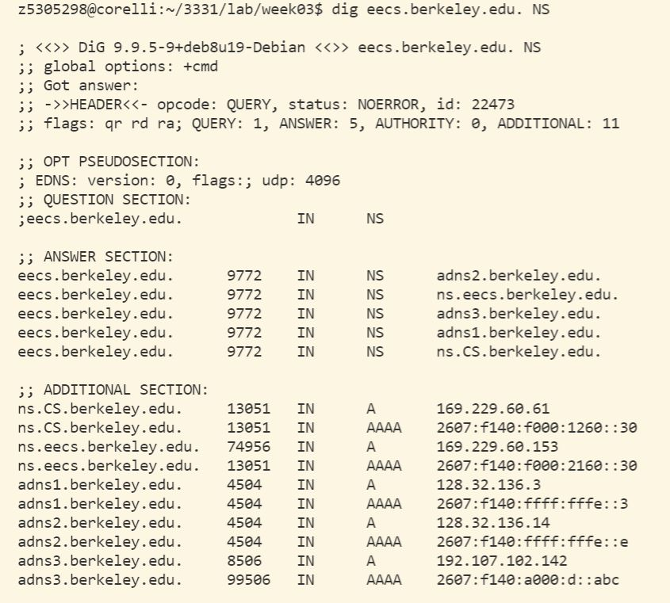

1. The DNS name is “webserver.seecs.nust.edu.pk.”. The type of query is PTR.

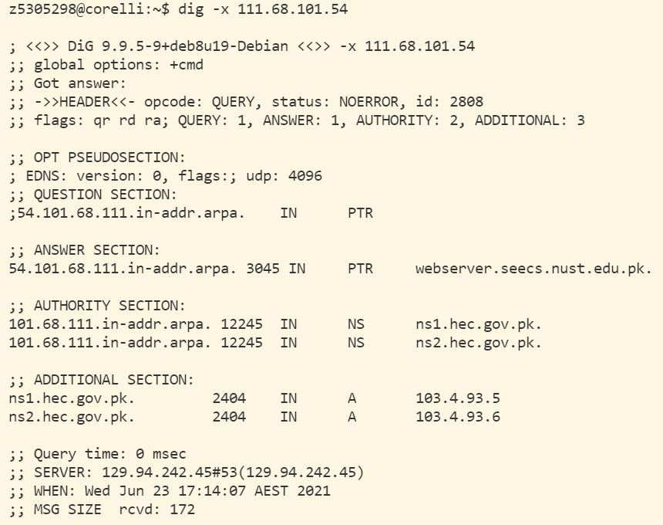

1. Yes. Because the query type in authority section is NS.

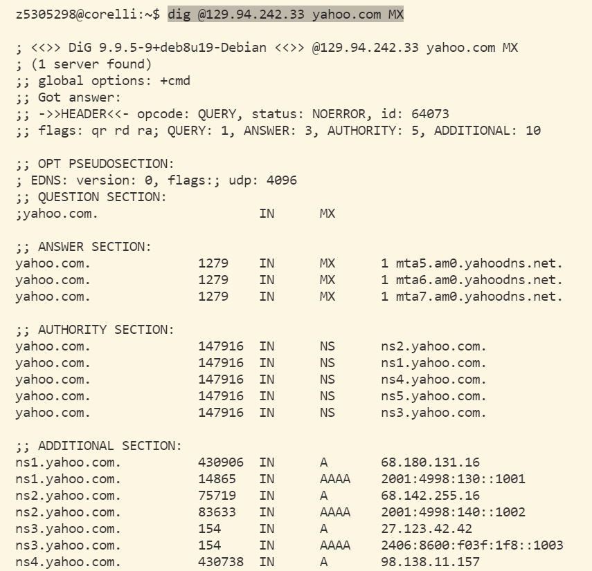

1. I do not get authoritative answer. There is not any useful result.

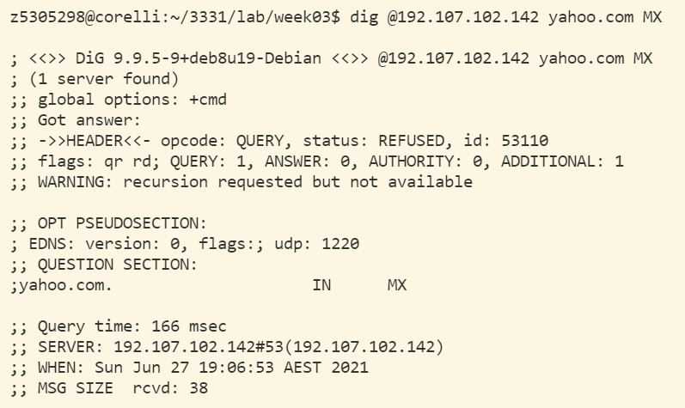

1. The type of query is NS.

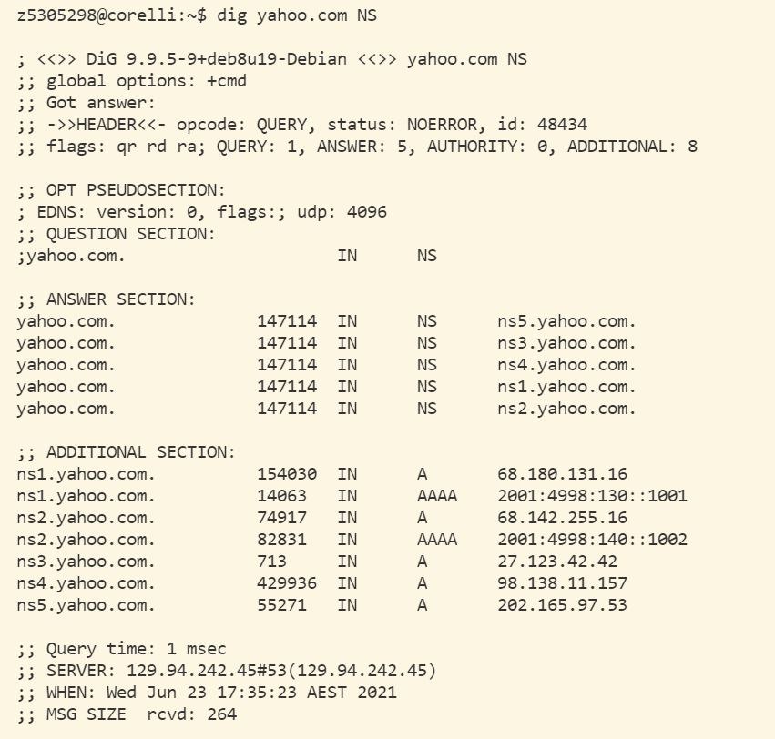

1. 6 queries in total. They are: root server, au. server, edu.au. server, unsw.edu.au. server, cse.unsw.edu.au. server and a query for IP address of “lyre00.cse.unsw.edu.au”.

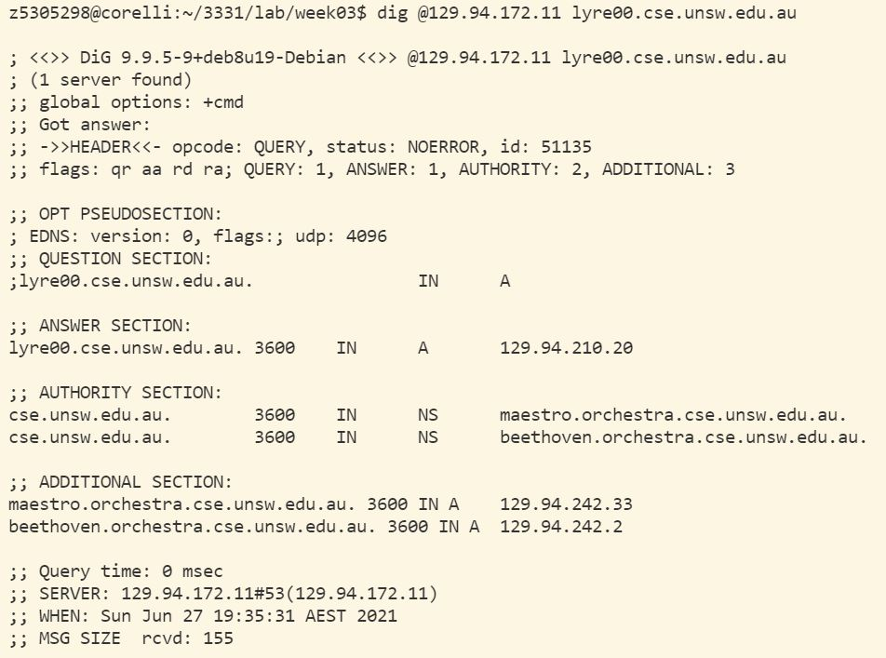

1. No. One physical machine can only have one IP addresses associated with it.