P6 - Verilog流水Plus（工程化方法）

一．整体结构

1. 处理器应支持MIPS-lite3指令集。

MIPS-lite3={ LB、LBU、LH、LHU、LW、SB、SH、SW、ADD、ADDU、SUB、 SUBU、 SLL、 SRL、 SRA、 SLLV、SRLV、SRAV、SLT、SLTU、AND、OR、XOR、NOR、ADDI、ADDIU、ANDI、ORI、XORI、LUI、SLTI、SLTIU、BEQ、BNE、BLEZ、BGTZ、BLTZ、BGEZ、J、JAL、JALR、JR、MULT、 MULTU、 DIV、 DIVU、MFHI、MFLO、MTHI、MTLO}

2. 处理器为流水线设计。

3. 顶层文件为mips.v，接口定义如下：

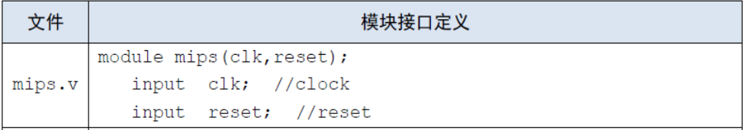

二．模块规格

1.pc.v

|  |  |
| --- | --- |
| 文件 | 模块接口定义 |
| pc.v | module pc(  input clk,  input reset,  input en,  input[31:0] next_pc,  output reg[31:0] pc  ); |

模块接口

|  |  |  |
| --- | --- | --- |
| 信号名 | 方向 | 功能描述 |
| Clk | I | 时钟信号 |
| Reset | I | 复位信号  1：复位  0：无效 |
| en | I | 使能信号 |
| next_pc | I | 更新的PC（时钟上升沿更新） |
| Pc | I | PC |

功能定义

|  |  |  |
| --- | --- | --- |
| 序号 | 功能名称 | 功能描述 |
| 1 | 复位 | 当复位信号有效时，PC被设置为0x00003000 |
| 2 | 更新pc | 时钟上升沿时改变pc=next_pc |

2.im.v

|  |  |
| --- | --- |
| 文件 | 模块接口定义 |
| im.v | module im(  input [31:0] PC,  output[31:0] instruction  ); |

模块接口

|  |  |  |
| --- | --- | --- |
| 信号名 | 方向 | 功能描述 |
| PC[31:0] | I | 32位PC |
| Instruction[31:0] | O | 32位当前指令 |

功能定义

|  |  |  |
| --- | --- | --- |
| 序号 | 功能名称 | 功能描述 |
| 1 | 取指令 | 根据 PC 从 IM 中取出指令 |

3.ID.v

模块接口

|  |  |
| --- | --- |
| 文件 | 模块接口定义 |
| ID.v | module ID(  input clk,  input reset,  input en,  input [31:0] Instr,  input [31:0] PC,  output reg[31:0] IR_D,  output reg[31:0] PC_D,  output reg[31:0] PC4_D,  output reg[31:0] PC8_D  ); |

功能定义

|  |  |  |
| --- | --- | --- |
| 序号 | 功能名称 | 功能描述 |
| 1 | IF/ID流水线寄存器 | 保存PC,IR等信号的值 |

4.grf.v

|  |  |
| --- | --- |
| 文件 | 模块接口定义 |
| grf.v | module grf(  input clk,  input reset,  input RegWrite,  input [4:0] RA1,  input [4:0] RA2,  input [4:0] WA,  input [31:0] WD,  input [31:0] PC,  output [31:0] RD1,  output [31:0] RD2  ); |

模块接口

|  |  |  |
| --- | --- | --- |
| 信号名 | 方向 | 功能描述 |
| WD[31:0] | I | 写入数据的输入 |
| RA1[4:0] | I | 读寄存器地址 1 |
| RA2[4:0] | I | 读寄存器地址 2 |
| WA[4:0] | I | 写寄存器地址 |
| Clk | I | 时钟信号 |
| Reset | I | 复位信号  1：复位  0：无效 |
| PC[31:0] | I | 当前PC |
| RegWrite | I | 是否可以写入控制信号(随时都可以读出)  1：可以写  0：不可以写 |
| RD1[31:0] | O | 32 位数据输出 1 |
| RD2[31:0] | O | 32 位数据输出 2 |

功能定义

|  |  |  |
| --- | --- | --- |
| 序号 | 功能名称 | 功能描述 |
| 1 | 复位 | 当复位信号有效时，所有寄存器被设置为 0x00000000 |
| 2 | 读寄存器 | 根据输入的寄存器地址读出32位数据 |
| 3 | 写寄存器 | 根据输入的地址，把输入的数据写进所选的寄存器 |

5.cmp.v

|  |  |
| --- | --- |
| 文件 | 模块接口定义 |
| cmp.v | module cmp(  input [31:0] D1,  input [31:0] D2,  output Equal  ); |

模块接口

|  |  |  |
| --- | --- | --- |
| 信号名 | 方向 | 功能描述 |
| D1[31:0] | I | 输入1 |
| D2[31:0] | I | 输入2 |
| Equal | O | 判断两个输入是否相等 |

功能定义

|  |  |  |
| --- | --- | --- |
| 序号 | 功能名称 | 功能描述 |
| 1 | 比较器 | 比较两个输入是否相等 |

6. ext.v

|  |  |
| --- | --- |
| 文件 | 模块接口定义 |
| ext.v | module ext(  input [15:0] in,  input [1:0] ExtOp,  output reg [31:0] out  ); |

模块接口

|  |  |  |
| --- | --- | --- |
| 信号名 | 方向 | 功能描述 |
| In[15:0] | I | 16 位数据输入 |
| Out[31:0] | O | 32 位数据输出 |
| ExtOp[1:0] | I | 扩展方式选择信号 |

功能定义

|  |  |  |
| --- | --- | --- |
| 序号 | 功能名称 | 功能描述 |
| 1 | 高位符号扩展 | 高16位补符号位 |
| 2 | 高位0扩展 | 高16位补0 |
| 3. | 低位0扩展 | 低16位补0 |

7. npc.v

|  |  |
| --- | --- |
| 文件 | 模块接口定义 |
| npc.v | module npc(  input [31:0] PC4,  input [31:0] PC4D,  input [25:0] I26,  input [31:0] MFRSD,  input Zero,  input Branch,  input if_j,//j或jal  input[1:0] PC_sel,  output reg[31:0] next_pc  ); |

模块接口

|  |  |  |
| --- | --- | --- |
| 信号名 | 方向 | 功能描述 |
| PC4 | I | PC+4的值(对应于无跳转 直接执行下一句) |
| PC4D | I | D级PC+4 |
| I26 | I | 26位立即数 |
| MFRSD | I | 转发PC的MUX结果（jr jalr需要转发） |
| Zero | I | 比较两个数是否相等的结果 |
| Branch | I | 判断是不是beq类指令 |
| If_j | I | 判断是不是j/jal指令 |
| PC_sel[1:0] | I | PC的选择信号 |
| Next_pc | O | 更新的pc值 |

功能定义

|  |  |  |
| --- | --- | --- |
| 序号 | 功能名称 | 功能描述 |
| 1 | 更新PC | 更新PC |

8.controller.v （分布式译码 实例化4个）

|  |  |
| --- | --- |
| 文件 | 模块接口定义 |
| controller.v | module controller(  input [5:0] op,  input [5:0] func,  input [4:0] rt,  output reg[3:0] ALUCtrl,  output reg[1:0] RegDst,  output reg ALUASrc,  output reg ALUBSrc,  output reg RegWrite,  output reg MemRead,  output reg MemWrite,  output reg [1:0] MemtoReg,  output reg [1:0]ExtOp,  output reg if_beq,  output reg if_bne,  output reg if_blez,  output reg if_bgez,  output reg if_bltz,  output reg if_bgtz,  output reg if_j,  output reg [1:0]PCsel,  output reg if_sh,  output reg if_sb,  output reg[2:0] dataOp,  output reg[1:0] multdivOp,  output reg start,  output reg if_mthi,  output reg if_mtlo,  output reg if_mfhi,  output reg if_mflo  ); |

模块接口

|  |  |  |
| --- | --- | --- |
| 信号名 | 方向 | 功能描述 |
| Op[5:0] | I | 6位opcode段 |
| Func[5:0] | I | 6位func段 |
| ALUCtrl[3:0] | O | ALU控制信号 |
| RegDst[1:0] | O | 写地址控制 选择RT,RD |
| ALUASrc | O | ALU第一操作数选择控制 |
| ALUBSrc | O | ALU第二操作数选择控制 |
| RegWrite | O | GRF 写入控制 |
| MemRead | O | DM读信号 |
| MemWrite | O | DM写信号 |
| MemToReg[1:0] | O | GRF写入数据的选择信号 |
| ExtOp | O | 高位扩展方式选择信号 |
| If_beq | O | 判断是否为beq指令的信号 |
| If_bne | O | 判断是否为bne指令的信号 |
| If_bgez | O | 判断是否为bgez指令的信号 |
| If_blez | O | 判断是否为blez指令的信号 |
| If_bgtz | O | 判断是否为bgtz指令的信号 |
| If_bltz | O | 判断是否为bltz指令的信号 |
| If_j | O | 判断是不是jal/j指令 是则为1 |
| PC_sel[1:0] | O | PC选择信号 |
| If_sh | O | 判断是否为sh指令的信号 |
| If_sb | O | 判断是否为sb指令的信号 |
| dataOp | O | 数据扩展方式控制信号 |
| multdivOp | O | 乘除法方式控制信号 |
| Start | O | 乘除法开始信号 |
| If_mthi | O | 判断是否为if_mthi指令的信号 |
| If_mtlo | O | 判断是否为if_mtlo指令的信号 |
| If_mfhi | O | 判断是否为if_mfhi指令的信号 |
| If_mflo | O | 判断是否为if_mflo指令的信号 |

功能定义

|  |  |  |
| --- | --- | --- |
| 序号 | 功能名称 | 功能描述 |
| 1 | 产生控制信号 | 产生控制信号 |

9.EX.v

|  |  |
| --- | --- |
| 文件 | 模块接口定义 |
| EX.v | module EX(  input clk,  input reset,  input en,  input [31:0] IR_D,  input [31:0] PC_D,  input [31:0] PC4_D,  input [31:0] PC8_D,  input [31:0] RF_RD1,  input [31:0] RF_RD2,  input [31:0] EXT,  output reg[31:0] IR_E,  output reg[31:0] PC_E,  output reg[31:0] PC4_E,  output reg[31:0] PC8_E,  output reg[31:0] RS_E,  output reg[31:0] RT_E,  output reg[31:0] EXT_E  ); |

功能定义

|  |  |  |
| --- | --- | --- |
| 序号 | 功能名称 | 功能描述 |
| 1 | ID/EX流水线寄存器 | 保存PC,IR等信号的值 |

10.alu.v

|  |  |
| --- | --- |
| 文件 | 模块接口定义 |
| alu.v | module alu(  input [31:0] A,  input [31:0] B,  input [3:0] ALUCtrl,  output reg[31:0] Result  ); |

模块接口

|  |  |  |
| --- | --- | --- |
| 信号名 | 方向 | 功能描述 |
| A[31:0] | I | 32 位输入数据 1 |
| B[31:0] | I | 32 位输入数据 2 |
| ALUCtrl[3:0] | I | 控制信号  000：与  001：或  010：加  011：减  100：移位 |
| Result[31:0] | O | 32 位数据输出 |

功能定义

|  |  |  |
| --- | --- | --- |
| 序号 | 功能名称 | 功能描述 |
| 1 | 与 | A&B |
| 2 | 或 | A|B |
| 3 | 加 | A+B |
| 4 | 减 | A-B |
| 5 | 异或 | A^B |
| 6 | 或非 | ~(A|B) |
| 7 | 逻辑左 | B << A[4:0] |
| 8 | 逻辑右 | B >> A[4:0] |
| 9 | 算数右 | $signed($signed(B) >>> A[4:0]); |
| 10 | 符号数小于置一 | ($signed(A)<$signed(B)) ? 32'b1 : 32'b0; |
| 11 | 无符号数小于置一 | (A<B) ? 32'b1 : 32'b0; |

11. Mult_Div.v

|  |  |
| --- | --- |
| 文件 | 模块接口定义 |
| Mult_Div.v | module Mult_Div(  input clk,  input reset,  input [31:0] A,  input [31:0] B,  input [1:0] op,  input start,  input if_mthi,  input if_mtlo,  output reg Busy,  output [31:0] High,  output [31:0] Low  ); |

模块接口

|  |  |  |
| --- | --- | --- |
| 信号名 | 方向 | 功能描述 |
| Clk | I | 时钟信号 |
| Reset | I | 复位信号 |
| A | I | 输入A |
| B | I | 输入B |
| Op | I | 运算方式选择 |
| Start | I | 开始信号 |
| If_mthi | I | 判断是不是mthi |
| If_mtlo | I | 判断是不是mtlo |
| Busy | O | 忙碌信号 |
| High | O | High寄存器 |
| Low | O | Low寄存器 |

功能定义

|  |  |  |
| --- | --- | --- |
| 序号 | 功能名称 | 功能描述 |
| 1 | 无符号乘 | 无符号乘 |
| 2 | 符号乘 | 符号乘 |
| 3 | 无符号除 | 无符号除 |
| 4 | 符号除 | 符号除 |

12.MEM.v

|  |  |
| --- | --- |
| 文件 | 模块接口定义 |
| MEM.v | module MEM(  input clk,  input reset,  input en,  input [31:0] IR_E,  input [31:0] PC_E,  input [31:0] PC4_E,  input [31:0] PC8_E,  input [31:0] ALU,  input [31:0] Mult_Div,  input [31:0] RT_E,  output reg[31:0] IR_M,  output reg[31:0] PC_M,  output reg[31:0] PC4_M,  output reg[31:0] PC8_M,  output reg[31:0] AO_M,  output reg[31:0] MDO_M,  output reg[31:0] RT_M  ); |

功能定义

|  |  |  |
| --- | --- | --- |
| 序号 | 功能名称 | 功能描述 |
| 1 | EX/MEM流水线寄存器 | 保存PC,IR等信号的值 |

13.dm.v

|  |  |
| --- | --- |
| 文件 | 模块接口定义 |
| dm.v | module dm(  input clk,  input reset,  input MemWrite,  input MemRead,  input [31:0] MemAddr,  input [31:0] WD,  input [31:0] PC,  output [31:0] RD  ); |

模块接口

|  |  |  |
| --- | --- | --- |
| 信号名 | 方向 | 功能描述 |
| Clk | I | 时钟信号 |
| Reset | I | 复位信号  1：复位  0：无效 |
| MemWrite | I | 读写控制信号  1：写操作 |
| MemRead | I | 读写控制信号  1：读操作 |
| MemAddr[31:0] | I | 操作寄存器地址 |
| WD[31:0] | I | 输入（写入内存）的32位数据 |
| PC[31:0] | I | 当前PC |
| RD[31:0] | O | 32 位数据输出 |

功能定义

|  |  |  |
| --- | --- | --- |
| 序号 | 功能名称 | 功能描述 |
| 1 | 复位 | 当复位信号有效时，所有数据被设置为 0x00000000 |
| 2 | 读 | 根据输入的寄存器地址读出数据 |
| 3 | 写 | 根据输入的地址，把输入的数据写入 |

14.WB.v

模块接口

|  |  |
| --- | --- |
| 文件 | 模块接口定义 |
| WB.v | module WB(  input clk,  input reset,  input en,  input [31:0] IR_M,  input [31:0] PC_M,  input [31:0] PC4_M,  input [31:0] PC8_M,  input [31:0] AO_M,  input [31:0] MDO_M,  input [31:0] DM,  output reg[31:0] IR_W,  output reg[31:0] PC_W,  output reg[31:0] PC4_W,  output reg[31:0] PC8_W,  output reg[31:0] AO_W,  output reg[31:0] MDO_W,  output reg[31:0] DR_W  ); |

功能定义

|  |  |  |
| --- | --- | --- |
| 序号 | 功能名称 | 功能描述 |
| 1 | MEM/WB流水线寄存器 | 保存PC,IR等信号的值 |

15. DataExt.v

|  |  |
| --- | --- |
| 文件 | 模块接口定义 |
| DataExt.v | module DataExt(  input [31:0] Din,  input [2:0] dataOp,  input [1:0] Addr,  output reg[31:0] Dout  ); |

模块接口

|  |  |  |
| --- | --- | --- |
| 信号名 | 方向 | 功能描述 |
| Din[31:0] | I | 32位输入 |
| dataOp[2:0] | I | 扩展方式控制信号 |
| Addr[1:0] | I | 地址信号 |
| Dout[31:0] | O | 扩展结果 |

功能定义

|  |  |  |
| --- | --- | --- |
| 序号 | 功能名称 | 功能描述 |
| 1 | 扩展 | 扩展 |
| 2 | 无扩展 | 无扩展 |
| 3 | 无符号字节数据扩展 | 无符号字节数据扩展 |
| 4 | 符号字节数据扩展 | 符号字节数据扩展 |
| 5 | 无符号半字数据扩展 | 无符号半字数据扩展 |
| 6 | 符号半字数据扩展 | 符号半字数据扩展 |

16.mux.v

模块接口

|  |  |
| --- | --- |
| 文件 | 模块接口定义 |
| mux.v | module mux(  input [31:0] EXT_E,  input [31:0] IR_E,  input [31:0] IR_W,  input [31:0] DR_Wnew,  input [31:0] AO_W,  input [31:0] MDO_W,  input [31:0] PC8_W,  input [31:0] MFRSE,  input [31:0] MFRTE,  input [31:0] High,  input [31:0] Low,  input ALUasel,  input ALUbsel,  input if_mfhi,  input if_mflo,  input [1:0] RegDst,  input [1:0] MemtoReg,  output reg[31:0] ALU_A,  output reg[31:0] ALU_B,  output reg[4:0] MUX_A3,  output reg[31:0] MUX_WD,  output reg[31:0] MD_out  ); |

功能定义

|  |  |  |
| --- | --- | --- |
| 序号 | 功能名称 | 功能描述 |
| 1 | 多路选择器 | 各级多路选择器  ALU_A,ALU_B,MUX_WD,MUX_A3 |

17.forward_mux.v

模块接口

|  |  |
| --- | --- |
| 文件 | 模块接口定义 |
| Forward_mux.v | module forward_mux(  input [31:0] RS_E,  input [31:0] RT_E,  input [31:0] RT_M,  input [31:0] WD,  input [31:0] AO_M,  input [31:0] MDO_M,  input [31:0] MD_out,  input [31:0] PC8_E,  input [31:0] PC8_M,  input [31:0] PC8_W,  input [31:0] RF_RD1,  input [31:0] RF_RD2,  input [2:0] ForwardRSD,  input [2:0] ForwardRTD,  input [2:0] ForwardRSE,  input [2:0] ForwardRTE,  input [2:0] ForwardRTM,  output reg[31:0] MFRSD,  output reg[31:0] MFRTD,  output reg[31:0] MFRSE,  output reg[31:0] MFRTE,  output reg[31:0] MFRTM  ); |

功能定义

|  |  |  |
| --- | --- | --- |
| 序号 | 功能名称 | 功能描述 |
| 1 | 各级转发MUX | 转发信号的选择  MFRSD,MFRTD,MFRSE,MFRTE,MFRTM |

18. hazardUnit.v

模块接口

|  |  |
| --- | --- |
| 文件 | 模块接口定义 |
| hazardUnit.v | module hazardUnit(  input [31:0] IR_D,  input [31:0] IR_E,  input [31:0] IR_M,  input [31:0] IR_W,  input Busy,  output IR_D_en,  output IR_E_clr,  output PC_en,  output [2:0]ForwardRSD,  output [2:0]ForwardRTD,  output [2:0]ForwardRSE,  output [2:0]ForwardRTE,  output [2:0]ForwardRTM  ); |

功能定义

|  |  |  |
| --- | --- | --- |
| 序号 | 功能名称 | 功能描述 |
| 1 | 冒险控制单元 | 产生转发和暂停的控制信号 |

三．控制器设计

数据通路如下

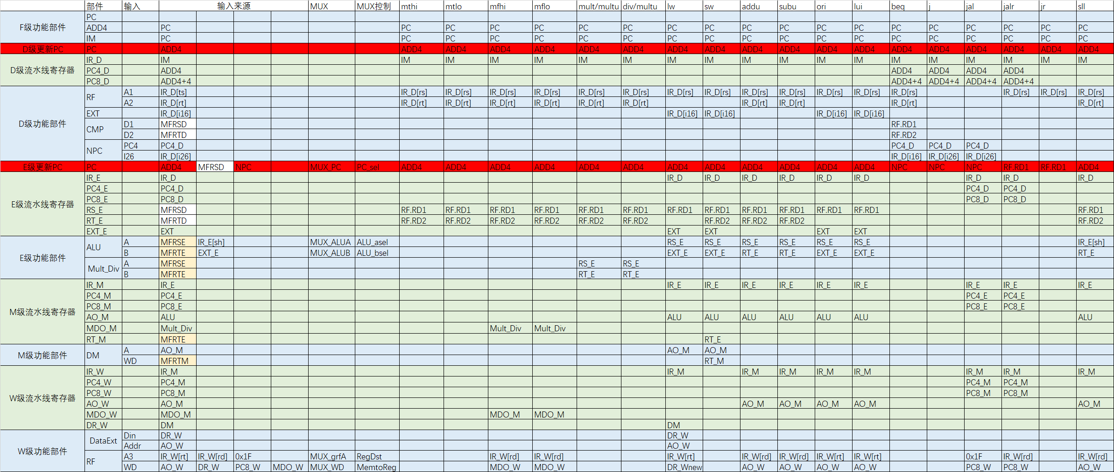

由此可见需要以下几个MUX多路选择器

1.GRF的WA端选择Rd,Rt需要一个MUX，控制信号RegDst[1:0]

2.GRF的WD输入端，有三种选择：RF.RD2，ALU的输出，lui指令直接对imm16后边补16位0，需要2选4MUX,选择信号MemToReg[1:0]

3.扩展方式的选择（符号扩展，0扩展）选择信号EXTOp[1:0]

4. ALU的A端两种选择，RF.RD1或IR_E[sh]的输出，选择信号ALUASrc

5.ALU的B端两种选择，RF.RD2或EXT的输出，选择信号ALUBSrc

6.j/jal指令 跳转地址的选择 if_j

7.PC的选择信号 PCsel[1:0]

8.beq类指令 跳转地址的选择 Branch

除了上述Branch, ALUASrc, ALUBSrc, EXTOp[1:0], MemToReg[1:0], RegDst[1:0] ,if_j, PC_sel[1:0] 还有三个读写控制信号，RegWrite是GRF写入信号，

MemRead, MemWrite是DM读写信号，ALUCtrl[2:0]是ALU控制信号，所以控制器Controller需要设计这12个控制信号。

|  |  |  |
| --- | --- | --- |
| 信号名 | 方向 | 功能描述 |
| Op[5:0] | I | 6位opcode段 |
| Func[5:0] | I | 6位func段 |
| ALUCtrl[3:0] | O | ALU控制信号 |
| RegDst[1:0] | O | 写地址控制 选择RT,RD |
| ALUASrc | O | ALU第一操作数选择控制 |
| ALUBSrc | O | ALU第二操作数选择控制 |
| RegWrite | O | GRF 写入控制 |
| MemRead | O | DM读信号 |
| MemWrite | O | DM写信号 |
| MemToReg[1:0] | O | GRF写入数据的选择信号 |
| ExtOp | O | 高位扩展方式选择信号 |
| If_beq | O | 判断是否为beq指令的信号 |
| If_bne | O | 判断是否为bne指令的信号 |
| If_bgez | O | 判断是否为bgez指令的信号 |
| If_blez | O | 判断是否为blez指令的信号 |
| If_bgtz | O | 判断是否为bgtz指令的信号 |
| If_bltz | O | 判断是否为bltz指令的信号 |
| If_j | O | 判断是不是jal/j指令 是则为1 |
| PC_sel[1:0] | O | PC选择信号 |
| If_sh | O | 判断是否为sh指令的信号 |
| If_sb | O | 判断是否为sb指令的信号 |
| dataOp | O | 数据扩展方式控制信号 |
| multdivOp | O | 乘除法方式控制信号 |
| Start | O | 乘除法开始信号 |
| If_mthi | O | 判断是否为if_mthi指令的信号 |
| If_mtlo | O | 判断是否为if_mtlo指令的信号 |
| If_mfhi | O | 判断是否为if_mfhi指令的信号 |
| If_mflo | O | 判断是否为if_mflo指令的信号 |

画出如下表格

|  |  |  |  |  |  |  |  |  |  |  |  |  |
| --- | --- | --- | --- | --- | --- | --- | --- | --- | --- | --- | --- | --- |
| name | lw | sw | beq | lui | ori | jal | j | addu | subu | jr | sll | Jalr |
| Op5 | 1 | 1 | 0 | 0 | 0 | 0 | 0 | 0 | 0 | 0 | 0 | 0 |
| Op4 | 0 | 0 | 0 | 0 | 0 | 0 | 0 | 0 | 0 | 0 | 0 | 0 |
| Op3 | 0 | 1 | 0 | 1 | 1 | 0 | 0 | 0 | 0 | 0 | 0 | 0 |
| Op2 | 0 | 0 | 1 | 1 | 1 | 0 | 0 | 0 | 0 | 0 | 0 | 0 |
| Op1 | 1 | 1 | 0 | 1 | 0 | 1 | 1 | 0 | 0 | 0 | 0 | 0 |
| Op0 | 1 | 1 | 0 | 1 | 1 | 1 | 0 | 0 | 0 | 0 | 0 | 0 |
| Func5 |  |  |  |  |  |  |  | 1 | 1 | 0 | 0 | 0 |
| Func4 |  |  |  |  |  |  |  | 0 | 0 | 0 | 0 | 0 |
| Func3 |  |  |  |  |  |  |  | 0 | 0 | 1 | 0 | 1 |
| Func2 |  |  |  |  |  |  |  | 0 | 0 | 0 | 0 | 0 |
| Func1 |  |  |  |  |  |  |  | 0 | 1 | 0 | 0 | 0 |
| Func0 |  |  |  |  |  |  |  | 1 | 1 | 0 | 0 | 1 |
| RegDst[1:0] | 00 | 00 | 00 | 00 | 00 | 10 | 00 | 01 | 01 | 01 | 01 | 01 |
| ALUASrc | 0 | 0 | 0 | 0 | 0 | 0 | 0 | 0 | 0 | 0 | 1 | 0 |
| ALUBSrc | 1 | 1 | 0 | 1 | 1 | 0 | 0 | 0 | 0 | 0 | 0 | 0 |
| RegWrite | 1 | 0 | 0 | 1 | 1 | 1 | 0 | 1 | 1 | 1 | 1 | 1 |
| MemRead | 1 | 0 | 0 | 0 | 0 | 0 | 0 | 0 | 0 | 0 | 0 | 0 |
| MemWrite | 0 | 1 | 0 | 0 | 0 | 0 | 0 | 0 | 0 | 0 | 0 | 0 |
| MemToReg[1:0] | 01 | 00 | 00 | 00 | 00 | 10 | 00 | 00 | 00 | 00 | 00 | 10 |
| EXTOp[1:0] | 00 | 00 | 00 | 10 | 01 | 00 | 00 | 00 | 00 | 00 | 00 | 00 |
| If_beq | 0 | 0 | 1 | 0 | 0 | 0 | 0 | 0 | 0 | 0 | 0 | 0 |
| ALUCtrl[3:0] | 0010 | 0010 | 0111 | 0010 | 0001 | 0111 | 0111 | 0010 | 0011 | 0111 | 0100 | 0000 |
| If_j | 0 | 0 | 0 | 0 | 0 | 1 | 1 | 0 | 0 | 0 | 0 | 0 |
| PC_sel[1:0] | 00 | 00 | 10 | 00 | 00 | 10 | 10 | 00 | 00 | 01 | 00 | 01 |

分布式译码 实例化四级控制器（译码器）

controller my_controllerD(.op(IR_D[`op]),.func(IR_D[`func]),.rt(IR_D[`rt]),.ExtOp(EXTop),.if_beq(if_beq),.if_bne(if_bne),.if_blez(if_blez),.if_bgtz(if_bgtz),.if_bgez(if_bgez),.if_bltz(if_bltz),.if_j(if_j),.PCsel(PC_sel));

controller my_controllerE(.op(IR_E[`op]),.func(IR_E[`func]),.rt(IR_D[`rt]),.ALUCtrl(ALUCtrl),.ALUASrc(ALUASrc),.ALUBSrc(ALUBSrc),.multdivOp(multdivOp),.start(start),.if_mthi(if_mthi),.if_mtlo(if_mtlo),.if_mfhi(if_mfhi),.if_mflo(if_mflo));

controller my_controllerM(.op(IR_M[`op]),.func(IR_M[`func]),.rt(IR_D[`rt]),.MemRead(MemRead),.MemWrite(MemWrite),.if_sh(if_sh),.if_sb(if_sb));

controller my_controllerW(.op(IR_W[`op]),.func(IR_W[`func]),.rt(IR_D[`rt]),.RegDst(RegDst),.RegWrite(RegWrite),.MemtoReg(MemtoReg),.dataOp(dataOp));

四．冒险处理单元设计

**需求时间——供给时间模型**。

Tuse

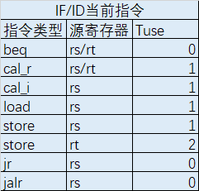

Tnew



暂停

|  |  |  |  |  |  |  |
| --- | --- | --- | --- | --- | --- | --- |
| IF/ID当前指令 | | | ID/EX | | | EX/MEM |
| 指令类型 | 源寄存器 | Tuse | Tnew | | | Tnew |
| cal_r | cal_i | load | load |
| 1/rd | 1/rt | 2/rt | 1/rt |
| beq | rs/rt | 0 | 暂停 | 暂停 | 暂停 | 暂停 |
| cal_r | rs/rt | 1 |  |  | 暂停 |  |
| cal_i | rs | 1 |  |  | 暂停 |  |
| load | rs | 1 |  |  | 暂停 |  |
| store | rs | 1 |  |  | 暂停 |  |
| store | rt | 2 |  |  |  |  |
| jr | rs | 0 | 暂停 | 暂停 | 暂停 | 暂停 |
| jalr | rs | 0 | 暂停 | 暂停 | 暂停 | 暂停 |

由此可以写出各种控制信号的表达式如下

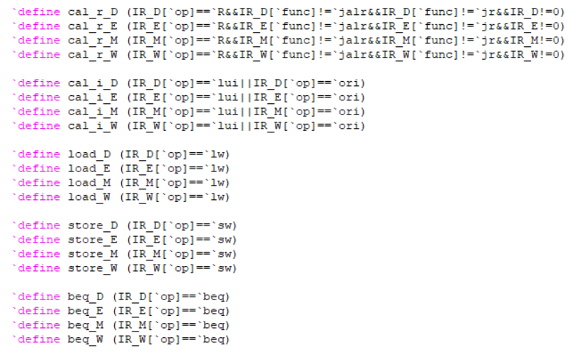

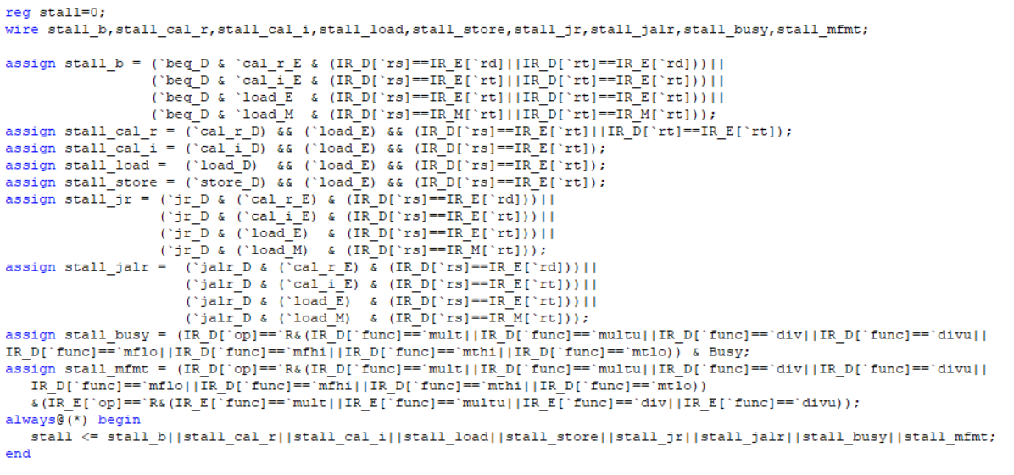

转发

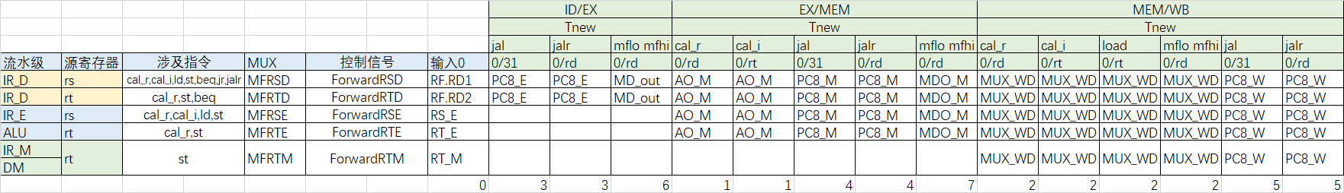

由此可以写出各种控制信号的表达式如下

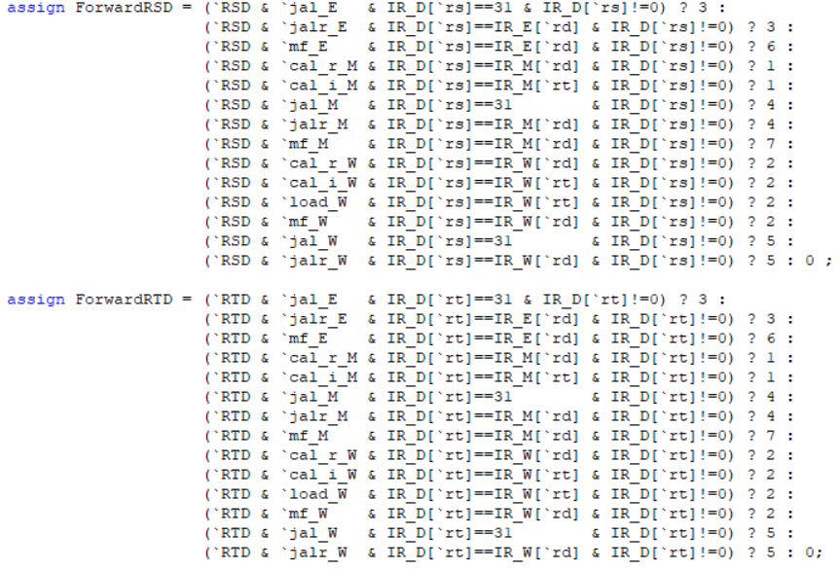

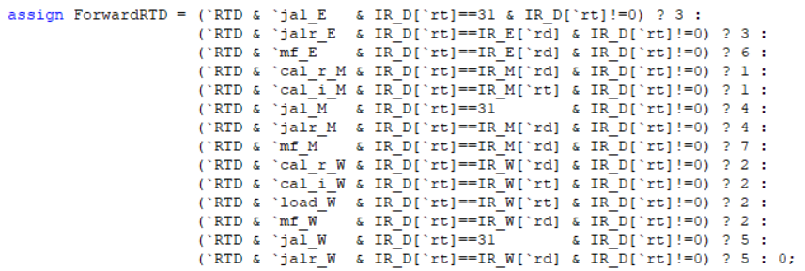

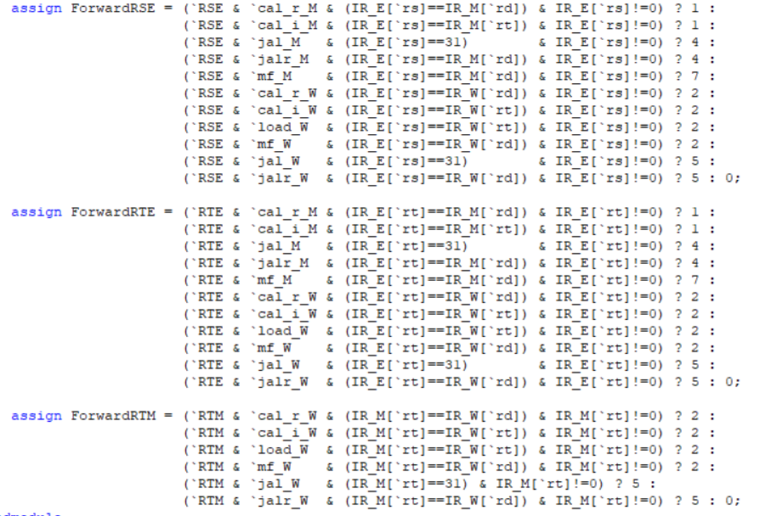

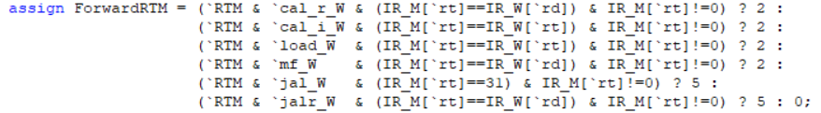

更新后的数据通路 加入了转发MUX



Forward_mux代码如下

always@(*) begin

case(ForwardRSD)

3'b000 : MFRSD <= RF_RD1;

3'b001 : MFRSD <= AO_M;

3'b010 : MFRSD <= WD;

3'b011 : MFRSD <= PC8_E;

3'b100 : MFRSD <= PC8_M;

3'b101 : MFRSD <= PC8_W;

3'b110 : MFRSD <= MD_out;

3'b111 : MFRSD <= MDO_M;

default : MFRSD <= 0;

endcase

case(ForwardRTD)

0: MFRTD <= RF_RD2;

1: MFRTD <= AO_M;

2: MFRTD <= WD;

3: MFRTD <= PC8_E;

4: MFRTD <= PC8_M;

5: MFRTD <= PC8_W;

6: MFRTD <= MD_out;

7: MFRTD <= MDO_M;

default: MFRTD <= 0;

endcase

case(ForwardRSE)

0:MFRSE <= RS_E;

1:MFRSE <= AO_M;

2:MFRSE <= WD;

3:MFRSE <= 0;

4:MFRSE <= PC8_M;

5:MFRSE <= PC8_W;

6:MFRSE <= 0;

7:MFRSE <= MDO_M;

default:MFRSE <= 0;

endcase

case(ForwardRTE)

0:MFRTE <= RT_E;

1:MFRTE <= AO_M;

2:MFRTE <= WD;

3:MFRTE <= 0;

4:MFRTE <= PC8_M;

5:MFRTE <= PC8_W;

6:MFRTE <= 0;

7:MFRTE <= MDO_M;

default:MFRTE <= 0;

endcase

case(ForwardRTM)

0:MFRTM <= RT_M;

1:MFRTM <= 0;

2:MFRTM <= WD;

3:MFRTM <= 0;

4:MFRTM <= 0;

5:MFRTM <= PC8_W;

6:MFRTM <= 0;

7:MFRTM <= 0;

default:MFRTM <= 0;

endcase

end

五．主程序，数据通路设计，tb

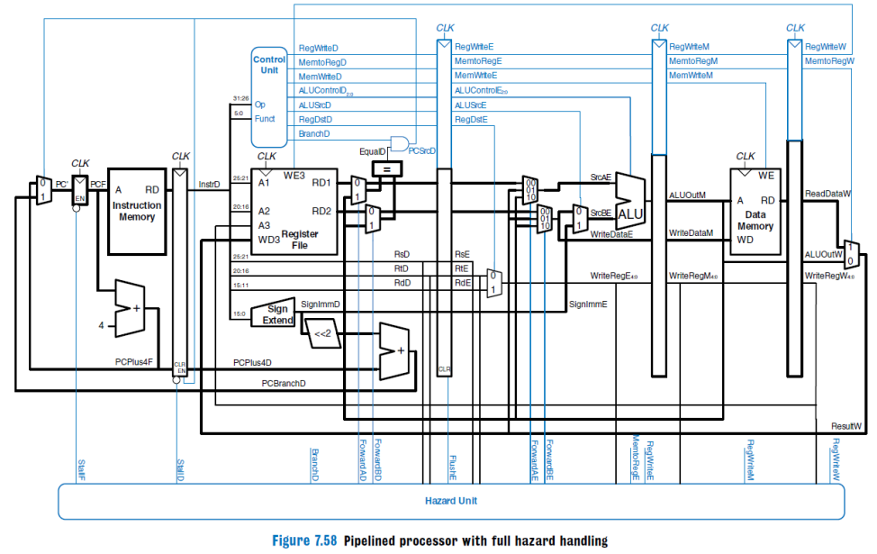

数据通路主要采用如上架构 区别是分布式译码

1. 流水线的设计以追求性能为第一目标，因此必须尽最大可能**支持转发**以解决数据冒险。这一点在本project的最终成绩中所占比重较大，课上测试时会通过测试程序所跑的**总周期数**进行判定，望大家慎重对待。

2. 对于 b 类和 j 类指令， 流水线设计必须**支持延迟槽**，因此设计需要注意使用 **PC+8**。

3. 为了解决数据冒险而设计的转发数据来源必须是**某级流水线寄存器**，**不允许**对功能部件的输出直接进行转发。

4.分布式译码

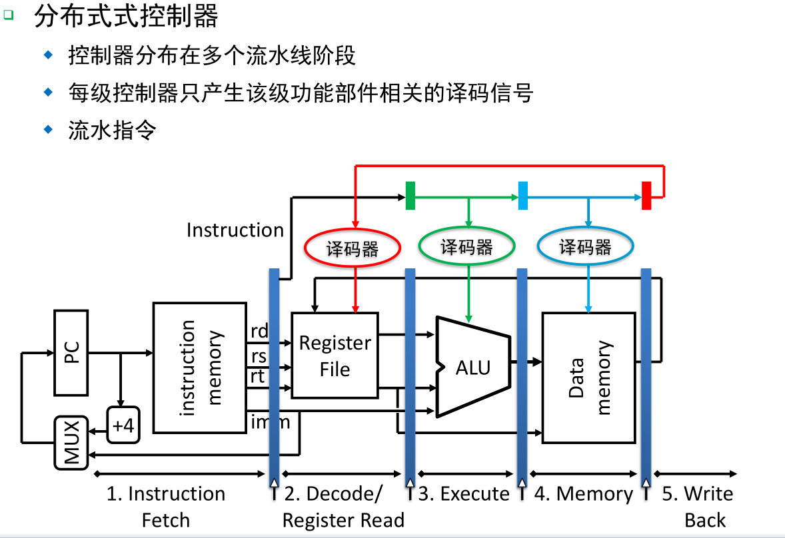

需要以下几个MUX多路选择器

1.GRF的WA端选择Rd,Rt需要一个MUX，控制信号RegDst[1:0]

2.GRF的WD输入端，有三种选择：RF.RD2，ALU的输出，lui指令直接对imm16后边补16位0，需要2选4MUX,选择信号MemToReg[1:0]

3. ALU的A端两种选择，RF.RD1或IR_E[sh]的输出，选择信号ALUASrc

4.ALU的B端两种选择，RF.RD2或EXT的输出，选择信号ALUBSrc

1.mux.v

模块接口

|  |  |
| --- | --- |
| 文件 | 模块接口定义 |
| mux.v | module mux(  input [31:0] EXT_E,  input [31:0] IR_E,  input [31:0] IR_W,  input [31:0] DR_Wnew,  input [31:0] AO_W,  input [31:0] MDO_W,  input [31:0] PC8_W,  input [31:0] MFRSE,  input [31:0] MFRTE,  input [31:0] High,  input [31:0] Low,  input ALUasel,  input ALUbsel,  input if_mfhi,  input if_mflo,  input [1:0] RegDst,  input [1:0] MemtoReg,  output reg[31:0] ALU_A,  output reg[31:0] ALU_B,  output reg[4:0] MUX_A3,  output reg[31:0] MUX_WD,  output reg[31:0] MD_out  ); |

always@(*) begin

case(ALUasel)

1'b0: ALU_A<=MFRSE;

1'b1: ALU_A<={27'b0,IR_E[10:6]};

endcase

case(ALUbsel)

1'b0: ALU_B<=MFRTE;

1'b1: ALU_B<=EXT_E;

endcase

case(RegDst)

2'b00: MUX_A3<=IR_W[20:16];

2'b01: MUX_A3<=IR_W[15:11];

2'b10: MUX_A3<=32'h1f;

2'b11: MUX_A3<=0;

endcase

case(MemtoReg)

2'b00: MUX_WD<=AO_W;

2'b01: MUX_WD<=DR_Wnew;

2'b10: MUX_WD<=PC8_W;

2'b11: MUX_WD<=MDO_W;

endcase

if(if_mfhi) MD_out<=High;

else if(if_mflo) MD_out<=Low;

else MD_out<=0;

end

2.mips.v

|  |  |
| --- | --- |
| 文件 | 模块接口定义 |
| mips.v | module mips(  input clk,  input reset  ); |

pc my_pc(clk,reset,PC_en,next_pc,PC);

im my_im(PC,Instr);

ID my_ID(clk,ID_reset||reset,ID_en,Instr,PC,IR_D,PC_D,PC4_D,PC8_D);

controller my_controllerD(.op(IR_D[`op]),.func(IR_D[`func]),.rt(IR_D[`rt]),.ExtOp(EXTop),.if_beq(if_beq),.if_bne(if_bne),

.if_blez(if_blez),.if_bgtz(if_bgtz),.if_bgez(if_bgez),.if_bltz(if_bltz),.if_j(if_j),.PCsel(PC_sel));

grf my_grf(clk,reset,RegWrite,IR_D[`rs],IR_D[`rt],MUX_A3,MUX_WD,PC_W,RF_RD1,RF_RD2);

cmp my_cmp(MFRSD,MFRTD,Zero,more,less);

ext my_ext(IR_D[`imm16],EXTop,EXT_out);

npc my_npc(PC4,PC4_D,IR_D[`imm26],MFRSD,Zero,more,less,if_beq,if_bne,if_bgtz,if_blez,if_bgez,if_bltz,if_j,PC_sel,next_pc);

EX my_EX(clk,EX_reset||reset,EX_en,IR_D,PC_D,PC4_D,PC8_D,MFRSD,MFRTD,EXT_out,IR_E,PC_E,PC4_E,PC8_E,RS_E,RT_E,EXT_E);

controller my_controllerE(.op(IR_E[`op]),.func(IR_E[`func]),.rt(IR_D[`rt]),.ALUCtrl(ALUCtrl),.ALUASrc(ALUASrc),.ALUBSrc(ALUBSrc),

.multdivOp(multdivOp),.start(start),.if_mthi(if_mthi),.if_mtlo(if_mtlo),.if_mfhi(if_mfhi),.if_mflo(if_mflo));

alu my_alu(ALU_A,ALU_B,ALUCtrl,ALU_out);

Mult_Div my_Mult_Div(clk,reset,MFRSE,MFRTE,multdivOp,start,if_mthi,if_mtlo,Busy,High,Low);

MEM my_MEM(clk,MEM_reset||reset,MEM_en,IR_E,PC_E,PC4_E,PC8_E,ALU_out,MD_out,MFRTE,IR_M,PC_M,PC4_M,PC8_M,AO_M,MDO_M,RT_M);

controller my_controllerM(.op(IR_M[`op]),.func(IR_M[`func]),.rt(IR_D[`rt]),.MemRead(MemRead),.MemWrite(MemWrite),.if_sh(if_sh),.if_sb(if_sb));

dm my_dm(clk,reset,MemWrite,MemRead,if_sh,if_sb,AO_M,MFRTM,PC_M,DM_out);

WB my_WB(clk,WB_reset||reset,WB_en,IR_M,PC_M,PC4_M,PC8_M,AO_M,MDO_M,DM_out,IR_W,PC_W,PC4_W,PC8_W,AO_W,MDO_W,DR_W);

controller my_controllerW(.op(IR_W[`op]),.func(IR_W[`func]),.rt(IR_D[`rt]),.RegDst(RegDst),.RegWrite(RegWrite),.MemtoReg(MemtoReg),.dataOp(dataOp));

DataExt my_DataExt(DR_W,dataOp,AO_W[1:0],DR_Wnew);

mux my_mux(EXT_E,IR_E,IR_W,DR_Wnew,AO_W,MDO_W,PC8_W,MFRSE,MFRTE,High,Low,ALUASrc,ALUBSrc,if_mfhi,if_mflo,RegDst,MemtoReg,ALU_A,ALU_B,MUX_A3,MUX_WD,MD_out);

forward_mux my_forward(RS_E,RT_E,RT_M,MUX_WD,AO_M,MDO_M,MD_out,PC8_E,PC8_M,PC8_W,RF_RD1,RF_RD2,ForwardRSD,ForwardRTD,ForwardRSE,ForwardRTE,ForwardRTM,MFRSD,MFRTD,MFRSE,MFRTE,MFRTM);

hazardUnit my_hazard(IR_D,IR_E,IR_M,IR_W,Busy,start,ID_en,EX_reset,PC_en,ForwardRSD,ForwardRTD,ForwardRSE,ForwardRTE,ForwardRTM);

3.tb

module test;

// Inputs

reg clk;

reg reset;

// Instantiate the Unit Under Test (UUT)

mips uut (

.clk(clk),

.reset(reset)

);

initial begin

clk = 0;

reset = 1;

#12 reset = 0;

end

always #10 clk = ~clk;

endmodule

五．测试程序

(1)转发机制覆盖测试

**测试目录：**

一．D级rs

1.D级Rs与E级jal

2.D级Rs与E级jalr

3.D级Rs与E级 mflo/mfhi

4.D级Rs与M级cal_r

5.D级Rs与M级cal_i

6.D级Rs与M级jal

7.D级Rs与M级jalr

8.D级Rs与M级mflo/mfhi

9.D级Rs与W级cal_r

10.D级Rs与W级cal_i

11.D级Rs与W级load rt

12.D级Rs与W级jal

13.D级Rs与W级jalr

14.D级Rs与W级jalr

每一项又分为：cal_r,cal_i,ld,st,beq,jr,jalr

二．D级Rt

1.D级Rt与E级jal

2.D级Rt与E级jalr

3.D级Rt与E级 mflo/mfhi

4.D级Rt与M级cal_r

5.D级Rt与M级cal_i

6.D级Rt与M级jal

7.D级Rt与M级jalr

8.D级Rt与M级mflo/mfhi

9.D级Rt与W级cal_r

10.D级Rt与W级cal_i

11.D级Rt与W级load rt

12.D级Rt与W级jal

13.D级Rt与W级jalr

14.D级Rt与W级jalr

每一项又分为：cal_r,st,beq

三．E级Rs

1.E级Rs与M级cal_r

2.E级Rs与M级cal_i

3.E级Rs与M级jal

4.E级Rs与M级jalr

5.E级Rs与M级mflo/mfhi

6.E级Rs与W级cal_r

7.E级Rs与W级cal_i

8.E级Rs与W级load

9.E级Rs与W级jal

10.E级Rs与W级jalr

11.E级Rs与W级mflo/mfhi

每一项又分为：cal_r,cal_i,ld,st

四．E级Rt

1.E级Rt与M级cal_r

2.E级Rt与M级cal_i

3.E级Rt与M级jal

4.E级Rt与M级jalr

5.E级Rt与M级mflo/mfhi

6.E级Rt与W级cal_r

7.E级Rt与W级cal_i

8.E级Rt与W级load

9.E级Rt与W级jal

10.E级Rt与W级jalr

11.E级Rt与W级mflo/mfhi

每一项又分为：cal_r,st

五．M级Rt

1.M级Rt与W级cal_r

2.M级Rt与W级cal_i

3.M级Rt与W级load

4.M级Rt与W级jal

5.M级Rt与W级jalr

6.M级Rt与W级mflo/mfhi

每一项又分为：st

一．D级rs

1.D级rs与E级jal

(1)Rs----cal_r

ori $t0,11

jal eee

addu $t0,$ra,$0

eee:

110@00003000: $ 8 <= 0000000b

130@00003004: $31 <= 0000300c

150@00003008: $ 8 <= 0000300c

(2)Rs---cal_i

ori $t0,11

jal eee

ori $t0,$ra,11

eee:

110@00003000: $ 8 <= 0000000b

130@00003004: $31 <= 0000300c

150@00003008: $ 8 <= 0000300f

2.D级Rs与E级jalr

(1)Rs----cal_r

ori $t0,0x0000300c

jalr $t1,$t0

addu $t2,$t1,$t0

nop

110@00003000: $ 8 <= 0000300c

150@00003004: $ 9 <= 0000300c

170@00003008: $10 <= 00006018

(2)Rs---cal_i

ori $t0,0x0000300c

jalr $t1,$t0

xori $t2,$t1,111

nop

110@00003000: $ 8 <= 0000300c

150@00003004: $ 9 <= 0000300c

170@00003008: $10 <= 00003063

3.D级Rs与E级 mflo/mfhi

(1)Rs----cal_r

ori $t0,11

ori $t1,12

multu $t0,$t1

mflo $t2

addu $t1,$t2,$t0

mfhi $t2

and $t1,$t2,$t0

110@00003000: $ 8 <= 0000000b

130@00003004: $ 9 <= 0000000c

290@0000300c: $10 <= 00000084

310@00003010: $ 9 <= 0000008f

330@00003014: $10 <= 00000000

350@00003018: $ 9 <= 00000000

(2)Rs---cal_i

ori $t0,11

ori $t1,12

multu $t0,$t1

mflo $t2

lui $t1,$t2,100

mfhi $t2

addiu $t1,$t2,99

110@00003000: $ 8 <= 0000000b

130@00003004: $ 9 <= 0000000c

290@0000300c: $10 <= 00000084

310@00003010: $ 9 <= 000000e8

330@00003014: $10 <= 00000000

350@00003018: $ 9 <= 00000063

(3)Rs---load

ori $t0,11

ori $t1,12

multu $t0,$t1

mflo $t2

lb $t1,0($t2)

mfhi $t2

lbu $t1,0($t2)

110@00003000: $ 8 <= 0000000b

130@00003004: $ 9 <= 0000000c

290@0000300c: $10 <= 00000084

310@00003010: $ 9 <= 00000000

330@00003014: $10 <= 00000000

350@00003018: $ 9 <= 00000000

(4)Rs---store

ori $t0,11

ori $t1,12

multu $t0,$t1

mflo $t2

sh $t1,0($t2)

mfhi $t2

sb $t1,0($t2)

110@00003000: $ 8 <= 0000000b

130@00003004: $ 9 <= 0000000c

290@0000300c: $10 <= 00000084

290@00003010: *00000084 <= 0000000c

330@00003014: $10 <= 00000000

330@00003018: *00000000 <= 0000000c

(5)Rs---beq

ori $t0,11

ori $t1,12

multu $t0,$t1

mfhi $t2

beq $t2,$t1,out

nop

out:

nop

110@00003000: $ 8 <= 0000000b

130@00003004: $ 9 <= 0000000c

290@0000300c: $10 <= 00000000

(6)Rs---jr

ori $t0,11

ori $t1,12

multu $t0,$t1

mflo $t2

jr $t2

nop

out:

nop

110@00003000: $ 8 <= 0000000b

130@00003004: $ 9 <= 0000000c

290@0000300c: $10 <= 00000084

(7) Rs---jalr

ori $t0,11

ori $t1,12

multu $t0,$t1

mflo $t2

jalr $t1,$t2

nop

out:

nop

110@00003000: $ 8 <= 0000000b

130@00003004: $ 9 <= 0000000c

290@0000300c: $10 <= 00000084

310@00003010: $ 9 <= 00003018

4.D级Rs与M级cal_r

(1)Rs----cal_r

ori $t0,11

addu $t1,$t2,$t0

nop

addu $t2,$t1,$t0

110@00003000: $ 8 <= 0000000b

130@00003004: $ 9 <= 0000000b

170@0000300c: $10 <= 00000016

(2)Rs---cal_i

ori $t0,11

addu $t1,$t2,$t0

nop

ori $t0,$t1,1

110@00003000: $ 8 <= 0000000b

130@00003004: $ 9 <= 0000000b

170@0000300c: $ 8 <= 0000000b

(3)Rs---load

addu $a0,$0,$0

nop

lw $t0,0($a0)

110@00003000: $ 4 <= 00000000

150@00003008: $ 8 <= 00000000

(4)Rs---store

ori $t0,111

addu $a0,$0,$0

nop

sw $t0,0($a0)

110@00003000: $ 8 <= 0000006f

130@00003004: $ 4 <= 00000000

150@0000300c: *00000000 <= 0000006f

(5)Rs---beq

ori $t1,1

addu $t2,$t1,$0

nop

beq $t2,$t1,out

nop

out:

nop

110@00003000: $ 9 <= 00000001

130@00003004: $10 <= 00000001

(6)Rs---jr

ori $t1,0x00003014

addu $t2,$t1,$0

nop

jr $t2

nop

out:

nop

110@00003000: $ 9 <= 00003014

130@00003004: $10 <= 00003014

(7)Rs-jalr

ori $t1,0x00003014

or $t2,$t1,$0

nop

jalr $t1,$t2

nop

out:

nop

110@00003000: $ 9 <= 00003014

130@00003004: $10 <= 00003014

170@0000300c: $ 9 <= 00003014

5.D级Rs与M级cal_i

(1)Rs----cal_r

ori $t0,11

ori $t1,$t2,0

nop

addu $t2,$t1,$t0

110@00003000: $ 8 <= 0000000b

130@00003004: $ 9 <= 00000000

170@0000300c: $10 <= 0000000b

(2)Rs---cal_i

ori $t0,11

ori $t1,$t2,0

nop

ori $t0,$t1,1

110@00003000: $ 8 <= 0000000b

130@00003004: $ 9 <= 00000000

170@0000300c: $ 8 <= 00000001

190@00003010: $ 8 <= 0000000b

210@00003014: $ 9 <= 00000000

250@0000301c: $ 8 <= 00000001

(3)Rs---load

ori $a0,$0,0

nop

lw $t0,0($a0)

110@00003000: $ 4 <= 00000000

150@00003008: $ 8 <= 00000000

(4)Rs---store

ori $t0,111

ori $a0,$0,0

nop

sw $t0,0($a0)

110@00003000: $ 8 <= 0000006f

130@00003004: $ 4 <= 00000000

150@0000300c: *00000000 <= 0000006f

(5)Rs---beq

ori $t1,1

ori $t2,$t1,0

nop

beq $t2,$t1,out

nop

out:

nop

110@00003000: $ 9 <= 00000001

130@00003004: $10 <= 00000001

(6)Rs---jr

ori $t1,0x00003014

ori $t2,$t1,0

nop

jr $t2

nop

out:

nop

110@00003000: $ 9 <= 00003014

130@00003004: $10 <= 00003014

(7)Rs-jalr

ori $t1,0x00003014

ori $t2,$t1,0

nop

jalr $t1,$t2

nop

out:

nop

110@00003000: $ 9 <= 00003014

130@00003004: $10 <= 00003014

170@0000300c: $ 9 <= 00003014

6.D级Rs与M级jal

(1)Rs----cal_r

ori $t0,11

jal eee

nop

nor $t0,$ra,$0

eee:

110@00003000: $ 8 <= 0000000b

130@00003004: $31 <= 0000300c

(2)Rs---cal_i

ori $t0,11

jal eee

nop

ori $t0,$ra,11

eee:

110@00003000: $ 8 <= 0000000b

130@00003004: $31 <= 0000300c

(3)Rs---load

ori $a0,$0,0x00003000

jal eee

subu $ra,$ra,$a0

eee:

lw $t1,0($ra)

110@00003000: $ 4 <= 00003000

130@00003004: $31 <= 0000300c

150@00003008: $31 <= 0000000c

170@0000300c: $ 9 <= 00000000

(4)Rs---store

ori $t1,1

ori $a0,$0,0x00003000

jal eee

subu $ra,$ra,$a0

eee:

sw $t1,0($ra)

110@00003000: $ 9 <= 00000001

130@00003004: $ 4 <= 00003000

150@00003008: $31 <= 00003010

170@0000300c: $31 <= 00000010

170@00003010: *00000010 <= 00000001

7.D级Rs与M级jalr

(1)Rs----cal_r

ori $t0,0x0000300c

jalr $t1,$t0

nop

addu $t2,$t1,$t0

nop

110@00003000: $ 8 <= 0000300c

150@00003004: $ 9 <= 0000300c

170@0000300c: $10 <= 00006018

(2)Rs---cal_i

ori $t0,0x0000300c

jalr $t1,$t0

nop

xori $t2,$t1,111

nop

110@00003000: $ 8 <= 0000300c

150@00003004: $ 9 <= 0000300c

170@0000300c: $10 <= 00003063

8.D级Rs与M级 mflo/mfhi

(1)Rs----cal_r

ori $t0,11

ori $t1,12

multu $t0,$t1

mflo $t2

addu $t1,$t2,$t0

mfhi $t2

nop

and $t1,$t2,$t0

110@00003000: $ 8 <= 0000000b

130@00003004: $ 9 <= 0000000c

290@0000300c: $10 <= 00000084

310@00003010: $ 9 <= 0000008f

330@00003014: $10 <= 00000000

350@00003018: $ 9 <= 00000000

(2)Rs---cal_i

ori $t0,11

ori $t1,12

multu $t0,$t1

mflo $t2

lui $t1,$t2,100

mfhi $t2

nop

addiu $t1,$t2,99

110@00003000: $ 8 <= 0000000b

130@00003004: $ 9 <= 0000000c

290@0000300c: $10 <= 00000084

310@00003010: $ 9 <= 000000e8

330@00003014: $10 <= 00000000

350@00003018: $ 9 <= 00000063

(3)Rs---load

ori $t0,11

ori $t1,12

multu $t0,$t1

mflo $t2

lb $t1,0($t2)

mfhi $t2

nop

lbu $t1,0($t2)

110@00003000: $ 8 <= 0000000b

130@00003004: $ 9 <= 0000000c

290@0000300c: $10 <= 00000084

310@00003010: $ 9 <= 00000000

330@00003014: $10 <= 00000000

350@00003018: $ 9 <= 00000000

(4)Rs---store

ori $t0,11

ori $t1,12

multu $t0,$t1

mflo $t2

sh $t1,0($t2)

mfhi $t2

nop

sb $t1,0($t2)

110@00003000: $ 8 <= 0000000b

130@00003004: $ 9 <= 0000000c

290@0000300c: $10 <= 00000084

290@00003010: *00000084 <= 0000000c

330@00003014: $10 <= 00000000

330@00003018: *00000000 <= 0000000c

(5)Rs---beq

ori $t0,11

ori $t1,12

multu $t0,$t1

mfhi $t2

nop

beq $t2,$t1,out

nop

out:

nop

110@00003000: $ 8 <= 0000000b

130@00003004: $ 9 <= 0000000c

290@0000300c: $10 <= 00000000

(6)Rs---jr

ori $t0,11

ori $t1,12

multu $t0,$t1

mflo $t2

nop

jr $t2

nop

out:

nop

110@00003000: $ 8 <= 0000000b

130@00003004: $ 9 <= 0000000c

290@0000300c: $10 <= 00000084

(7) Rs---jalr

ori $t0,11

ori $t1,12

multu $t0,$t1

mflo $t2

nop

jalr $t1,$t2

nop

out:

nop

110@00003000: $ 8 <= 0000000b

130@00003004: $ 9 <= 0000000c

290@0000300c: $10 <= 00000084

310@00003010: $ 9 <= 00003018

9.D级Rs与W级cal_r

(1)Rs----cal_r

ori $t0,11

addu $t1,$t2,$t0

nop

nop

addu $t2,$t1,$t0

(2)Rs---cal_i

ori $t0,11

addu $t1,$t2,$t0

nop

nop

ori $t0,$t1,1

(3)Rs---load

addu $a0,$0,$0

nop

nop

lw $t0,0($a0)

(4)Rs---store

ori $t0,111

addu $a0,$0,$0

nop

nop

sw $t0,0($a0)

(5)Rs---beq

ori $t1,1

addu $t2,$t1,$0

nop

nop

beq $t2,$t1,out

nop

out:

nop

(6)Rs---jr

ori $t1,0x00003014

addu $t2,$t1,$0

nop

nop

jr $t2

nop

out:

nop

(7)Rs---jalr

ori $t1,0x00003014

addu $t2,$t1,$0

nop

nop

jalr $t1,$t2

nop

out:

nop

10.D级Rs与W级cal_i

(1)Rs----cal_r

ori $t0,11

ori $t1,$t2,0

nop

nop

addu $t2,$t1,$t0

(2)Rs---cal_i

ori $t0,11

ori $t1,$t2,0

nop

nop

ori $t0,$t1,1

(3)Rs---load

ori $a0,$0,0

nop

nop

lw $t0,0($a0)

(4)Rs---store

ori $t0,111

ori $a0,$0,0

nop

nop

sw $t0,0($a0)

(5)Rs---beq

ori $t1,1

ori $t2,$t1,0

nop

nop

beq $t2,$t1,out

nop

out:

nop

(6)Rs---jr

ori $t1,0x00003014

ori $t2,$t1,0

nop

nop

jr $t2

nop

out:

nop

(7)Rs---jalr

ori $t1,0x00003014

ori $t2,$t1,0

nop

nop

jalr $t1,$t2

nop

out:

nop

11.D级Rs与W级load rt

(1)Rs----cal_r

ori $t1,1

ori $t0,0x00000000

lw $t1,0($t0)

nop

nop

addu $t2,$t1,$t0

110@00003000: $ 9 <= 00000001

130@00003004: $ 8 <= 00000000

150@00003008: $ 9 <= 00000000

210@00003014: $10 <= 00000000

(2)Rs---cal_i

ori $t1,1

ori $t0,0x00000000

lw $t1,0($t0)

nop

nop

ori $t0,$t1,1

110@00003000: $ 9 <= 00000001

130@00003004: $ 8 <= 00000000

150@00003008: $ 9 <= 00000000

210@00003014: $ 8 <= 00000001

(3)Rs---load

ori $t0,0x00000000

lw $t1,0($t0)

nop

nop

lw $t0,0($t1)

110@00003000: $ 8 <= 00000000

130@00003004: $ 9 <= 00000000

190@00003010: $ 8 <= 00000000

(4)Rs---store

ori $t0,0x00000000

lw $t1,0($t0)

nop

nop

sw $t0,0($t1)

110@00003000: $ 8 <= 00000000

130@00003004: $ 9 <= 00000000

170@00003010: *00000000 <= 00000000

(5)Rs---beq

ori $t1,1

ori $t0,0x00000000

lw $t1,0($t0)

ori $t2,$t1,0

nop

beq $t1,$t2,out

nop

out:

nop

110@00003000: $ 9 <= 00000001

130@00003004: $ 8 <= 00000000

150@00003008: $ 9 <= 00000000

190@0000300c: $10 <= 00000000

(6)Rs---jr

ori $t0,0x00000000

ori $t2,$0,0x00003020

sw $t2,0($t0)

lw $t1,0($t0)

nop

nop

jr $t1

nop

out:

nop

110@00003000: $ 8 <= 00000000

130@00003004: $10 <= 00003020

130@00003008: *00000000 <= 00003020

170@0000300c: $ 9 <= 00003020

(7)Rs---jalr

ori $t0,0x00000000

ori $t2,$0,0x00003020

sw $t2,0($t0)

lw $t1,0($t0)

nop

nop

jalr $t2,$t1

nop

out:

nop

110@00003000: $ 8 <= 00000000

130@00003004: $10 <= 00003020

130@00003008: *00000000 <= 00003020

170@0000300c: $ 9 <= 00003020

230@00003018: $10 <= 00003020

12.D级Rs与W级jal

(1)Rs----cal_r

ori $t0,11

jal eee

nop

nop

nor $t0,$ra,$0

eee:

110@00003000: $ 8 <= 0000000b

130@00003004: $31 <= 0000300c

(2)Rs---cal_i

ori $t0,11

jal eee

nop

nop

ori $t0,$ra,11

eee:

110@00003000: $ 8 <= 0000000b

130@00003004: $31 <= 0000300c

(3)Rs---load

ori $a0,$0,0x00003000

jal eee

subu $ra,$ra,$a0

eee:

nop

lw $t1,0($ra)

110@00003000: $ 4 <= 00003000

130@00003004: $31 <= 0000300c

150@00003008: $31 <= 0000000c

170@0000300c: $ 9 <= 00000000

(4)Rs---store

ori $t1,1

ori $a0,$0,0x00003000

jal eee

subu $ra,$ra,$a0

eee:

nop

sw $t1,0($ra)

110@00003000: $ 9 <= 00000001

130@00003004: $ 4 <= 00003000

150@00003008: $31 <= 00003010

170@0000300c: $31 <= 00000010

170@00003010: *00000010 <= 00000001

13.D级Rs与M级jalr

(1)Rs----cal_r

ori $t0,0x0000300c

jalr $t1,$t0

nop

nop

addu $t2,$t1,$t0

nop

110@00003000: $ 8 <= 0000300c

150@00003004: $ 9 <= 0000300c

210@00003010: $10 <= 00006018

(2)Rs---cal_i

ori $t0,0x0000300c

jalr $t1,$t0

nop

nop

xori $t2,$t1,111

nop

110@00003000: $ 8 <= 0000300c

150@00003004: $ 9 <= 0000300c

170@0000300c: $10 <= 00003063

14.D级Rs与M级 mflo/mfhi

(1)Rs----cal_r

ori $t0,11

ori $t1,12

multu $t0,$t1

mflo $t2

addu $t1,$t2,$t0

mfhi $t2

nop

nop

and $t1,$t2,$t0

110@00003000: $ 8 <= 0000000b

130@00003004: $ 9 <= 0000000c

290@0000300c: $10 <= 00000084

310@00003010: $ 9 <= 0000008f

330@00003014: $10 <= 00000000

350@00003018: $ 9 <= 00000000

(2)Rs---cal_i

ori $t0,11

ori $t1,12

multu $t0,$t1

mflo $t2

lui $t1,$t2,100

mfhi $t2

nop

nop

addiu $t1,$t2,99

110@00003000: $ 8 <= 0000000b

130@00003004: $ 9 <= 0000000c

290@0000300c: $10 <= 00000084

310@00003010: $ 9 <= 000000e8

330@00003014: $10 <= 00000000

350@00003018: $ 9 <= 00000063

(3)Rs---load

ori $t0,11

ori $t1,12

multu $t0,$t1

mflo $t2

lb $t1,0($t2)

mfhi $t2

nop

nop

lbu $t1,0($t2)

110@00003000: $ 8 <= 0000000b

130@00003004: $ 9 <= 0000000c

290@0000300c: $10 <= 00000084

310@00003010: $ 9 <= 00000000

330@00003014: $10 <= 00000000

350@00003018: $ 9 <= 00000000

(4)Rs---store

ori $t0,11

ori $t1,12

multu $t0,$t1

mflo $t2

sh $t1,0($t2)

mfhi $t2

nop

nop

sb $t1,0($t2)

110@00003000: $ 8 <= 0000000b

130@00003004: $ 9 <= 0000000c

290@0000300c: $10 <= 00000084

290@00003010: *00000084 <= 0000000c

330@00003014: $10 <= 00000000

330@00003018: *00000000 <= 0000000c

(5)Rs---beq

ori $t0,11

ori $t1,12

multu $t0,$t1

mfhi $t2

nop

nop

beq $t2,$t1,out

nop

out:

nop

110@00003000: $ 8 <= 0000000b

130@00003004: $ 9 <= 0000000c

290@0000300c: $10 <= 00000000

(6)Rs---jr

ori $t0,11

ori $t1,12

multu $t0,$t1

mflo $t2

nop

nop

jr $t2

nop

out:

nop

110@00003000: $ 8 <= 0000000b

130@00003004: $ 9 <= 0000000c

290@0000300c: $10 <= 00000084

(7) Rs---jalr

ori $t0,11

ori $t1,12

multu $t0,$t1

mflo $t2

nop

nop

jalr $t1,$t2

nop

out:

nop

110@00003000: $ 8 <= 0000000b

130@00003004: $ 9 <= 0000000c

290@0000300c: $10 <= 00000084

350@00003018: $ 9 <= 00003020

二．D级Rt

1.D级rt与E级jal

(1)Rt----cal_r

ori $t0,11

jal eee

addu $t0,$0,$ra

eee:

110@00003000: $ 8 <= 0000000b

130@00003004: $31 <= 0000300c

150@00003008: $ 8 <= 0000300c

2.D级Rt与E级jalr

(1)Rt----cal_r

ori $t0,0x0000300c

jalr $t1,$t0

addu $t2,$t0,$t1

nop

110@00003000: $ 8 <= 0000300c

150@00003004: $ 9 <= 0000300c

170@00003008: $10 <= 00006018

3.D级Rt与E级 mflo/mfhi

(1)Rt----cal_r

ori $t0,11

ori $t1,12

multu $t0,$t1

mflo $t2

addu $t1,$t0,$t2

mfhi $t2

and $t1,$t2,$t0

110@00003000: $ 8 <= 0000000b

130@00003004: $ 9 <= 0000000c

290@0000300c: $10 <= 00000084

310@00003010: $ 9 <= 0000008f

330@00003014: $10 <= 00000000

350@00003018: $ 9 <= 00000000

(2)Rt---store

ori $t0,11

ori $t1,12

multu $t0,$t1

mflo $t2

sh $t2,0($t2)

mfhi $t2

sb $t2,0($t2)

110@00003000: $ 8 <= 0000000b

130@00003004: $ 9 <= 0000000c

290@0000300c: $10 <= 00000084

290@00003010: *00000084 <= 0000000c

330@00003014: $10 <= 00000000

330@00003018: *00000000 <= 0000000c

(3)Rt---beq

ori $t0,11

ori $t1,12

multu $t0,$t1

mfhi $t2

beq $t1,$t2,out

nop

out:

nop

110@00003000: $ 8 <= 0000000b

130@00003004: $ 9 <= 0000000c

290@0000300c: $10 <= 00000000

4.D级Rt与M级cal_r

(1)Rt----cal_r

ori $t0,11

addu $t1,$t2,$t0

nop

addu $t2,$t0,$t1

(2)Rt---store

ori $t0,111

addu $a0,$t0,$0

nop

sw $a0,0($0)

(3)Rt---beq

ori $t1,1

addu $t2,$t1,$0

nop

beq $t1,$t2,out

nop

out:

nop

5.D级Rt与M级cal_i

(1)Rt----cal_r

ori $t0,11

ori $t1,$t2,0

nop

addu $t2,$t0,$t1

(2)Rt---store

ori $a0,$0,111

nop

sw $a0,0($0)

(3)Rt---beq

ori $t1,1

ori $t2,$t1,0

nop

beq $t1,$t2,out

nop

out:

nop

6.D级Rt与M级jal

(1)Rt----cal_r

ori $t0,11

jal eee

nop

addu $t0,$0,$ra

eee:

(2)Rt---store

ori $t1,1

ori $a0,$0,0x00003000

jal eee

subu $ra,$ra,$a0

eee:

sw $ra,0($0)

7.D级Rt与M级jalr

(1)Rt----cal_r

ori $t0,0x0000300c

jalr $t1,$t0

nop

addu $t2,$t0,$t1

nop

110@00003000: $ 8 <= 0000300c

150@00003004: $ 9 <= 0000300c

170@00003008: $10 <= 00006018

8.D级Rt与M级 mflo/mfhi

(1)Rt----cal_r

ori $t0,11

ori $t1,12

multu $t0,$t1

mflo $t2

addu $t1,$t0,$t2

mfhi $t2

nop

and $t1,$t2,$t0

110@00003000: $ 8 <= 0000000b

130@00003004: $ 9 <= 0000000c

290@0000300c: $10 <= 00000084

310@00003010: $ 9 <= 0000008f

330@00003014: $10 <= 00000000

370@0000301c: $ 9 <= 00000000

(2)Rt---store

ori $t0,11

ori $t1,12

multu $t0,$t1

mflo $t2

sh $t2,0($t2)

mfhi $t2

nop

sb $t2,0($t2)

110@00003000: $ 8 <= 0000000b

130@00003004: $ 9 <= 0000000c

290@0000300c: $10 <= 00000084

290@00003010: *00000084 <= 00000084

330@00003014: $10 <= 00000000

350@0000301c: *00000000 <= 00000000

(3)Rt---beq

ori $t0,11

ori $t1,12

multu $t0,$t1

mfhi $t2

nop

beq $t1,$t2,out

nop

out:

nop

110@00003000: $ 8 <= 0000000b

130@00003004: $ 9 <= 0000000c

290@0000300c: $10 <= 00000000

9.D级Rt与W级cal_r

(1)Rt----cal_r

ori $t0,11

addu $t1,$t2,$t0

nop

nop

addu $t2,$t0,$t1

(2)Rt---store

ori $t0,111

addu $a0,$0,$0

nop

nop

sw $a0,0($0)

(3)Rt---beq

ori $t1,1

addu $t2,$t1,$0

nop

nop

beq $t1,$t2,out

nop

out:

nop

10.D级Rt与W级cal_i

(1)Rt----cal_r

ori $t0,11

ori $t1,$t2,0

nop

nop

addu $t2,$t0,$t1

(4)Rt---store

ori $t0,111

ori $a0,$0,0

nop

nop

sw $a0,0($0)

(5)Rt---beq

ori $t1,1

ori $t2,$t1,0

nop

nop

beq $t1,$t2,out

nop

out:

nop

11.D级Rt与W级load rt

(1)Rt----cal_r

ori $t1,1

ori $t0,0x00000000

lw $t1,0($t0)

nop

nop

addu $t2,$t0,$t1

(2)Rt---store

ori $t0,0x00000000

lw $t1,0($t0)

nop

nop

sw $t1,0($0)

(3)Rs---beq

ori $t1,1

ori $t0,0x00000000

lw $t1,0($t0)

ori $t2,$t1,0

nop

beq $t2,$t1,out

nop

out:

nop

12.D级Rt与W级jal

(1)Rt----cal_r

ori $t0,11

jal eee

nop

nop

addu $t0,$0,$ra

eee:

(2)Rt---store

ori $t1,1

ori $a0,$0,0x00003000

jal eee

subu $ra,$ra,$a0

eee:

nop

sw $ra,0($0)

13. D级Rt与W级jalr

(1)Rt----cal_r

ori $t0,0x0000300c

jalr $t1,$t0

nop

nop

addu $t2,$t0,$t1

nop

110@00003000: $ 8 <= 0000300c

150@00003004: $ 9 <= 0000300c

170@00003008: $10 <= 00006018

14.D级Rt与W级 mflo/mfhi

(1)Rt----cal_r

ori $t0,11

ori $t1,12

multu $t0,$t1

mflo $t2

addu $t1,$t0,$t2

mfhi $t2

nop

nop

and $t1,$t2,$t0

110@00003000: $ 8 <= 0000000b

130@00003004: $ 9 <= 0000000c

290@0000300c: $10 <= 00000084

310@00003010: $ 9 <= 0000008f

330@00003014: $10 <= 00000000

370@0000301c: $ 9 <= 00000000

(2)Rt---store

ori $t0,11

ori $t1,12

multu $t0,$t1

mflo $t2

sh $t2,0($t2)

mfhi $t2

nop

nop

sb $t2,0($t2)

110@00003000: $ 8 <= 0000000b

130@00003004: $ 9 <= 0000000c

290@0000300c: $10 <= 00000084

290@00003010: *00000084 <= 00000084

330@00003014: $10 <= 00000000

350@0000301c: *00000000 <= 00000000

(3)Rt---beq

ori $t0,11

ori $t1,12

multu $t0,$t1

mfhi $t2

nop

nop

beq $t1,$t2,out

nop

out:

nop

110@00003000: $ 8 <= 0000000b

130@00003004: $ 9 <= 0000000c

290@0000300c: $10 <= 00000000

三．E级Rs

1.E级Rs与M级cal_r

(1)Rs----cal_r

ori $t2,$0,111

addu $t1,$t2,$t3

subu $t4,$t1,$0

110@00003000: $10 <= 0000006f

130@00003004: $ 9 <= 0000006f

150@00003008: $12 <= 0000006f

(2)Rs----cal_i

ori $t2,$0,111

subu $t4,$t2,$0

ori $t2,$t4,111

(3)Rs----load

addu $t1,$t2,$t3

lw $t2,0($t1)

110@00003000: $ 9 <= 00000000

130@00003004: $10 <= 00000000

(4)Rs----store

addu $t1,$t2,$t3

sw $t2,0($t1)

2.E级Rs与M级cal_i

(1)Rs----cal_r

ori $t2,$0,111

ori $t1,$t2,0

subu $t4,$t1,$0

(2)Rs----cal_i

ori $t2,$0,111

ori $t4,$t2,0

(3)Rs----load

ori $t1,$t2,$t3

lw $t2,0($t1)

(4)Rs----store

ori $t1,$t2,$t3

sw $t2,0($t1)

3.E级Rs与M级jal

(1)Rs----cal_r

jal eee

subu $t1,$ra,$t2

eee:

(2)Rs----cal_i

jal eee

lui $ra,111

eee:

(3)Rs----load

jal eee

lw $0,0($ra)

eee:

(4)Rs----store

jal eee

sw $0,0($ra)

eee:

4.E级Rs与M级jalr

(1)Rs----cal_r

ori $t1,0x0000300c

jalr $t2,$t1

subu $t1,$t1,$t2

nop

110@00003000: $ 9 <= 0000300c

150@00003004: $10 <= 0000300c

170@00003008: $ 9 <= 00000000

(2)Rs----cal_i

ori $t1,0x0000300c

jalr $t2,$t1

addi $t2,$t2,1

nop

(3)Rs----load

ori $t1,0x0000300c

jalr $t2,$t1

lw $0,0($t2)

(4)Rs----store

ori $t1,0x0000300c

jalr $t2,$t1

sw $0,0($t2)

5.E级Rs与M级mflo/mfhi

(1)Rs----cal_r

ori $t0,11

ori $t1,12

multu $t0,$t1

mflo $t2

sub $t3,$t2,$t2

(2)Rs----cal_i

ori $t0,11

ori $t1,12

multu $t0,$t1

mflo $t2

or $t3,$t2,1

(3)Rs----load

ori $t0,11

ori $t1,12

multu $t0,$t1

mflo $t2

lw $t2,0($t2)

(4)Rs----store

ori $t0,11

ori $t1,12

multu $t0,$t1

mflo $t2

sw $t2,0($t2)

6.E级Rs与W级cal_r

(1)Rs----cal_r

ori $t2,$0,111

addu $t1,$t2,$t3

nop

subu $t4,$t1,$0

(2)Rs----cal_i

ori $t2,$0,111

subu $t4,$t2,$0

nop

ori $t2,$t4,111

(3)Rs----load

addu $t1,$t2,$t3

nop

lw $t2,0($t1)

(4)Rs----store

addu $t1,$t2,$t3

nop

sw $t2,0($t1)

7.E级Rs与W级cal_i

(1)Rs----cal_r

ori $t2,$0,111

ori $t1,$t2,0

nop

subu $t4,$t1,$0

(2)Rs----cal_i

ori $t2,$0,111

nop

ori $t4,$t2,0

(3)Rs----load

ori $t1,$t2,$t3

nop

lw $t2,0($t1)

(4)Rs----store

ori $t1,$t2,$t3

nop

sw $t2,0($t1)

8.E级Rs与W级load

(1)Rs----cal_r

ori $t1,1

ori $t0,0x00000000

lw $t1,0($t0)

nop

addu $t2,$t1,$t0

(2)Rs---cal_i

ori $t1,1

ori $t0,0x00000000

lw $t1,0($t0)

nop

ori $t0,$t1,1

(3)Rs---load

ori $t0,0x00000000

lw $t1,0($t0)

nop

lw $t0,0($t1)

(4)Rs---store

ori $t0,0x00000000

lw $t1,0($t0)

nop

sw $t0,0($t1)

9.E级Rs与W级jal

(1)Rs----cal_r

jal eee

nop

eee:

subu $t1,$ra,$t2

(2)Rs----cal_i

jal eee

nop

eee:

lui $ra,111

(3)Rs----load

ori $t1,0x00003000

jal eee

eee:

subu $ra,$ra,$t1

lw $0,0($ra)

(4)Rs----store

ori $t1,0x00003000

jal eee

eee:

subu $ra,$ra,$t1

sw $0,0($ra)

10. E级Rs与M级jalr

(1)Rs----cal_r

ori $t1,0x0000300c

jalr $t2,$t1

nop

subu $t1,$t1,$t2

nop

110@00003000: $ 9 <= 0000300c

150@00003004: $10 <= 0000300c

170@00003008: $ 9 <= 00000000

(2)Rs----cal_i

ori $t1,0x0000300c

jalr $t2,$t1

nop

addi $t2,$t2,1

nop

(3)Rs----load

ori $t1,0x0000300c

jalr $t2,$t1

nop

lw $0,0($t2)

(4)Rs----store

ori $t1,0x0000300c

jalr $t2,$t1

nop

sw $0,0($t2)

11.E级Rs与M级mflo/mfhi

(1)Rs----cal_r

ori $t0,11

ori $t1,12

multu $t0,$t1

mflo $t2

nop

sub $t3,$t2,$t2

(2)Rs----cal_i

ori $t0,11

ori $t1,12

multu $t0,$t1

mflo $t2

nop

or $t3,$t2,1

(3)Rs----load

ori $t0,11

ori $t1,12

multu $t0,$t1

mflo $t2

nop

lw $t2,0($t2)

(4)Rs----store

ori $t0,11

ori $t1,12

multu $t0,$t1

mflo $t2

nop

sw $t2,0($t2)

四．E级Rt

1.E级Rt与M级cal_r

(1)Rt----cal_r

ori $t2,$0,111

addu $t1,$t2,$t3

subu $t4,$0,$t1

110@00003000: $10 <= 0000006f

130@00003004: $ 9 <= 0000006f

150@00003008: $12 <= ffffff91

170@0000300c: $10 <= 0000006f

190@00003010: $ 9 <= 0000006f

210@00003014: $12 <= ffffff91

(2)Rt----store

addu $t1,$t2,$t3

sw $t1,0($t2)

110@00003000: $ 9 <= 00000000

110@00003004: *00000000 <= 00000000

2.E级Rt与M级cal_i

(1)Rt----cal_r

ori $t2,$0,111

ori $t1,$t2,0

subu $t4,$0,$t1

110@00003000: $10 <= 0000006f

130@00003004: $ 9 <= 0000006f

150@00003008: $12 <= ffffff91

(2)Rt----store

ori $t1,$t2,100

sw $t1,0($t1)

110@00003000: $ 9 <= 00000064

110@00003004: *00000064 <= 00000064

3.E级Rt与M级jal

(1)Rt----cal_r

jal eee

subu $t1,$t2,$ra

eee:

110@00003000: $31 <= 00003008

130@00003004: $ 9 <= ffffcff8

(2)Rt----store

jal eee

sw $ra,0($0)

eee:

110@00003000: $31 <= 00003008

110@00003004: *00000000 <= 00003008

4. E级Rt与M级jalr

(1)Rt----cal_r

jalr $t3,$t2

subu $t1,$t2,$t2

110@00003000: $11 <= 00003008

130@00003004: $ 9 <= 00000000

(2)Rt----store

jalr $t3,$t2

sw $t2,0($0)

110@00003000: $11 <= 00003008

110@00003004: *00000000 <= 00000000

5. E级Rt与M级mflo mfhi

(1)Rt----cal_r

ori $t0,11

ori $t1,12

multu $t0,$t1

mflo $t2

sub $t3,$t2,$t2

(2)Rt----store

ori $t0,11

ori $t1,12

multu $t0,$t1

mflo $t2

sw $t2,0($t2)

6.E级Rt与W级cal_r

(1)Rt----cal_r

ori $t2,$0,111

addu $t1,$t2,$t3

nop

subu $t4,$0,$t1

110@00003000: $10 <= 0000006f

130@00003004: $ 9 <= 0000006f

170@0000300c: $12 <= ffffff91

(2)Rt----store

addu $t1,$t2,$t3

nop

sw $t1,0($t2)

110@00003000: $ 9 <= 00000000

130@00003008: *00000000 <= 00000000

7.E级Rt与W级cal_i

(1)Rt----cal_r

ori $t2,$0,111

ori $t1,$t2,0

nop

subu $t4,$0,$t1

110@00003000: $10 <= 0000006f

130@00003004: $ 9 <= 0000006f

170@0000300c: $12 <= ffffff91

(2)Rt----store

ori $t1,$t2,$t3

nop

sw $t1,0($t2)

110@00003000: $ 9 <= 00000064

130@00003008: *00000000 <= 00000064

8.E级Rt与W级load

(1)Rt----cal_r

ori $t1,1

ori $t0,0x00000000

lw $t1,0($t0)

nop

addu $t2,$t0,$t1

110@00003000: $ 9 <= 00000001

130@00003004: $ 8 <= 00000000

150@00003008: $ 9 <= 00000000

190@00003010: $10 <= 00000000

(2)Rt---store

ori $t0,0x00000000

lw $t1,0($t0)

nop

sw $t1,0($t0)

110@00003000: $ 8 <= 00000000

130@00003004: $ 9 <= 00000000

150@0000300c: *00000000 <= 00000000

9.E级Rt与W级jal

(1)Rt----cal_r

jal eee

nop

eee:

subu $t1,$t2,$ra

110@00003000: $31 <= 00003008

150@00003008: $ 9 <= ffffcff8

(2)Rt----store

ori $t1,0x00003000

jal eee

subu $ra,$ra,$t1

eee:

sw $ra,0($0)

110@00003000: $ 9 <= 00003000

130@00003004: $31 <= 0000300c

150@00003008: $31 <= 0000000c

150@0000300c: *00000000 <= 0000000c

10. E级Rt与W级jalr

(1)Rt----cal_r

jalr $t3,$t2

nop

subu $t1,$t2,$t2

110@00003000: $11 <= 00003008

130@00003004: $ 9 <= 00000000

(2)Rt----store

jalr $t3,$t2

nop

sw $t2,0($0)

110@00003000: $11 <= 00003008

110@00003004: *00000000 <= 00000000

11. E级Rt与W级mflo mfhi

(1)Rt----cal_r

ori $t0,11

ori $t1,12

multu $t0,$t1

mflo $t2

nop

sub $t3,$t2,$t2

110@00003000: $ 8 <= 0000000b

130@00003004: $ 9 <= 0000000c

290@0000300c: $10 <= 00000084

330@00003014: $11 <= 00000000

(2)Rt----store

ori $t0,11

ori $t1,12

multu $t0,$t1

mflo $t2

nop

sw $t2,0($t2)

110@00003000: $ 8 <= 0000000b

130@00003004: $ 9 <= 0000000c

290@0000300c: $10 <= 00000084

310@00003014: *00000084 <= 00000084

五．M级Rt

1.M级Rt与W级cal_r

ori $t2,10

addu $t1,$t2,$t3

sw $t1,0($0)

110@00003000: $10 <= 0000000a

130@00003004: $ 9 <= 0000000a

130@00003008: *00000000 <= 0000000a

2.M级Rt与W级cal_i

ori $t2,10

ori $t1,$t2,10

sw $t1,0($0)

110@00003000: $10 <= 0000000a

130@00003004: $ 9 <= 0000000a

130@00003008: *00000000 <= 0000000a

3.M级Rt与W级load

ori $t2,10

lw $t2,0($0)

sw $t2,0($0)

110@00003000: $10 <= 0000000a

130@00003004: $10 <= 00000000

130@00003008: *00000000 <= 00000000

4.M级Rt与W级jal

ori $t2,10

jal eee

sw $ra,0($0)

eee:

110@00003000: $10 <= 0000000a

130@00003004: $31 <= 0000300c

130@00003008: *00000000 <= 0000300c

5. M级Rt与W级jalr

jalr $t3,$t2

sw $t3,0($0)

110@00003000: $11 <= 00003008

110@00003004: *00000000 <= 00003008

6. M级Rt与W级mflo mfhi

ori $t0,11

ori $t1,12

multu $t0,$t1

mflo $t2

sb $t2,0($0)

110@00003000: $ 8 <= 0000000b

130@00003004: $ 9 <= 0000000c

290@0000300c: $10 <= 00000084

290@00003010: *00000000 <= 00000084

(2)暂停机制覆盖测试

测试目录：

一．Beq_rs/rt

(1)E级cal_r_rd

(2) E级cal_i_rt

(3) E级load_rt

(4) M级load_rt

二．Cal_r_rs/rt

E级load_rt

三．Cal_i_rs

E级load_rt

四．load_rs

E级load_rt

五．store_rs

E级load_rt

六．jr_rs

(1)E级cal_r_rd

(2) E级cal_i_rt

(3) E级load_rt

(4) M级load_rt

七. mult multu div divu

mflo mfhi mtlo mthi导致的暂停

一．Beq

(1) E段cal_r

ori $s0,1

addu $s1,$s0,$0

beq $s0,$s1,eee

nop

eee:

nop

110@00003000: $16 <= 00000001

130@00003004: $17 <= 00000001

(2) E段cal_i

ori $s0,1

ori $s1,$s0,2

beq $s1,$s0,eee

nop

eee:

nop

110@00003000: $16 <= 00000001

130@00003004: $17 <= 00000003

(3) E段load

ori $s0,$0,10

lw $s1,0($0)

beq $s1,$s0,eee

nop

eee:

nop

110@00003000: $16 <= 0000000a

130@00003004: $17 <= 00000000

(4) M段load

ori $s0,$0,10

lw $s1,0($0)

nop

beq $s1,$s0,eee

nop

eee:

addu $t0,$t0,$t0

110@00003000: $16 <= 0000000a

130@00003004: $17 <= 00000000

230@00003014: $ 8 <= 00000000

二．Cal_r

E段load

lw $t2,0($0)

addu $t2,$t2,$t2

110@00003000: $10 <= 00000000

150@00003004: $10 <= 00000000

三．Cal_i

E段load

lw $t2,0($0)

ori $t2,$t2,100

110@00003000: $10 <= 00000000

150@00003004: $10 <= 00000064

四．Load

E段load

lw $t2,0($0)

lw $t3,0($t2)

110@00003000: $10 <= 00000000

150@00003004: $11 <= 00000000

五．store

E段load

lw $t2,0($0)

sw $t3,0($t2)

110@00003000: $10 <= 00000000

130@00003004: *00000000 <= 00000000

六．Jr

(1) E段cal_r

ori $t3,$0,0x0000300c

addu $t2,$t2,$t3

jr $t2

nop

110@00003000: $11 <= 0000300c

130@00003004: $10 <= 0000300c

(2) E段cal_i

ori $t3,$0,0x0000300c

ori $t2,$t3,0

jr $t2

nop

110@00003000: $11 <= 0000300c

130@00003004: $10 <= 0000300c

(3) E段load

ori $t3,$0,0x0000300c

sw $t3,0($0)

lw $t2,0($0)

jr $t2

nop

110@00003000: $11 <= 0000300c

110@00003004: *00000000 <= 0000300c

150@00003008: $10 <= 0000300c

(4) M段load

ori $t3,$0,0x0000300c

sw $t3,0($0)

lw $t2,0($0)

nop

jr $t2

nop

110@00003000: $11 <= 0000300c

110@00003004: *00000000 <= 0000300c

150@00003008: $10 <= 0000300c

七. 乘除相关

(1) busy

ori $t0,11

ori $t1,12

multu $t0,$t1

nop

mflo $t1

mfhi $t2

mtlo $t2

mthi $t1

110@00003000: $ 8 <= 0000000b

130@00003004: $ 9 <= 0000000c

290@00003010: $ 9 <= 00000084

310@00003014: $10 <= 00000000

(2)start

ori $t0,11

ori $t1,12

divu $t0,$t1

mflo $t1

mfhi $t2

mtlo $t2

mthi $t1

110@00003000: $ 8 <= 0000000b

130@00003004: $ 9 <= 0000000c

390@0000300c: $ 9 <= 00000000

410@00003010: $10 <= 0000000b

(3)测试乘除法

ori $t0,2

ori $t1,-3

mult $t0,$t1

mfhi $a0

mflo $a1

multu $t0,$t1

mthi $t0

mfhi $a2

mflo $a3

sw $a2,0($0)

sb $a3,2($0)

ori $t0,4

ori $t1,5

mtlo $t0

mult $t0,$t1

mfhi $a0

mflo $a1

multu $t0,$t1

mfhi $a2

mflo $a3

sh $a2,2($0)

sb $a3,13($0)

ori $t0,-3

ori $t1,-5

mult $t0,$t1

mfhi $a0

mflo $a1

multu $t0,$t1

mfhi $a2

mflo $a3

sw $a2,16($0)

sb $a3,15($0)

ori $t0,25

ori $t1,-5

div $t0,$t1

mfhi $a0

mflo $a1

divu $t0,$t1

mfhi $a2

mflo $a3

mthi $a3

sw $a2,4($0)

sw $a3,8($0)

ori $t0,2

ori $t1,5

div $t0,$t1

mfhi $a0

mflo $a1

divu $t0,$t1

mthi $a1

mtlo $a2

mfhi $a2

mflo $a3

sb $a2,1($0)

sw $a3,12($0)

ori $t0,-999

ori $t1,-5

div $t0,$t1

mfhi $a0

mthi $a0

mflo $a1

mtlo $a0

divu $t0,$t1

mfhi $a2

mflo $a3

sw $a2,0($0)

sb $a3,4($0)

110@00003000: $ 8 <= 00000002

130@00003004: $ 1 <= ffff0000

150@00003008: $ 1 <= fffffffd

170@0000300c: $ 9 <= fffffffd

330@00003014: $ 4 <= ffffffff

350@00003018: $ 5 <= fffffffa

530@00003024: $ 6 <= 00000002

550@00003028: $ 7 <= fffffffa

550@0000302c: *00000000 <= 00000002

570@00003030: *00000000 <= 00fa0002

610@00003034: $ 8 <= 00000006

630@00003038: $ 9 <= fffffffd

810@00003044: $ 4 <= ffffffff

830@00003048: $ 5 <= ffffffee

990@00003050: $ 6 <= 00000005

1010@00003054: $ 7 <= ffffffee

1010@00003058: *00000000 <= 00050002

1030@0000305c: *0000000c <= 0000ee00

1070@00003060: $ 1 <= ffff0000

1090@00003064: $ 1 <= fffffffd

1110@00003068: $ 8 <= ffffffff

1130@0000306c: $ 1 <= ffff0000

1150@00003070: $ 1 <= fffffffb

1170@00003074: $ 9 <= ffffffff

1330@0000307c: $ 4 <= 00000000

1350@00003080: $ 5 <= 00000001

1510@00003088: $ 6 <= fffffffe

1530@0000308c: $ 7 <= 00000001

1530@00003090: *00000010 <= fffffffe

1550@00003094: *0000000c <= 0100ee00

1590@00003098: $ 8 <= ffffffff

1610@0000309c: $ 1 <= ffff0000

1630@000030a0: $ 1 <= fffffffb

1650@000030a4: $ 9 <= ffffffff

1910@000030ac: $ 4 <= 00000000

1930@000030b0: $ 5 <= 00000001

2190@000030b8: $ 6 <= 00000000

2210@000030bc: $ 7 <= 00000001

2230@000030c4: *00000004 <= 00000000

2250@000030c8: *00000008 <= 00000001

2290@000030cc: $ 8 <= ffffffff

2310@000030d0: $ 9 <= ffffffff

2570@000030d8: $ 4 <= 00000000

2590@000030dc: $ 5 <= 00000001

2890@000030ec: $ 6 <= 00000001

2910@000030f0: $ 7 <= 00000000

2910@000030f4: *00000000 <= 00050102

2930@000030f8: *0000000c <= 00000000

2970@000030fc: $ 1 <= ffff0000

2990@00003100: $ 1 <= fffffc19

3010@00003104: $ 8 <= ffffffff

3030@00003108: $ 1 <= ffff0000

3050@0000310c: $ 1 <= fffffffb

3070@00003110: $ 9 <= ffffffff

3330@00003118: $ 4 <= 00000000

3370@00003120: $ 5 <= 00000001

3650@0000312c: $ 6 <= 00000000

3670@00003130: $ 7 <= 00000001

3670@00003134: *00000000 <= 00000000

3690@00003138: *00000004 <= 00000001

六．思考题

1.为什么需要有单独的乘除法部件而不是整合进ALU？为何需要有独立的HI、LO寄存器？

因为32位和32位做乘法的结果可能超过32位了，直接存会有溢出，所以多加了HI,LO，如果直接mult $1,$2,$3, $1可能存不下结果。整合进ALU的话，对HI,LO的处理不方便了，ALU的接口更多了，比较复杂。

2.参照你对延迟槽的理解，试解释“乘除槽”。

类似延迟槽，当乘除法进行的时候，会有一个start信号，在下一个周期会产生busy信号，但是这个时间内并不影响其他指令的执行，而且不止一条其他指令，而延迟槽只是一条指令。当然，如果mult/multu/div/divu后边跟的是同样的乘除法指令或者mflo/mfhi/mtlo/mthi的话，就需要暂停了。

3.为何上文文末提到的lb等指令使用的数据扩展模块应在 MEM/WB 之后，而不能在 DM 之后?

DM的写入时所占用的cpu的时间相比于读取是很短的。

一个是实际上写入是写到一个缓存中，然后缓存向主存写入，而读取最坏情况是直接从主存储器读取。 另一个是写入时，只需要一个建立时间，而之后存储器中值什么时候改变，并不需要关心（不是这个周期的事）

为了防止以功能部件作为转发源的话，可能会导致冲突级的延迟会加上转发过后的组合逻辑延迟。因此的确是放到后面好。

4.举例说明并分析何时按字节访问内存相对于按字访问内存性能上更有优势。（Hint： 考虑C语言中字符串的情况）

”abcdefg”按照字访问，想取出一个字符，需要先取字，再取字符，而字节访问就比较简单，可以直接取一个字符。此时按字节访问内存相对于按字访问内存性能上更有优势。

5.如何概括你所设计的CPU的设计风格？为了对抗复杂性你采取了哪些抽象和规范手段？

**规划者（PLANNER）型**

采用宏定义。`define store_D (IR_D[`op]==`sw||IR_D[`op]==`sh||IR_D[`op]==`sb)，`define RTD (`cal_r_D||`store_D||`beq_D) 把同一类的指令归结到一起。



代码规整对齐。

6.你对流水线CPU设计风格有何见解？

**（如果你觉得你的思考值得分享，不妨请在讨论发表你自己的观点和文章，我们会从中发掘优秀文本以飨后辈并予以分数上的鼓励。）**

**规划者（PLANNER）型，设计与实现分离，使思路更加清晰，错误率低，显式进行冲突处理，所见即所得，在初期设计好冲突的处理方案（暂停与转发），并且借助宏定义，可以减少后期添加指令时的繁琐。所有的复杂（重复性）的代码编程全都在初期一并完成，之后添加指令的时候首先考虑指令的分类，看能不能define在同一类里边，不能的话则会涉及很多需要修改的冲突处理部分的代码的修改了，比较繁琐，但是代码写的规范规整一些，看起来清晰一些，改起来就方便一点。**

7. 在本实验中你遇到了哪些不同指令组合产生的冲突？你又是如何解决的？相应的测试样例是什么样的？请有条理的罗列出来。(**非常重要**)

冲突（转发与暂停机制）已经在测试程序中覆盖测试，参见上一块内容。

转发：

一．D级rs

1.D级Rs与E级jal

2.D级Rs与E级jalr

3.D级Rs与E级 mflo/mfhi

4.D级Rs与M级cal_r

5.D级Rs与M级cal_i

6.D级Rs与M级jal

7.D级Rs与M级jalr

8.D级Rs与M级mflo/mfhi

9.D级Rs与W级cal_r

10.D级Rs与W级cal_i

11.D级Rs与W级load rt

12.D级Rs与W级jal

13.D级Rs与W级jalr

14.D级Rs与W级jalr

每一项又分为：cal_r,cal_i,ld,st,beq,jr,jalr

二．D级Rt

1.D级Rt与E级jal

2.D级Rt与E级jalr

3.D级Rt与E级 mflo/mfhi

4.D级Rt与M级cal_r

5.D级Rt与M级cal_i

6.D级Rt与M级jal

7.D级Rt与M级jalr

8.D级Rt与M级mflo/mfhi

9.D级Rt与W级cal_r

10.D级Rt与W级cal_i

11.D级Rt与W级load rt

12.D级Rt与W级jal

13.D级Rt与W级jalr

14.D级Rt与W级jalr

每一项又分为：cal_r,st,beq

三．E级Rs

1.E级Rs与M级cal_r

2.E级Rs与M级cal_i

3.E级Rs与M级jal

4.E级Rs与M级jalr

5.E级Rs与M级mflo/mfhi

6.E级Rs与W级cal_r

7.E级Rs与W级cal_i

8.E级Rs与W级load

9.E级Rs与W级jal

10.E级Rs与W级jalr

11.E级Rs与W级mflo/mfhi

每一项又分为：cal_r,cal_i,ld,st

四．E级Rt

1.E级Rt与M级cal_r

2.E级Rt与M级cal_i

3.E级Rt与M级jal

4.E级Rt与M级jalr

5.E级Rt与M级mflo/mfhi

6.E级Rt与W级cal_r

7.E级Rt与W级cal_i

8.E级Rt与W级load

9.E级Rt与W级jal

10.E级Rt与W级jalr

11.E级Rt与W级mflo/mfhi

每一项又分为：cal_r,st

五．M级Rt

1.M级Rt与W级cal_r

2.M级Rt与W级cal_i

3.M级Rt与W级load

4.M级Rt与W级jal

5.M级Rt与W级jalr

6.M级Rt与W级mflo/mfhi

每一项又分为：st

暂停：

一．Beq_rs/rt

(1)E级cal_r_rd

(2) E级cal_i_rt

(3) E级load_rt

(4) M级load_rt

二．Cal_r_rs/rt

E级load_rt

三．Cal_i_rs

E级load_rt

四．load_rs

E级load_rt

五．store_rs

E级load_rt

六．jr_rs

(1)E级cal_r_rd

(2) E级cal_i_rt

(3) E级load_rt

(4) M级load_rt

七. mult multu div divu

mflo mfhi mtlo mthi导致的暂停