ReqSoftware Engineering Lab: From Personas & Requirements to Use Cases & UML
Course: CS3151 Software Engineering
Lab Duration: 2–3 hours (with a 1-week post‑lab)
Context: You already have a Business Model Canvas, initial requirements, and customer personas for your project. In this lab you will transform these into use cases and a consistent set of UML artifacts.
Team: New Group 8 EquRental — Alaa Alqurashi, Faisal Alburti, Hashim Alsayed
Project: Equipment Rental Management System (EquRental) — tracks equipment availability, rentals, returns, overdue items, maintenance status, customer records and payments for small/medium rental businesses (bilingual Arabic/English). Based on a real family equipment rental business.
Course / inputs: Effat University, CS3151 Software Engineering — Lab 4: Use Cases & UML. Builds on our Lab 1 market study, Lab 2 personas/user stories and Lab 3 SMART requirements (US-01…US-08, ER-01…ER-19).

Learning Objectives
By the end of this lab, you will be able to:
1. Identify actors and user goals from personas and requirements.
2. Define and prioritize a use case list; write both brief and fully dressed use cases.
3. Draw a Use Case Diagram with correct system boundary, includes/extends, and generalization.
4. Elaborate behavior with Activity and Sequence Diagrams for key scenarios.
5. Extract a Domain Model (Class Diagram) from the problem domain (not the database schema).
6. Check consistency across artifacts and run a structured peer review.

Deliverables (What to Submit)
Upload a single PDF named TeamName_UML_Lab.pdf containing: -
• D1. Use Case List (prioritized with MoSCoW or similar) and Actor definitions
• D2. Two fully dressed Use Case specifications (one primary, one alternate/edge)
• D3. Use Case Diagram
• D4. Activity Diagram for the most complex use case
• D5. Sequence Diagram for the main success scenario
• D6. Domain Model (Class Diagram)
• D7. Consistency checklist + Peer-review sheet
(Optionally, include PlantUML source in an appendix.)

Tooling (Choose any)
- Draw.io/diagrams.net, StarUML, PlantUML, Lucidchart, Visual Paradigm
- If using PlantUML, keep code blocks in your appendix for reproducibility.

Lab Steps & Activities

Step 0 — Warm‑up (10 min)
Quickly re‑read your personas and top 10 user stories/requirements. Highlight verbs (actions) and nouns (entities). Keep these highlights visible.
Our verbs (→ use cases): view/search, rent, record, return, inspect, mark (under maintenance), pay, issue (receipt), add/update, follow up (overdue).
Our nouns (→ domain classes): equipment, status, rental, due date, return condition, customer, payment, receipt, balance, rental request, staff.
Sources re-read: Lab 3 user stories US-01 to US-08 (requirements ER-01 to ER-19) and the six Lab 2 persona stories for Ahmed Al-Harbi, Khalid Hassan and Omar Saleh.

Step 1 — Identify Actors & Goals (25 min)
- List all external actors (human roles, systems, devices, timers).
- For each persona, map to one or more actors.
- Derive user goals (what success looks like for each actor).
Template: Actor Card
Actor | Description | Triggers/Interests | Challanges | Notes
Rental Clerk | Shop employee at the rental counter; primary actor for daily operations. | Customer at the counter wants to rent or return an item; wants fast availability checks and accurate rental, return and payment records. | Manual checks, wrong rental details, spotting overdue items while busy. | Persona: Khalid Hassan (27, rental shop employee). Primary actor of UC-1, 2, 3, 5, 6, 7, 8.
Business Owner | Owner/manager of the business. Specialization of Rental Clerk: can do everything a clerk does. | Wants to know where every item is, recover overdue equipment, keep damaged items out of rental, follow payments. | Paper records, forgotten return dates, late payments, lost equipment. | Persona: Ahmed Al-Harbi (42). Inherits all clerk use cases; own use cases UC-9, UC-12.
Customer | Person or small business renting equipment; uses the public catalog on a phone. | Needs equipment for a project; wants to see availability and price and reserve without calling. | Unclear availability and prices, slow rental process. | Persona: Omar Saleh (31). Primary actor of UC-10, UC-11; offstage stakeholder in UC-1 and UC-2 (served by the clerk).
System Clock (timer) — future | Time-based trigger outside the system. | Would start daily overdue reminders. | — | Not used in this release: overdue is calculated when the list is opened (ER-08). Needed only for UC-13 (Won’t).
Payment Gateway (external system) — future | Online card payment service. | Would charge cards online. | — | Out of scope: Lab 3 records payments at the counter only (no online card processing). Needed only for UC-14 (Won’t).
Persona → actor mapping and user goals (what success looks like)
Persona (Lab 2) | Actor | User goals / success
Ahmed Al-Harbi — Business Owner | Business Owner (inherits Rental Clerk) | Sees all overdue rentals with customer phone in one list; damaged items are Under maintenance and cannot be rented; payments and balances are recorded.
Khalid Hassan — Rental Shop Employee | Rental Clerk | Creates a rental in one flow and gets a rental ID and due date; closes returns with the right equipment status; records payments and prints receipts.
Omar Saleh — Customer | Customer | Finds available equipment and the daily rate on his phone (Arabic or English); sends a rental request for his dates; gets a clear due date and receipt from the shop.

Step 2 — Draft the Use Case List (20 min)
Create a candidate list of use cases (goal‑level). Avoid UI details; think outcomes.
Checklist: -
- Named as Verb + Noun (e.g., Place Order, Schedule Pickup)
- Scope is the system, not a single page/button
- Prioritize with MoSCoW (Must, Should, Could, Won’t for now)
Template: Use Case List
ID | Use Case Name | Primary Actor | Goal/Outcome | Priority (M/S/C/W)
UC-1 | Rent Equipment | Rental Clerk | Rental recorded for a customer; item set to Rented; rental ID and due date shown | M
UC-2 | Return Equipment | Rental Clerk | Rental closed; item Available or Under maintenance depending on condition | M
UC-3 | Search Available Equipment | Rental Clerk | Available items listed by ID, name or type | M
UC-4 | Verify Equipment Availability («include») | — (included by UC-1, UC-11) | Item confirmed still Available before a rental or request is saved | M
UC-5 | Record Payment | Rental Clerk | Payment saved, balance updated, receipt printed | M
UC-6 | Manage Customer Records | Rental Clerk | Customer added or contact details updated (unique customer ID) | M
UC-7 | Manage Equipment Records | Rental Clerk | Equipment added or updated (unique equipment ID) | M
UC-8 | View Overdue Rentals | Rental Clerk, Business Owner | Unreturned past-due rentals listed with customer phone for follow-up | M
UC-9 | Update Maintenance Status | Business Owner | Item moved between Available and Under maintenance | M
UC-10 | Browse Equipment Catalog | Customer | Available equipment and daily rates shown in Arabic or English | S
UC-11 | Submit Rental Request | Customer | Request for an item and dates sent to the shop for staff confirmation | C
UC-12 | View Business Reports | Business Owner | Rental and payment summary for a chosen period | C
UC-13 | Send Overdue Reminders | System Clock | Automatic SMS/e-mail reminder to customers with overdue items | W
UC-14 | Pay Online by Card | Customer (Payment Gateway supports) | Customer pays online by card | W
Priority rationale: M = covered by our Lab 3 SMART requirements (core counter workflow). S/C = Lab 2 persona features not yet written as SMART requirements. W = excluded by the Lab 3 scope note (no online card processing, no automatic late fees/notifications) — kept for a later release and not drawn in the diagram.
Traceability matrix.
UC | Use case | User story (Lab 2 / Lab 3) | Requirements (Lab 3) | Persona
UC-1 | Rent Equipment | US-02; Khalid story 2 | ER-03, ER-04, ER-05 | Khalid
UC-2 | Return Equipment | US-03; Khalid story 2 | ER-06, ER-07 | Khalid
UC-3 | Search Available Equipment | US-01; Khalid story 1 | ER-01, ER-02 | Khalid
UC-4 | Verify Equipment Availability | US-02 | ER-04 | Khalid, Omar
UC-5 | Record Payment | US-07 | ER-15, ER-16, ER-17 | Khalid, Ahmed
UC-6 | Manage Customer Records | US-08 | ER-18, ER-19 | Khalid
UC-7 | Manage Equipment Records | US-05 | ER-10, ER-11 | Khalid, Ahmed
UC-8 | View Overdue Rentals | US-04; Ahmed story 1 | ER-08, ER-09 | Ahmed, Khalid
UC-9 | Update Maintenance Status | US-06 | ER-12, ER-13, ER-14 | Ahmed
UC-10 | Browse Equipment Catalog | Omar story 1 | — (to be specified) | Omar
UC-11 | Submit Rental Request | Omar story 2 | — (to be specified) | Omar
UC-12 | View Business Reports | Ahmed story 2 | — (to be specified) | Ahmed
UC-13 | Send Overdue Reminders | Ahmed usage scenario (contact overdue customer) | Out of scope (Lab 3) | Ahmed
UC-14 | Pay Online by Card | Omar motivation (no shop visit) | Out of scope (Lab 3 payment note) | Omar

Step 3 — Write Use Case Specifications (35 min)
Select two use cases: one core (happy path) and one complex/edge.
Our selection: UC-1 Rent Equipment (core, happy path — the main counter task) and UC-2 Return Equipment (complex/edge — overdue returns, damaged items, outstanding balance).
A. Brief (for all use cases)
Use Case | Primary Actor | Pre-conditions | Post-conditions | Main Success Scenario (1–2 lines)
UC-1 Rent Equipment | Rental Clerk | Clerk logged in; customer and equipment records exist | Rental saved; item Rented | Clerk selects customer and item, enters dates and charge, confirms; system verifies availability, saves the rental and shows rental ID and due date.
UC-2 Return Equipment | Rental Clerk | Active rental exists | Rental closed; item Available or Under maintenance | Clerk finds the rental, enters return time and condition; system closes the rental and updates the item status.
UC-3 Search Available Equipment | Rental Clerk | Clerk logged in | Matching Available items shown, or “No available equipment found” | Clerk searches by ID, name or type; system lists Available items with ID, name and type.
UC-4 Verify Equipment Availability | — (included) | Equipment ID given by UC-1 or UC-11 | Item confirmed Available, or the base use case is stopped | System checks the item status is Available and it has no active rental.
UC-5 Record Payment | Rental Clerk | Rental exists with balance > 0 | Payment saved; balance updated; receipt shown | Clerk enters amount and method; system checks 0 < amount ≤ balance, saves the payment and prints a receipt.
UC-6 Manage Customer Records | Rental Clerk | Clerk logged in | Customer saved with unique ID; rental links kept | Clerk enters or edits name and phone; system validates and saves.
UC-7 Manage Equipment Records | Rental Clerk | Clerk logged in | Equipment saved with unique ID | Clerk enters ID, name, type and initial status; system rejects duplicates and saves.
UC-8 View Overdue Rentals | Rental Clerk, Business Owner | User logged in | Overdue list shown (no data changed) | User opens the list; system shows each unreturned past-due rental with customer name, phone and due date.
UC-9 Update Maintenance Status | Business Owner | Item is not on an active rental | New status saved (Available ↔ Under maintenance) | Owner selects the item and new status; system saves it and updates availability.
UC-10 Browse Equipment Catalog | Customer | Catalog is online | None (read only) | Customer filters by type in Arabic or English; system shows available items and daily rates.
UC-11 Submit Rental Request | Customer | Customer gives name and phone | Request saved as Pending for staff | Customer picks an item and dates; system verifies availability and saves the request.
UC-12 View Business Reports | Business Owner | Owner logged in | None (read only) | Owner selects a period; system shows rentals, payments and outstanding balances.
B. Fully Dressed (for 2 selected cases)
Each activity in the UC
UC-1 Rent Equipment — core use case (primary, happy path)
Field | Content
Use Case | UC-1 Rent Equipment
Activity Name | Record a counter rental (create the rental and mark the equipment Rented)
Primary Actor | Rental Clerk (persona Khalid Hassan)
Stakeholders & Interests | Rental Clerk – quick, error-free rental at the counter.  Customer (Omar, offstage) – gets the right item, a clear due date and the agreed charge.  Business Owner (Ahmed) – every item that leaves the shop is recorded and never rented twice.
Preconditions (Ip) | Clerk is logged in; customer and equipment records exist (ER-10, ER-18).  Inputs: customer ID, equipment ID, start date/time, due date/time, agreed rental charge.
PostConditions (Op) | One unique rental record is saved, linked to the customer and the equipment, and the equipment status is Rented — both saved as one operation (ER-05).  Output: rental ID and due date displayed.
Main Scenario (Flow of Control) | 1) Clerk searches for the customer by name or phone.  2) System shows matching customers; clerk selects one.  3) Clerk enters the equipment ID (found with UC-3 if needed).  4) Clerk enters start date/time, due date/time and agreed rental charge.  5) Clerk confirms the rental.  6) System validates the details (ER-03).  7) System verifies the equipment is still Available — «include» UC-4 (ER-04).  8) System creates the rental and sets the equipment to Rented (ER-05).  9) System displays the rental ID and due date.
Extensions (Alternatives) | 2a) Customer not found → 2a1) Clerk adds the customer with UC-6 Manage Customer Records (ER-18); 2a2) resume at step 2.  6a) Missing or invalid field (due not later than start, negative charge) → 6a1) System highlights the field and blocks confirmation; 6a2) clerk corrects and resumes at step 5.  7a) Equipment is Rented or Under maintenance (or another clerk just rented it) → 7a1) System shows “Equipment not available” and saves nothing; 7a2) clerk picks another item with UC-3 and resumes at step 3, or cancels.  8a) Save fails → 8a1) System rolls back: neither the rental nor the status change is saved; error shown.  9a) Customer pays at pickup → 9a1) «extend» UC-5 Record Payment; receipt printed.
Special Requirements | Bilingual Arabic/English screens (right-to-left for Arabic); confirmation shown within 3 seconds; works in desktop and phone browsers; only logged-in staff can create rentals.
Constraints | One active rental per item; item must be Available; due date/time later than start; agreed charge ≥ 0; one item per rental in this version; no online card payment and no automatic late fees (Lab 3 scope).
Open Issues | Should one rental hold several items (e.g., generator + cables)? Is a deposit needed? How does an accepted UC-11 request become a rental?
UC-2 Return Equipment — complex / edge use case
Field | Content
Use Case | UC-2 Return Equipment
Activity Name | Process an equipment return (close the rental, record condition, update equipment status)
Primary Actor | Rental Clerk (persona Khalid Hassan)
Stakeholders & Interests | Rental Clerk – closes the return quickly and correctly.  Business Owner (Ahmed) – damaged items are not rented again, overdue items are recovered, balances are collected.  Customer (Omar, offstage) – rental closed correctly and he knows what he still owes.
Preconditions (Ip) | Clerk is logged in; the rental is active (not yet returned).  Inputs: rental ID or equipment ID, actual return date/time, condition (Good / Needs maintenance).
PostConditions (Op) | Rental closed with return date/time and condition; equipment Available (Good) or Under maintenance (Needs maintenance), saved as one operation (ER-07); the rental no longer appears on the overdue list.  Output: return confirmation with equipment status and remaining balance.
Main Scenario (Flow of Control) | 1) Clerk looks up the active rental by rental ID or equipment ID.  2) System displays the rental details (customer, equipment, due date, balance).  3) Clerk enters the actual return date/time.  4) Clerk inspects the equipment and records condition Good.  5) Clerk confirms the return.  6) System validates the return data (ER-06).  7) System closes the rental and sets the equipment to Available (ER-07).  8) System displays the return confirmation and remaining balance (zero).
Extensions (Alternatives) | 1a) No active rental found, or rental already returned → System shows “No active rental found”; use case ends.  2a) Due date/time already passed → System flags the rental as overdue and shows days late; continue at step 3 (no automatic late fee in this version).  4a) Equipment needs maintenance → 4a1) Clerk records “Needs maintenance”; 4a2) at step 7 the system sets the status to Under maintenance, so the item is excluded from availability.  6a) Missing data or return time before the rental start → System rejects and highlights the fields; resume at step 3.  8a) Outstanding balance > 0 → «extend» UC-5 Record Payment; receipt shows the remaining balance.
Special Requirements | Bilingual Arabic/English; return confirmed within 3 seconds; condition chosen from a fixed list (Good / Needs maintenance).
Constraints | Only active rentals can be returned; return time not before rental start; while an item is rented its status can change only through this return process (ER-14).
Open Issues | Should late returns add a late fee in a later version? Should a damage note or photo be stored with the condition?

Step 4 — Draw the Use Case Diagram (20 min)
Include system boundary, actors, associations, and use relationships («include», «extend», generalization when justified.
PlantUML Example
@startuml
left to right direction
actor Customer
actor Admin
rectangle "UC1- Place Order" {
usecase "Place Order" as UC1
usecase "Apply Discount" as UC2
usecase "Process Payment" as UC3
}
Customer --> UC1
UC1 .> UC3 : <<include>>
UC1 .> UC2 : <<extend>> [promo]
Admin --> UC2
@enduml
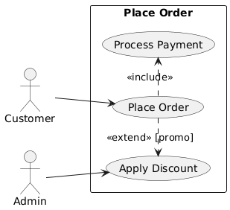

D3 — EquRental Use Case Diagram
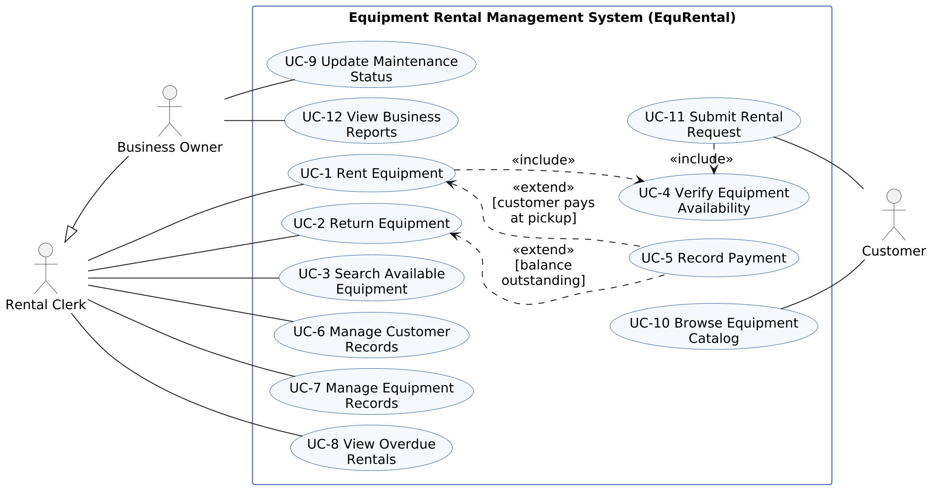
Notes: The rectangle is the system boundary; actors stay outside. Business Owner → Rental Clerk is an actor generalization (the owner can do every clerk task plus UC-9 and UC-12). «include» points from the base to the always-required use case (UC-1 and UC-11 always run UC-4). «extend» points from the optional use case to the base, with its condition (UC-5 extends UC-1 when the customer pays at pickup, and UC-2 when a balance is outstanding). UC-5 is started by the Rental Clerk inside UC-1 or UC-2, so it has no separate actor line. Won’t-have use cases UC-13 and UC-14 are not part of this release, so they are not drawn.

Step 5 — Elaborate Behavior
5A. Activity Diagram for the Complex Case (25 min) Model the workflow including decisions, parallelism (fork/join), and guards.
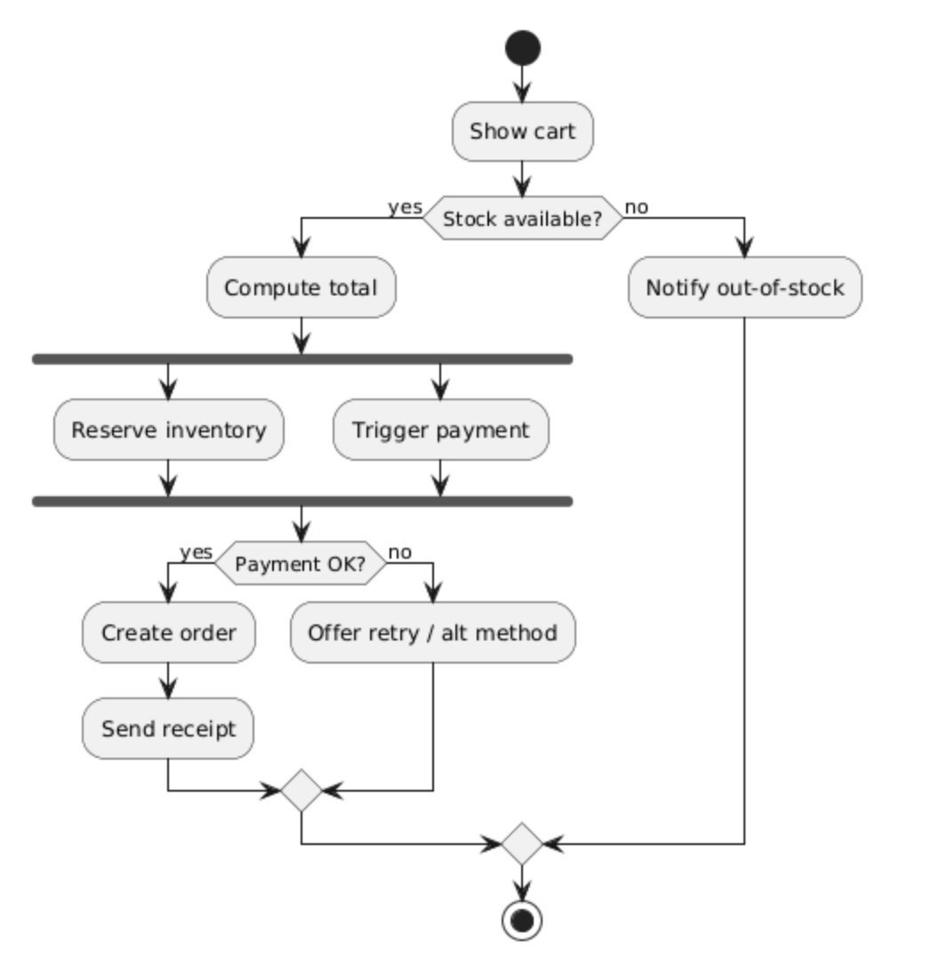
@startuml
start
:Show cart;
if (Stock available?) then (yes)
:Compute total;
fork
:Reserve inventory;
fork again
:Trigger payment;
end fork
if (Payment OK?) then (yes)
:Create order;
:Send receipt;
else (no)
:Offer retry / alt method;
endif
else (no)
:Notify out-of-stock;
endif
stop
@enduml
D4 — Activity Diagram: UC-2 Return Equipment (our most complex use case)
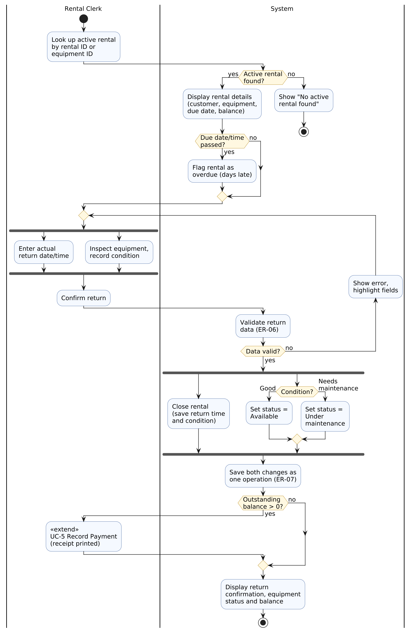
Notes: Swimlanes show who does each action. Decisions use guards that match the UC-2 extensions: [Active rental found?] = 1a, [Due date/time passed?] = 2a, [Data valid?] = 6a, [Condition?] = 4a, [Outstanding balance > 0?] = 8a. Fork/join: the clerk can enter the return time and inspect the item in any order, and the system closes the rental and updates the equipment status together (one operation, ER-07).
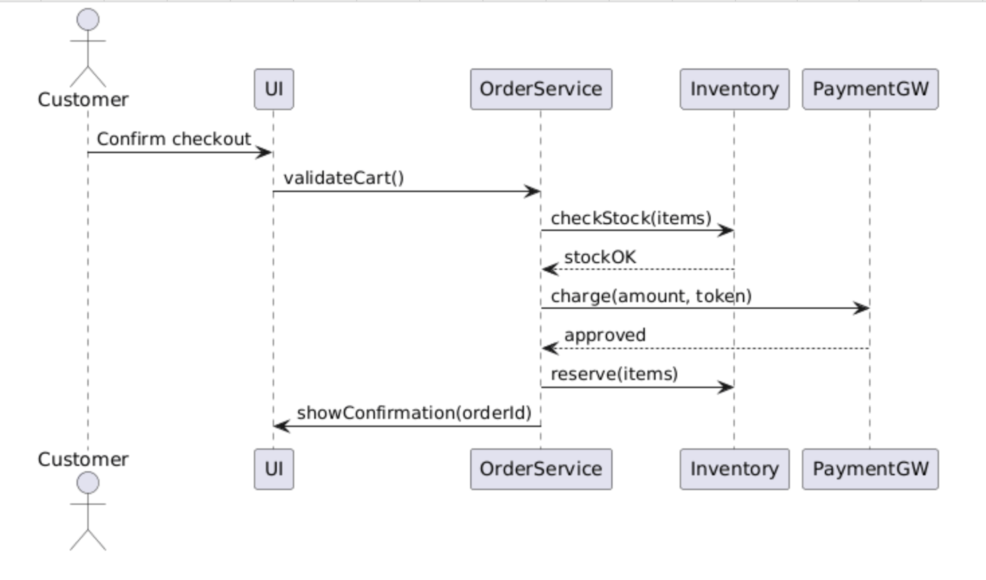
5B. Sequence Diagram for Main Success (25 min) Capture object interactions and lifelines.
@startuml
actor Customer
participant UI
participant OrderService
participant Inventory
participant PaymentGW as PG
Customer -> UI: Confirm checkout
UI -> OrderService: validateCart()
OrderService -> Inventory: checkStock(items)
Inventory --> OrderService: stockOK
OrderService -> PG: charge(amount, token)
PG --> OrderService: approved
OrderService -> Inventory: reserve(items)
OrderService -> UI: showConfirmation(orderId)
@enduml
D5 — Sequence Diagram: UC-1 Rent Equipment, main success scenario
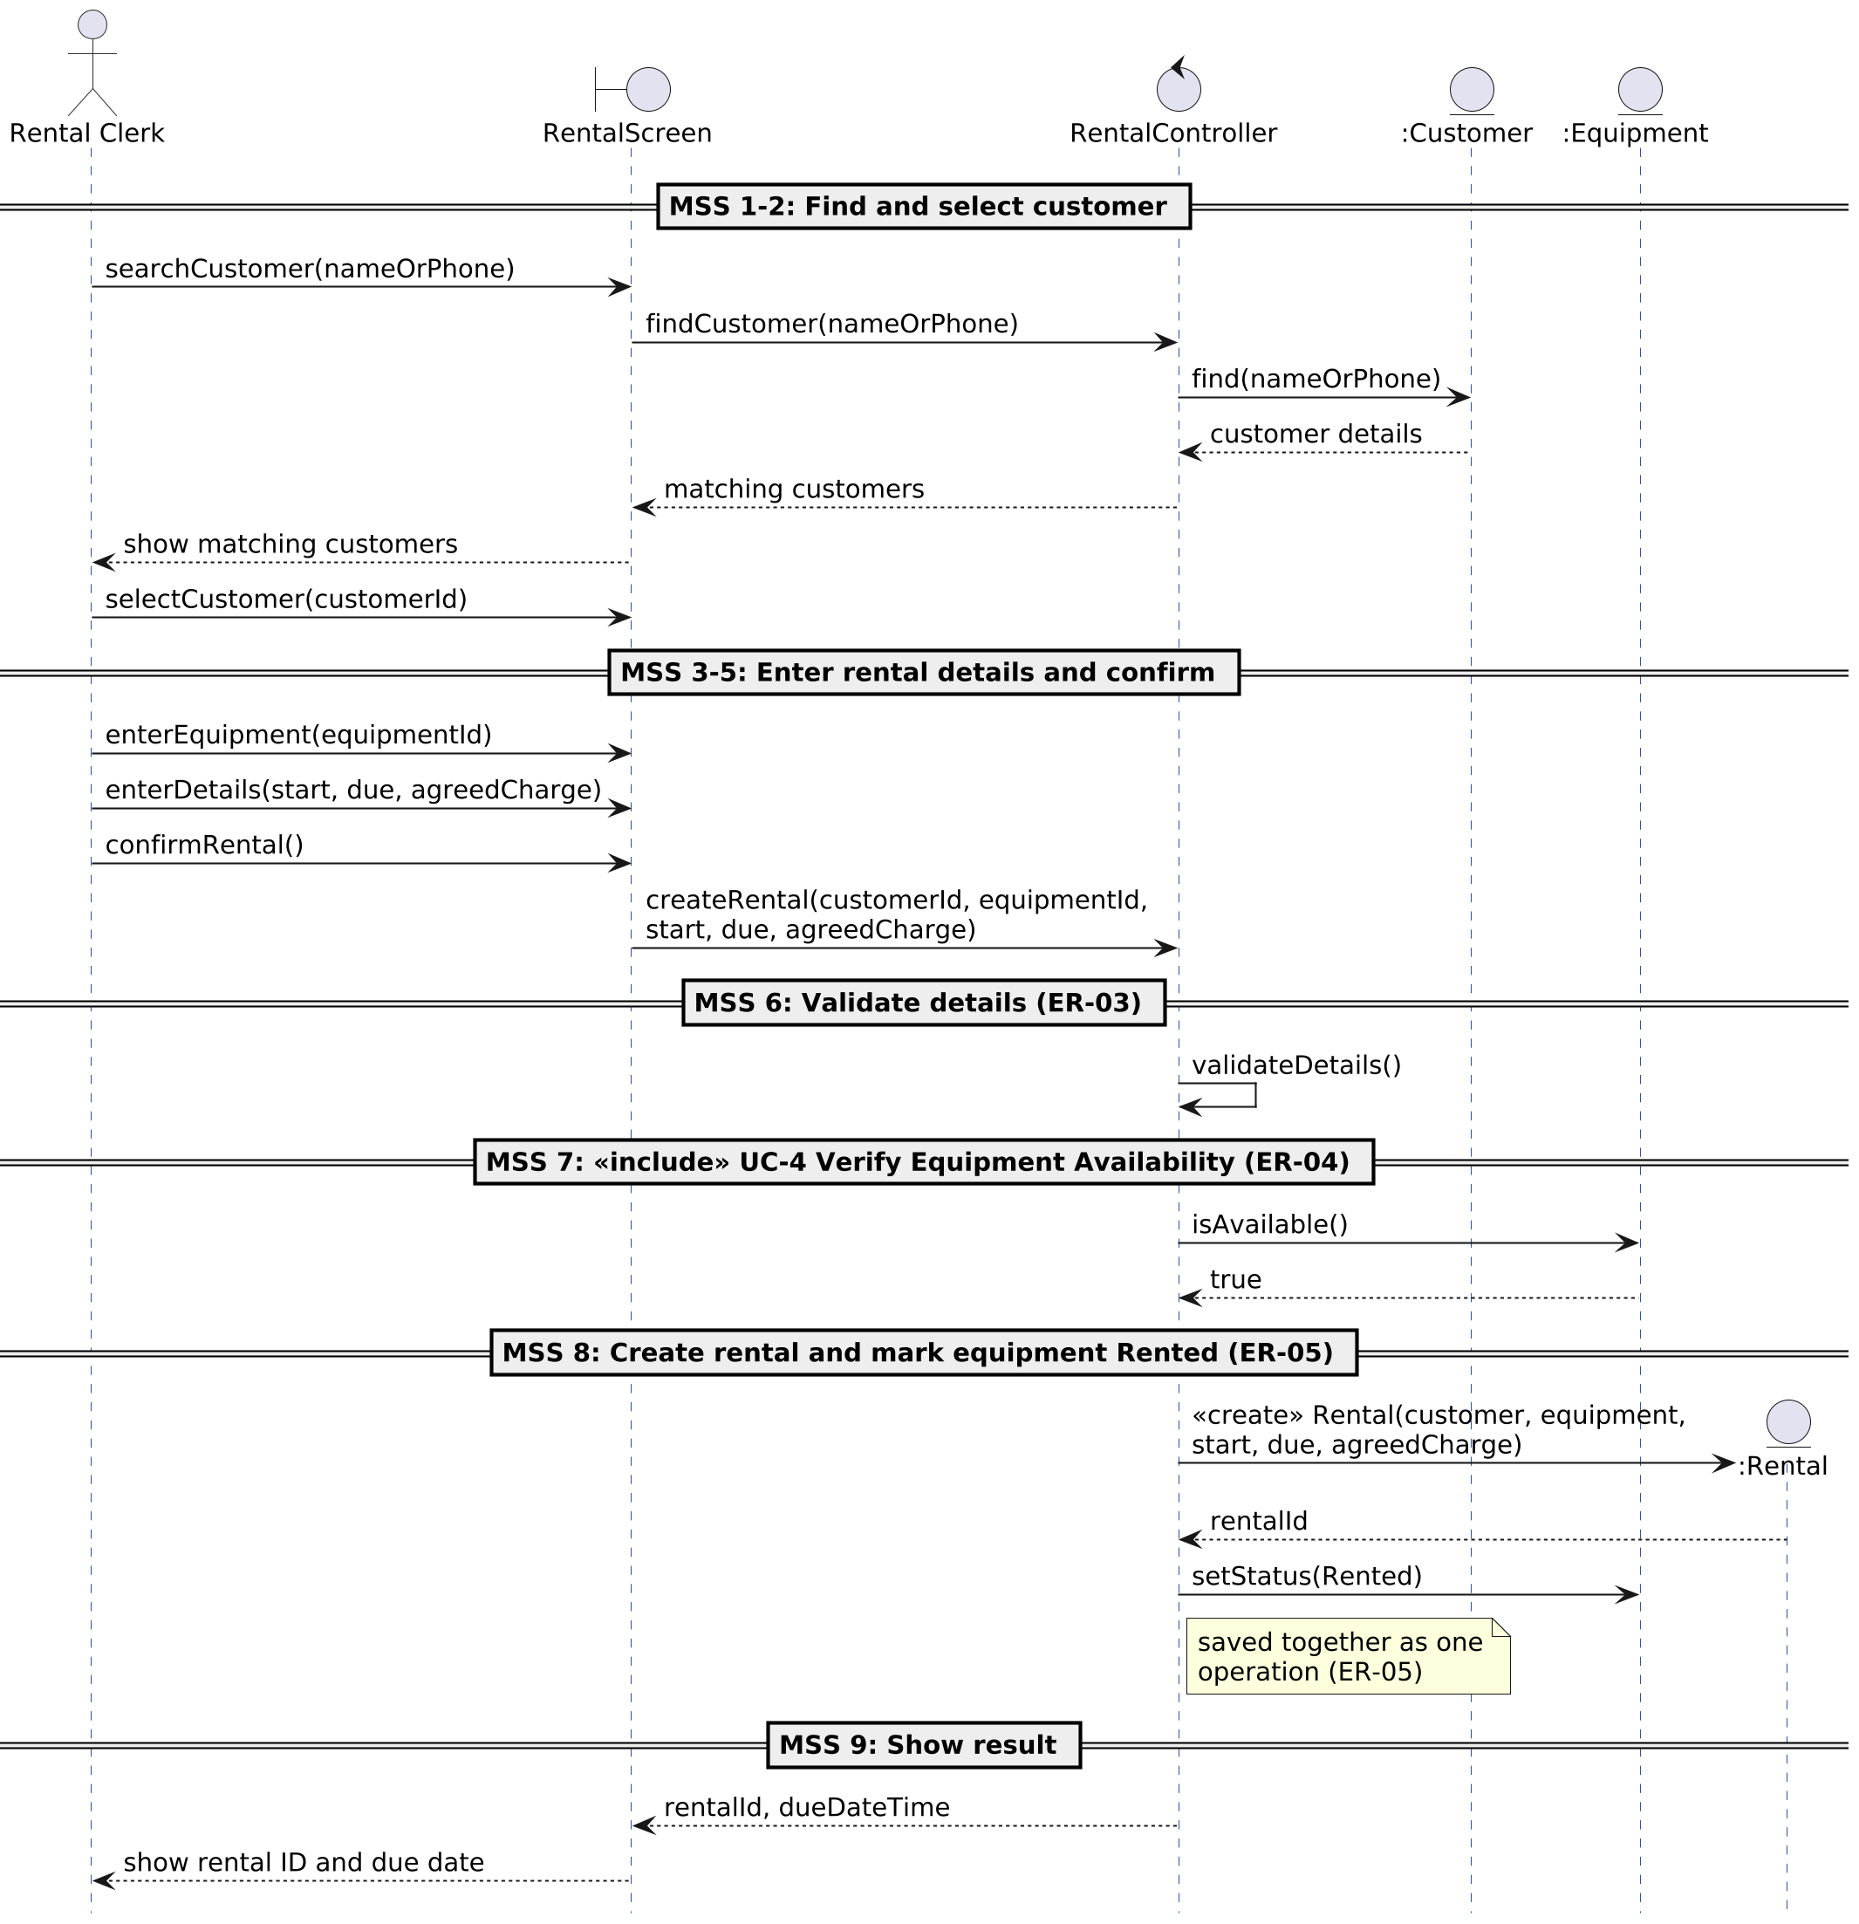
Notes: Each divider names the MSS steps of UC-1 it covers (steps 1–9). Lifelines use boundary/control/entity objects; the entity lifelines (:Customer, :Equipment, :Rental) are classes from the domain model (D6). Solid arrows are calls, dashed arrows are returns.

Step 6 — Domain Model (Class Diagram) (30 min)
Extract domain concepts (nouns) and relationships (associations, multiplicities, composition) from your requirements and use cases. Avoid technical/database details.
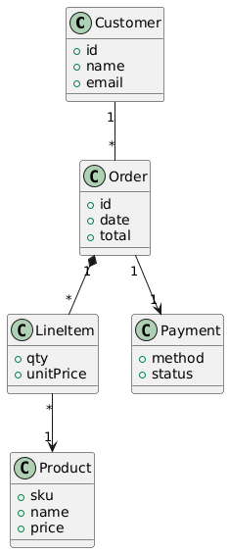
@startuml
class Customer {
+id
+name
+email
}
class Order {
+id
+date
+total
}
class LineItem {
+qty
+unitPrice
}
class Product {
+sku
+name
+price
}
class Payment {
+method
+status
}

Customer "1" -- "*" Order
Order "1" *-- "*" LineItem
LineItem "*" --> "1" Product
Order "1" --> "1" Payment
@enduml
@
D6 — EquRental Domain Model (Class Diagram)
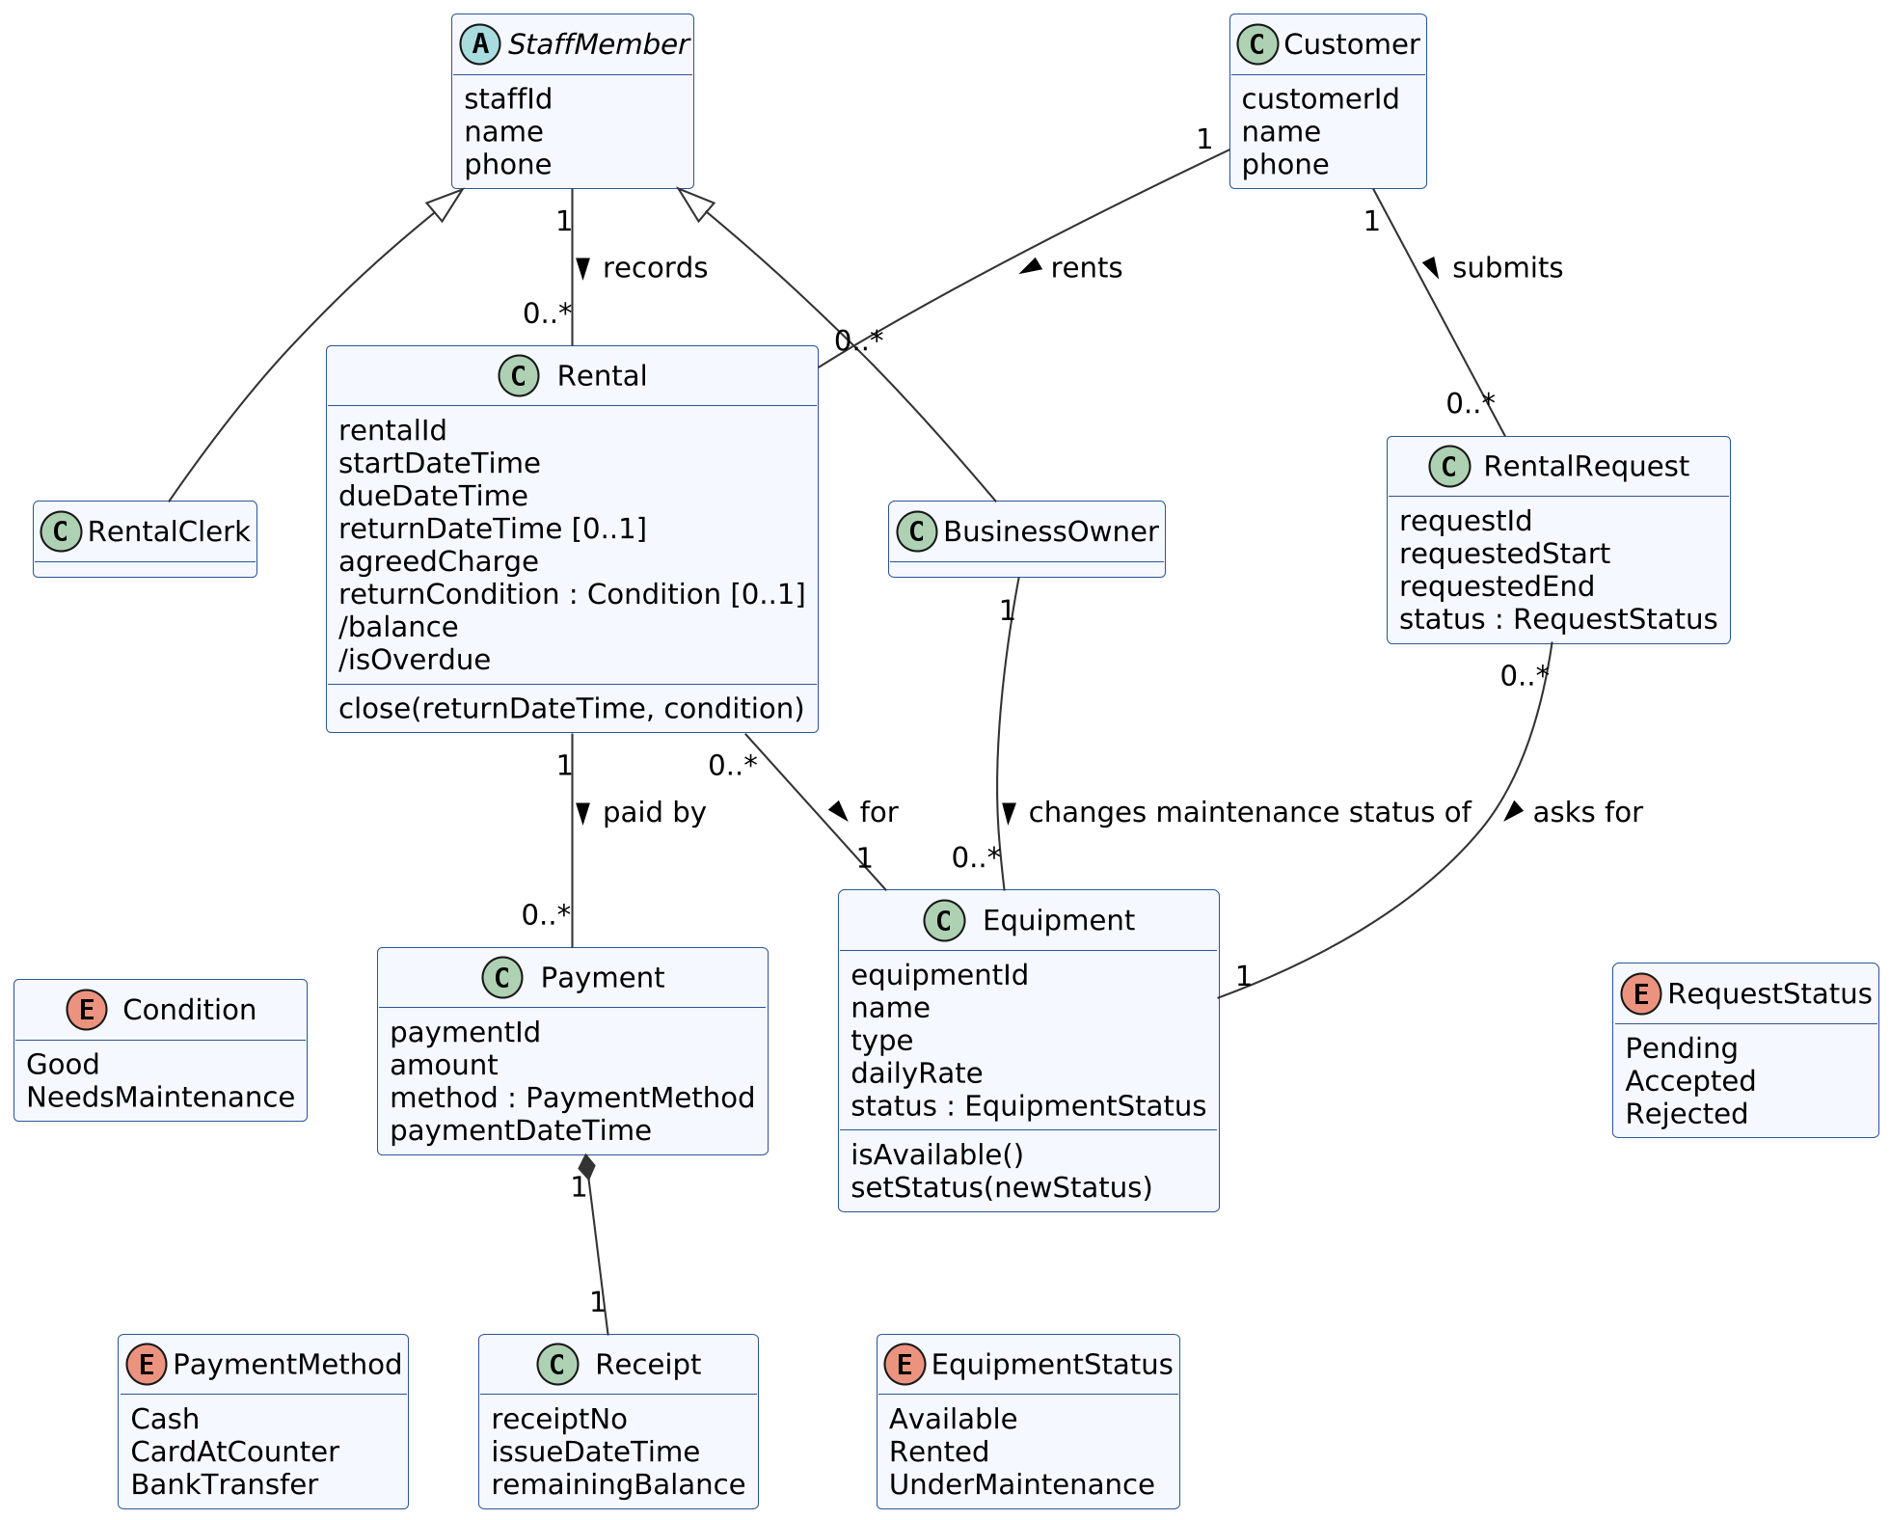
Notes: Concepts come from the nouns in our requirements and use cases (no screens or database tables). A Customer rents many Rentals; each Rental is for exactly one Equipment item (one item per rental, ER-03) and is recorded by one StaffMember. A Rental can be paid in several Payments; each Payment owns one Receipt (composition, ER-17). /balance (= agreed charge − payments, ER-16) and /isOverdue (due date passed and not returned, ER-08) are derived. RentalClerk and BusinessOwner specialize StaffMember, matching the actor generalization in D3. RentalRequest supports UC-11.

Step 7 — Consistency Checks (10 min)
- Every use case is traceable to at least one actor and appears in the Use Case Diagram.
- The Sequence Diagram messages align with the Main Success Scenario steps.
- The Activity Diagram branches match Extensions/guards in the use case.
- All domain classes appear in at least one use case/sequence; names consistent.
- Non‑functional constraints in the use case appear as notes/stereotypes where relevant.
D7 — Our consistency checklist (evidence)
Check | Status | Evidence
Every use case traceable to an actor and in the UCD | ✔ Done | All 12 M/S/C use cases are in D3. Each links to an actor directly, by inheritance (Business Owner), or through its base use case (UC-4 included by UC-1/UC-11; UC-5 extends UC-1/UC-2). UC-13/UC-14 are Won’t and listed only in D1.
Sequence messages align with MSS | ✔ Done | D5 dividers follow UC-1 steps 1–9: confirmRental() = step 5, validateDetails() = step 6, isAvailable() = step 7 («include» UC-4), «create» Rental + setStatus(Rented) = step 8, rental ID and due date = step 9.
Activity branches match extensions/guards | ✔ Done | D4 guards map to UC-2 extensions 1a, 2a, 4a, 6a, 8a (see notes under D4).
Domain classes used in use cases/sequence; names consistent | ✔ Done | Customer, Equipment, Rental are lifelines in D5; Payment and Receipt appear in UC-5; RentalRequest in UC-11; StaffMember/RentalClerk/BusinessOwner match the actors. Status names (Available, Rented, Under maintenance) are identical in D2, D4, D6 and the state machine.
Non-functional constraints shown as notes/stereotypes | ✔ Done | “One operation” notes (ER-05, ER-07) in D4 and D5; «include»/«extend» stereotypes in D3; bilingual UI and 3-second response are in the Special Requirements of UC-1 and UC-2.

Step 8 — Peer Review (15 min)
Swap with another team and complete the checklist below.
Team being reviewed: New Group 8 EquRental — Alaa Alqurashi, Faisal Alburti, Hashim Alsayed
Reviewing team: ____________________ Reviewer name(s): ____________________
Review date: ____________
The checklist below is completed by the reviewing team (ticks and comments left blank for them).
Peer‑Review Checklist –
[ ] Actors cover all personas and external systems –
[ ] Use case names are goal‑level and unambiguous –
[ ] Includes/extends used sparingly and correctly –
[ ] Activity/Sequence diagrams match narratives –
[ ] Class diagram avoids UI/DB details; multiplicities make sense –
[ ] Clear pre/post‑conditions and success guarantees –
[ ] Consistency across all artifacts –
[ ] Clarity, readability, and professional style
Reviewer comments: ________________________________________________
Changes we made after the review: ____________________________________

Grading Rubric (100 pts)
Component | Criteria | Pts
Actors & Use Case List | Complete, prioritized, correct scoping | 15
Fully Dressed Use Cases (×2) | Preconditions, MSS, extensions, NFRs | 25
Use Case Diagram | Correct notation, relationships, boundary | 15
Activity Diagram | Flow accuracy, guards, concurrency | 15
Sequence Diagram | Lifelines, messages align with MSS | 15
Domain Model | Correct concepts/relations, multiplicities | 10
Consistency + Peer Review | Checklist evidence, coherence | 5

Submission & Naming
- File: TeamName_UML_Lab.pdf. If using PlantUML, append a ZIP with .puml sources.

Extension (Optional, for +5 pts each)
- State Machine Diagram for a key entity (e.g., Order lifecycle)
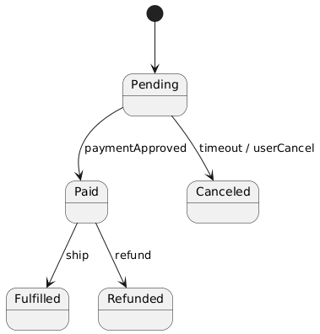
- System Sequence Diagram for an alternative flow (e.g., failed payment)
State Machine Example
@startuml
[*] --> Pending
Pending --> Paid : paymentApproved
Paid --> Fulfilled : ship
Paid --> Refunded : refund
Pending --> Canceled : timeout / userCancel
@enduml
Our Extension 1 — State Machine Diagram: Equipment lifecycle
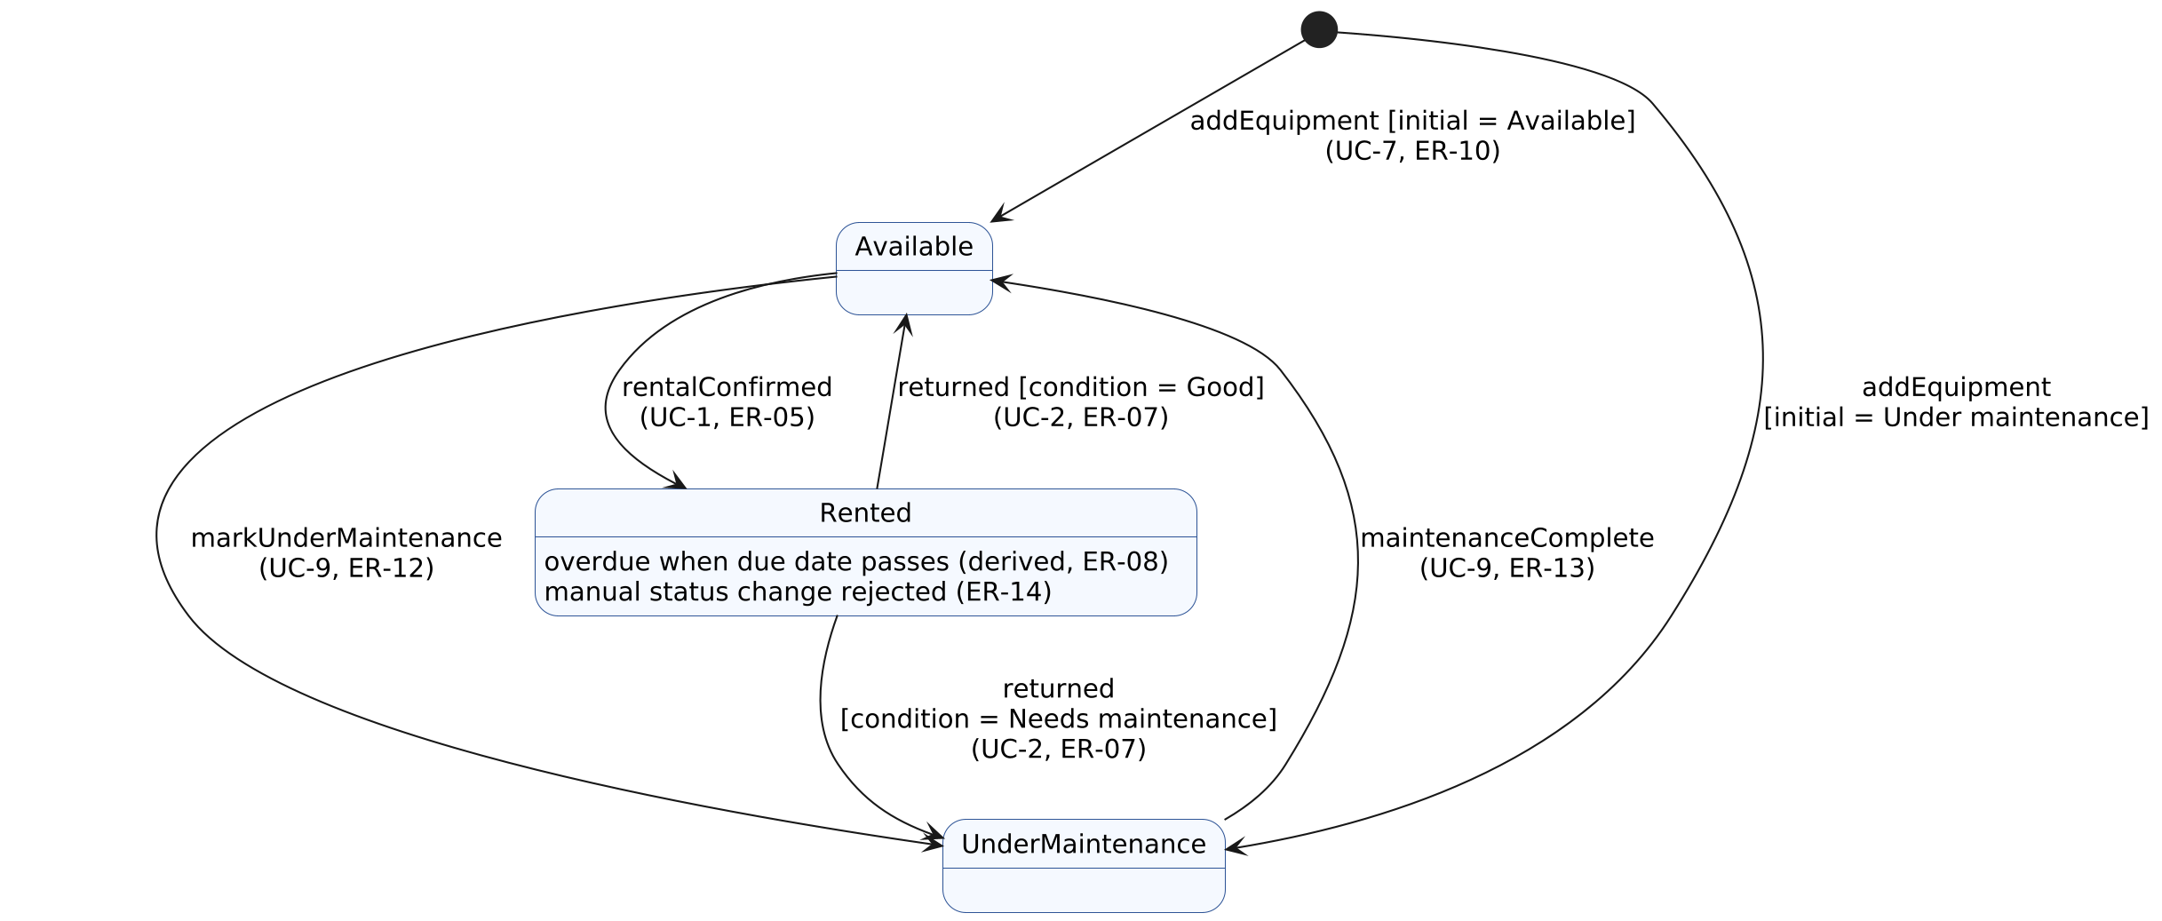
Notes: Uses the same three statuses as the requirements and domain model. “Overdue” is not a separate state; it is derived while the item is Rented (ER-08).
Our Extension 2 — System Sequence Diagram: UC-1 alternative flow 7a (equipment not available)
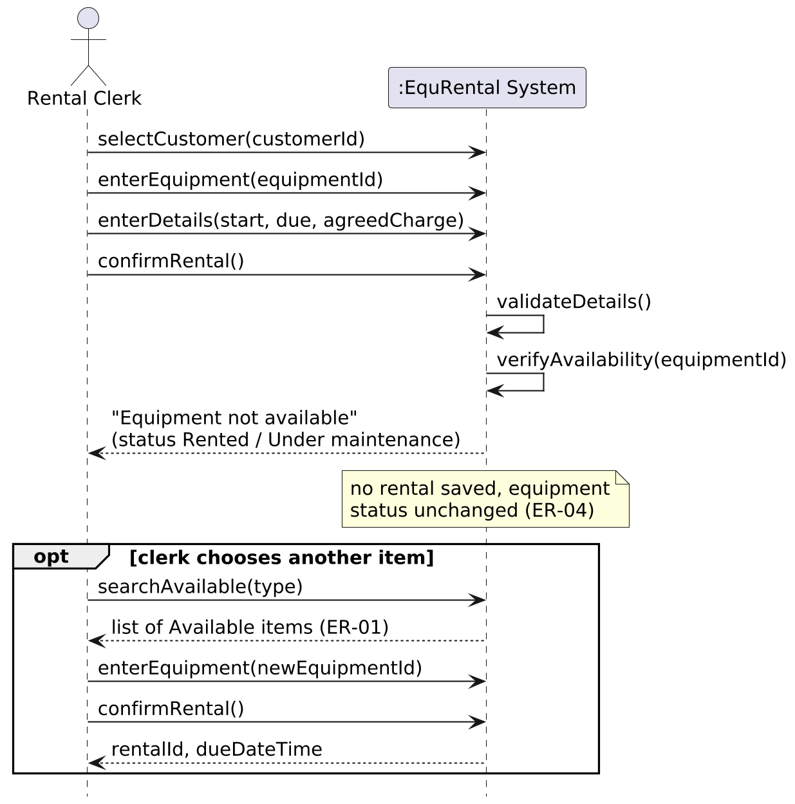

Quick Reference — When to Use Which UML
- Use Case Diagram: scope & goals from user perspective
- Activity Diagram: end‑to‑end workflow with decisions/parallelism
- Sequence Diagram: object interactions over time for a scenario
- Class Diagram: static domain structure and relationships
- State Machine: lifecycle of a complex entity
Tip: Start from personas → goals → use cases; only then elaborate behavior and structure. Keep names consistent across all artifacts.

Appendix — PlantUML Source (our diagrams)
D3 Use Case Diagram (d3_usecase.puml)
@startuml d3_usecase
left to right direction
actor "Rental Clerk" as Clerk
actor "Business Owner" as Owner
actor "Customer" as Cust
rectangle "Equipment Rental Management System (EquRental)" {
usecase "UC-1 Rent Equipment" as UC1
usecase "UC-2 Return Equipment" as UC2
usecase "UC-3 Search Available\nEquipment" as UC3
usecase "UC-4 Verify Equipment\nAvailability" as UC4
usecase "UC-5 Record Payment" as UC5
usecase "UC-6 Manage Customer\nRecords" as UC6
usecase "UC-7 Manage Equipment\nRecords" as UC7
usecase "UC-8 View Overdue\nRentals" as UC8
usecase "UC-9 Update Maintenance\nStatus" as UC9
usecase "UC-10 Browse Equipment\nCatalog" as UC10
usecase "UC-11 Submit Rental\nRequest" as UC11
usecase "UC-12 View Business\nReports" as UC12
}
Clerk <|-- Owner
Clerk -- UC3
Clerk -- UC6
Clerk -- UC1
Clerk -- UC2
Clerk -- UC7
Clerk -- UC8
Owner -- UC9
Owner -- UC12
UC1 ..> UC4 : <<include>>
UC1 <.. UC5 : <<extend>>\n[customer pays\nat pickup]
UC2 <.. UC5 : <<extend>>\n[balance\noutstanding]
UC12 -[hidden]- UC11
UC6 -[hidden]- UC10
UC11 .[norank].> UC4 : <<include>>
UC11 -- Cust
UC10 -- Cust
@enduml
D4 Activity Diagram (d4_activity_return.puml)
@startuml d4_activity_return
|Rental Clerk|
start
:Look up active rental\nby rental ID or\nequipment ID;
|System|
if (Active rental\nfound?) then (yes)
:Display rental details\n(customer, equipment,\ndue date, balance);
if (Due date/time\npassed?) then (yes)
:Flag rental as\noverdue (days late);
else (no)
endif
else (no)
:Show "No active\nrental found";
stop
endif
|Rental Clerk|
repeat
fork
:Enter actual\nreturn date/time;
fork again
:Inspect equipment,\nrecord condition;
end fork
:Confirm return;
|System|
:Validate return
data (ER-06);
backward:Show error,\nhighlight fields;
repeat while (Data valid?) is (no) not (yes)
fork
:Close rental\n(save return time\nand condition);
fork again
if (Condition?) then (Good)
:Set status =\nAvailable;
else (Needs\nmaintenance)
:Set status =\nUnder\nmaintenance;
endif
end fork
:Save both changes as
one operation (ER-07);
if (Outstanding\nbalance > 0?) then (yes)
|Rental Clerk|
:<<extend>>\nUC-5 Record Payment\n(receipt printed);
else (no)
endif
|System|
:Display return\nconfirmation, equipment\nstatus and balance;
stop
@enduml
D5 Sequence Diagram (d5_sequence_rent.puml)
@startuml d5_sequence_rent
hide footbox
actor "Rental Clerk" as Clerk
boundary "RentalScreen" as UI
control "RentalController" as Ctrl
entity ":Customer" as Cust
entity ":Equipment" as Eq
entity ":Rental" as Rent
== MSS 1-2: Find and select customer ==
Clerk -> UI : searchCustomer(nameOrPhone)
UI -> Ctrl : findCustomer(nameOrPhone)
Ctrl -> Cust : find(nameOrPhone)
Cust --> Ctrl : customer details
Ctrl --> UI : matching customers
UI --> Clerk : show matching customers
Clerk -> UI : selectCustomer(customerId)
== MSS 3-5: Enter rental details and confirm ==
Clerk -> UI : enterEquipment(equipmentId)
Clerk -> UI : enterDetails(start, due, agreedCharge)
Clerk -> UI : confirmRental()
UI -> Ctrl : createRental(customerId, equipmentId,\nstart, due, agreedCharge)
== MSS 6: Validate details (ER-03) ==
Ctrl -> Ctrl : validateDetails()
== MSS 7: <<include>> UC-4 Verify Equipment Availability (ER-04) ==
Ctrl -> Eq : isAvailable()
Eq --> Ctrl : true
== MSS 8: Create rental and mark equipment Rented (ER-05) ==
Ctrl -> Rent ** : <<create>> Rental(customer, equipment,\nstart, due, agreedCharge)
Rent --> Ctrl : rentalId
Ctrl -> Eq : setStatus(Rented)
note right of Ctrl : saved together as one\noperation (ER-05)
== MSS 9: Show result ==
Ctrl --> UI : rentalId, dueDateTime
UI --> Clerk : show rental ID and due date
@enduml
D6 Domain Model (d6_domain_model.puml)
@startuml d6_domain_model
hide empty methods
abstract class StaffMember {
staffId
name
phone
}
class RentalClerk
class BusinessOwner
class Customer {
customerId
name
phone
}
class Equipment {
equipmentId
name
type
dailyRate
status : EquipmentStatus
isAvailable()
setStatus(newStatus)
}
class Rental {
rentalId
startDateTime
dueDateTime
returnDateTime [0..1]
agreedCharge
returnCondition : Condition [0..1]
/balance
/isOverdue
close(returnDateTime, condition)
}
class Payment {
paymentId
amount
method : PaymentMethod
paymentDateTime
}
class Receipt {
receiptNo
issueDateTime
remainingBalance
}
class RentalRequest {
requestId
requestedStart
requestedEnd
status : RequestStatus
}
enum EquipmentStatus {
Available
Rented
UnderMaintenance
}
enum Condition {
Good
NeedsMaintenance
}
enum PaymentMethod {
Cash
CardAtCounter
BankTransfer
}
enum RequestStatus {
Pending
Accepted
Rejected
}
StaffMember <|-- RentalClerk
StaffMember <|-- BusinessOwner
Customer "1" -- "0..*" Rental : rents >
Rental "0..*" -- "1" Equipment : for >
StaffMember "1" -- "0..*" Rental : records >
Rental "1" -- "0..*" Payment : paid by >
Payment "1" *-- "1" Receipt
Customer "1" -- "0..*" RentalRequest : submits >
RentalRequest "0..*" -- "1" Equipment : asks for >
BusinessOwner "1" -- "0..*" Equipment : changes maintenance status of >
Equipment -[hidden]- EquipmentStatus
Rental -[hidden]- Condition
Payment -[hidden]- PaymentMethod
RentalRequest -[hidden]- RequestStatus
@enduml
Extension: State Machine (ext_state_equipment.puml)
@startuml ext_state_equipment
[*] --> Available : addEquipment [initial = Available]\n(UC-7, ER-10)
[*] --> UnderMaintenance : addEquipment\n[initial = Under maintenance]
Available --> Rented : rentalConfirmed\n(UC-1, ER-05)
Rented --> Available : returned [condition = Good]\n(UC-2, ER-07)
Rented --> UnderMaintenance : returned\n[condition = Needs maintenance]\n(UC-2, ER-07)
Available --> UnderMaintenance : markUnderMaintenance\n(UC-9, ER-12)
UnderMaintenance --> Available : maintenanceComplete\n(UC-9, ER-13)
Rented : overdue when due date passes (derived, ER-08)
Rented : manual status change rejected (ER-14)
@enduml
Extension: System Sequence Diagram (ext_ssd_unavailable.puml)
@startuml ext_ssd_unavailable
hide footbox
actor "Rental Clerk" as Clerk
participant ":EquRental System" as Sys
Clerk -> Sys : selectCustomer(customerId)
Clerk -> Sys : enterEquipment(equipmentId)
Clerk -> Sys : enterDetails(start, due, agreedCharge)
Clerk -> Sys : confirmRental()
Sys -> Sys : validateDetails()
Sys -> Sys : verifyAvailability(equipmentId)
Sys --> Clerk : "Equipment not available"\n(status Rented / Under maintenance)
note over Sys : no rental saved, equipment\nstatus unchanged (ER-04)
opt clerk chooses another item
Clerk -> Sys : searchAvailable(type)
Sys --> Clerk : list of Available items (ER-01)
Clerk -> Sys : enterEquipment(newEquipmentId)
Clerk -> Sys : confirmRental()
Sys --> Clerk : rentalId, dueDateTime
end
@enduml

