ReqSoftware Engineering Lab: From Personas & Requirements to Use Cases & UML
Course: CS3151 Software Engineering
Lab Duration: 2–3 hours (with a 1-week post‑lab)
Context: You already have a Business Model Canvas, initial requirements, and customer personas for your project. In this lab you will transform these into use cases and a consistent set of UML artifacts.

Learning Objectives
By the end of this lab, you will be able to:
1. Identify actors and user goals from personas and requirements.
2. Define and prioritize a use case list; write both brief and fully dressed use cases.
3. Draw a Use Case Diagram with correct system boundary, includes/extends, and generalization.
4. Elaborate behavior with Activity and Sequence Diagrams for key scenarios.
5. Extract a Domain Model (Class Diagram) from the problem domain (not the database schema).
6. Check consistency across artifacts and run a structured peer review.

Deliverables (What to Submit)
Upload a single PDF named TeamName_UML_Lab.pdf containing: -
• D1. Use Case List (prioritized with MoSCoW or similar) and Actor definitions
• D2. Two fully dressed Use Case specifications (one primary, one alternate/edge)
• D3. Use Case Diagram
• D4. Activity Diagram for the most complex use case
• D5. Sequence Diagram for the main success scenario
• D6. Domain Model (Class Diagram)
• D7. Consistency checklist + Peer-review sheet
(Optionally, include PlantUML source in an appendix.)

Tooling (Choose any)
- Draw.io/diagrams.net, StarUML, PlantUML, Lucidchart, Visual Paradigm
- If using PlantUML, keep code blocks in your appendix for reproducibility.

Lab Steps & Activities

Step 0 — Warm‑up (10 min)
Quickly re‑read your personas and top 10 user stories/requirements. Highlight verbs (actions) and nouns (entities). Keep these highlights visible.

Step 1 — Identify Actors & Goals (25 min)
- List all external actors (human roles, systems, devices, timers).
- For each persona, map to one or more actors.
- Derive user goals (what success looks like for each actor).
Template: Actor Card
Actor | Description | Triggers/Interests | Challanges | Notes
e.g., Registered Customer | Authenticated end user | Wants to order quickly; track order, quick find my favorite items | Returns, have favorites | Persona: “Busy Sara”

Step 2 — Draft the Use Case List (20 min)
Create a candidate list of use cases (goal‑level). Avoid UI details; think outcomes.
Checklist: -
- Named as Verb + Noun (e.g., Place Order, Schedule Pickup)
- Scope is the system, not a single page/button
- Prioritize with MoSCoW (Must, Should, Could, Won’t for now)
Template: Use Case List
ID | Use Case Name | Primary Actor | Goal/Outcome | Priority (M/S/C/W)
UC-1 | Place Order | Customer | Order submitted and paid | M
Traceability matrix.

Step 3 — Write Use Case Specifications (35 min)
Select two use cases: one core (happy path) and one complex/edge.
A. Brief (for all use cases)
Use Case | Primary Actor | Pre-conditions | Post-conditions | Main Success Scenario (1–2 lines)
B. Fully Dressed (for 2 selected cases)
Each activity in the UC
Field | Content
Use Case | UC-1 Place Order
Activity Name | Plae Order
Primary Actor | Customer
Stakeholders & Interests | Customer (quick, secure purchase); Payment Gateway (valid charge); Merchant (accurate order)
Preconditions (Ip) | User is authenticated; cart not empty
PostConditions (Op) | Order recorded; receipt issued; inventory reserved
Main Scenario (Flow of Control) | 1) Customer confirms cart  2) System validates stock  3) System totals cost  4) Customer pays  5) System confirms order & receipt
Extensions (Alternatives) | 4a) Payment fails → 4a1) Offer retry; 4a2) Choose another method
Special Requirements | PCI compliance; response < 2s for payment step
Constraints | - Items in the cart  - Cash on delivery if trusted user  - …
Open Issues | Promo codes interaction with bundles

Step 4 — Draw the Use Case Diagram (20 min)
Include system boundary, actors, associations, and use relationships («include», «extend», generalization when justified.
PlantUML Example
@startuml
left to right direction
actor Customer
actor Admin
rectangle "UC1- Place Order" {
usecase "Place Order" as UC1
usecase "Apply Discount" as UC2
usecase "Process Payment" as UC3
}
Customer --> UC1
UC1 .> UC3 : <<include>>
UC1 .> UC2 : <<extend>> [promo]
Admin --> UC2
@enduml
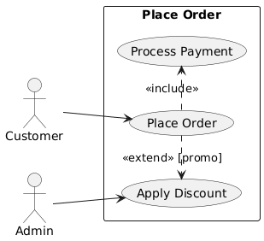

Step 5 — Elaborate Behavior
5A. Activity Diagram for the Complex Case (25 min) Model the workflow including decisions, parallelism (fork/join), and guards.
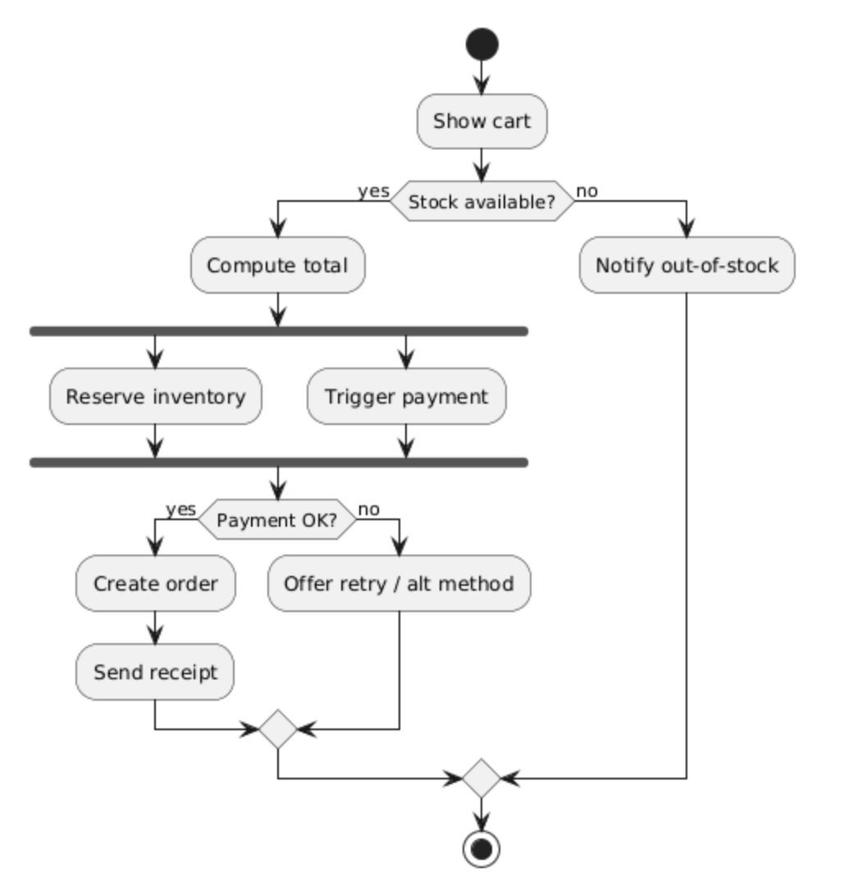
@startuml
start
:Show cart;
if (Stock available?) then (yes)
:Compute total;
fork
:Reserve inventory;
fork again
:Trigger payment;
end fork
if (Payment OK?) then (yes)
:Create order;
:Send receipt;
else (no)
:Offer retry / alt method;
endif
else (no)
:Notify out-of-stock;
endif
stop
@enduml
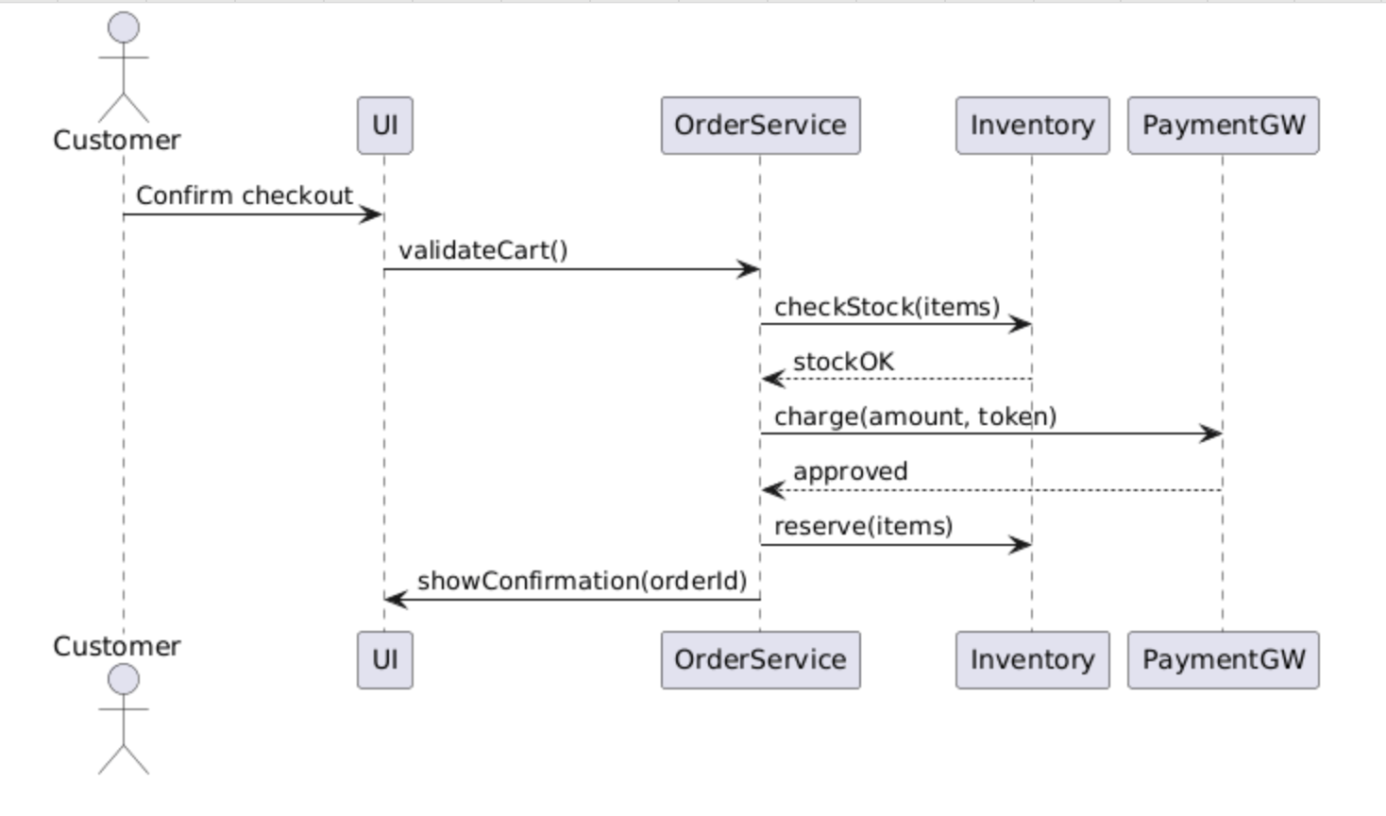
5B. Sequence Diagram for Main Success (25 min) Capture object interactions and lifelines.
@startuml
actor Customer
participant UI
participant OrderService
participant Inventory
participant PaymentGW as PG
Customer -> UI: Confirm checkout
UI -> OrderService: validateCart()
OrderService -> Inventory: checkStock(items)
Inventory --> OrderService: stockOK
OrderService -> PG: charge(amount, token)
PG --> OrderService: approved
OrderService -> Inventory: reserve(items)
OrderService -> UI: showConfirmation(orderId)
@enduml

Step 6 — Domain Model (Class Diagram) (30 min)
Extract domain concepts (nouns) and relationships (associations, multiplicities, composition) from your requirements and use cases. Avoid technical/database details.
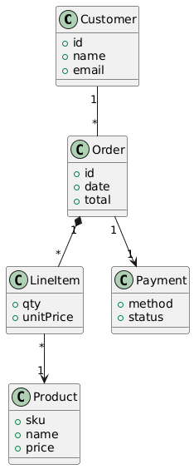
@startuml
class Customer {
+id
+name
+email
}
class Order {
+id
+date
+total
}
class LineItem {
+qty
+unitPrice
}
class Product {
+sku
+name
+price
}
class Payment {
+method
+status
}

Customer "1" -- "*" Order
Order "1" *-- "*" LineItem
LineItem "*" --> "1" Product
Order "1" --> "1" Payment
@enduml
@

Step 7 — Consistency Checks (10 min)
- Every use case is traceable to at least one actor and appears in the Use Case Diagram.
- The Sequence Diagram messages align with the Main Success Scenario steps.
- The Activity Diagram branches match Extensions/guards in the use case.
- All domain classes appear in at least one use case/sequence; names consistent.
- Non‑functional constraints in the use case appear as notes/stereotypes where relevant.

Step 8 — Peer Review (15 min)
Swap with another team and complete the checklist below.
Peer‑Review Checklist –
[ ] Actors cover all personas and external systems –
[ ] Use case names are goal‑level and unambiguous –
[ ] Includes/extends used sparingly and correctly –
[ ] Activity/Sequence diagrams match narratives –
[ ] Class diagram avoids UI/DB details; multiplicities make sense –
[ ] Clear pre/post‑conditions and success guarantees –
[ ] Consistency across all artifacts –
[ ] Clarity, readability, and professional style

Grading Rubric (100 pts)
Component | Criteria | Pts
Actors & Use Case List | Complete, prioritized, correct scoping | 15
Fully Dressed Use Cases (×2) | Preconditions, MSS, extensions, NFRs | 25
Use Case Diagram | Correct notation, relationships, boundary | 15
Activity Diagram | Flow accuracy, guards, concurrency | 15
Sequence Diagram | Lifelines, messages align with MSS | 15
Domain Model | Correct concepts/relations, multiplicities | 10
Consistency + Peer Review | Checklist evidence, coherence | 5

Submission & Naming
- File: TeamName_UML_Lab.pdf. If using PlantUML, append a ZIP with .puml sources.

Extension (Optional, for +5 pts each)
- State Machine Diagram for a key entity (e.g., Order lifecycle)
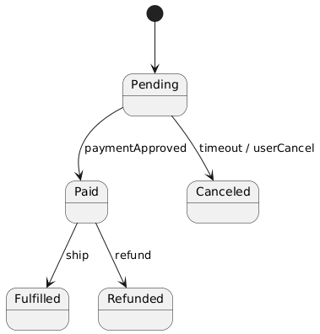
- System Sequence Diagram for an alternative flow (e.g., failed payment)
State Machine Example
@startuml
[*] --> Pending
Pending --> Paid : paymentApproved
Paid --> Fulfilled : ship
Paid --> Refunded : refund
Pending --> Canceled : timeout / userCancel
@enduml

Quick Reference — When to Use Which UML
- Use Case Diagram: scope & goals from user perspective
- Activity Diagram: end‑to‑end workflow with decisions/parallelism
- Sequence Diagram: object interactions over time for a scenario
- Class Diagram: static domain structure and relationships
- State Machine: lifecycle of a complex entity
Tip: Start from personas → goals → use cases; only then elaborate behavior and structure. Keep names consistent across all artifacts.

